4.6.1 Test set up
These characteristics shall applicable for ESD tests
The circuit characteristics will be adjusted in order to get the proper current.
Test set-up component are defined in the following table :

Test set-up components
Rs = Decoupling resistor | 4.7kW
C = Discharge capacitor | 50pF
R = Discharge resistor | 100W
Spark gap voltage | 6kV
Table 4.6.1-1: Test set Up component definition
The DCDC board included in a mechanical box fitted with its test harness shall not exhibit any malfunction, degradation of performance, or deviation from specified indication beyond tolerances indicated in the corresponding subsystem specification when subjected to conducted discharges into unit structure and wire inside the bundle.
The discharge signal shall have the following characteristics:
- amplitude: 50 A peak min
- duration: 50 nsec
- rise time: 10 ns
a. Conducted discharges into unit structure
The two injection points shall be the most distant points of the unit structure where electrical connection is feasible (mounting hole, bonding point, connector, cover screw...).
b. Conducted discharges into wire inside bundle:
The distance of the parallel wire inside the bundle shall be 0.2 m.
The ESD test set-up for conducted discharge into wire coupled to the harness is given hereafter

Référence Fichier : Tech Spec DCDC Loutch IRZ.doc du 06/11/2007 15:41 Adresse de l’original :
Reproduction interdite
Ó THALES ALENIA SPACE Company confidential
Référence du modèle : M032-2

Référence : 100219920T
Date : 30/10/2007


Issue :
00
Page : 55

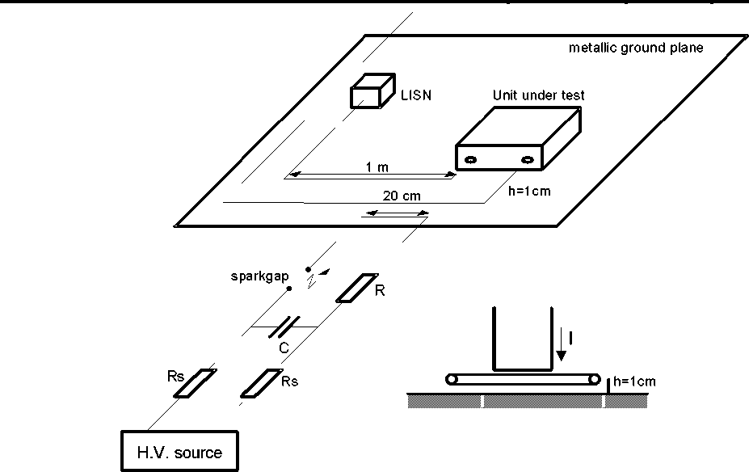

Figure 4.6.1-1 : Test set up for conducted discharges into wires inside bundles
4.6.2 Line Impedance Stabilization Network ( LISN ) specification
In order to normalize the measurement conditions between the various test sites, the measurement of the interference conducted emission on the power supply leads shall be performed by standardizing the source impedance, in accordance with Figure 4.6.3-1.
This curve can be obtained by using either the LISN shown in Figure 4.6.4-1 or any other circuit with the same impedance.
Under test, the LISN shall be set between the power source and the unit DC/DC converter input at a distance less than 1 meter.
The actual LISN impedance shall be measured before to start the EMC tests and the diagram shall be included in the test report.

Référence Fichier : Tech Spec DCDC Loutch IRZ.doc du 06/11/2007 15:41 Adresse de l’original :
Reproduction interdite
Ó THALES ALENIA SPACE Company confidential
Référence du modèle : M032-2

Référence : 100219920T
Date : 30/10/2007
Issue : 00 Page : 56

4.6.3 LISN curve impedance
See AD06
Figure 4.6.3-1: LISN theoretical curve impedance
4.6.4 LISN electrical diagram
See AD06
Figure 4.6.4-1: Constitution of the line impedance stabilization network
4.6.5 Test Sample Loading and Stimuli
The use of actual flight loads and simulating circuits is preferred to loading and stimulating the test sample. In the event that such flight loads or sources are impractical or unavailable, the impedance characteristics of such loads and sources shall be simulated.
This simulation shall consist of appropriate resistance and reactance necessary for operation of the test sample.
Référence Fichier : Tech Spec DCDC Loutch IRZ.doc Référence du modèle : M032-2
du 06/11/2007 15:41 Adresse de l’original :
Reproduction interdite Ó THALES ALENIA SPACE Company confidential

Référence : 100219920T
Date : 30/10/2007

Issue :
00
Page : 57

4.6.6 Operational Model Selection
For emission measurements, the mode of operation of the test sample shall maximize the amount of the particular interference quantity being measured. A mode shall be selected to maximize current for current measurement, voltage for voltage measurement, etc. For susceptibility testing, the mode selection shall maximize the response of the device to the particular environment being created.
4.6.7 Susceptibility Criteria
During the susceptibility test (conducted) the item under test shall maintain its performance in accordance with the relevant specification.
4.6.8 EMC Measurement Equipment
a. EMC measurement equipment grounding
The grounding of the EMC measuring equipment shall be implemented in accordance with the details of this section in order to avoid false data introduced by ground loops and minimize the likelihood of shock hazards.
- The measuring instruments shall be physically grounded by only one connection to the ground plane.
- The measuring instruments shall be connected to their power supply input through an isolation transformer.
b. Measurement bandwidths
The analysis bandwidths to be used for narrowband (NB) recording shall be as follows:

FREQUENCY RANGE | MINIMUM BANDWIDTH
30 Hz to 1 kHz | 10 Hz
1 kHz to 10 kHz | 50 Hz
10 kHz to 2.5 MHz | 500 Hz
2.5 MHz to 25 MHz | 5 kHz
25 MHz to 1 GHz | 50 kHz
above 1 GHz | 500 kHz
For frequencies above 1 GHz each individual noise signal (NB) shall be measured with a maximum band of 100 kHz.

Référence Fichier : Tech Spec DCDC Loutch IRZ.doc du 06/11/2007 15:41 Adresse de l’original :
Reproduction interdite
Ó THALES ALENIA SPACE Company confidential
Référence du modèle : M032-2

Référence : 100219920T
Date : 30/10/2007
Issue : 00 Page : 58

4.6.9 EMC Test Methods
EMC testing shall be performed in accordance with MIL-STD-462 test methods or equivalent approved test methods.
4.7 Radiation
This chapter defines the radiation requirements for a 18-year mission time in geostationary orbit. The DC/DC Converter must be designed to sustain the effects of the specified environment, consisting of ionizing radiation resulting in total dose degradation and cosmic rays producing single event effects.
4.7.1 Parts Requirements
See AD02.
4.7.2 Analysis Requirements
For analysis, a worst-case spacecraft and equipment shielding corresponding to 1.4 mm (0.6 mm equipment + 0.8 mm for satellite) omnidirectional equivalent thickness of mm Aluminum shall be assumed.
4.8 Structural Analysis
A structural analysis shall be performed to demonstrate that the equipment design shall satisfy the requirements specified in section 3.5.3.1 to 3.5.3.8 inclusive. As a minimum, the analysis shall be in accordance with the following criteria:
a. Perform a classical « desk-top » method (hand calculation) or preliminary FEM analysis to establish an
initial design concept.
b. Perform some desktop of FEM estimates of stress levels in critical areas.
c. Construct, where appropriate, a finite element mathematical model (FEM).
d. Perform a normal mode analysis to determined critical eigen frequencies.
e. Provide a structural analysis report including a strength summary, identifying component, critical design
case, material, applied stress or load, allowable stress or load, and margins of safety. Particular attention
shall be given to the strength of fasteners.
Référence Fichier : Tech Spec DCDC Loutch IRZ.doc Référence du modèle : M032-2
du 06/11/2007 15:41 Adresse de l’original :
Reproduction interdite Ó THALES ALENIA SPACE Company confidential

Référence : 100219920T
Date : 30/10/2007

Issue :
00
Page : 59

4.9 Thermal Analysis
A thermal analysis shall be performed in order to demonstrate that all components operate within temperature limits which shall not adversely affect the unit’s reliability under all relevant thermal interfaces, and steady state/transient, operating/non-operating conditions.

Référence Fichier : Tech Spec DCDC Loutch IRZ.doc du 06/11/2007 15:41 Adresse de l’original :
Reproduction interdite
Ó THALES ALENIA SPACE Company confidential
Référence du modèle : M032-2

Référence : 100219920T
Date : 30/10/2007
Issue : 00 Page : 60

5. ABBREVIATIONS
DC | Direct Current
EOL | End Of Life
TBS | To Be Supplied
ICD | Interface Control Drawing
ESD | Electronic Discharge
EBB | Elegant Bread Board
PFM | Proto Flight Model
SEE | Single Event Effect
LET | Linear Energy Transfer
SEU | Single Event Upset
SEL | Single Event Latchup
SEB | Single Event Burn-out
SEGR Single Event Gate Rupter
FIN DE DOCUMENT END OF DOCUMENT
Référence Fichier : Tech Spec DCDC Loutch IRZ.doc Référence du modèle : M032-2

