1. A state of a question and the operation purpose
The operation purpose is the possibility of listening of a radio channel «Radio Vera» from mobile platforms iOS and Android.
2. Operation stages
Operations are fulfilled in 2 stages:
- Release and publication of application for iOS
- Release and publication of application for Android
3. Requirements
3.1 Applications have to work on following mobile devices:
- For devices iOS (iPhone 3, 3S, 4, 4S, 5, 5S, 5C)
- For devices Android (OC - Android 4.1 and higher,a normal display for following screen resolutions 4:3 (1024х768, 320х240), 16:9 (1920х1080б1280х720, 800х480, 960х540) and 3:2 (480х320))
3.2 Application design has to match with the image on fig. 1

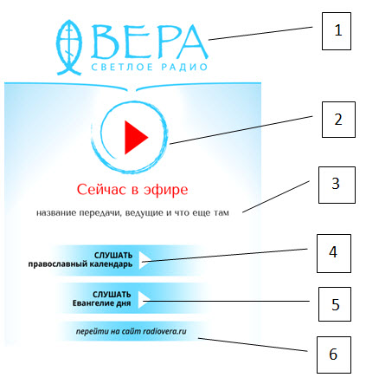 | Pos. 1 | Radio station logotype
 | Pos. 2 | Button «Play»
 | Pos. 3 | Meta-information about a current composition/transmission
 | Pos. 4 | Button «Listen to the orthodox calendar»
 | Pos. 5 | Button «Listen to the Gospel of the day»
 | Pos. 6 | Button «Go to a site radiovera.ru»

Перевод надписей на изображении.
«Vera» - a fair radio.
Now on air – сейчас в эфире.
Bbroadcast name, radio hosts etc. – название передачи, ведущие и т.д.
Цифры 4, 5, 6 переведены выше.
3.3 At pushing button "Play", the torrent http://radiovera64.streamr.ru. has to play. At pushing, the button has to pass in a "Pause" position.
3.4 Meta- information about a current composition/transmission undertakes from a file <http://radiovera.ru/programm/cur_playing.xml> from the bloc
<ELEM PLAYER_NAME="Плеер" SCH_ID="1" SCH_NAME="Default" STATUS="playing">
Thus it is necessary:
a. Ignore elements of the type <TYPE> Д </TYPE>
b. Among elements of the type <TYPE> M </TYPE> take NAME and ARTIST
c. Among elements of the type <TYPE> П </TYPE> take NAME and AUTHOR
3.5 At pushing button «Listen to the orthodox calendar», there should be a playing of a file having a current date designation (maskYYYYMMDD.mp3 and accessible from a folder http://radiovera.ru/today_gospel/, thus, playing of all other torrents has to stop and the button has to pass to a "Pause" position. An example of the link for playing http://radiovera.ru/today_calendar/20131004.mp3
3.6 At pushing button «Listen to the Gospel of the day», there should be a playing of a file having a current date designation (maskYYYYMMDD.mp3 and accessible from a folder http://radiovera.ru/today_gospel/, thus, playing of all other torrents has to stop and the button has to pass to a "Pause" position. An example of the link for playing http://radiovera.ru/today_gospel/131004.mp3
3.7 At pushing button «Go to a site radiovera.ru», the browser has to open by default and a passage to page http://radiovera.ru. has to be fulfilled.
3.8 Volume has not to be regulated by a program. Volume control has to be fulfilled by means of hardware (as a rule, it is a button-swing laterally of the devices).
3.9 Application has to provide functioning possibility in a background mode.
3.10 At switching of networks (for example, from 3G to Wi-fi) or at network loss, and at communication recovery, the application has to reconnect independently to the media server with an output of the message to the screen «At the moment, communication with the server is recovered».
4. Operation results and the implementation (realization) order
4.1 Functioning and ready to the publication in Android Market and Appstore mobile applications on platforms iOS and Android.

