Web development services
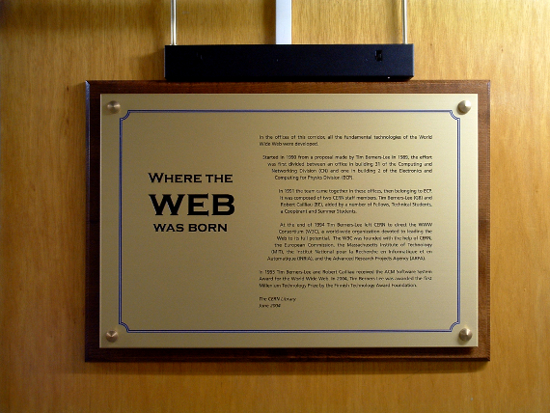
The web development services is a development of different applications for your on-line business. Our company will develop a magnificent and beneficial business website for you - and offer continuous support. Besides, as well as web development services we offer a full range of on-line marketing services so that your site focuses and delivers targeted, purchase ready traffic in your business sector. If you gain traffic it means you have more visitors and great number of visitors means sales, sales means profits and money.
Due to our knowledge and experience we know how to make your on-line business earn money from the site - and how to beat your competitors. Our web development team consists of professional programmers with high level experience.

Face It company provides with numerous web development services. We can offer you:
- corporate sites
- on-line stores
- information portals
- internal corporate portals (intranet)
- community sites
- social networks
- web-integration

We have got ready typical solutions:
- Site-card
- Blog
- Audio-video gallery
- Educational institution site
- Restaurant or cafe website
- Business Directory, or Guide
- Travel Agency Site
- Real Estate Website
- The portal or on-line community
- On-line Store
- File archive
- Forum
- Web chat
- Web site with paid access to the content
- Catalog of sites
Website development is a complicated process but our company works hard to make it easy and available for the clients. Mostly we develop websites using content management system (CMS). Our company developed difficult web applications in many spheres.
We have achieved success in the field of website development not only because of the profound knowledge of technology but also because our team has knowledge in advertising and marketing fields.

We can easily create a website for you:
- if you have enough information and you are ready to order a website we will create it according to your needs;
- ask your questions related to website development if you are willing to listen to the recommendations of professionals;
- read a little more information - we have specially selected for you the information about what is website development, what sites are, etc.
Whatever people say but the price is an indicator, which is oriented in order to develop sites. High-quality site may not be very cheap, but compared to how much time and effort needed to create an original website design, we offer our services for the development and site promotion - inexpensively and of high quality.
We suggest a fair price for a professional work. A price is not only certain sum of money but also, a cost of the services of professionally trained experts with successful experience in developing and manufacturing sites. Our price reflects a real value of professional work on the site. We have created a stable and professionally trained staff.
There is such a concept in marketing as a unique selling proposition. Unique proposition is a feature that profitably distinguishes the company in the market.

Our uniqueness lies in 3 things:
- successful experience;
- great professionalism;
- a clearly defined specialization.
Exactly these components provide with high demand for our services. Our advantages is several years of hard and successful work consequence.
Thus, a result of a large experience, qualification and diverse expertise enables us to solve problems of any complexity. In addition, we do not just create websites, we also offer you support and promotion of Internet sites to increase its attendance.
Face It company is ready to help you get your desirable results in the global network.

