**Player control**

**New control**

Playback speed and volume control changed in the player starting with version 2.3. Now the volume is regulated by gestures up/down by default.

For variable speed playback, switch the control mode by clicking the icon on the right sidebar.

After pressing the following icon appears , it means that now playback speed is regulated by gesturing up/down.

**Note:** The playback speed can also be changed without affecting the volume. To do this, use two-finger gestures up/down.

**Gesture control**

Video player can be controlled by the following gestures:

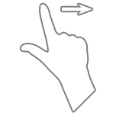 fast forward for 15 seconds

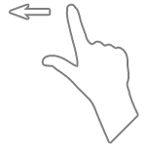 rewind for 15 seconds

 double tap, change the aspect ratio of the video

two-finger tap, to show/hide the side panels

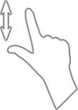 change the volume

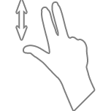change playback speed

**Player buttons**

 play the following video/audio recording

 pause the video\audio recording

 start playing the video\audio recording

 play previous video/audio recording

 switch the playback on a TV screen using AirPlay

 exit from the player to a playlist

 change aspect ratio of the video

 loop the playlist

 random selection

 block orientation when rotating the device

 lock the device screen

 open playlist

 take a screen shot

 change of volume/playback speed