Ivan Ivanov

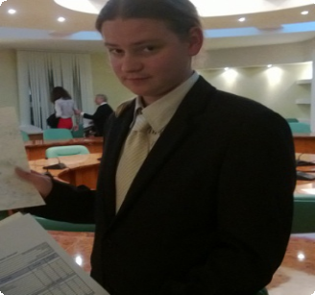

E-mail : Phone :

[ivanov@yandex.ru](mailto:plushoma@yandex.ru)

+38 063 123456

Website: Address:

http://site1.ru, <http://site.im>

123450, Ivanova str.,

111-111, Kiev, Ukraine

Work experience

Service Ltd. Mar 2012 — Jun 2013

System administrator

Configuration and installation of Windows servers

Installation and configuration of operating systems and different software

Network services administration

Working with hardware and office supplies Development and support of network infrastructure Network monitoring and error analysis

"My life" Ltd. Oct 2012 — Mar 2013

System administrator

Configuration and installation of Windows servers and OS Installation of different software

Working with 1C software and database

Network services administration

Working with hardware and office supplies

No Jan 2004 — Present

Free game developer

Working for myself as a free game developer, creating Big Ideas, communicating with other gamers & game dvelopers. Unofficially.

Qualifications

University degree in Marketing, management and business administration in IT. Diplomas:

Spanish Graduate School of Business - CESTE, Spain

Institute of Management, Business and Law, Russia.

Basic programming experience in PHP. Working with html, css, MySQL. Working with game servers.

Knowledge of PC hardware and software.

Education

Accounting and Auditing sept 2004 — june 2008

Donbass State Engineering Academy

Appl. Informatics sept 2010 — june 2013

Institute of Management Business and Law (IMBL)

Direction of training: Appl. Informatics in Management (IT projects manager)

International Marketing Management sept 2010 — june 2013

CESTE (Spanish Business School)

European BBA diploma.

Interests

Since my childhood I've been interested in computer games. It all starts a long time ago, in a computer club far, far away... During my school education I’ve developed Linage server which brought me my first money. My hobbies were creating mods for popular games and level re-design. And still I have a lot of unrealized ideas that I want to implement. Unfortunately, Russian and Ukranian reality hardly allows doing it. Therefore I’m ready to change my place of residence.

I dare to say that I know game process from within. I have some experience in developing games on freelance basis (for example, I’ve been participating in development of “Shambala” game as a game-designer/screenwriter). I try to keep abreast of all the news from game world.

Knowing all the features in game development and all my diplomas can help me to become an effective manager.

Ready to qualify. Ready for dialog.

Ready to start from below.

Ready to put my ideas and brains in my job!

**I’m learning fast. I’m young, strong and ambitious. I’m ready to start!**

References

References available upon request.