Министерство образования РФ
Московский Государственный Открытый Университет
Факультет лингвистики и межкультурной коммуникации
Курсовая работа
The history of the English Language
«The history of the first English alphabet, runes, old English manuscripts»

Выполнил: студент 4 курса
Ермаков В.А.
Проверила: Акапян.К.В.

Contents
1. Introduction……………………………………………………………………...3
2. History of the English Language………………………………………………...6
2.1. Runic alphabet…………………………………………………………………6
2.1.1. The history of runic alphabet………………………………………………...6
2.1.2. Mythological…………………………………………………………………8
2.1.3 Historical……………………………………………………………………10
2.2. Old English…………………………………………………………………...12
2.2.1. Old English Manuscripts…………………………………………………...14
2.3. Middle English……………………………………………………………….20
2.4. Modern English………………………………………………………………22
2.4.1 Early modern English……………………………………………………….22
2.4.2. Late modern English………………………………………………………..23
Appendix A brief chronology of English…………………………………………24
Conclusion………………………………………………………………………...25
Literature………………………………………………………………………….25

1. Introduction

English language concerns to the West-German group индоевропейских languages. In English speak and use in the state office-work, the literature and a science nearby 200 million чел. - in the Great Britain and Ireland (alongside with Irish), in the USA, Canada (alongside with French), Australia, New Zealand, partially in Southern Africa and India.

One of five official and the working languages accepted by the United Nations. English language conducts the beginning from language old german (Anglos, Saxophones and Juts), moved in 5-6 centuries from continent to Britain.

Complex interaction old german the breeding adverbs brought to Britain, occupied celtic tribes (Britts and Galls), and developed conditions of formation of an English nationality, has led to formation of territorial dialects on an old breeding basis. During the old english period (7-11 centuries) Language is presented by four dialects: Northumbrian, Mercian, Wessex and Kent. Owing to economic and political influence of kingdom Wessex in 9-10 centuries in a cultural life of England the greatest value has got Wessex a dialect.

After penetration into England into 6 century of christianity the latin alphabet has replaced old german runes, and influence of latin language was reflected in English lexicon. From language subdued by anglo-saxons celtic the population of Britain were kept mainly place names. Attacks of Scandinavians (the end 8 century), The England which have ended by submission in 1016 Danish king, have caused creation of the Scandinavian settlements in the country. Interaction of closely related languages - English and Scandinavian - has affected available in modern English language of a significant amount of words of the Scandinavian origin, and also some phonetic features describing dialects of northern England.

Mixture with the Scandinavian languages promoted strengthening and of some the grammatic tendencies which are available in English language. The gain of England Normen in 1066 has led to the long period двуязычья when the English language had three basic territorial dialects (northern, central and southern), was kept as language of people, but the French language its Long use was considered as a state language at a royal court yard, in parliament, court and school has led to that after replacement of the French language from these spheres (to 14 century) in English language extensive layers of the French lexicon were kept.

During formation of the nation there was a formation of the national English language developed on the basis of the London dialect which combined southern and East-central dialect features. In 2-nd half 13 and 1-st half 14 centuries are noticed replacement of southern dialect features from language of London and replacement with their features of the East-central dialect. The Middle English period (12-15 centuries) developments of English language is characterized by a number of changes, is sharp circumscribed Middle English sound system from old english. As all inflections were unaccented, the reduction of unaccented vowels has affected and significant simplification of morphological structure of English language. Introduction in England of publishing (1476) promoted fastening and distribution of the London forms that was much helped by popularity of products of large writer Geoffrey Chaucer (1340-1400), written on the London dialect.

However publishing fixed some traditional the writing, not so pronunciations of the end not reflected norms 15 century about., so characteristic divergence for modern English language between a pronunciation and a writing has begun. In 16-17 centuries develops i.e. new English language. Scientific and philosophical products began to be written in English, instead of in latin language, and it has demanded development of terminology. Sources of updating were loans from latin and Greek, partly from Italian and Spanish, and in 17 century from French of languages. In the field of grammar modern English language is characterized analytical строем, т. е. Such structure at which the basic means of expression of grammatic values are the word order and the syntactic words showing the attitudes between words or groups of words.

In 2-nd half 17 century and especially in 18 century are published set of managements on орфоэпии and normative grammar which authors aspire to order grammatic norms of language: one - on the basis of rational grammar, others - proceeding from the alive use of forms of language. Puristic current 18 century (J. Swift, J. Addison) it has been directed against penetration into literary English language of neologisms of colloquial type (for example, the truncated words) and excessive loans.
In the given work we shall consider history of the English letter in a historical context and today.

2. History of the English Language

2.1. Runic alphabet
2.1.1. The history of runic alphabet
The Runic alphabets are a set of related alphabets using letters (known as runes) used to write Germanic languages prior to the adaption of the Latin alphabet and for specialized purposes after. The Scandinavian variants are also known as Futhark (or fuþark, derived from their first six letters of the alphabet: F, U, Þ, A, R, and K); the Anglo-Saxon variant as futhorc (due to sound changes undergone in Old English by the same six letters).
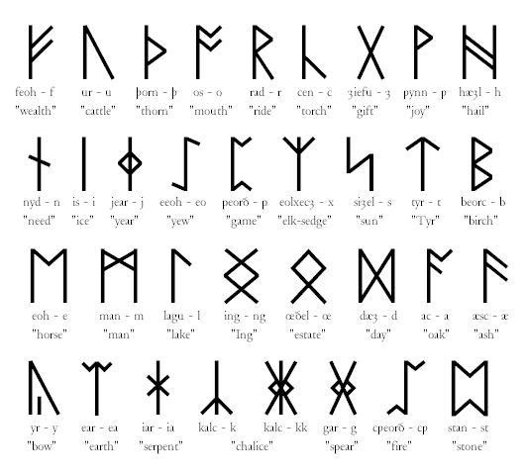
The futhorc.
The earliest runic inscriptions date from around 150 CE, and the alphabet was generally replaced by the Latin alphabet with Christianization by around 700 CE in central Europe and by around 1100 CE in Scandinavia; however, the use of runes persisted for specialized purposes in Scandinavia, longest in rural Sweden until the early twentieth century (used mainly for decoration as runes in Dalarna and on Runic calendars).
The three best-known runic alphabets are the Elder Futhark (around 150 to 800 CE), the Anglo-Saxon runes (400 to 1100 CE), and the Younger Futhark (800–1100). The Younger Futhark is further divided into the long-branch runes (also called Danish, although they were also used in Norway and Sweden), short-twig or Rök runes (also called Swedish-Norwegian, although they were also used in Denmark), and the Hälsinge runes (staveless runes). The Younger Futhark developed further into the Marcomannic runes, the Medieval runes (1100 CE to 1500 CE), and the Dalecarlian runes (around 1500 to 1800 CE).
The origins of the runic alphabet is uncertain. Many characters of the Elder Futhark bear a close resemblance to characters from the Latin alphabet. Other candidates are the 5th to 1st century BCE Northern Italic alphabets: Lepontic, Rhaetic and Venetic, all of which are closely related to each other and descend from the Old Italic alphabet.
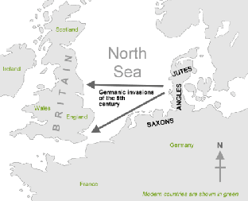
Germanic invaders entered Britain on the east and south coasts in the 5th century.

2.1.2. Mythological
In Norse mythology, the runic alphabet is attested to a divine origin (Old Norse: reginkunnr). This is attested as early as on the Noleby Runestone from around 600 CE that reads Runo fahi raginakundo toj[e'k]a..., meaning "I prepare the suitable divine rune ..." and in an attestation from the 9th century on the Sparlösa Runestone which reads Ok rað runaR þaR rægi[n]kundu, meaning "And interpret the runes of divine origin". More notably, in the Poetic Edda poem Hávamál, Stanza 80, the runes are also described as reginkunnr:
Þat er þá reynt,  er þú að rúnum spyrr  inum reginkunnum,  þeim er gerðu ginnregin  ok fáði fimbulþulr,  þá hefir hann bazt, ef hann þegir. | That is now proved, what you asked of the runes,  of the potent famous ones,  which the great gods made,  and the mighty sage stained,  that it is best for him if he stays silent.
The poem Hávamál explains that the originator of the runes was the major god Odin. Stanza 138 describes how Odin received the runes through self-sacrifice:
Veit ec at ec hecc vindga meiði a  netr allar nío,  geiri vndaþr oc gefinn Oðni,  sialfr sialfom mer,  a þeim meiþi, er mangi veit, hvers hann af rótom renn. | I know that I hung on a windy tree  nine long nights,  wounded with a spear, dedicated to Odin,  myself to myself,  on that tree of which no man knows  from where its roots run.

In stanza 139, Odin continues:
Við hleifi mic seldo ne viþ hornigi,  nysta ec niþr,  nam ec vp rvnar,  opandi nam,  fell ec aptr þaðan. | No bread did they give me nor a drink from a horn,  downwards I peered;  I took up the runes, screaming I took them,  then I fell back from there.
In the Poetic Edda poem Rígsþula another origin is related of how the runic alphabet became known to man. The poem relates how Ríg, identified as Heimdall in the introduction, sired three sons (Thrall (slave), Churl (freeman) and Jarl (noble)) on human women. These sons became the ancestors of the three classes of men indicated by their names. When Jarl reached an age when he began to handle weapons and show other signs of nobility, Rig returned and, having claimed him as a son, taught him the runes. In 1555, the exiled Swedish archbishop Olaus Magnus recorded a tradition that a man named Kettil Runske had stolen three rune staffs from Odin and learned the runes and their magic.

2.1.3. Historical
The runes developed centuries after the Mediterranean alphabets from which they are potentially descended. There are some similarities to alphabets of Phoenician origin (Latin, Greek, Italic) that cannot possibly all be due to chance; an Old Italic alphabet, more particularly the Raetic alphabet of Bolzano, is often quoted as a candidate for the origin of the runes, with only five Elder Futhark runes ( ᛖ e, ᛇ ï, ᛃ j, ᛜ ŋ, ᛈ p) having no counterpart in the Bolzano alphabet (Mees 2000). This hypothesis is often denied by Scandinavian scholars, who usually favour a Latin origin for most or all of the runic letters (Odenstedt 1990; Williams 1996). An Old Italic or "North Etruscan" thesis is supported by the inscription on the Negau helmet dating to the 2nd century BCE (Markey 2001). This is in a northern Etruscan alphabet, but features a Germanic name, Harigast. New archaeological evidence came from Monte Calvario (Auronzo di Cadore).
The angular shapes of the runes are shared with most contemporary alphabets of the period used for carving in wood or stone. A peculiarity of the runic alphabet as compared to the Old Italic family is rather the absence of horizontal strokes. Runes were commonly carved on the edge of narrow pieces of wood. The primary grooves cut spanned the whole piece vertically, against the grain of the wood: curves are difficult to make, and horizontal lines get lost among the grain of the split wood. This vertical characteristic is also shared by other alphabets, such as the early form of the Latin alphabet used for the Duenos inscription.
The "West Germanic hypothesis" speculates on an introduction by West Germanic tribes. This hypothesis is based on claiming that the earliest inscriptions of around 200 CE, found in bogs and graves around Jutland (the Vimose inscriptions), exhibit word endings that, being interpreted by Scandinavian scholars to be Proto-Norse, are considered unresolved and having been long the subject of discussion. Inscriptions like wagnija, niþijo, and harija are supposed to incarnate tribenames, tentatively proposed to be Vangiones, the Nidensis and the Harii, tribes located in the Rhineland.
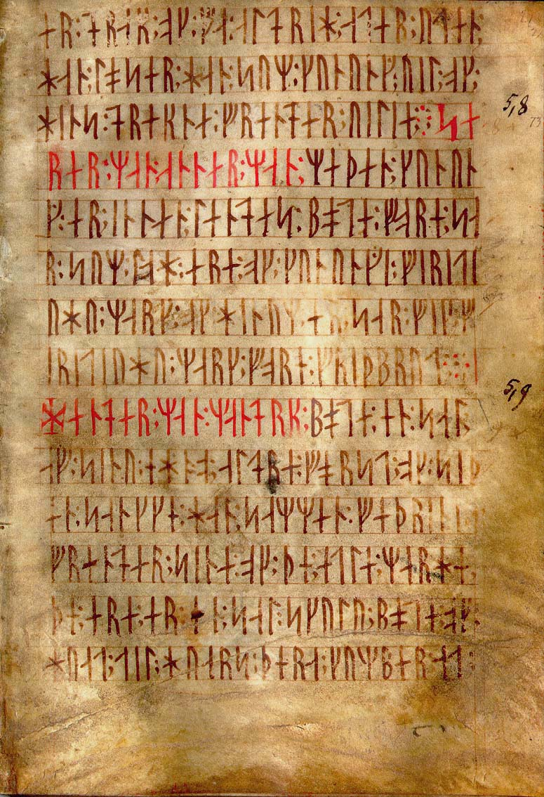Codex Runicus, a vellum manuscript from around 1300 CE containing one of the oldest and best preserved texts of the Scanian Law, written entirely in runes.
2.2. Old English (450-1100 AD)
The invaders' Germanic language displaced the indigenous Brythonic languages of what became England. The original Celtic languages remained in Scotland, Wales and Cornwall. The dialects spoken by the Anglo-Saxons formed what is now called Old English. Later, it was strongly influenced by the North Germanic language Norse, spoken by the Vikings who invaded and settled mainly in the northeast of England (see Jórvík and Danelaw). The new and the earlier settlers spoke languages from different branches of the Germanic family; many of their lexical roots were the same or similar, although their grammars were more distinct, including the prefix, suffix and inflection patterns for many of their words. The Germanic language of these Old English speaking inhabitants of Britain was influenced by contact with Norse invaders, which might have been responsible for some of the morphological simplification of Old English, including loss of grammatical gender and explicitly marked case (with the notable exception of the pronouns). The most famous surviving work from the Old English period is a fragment of the epic poem "Beowulf", by an unknown poet, though substantially modified, likely by one or more Christian clerics long after its composition.
The period when England was ruled by Anglo-Saxon kings, with the assistance of Anglo-Saxon clergy, was a period when the Old English language was alive and growing. Since it was used for legal, political, religious and other intellectual purposes, Old English coined new words from native Anglo-Saxon roots, rather than "borrowing" foreign words. (This point is made in a standard text, The History of the English Language, by Baugh.)
The introduction of Christianity added another wave of Latin and some Greek words.
The Old English period formally ended with the Norman conquest, when the language was influenced, to an even greater extent, by the Norman-speaking Normans.
The use of Anglo-Saxon to describe a merging of Anglian and Saxon languages and cultures is a relatively modern development. According to Lois Fundis, (Stumpers-L, Fri, 14 Dec 2001) "The first citation for the second definition of 'Anglo-Saxon', referring to early English language or a certain dialect thereof, comes during the reign of Elizabeth I, from a historian named Camden, who seems to be the person most responsible for the term becoming well-known in modern times."
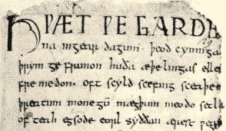

Part of Beowulf, a poem written in Old English.

2.2.1. Old English Manuscripts

Our knowledge of the OE language comes mainly from manuscripts written in Latin characters. Like elsewhere in Western Europe Latin in England was the language of the church and also the language of writing and education. The monks were practically the only literature people; they read and wrote Latin and therefore began to use Latin letters to write down English words. Like the scribes of other countries, British scribes modified the Latin script to suit their needs; they changed the shape of some letters, added new symbols to indicate sounds, which Latin had no equivalents, attached new sound values to Latin letters.

The first English words to be written down with the help of Latin characters were personal names and place names inserted in Latin texts; then came glosses and longer textual insertions.

All over the country in the, in the kingdoms of England all kinds of legal documents were written and copied. At first they were made in Latin, with English names and place-names spelt by means of Latin letters, later they were also written in the local dialects. Many documents have survived on single sheets or have been copied into large manuscripts: various wills, grants, deals of purchase, agreements, proceedings of church councils, laws, etc. most of them are now commonly known under the general heading of “Anglo-Saxon Characters”; the earliest are in Kentish and Mercian (8-9th c.); later laws and characters are written in West Saxon though they do not necessarily come from Wessex; West Saxon as the written form of language was used in different regions.

Glosses to the Gospels and other religious texts were made in many English monasteries, for the benefit of those who did not know enough Latin. Their chronology is uncertain but, undoubtedly, they constitute early samples of written English. We may mention the Corpus and Epinal glossaries in the 8th c. Mercian, consisting of words to the Latin text arranged alphabetically, the interlinear glosses to the Lindisfarne Gospels: separate words and word-for-word translations scribbled between the Latin lines of beautifully ornamented manuscripts, and the glosses in the Durham Ritual, both in the 10th c. Northumbrian; and … Gospels in Mercian and Northumbrian of the same century.

Among the earliest insertions in Latin texts art pieces of OE poetry. Bede's HISTORIA ECCLESIASTICA GENTIS ANGLO-RUM (written in Latin in the 8th c.) contains an English fragment of Five lines known as "Bede's Death Song" and a religious poem of nine lines, "Caedmon's Hymn".

OE poetry constitutes a most precious literary relic and quite a substantial portion of the records in the vernacular. All in all we have about 30,000 lines of OE verse from many poets of some three centuries. The names of the poets are unknown except Caedmon and Cynewulf, two early Northumbrian authors.
OE poetry is mainly restricted to three subjects: heroic, religious and lyrical. It is believed that many OE poems, especially those dealing with heroic subjects, were composed a long time before they were written down; they were handed down from generation to generation in oral form. Perhaps, they were first recorded in Northumbria some time in the 8th c, but have survived only in West Saxon copies made a long time afterwards—the 10th or 11th c.

The greatest poem of the time was BEOWULF, an epic of the 7th or 8th c. It was originally composed in the Mercian or Northumbrian dialect, but has come down to us in a 10th c. West Saxon copy. It is valued both as a source of linguistic material and as a work of art; it is the oldest poem in Germanic literature. BEOWULF is built up of several songs arranged in three chapters (over 3,000 lines in all). It is based on old legends about the tribal life of the ancient Teutons. The author (unknown) depicts vividly the adventures and fights of legendary heroes some of which can be traced to historical events.

In the 10th c., when the old heroic verses were already declining, some new war poems were composed and inserted in the prose historical chronicles: THE BATTLE OF BRUNANBURH, THE BATTLE OF MALDON. They bear resemblance to the ancient heroic poems but deal with contemporary events: the wars with the Scots, the Picts and the raiders from Scandinavia.

Another group of poems are OE elegiac (lyrical) poems: WIDSITH ("The Traveller's Song"), THE WANDERER, THE SEAFARER, and others. THE WANDERER depicts the sorrows and bereavement of a poet in exile: he laments the death of his protectors and friends and expresses his resignation to the gloomy fate. THE SEAFARER is considered to be the most original of the poems; it gives a mournful picture of the dark northern seas and sings joy at the return of the spring. Most of those poems are ascribed to Cynewulf.

Religious poems paraphrase, more or less closely, the books of the Bible - GENESIS, EXODUS (written by Caedmon), ELENE, ANDREAS, CHRIST, FATE OF THE APOSTLES tell the life-stories of apostles and saints or deal with various subjects associated with the Gospels (e.g. in the DREAM OF THE ROOD, the tree of which the cross was made tells its story from the time it was cut to the crucifixion of Christ; extracts from this poem were carved in runes en the Ruthwell Cross).

OE poetry is characterized by a specific system of versification and some peculiar stylistic devices. Practically all of it is written in the OG alliterative verse: the lines are not rhymed and the number of the syllables in a line is free, only the number of stressed syllables being fixed. The line is divided into two halves with two strongly stressed syllables in each half and is bound together by the use of the same sound at the beginning of at least two stressed syllables in the line.
Here is the beginning of BEOWULF arranged in lines with stressed syllables and alliterating sounds italicized:

Hwæt! We ʒar-Dena in ʒear-daʒum,
Lo, we of the spear-Danes in yore-days

Þêod-cyninʒa, thrym ʒefrunon,
of the(ir) folk-kings the fame have heard

hũ Þã æthelinʒas ellen fremedon!"
how the nobly-descended (ones) deeds of valour wrought."

The style of OE poetry is marked by the wide use of metaphorical phrases or compounds describing the qualities or functions of the thing; e.g. OE heapu-swat— 'war-sweat' for blood, OE breost-hord — 'breast-hoard' for though). This kind of metaphor naturally led to the composition of riddles, another peculiar production of OE poetry. (Some riddles contain descriptions of nature; many riddles describe all kinds of everyday objects in roundabout terms and make a sort of encyclopedia of contemporary life; for instance, the riddle of the shield which describes its sufferings on the battle-field; of an ox-horn used as a trumpet and as a drinking cup: a swan, a cuckoo, a bookworm.

OE prose is a most valuable source of information for the history of the language. The earliest samples of continuous prose are the first pages of the ANGLO-SAXON CHRONICLES: brief annals of the year's happenings made at various monasteries. In the 9th c. the chronicles were unified at Winchester, the capital of Wessex. Though sometimes dropped or started again, the Chronicles developed into a fairly complete prose history of England; the Winchester annals were copied and continued in other monasteries.

Several versions of the ANGLO-SAXON CHRONICLES have survived. Having no particular literary value they are of greatest interest to the philologist, as they afford a closer approach to spoken OE than OE poetry or prose translations from Latin; the style lacks conciseness, the syntax is primitive, for it reflects faithfully the style of oral narration.

Literary prose does not really begin until the 9th c. which witnessed a flourishing of learning and literature in Wessex during King Alfred's reign. The flourishing is justly attributed to King Alfred and a group of scholars he had gathered at his court at Winchester. An erudite himself, Alfred realised that culture could reach the people only in their own tongue. He translated from Latin books on geography, history and philosophy popular at the time. One of his most important contributions is the West Saxon version of Orsius’s World History (HISTORIARUM ADVERSUS PAGANOS LIBRI SEPTEM “Seven books of history against the heathens”). It abounds in deviations from the original, expansions and insertions, which make it the more interesting; he included there a full description of the lands where Germanic languages were spoken; two accounts of voyages: one made by Ohthere, a Norwegian, who had sailed along the coast of Scandinavia into the White Sea (some passages from this account are quoted in §113); another by Wulfstan, a Dane, who had travelled around the Baltic Sea. Alfred’s (or his associates’) other translations were a book of instructions for parish priests PASTORAL CARE (CURA PASTORALIS) by Pope Gregory the Great; the famous philosophical treatise ON THE CONSOLATION OF PHILOSOPHY (DE CONSOLATIONE PHILOSOPHIAE) by Boethius, a roman philosopher and statesman. Bede’s ECCLESIASTICAL HISTORY OF THE ENGLISH PEOPLE, written about a hundred and fifty years before, was first rendered in English in Alfred’s time, if not by Alfred himself.

By the 10th c. the West Saxon dialect had firmly established itself as the written form of English. The two important 10th c. writers are Aelfric and Wulfstan , they wrote in a form of Late West Saxon which is believed to have considerably deviated from spoken West Saxon and to have developed into a somewhat artificial bookish language.

Aelfric was the most outstanding writer of the later OE period. He produced a series of homilies to be used by the clergy during a year’s service; the LIVES OF THE SAINTS written in an alliterative metrical prose. He was the first to translate from Latin some parts of the Bible. Of especial interest are his textbooks: the COLLOQUIUM, which is a series of dialogues written as a manual for boys at a monastic school in Winchester and a LATIN GRAMMAR giving OE equivalents of Latin forms and constructions. The grammar shows the author’s great ingenuity in devising English grammatical terms by means of translation-loans.

Wulfstan, the second prominent late West Saxon author, was Arch-bishop of York in the early 11th c. he is famous for his collections of passionate sermons known as the HOMILIES.

It was many hundred years later that scholars began to take an interest in older forms of the language and turned their attention to the old manuscripts. In the 17th c. Franciscuc Junius, of Holland, accomplished an enormous amount of work in the study of early written records in OG tongues. He published the Gothic Gospels and a number of OE texts. Later in 18th and 19th c., many more OE texts were discovered; they were published in facsimile editions, and in the more modern English script with commentary and translations. Most of the OE written material is kept in the British Museum; some of it is scattered elsewhere. A valuable manuscript of Bede’s ECCLESIASTICAL HISTORY dated in the year 746 is preserved in the Leningrad Public Library, the Latin text contains OE personal names, place-names and an early version of Caedmon’s famous hymn in the Northumbrian dialect.

Middle English (1100-1500)

For about 300 years following the Norman Conquest in 1066, the Norman kings and their high nobility spoke only one of the langues d'oïl called Anglo-Norman. English continued to be the language of the common people. Various contemporary sources suggest that within fifty years of the invasion most of the Normans outside the royal court had switched to English, with French remaining the prestige language of government and law largely out of social inertia. For example, Orderic Vitalis, a historian born in 1075 and the son of a Norman knight, said that he learned French only as a second language. A tendency for French-derived words to have more formal connotations has continued to the present day; most modern English speakers would consider a "cordial reception" (from French) to be more formal than a "hearty welcome" (Germanic). Another homely example is that of the names for meats, such as beef and pork from French boeuf and porc. The animals from which the meats come are called by Anglo Saxon words, such as cow and pig. This might be because Anglo-Saxon peasants raised the animals; Norman-French lords ate the meat.
While the Anglo-Saxon Chronicle continued until 1154, most other literature from this period was in Old Norman or Latin. A large number of Norman words were taken into Old English, with many doubling for Old English words (examples include, ox/beef, sheep/mutton and so on). The Norman influence reinforced the continued changes in the language over the following centuries, producing what is now referred to as Middle English. Among the changes was an increase in the use of a unique aspect of English grammar, the "continuous" tenses, with the suffix "-ing". English spelling was also influenced by Norman in this period, with the /θ/ and /ð/ sounds being spelled th rather than with the Old English letters þ (thorn) and ð (eth), which did not exist in Norman. The most famous writer from the Middle English period is Geoffrey Chaucer and of his works, The Canterbury Tales is the best known.
English literature started to reappear ca 1200, when a changing political climate and the decline in Anglo-Norman made it more respectable. The Provisions of Oxford, released in 1258, were the first English government document to be published in the English language since the Conquest.^{[1]} Edward III became the first king to address Parliament in English when he did so in 1362.^{[2]} By the end of that century, even the royal court had switched to English. Anglo-Norman remained in use in limited circles somewhat longer, but it had ceased to be a living language.
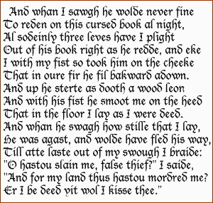
An example of Middle English by Chaucer.

2.4. Modern English

2.4.1. Early Modern English (1500-1800)
Modern English is often dated from the Great Vowel Shift, which took place mainly during the 15th century. English was further transformed by the spread of a standardised London-based dialect in government and administration and by the standardising effect of printing. By the time of William Shakespeare (mid-late 16th century) the language had become clearly recognizable as Modern English.
English has continuously adopted foreign words, especially from Latin and Greek, since the Renaissance. (In the 17th century, Latin words were often used with the original inflections, but these eventually disappeared.) As there are many words from different languages and English spelling is variable, the risk of mispronunciation is high, but remnants of the older forms remain in a few regional dialects, most notably in the West Country.
In 1755 Samuel Johnson published the first significant English dictionary, his Dictionary of the English Language.
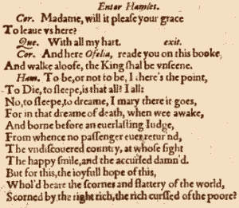
Hamlet's famous "To be, or not to be" lines,
written in Early Modern English by Shakespeare.

2.4.2. Late Modern English (1800-Present)
The main difference between Early Modern English and Late Modern English is vocabulary. Late Modern English has many more words, arising from two principal factors: firstly, the Industrial Revolution and technology created a need for new words; secondly, the British Empire at its height covered one quarter of the earth's surface, and the English language adopted foreign words from many countries.
Appendix
A brief chronology of English
BC 55 | Roman invasion of Britain by Julius Caesar. | Local inhabitants speak Celtish
BC 43 | Roman invasion and occupation. Beginning of Roman rule of Britain. | Local inhabitants speak Celtish
436 | Roman withdrawal from Britain complete. | Local inhabitants speak Celtish
449 | Settlement of Britain by Germanic invaders begins | Local inhabitants speak Celtish
450-480 | Earliest known Old English inscriptions. | Old English
1066 | William the Conqueror, Duke of Normandy, invades and conquers England. | Old English
c1150 | Earliest surviving manuscripts in Middle English. | Middle English
1348 | English replaces Latin as the language of instruction in most schools. | Middle English
1362 | English replaces French as the language of law. English is used in Parliament for the first time. | Middle English
c1388 | Chaucer starts writing The Canterbury Tales. | Middle English
c1400 | The Great Vowel Shift begins. | Middle English
1476 | William Caxton establishes the first English printing press. | Early Modern English
1564 | Shakespeare is born. | Early Modern English
1604 | Table Alphabeticall, the first English dictionary, is published. | Early Modern English
1607 | The first permanent English settlement in the New World (Jamestown) is established. | Early Modern English
1616 | Shakespeare dies. | Early Modern English
1623 | Shakespeare's First Folio is published | Early Modern English
1702 | The first daily English-language newspaper, The Daily Courant, is published in London. | Early Modern English
1755 | Samuel Johnson publishes his English dictionary. | Early Modern English
1776 | Thomas Jefferson writes the American Declaration of Independence. | Early Modern English
1782 | Britain abandons its American colonies. | Early Modern English
1828 | Webster publishes his American English dictionary. | Late Modern English
1922 | The British Broadcasting Corporation is founded. | Late Modern English
1928 | The Oxford English Dictionary is published. | Late Modern English

3. Conclusion
In the given work the history of English language in diachronical aspect in brief has been considered. The periods with 5 for 20 century have been considered. Also some literary and historical monuments which most brightly reflect a context of language of the described period have been presented. It is necessary to understand, that in work of such level it is impossible to consider is more volumetric a task in view. From this follows, that the material is given with reductions.

Literature:
1. Runic alphabet http://en.wikipedia.org/wiki/Runic_alphabet.
2.The history of the English Language.
3."The history of the first english alphabet,runes,old english manuscripts".
4. Ильиш, Расторгуева и Резник "The History of the English Language".

