www.aeroidea.ru

Administrator manual member.startchr.nyc

Version 1.0
23d December 2015

Contents

1.Login
2. Administration block
2.1. Browse list of users
2.1.1. List of users filter
2.1.3. List of users sorting
2.1.4. Managing users
2.2. Assign system roles
2.2.1. User role assignment
2.3. Manage course
2.3.1.Managing categories
2.3.2. Managing courses
2.4. Manage webinars
2.5. Create webinar
2.6. Browse deleted posts
2.7. Turn course editing off
2.7.1. Adding resource
2.7.2. Adding activity
2.8. Activity chooser off/Activity chooser on
2.8. Course completion

1. Login
To login the system the administrator should go to member.startchr.nyc and enter his login and password in the authorization window. Afterwards the administrator should click “Join the Conversation”.

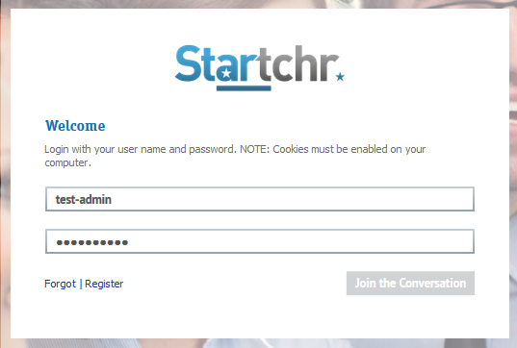

2. Administration block
Managing of the website contents is done in administration block in the lower right hand corner of the website. The following points are to be found in the administration block:
- Browse list of users
- Assign system roles
- Manage course
- Manage webinars
- Create webinar
- Browse deleted posts
- Turn course editing off/Turn course editing on (displayed only on course page)
- Activity chooser off/Activity chooser on (displayed only on course page)
- Course completion (displayed only on course page).

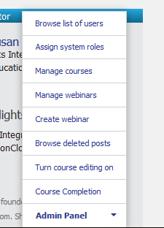

2.1. Browse list of users
List of all users is stored in this section. In this section, the following options are available for the administrator:
- Browse list of users
- Filter list of users
- Filter tuning
- Sorting users
- Managing users.

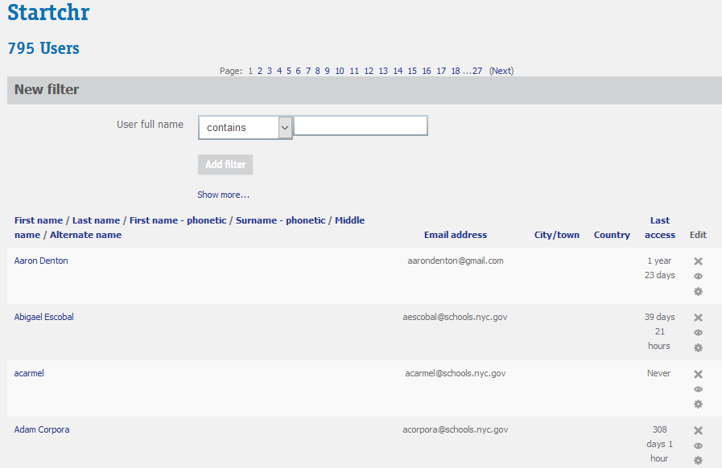

2.1.1. List of users filter
Default filter by user name is available. Filter settings are to be chosen from the list (contains, doesn’t contain, is equal to, starts to, ends to, is empty). User name (full or partial), which is required to be filtered, is to be entered in the text box. Next click on the “Add filter” icon to filter user list according to preferences chosen.
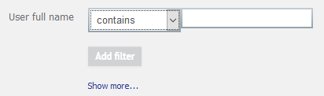
To use advanced filter click “Show more..” link. Other filters block will be opened. To hide advanced filter click on “Show less...” link. Applied filters are displayed above the filtered list of users. To remove all filters click on “Remove all filters”, to remove selected filters select them and click on “Remove selected”.

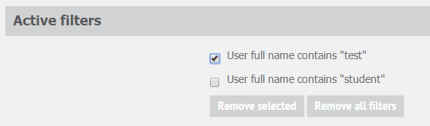

2.1.3. List of users sorting
The following options for list of users sorting are available:
- First name
- Last name
- First name - phonetic
- Surname - phonetic
- Middle name
- Alternate name

2.1.4. Managing users
The following actions are available for user accounts:
- Deleting (button)
- Suspending user ( “Suspend user account” button). User remains suspended until “Activate user account” button is not pressed
- Editing ( “Edit” button).

2.2. Assign system roles
In this section administrator has an opportunity to assign user roles. In the table below a list of roles and users with these roles are displayed.
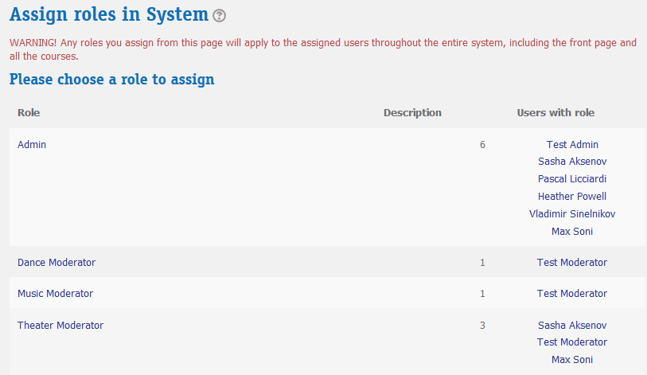

2.2.1. User role assignment
To assign role for user, click on role name in the table. Choose user in “Potential users” block and click “Add” on the new opened page. User will be moved to “Existing users” block and corresponding role will be assigned to user. To remove role from user choose user in “Existing users” block and click “Remove” button.

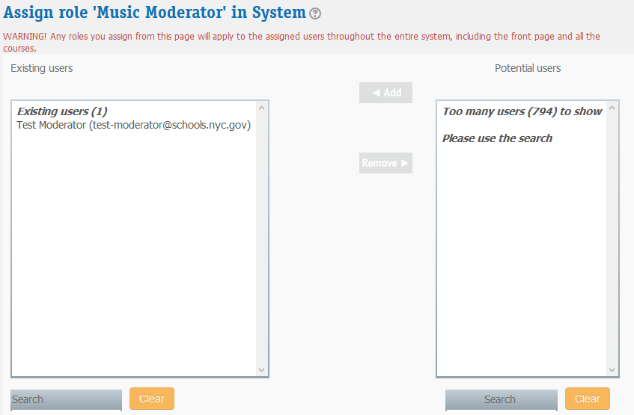

User search is also available according to the following options:
- Keep selected users, even if they no longer match the search
- If only one user matches the search, select them automatically
- Match the search text anywhere in the displayed fields.

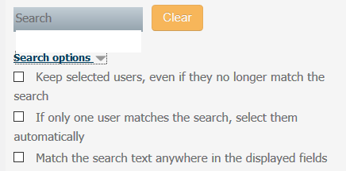

To assign users for other roles choose necessary role in drop-down list “Assign another role”. Users with corresponding role will be displayed in “Existing users”. Users with corresponding role can be added or removed.
By clicking on Back to the list of all roles link roles list is opened.

2.3. Manage course
In this section administrator manages categories and courses.

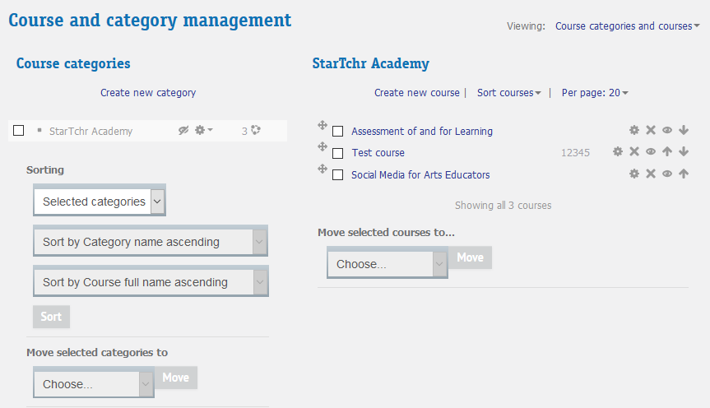
For display courses and categories configurations, Viewing configuration is designed.
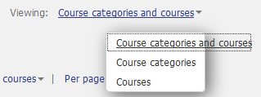
According to the value chosen, only categories, only courses, or both categories and courses will be displayed.

2.3.1. Managing categories
To add new category click on “Create new category” link, fill in the form and click “Create category”.

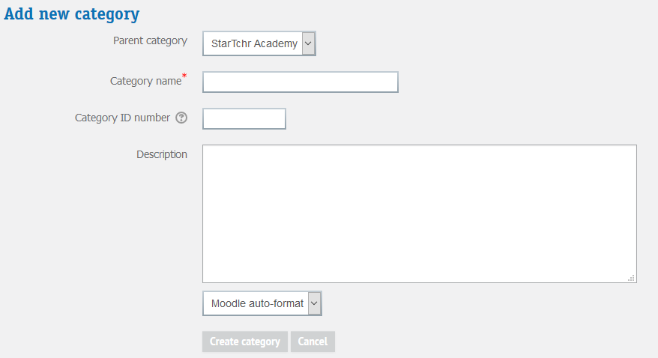

The following actions are available for categories:
- Show/hide
- Edit
- Create new subcategory
- Delete
- Assign roles
- Permissions
- Cohorts
- Filters
- Restore course
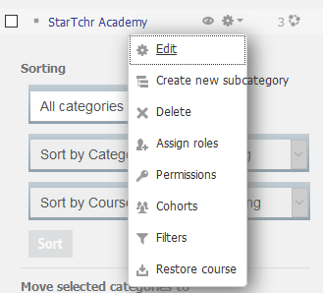

Sorting

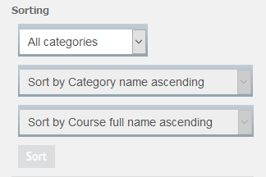

2.3.2. Managing courses
Create new course
To create new course click on “Create new course” link, fill in the form and save changes.

Sorting courses list
To sort list of courses click on “Sort courses” and choose required sorting option 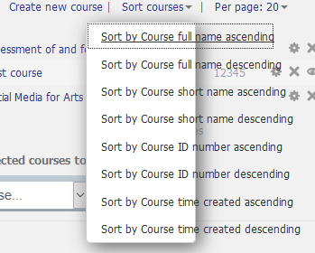

Moving courses to categories

To move courses to a definite category choose relevant courses, choose relevant category in drop-down list and click on “Move” button.

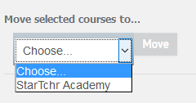

Number of courses displayed on page preferences
To set up number of courses displayed on one page, choose the necessary number of courses in drop-down list “Per page”.
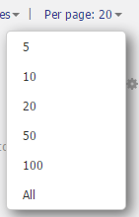

Courses manipulations
The following manipulations with courses are available:
- editing (“Edit” button)
- deleting (“Delete” button)
- hiding/showing course on website (“Hide/Show” button)
- Moving courses up/down in “StarTchr Academy” list of courses (“Up/Down” button)
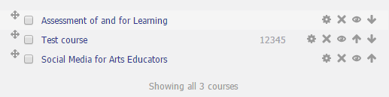

2.4. Manage webinars
In this section administrator manages webinars:
- Editing (“Edit webinar” button). Editing webinar page is similar to creating webinar form.
- Managing list of enrolled users
By clicking on the button, enrolled users managing page is accessed.
In “Enrolled users” block, users enrolled on webinar are displayed. To delete user from enrolled users list click on “Remove” button, to add users enter search query in search bar (below “Not enrolled users” block), click on “Search” button, choose users from “Not enrolled users” block and click on “Add” button.
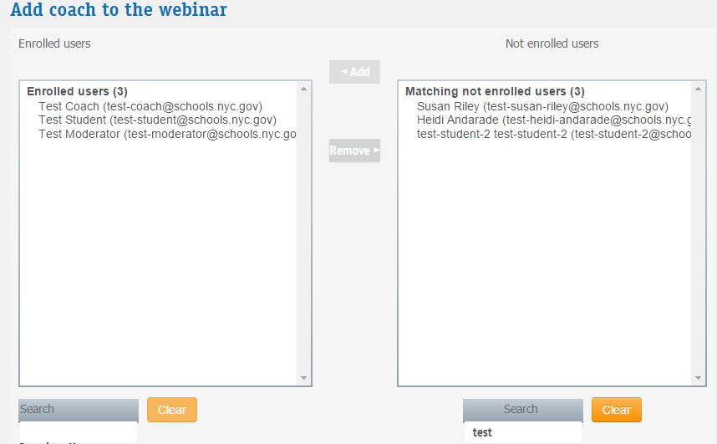

- Deleting webinar (“Delete” button). To delete webinar click on “Delete” button, confirm deleting by pressing “Yes” button in pop-up window (“Delete webinar?”). After that webinar will be deleted.
- Disabling “LiveSeries” section in public website part.

2.5. Create webinar
This page is designed to create webinars.
To create webinar, the following fields should be filled in.:
- Category – choose one of the categories
- Title
- Live location
- Address
- Tickets
- Date time – time and date of webinar
- Time duration – webinar duration with possibility of stating units of measuring time (minutes, hours, days, etc.)
- Poster
- Video
- Description

Fields marked with a red asterisk are mandatory.
By clicking “Save” button, webinar is created. By clicking “Cancel”, list of webinars is landed (“Manage Webinars” section) without saving any changes.
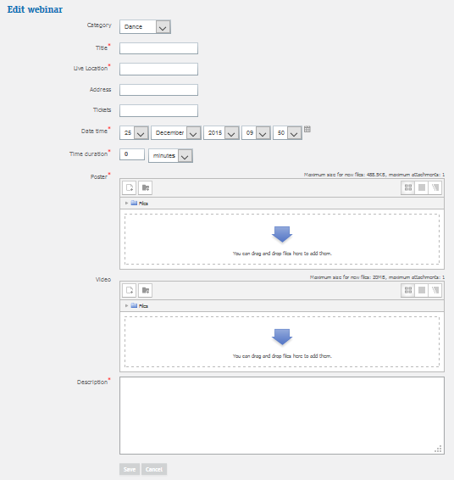

2.6. Browse deleted posts
Deleted posts are displayed in this section. To undelete post, the following is required:
- Proceed to post editing page
- In box “Publish to” choose “Anyone on this site”, edit post if necessary
- Click on “Publish Post”. Post will appear in public website part.

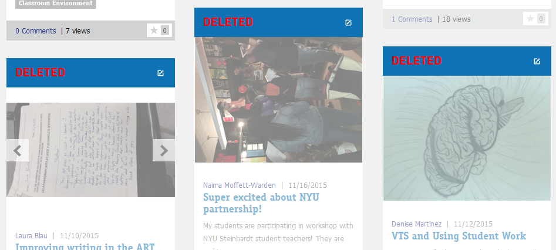

2.7. Turn course editing off
This menu option can be found only in administration block on course page. It is required to turn on course editing mode. To edit course, go to course page, choose option “Turn course editing off” in administration block. In editing mode a resource or activity can be added.

2.7.1. Adding resources
To add resource, choose one of the options in drop-down list “Add a resource..”: Book, File, Folder, IMS content package, Label, Page, URL. After that a form for creating corresponding resource will appear. Fill in the form and click on “Save and return to course” button. Then you can go on to edit the course.

2.7.2. Adding activities
To add activity, choose one of the options in drop-down list “Add an activity”. After that, a form with preferences for this activity will be opened. When finished setting up activity, click on “Save and return to course”. Then you can go on to edit the course.

2.8. Activity chooser off/Activity chooser on
This menu option can be found only in administration block on course page.
Turning on “Activity chooser on”/Activity chooser off” mode allows turning on/off resources editing on course page. This mode is available only with “Turn course editing on” chosen.
To turn on adding, deleting and editing opportunities, it is required:
- Proceed to course page
- Turn on “Turn course editing on” in administration block
- Turn on “Activity chooser on” mode in administration block.
To block adding, deleting and editing course resources and activities opportunities, choose “Turn course editing off”.

2.8. Course completion
This menu option can be found only in administration block on course page.
By clicking on “Course completion”, a page with course completion settings appears.
If at least one enrolled user has completed all the required conditions to complete the course, the settings become locked for editing.

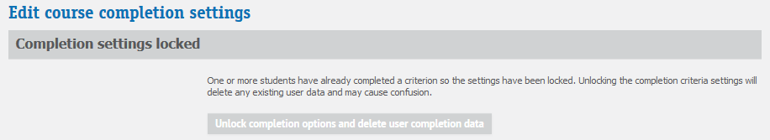
Administrator can unlock settings by clicking “Unlock completion options and delete user completion data”.

Course completion criteria:
- General
  - Completion requirements
- Condition: Activity completion – activities to be completed should be stated here (e.g., test completion)
- Condition: Completion of other courses
  - Courses available
- Condition: Date
  - Enable
  - User must remain enrolled until
- Condition: Enrollment duration
  - Enable
  - User must remain enrolled for
- Condition: Unenrollment
  - Enable
- Condition: Course grade
  - Enable
  - Required course grade
- Condition: Manual self completion
  - Enable
- Condition: Manual completion by others – settings for roles which manual course completion is available for
  - Manager
  - Teacher
  - Non-editing teacher
  - Dance Moderator
  - Music Moderator
  - Theater Moderator
  - Visual Arts Moderator
  - Admin
  - Condition requires

