

“NAVIGATOR LUKS”
TWO-CHANNEL ELECTRONIC
TEMPERATURE REGULATOR

OPERATION MANUAL

1. Purpose

1.1. The “Navigator-Luks” two-channel electronic temperature regulator (hereinafter referred to as “temperature regulator”) is designed for maintenance of the specified thermal operating mode of the single-phase electric heaters working at the power up to 6 kW (Navigator 6 Luks), three-phase electric heaters working at the power up to 18 kW (Navigator 18 Luks), and three-phase electric heaters working at the power up to 30 kW (Navigator 30 Luks), which include electrode water heaters, tubular electric heating boilers, heat guns, heat curtains, heat convectors, etc.
1.2. The thermoregulation is carried out by two channels of the feed pipe and the return pipe. Also the thermoregulation of the air temperature in the premises can be carried out by means of the “Istopnik” controller or the “Galan-GSM” Cellular Monitoring System of the Heating Equipment (CMSHE).
1.3. The application of the temperature regulator allows to reduce power consumption and to create the most favorable temperature conditions in the heated premises.
1.4. The manufacturer has the right to make modifications to the construction and electric diagrams of the temperature regulator which do not worsen its metrological and technical characteristics.

2. Components

The “Navigator-Luks” digital temperature regulator consists of the metal or plastic case, controller module, power relays, key switch, terminal connectors for connecting the leading-in cables, circulation pump, and temperature-sensitive elements (red element is used for the feed pipe, and blue element is used for the return pipe). The connection jacks for “Istopnik” and “Galan-GSM” CMSHE are located at the top of the temperature regulator.

3. Completeness

- The “Navigator Luks” two-channel electronic temperature regulator – 1 item.
- Operation manual – 1 item.
- Package – 1 item.

The complete set of delivery does not include digital integrated temperature-sensitive elements. These temperature-sensitive elements are purchased separately.

The digital integrated temperature-sensitive elements are installed into the “Galaks” boilers by the factory of origin. The contacts No. 10, 11, and 13 of the “Navigator Luks” terminal connector are connected by the wires with contacts No. 10, 11, and 13 of the “Galaks” boiler terminal connector.

4. Safety requirements

4.1. By the way of protection against electric-shock hazard the temperature regulator meets the requirements of class “1” of the All-Union State Standard No. 12.2.007.0-75.

4.2. The voltage which is hazardous to life is used in the temperature regulator. In the course of performing the malfunction repair, maintenance service, and installation tasks it is necessary to disconnect the temperature regulator and the equipment which is connected to the temperature regulator from the power network.

4.3. The temperature regulator is intended for operation in explosion-proof premises.

4.4. The ingress of water on the output contacts of the terminal block and internal electric elements of the temperature regulator is prohibited. It is prohibited to use the temperature regulator in the corrosive environment containing acid, alkali, oil, etc. in the atmosphere.

4.5. Mounting and maintenance service of the temperature regulator should be performed by the qualified specialists. These specialists should be acquainted with the given Operation manual.

4.6. In the course of operation and maintenance service it is necessary to observe the provisions of the All-Union State Standard No. 12.3.019-80, “User rules for operating electrical equipment”, and “Safety rules for operating electrical equipment”.

4.7. The operation of the temperature regulator without the proper circuit breaker is prohibited.

5. Mounting and pre-starting procedure

5.1. The connection of the temperature regulator should be organized through the circuit breaker according to the power (current strength) and type of the power network (220 V or 380 V) used by the electric boiler.

5.2. Fasten the block vertically to the wall in the dry and ventilated room by means of the self-tapping screws. Cut the openings in the unit casting according to the marking and lay out leading-in cables. The recommended values of cross section of power wires for the corresponding boilers are specified in the Table 1 and Table 2.

Table 1

Name of the boiler | “Ochag-2” | “Ochag-3” | “Ochag-5” | “Geyser-9” | “Geyser-15” | “Vulkan-25”
Cross section of wires, sq. mm (220 V) | 2,5 | 2,5 | 4,0 | 6,0 | - | -
Cross section of wires, sq. mm (380 V) | - | - | - | 4x2,5 | 4x4 | 4x6

Table 2

Name of the boiler | “Galaks-3”  “Ochag Turbo-3” | “Galaks-3;5;6;7”  “Ochag Turbo-3;4;5;6” | “Ochag Turbo-9” | “Geyser Turbo-12”
Cross section of wires, sq. mm (220 V) | 2,5 | 4 | 6 | -
Cross section of wires, sq. mm (380 V) | - | 4x2,5 | 4x2,5 | 4x4
Name of the boiler | “Geyser Turbo-15” | “Vulkan Turbo-18” | “Vulkan Turbo-24” | “Vulkan Turbo-30”
Cross section of wires, sq. mm (220 V) | - | - | - | -
Cross section of wires, sq. mm (380 V) | 4x4 | 4x6 | 4x6 | 4x10

5.3. Lay out connection cables from the temperature-sensitive elements and external equipment controllers sensors.

5.4. In the course of mounting of the external connections it is necessary to provide the reliable contact of these connections with the terminals of the temperature regulator. For control cable mounting use a cable with cross-section of 0,12 – 2,5 sq. mm. Strip the end of the cable by 7 ± 0,5 mm for connecting the control circuits, strip the end of the cable by 10 ± 0,5 mm for connecting the power circuits. The end of the cable with the length which is longer than the specified value may cause a short circuit and the end of the cable with the length which is shorter than the specified value may cause unreliable contact. Remove a screw of the terminal and insert the stripped end of the cable into the terminal. Torque a terminal to 0,5 N/m (recommended value for control circuits) or to 2 N/m (recommended value for power circuits). A weak tightening may cause a disconnection and incorrect functioning and over-tightening may cause a short circuit or damage of the terminal strip.

Attention! Twist the wires of the stripped end of the cable or use a thimble for the connection (Do not tin an end of the wire to avoid a poor contact).

5.5. To connect the temperature regulator to the power network or to connect the external equipment use the diagrams depicted in figures specified below.

5.6. Attention! A voltage applying is performed after checking the correctness of connecting of all devices and after checking the tightening of all threaded electrical connections.

After a voltage applying a digital indicator will display the information about the operating mode of the temperature regulator.

6. Switching on and setting the operating modes of the “Navigator Luks” digital temperature regulator

The “Navigator-Luks” electronic temperature regulator is distinguished by the built-in electronic control device on the basis of the processor with nonvolatile memory.

The key switch enables one to switch on and off the temperature regulator. On switching on the temperature regulator the indicators of stages of warming up of the heating system (1, 2, 3 – initial stage; 1, 2 – middle stage; 1 – final stage), the digital temperature indicator, and the indicator of the temperature-sensitive elements (return and feed) are shone. The regulating handle is used for choosing the setting (temperature of the return pipe or temperature of the feed pipe). By pressing the handle it is possible to choose the setting.
By rotating the handle at the time of blinking of the indicator of the chosen built-in temperature-sensitive element (return or feed) it is possible to change the parameter (temperature of the return pipe or temperature of the feed pipe). After changing of the parameter the indicator of the chosen built-in temperature-sensitive element stops blinking and digital temperature indicator will display the temperature of the chosen built-in temperature-sensitive element.

Control range: | return +10 ÷ +80º C  feed +10 ÷ +85º C
Recommended settings: | return +40 ÷ +50º C  feed +65 ÷ +75º C

The temperature of the return pipe is a control parameter. The temperature of the feed pipe is so chosen, that it cannot be reached in normal conditions.
In case of malfunctioning (circulation pump does not work, volume of the air is exceeded in the heating system, filter is clogged, or in case of any other condition which causes the deterioration of the heat-transfer agent circulation) the temperature of the supply pipe exceeds the specified temperature and the built-in electronic control device switches off the heating. After cooling of the heating system by approximate value of 10º C the heating will be switched on.
The built-in electronic control device of the “Navigator 18 Luks” and “Navigator 30 Luks” temperature regulators automatically chooses the value of 1/3, 2/3 of power or the full power, and evaluates the most efficient working mode.

7. Maintenance service

The maintenance service of the temperature regulator is performed at least every six months.

It is necessary to examine a fastening of the temperature regulator, to check the state of electrical connections, and to dust off the terminal strips.

8. Storage instructions

The temperature regulators packaged by the manufacturer should be stored in storehouses at a temperature lying in the range from -50° C to +40° C and at relative humidity of an air up to 85%.

In the storehouses there should not be dust, steams of acids, alkalis, and gases causing the corrosion. In storage the temperature regulator is released from the transport container.

9. Delivery and sale certificate

The two-channel electronic temperature regulator (serial number __________) meets the requirements of the Technical Specifications (TS) No. 4211-003-17289826-2008 and is recognized as serviceable.

Date of issue “___” __________ _____

Seal of the Quality Department

Sold ___________________________

Date of sale “___” __________ _____

10. List of possible malfunctions and methods of malfunction repair

Possible malfunction | Probable cause of malfunction | Method of malfunction repair
There is no indication of the unit operation | 1. There is no power network voltage.  2. The connection does not correspond to the diagrams specified in the Operation manual. | 1. Check the presence of voltage in the power network.  2. Connect the regulator.
The appearance of the “Err” inscription on the indicator | 1. Poor contact in the temperature-sensitive elements connections.  2. A wire of the temperature-sensitive element is broken.  3. Temperature-sensitive element failure. | 1. Check the contact of the terminal strips.  2. Restore the integrity of a wire.  3. Replace the temperature-sensitive element.
There is no indication of switching on | The specified temperature is set incorrectly. | Set the specified temperature to a value which is higher than a value of the actual temperature.

Ochag 2-3-5-6 kW, 220 V connection diagram (Navigator 6 Luks)

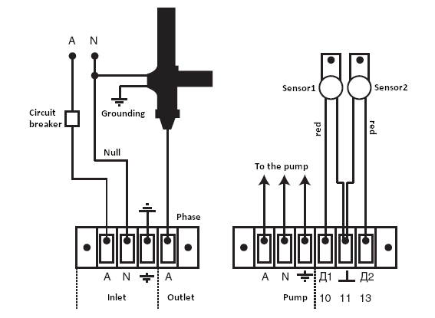

Geyser 9-15 kW (Navigator 18 Luks); Vulkan 25 kW, 380 V (Navigator 30 Luks) connection diagram

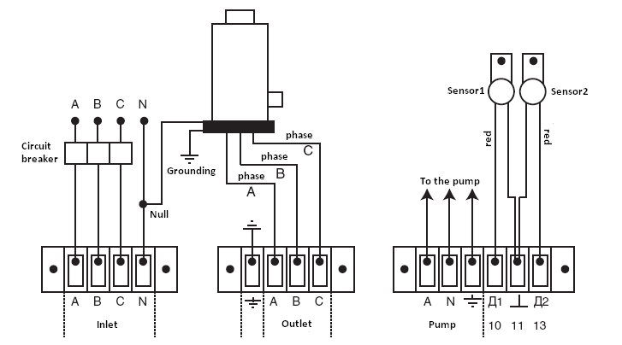

Ochag Turbo 3-4, 5-6 kW, 220 V (Navigator 6 Luks) connection diagram

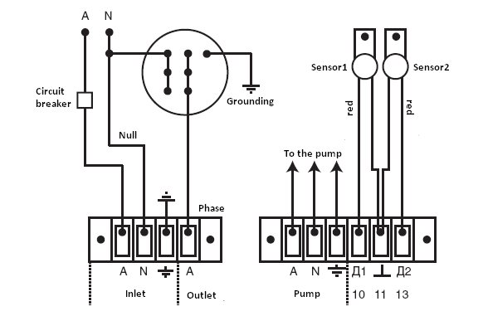

Ochag Turbo 3-4, 5-6 kW, 220 V (Navigator 18 Luks) connection diagram (with the ability of automatically choosing the value of 1/3, 2/3 of power or the full power)

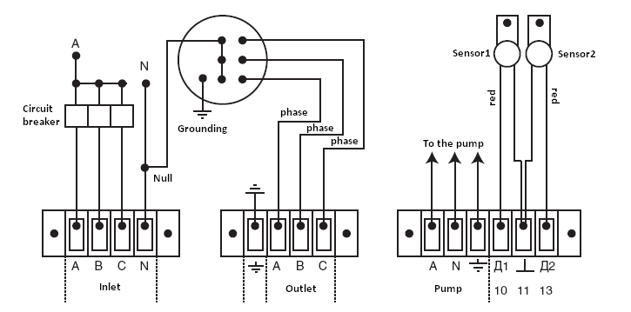

Ochag Turbo 3-4, 5-6-9 kW; Geyser Turbo 12-15 kW, 380 V (Navigator 18 Luks) connection diagram

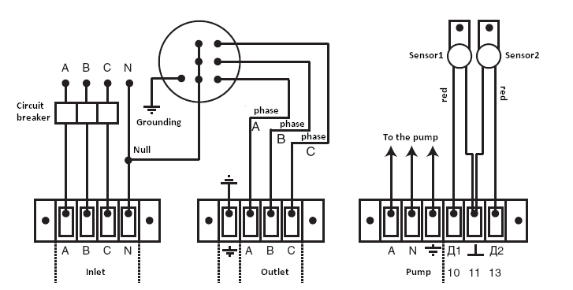

Vulkan Turbo 18 kW (Navigator 18 Luks), Vulkan Turbo 24-30 kW, 380 V (Navigator 30 Luks) connection diagram

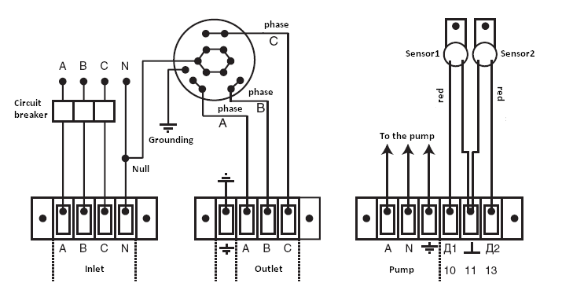

Galaks 3-5-6-7 kW, 380 V (Navigator 18 Luks) boiler connection diagram

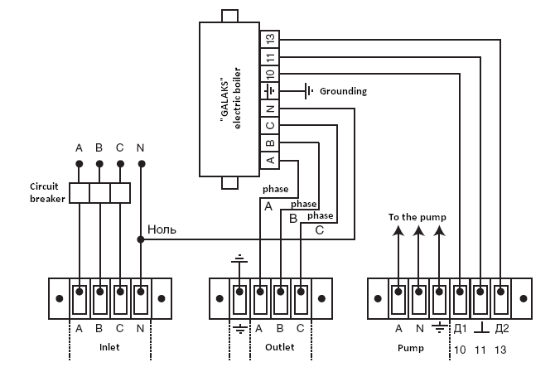

Galaks 3-5-6 kW, 220 V (Navigator 6 Luks) boiler connection diagram

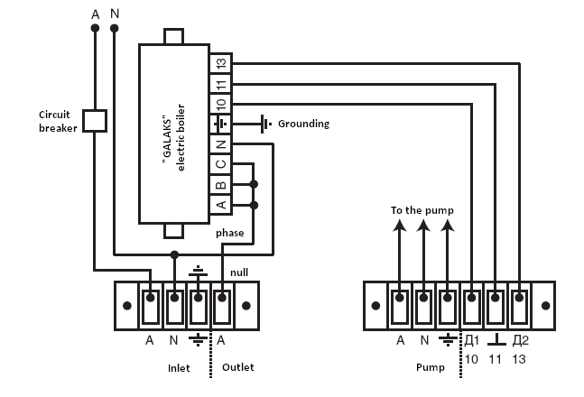

Galaks 3-5-6-7 kW, 220 V (Navigator 18 Luks) boiler connection diagram (with the ability of automatically choosing the value of 1/3, 2/3 of power or the full power)

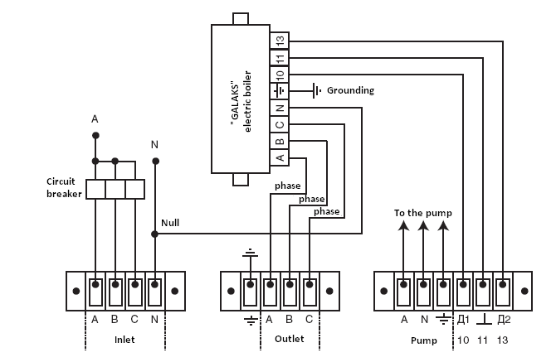
COUPON № 1

For warranty repair (warranty service) of the two-channel electronic |  |  |  | COUNTERFOIL OF THE COUPON № 1  FOR WARRANTY REPAIR (WARRANTY SERVICE)  Date of withdrawal “___” __________ _____ Executor  ___________________________________  (last name, name, surname)
temperature regulator
Sold by the shop
 | Name of the shop
 | Address of the shop
 | Date of sale “___” __________ _____
Performed tasks
Executor |  | Owner
 | last name, name, and surname |  | signature
Name of the company performing the warranty repair

Place of the seal

Post and signature of the director of the company performing the warranty repair

11. Guarantee commitments

The guarantee period of operation of the two-channel electronic temperature regulator comprises 12 months from the date of sale.
During a guarantee period and a period of operation the manufacturer performs a repairing of the temperature regulator gratuitously in case of its discrepancy to requirements of specifications and at observance by the consumer of storage, connection, and operation rules. Warranty service of the temperature regulator is carried out by granting of correctly filled warranty repair coupon and the commodity check.
The temperature regulator is not a subject to warranty service in the following cases:
- The termination of the guarantee period.
- The operating conditions and the electrical diagram do not correspond to the given Operation manual.
- The completeness of the product does not correspond to the given Operation manual (absence of the temperature-sensitive elements and adapters, changing of the electrical diagram, changing of the component values).
- The product has mechanical damages (breaking of the sealing, off-grade appearance, burning of the power terminals).
- There is a presence of moisture, extraneous objects, dust and mud (including insects) on the internal parts of the product.
- In case of lightening stroke, fire, water flooding, absence of ventilation, and other situations which are not controlled by the manufacturer.
The warranty is not applied to the circuit breaker and mechanical damages of the temperature-sensitive elements.

12. Certification information

The “Firma “Galan” Joint-Stock Company 123098, Moscow, ul. Marshala Novikova, 2, building 1.
Number of the certificate of conformity: РОСС RU.ME69.B03568.

PERFORMED TASKS

Date, task description | Address, license number, signature, and seal of the executor

Contents

Purpose 2
Components 2
Completeness 2
Safety requirements 2
Mounting and pre-starting procedure 3
Switching on and setting the operating modes of the “Navigator Luks” digital temperature regulator 4
Maintenance service 4
Storage instructions 4
Delivery and sale certificate 5
List of possible malfunctions and methods of malfunction repair 5
Guarantee commitments 12
Certification information 12

“ГАЛАН МИР ТЕПЛА” and “GALAN WARMWORLD” are registered trade marks of the
“Firma “GALAN” Joint-Stock Company

Central department:
Phone: (499) 196 04 40, 196 04 41
123098, Moscow, m. “Shchukinskaya”, ul. Marshala Novikova, 2, building 1
http://www.galan.ru, e-mail: office@galan.ru

MAXIMUM WARMTH – MINIMUM COSTS

OUR COMPANY PERFORMS THE DESIGNING, INSTALLATION ON A TURN-KEY BASIS, AND WARRANTY SERVICE OF THE HEATING SYSTEMS, WATER DISTRIBUTION SYSTEMS, AND SEWERAGE SYSTEMS

