Title: Top new businesses
Date: 16.04.2016
Tags: business financial news, new business, investing, online business
Description: What new business directions are available now? Which of them are the most profitable? The answer is in this article.
Business is being developed every day in every time of the year. What kinds of top new businesses have recently appeared?
Construction business
It is believed to be the most beneficial money investment, and the most perspective is building new city objects, but this field is also filled with high commercial competition. The idea of the construction business itself is not new at all, as it has always been one of the most popular businesses ever; however it has a lot of new directions which constantly increase.
Building is one of the most ancient occupations which still stays popular for the variety of different directions and approaches
- Roof covering
Repairing works are always needed by people, especially for those have country houses somewhere in the uptown. This business includes not just the mechanical process of roof covering, but also relevant material such as slates, tiles, paints and other items, selling which often becomes an independent business.
Roofs are one of the most essential parts of the building. No doubt that there are a lot of people who need help with the roof covering.
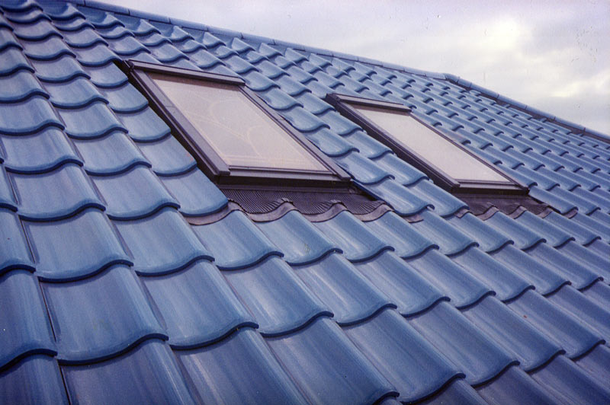
- Design is one more idea in the business world which never loses its popularity. It divides into a lot of branches and up-to-date style directions, so good designers make huge sums of money for their services.
There is a plenty of different designs, as well as there is a plenty of people who want their dwellings to be a peace of art.
- Producing/installation of doors, windows, balconies, double gazing
Doing all these jobs on your own is a rather time-consuming and difficult job, so thousands of people turn to special agencies and companies for help. Assembly and door installation are a profitable business. In addition, some of the firms offer the service of making the objects to a consumer’s order. Nowadays there is a wide variety of designs, so using them allows fabricating unique products which are in demand by those, who due to some reasons choose nonstandard product.
The installation works are needed all the time, although the market is filled with such offers.
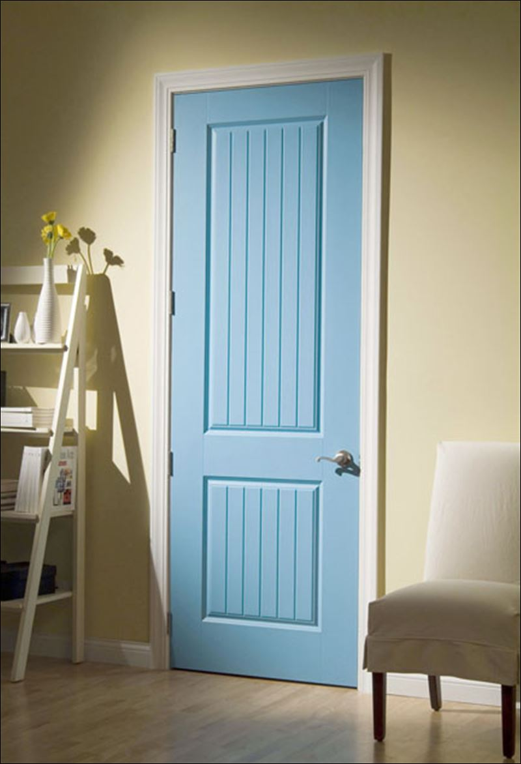
Online shops
This kind of business is among new online businesses which are available in the Internet. E-shops are relatively new, by now, they are everywhere. The World Wide Web is full of advertisements of online shops of clothes, cosmetics, technical details, jewelry and other products whose variety is not always available in the simple stores. No wonder that now lots of consumers prefer online shopping where everything can be found for a reasonable price.
One the one hand, this option is often chosen, since you do not have to worry about a rent, on the other you get into the very high competition, as it is extremely difficult to make up something original, to find a unique product for sale. It is not enough just to launch the e-shop, people also have to know about your business, so it is important to organize advertising that will catch an eye of your potential clients.
Running the e-shop is extremely time and energy consuming, besides there is a high compentition. However if you are sure that your ideas are relevant and original, it is worth a try.

Zoo business
It is said that the latest business connected with animals can be divided into two sections: organizing the animal shelters, creation the special conditions for endangered species, such as making reserves, forbidding of slaying animals. Other direction of the world markets today is selling products for pets. The variety of the such products ranges from producing pet food, toys and aquariums to the wheelchairs for animals with special needs.
Today our society pays a lot of attention to the disabled animals; it is not a problem anymore to acquire a pet with special needs.

