Apr 2006
Metaphoric optical computing of fluid dynamics

Mankei Tsang and Demetri Psaltis

Department of Electrical Engineering, California Institute of Technology, Pasadena, California 91125

Compiled March 23, 2011

We present theoretical and numerical evidence to show that self-defocusing nonlinear optical propagation can be used to compute Euler fluid dynamics and possibly Navier-Stokes flui d dynamics. In particular, the formation of twin vortices and the K´arm´an vortex street behind an obstacle, two well-known v iscous fluid phenomena, is numerically demonstrated using t he nonlinear Schr ¨odinger equation. c 2011 Optical Society of America

OCIS codes: (200.0200) Optical computing; (190.5530) Pulse propagation and solitons

arXiv:physics/0604149v1 [physics.optics] 18
1. Introduction

- Philosophy of metaphoric computing

Nonlinear dynamical systems, such as weather, plasma, and the economy, are ubiquitous in nature and everyday's life, yet such systems are typified by their highly complex and chaotic behaviors, making them notoriously difficult to study theo-retically, experimentally, and numerically. Analytic solutions of nonlinear systems are rare, experiments are often too in-flexible or impractical, and numerical simulations must tak e into account a large number of data points in multiple dimen-sions in order to accurately model a problem of interest, such that even the fastest supercomputers today would take days or weeks to simulate relatively simple nonlinear dynamics that a physical system exhibits in seconds.

On the opposite side of the same coin, we can regard the physical system as a computational device that computes its own dynamics at a speed unimaginable by supercomputers. The key to harnessing this tremendous computing power of a physical system is therefore to make it compute other inter-esting problems of the same order of complexity. Of course, a conventional digital computer is itself a physical system, but it makes use of complex semiconductor physics to com-pute elementary logic operations, and in doing so, discards a large amount of information that is considered extraneous. In this perspective, a digital computer is an extremely inef-ficient computing device, as it only utilizes an exceedingly small amount of the full computing capability potentially of-fered by its physics. The advantage in this case is the flexibi l-ity in cascading different logic operations for general-purpose computing, but as evidenced by the difficulties in the numer-ical simulations of nonlinear dynamical systems, this ineffi-cient computing method is often inadequate.

In order to make full use of the computing capability of-fered by a physical system, we hereby propose the concept of metaphoric computing, which makes use of a more ex-perimentally accessible nonlinear dynamical system to simu-late another nonlinear dynamical system. An example of this computing method is a wind tunnel, in which a small-scale fluid experiment is performed to simulate large-scale fluid dynamics, by virtue of the scaling laws inherent in fluid dy-namics. Metaphoric computing, however, is not restricted to the use of similar physical systems to simulate each other. In this paper, we show in particular that nonlinear optics

can compute fluid dynamics as well. An optical beam in-herently holds three-dimensional spatiotemporal information, and nonlinear optical propagation computes the evolution of this large amount of information simultaneously at the speed of light, promising substantial parallelism and speed for com-puting. Although the use of nonlinear optics for digital com-puting has not been as successful as the use of solid-state elec-tronics, forcing optical beams to compute binary logic wastes most of the spatiotemporal information that can be manip-ulated in optical beams. Instead of fitting a square peg in a round hole, using optics to simulate other nonlinear dynami-cal systems provides a natural way of making full use of the computing capacity offered by a nonlinear optical system.

Fluid dynamics, the foundation of a wide variety of im-portant research fields including meteorology, aeronautic s, plasma physics, superfluids, and Bose-Einstein condensate s, is an ideal problem to solve by metaphoric computing. In-tractable theoretical analysis and inflexible experiments com-pel the use of numerical simulations, the difficulty of which nonetheless gives rise to a whole new field, computational fluid dynamics, in itself. The main difficulty is due to the in-herent complexity of a fluid dynamics problem, which is non-linear and continuously generates finer structures as the flu id dynamics evolves. For problems that are of practical inter-est, such fine structures are often orders-of-magnitude sma ller than the size of the objects under consideration, thus requir-ing a large number of data points in each of the three spatial dimensions to be manipulated at each time step, which must also be correspondingly small to avoid numerical instabilities. An alternative method of simulating complex fluid dynamics that combines the speed of a fluid experiment and the flexi-bility of a numerical analysis is hence of great practical im-portance. In this paper, we show that, via a suitable transfor-mation, nonlinear optical propagation can be utilized to simu-late Euler fluid dynamics, which is known to be computation-ally expensive and unstable to solve numerically . We also provide strong evidence that nonlinear optics can simulate high-Reynolds-number Navier-Stokes fluid dynamics as well , which include a large class of important and computationally difficult problems, such as turbulence. With the speed, para l-lelism, and configurability of optics, an “optical wind tunn el” may one day become a viable alternative to experiments and numerical analysis in the study of fluid dynamics.

1

- Correspondence between nonlinear optics and fluid dy-metaphoric optical computing in preference to conventional

namics

The analogy between nonlinear optics and fluid dynamics has been noted by many authors.^{1–18} Wagner et al. first suggested

that the nonlinear propagation equation of an optical beam can be recast into equations that resemble the continuity equa-tion and the Bernoulli equation in irrotational fluid dynam-ics.¹ Coullet et al. first coined the term “optical vortices,” which shows the analogy between phase singularities in op-tics and fluid vortices. ² Brambilla et al. noted that laser equa-tions can be transformed to a hydrodynamic form.³ Arecchi et al. first experimentally demonstrated the dynamics of opti-cal vortices in nonlinear optics.⁴ Akhmanov et al. called the rich nonlinear dynamics observed in a nonlinear resonator “optical turbulence.” ⁵ Swartzlander and Law observed opti-cal vortex solitons created via the instability of dark soliton stripes analogous to the Kelvin-Helmholtz instability in fl uid dynamics.⁶ Staliunas showed that a laser can be described by the Ginzburg-Landau equation, which can be transformed into equations resembling the Navier-Stokes equations that describe viscous fluid dynamics. ⁷ Vaupel et al. observed vor-tex pair nucleation by the interference of two modes in a laser and claimed that it was an analog of a vortex street behind an obstacle in a fluid flow. ⁸ Molina-Terriza et al. also observed optical vortex streets in walking second-harmonic genera-tion.⁹ Roux¹⁰ and Rozas et al.¹¹ studied the interactions be-tween optical vortices and found that their interactions resem-ble those of fluid vortices. Rozas et al. then experimentally demonstrated the fluidlike motion of a pair of optical vor-tices.¹² Michinel et al. ¹³ and Paz-Alonso et al.¹⁴ found that optical propagation in a cubic-quintic nonlinear medium re-sembles a liquid drop, and optical vortices in such a medium also have fluidlike motions. ¹⁵ On the other hand, nonlinear optics has been compared with superfluids and Bose-Einistei n condensates, as they can all be described, to varying de-grees, by the nonlinear Schr ¨odinger equation,^{19, 20} commonly known as the Gross-Pitaevskii equation in the field of super-fluids. ²¹ Pomeau and Rica suggested that the phenomenon of transition to dissipation in a superflow ²² can be observed in nonlinear diffraction.¹⁶ Bolda et al. numerically demon-strated the same phenomenon in a nonlinear Fabry-P´erot cav - ity.¹⁷ Chiao also found that photons in such a cavity should obey the Bogoliubov dispersion relation for a superfluid. ¹⁸

The abundant amount of prior work credited above pro-vides ample evidence that nonlinear optics resembles fluid dynamics to a certain degree. In order to use nonlinear op-tics as a useful and practical computational tool for fluid dynamics, however, simply drawing analogies between the two kinds of dynamics is not enough. One must be able to show an exact correspondence, or at the very least, an ap-proaching convergence between a problem in nonlinear op-tics and a problem in fluid dynamics, in order to produce any useful prediction of fluid dynamics via nonlinear optics . Moreover, as computers nowadays have enough capabilities to simulate two-dimensional fluids, the mere correspondenc e between optics and two-dimensional fluid dynamics consid-ered in most of the prior work would not motivate the use of

digital computing. A three-dimensional fluid modeling, on the other hand, requires a processing capability orders-of-magnitude higher than that available in today's supercomput-ers, so metaphoric optical computing would need to compute such problems much more efficiently to compete with elec-tronic computers and the Moore's law.

In the following sections, we shall attempt to estab-lish the correspondence between nonlinear optics and three-dimensional fluid dynamics. We shall show that, taking group-velocity dispersion into account, nonlinear optical dy-namics approaches three-dimensional inviscid Euler fluid d y-namics in the highly nonlinear self-defocusing regime, where the optical intensity represents the fluid density, the opti cal phase gradient represents the fluid velocity, the nonlinear re-fractive index perturbation represents pressure, the propaga-tion distance represents time, and the temporal dimension of the optical pulse represents the third dimension of the fluid . As Euler fluid equations often exhibit high numerical instab il-ities, this correspondence in itself should be useful in model-ing high-Reynolds-number fluid dynamics away from objects and boundaries. In the convergence of nonlinear Schr ¨odinger equation towards the Euler equations, a “quantum pressure” term arising from the nonlinear Schr ¨odinger equation plays the role of a small parameter. As this quantum pressure term plays analogous roles to viscosity in the Navier-Stokes equa-tions, we argue that nonlinear optics should be able to ap-proximate viscous Navier-Stokes fluid dynamics as well, in the regime where quantum pressure and viscosity both play the role of small parameters in the respective equations. That said, we do not pretend that we have established the equiva-lence between nonlinear optics and Navier-Stokes dynamics, as the similarity between quantum pressure and viscosity is still an open problem.

On the practical side, in cases where ideal nonlinear op-tics setup is not available, we suggest a split-step method that pieces together different optical devices to approximate an ideal nonlinear optics experiment. This method is very similar to the method proposed to simulate quantum systems using a quantum computer.²³
It must be stressed that although we focus on simula-tions of classical physical systems, future quantum com-puters that simulate quantum systems²³ would run into the same problem of manipulating a large amount of multi-dimensional information. In the case of quantum sys-tems, multi-dimensional quantum information, such as a multi-particle multi-spatiotemporal-dimensional wavefunc-tion, needs to be processed in parallel. Quantum comput-ers can naturally parallelize the multi-particle aspect, but there is no obvious way of parallelizing the manipulation of multi-spatiotemporal-dimensional information via simple binary quantum logic. Perhaps a quantum metaphoric com-puting would then be necessary, where a more accessible multi-dimensional quantum system is used to simulate an-other quantum system.

2

such that the evolution equations for the intensity, I, and the phase gradient, k, are given by

where z is the propagation distance, k₀ = 2πn₀/λ₀ is the car-rier wave number, β₂ is the group-velocity dispersion coef-ficient, T is the time coordinate in the moving frame of the pulse, and n₂ is the nonlinear Kerr coefficient. To use the time coordinate as the third spatial dimension of a fluid, anomalo us group-velocity dispersion, or β₂ < 0, is required. Dispersion can then be regarded in equal footing as diffraction if a nor-malized time coordinate is defined as
2. Correspondence between nonlinear optics and Euler |  |  |  |  |  |  |  |  |  |  | term in Eq. (8) is a peculiar term that arises from optical
 | fluid dynamics |  |  |  |  |  |  |  |  |  | diffraction and dispersion, does not exist in classical flui d dy-
A. | Madelung transformation |  |  |  |  |  |  |  |  |  | namics, and is commonly called the “quantum pressure.”
A. |  |  |  |  |  |  |  |  |  |  | In order to compare these equations with fluid equations
We now proceed to show mathematically how the self-
 |  |  |  |  |  |  |  |  |  |  | more easily, we use the following normalized variables,
defocusing nonlinear optical propagation equation, including |  |  |  |  |  |  |  |  |  |  |  |  |  |  |  |  |  |  |  |  |  |  | K
the effect of group-velocity dispersion, can be transformed to |  |  |  |  |  |  |  |  |  |  |  |  |  |  |  | Ñ = W Ñ′, |  |  |  |  | ζ = |  |  |  | z, | (9)
three-dimensional hydrodynamic equations. First, we show |  |  |  |  |  |  |  |  |  |  |  |  |  |  |  |  |  |  |  | k |  | W k₀
how the optics equations, in the absence of optical vortices, |  |  |  |  |  |  |  |  |  |  |  |  |  | ρ = |  |  | I |  | , u = | k | = | 1 |  | Ñφ, |  | (10)
correspond to inviscid and irrotational fluid equations. Th is |  |  |  |  |  |  |  |  |  |  |  |  |  |  |  |  |  |  | , u = | K | = | KW |  |  |  | (10)
 |  |  |  |  |  |  |  |  |  |  |  |  |  |  |  |  | I₀ |  |  | K
form of transformation is widely attributed to Madelung.²⁴ |  |  |  |  |  |  |  |  |  |  | a = |  | 1 |  |  |  |  | M = Ka, R = KW, |  |  |  |  |  |  |  | (11)
We model the paraxial nonlinear propagation of an optical |  |  |  |  |  |  |  |  |  |  | a = | ^{k}0 | √ |  | , |  |  |  |  |  |  |  |  |  |  | (11)
 |  |  |  |  |  |  |  |  |  |  |  |  |  | −n₂I₀ | , |  |  |  |  |  |  |  |  |  |  | (11)
beam, described by the envelope function ψ(z, x, y, T ), via the |  |  |  |  |  |  |  |  |  |  | where W is the |  | characteristic size, |  |  |  |  |  |  | K is |  | the characteristic
nonlinear Schr ¨odinger equation,^{19, 20}
 |  |  |  |  |  |  |  |  |  |  | phase gradient, I₀ is some characteristic optical intensity
 | ∂ ψ | 1 |  | ∂ ² |  |  | ∂ ² |  | β | ∂ ²ψ | of the propagation, and a is the so-called “healing” length,
i | ∂ z | = − |  |  |  | + |  | ψ + | 2 | ∂ _{T} ₂ ⁻ ^{k}0^{n}2|ψ^{|2}ψ, | which is the length scale at which the quantum pressure term
i | ∂ z | = − | 2k₀ |  | ∂ x² | + | ∂ y² | ψ + | 2 | ∂ _{T} ₂ ⁻ ^{k}0^{n}2|ψ^{|2}ψ,
- has the same order of magnitude as the nonlinear term on the right hand side of Eq. (8), M is the Mach number, which measures the relative strength of fluid pressure compared with convection, and R is another number that measures the relative strength of fluid convection compared with quantum pressure. The normalized equations become

 |  |  | τ ≡ |  |  |  |  |  |  | T |  |  |  |  |  | ,
 |  |  |  |  |  | p
 |  |  |  |  |  |  |  | −β₂n₀k₀
such that
∂ ψ | 1 | ∂ ² |  |  | ∂ ² |  |  |  |  |  | ∂ ²
i ∂ _{z} = − |  |  |  | + |  |  |  |  | + |  |  |  | ψ − k₀n₂|ψ|²ψ.
i ∂ _{z} = − | 2k₀ |  | ∂ x² | + | ∂ y² |  |  |  |  |  | ∂ τ²
The Madelung transformation is defined as follows,
 | ψ = |ψ|exp( jφ),
 | I = |ψ|², |  |  |  |  |  | ∂ |  |  |  |  | ∂ |  |  |  |  |  | ∂
 | k = Ñ′φ = xˆ |  |  |  |  |  |  |  |  | + yˆ |  |  |  | + τˆ |  |  |  |  |  | ,
 |  |  |  |  |  |  | ∂ x |  |  |  |  | ∂ y |  |  |  |  |  | ∂ τ

 | ∂ I |  | + |  | 1 | Ñ′ · (Ik) = 0,
 | ∂ z
∂ z |  |  |  |  | k₀
∂ z | + _{k0} Ñ′ ₂ k · k |  |  |  |  |  |  |  | = Ñ′(k₀n₂I)+
∂ k | 1 |  |  |  |  | 1
 |  |  |  |  |  |  |  |  |  | _{k0} Ñ′ |  | ₂ |  | _{√I} _{Ñ}′2√_{I} |  |  |  |  | .
 |  |  |  |  |  |  |  |  | 1 |  |  |  |  | 1

 | ∂ ζ | ∂∂ _{ζ}^{ρ} + Ñ · (ρu) = 0, |  |  |  |  |  |  | Ñ | ₂ _{ρ}2 |  |  |  | (12)
 | ∂ ζ | + Ñ | ₂ u · u |  |  | ⁼ ⁻_{M} 2_{ρ} |  |  | Ñ
 | ∂ u |  | 1 |  |  | 1 |  |  |  | 1
(2)
(2) |  |  |  |  |  | ⁻ _{R}2 ^{Ñ} |  |  |  | ₂√_{ρ} Ñ^{2√}ρ |  |  |  | .(13)
(2) |  |  |  |  |  |  | 1 |  |  | 1

Equation (12) is exactly the same as the fluid continuity equa - tion, and in the limit of M /R → 0, which is the highly self-

- defocusing regime, Eq. (13) is the same as the hydrodynamic equation of motion that describes inviscid and irrotational flu-ids. Equations (12) and (13) also admit sound wave solutions, which describe travelling perturbations to the density and the

- velocity. As long as the sound waves are weak, the depen-

- dence of pressure on the density is not crucial, and the use of self-defocusing Kerr nonlinearity is adequate. This restricts
- the correspondence to slightly compressible barotropic flu ids.

In order to model slightly compressible fluids, the opti-cal beam needs to have a relatively constant intensity back-ground. This can be achieved approximately near the cen-ter of a very large beam, in a large multimode waveguide as a container in two spatial dimensions, or in a cubic-

- quintic nonlinear medium to provide a “surface tension” to _{the beam.}13–15, 25

B. Vorticity

- In general, the fluid velocity vector should contain an irrot a-tional component and a rotational component,

One can already see that Eq. (7) has the exact same form as the fluid continuity equation, while Eq. (8) resembles the Bernoulli equation,¹ if one regards the intensity as the fluid density and the phase gradient as the fluid velocity. The non-linear refractive index term, k₀n₂I, would resemble the fluid pressure if n₂ < 0, so self-defocusing is required. The last

u = −Ñϕ − Ñ × A, | (14)

where ϕ is called the velocity potential, and the curl of u is defined as the fluid vorticity,

ω = Ñ × u = −Ñ × (Ñ × A). | (15)

3

The dynamics of vorticity is arguably the cornerstone of hy- |  |  |  |  |  |  |  |  |  |  |  |  |  |  |  |  |  |  |  |  |  |  |  |  |  |  |  |  |  | the dark spot of a vortex soliton. In three dimensions, a vor-
drodynamics.²¹ The inviscid fluid dynamics that includes the |  |  |  |  |  |  |  |  |  |  |  |  |  |  |  |  |  |  |  |  |  |  |  |  |  |  |  |  |  | tex soliton exists as a vortex filament. We shall hereafter co n-
rotational effect is governed by the Euler equation, |  |  |  |  |  |  |  |  |  |  |  |  |  |  |  |  |  |  |  |  |  |  |  |  |  |  |  |  |  | sider single-charged vortex solitons with m = ±1 only, as they
∂ u |  |  |  |  |  |  |  |  |  |  |  |  |  |  |  | 1 |  |  |  |  |  |  |  |  |  |  |  |  |  | have the lowest energy and are the most prevalent ones aris-
 |  |  |  |  |  |  |  |  |  |  |  |  |  |  |  | 1 |  |  |  |  |  |  |  |  |  |  |  |  |  | ing from an experimental situation. It is also more accurate to
_{∂ ζ} + u · Ñu = − |  |  |  |  |  |  |  |  |  |  |  |  |  |  |  |  |  |  | ÑP, |  |  |  |  |  |  |  | (16)
 |  |  |  |  |  |  |  |  |  |  |  |  | M ²ρ |  |  |  |  |  |  |  |  |  |  |  |  |  |  |  | approximate continuous vorticity with only discrete vortices
where P is the pressure. For incompressible fluids, |  |  |  |  |  |  |  |  |  |  |  |  |  |  |  |  |  |  |  |  |  |  |  |  |  |  | M << 1, |  |  | with the smallest topological charge.
 |  |  |  |  |  |  |  |  |  |  |  |  |  |  |  |  |  |  |  |  |  |  |  |  |  |  |  |  |  |  |  | Eq. (22) suggests that an optical vortex soliton resembles
and as long as P increases with ρ, the specific dependence
 |  |  |  |  |  |  |  |  |  |  |  |  |  |  |  |  |  |  |  |  |  |  |  |  |  |  |  |  |  | an ideal point vortex in incompressible fluids. Indeed, the m o-
of P on the fluid properties is not important. Equation (16)
 |  |  |  |  |  |  |  |  |  |  |  |  |  |  |  |  |  |  |  |  |  |  |  |  |  |  |  |  |  | tion of optical vortices in the highly self-defocusing limit can
contains the convective term u · Ñu, which can be written as
 |  |  |  |  |  |  |  |  |  |  |  |  |  |  |  |  |  |  |  |  |  |  |  |  |  |  |  |  |  | be rigorously proven to behave in the same way as point fluid
u · Ñu = Ñ |  |  |  | 1 |  |  |  |  |  | u | · u + (Ñ × u) × u |  |  |  |  |  |  |  |  |  |  |  |  |  |  |  | (17) |  |  | _{vortices.}10, 11, 28–31 |  |  |  |  |  |  |  |  |  |  |  |  |  |  |  |  |  |  |  |  |  | If one defines the position of each vortex
 |  |  |  | 2 |  |  |  |  |  | u |  |  |  |  |  |  |  |  |  |  |  |  |  |  |  |  |  |  |  | filament as |  |  |  |  |  |  |  |  |  | x _{j} , then the fluid velocity at each point due to
= Ñ |  |  |  | 1 |  |  |  |  |  | u | · u + ω × u. |  |  |  |  |  |  |  |  |  |  |  |  |  |  |  |  |  |  | the presence of the vortex filaments in the limit of high self-
 |  |  |  |  |  |  |  |  |  | u |  |  |  |  |  |  |  |  |  |  |  |  |  |  |  |  | (18) |  |  | defocusing is given by
 |  |  |  | 2 |  |  |  |  |  | u |  |  |  |  |  |  |  |  |  |  |  |  |  |  |  |  |  |  |  |  |  |  |  |  |  |  |  |  |  |  |  |  |  |  |  |  |  |  |  |  |  |  |  |  |  |  |  | _{j} Z |  |  |  | 4⁻ x x |  |  |  |  |  |  |  |  |  | − Ñϕ |  |  |  |  |  |  |  | →
 |  |  |  |  |  |  |  |  |  |  |  |  |  |  |  |  |  |  |  |  |  |  |  |  |  |  |  |  |  |  |  |  |  |  |  | ζ |  |  |  |  |  | −å |  |  |  |  |  |  |  |  |  |  |  | π |  |  |  |  |  |  |  |  |  |  |  |  |  |  |  | 3
One can then see that the optical Bernoulli equation, Eq. (13), |  |  |  |  |  |  |  |  |  |  |  |  |  |  |  |  |  |  |  |  |  |  |  |  |  |  |  |  |  |  |  | u(x, |  |  |  |  |  | ) = |  |  |  |  |  |  |  |  |  |  |  | 2 |  |  |  |  |  | m |  |  |  |  |  | (x |  | x _{j}) × dx _{j} |  |  |  |  |  |  |  |  |  |  |  | , |  | a |  |  |  | 0,
misses the rotational component of the convective term. In |  |  |  |  |  |  |  |  |  |  |  |  |  |  |  |  |  |  |  |  |  |  |  |  |  |  |  |  |  |  |  |  |  |  |  |  |  |  |  |  |  |  |  |  |  | j |  |  |  |  |  |  |  |  |  |  |  |  |  |  |  |  |  | π| − |  |  |  | _{j}|
other words, the Madelung transformation is only able to de- |  |  |  |  |  |  |  |  |  |  |  |  |  |  |  |  |  |  |  |  |  |  |  |  |  |  |  |  |  |  |  |  |  |  |  |  |  |  |  |  |  |  |  |  |  |  |  |  |  |  |  |  |  |  |  |  |  |  |  |  |  |  |  |  |  |  |  |  |  |  |  |  |  |  |  |  |  |  |  |  |  | (23)
scribe the irrotational part of the fluid motion, but not the |  |  |  |  |  |  |  |  |  |  |  |  |  |  |  |  |  |  |  |  |  |  |  |  |  |  |  |  |  | where x is the normalized three-dimensional position vector,
more important rotational part.
The inability of the Madelung transformation to describe |  |  |  |  |  |  |  |  |  |  |  |  |  |  |  |  |  |  |  |  |  |  |  |  |  |  |  |  |  | m _{j} is the topological charge of vortex j, and −Ñϕ describes
vorticity is due to the failure of the transformation near opti- |  |  |  |  |  |  |  |  |  |  |  |  |  |  |  |  |  |  |  |  |  |  |  |  |  |  |  |  |  | the irrotational flow according to Eq. (13). In particular, t he
cal vortices, where Eq. (13) is ill-defined. To understand th is |  |  |  |  |  |  |  |  |  |  |  |  |  |  |  |  |  |  |  |  |  |  |  |  |  |  |  |  |  | motion of each filament is given by,
problem, consider a rectilinear optical vortex in polar coordi- |  |  |  |  |  |  |  |  |  |  |  |  |  |  |  |  |  |  |  |  |  |  |  |  |  |  |  |  |  |  |  | ∂ x_{i} |  |  |  |  |  | − |  | å |  |  |  |  |  | π |  |  |  |  |  | j ^{Z} |  |  |  |  |  | 4 |  | ⁻x x |  |  |  |  |  | 3 |  |  |  | − Ñϕ |  |  |  |  |  |  |  | →
nates and neglect the third fluid dimension for now, |  |  |  |  |  |  |  |  |  |  |  |  |  |  |  |  |  |  |  |  |  |  |  |  |  |  |  |  |  |  |  |  |  | = |  |  |  |  |  |  |  |  |  | 2 |  |  |  | m |  |  |  |  |  |  |  |  |  | (x_{i} |  |  |  | x _{j}) × dx _{j} |  |  |  |  |  |  |  |  |  |  |  | , a |  |  |  |  |  | 0, |  | (24)
 |  |  |  |  |  |  |  | ψ = f (r) exp(imθ ), |  |  |  |  |  |  |  |  |  |  |  |  |  |  |  |  |  |  | (19) |  |  |  |  | ∂ ζ |  |  |  |  |  |  |  |  |  | j |  |  |  |  |  |  |  |  |  |  |  |  |  |  |  |  |  | π| |  |  |  | i − |  | j|
 |  |  |  |  |  |  |  |  |  |  |  |  |  |  |  |  |  |  |  |  |  |  |  |  |  |  |  |  |  | in the leading order. These equations of vortex motion are
 |  |  |  |  |  |  |  |  |  |  |  |  |  |  |  |  |  |  |  |  | y
_{r} ₌ ^{p}_{x}2 ₊ _{y}2, |  |  |  |  |  |  |  |  |  |  |  | _{θ} ₌ _{tan}−1 |  |  |  |  |  |  |  |  |  | , |  |  |  |  | (20) |  |  | valid as long as the separations of the vortices are much larger
 |  |  |  |  |  |  |  |  |  |  |  |  |  |  |  |  |  |  |  |  | x
where m is an integer and is called the topological charge of |  |  |  |  |  |  |  |  |  |  |  |  |  |  |  |  |  |  |  |  |  |  |  |  |  |  |  |  |  | than a. For example, Fig. 1 plots the intensity, phase, and
 |  |  |  |  |  |  |  |  |  |  |  |  |  |  |  |  |  |  |  |  |  |  |  |  |  |  |  |  |  | phase gradient of two rectilinear optical vortex solitons with
an optical vortex. The phase gradient is then given by
 |  |  |  |  |  |  |  |  |  |  |  |  |  |  |  |  |  |  |  |  |  |  |  |  |  |  |  |  |  | the same charge, which should rotate around each other, and
 | ˆ | 1 |  |  | ∂ |  |  |  |  |  |  |  |  |  |  | ˆ | m |  |  |  |  |  |  |  |  |  |  |  |  | those of two vortices with opposite charges, which should
k = θ |  | r |  |  |  | ∂ θ |  |  |  |  | (mθ ) = θ |  |  |  |  |  | r |  |  | . |  |  |  |  |  |  | (21) |  |  | drift in the same direction perpendicular to their separation.
The fluid vorticity is proportional to the curl of |  |  |  |  |  |  |  |  |  |  |  |  |  |  |  |  |  |  |  |  |  |  |  | k,
Ñ × k = zˆ |  |  |  |  |  |  |  |  |  |  |  | 2πm |  |  | δ (r), |  |  |  |  |  |  |  |  |  |  |  | (22)
 |  |  |  |  |  |  |  |  |  |  |  | r
which resembles the vorticity of an ideal point fluid vortex. ²⁶
The motion of these vortices, however, cannot be described
by the Madelung transformed equations due to two problems:
k diverges when r → 0, so the fluid velocity u_{m}at the center of
a vortex is infinite, and f (r) must approach r |  |  |  |  |  |  |  |  |  |  |  |  |  |  |  |  |  |  |  |  |  |  |  | in the limit of
r → 0 to maintain the continuity of ψ, so the quantum pres-
sure term, with √ρ in the denominator, is also infinite near
the vortex center.
To overcome these difficulties, it is necessary to consider
the motion of the optical vortices separate from the irrota- |  |  |  |  |  |  |  |  |  |  |  |  |  |  |  |  |  |  |  |  |  |  |  |  |  |  |  |  |  | Fig. 1. Intensity (left column), phase (middle column), and
tional optical flow. |  |  |  |  |  |  |  |  |  |  |  |  |  |  |  |  |  |  |  |  |  |  |  |  |  |  |  |  |  | phase gradient (right column) of two optical vortex solitons
C. Optical vortex solitons and point vortices |  |  |  |  |  |  |  |  |  |  |  |  |  |  |  |  |  |  |  |  |  |  |  |  |  |  |  |  |  | with the same charge (top row), which should rotate in the
 |  |  |  |  |  |  |  |  |  |  |  |  |  |  |  |  |  |  |  |  |  |  |  |  |  |  |  |  |  | same sense, and those of two vortex solitons with opposite
In a relatively constant intensity background, optical vortices |  |  |  |  |  |  |  |  |  |  |  |  |  |  |  |  |  |  |  |  |  |  |  |  |  |  |  |  |  | charges, which should drift in a direction perpendicular to
exist as optical vortex solitons.^{6, 25, 27} The optical envelope |  |  |  |  |  |  |  |  |  |  |  |  |  |  |  |  |  |  |  |  |  |  |  |  |  |  |  |  |  | their separation. The phase gradient near the centers of the
function ψ of a vortex soliton is given by Eq. (19), where |  |  |  |  |  |  |  |  |  |  |  |  |  |  |  |  |  |  |  |  |  |  |  |  |  |  |  |  |  | vortices is not plotted due to its divergence.
f (r) → r^{m} for r << a, and |  |  |  |  |  |  |  |  |  |  | f (r) approaches a constant for
r >> a, where a is the healing length and also the size of |  |  |  |  |  |  |  |  |  |  |  |  |  |  |  |  |  |  |  |  |  |  |  |  |  |  |  |  |  |  |  | With the vortex filaments, one can define the equivalent
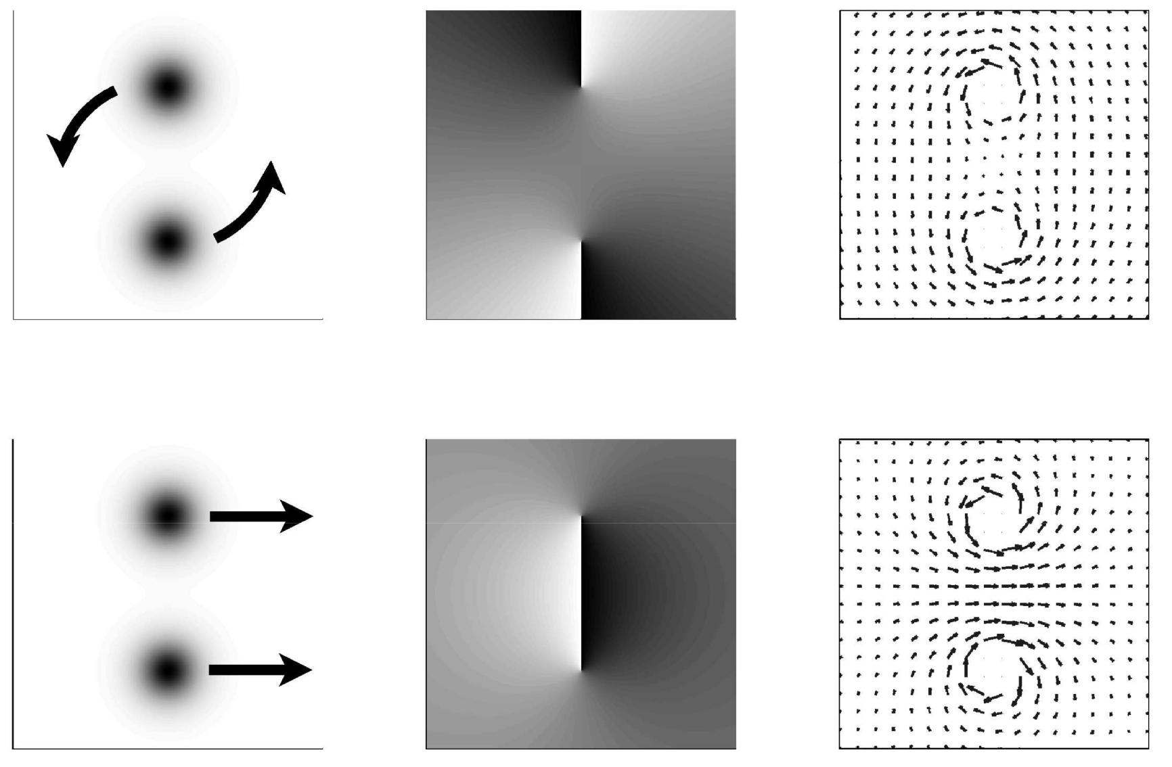

4

This modification of the equation of motion can be attributed to the phenomenon of phase slippage,^{21, 32} well known in the field of superfluids. The use of discrete point vortex interac - tions to calculate Euler fluid dynamics is also a well-known numerical method in computational fluid dynamics. ³³ Hence, to simulate Euler fluid dynamics, one can approximate both the rotational and irrotational components of the initial fl uid velocity profile by the optical phase and the phase singular-ities in an optical beam, and the nonlinear self-defocusing propagation of the beam would converge to incompressible Euler fluid dynamics in the strongly self-defocusing regime . One can also borrow from the well-established numerical techniques³³ to determine how the distribution of optical vor-tices sufficiently approximates the continuous vorticity i n flu-ids.
vorticity in an optical beam,
ω(x, ζ ) = å2πm _{j} ^{Z} dx _{j} δ (x − x _{j}), | (25)
j

which can be used to approximate the continuous vorticity of a fluid, if the number of vortex filaments is large enough. In this case, to include the vorticity effect in the nonlinear optical dynamics, one can phenomenologically patch up the irrotational equation of motion, Eq. (13),
∂ ζ | + Ñ | 2 | u · u | + ω × u = −_{M} ₂ Ñρ. |  |  | (26)
∂ u |  | 1 |  |  | 1

an optical beam, including the center of an optical vortex. In terms of the flux, the tensor dynamical equations now read ³⁴

 |  | ∂ ρ |  |  | ∂ J_{i} |  | = 0, |  |  |  |  |  |  |  |  |  |  |  |  |  |  |  |  | (28)
∂ ζ^{i} |  | ∂ ζ |  | ⁺ ∂ x_{i} |  |  |  |  |  |  |  |  |  |  |  |  | ₂ _{ρ}2 ₋
∂ ζ^{i} | ⁺ ∂ x _{j} |  | ρ |  |  |  | ⁼ ⁻_{M} 2 ∂∂_{xi}
∂ J |  | ∂ |  |  | ^{J}i^{J} j |  |  |  | 1 |  |  |  |  |  |  |  |  |  | 1
 |  |  |  |  |  |  | 1 ∂ 1 |  |  |  |  |  |  |  |  |  |  | ∂ √ρ ∂ √ρ |  |  |  |  |  | ∂ 2√_{ρ}
 |  |  |  |  |  |  |  |  |  |  |  |  |  |  |  |  |  |  |  |  |  |  | − √ρ |  | ,
 |  |  |  |  |  |  |  | R² |  |  | ∂ x _{j} |  |  |  | 2 |  |  | ∂ x_{i} |  |  |  | ∂ x _{j} | − √ρ | ∂ x_{i}∂ x _{j} | ,
 |  |  |  |  |  |  |  |  |  |  |  |  |  |  |  |  |  |  |  |  |  |  |  | (29)

where J_{i} is the ith component of J, ∂ /∂ x_{i} is the ith spatial derivative, and repeated indices are implicitly summed in the manner of Einstein's summation. These equations have the same form as the normalized Euler equations in the tensor form,

 |  | ∂ ρ |  |  | ∂ J_{i} |  | = 0, |  |  | (30)
∂ ζ^{i} |  | ∂ ζ |  | ⁺ ∂ x_{i} |  |  | = 0, |  | ∂ x_{i} , | (30)
∂ ζ^{i} | ⁺ ∂ x _{j} |  | _{ρ} |  |  |  | ⁼ ⁻_{M} 2 |  | ∂ x_{i} , | (31)
∂ J |  | ∂ |  |  | ^{J}i^{J} j |  |  | 1 | ∂ P

 |  |  |  |  |  |  |  | except the quantum pressure term in Eq. (29). Hence, in the
 |  |  |  |  |  |  |  | flux representation, we have successfully avoided the probl em
 |  |  |  |  |  |  |  | of divergent quantities. Furthermore, Eq. (29), in contrast to
 |  |  |  |  |  |  |  | Eq. (13), includes the correct convective term.
 |  |  |  |  |  |  |  | The use of momentum density in the description of non-
 |  |  |  |  |  |  |  | linear optical dynamics is more natural and appropriate than
D. The fluid flux representation |  |  |  |  |  |  |  | the use of velocity in the Madelung transformation, as the dy-
So far, we have shown that optical vortex solitons behave like |  |  |  |  |  |  |  | namics ultimately evolves according to the basic law of mo-
 |  |  |  |  |  |  |  | mentum conservation. As we shall show next, when compar-
point vortices in fluids when they are far away from each
 |  |  |  |  |  |  |  | ing the optical flux to the fluid flux, the dynamics of optical
other, and this behavior can be used to approximate Euler
 |  |  |  |  |  |  |  | vortex solitons are much more similar to that of less singu-
fluid dynamics. However, there is no guarantee that the vor-
 |  |  |  |  |  |  |  | lar fluid vortices than point vortices, and the corresponden ce
tices would remain well separated in the course of the vor-
 |  |  |  |  |  |  |  | between nonlinear optics and Euler fluid dynamics is still ju s-
tex dynamics. If optical vortices behaved exactly like point
 |  |  |  |  |  |  |  | tified when a is finite.
vortices, then their velocities would diverge when they are |  |  |  |  |  |  |  | tified when a is finite.
close to each other. This velocity divergence is well known to |  |  |  |  |  |  |  | E. Optical vortex solitons and vortex blobs
cause significant numerical instability in the use of point v or-
 |  |  |  |  |  |  |  | In light of the fluid flux representation, one should therefor |  |  | e
tices for computational fluid dynamics. ³³ Another problem is |  |  |  |  |  |  |  |  |  |  | e
that in three dimensions, the self-induced velocity of a curved |  |  |  |  |  |  |  | compare the flux of an optical vortex soliton to the flux of
point vortex | filament diverges logarithmically |  |  | ln 1 | a |  | in | a fluid vortex. In an incompressible fluid, the density is con-
point vortex |  | 33 |  | ∼ ( / |  | ) |  | stant, so the flux is proportional to the velocity, and the flux |  |  | at
the limit of a → 0. |  |  | Since the optical intensity decreases to |  |  |  |  | the center of a point vortex has the same singular behavior as
zero near the center of an optical vortex, the quantum pres-
sure term, which determines the size of the vortex dark spot, |  |  |  |  |  |  |  | the velocity. Near a vortex soliton, however, the flux is finit |  |  | e.
can no longer be ignored, and the optical vortex interactions |  |  |  |  |  |  |  | Consider the example of a single-charged vortex soliton. The
should differ markedly from point vortex interactions when |  |  |  |  |  |  |  | flux near the center is given by
their separation is on the order of a. |  |  |  |  |  |  |  | ˆ
To investigate the optical vortex dynamics when they are |  |  |  |  |  |  |  | J µ θ r, r << a, |  | (32)
close to each other, the fluid velocity is no longer an appropr i- |  |  |  |  |  |  |  | which vanishes as r → 0, as opposed to the divergence of
ate quantity to study, because it diverges near a vortex center.
The density, on the other hand, approaches zero towards the |  |  |  |  |  |  |  | J ∼ 1/r at the center of a point vortex.
center. This motivates us to define an alternative finite quan |  |  |  |  |  |  | - | Instead of comparing a vortex soliton to a point vortex, one
 |  |  |  |  |  |  | - | should hence compare the soliton to a vortex blob,³³ which
tity by multiplying the velocity and the density,
 |  |  |  |  |  |  |  | has finite vorticity over a finite area. The vorticity of a vort |  |  | ex
 |  |  | J ≡ ρu. |  | (27) |  |  | blob filament is mathematically described by
which is the fluid flux, or the momentum density. Simple cal- |  |  |  |  |  |  |  | ω(x, ζ ) = 2πm _{j} ^{Z} | dx _{j} γ(|x − x _{j}|) | (33)
culations show that the flux is indeed finite everywhere in |  |  |  |  |  |  |  | ω(x, ζ ) = 2πm _{j} ^{Z} | dx _{j} γ(|x − x _{j}|)

5

so in an incompressible fluid, the fluid flux of an optical vor-tex soliton with size a is the same as that of a vortex blob with size a. See Fig. 2 for a graphical illustration. The dy-
Fig. 2. Sketches of velocity and flux of a vortex blob and an optical vortex along a line across the center, to illustrate the similarities between the two in terms of the flux.
where γ is a vorticity distribution function for the filament. |  |  |  |  |  | Schr ¨odinger equation by Nore et al.^{36, 37} Using the nonlin-
The velocity near the center of a rectilinear vortex blob and |  |  |  |  |  | ear Schr ¨odinger equation, Noreet al. numerical demonstrated
far away from the center is |  |  |  |  |  | the Euler fluid dyanmics of a jet made of an array of counter-
 | ˆ |  |  | r << a, | (34) | rotating vortices, which exhibit sinuous and varicose instabil-
 |  |  |  | r << a, | (34) | ities. | 36 | In another study, Nore et al. also demonstrated three-
u ∝ θ r, |  |  |  | r << a, | (34) | ities. |  | In another study, Nore et al. also demonstrated three-
ˆ | 1 |  |  |  |  | dimensional shear flows and showed that numerically solving
u ∝ θ |  |  | , | r >> a, | (35) | nonlinear Schr ¨odinger equation is a viable alternative toEuler
u ∝ θ |  | r
and Navier-Stokes equations for the numerical study of shear flows. ³⁷ As nonlinear optical propagation is governed by non-linear Schr ¨odinger equation, The numerical experiments by Nore et al. show that nonlinear optics should also be able to compute Euler fluid dynamics.
3. Similarities between nonlinear Schrodinger¨ dynamics and Navier-Stokes fluid dynamics
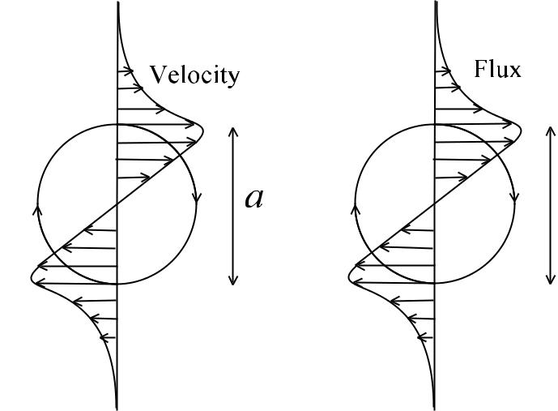
In the previous sections, we have shown the correspondence between self-defocusing optical propagation and inviscid Eu-ler fluid dynamics via a variety of methods, including the Madelung transformation, the incorporation of vorticity ef-fect due to the “phase slip” phenomenon, the fluid flux rep-resentation, and the comparison between optical vortex soli-tons and vortex blobs. Even though viscosity plays the role of a small parameter in most interesting fluid dynamics prob-lems, its effects are of paramount importance near a “no-slip” boundary and in the dissipation of eddies, in which cases the viscous Navier-Stokes equations should be used. In this section we shall present evidence that the nonlinear Schr ¨odinger equation exhibits many of the same behaviors of viscous Navier-Stokes fluid dynamics, and in each case, quantum pressure plays an analogous role to viscosity.
The normalized Navier-Stokes equations in the flux repre-sentation are given by
namics of a vortex blob and that of a vortex soliton are also |  |  |  |  |  |  |  |  |  |  |  |  |  |  | ∂ ρ |  | ∂ J_{i}
extremely similar. For example, the rotation frequency Ω of |  |  |  |  |  |  |  |  |  |  |  |  |  |  |  |  |  |  | = 0, |  |  |  |  |  |  |  |  |  |  |  |  |  |  |  |  |  |  |  | (37)
two like-charged vortex blobs approaches a constant ∝ 1/a² |  |  |  |  |  |  |  |  |  |  |  |  |  |  | ∂ ζ ⁺ ∂ x_{i} |  |  |  |  |  |  |  |  |  |  |  |  |  |  |  |  |  |  |  |  |  |  |  | (37)
when their separation goes to zero. Numerical simulations of |  |  |  |  |  |  |  |  |  |  |  |  | ∂ J | ∂ |  |  | J_{i} J _{j} |  | 1 |  |  |  |  |  |  |  |  |  | ∂ P
the nonlinear Schr ¨odinger equation also show that the rota- |  |  |  |  |  |  |  |  |  |  |  |  | ∂ ζ^{i} | + |  |  |  |  | = − |  |  |  |  |  |  |  |  |  | ∂ x_{i} ⁺
 |  |  |  |  |  |  |  |  |  |  |  |  | ∂ ζ^{i} | + | ∂ x _{j} |  | ρ |  |  |  |  | M ²
tion frequency of two like-charged vortex solitons approaches |  |  |  |  |  |  |  |  |  |  |  |  |  |  |  |  |  |  | 1 ∂ |  |  |  |  |  |  |  |  |  |  |  | ∂ u_{i} |  |  |  | ∂ u _{j}
 | constant |  |  |  | 1 |  | a² and does not diverge like two point vor-
a |  |  |  | ∝ | 1 | / |  |  |  |  |  |  |  |  |  |  |  |  |  | R ∂ x _{j} |  |  |  |  |  |  |  | ∂ x _{j} |  |  |  |  | ⁺ ∂ x_{i} |  |  |  | , |  | (38)
a |  | 35 |  | ∝ |  | /
tices. |  |  | On the other hand, the self-induced velocity of a
curved vortex blob filament is given by ³³ |  |  |  |  |  |  |  |  |  |  |  |  | where the last term in Eq. (38) is the viscosity term and R
 |  |  |  |  |  |  |  | ∂ x_{i} |  | m_{i}b | ρ_{c} |  | is called the Reynolds number, which describes the relative
 |  |  |  |  |  |  |  | ∂ x_{i} |  | m_{i}b | ρ_{c} |  | strength of convection compared to viscosity,
 |  |  |  |  |  |  |  |  | = |  | ln _{a} , | (36)
 |  |  |  |  |  |  |  | ∂ ζ | = | 2ρ_{c} | ln _{a} , | (36)
where b is the unit binomial vector of the filament and |  |  |  |  |  |  |  |  |  |  |  | ρ_{c} is |  |  |  |  |  |  | R = |  |  |  |  |  |  | U L |  |  | , |  |  |  |  |  |  |  |  |  | (39)
 |  |  |  |  |  |  |  |  |  |  |  | ρ_{c} is |  |  |  |  |  |  |  |  |  |  |  |  |  | ν
the radius of curvative. The self-induced velocity of an optical
 |  |  |  |  |  |  |  |  |  |  |  |  | where U is the characteristic velocity of the fluid system, |  |  |  |  |  |  |  |  |  |  |  |  |  |  |  |  |  |  |  |  |  |  |  |  |  | L is
vortex soliton filament is proven to be exactly the same. ²⁹ |  |  |  |  |  |  |  |  |  |  |  |  |  |  |  |  |  |  |  |  |  |  |  |  |  |  |  |  |  |  |  |  |  |  |  |  |  |  | L is
Hence, optical vortex solitons act as vortex blobs, and a large |  |  |  |  |  |  |  |  |  |  |  |  | the characteristic length, and ν is the kinematic viscosity of
number of solitons can simulate Euler fluid dynamics, much |  |  |  |  |  |  |  |  |  |  |  |  | the fluid. Comparing the viscosity term in Eq. (38) with the
like the popular discrete vortex blob method in computational |  |  |  |  |  |  |  |  |  |  |  |  | quantum pressure term in Eq. (29) via a dimensional analy-
fluid dynamics. ³³ |  |  |  |  |  |  |  |  |  |  |  |  | sis would suggest that an analogous optical Reynolds number
 |  |  |  |  |  |  |  |  |  |  |  |  | would be defined as

- Numerical evidence of correspondence between nonlin-ear optics and Euler fluid dynamics

The most telling evidence of the correspondence between nonlinear optics and Euler fluid dynamics is perhaps the numerical fluid dynamics simulations using the nonlinear

R = KW, | (40)

where, to recall, K is the characteristic optical phase gradi-ent, and W is the characteristic size of the optical experiment setup. The optical Reynolds number thus roughly measures

6

the number of optical vortices. In other words, if the opti-cal Reynolds number indeed corresponds to its fluid counter-part, then the quantization of the optical vortices would play

an analogous role to fluid viscosity. This view seems to be echoed by other researchers in the field of superfluids, ^{38–41}

although we must stress that it is still an open problem as to what extent the quantization effect resembles the viscous ef-fect.⁴¹

- Zero-flux boundary conditions, boundary layers, and boundary layer separation

In classical fluid dynamics the “no-slip” boundary conditio n is most commonly used, and restricts the total velocity and hence the total flux to be zero at the boundary. For fluid flow above a surface, the velocity shear introduced must be bal-anced by a viscous stress, resulting in a boundary layer that connects the zero velocity at the boundary to the flow veloc-ity above the boundary in an asymptotic expansion.⁴² For the nonlinear Schr ¨odinger equation, the boundary condition of an impenetrable object can be specified by a very low refractive index region, which restricts the optical intensity to be zero at the surface⁴³ due to total internal reflection. Even though the tangential velocity can have a non-zero value at the surface, both the normal and tangential components of the flux must be zero there. This can hence be viewed as a zero-flux “no-slip” boundary condition. An optical boundary layer analo-gous to the viscous boundary layer in classical fluid dynamic s is also formed.⁴³ See Fig. 3 for a graphical illustration of the similarities between a viscous boundary layer and an optical boundary layer.
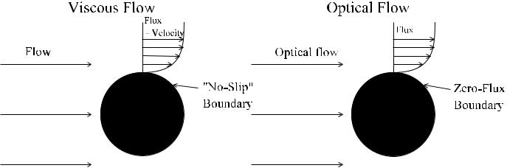

Fig. 3. Comparison between a viscous boundary layer and an optical boundary layer.

For a viscous fluid flow past an obstacle, as the Reynolds number increases, the boundary layer begins to separate and vorticity is convected behind the obstacle. An analogy in the dynamics of the nonlinear Schr ¨odinger equation, in the form of vortex nucleation on the boundary, is also predicted,²² and in the case of large objects, the instability of the optical boundary layer also depends on the optical Reynolds num-ber R defined in Eq. (40), ⁴⁰ much like the viscous boundary layer separation.

- Dissipation of eddies

Another important effect of viscosity is the dissipation of small-scale structures in turbulence. An analogous effect in nonlinear Schr ¨odinger equation is the emission of sound waves two vortices are close to each other³⁵ and the gener-ation of Kelvin waves in the process of vortex line recon-
nections.⁴⁴ The radiation of acoustic energy in both cases must cause a damping of the high-spatial-frequency convec-tion within the optical beam, and the effective Reynolds num-ber is again estimated to be equal to the optical Reynolds
_{number.}38, 39, 41

- Karm´an´ vortex street

The K´arm´an vortex street is a famous viscous fluid phe-nomenon, in which alternate fluid vortices are emitted from the back of an obstacle to the flow of a viscous fluid, when the Reynolds number increases beyond a certain threshold.^{26, 45} Using the numerical vortex blob method, Chorin first simu-lated such a phenomenon for a cylinder obstacle and obtained good agreement with experimental data.⁴⁶ Since an optical beam diffracting past a low refractive index region would also emit optical vortices and the vortices interact like vortex blobs in a self-defocusing medium, we performed a numerical ex-periment of the nonlinear Schr ¨odinger equation to investigate if we would observe a similar phenomenon for nonlinear op-tics.
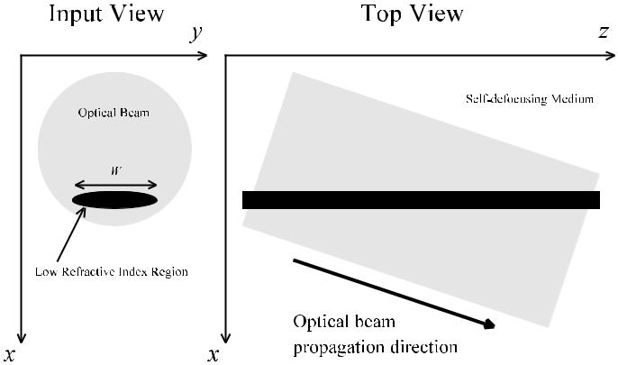

Fig. 4. Setup of numerical experiment (not-to-scale).

The numerical setup is sketched in Fig. 4. A big opti-cal beam is assumed to propagate at an angle to an ellip-soid cylinder, with a refractive index much lower than the surroundings to act as an impenetrable object, in a self-defocusing medium. The length of the long axis of the el-lipsoid cross section is assumed to be W , and the short axis is assumed to be one-fifth of W throughout the simulations. The two-dimensional nonlinear Schr ¨odinger equation is solved using the Fourier split-step method,²⁰ which implies a peri-odic boundary condition for the optical beam. This should not affect the qualitative behavior of the dynamics, if the optical beam is much bigger than the object. In all of the simula-tions, the Mach number M is fixed at 0.4, while the optical Reynolds number R is varied. Figure 5 plots the intensity of the optical beam at a normalized propagation distance ζ = 10 for an optical Reynolds number R = KW = 12.8. Optical vor-tex solitons are created on the top and bottom side of the low-refractive-index region, and they interact in such a way that resembles the phenomenon of twin vortices behind an obsta-

cle in a low-Reynolds-number viscous fluid flow.

Figure 6 plots the flux J = (ψ∗Ñψ − ψÑψ∗)/2i and Fig. 7 plots the momentum vorticity Ñ × J. Both plots confirm the

7

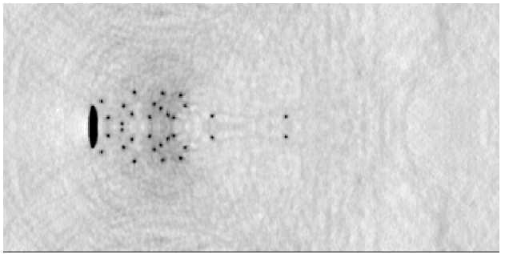

Fig. 5. The intensity of the optical beam at a normalized prop-agation distance ζ = 10, for M = 0.4 and R = 12.8. The dark ellipse is the low-refractive-index region that acts as an im-penetrable object. Optical vortex solitons are seen to be cre-ated on the top and bottom side of the ellipse, While the con-vection of the solitons behind the object resembles the twin vortices behind an obstacle in a viscous fluid flow.

similarity between the numerically observed dynamics and the phenomenon of twin vortices in a viscous fluid flow.
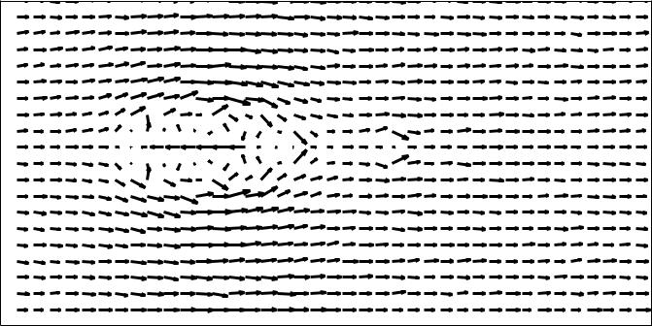

Fig. 6. A vector plot of the flux J at ζ = 10, for M = 0.4 and R = 12.8, which confirms the similarity between the nu-merically observed dynamics and the phenomenon of twin vortices.

Figures 8, 9, and 10 plot the intensity, flux, and momentum vorticity of the optical beam respectively, at a longer propaga-tion distance ζ = 20 for the same parameters. The qualitative dynamical behavior of vortices staying behind the object is essentially unchanged.

We now raise the Reynolds number to R = 25.6 and per-form the numerical experiment again. As seen from Figs. 11, 12, and 13, the optical vortex solitons become smaller and more abundant, but at ζ = 10 the phenomenon of twin vor-tices behind an obstacle is again observed.

At ζ = 20, however, significant instability in the twin vor-tices develops, such that the spatial symmetry between the upper plane and the lower plane is broken, and alternative bunches of optical vortices begin to be emitted from the back of the object. Figures 14, 15, and 16 plot the intensity, flux and vorticity at ζ = 20 respectively, which demonstrate a be-havior strongly resembling the famous K´arm´an vortex stre et phenomenon.

Due to computing power constraints, we are only able to simulate low-Reynolds-number flows, which we do not ex-pect to quantitatively reproduce viscous fluid dynamics. We

Fig. 7. A plot of the momentum vorticity Ñ × J at ζ = 10, for M = 0.4 and R = 12.8. A white dot indicates that the vor-tex has a positive topological charge and a black dot indicates that the vortex has a negative charge. The plot shows the sim-ilarity between the numerically observed dynamics and the phenomenon of twin vortices.
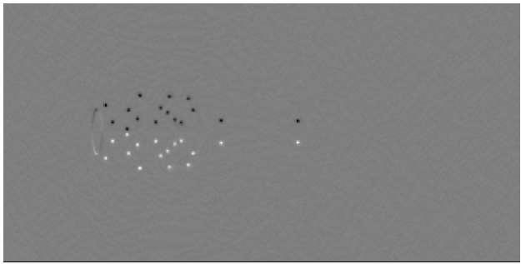
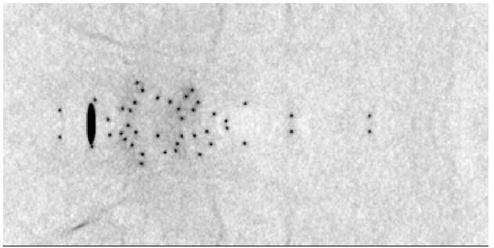

Fig. 8. The intensity of the optical beam at a normalized prop-agation distance ζ = 20, for M = 0.4 and R = 12.8. The qualitative dynamical behavior is essentially unchanged from that shown in Fig. 5.
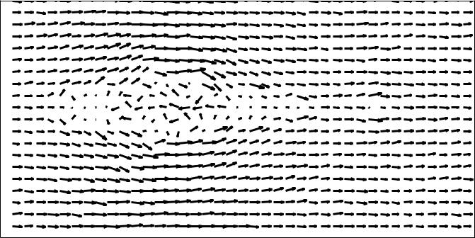

Fig. 9. A vector plot of the flux J at ζ = 20, for M = 0.4 and

R = 12.8.
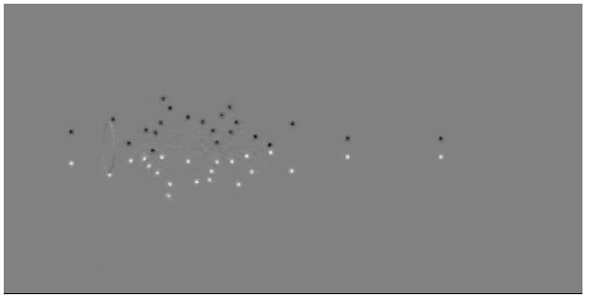

Fig. 10. A plot of the momentum vorticity Ñ × J at ζ = 20, for M = 0.4 and R = 12.8.

8

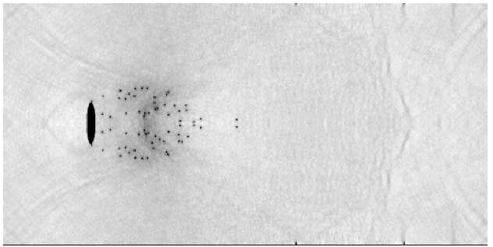

Fig. 11. The optical intensity at ζ = 10, for M = 0.4 and R = 25.6. The vortex solitons are observed to be smaller, and the phenomenon of twin vortices is again observed.
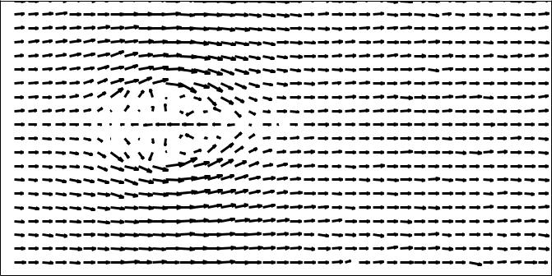

Fig. 15. Flux at ζ = 20, for M = 0.4 and R = 25.6, which shows a flow pattern strongly resembling the K´arm´an vortex street.
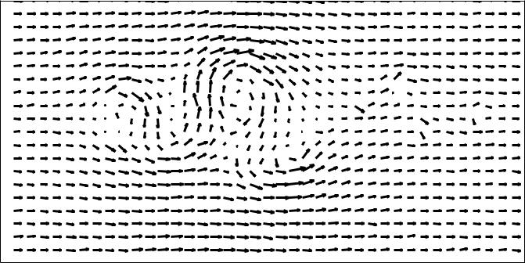
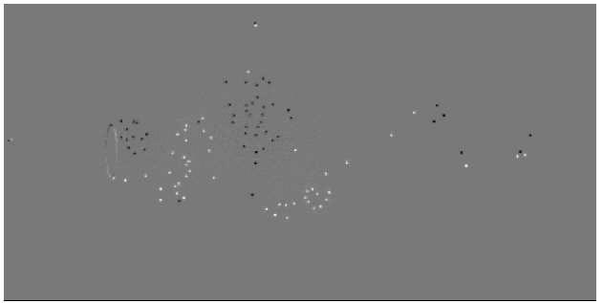

Fig. 12. The flux J at ζ = 10, for M = 0.4 and R = 25.6.
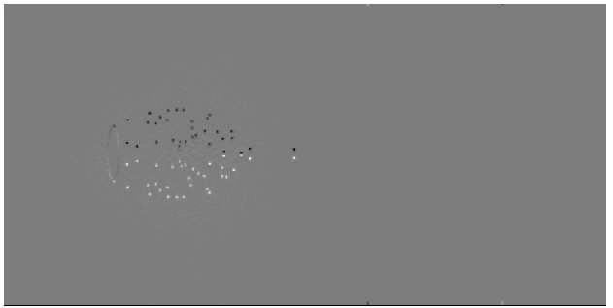

Fig. 16. Vorticity at ζ = 20, for M = 0.4 and R = 25.6, which confirms that the alternate bunches of vortices indeed have the right charges that resemble the K´arm´an vortex str eet phenomenon.

Fig. 13. The momentum vorticity Ñ × J at ζ = 10, for M = 0.4 and R = 25.6.
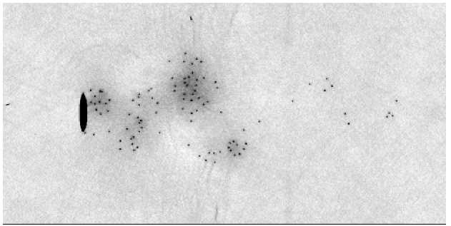

Fig. 14. Optical intensity at ζ = 20, for M = 0.4 and R = 25.6. The twin vortices become unstable and detach alterna-tively from the object.

have to use an ellipsoid cylinder in the numerical experi-ments, instead of the more conventional circular cylinder, to artificially generate more optical vortices, and the Mach number is a little too high for compressional waves not to play a significant role in the dynamics. With all that said, us - ing the nonlinear Schr ¨odinger equation, we are still able to qualitatively demonstrate, for the first time to our knowled ge, two well-known viscous fluid phenomena, namely, the forma-tion of twin vortices behind an obstacle, and the symmetry-breaking instability of the twin vortices that leads to the K´arm´an vortex street when the Reynolds number is increase d. Compared with previous claims of observing the K´arm´an vortex street in nonlinear optics numerically⁷ or experimen-tally,^{8, 9} our numerical results demonstrate an unprecedented level of correspondence between nonlinear optical dynamics and the K´arm´an vortex street phenomenon, thanks to the pre s-ence of a much larger number of optical vortices in our simu-lations.

D. Kolmogorov turbulence

The striking similarities between nonlinear optics and vis-cous fluid dynamics are not limited to low-Reynolds-number two-dimensional problems. As the Reynolds number is fur-ther increased to the order of a million, the viscous fluid flow enters a turbulent regime. Since this regime is highly chaotic, only statistical signatures can be reproduced in a tur-bulent fluid flow. A well-known signature of turbulence is the

9

Kolmogorov energy spectrum,⁴⁷ derived under the assump-tion that a “steady state” is reached when the macroscopic-scale fluid flow continuously generate finer spatial structur es via convection and viscosity dissipates the smallest struc-tures. As viscosity plays a significant role in the Kolmogoro v turbulence spectrum, it is surprising to see that numerical simulations of the three-dimensional nonlinear Schr ¨odinger equation also reproduce the Kolmogorov spectrum at high Reynolds numbers, and the vorticity dynamics of the “su-perflow” described by the nonlinear Schr ¨odinger equation r e-sembles that of the viscous flow, in which vortex reconnectio n events play a major role.^{38, 39}

But if Δζ is much smaller than 1/H where H is the magnitude of the operators, by virtue of the Baker-Hausdorff formula we

where propagation effects and boundary conditions are ex-
ˆ
pressed in terms of operators H_{n}. The formal solution is

41, 44

The dissipation of the smallest spatial structures in a su-perflow is speculated to be the Kelvin waves produced by

the natural motion and reconnections of vortex filaments,

and the corresponding Reynolds number is again speculated to be R = KW .⁴¹ Numerical and theoretical analyses of the so-called “quantum turbulence” exhibited by the nonlinear Schr ¨odinger equation all reveal striking similarities between quantum and classical fluids, and it is argued that the study o f quantum turbulence could lead to a better understanding of turbulence in normal fluids. ⁴⁸

the error order,
1 | ˆ | Δζ |  | N | ˆ | Δζ
1 |  | 2 |  | N |  | 2
m=N |  | 2 |  | n=1 |  | 2
ψ(ζ + Δζ ) = Õ exp | H_{m} |  |  | Õ exp | H_{n} |  | ψ(ζ )+
O(H³Δζ ³). |  |  |  |  |  |  | (44)

The split-step method is not unlike the proof of a quan-tum computer being able to simulate any quantum systems.²³ Whereas it is difficult to find a quantum device that performs the exact Hamiltonian of the quantum system of interest, it is possible to approximate the Hamiltonian in small time slices. Similarly, in a metaphoric optical computer, one can form a unit cell of a “meta-material” by combining a slice of defo-cusing material, a slice of material with anomalous group-velocity dispersion, a slice of ultrafast phase modulator to apply the three-dimensional boundary conditions, and a gain medium to compensate for loss. The optical beam can loop through the unit cell multiple times in a cavity, so that the outcome will approximate the true solution as if we had an ideal medium. See Fig. 17 for a graphical illustration of the method.

Ideal Nonlinear Medium

4. The split-step method

While a nonlinear optical system shows promise for com-puting Euler and Navier-Stokes fluid dynamics, it also poses serious technical challenges. Ideally one would like to have a configurable nonlinear material with low loss, anomalous group-velocity dispersion, high defocusing nonlinearity, and three-dimensional co-propagating boundaries. One may only be able to find separate materials or optical devices, each of which performs only some of the functions. Moreover, par-asitic effects such as loss, two-photon absorption, and high-order dispersion can be detrimental to the accuracy. To com-bine different devices and periodically compensate for para-sitic effects, we hereby propose the “split-step” method, t he inspiration of which comes from the numerical Fourier “spli t-step” method. ²⁰ Consider the general nonlinear Schr ¨odinger equation,

Input Beam | ˆ | ˆ | ˆ |  | Output Beam
 | ^{H}total = ^{H}1 |  | + H₂ | + ...
 | "Split-Step" System
ˆ |  | ˆ
^{H}1 |  | ^{H}2
Δζ |  | Δζ
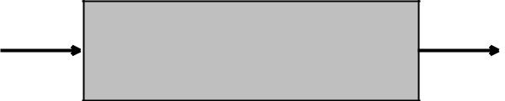
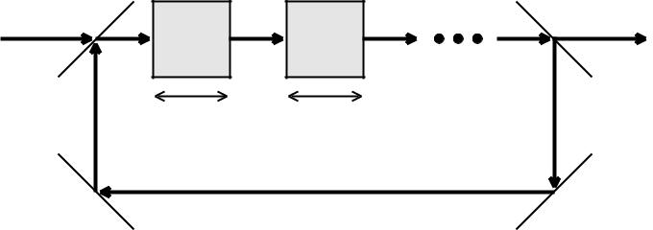

Fig. 17. Sketch of a split-step optical system that approxi-mates the ideal nonlinear medium.

 | ∂ ψ |  | N | ˆ
 | ∂ ζ |  | = å H_{n}ψ,
 | ∂ ζ |  | n=1
ψ(ζ + Δζ ) = exp |  | ^{Z} ^{ζ} ^{+Δζ} _{å} _{Hˆndζ} ′ |  |  | ψ(ζ ).
 |  |  |  | N
 |  |  | ζ | n=1
have
N |  |  | ˆ
n=1 |  |  | ˆ
ψ(ζ + Δζ ) = Õ exp |  |  | ˆ |  | 2 | Δζ | 2 | ).
 |  |  | H_{n}Δζ | ψ(ζ ) + O(H |  | Δζ |  | ).

The split-step method has the additional advantages that

- each subsystem can be tunable and easily substituted with an-other material or device, and the pulse evolution can be mon-itored more easily. The magnitude of each effect can be tuned by simply changing the propagation length in each device, In exchange of configurability we have sacrificed some ac-curacy due to discretization errors and instability. The com-
- putation speed may also be reduced by a large but constant fraction, as the pulse may spend most of its time on simply propagating from one device to the next and not performing the core computation by nonlinear propagation. The split-step method, however, does not detract from the inherent paral-lelism in the computation, as the transverse dimensions are
- not discretized.

Each of the propagation effects can hence be applied sepa-rately to an optical pulse, with a quadratic error term. A sym-metrized version of the split-step method can further reduce
5. Conclusion

In conclusion, we have used a variety of theoretical and nu-merical methods to show that self-defocusing optical propa-

10

gation has a converging correspondence with Euler fluid dy-namics and a striking similarity with Navier-Stokes fluid dy - namics. We have numerically shown that the interactions of a large number of optical vortex solitons are able to simu-late two well-known viscous fluid phenomena. We have also proposed the split-step method, a way of practically imple-menting the metaphoric optical computer.

There are serious technical challenges if a metaphoric com-puter is to become useful for computing fluid dynamics, es-pecially three-dimensional fluid dynamics problems, as tec h-niques for the complete specification and characterization of the spatiotemporal optical field are still in their infancy. The speed, configurability, and parallelism of a metaphoric opt ical simulator nonetheless promise vast advantages over conven-tional numerical simulations.

Since photons are quantum objects, optical propagation would also inherently compute the quantum dynamics of bosons, and may therefore be used as a metaphoric simula-tor of quantum fluids, such as superfluids, superconductors, and Bose-Einstein condensates. In this way the advantages of a metaphoric computer and those of a quantum computer are combined, and only then the classical and quantum comput-ing capabilities offered by photons would truly be exhausted. This extension of metaphoric optical computing will be a sub-ject of future work.

Acknowledgments

We would like to acknowledge helpful and inspiring discus-sions with Ravi Athale, Michael C. Cross, and Martin Cen-turion. This work is supported by the Defense Advanced Re-search Projects Agency (DARPA).

References

- W. G. Wagner, H. A. Haus, and J. H. Marburger, “Large-scale

self-trapping of optical beams in the paraxial ray approxima-tion,” Phys. Rev. 175, 256-266 (1968).

- P. Coullet, L. Gil, and F. Rocca, “Optical vortices,” Opt. Com-mun. 73, 403-408 (1989).

- M. Brambilla, L. A. Lugiato, V. Penna, F. Prati, C. Tamm, and C. O. Weiss, “Transverse laser patterns. II. Variational pr inci-
ple for pattern selection, spatial multistability, and laser hydro-dynamics,” Phys. Rev. A 43, 5114-5120 (1991).

- F. T. Arecchi, G. Giacomelli, P. L. Ramazza, and S. Resi-

dori, “Vortices and defect statistics in two-dimensional o ptical chaos,” Phys. Rev. Lett. 67, 3749-3751 (1991).

- S. A. Akhmanov, M. A. Vorontsov, V. Yu. Ivanov, A. V. Larichev, and N. I. Zheleznykh, “Controlling transverse-w ave
interactions in nonlinear optics: generation and interaction of spatiotemporal structures,” J. Opt. Soc. Am. B 9, 78-90 (1992).

- G. A. Swartzlander, Jr. and C. T. Law, “Optical vortex soli tons observed in Kerr nonlinear media,” Phys. Rev. Lett. 69, 2503-2505 (1992).

- K. Staliunas, “Laser Ginzburg-Landau equation and laser hy-drodynamics,” Phys. Rev. A 48, 1573-1581 (1993).

- M. Vaupel, K. Staliunas, and C. O. Weiss, “Hydrodynamic ph e-nomena in laser physics: Modes with flow and vortices behind an obstacle in an optical channel,” Phys. Rev. A 54, 880-892 (1996).

- G. Molina-Terriza, D. V. Petrov, J. Recolons, and L. Torner, “Observation of optical vortex streets in walking second-harmonic generation,” Opt. Lett. 27, 625-627 (2002).

- F. S. Roux, “Dynamical behavior of optical vortices,” J. Opt. Soc. Am. B 12, 1215-1221 (1995).

- D. Rozas, C. T. Law, and G. A. Swartzlander, Jr., “Propaga tion dynamics of optical vortices,” J. Opt. Soc. Am. B 14, 3054-3065 (1997).

- D. Rozas, Z. S. Sacks, and G. A. Swartzlander, Jr., “Exper -

imental observation of fluidlike motion of optical vortices ,” Phys. Rev. Lett. 79, 3399-3402 (1997).
13. | ´
13. | H. Michinel, J. Campos-T´aboas, R. Garc ia-Fern´andez, J. R.
 | Salgueiro, and M. L. Quiroga-Teixeiro, “Liquid light conde n-
 | sates,” Phys. Rev. E 65, 066604 (2002).
14. | M. J. Paz-Alonso, D. Olivieri, H. Michinel, and J. R. Salgueiro,
 | “Collisional dynamics of vortices in light condensates,” P hys.
 | Rev. E 69, 056601 (2004).
15. | M. J. Paz-Alonso and H. Michinel, “Superfluidlike motion of
 | vortices in light condensates,” Phys. Rev. Lett. 94, 093901
 | (2005).

- Y. Pomeau and S. Rica, “Nonlinear diffraction,” C. R. Aca d. Sci. Paris, 317, 1287-1292 (1993).

- E. L. Bolda, R. Y. Chiao, and W. H. Zurek, “Dissipative opt ical flow in a nonlinear Fabry-P´erot cavity,” Phys. Rev. Lett. 86, 416-418 (2001).

- R. Y. Chiao, “Bogoliubov dispersion relation for a 'phot on fluid': Is this a superfluid?” Opt. Commun. 179 157-166 (2000).

- R. W. Boyd, Nonlinear Optics (Academic Press, San Diego, 2002).

- G. P. Agrawal, Nonlinear Fiber Optics (Academic Press, San Diego, 2001).

- R. J. Donnelly, Quantized Vortices in Helium II (Cambridge University Press, New York, 1991).

- T. Frisch, Y. Pomeau, and S. Rica, “Transition to dissipa tion in a model of superflow,” Phys. Rev. Lett. 69, 1644-1646 (1992).
- S. Lloyd, “Universal quantum simulators,” Science 273, 1073-1078 (1996).

- E. Madelung, “Quantum theory in hydrodynamic form,” Z. Phys. 40, 322-326 (1926).

- M. Quiroga-Teixeiro and H. Michinel, “Stable azimuthal sta-

tionary state in quintic nonlinear optical media,” J. Opt. S oc. Am. B 14, 2004-2009 (1997).

- L. M. Milne-Thomson, Theoretical Hydrodynamics (The Macmillan Company, New York, 1968).

- A. W. Snyder, L. Poladian, and D. J. Mitchell, “Stable black self-guided beams of circular symmetry in a bulk Kerr medium,” Opt. Lett. 17 789-791 (1992).

- J. C. Neu, “Vortex dynamics of the nonlinear wave equatio n,” Physica D 43, 407-420 (1990).

- L. M. Pismen and J. Rubinstein, “Motion of vortex lines in the Ginzburg-Landau model,” Physica D 47, 353-360 (1991).

30. F.-H. Lin and J. X. Xin, “On the incompressible fluid limit and the vortex motion law of the nonlinear Schr ¨odinger equation,” Commun. Math. Phys. 200, 249-274 (1999).

- T.-C. Lin, “Rigorous and generalized derivation of vort ex line dynamics in superfluids and superconductors,” SIAM J. Appl. Math. 60, 1099-1110 (2000).

- E. B. Sonin, “Vortex oscillations and hydrodynamics of r otat-ing superfluids,” Rev. Mod. Phys. 59, 87-155 (1987).

- A. Leonard, “Vortex methods for flow simulation,” J. Comp . Phys. 37, 289-335 (1980).

11

- J. Grant, “Pressure and stress tensor expressions in the fluid mechanical formulation of the Bose condensate equations,” J. Phys. A 6, L151-153 (1973).

- I. Aranson and V. Steinberg, “Stability of multicharged vortices

in a model of superflow,” Phys. Rev. B 53, 75-78 (1996).

- C. Nore, M. E. Brachet, and S. Fauve, “Numerical study of h y-

drodynamics using the nonlinear Schr ¨odinger equation,” Phys-ica D 65, 154-162 (1993).

- C. Nore, M. Abid, and M. E. Brachet, “Numerical study of 3D

shear-flows using the nonlinear Schr ¨odinger equation,” C. R. Acad. Sci. Paris, 319, 733-737 (1994).

- C. Nore, M. Abid, and M. E. Brachet, “Kolmogorov turbulen ce in low-temperature superflows,” Phys. Rev. Lett. 78, 3896-3899 (1997).

- C. Nore, M. Abid, and M. E. Brachet, “Decaying Kolmogorov turbulence in a model of superflow,” Phys. FLuids 9, 2644-2669 (1997).

- J. S. Stiessberger and W. Zwerger, “Critical velocity of super-fluid flow past large obstacles in Bose-Einstein condensates ,” Phys. Rev. A 62, 061601 (2000).

- W. F. Vinen and J. J. Niemela, “Quantum turbulence,” J. Lo w Temp. Phys. 128, 167-231 (2002).

- H. Schlichting, K. Gersten, E. Krause, and H. Oertel Jr., Boundary-Layer Theory (Springer, New York, 2000).

- N. G. Berloff and P. H. Roberts, “Motions in a Bose conden-sate: VII. Boundary-layer separation,” J. Phys. A 33, 4025-4038 (2000).

- E. Kozik and B. Svistunov, “Kelvin-wave cascade and deca y of superfluid turbulence,” Phys. Rev. Lett. 92, 035301 (2004).

- C. H. K. Williamson, “Vortex dynamics in the cylinder wak e,” Annu. Rev. Fluid. Mech. 28,477-539 (1996).

- A. J. Chorin, “Numerical study of slightly viscous flow,” J. Fluid Mech. 57, 785-796 (1973).

- U. Frisch, Turbulence, the Legacy of A. N. Kolmogorov (Cam-bridge University Press, Cambridge, 1995).

- S. N. Fisher and G. R. Pickett, “Quantum turbulence,” Phy s. World April Issue (2006).

12

