- Lifters, transportation equipment and conveyors

- Vertical mast lifters
Vertical mast lifters are designed to lift and unload trolleys with raw materials.
By configuration the vertical mast lifters can be mobile or stationary. Each lifter is produced according to the technical requirements set by the customer (loading height, tare capture mechanism, etc.).
Work material--stainless steel AISI 304
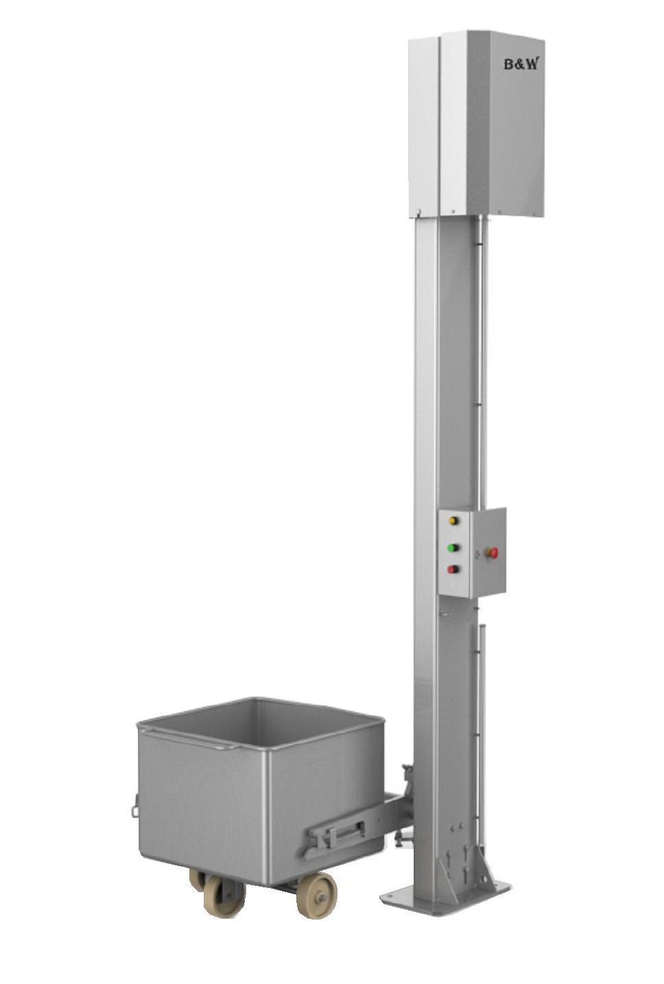

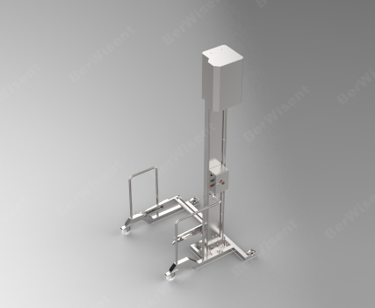
- Hydraulic lifters
Hydraulic lifters are designed for lifting and unloading trolleys with raw materials.
Lifting and flipping of the trolley is powered by the work of hydraulic cylinders.
By configuration hydraulic lifters can be mobile or stationary.
Each lifter is produced according to the customer provided technical requirements (loading height, tare capture mechanism, lifting capacity, etc.).
Work material--stainless steel AISI 304
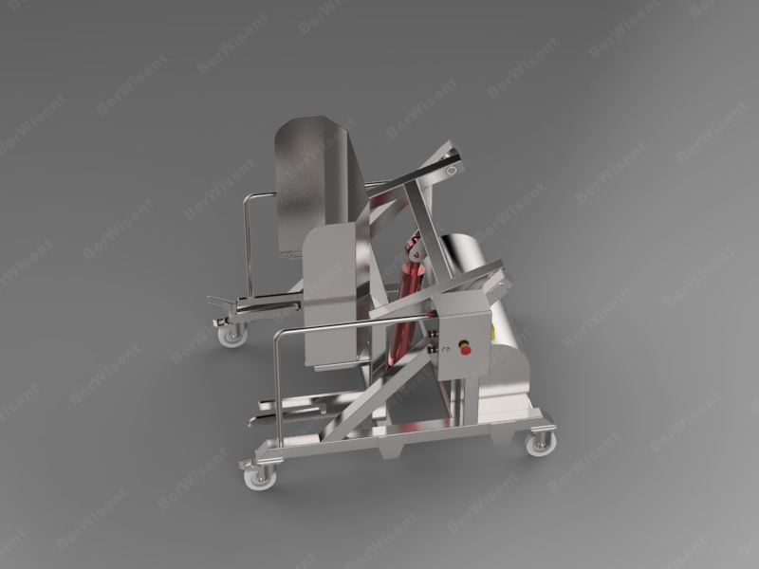

- Pneumatic lifters
Pneumatic lifters are designed to lift and unload trolleys with raw materials.
Lifting and flipping of the trolley is powered by the work of pneumatic cylinders.
By configuration the pneumatic lifters can be mobile or stationary.
Each lifter is produced according to the customer provided technical requirements (loading height, tare capture mechanism, lifting capacity, etc.).
Work material--stainless steel AISI 304
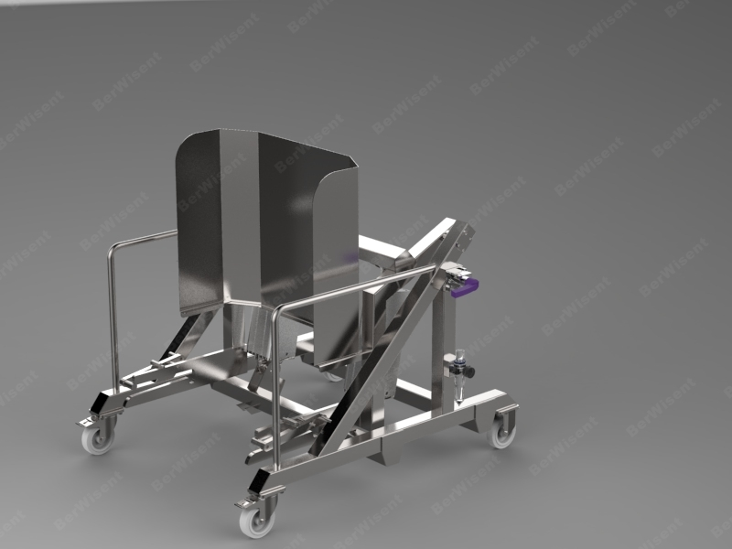

- Conveyor belts
The conveyor belt is designed to move bulk or piece goods.
We can produce conveyors various by type and configuration: steep angle, swivel, horizontal, vertical; floor-standing, suspended; of different dimensions.
At customer’s request conveyor belts can be equipped with frequency converters to adjust speed.
Roller conveyors are made of various length and configuration to fit customer’s needs.
Body work material -- stainless steel AISI 304.
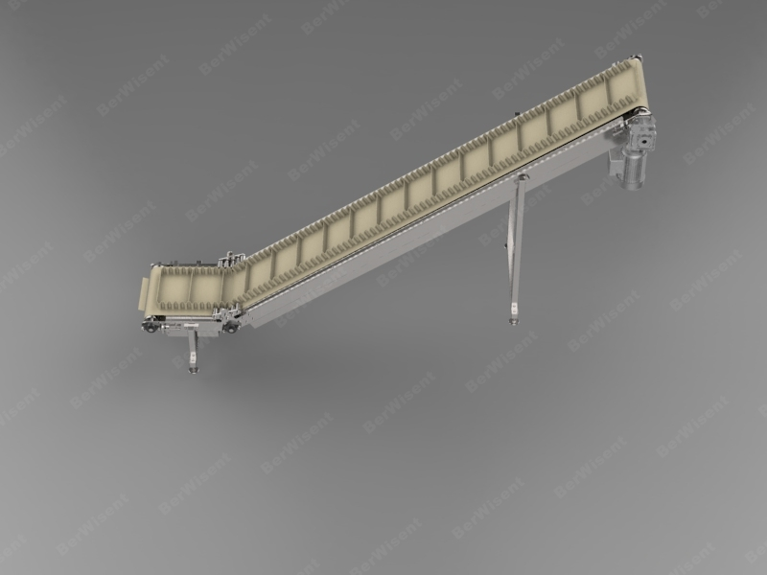
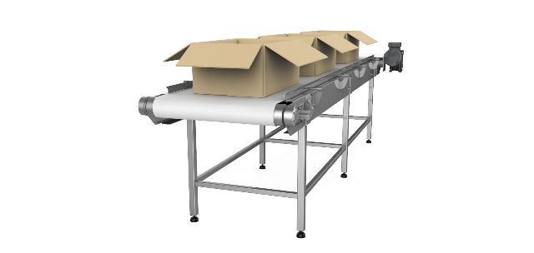
- Roller conveyors
Roller conveyors are designed for transporting loads horizontally or at a slight angle.
Loads are moved mechanically by conveyor rollers placed close to one another.
We can produce various roller conveyors different by type and configuration: steep angle, swivel, driving (equipped with a drive and a transmitting gear) or gearless and of various dimensions.
Roller conveyors are made of various length and configuration to fit customer’s needs.
Work material--stainless steel AISI 304
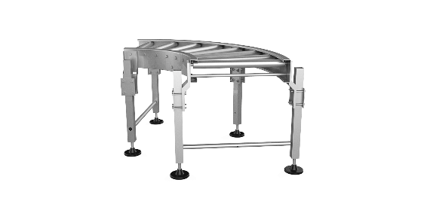

- Pneumatic conveyors
Pneumatic conveyor is used for moving, transporting, pumping the product by compressed air.
We can produce various pneumatic conveyors according to the required output.
Material-stainless steel AISI 304

- Hygienic equipment

- Hygiene stations (sanitary inspection rooms):
- Hygiene station (sanitary inspection rooms) for hands and footwear.
Hand and footwear hygiene stations are designed for automatic no-contact sanitation of hands and soles of the footwear before entering the restricted personnel zone.
These stations can be produced in various configurations. Various options of brushes for cleaning soles, boots and shoes of the working personnel are available.
At the customer’s request we can install the system for washing hands and hand drying. In the same way according to the customer’s requirements we can install access control card system, or to connect it to the existing access control system at the plant.
Work material--stainless steel AISI 304
Hygiene stations (sanitary inspection rooms) are equipped with master controller with programmable settings.
At the customer’s request the hygiene stations (sanitary inspection rooms) can be equipped with towel dispensers and rubbish bins.
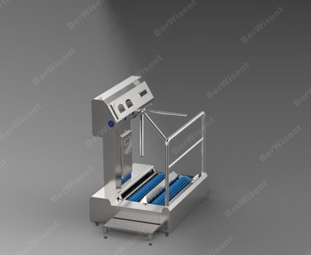
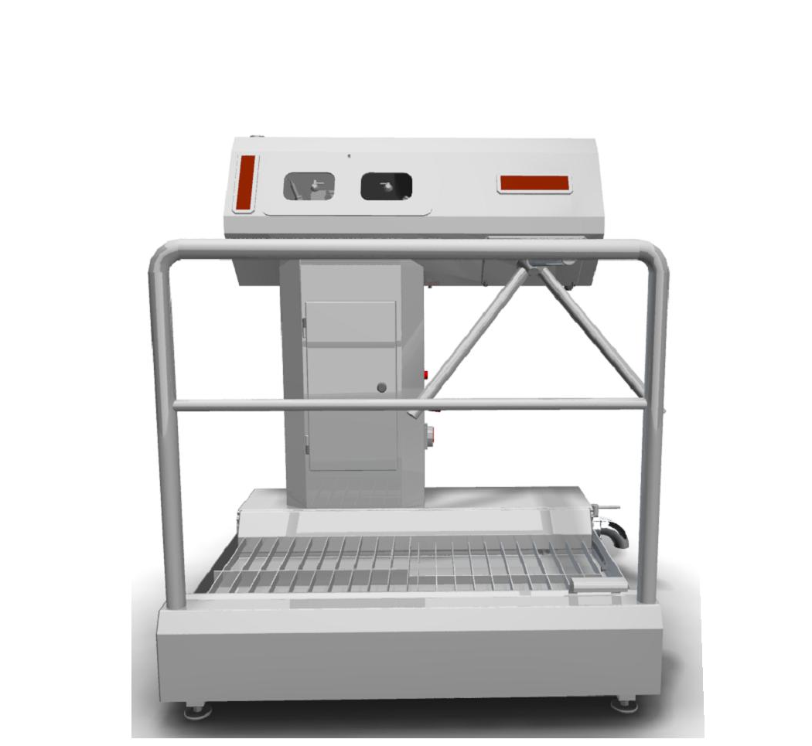
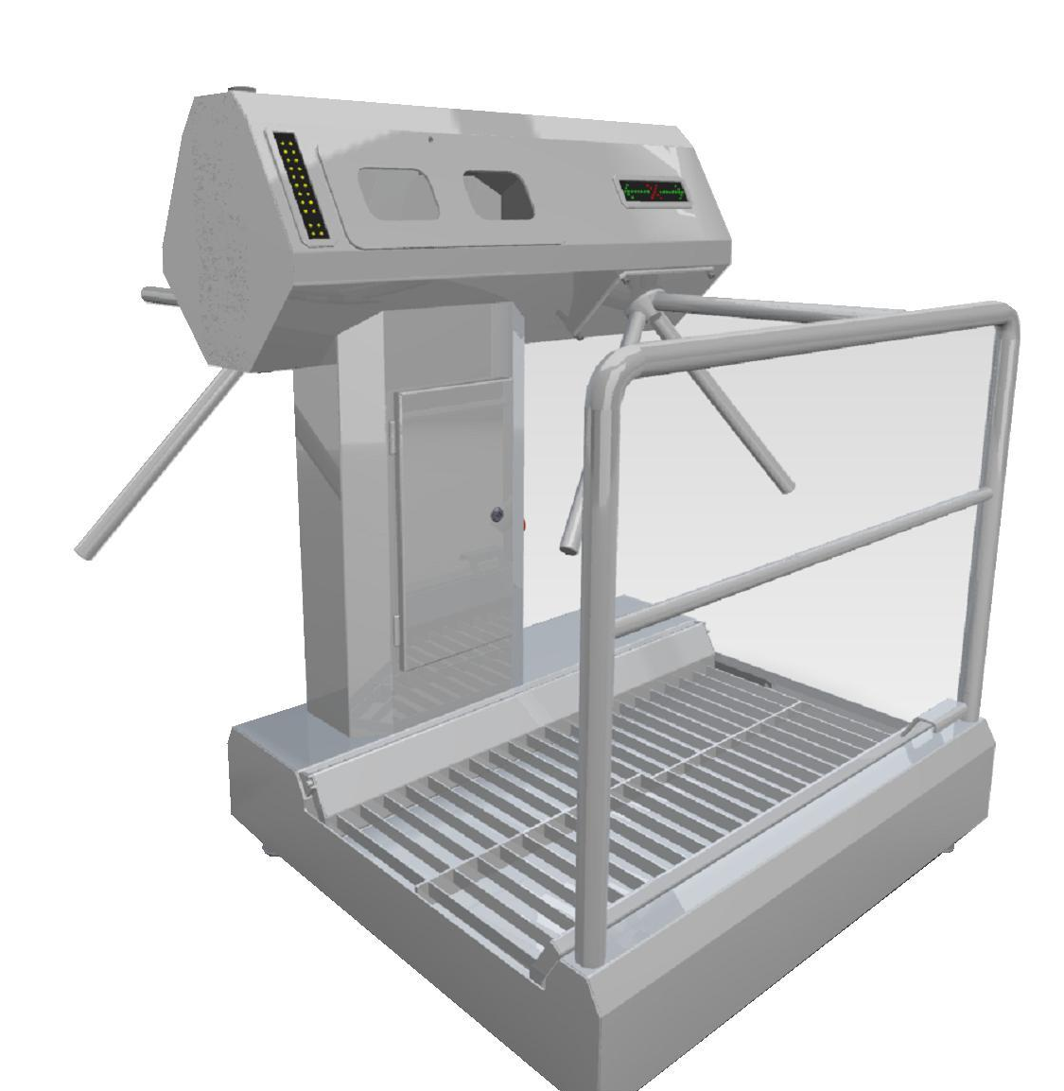
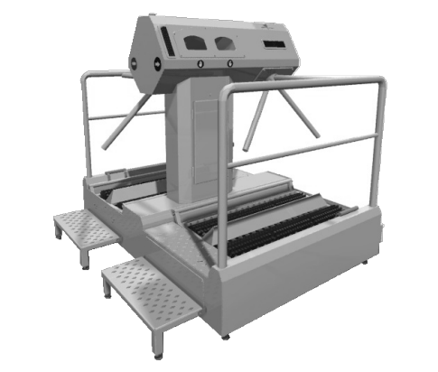

- Hygiene station (sanitary inspection rooms) for hands
Hand hygiene stations are designed for automatic no-contact sanitation of hands of the personnel before entering the restricted sanitary zone.
These stations can be produced in various modifications. At the customer’s request we can install the system for washing hands and hand drying. In the same way according to the customer’s requirements we can install access control card system, or to connect it to the existing access control system at the plant.
Work material--stainless steel AISI 304
Hygiene stations (sanitary inspection rooms) are equipped with master controller with programmable settings.
At the customer’s request the hygiene stations (sanitary inspection rooms) can be equipped with towel dispensers and rubbish bins.

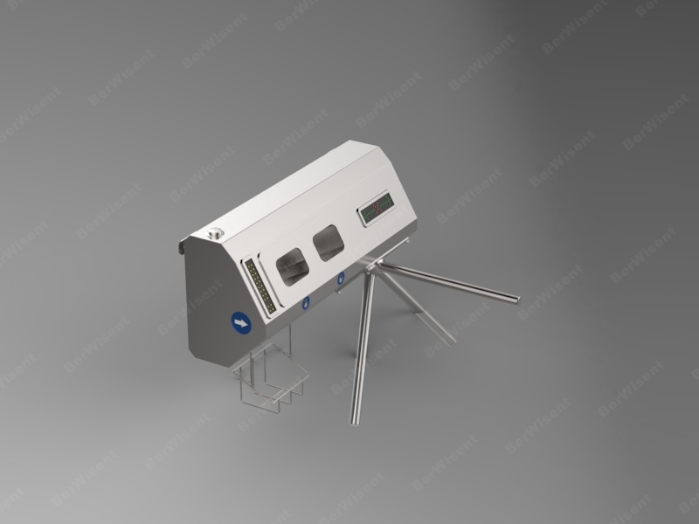

- Hygiene stations for footwear:
Hygiene stations for footwear are designed for manual or automatic washing and cleaning of staff footwear before entering (leaving) the sanitary zone.
Washing and cleaning of the footwear is done by the brush. Detergent is mixed with water and then is delivered onto the brush.
Material-stainless steel AISI 304

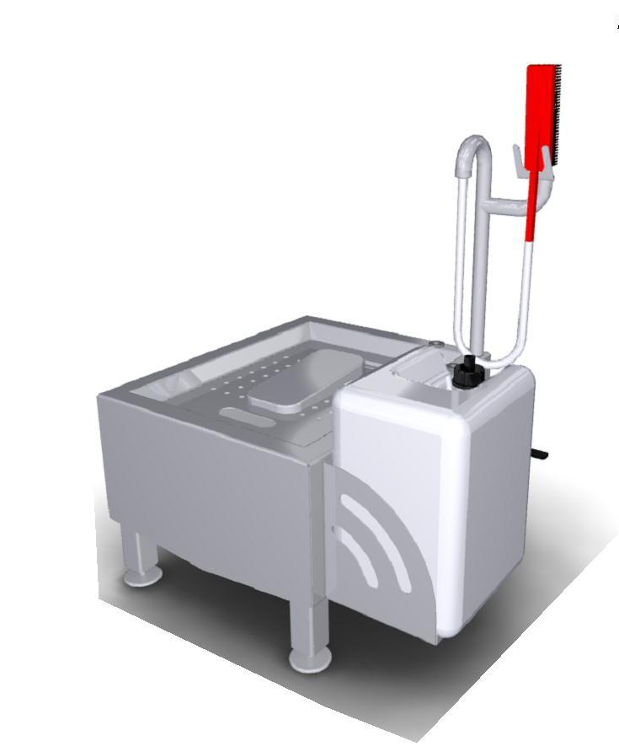

- Disinfection chambers:
Disinfection chamber is designed for sterile, compact and safe storage of tools (knives, axes, butcher steels, metal safety gloves).
Disinfection chamber is a chamber with a slanted top for easy cleaning. The tools are placed inside the cabinet in special grooves in specifically designed shelves. Sterile conditions are achieved by the working of bactericidal lamps. Bactericidal lamps are switched on after the activation of limit switches provided the doors are closed.
Work material--stainless steel AISI 304
We can manufacture models designed for different capacity.
Bactericidal lamp is included.

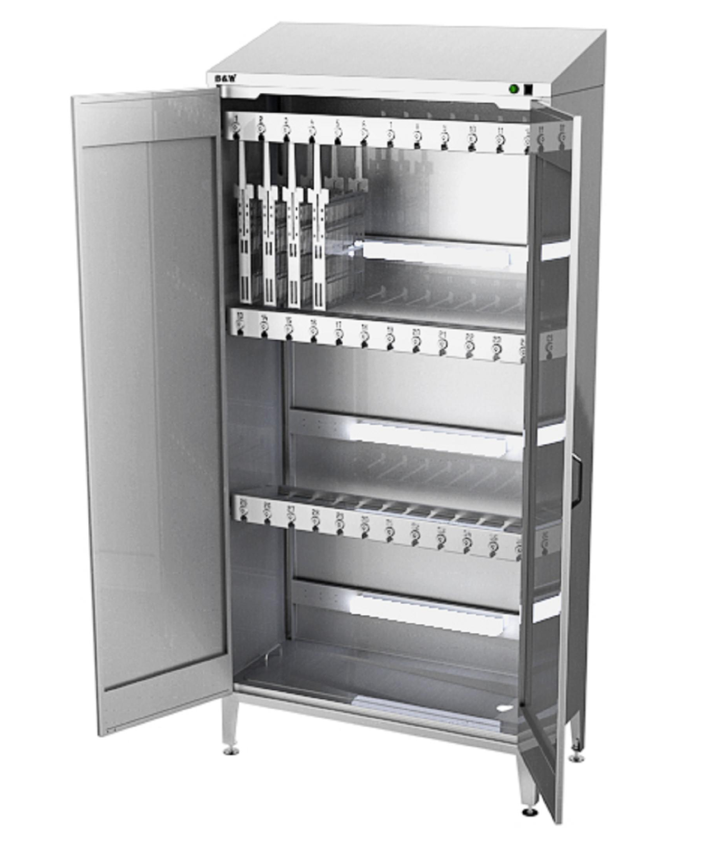
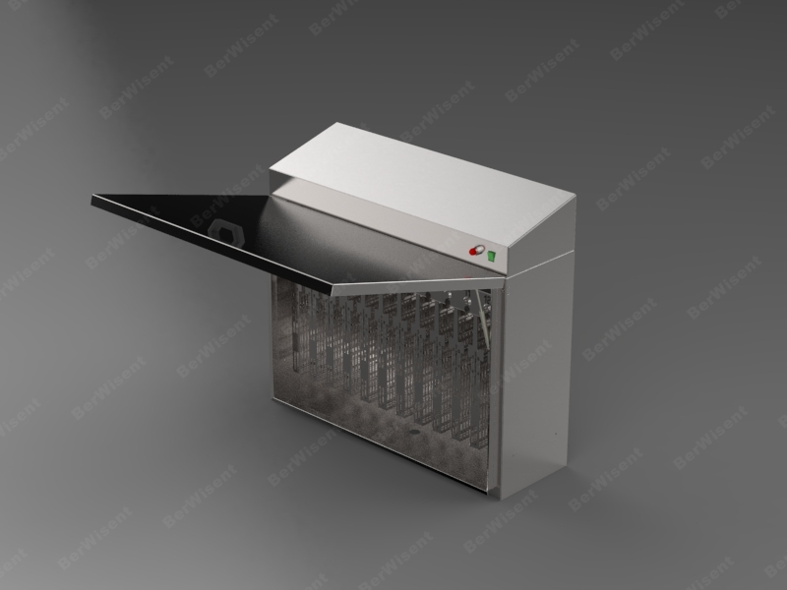
- Stands for washing aprons and footwear
The stand for washing aprons and footwear is designed for hand washing and cleaning aprons and footwear of the staff before leaving a sanitary zone.
Washing is done by a water pistol and brushes with water supply.
Work material--stainless steel AISI 304
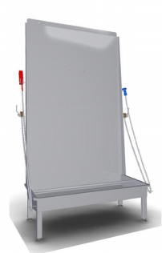

- Footwear dryer
Footwear dryer is designed for footwear drying and disinfection.
We produce both automatic dryers for footwear and simple (without forced air circulation). We can also manufacture dryers for different numbers of shoe pairs.
In automatic footwear dryer external cold air enters the frame of the dryer through the fan, is heated with an electric heater, and is then disinfected by the bactericidal lamp, and then moves through round tubes (jets) directly into the shoes thus ensuring highly efficient warm air drying and decontamination thanks to circulation throughout the inner part of the shoe.
Work material--stainless steel AISI 304

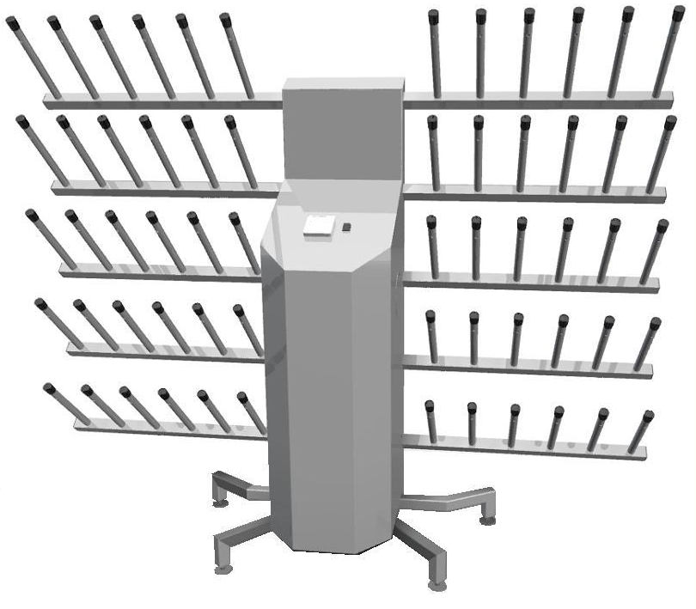

- No-touch washbasins
No-touch washbasins are designed to wash the personnel hands.
Washbasins can be equipped with a photocell or mechanical feed of the water supply (knee or foot type).
Depending on the customer’s request washbasins can include 1 to 6 sections. Available in the wall-mounted or the rack mode.
The set includes a faucet, a siphon and water hoses.
At the customer’s request water filters can be installed.
Work material--stainless steel AISI 304
Additionally equipped by elbow-operated hand sanitizer dispenser.
Additionally equipped by paper towel dispenser.
Additionally equipped by basket for used towels.
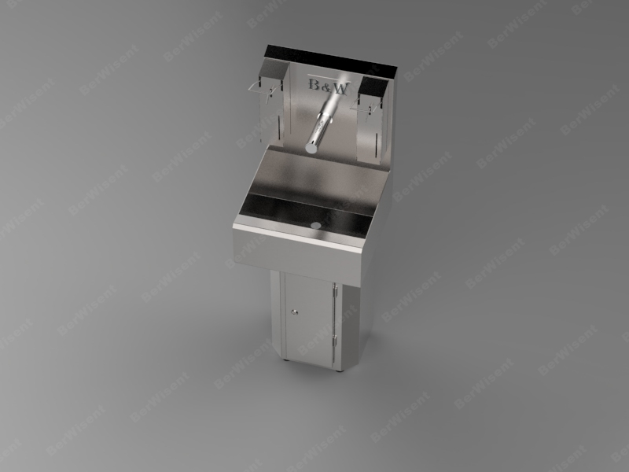
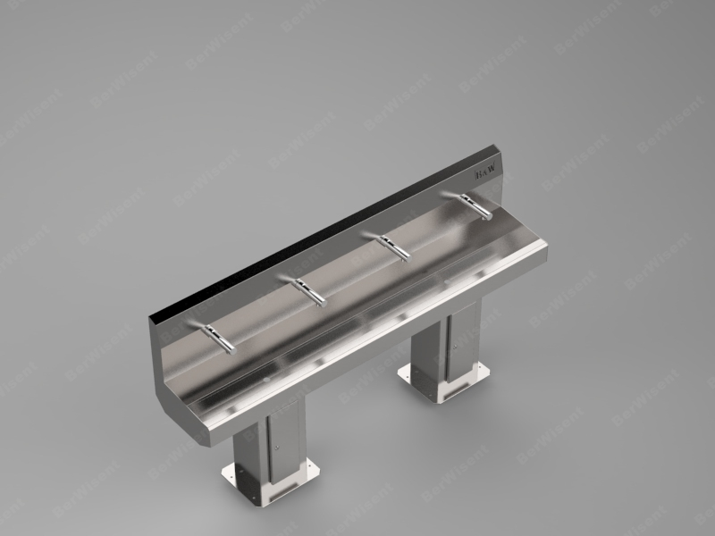

- Sterilizers
Sterilizers are designed for hot water sterilization of the knives and other tools used at the plants of food industry and catering.
The drain spout is provided in case the maximum water level is exceeded.
Sterilization temperature is maintained automatically by the digital controller. Additionally the body of the sterilizer has a pointer thermometer.
The sterilizer body has insulated walls.
Work material--stainless steel AISI 304
We manufacture wall-mounted mode.

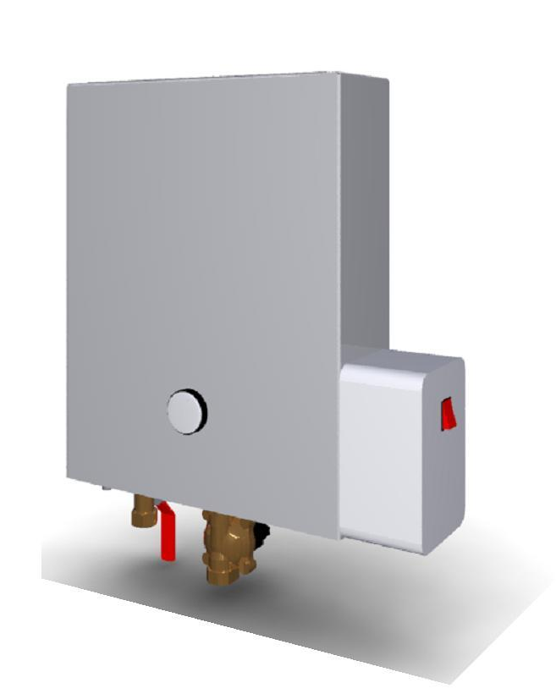

- By-products processing

- Cattle gut processing line:
The line represents the set of machines designed for automatic processing of cattle casings: emptying the raw intestine content, degreasing and eversion of the gut, slime removal.
The whole process is completed with the minimum staff required.
Each line is designed and customized individually based on the slaughter line performance at the given plant.
Work material--stainless steel AISI 304
The line is completed with recirculation systems for cold and hot water using steam or electric heating.
The line is equipped with centralized lubrication system.
At the customer’s request the line is completed with a wheel diversion.
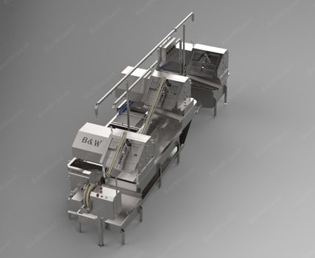

- Combined line for guts processing
The line represents the set of machines designed for automated processing of cattle, pigs and small cattle guts: emptying the raw intestine content, degreasing (cattle guts); outer tissues removal (pigs and small cattle casings); casing turning inside out (cattle), desliming.
The whole process is completed with the minimum staff required.
Each line is designed and customized individually based on the slaughter line performance at the given plant.
Work material--stainless steel AISI 304
The line is completed with recirculation systems for cold and hot water using steam or electric heating.
The line is equipped with centralized lubrication system.
At the customer’s request the line is completed with a wheel diversion.

The combined machines for casing processing of lower productivity are ideal for the plants with lower slaughter line capacity.
Unlike the full line machines, cattle, pig and small cattle gut processing on such machines is performed with significant staff involvement.
Combined machine for gut processing is designed to automatically deslime; degrease (cattle casings); remove the outer tissues (pigs/ small cattle casing), strip out the intestinal content (cattle).
Work material--stainless steel AISI 304
At the request of the customer:
The machine is equipped with recirculation systems for cold and hot water using steam or electric heating;
The machine is equipped with centralized lubrication system;
The machine is equipped with wheel diversion.

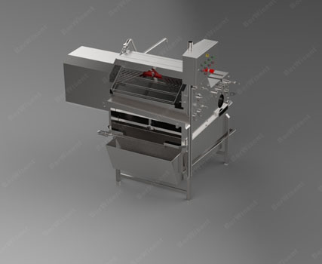

- Combined line for pigs and small cattle guts processing:
The line represents the set of machines designed for automated processing of pigs and small cattle guts: emptying the raw intestine content, desliming and outer tissues removal.
The whole process is completed with the minimum staff required.
Each line is designed and customized individually based on the slaughter line performance at the given plant.
Work material--stainless steel AISI 304
The line is completed with recirculation systems for cold and hot water using steam or electric heating.
The line is equipped with centralized lubrication system.
At the customer’s request the line is completed with a wheel diversion.

- Centrifuges for by-products processing:
- Centrifuges for processing paunches, omasums and abomasums:
This centrifuge is designed for processing paunches, omasums and abomasums.
The centrifuges for processing paunches, omasums and abomasums are represented in two types: for paunches, omasums, abomasums cleaning and for paunches, omasums degreasing.
Each centrifuge is individually designed according to the required productivity and other customer‘s requirements (manual loading, using
lifters of different types, lifting operated by pneumatic pistols, by different ways of unloading and transporting of the end product).
Centrifuges for processing paunches, omasums and abomasums are constructed according to different productivity and modifications (automatic, semi-automatic modes).
Centrifuges can be configured as free-standing units or as components of automated lines.
Work material--stainless steel AISI 304
Centrifuges are equipped with washing timer allowing you to customize the product processing time depending on the process.
Centrifuges are equipped with frequency converter for adjusting the rotation speed of the cleaning disc.
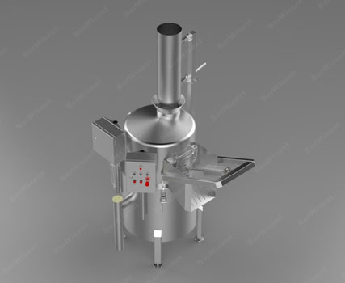

- Centrifuges for processing pig stomachs, bungs, rounds and rectums.
The centrifuges are designed for washing and desliming of pig stomachs, bungs, rounds and rectums.
Each centrifuge is individually designed according to the required productivity and other customer‘s requirements (manual loading, using
lifters of different types, lifting operated by pneumatic pistols, by different ways of unloading and transporting of the end product).
Centrifuges for processing pig stomachs, bungs, rounds and rectums can be constructed depending on the required productivity and configuration (automatic, semi-automatic modes).
Centrifuges can be configured as free-standing units or as components of automated lines.
Work material--stainless steel AISI 304
Centrifuges are equipped with washing timer allowing you to customize the product processing time depending on the process.
Centrifuges are equipped with frequency converter for adjusting the rotation speed of the cleaning disc.

- Centrifuges for processing haired by-products
Centrifuges for processing haired by-products are designed for washing and dehairing of cattle feet, cattle brow skin, pigs heads, pigs ears and tails.
By-products are dehaired as they rub against the equipment working surface.
Work material--stainless steel AISI 304
Centrifuges are equipped with washing timer allowing you to customize the product processing time depending on the process.
Centrifuges are equipped with frequency converter for adjusting the rotation speed of the cleaning disc.
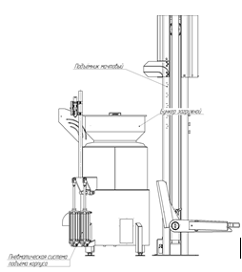

- Centrifuges for cleansing and shredding by-products
Centrifuges for cleansing and shredding of by-products are designed for processing intestine bags residues.
Residues of intestinal bags are charged into the machine where they are blade cut and cleansed with water.
Centrifuges for cleansing and shredding of by-products can be constructed depending on the required productivity and configuration (automatic, semi-automatic or manual modes).
On customer’s request they can be equipped with pneumatically operated conveyor or pneumatic pump for the processed products removal.
Work material--stainless steel AISI 304
Centrifuges are equipped with washing timer allowing you to customize the product processing time depending on the process.
Centrifuges are equipped with frequency converter for adjusting the rotation speed of the cleaning disc.
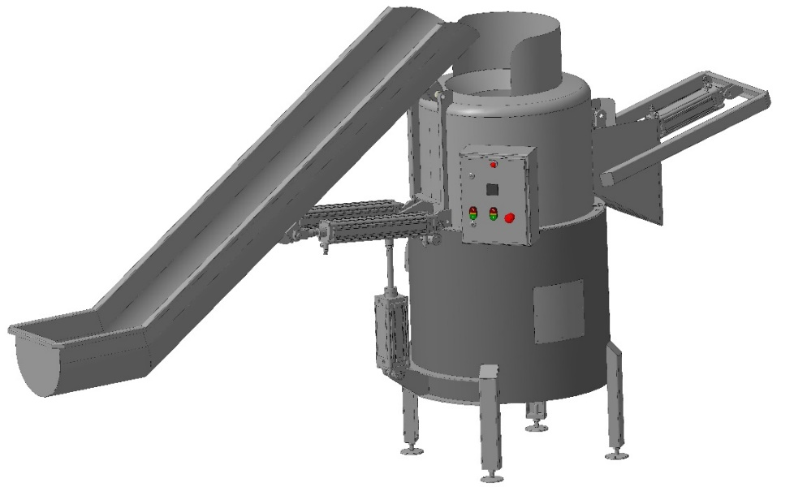

- Head-cutting machines
Head-cutting machines are designed for splitting cattle and pigs heads in two halves so that the brain remains intact.
The machine blade is driven by hydraulic mechanism.
For the staff’s safety matters the starting of the machine is done by simultaneously pressing the two buttons located at the both sides of the machine housing.
Work material--stainless steel AISI 304
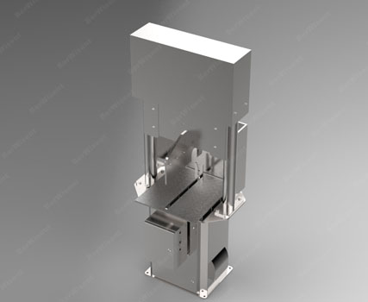

- Equipment for calibration, measuring and salting of casings:
- Semi-automatic calibration table
Semi-automatic calibration table is designed for calibration of pigs, cattle and small cattle casings according to the diameter.
The table is equipped with a pull-in wheel with adjustable speed, a calibration block and a crane.
To determine the caliber the casing is filled with pressurized water.
Casings diameter is measured every 2 meters by inserting the water-filled intestine into the notch of the calibration device.
In places where one caliber ends and another one begins or damage to shell casings is detected the casing is cut into pieces neatly trimming the ends of the intestine.
Work material--stainless steel AISI 304

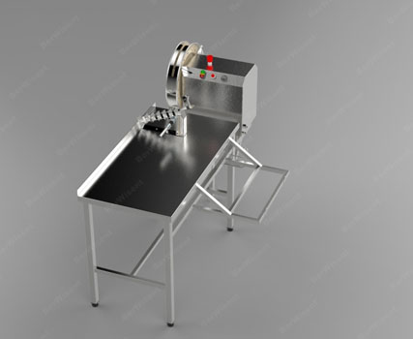
- The casing length measuring machine
The machine is designed for measuring the casing length of cattle, small cattle and pigs.
The machine has two counters: strips counter and length counter. The length counter is programmed to specified length making the machine stop as the required length is reached.
There is an option of adjusting the rotation speed.
Work material--stainless steel AISI 304
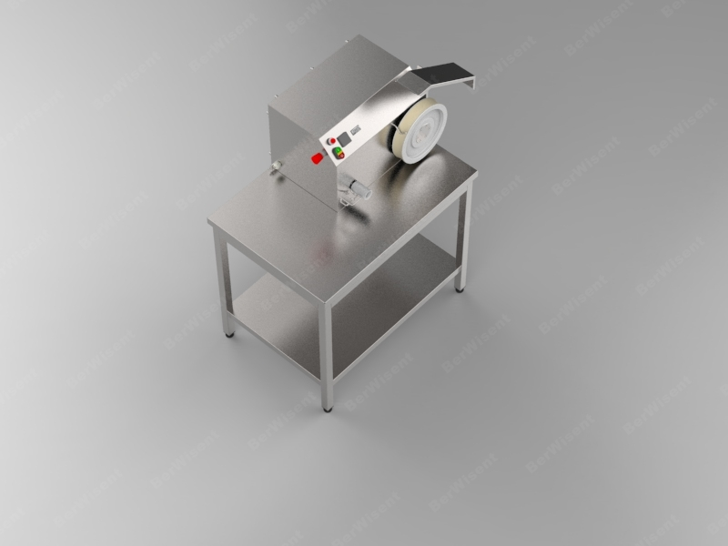

- Casing tubing machines
Casing tubing machine is designed for automatic spooling (tubing) of casings on special tubes.
Handling the casing shirred speeds up the production process when making sausages and reduces the operator’s fatigue thereby enhancing production figures.
Work material--stainless steel AISI 304
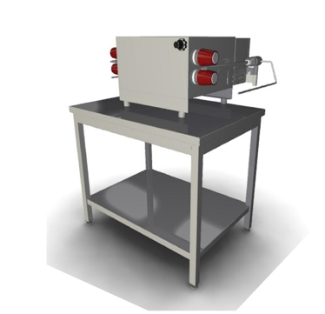

- The casing salting machine
The casing salting machine is designed to salt the casing. The machine consists of the salting table on the edge of which there is a special device for separating intestines (which prevents them from being tangled while salted) and the pulling device which captures the casing and pulls it along the salt-covered table.
Work material--stainless steel AISI 304

- The casing salting and bundling machine
The casing salting and bundling machine is designed for salting and bundling of the casing. The casing salting and bundling machine is designed for salting and bundling of the casing. The machine consists of the salting table and the edge of which there is a special device for separating intestines (which prevents them from being tangled while salted) and the spooling device which makes bundles of casings which are then tied.
Work material--stainless steel AISI 304

- Automatic packaging washing machines

- Boxes washing machines
Boxes washing machine is designed for automated washing of reusable boxes.
Effective box washing is done due to high pressure detergent solution delivery through the surface directed nozzles. Detergent solution and water heating is done out by electric heater or steam.
Suitable for various kinds of plastic boxes.
Each machine is manufactured in close consultation with the customer and the required productivity. The machines are additionally completed with the airflow system as well as the system of forced ventilation or the system of return of packaging to the operator.
Material of production -stainless steel A304.
Automatic maintenance of the water level (washing solution) in the washing and rinsing tank.
Automatic maintenance of water temperature (washing solution) with digital regulation.
Dual water filtration system (washing solution) for later use.

- Transport trolleys washing machines
Transport trolleys washing machine is designed for automatic washing of various kinds of trolleys and Big Boxes.
Effective trolley and box washing is done due to high pressure detergent solution delivery through the surface directed nozzles. Detergent solution and water heating is done by electric heater or steam. Detergent solution and water heating is done out by electric heater or steam.
Each machine is manufactured in close consultation with the customer and the required productivity. We can also manufacture the machines for simultaneous washing of trolleys and Big Boxes.
Work material--stainless steel AISI 304
Automatic maintenance of the water level (washing solution) in the washing and rinsing tank.
Automatic maintenance of water temperature (washing solution) with digital regulation.
Dual water filtration system (washing solution) for later use.
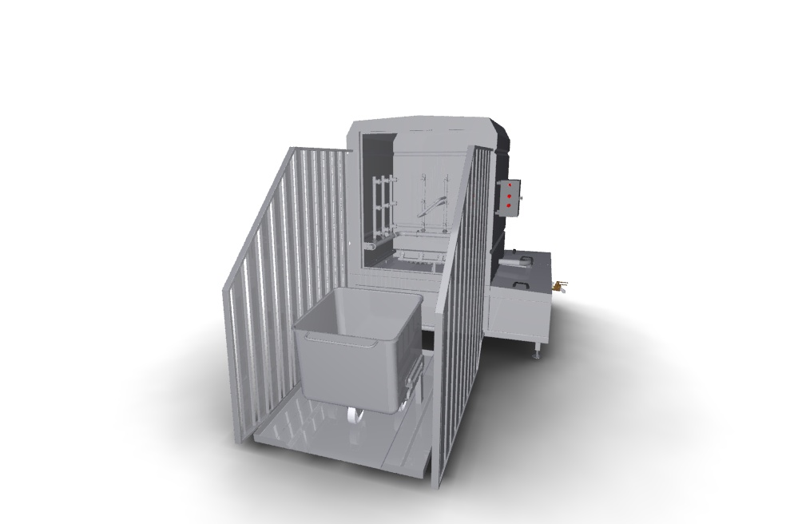

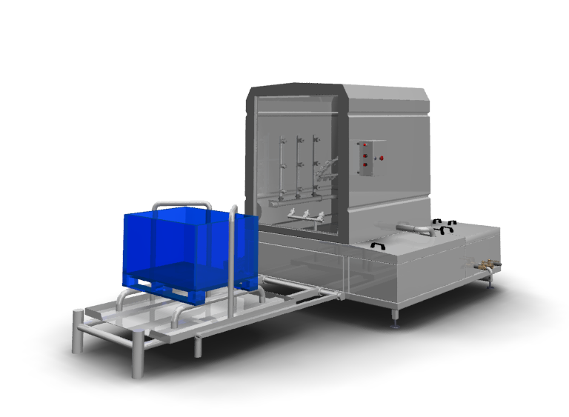

- Palettes washing machine
Palettes washing machine is designed for automatic washing of palettes.
Effective palettes washing is done due to high pressure detergent solution delivery through the surface directed nozzles. Detergent solution and water heating is done out by electric heater or steam. They are optionally equipped with the airflow system.
Work material--stainless steel AISI 304
Automatic maintenance of the water level (washing solution) in the washing and rinsing tank.
Automatic maintenance of water temperature (washing solution) with digital regulation.
Dual water filtration system (washing solution) for later use.

- Trolleys washing machines
Trolleys washing machine is designed for automatic washing of trolleys.
Effective trolley washing is done due to high pressure detergent solution delivery through the surface directed nozzles. Detergent solution and water heating is done out by electric heater or steam.
They are optionally equipped with the airflow system.
Work material--stainless steel AISI 304
Automatic maintenance of the water level (washing solution) in the washing and rinsing tank.
Automatic maintenance of water temperature (washing solution) with digital regulation.
Dual water filtration system (washing solution) for later use.

- Sewer systems

- Sewer traps
Sewer traps are designed to collect and discharge wastewater to the sewer.
Sewer traps are manufactured with various outlet directions (vertical, horizontal) and with different dimensions. The traps are equipped with devices for trapping impurities; with hydroseals and grids (mesh, slotted or grooved).
Work material--stainless steel AISI 304
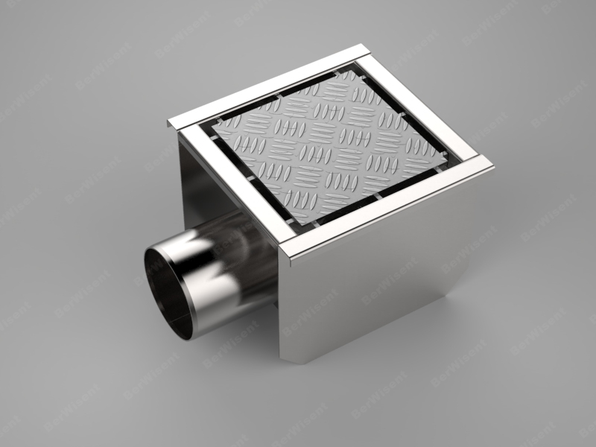

- Slotted trays
Slotted trays are designed to receive and discharge wastewater to the sewer. The slotted trays represent a simplified drainage system without bars or elements covering the channel. Slotted trays are used in facilities that require continuous drainage of a small amount of water.
We manufacture slotted trays of various dimensions and types depending on the customer’s requirements.
Work material--stainless steel AISI 304

- Sewer trays
Sewer trays are designed to receive and discharge wastewater to the sewer.
We produce sewer trays of various dimensions and types depending on the customer’s requirements.
Trays are equipped with adjustable legs to adjust the level.
Work material--stainless steel AISI 304

- Sewer grates
Sewer grates are designed to protect the sewer network from extraneous objects thus enabling the safe operation of sewer systems.
We manufacture sewer grates of various dimensions and types depending on the customer’s requirements.
Work material--stainless steel AISI 304

- Technological equipment

- Cabinets and stands:
- Multi-purpose stand
The stands are designed for storing, warehousing of raw materials, equipment, supplies and so on.
We manufacture stands of various configurations: floor-standing, wall-mounted, mobile, press-towers.
We produce stands with various shelves and racks configurations. We project the dimensions and loads according to the technical specifications provided by the customer.
Work material--stainless steel AISI 304

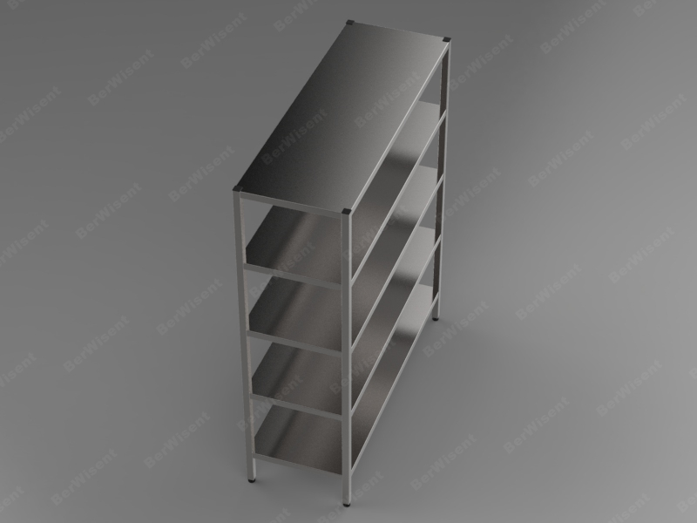
- Wardrobe racks
Wardrobe racks are designed to store the clothing and personal belongings of the staff.
We manufacture the wardrobe racks of different modifications: one- or multi-sectional, open, closed, with bench seat, with a grate for shoes.
Work material--stainless steel AISI 304
Each compartment is equipped with an individual lock.
Material of benches-polyamide.
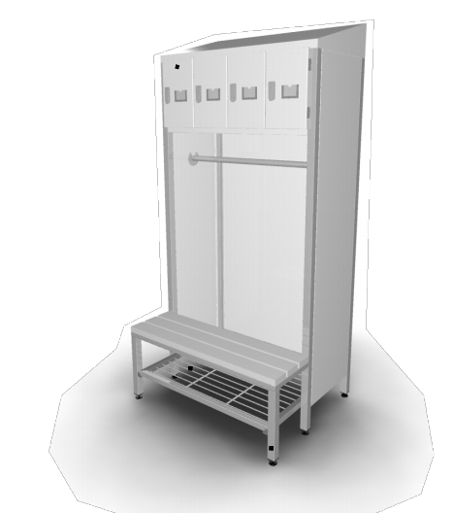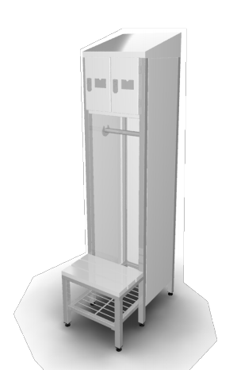

- Cabinets for cleaning equipment storage
Cabinets are designed to store the cleaning equipment, clothes and disinfectants.
We manufacture the wardrobe racks of different modifications: one-multi-sectional, open, closed, etc.
Work material--stainless steel AISI 304

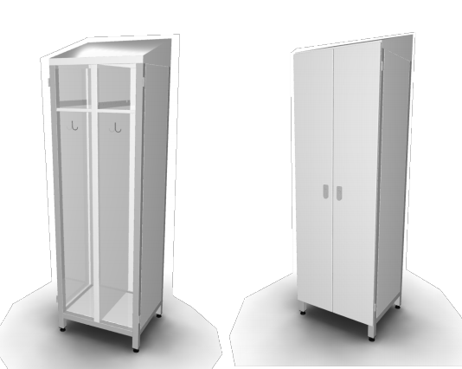

- Closets for storage
The closets are designed to store the personal belongings of the staff and they feature the cabinets divided into single cells each provided with an individual lock.
The number of cells in a closet can vary from 10 to 20.
Work material--stainless steel AISI 304

- Closet for dirty clothes
The closet for dirty clothes is designed for collecting used dirty clothes and it represents the cabinet with an upper hinged door (for dirty clothes loading) and the door for unloading clothes below.
Work material--stainless steel AISI 304
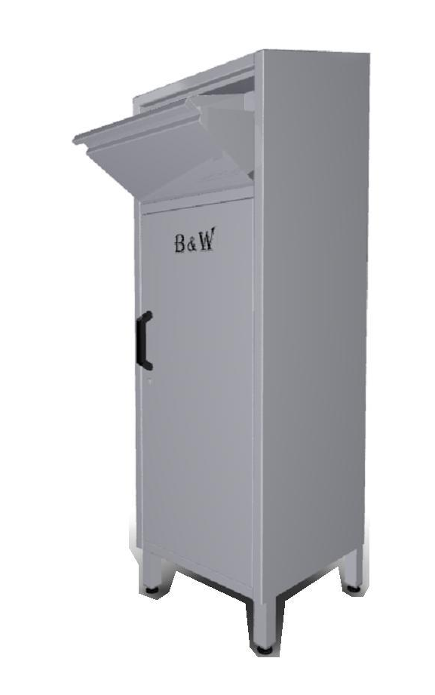
- Transportation carts:
- Wheeled hand carts
Wheeled hand cart is designed for the manual loads transportation in food industry.
Work material--stainless steel AISI 304
Wheel material-rubber or polyamide.
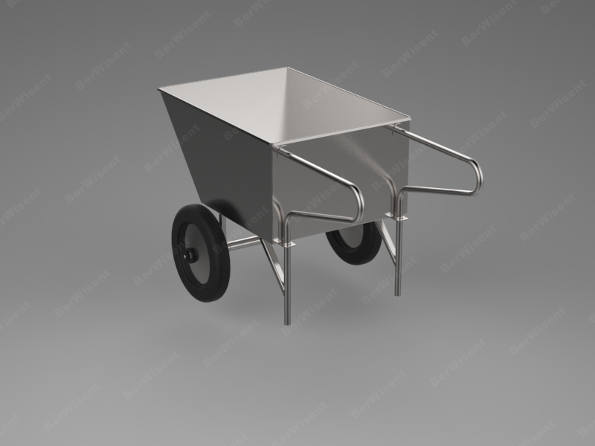

- Wagon cart
Wagon cart is designed to transport raw materials and products in food industry.
We can manufacture carts of various capacity and other configuration modes on customer’s request.
The carts are additionally completed with the lid.
Work material--stainless steel AISI 304
Wheel material- polyamide.
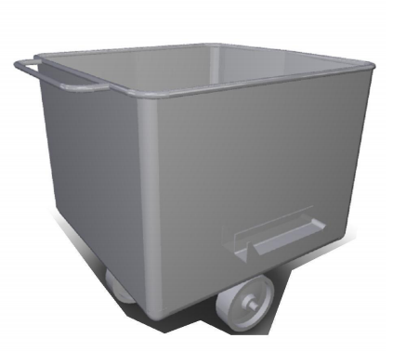

- Carts for boxes transportation
The carts are designed to transport and warehouse the processing vats.
The carts are equipped with handles for transportation.
Work material--stainless steel AISI 304
Wheel material- polyamide.

- Working tables:
- Deboning and sorting tables
The tables for deboning and sorting are designed to debone, sort and further process raw meat.
We manufacture tables of various configurations (shelves, tabletops materials etc.) and dimensions to fit customer’s needs.
Work material -- stainless steel AISI 304, polyamide.
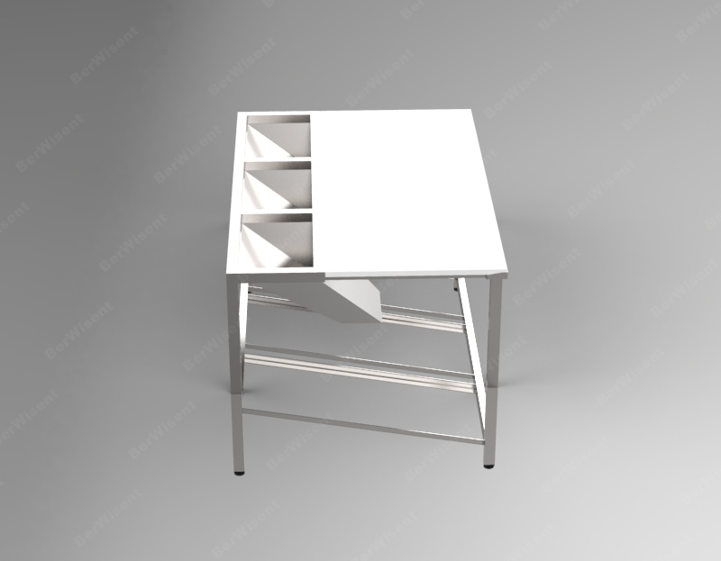

- Working table
Working tables are designed for separating/cutting, sorting and processing of raw materials and products in food industry.
We produce tables of various configurations (shelves, various materials for tabletops, upstands on countertop etc.) and dimensions according to the technical specifications provided by the customer.
Work material -- stainless steel AISI 304, polyamide.

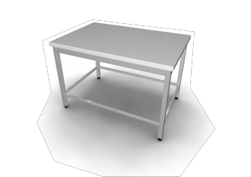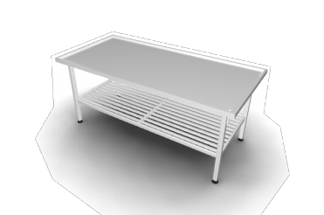
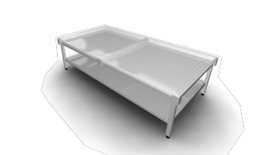

- Molds and smoking frames:
- ‘Z’-shaped smoking frames
‘Z’-shaped smoking frames are designed to transport and cure meat products in smoking chambers.
Various configurations and number of shelves are available.
Work material--stainless steel AISI 304
Wheel material- polyamide.
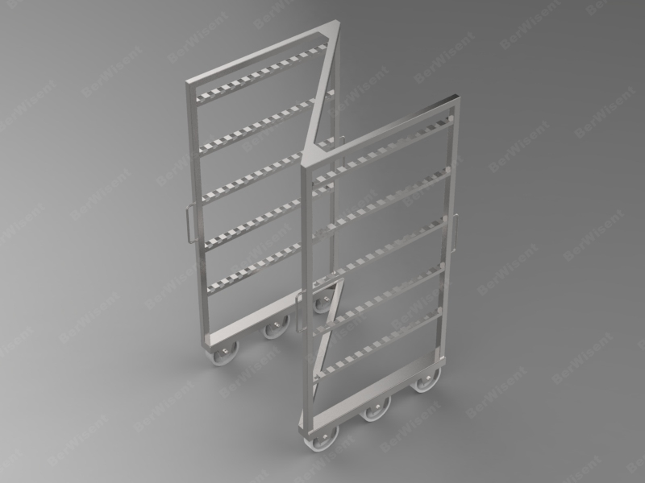
- ‘H’-shaped smoking frame
‘H-shaped smoking frames are designed to transport and cure meat products in smoking chambers.
Various configurations and number of shelves are available.
Work material--stainless steel AISI 304
Wheel material- polyamide.
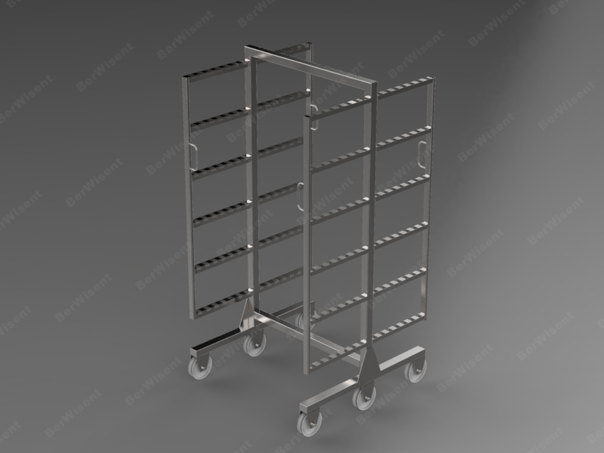

- Press-towers for smoking
The press towers for smoking are designed for cooking meat products in heat-chambers by keeping them under pressure of molds with meat products.
By operating mode the press-towers are divided into mechanic and pneumatically operated ones.
We offer press-towers of different configuration to fit the customer’s needs.
Work material--stainless steel AISI 304
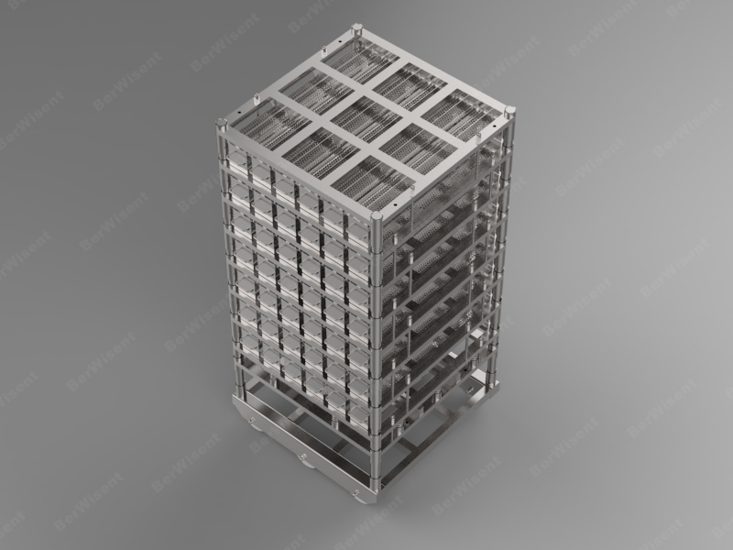

- Molds for meat
The molds are designed to mold the end product while processing.
All molds are manufactured to customer's specifications and can be of different dimensions with various perforation patterns.
Work material--stainless steel AISI 304

- Washing tubs:
- Single-section washing tubs
Single-section washing tubs are designed for washing tools, equipment, food etc. in food industry and public catering.
The tubs are manufactured to customer's specifications. The tubs are available in various configurations and features.
Work material--stainless steel AISI 304
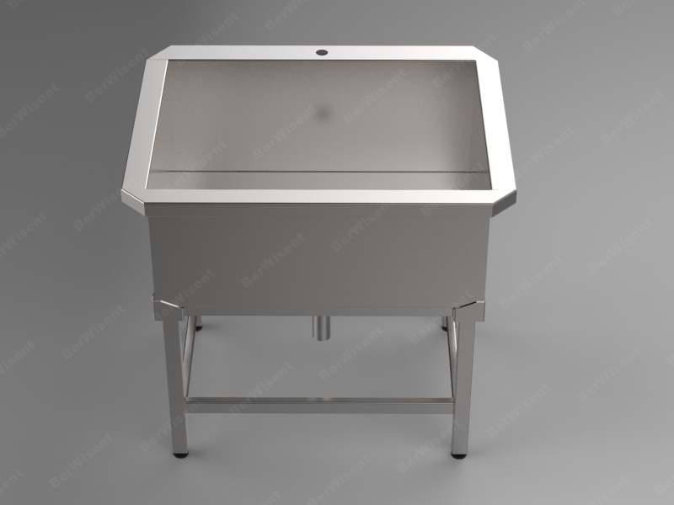

- Multi-section washing tubs
Multi-section washing tubs are designed for washing tools, equipment, food etc. in food industry and public catering. The number of sections can be specified by the customer. The tubs are available in various configurations and features.
Work material--stainless steel AISI 304
- Process tubs
The process tub is designed for temporary storage and warehousing of raw materials and end products.
We can manufacture tubs of various dimensions and shapes.
Work material--stainless steel AISI 304

- Baskets for tools, hoses holders and others:
- Baskets for knives
The baskets for knives are designed for transportation and sterilization of knives in hot water and sterilization of butcher steels in sterilizers.
Work material--stainless steel AISI 304
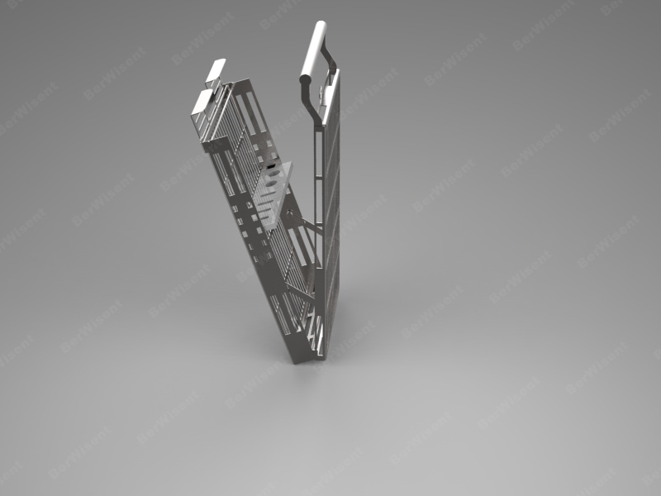
- Tool baskets
The tool baskets are designed for transportation and hot water sterilization of special tools in sterilizers.
Work material--stainless steel AISI 304

- Pad holder for hose
Pad holder for hoses is designed to safely place and store hoses.
Work material--stainless steel AISI 304

- Garbage bags racks
Mobile garbage bags rack is designed to place garbage bags.
We manufacture mobile and stationary modes – with cover and no-cover racks.
Work material--stainless steel AISI 304
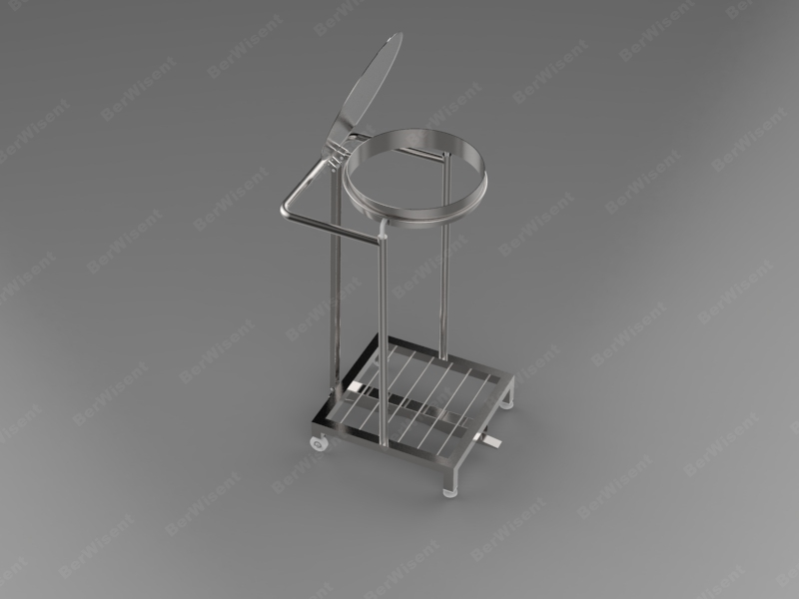

- Elbow-operated dispenser
Elbow-operated dispenser is designed to dispense detergents (soap) and disinfectants. Dispensing is done by pressing the stick by the elbow.
Work material--stainless steel AISI 304

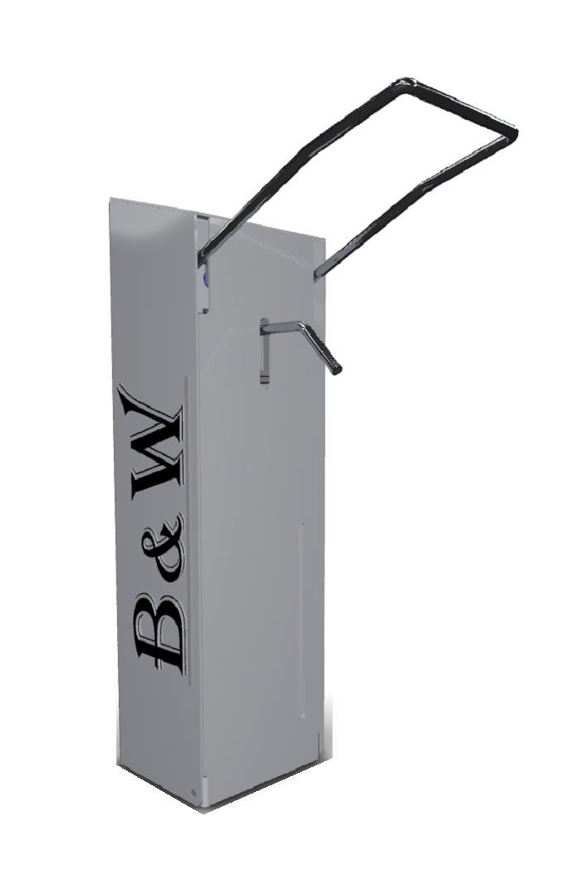
- Multi-purpose holders
Multi-purpose holder is designed for the storage and delivery of disposable hygiene items (paper towels, disposable caps, gloves, etc.)
Work material--stainless steel AISI 304
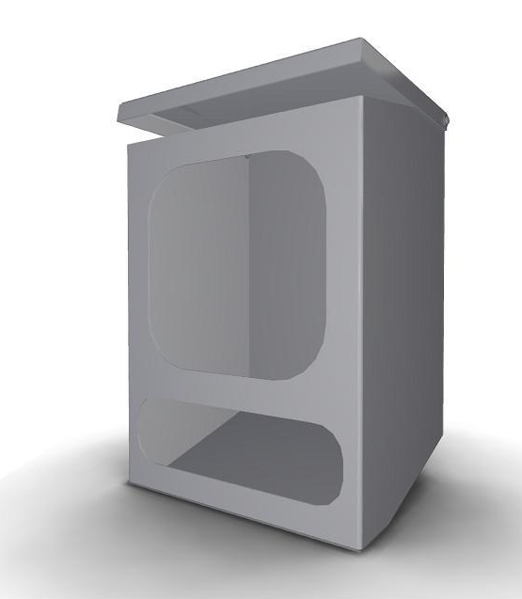
.

Our address:
37 Warshavskoye Highway, Brest, 224003, Belarus

Contacts:
Director: Dmitry Karpovich + 375 33 900 81 76 + 375 162 51 51 79
Marketing Director: Pavel Rayevsky +7 911 766 64 32 + 375 29 236 32 47
Deputy Director: Dmitry Saharchuk + 375 29 521 20 61
Sales Department: +375 (33) 371 67 85 +375 (33) 371 56 17 +375 (162) 51 71 78

