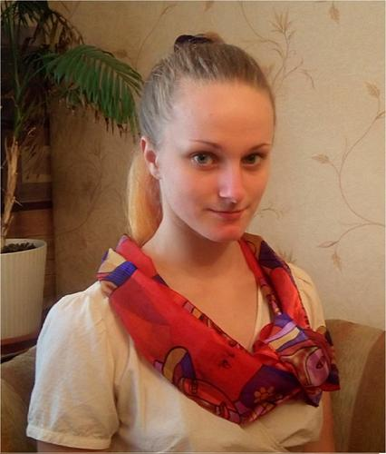Bakhvalova Anastasiya
translator

Personal date:
DOB: 23/08/1996
Address: 13 Kosmonavtov St,
Moscow, Russian Federation
Mobile phone: +79859921480
Email: asya.bakhvalova@yandex.ru
Languages: Russian- Native
German- Advanced
English- Pre-Intermediate
Spanish- Beginner

Objective:
Early career translator, 2 years worked with Germany native speaker. To obtain a job focusing in Personal Services, Entertainment and Media, Humanities, Community and Public Service or Technology.
Education:
2014-2018 Moscow State Pedagogical University, the chair of Roman and Germanic languages of humanitarian faculties, linguistic, theory and methods of teaching foreign languages and cultures. First language is German and the second is English.
Additional education:
2015 Spain, Barcelona, Language school BCN LIP, Spanish
2012-2014 Saint Petersburg City Palace of Youth Creativity, interpretation of literary text
Professional experience:
2014-2016 Embassy of the Federal Republic of Germany Moscow, German School Moscow, kindergarten, student assistant
Duties: communication, with children, parents and command only of Germany. Plays, creative activities, reading with children, preparation for festive events and excursions. Support for the kindergartner during the day, sometimes I toke the place of her (in group to 15 children).
2016 russian-german family, baby-tender
Duties: walks, plays, crafts with 2 boys (4 and 7 years old), native German speakers
2015 family, baby-tender by bilingual child
Duties: preparation of games and scientific experiments for boy (5 years old). His first language is German and second is Russian.

Key skills and competitions:
Able to fluently speak German
Excellent communication and social skill
Very high speed of reading (I was winner of speed reading competition at school )
Able to learn, I’m incredibly inquisitive
Positive thinking
Purpose
Creativity
Abstainer and non-smoker

Interests and hobbies:
Russian and world literature, the actor’s art( more 7 years), foreign languages, backpacking, trekking, water activities, area study, travel.
I am interested in bilingualism and original methods of teaching and studying foreign languages.

