Is it legal to download movies? Piracy alternative

In many countries piracy is outlawed. Illegal downloading from Internet is a crime. Nevertheless, every month more than 400 million people worldwide download pirated files while committing violation of intellectual property. According to statistics, every 4th inhabitant of Europe, Asia or North America is a pirate.
Mostly people are aware of the illegality of downloading material from file-sharing sites, but they doubt torrents are the same. It was felt that torrent clients, such as U-Torrent, are in law, because nobody can track that’s you have downloaded the file. Indeed, the torrent file is just a list of trackers and hash codes, nothing more. It is impossible to prove that it was specific person. But are you sure that you remain anonymous?
Scarcely. That’s because your actions in torrent client are managed by a decentralized list of servers. Many people are seeding a file and you download a little bit from everyone. Government can monitor the torrent network and determine your IP-address on the list of peers.
However, the problem is not in the torrent protocol, it is in content you download. But there is no guarantee that your address is being protected from government surveillance.
There are some websites in Internet where you can stream movies legally. If you prefer to download, we also have something to show and offer to your attention 3 useful Internet recourses:
1. The Internet Archive
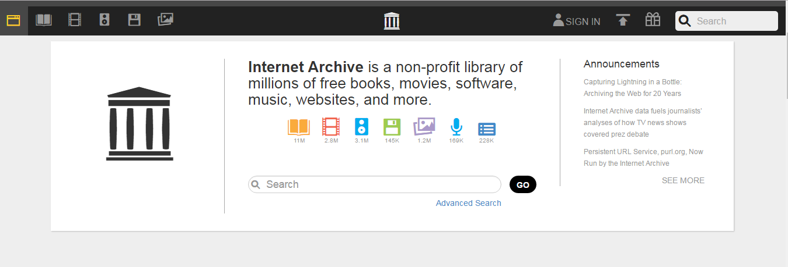
Here you can download movies for free. The main feature of this service is not only streaming but also watching movie on your device without having access to the Internet. Here you will find more than 2.8 million videos.
There is the ability to do genres and collections searches. Most of the videos are short videos or documentaries, but you can browse the sub-collections to find full-length movies more quickly. Click Feature Films and choose the genre you are interested in.
Almost all of the available video formats are supported by the standard video player on your computer. All content on the site is 100% legal.
2. FMD.net
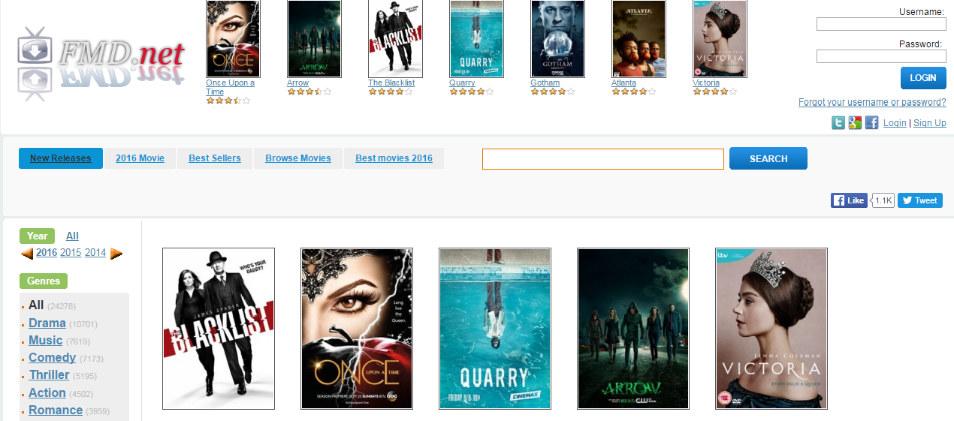
This site has a large collection of movies that you can buy and download legally, regardless of your residence. Main advantages of the resource are user-friendly interface and search function. It’s very simple to find the movie you need. On the top panel convenient tabs are located that make the search easier for an ordinary user.
About 25 thousand movies in HD quality are waiting for you. Drama, music, comedy, thriller, action, romance, horror, crime and other genres are represented here. Available formats are DVD, 3D, VHS, MP4, AVI, UMD and digital.
Database of this online cinema is constantly updated with new titles. If you can’t find the film you need, it will appear a little later.
3. Crackle
Crackle was created by Sony and is intended for free streaming. Service supports a variety of iOS, Android, WP devices, as well as Smart TV.
It is necessary to sign up to enjoy it fully. You are able to create watchlists and receive appropriate recommendations in your personal account. Streaming is free, but you should to view advertising and commercials as the nominal fee.
You can download movies from sites mentioned above legally, but remember such things:
- Do not redistribute the content without owners permission, keep it for personal consumption only;
- Do not modify downloaded content;
- Do not post a movie in your own name account on Youtube, Vimeo or other social networks that have video posting function.
So, you will be a law-abiding citizen while following these rules. Be like people from Japan, New Zealand and USA – piracy in these countries reaches less than 20%. But still, there are 71060 jobs lost in the United States every year due to online piracy. Take thought and download a movie legally.

