Оригинал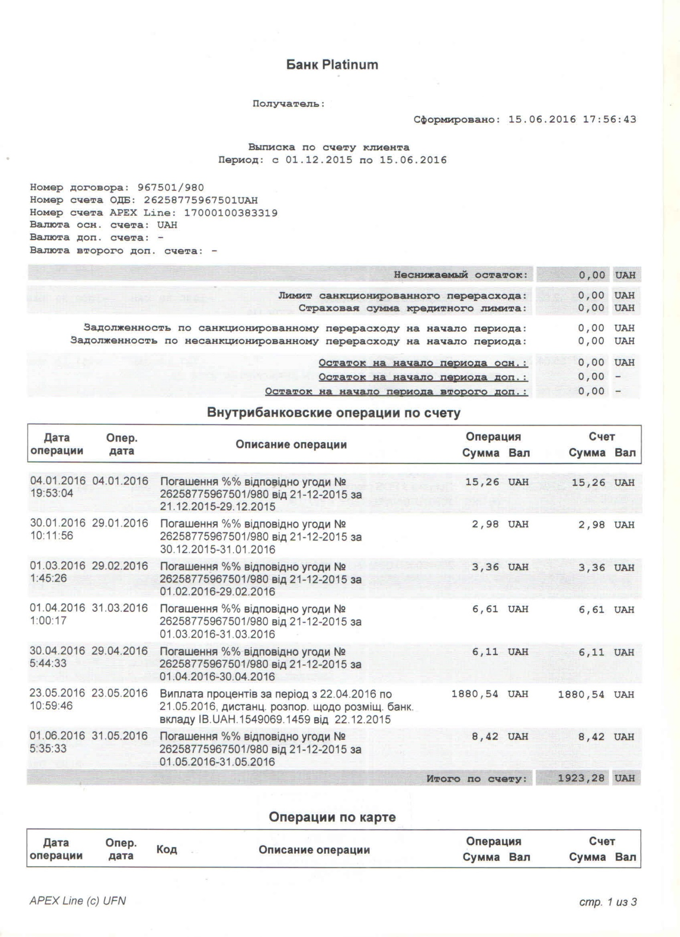
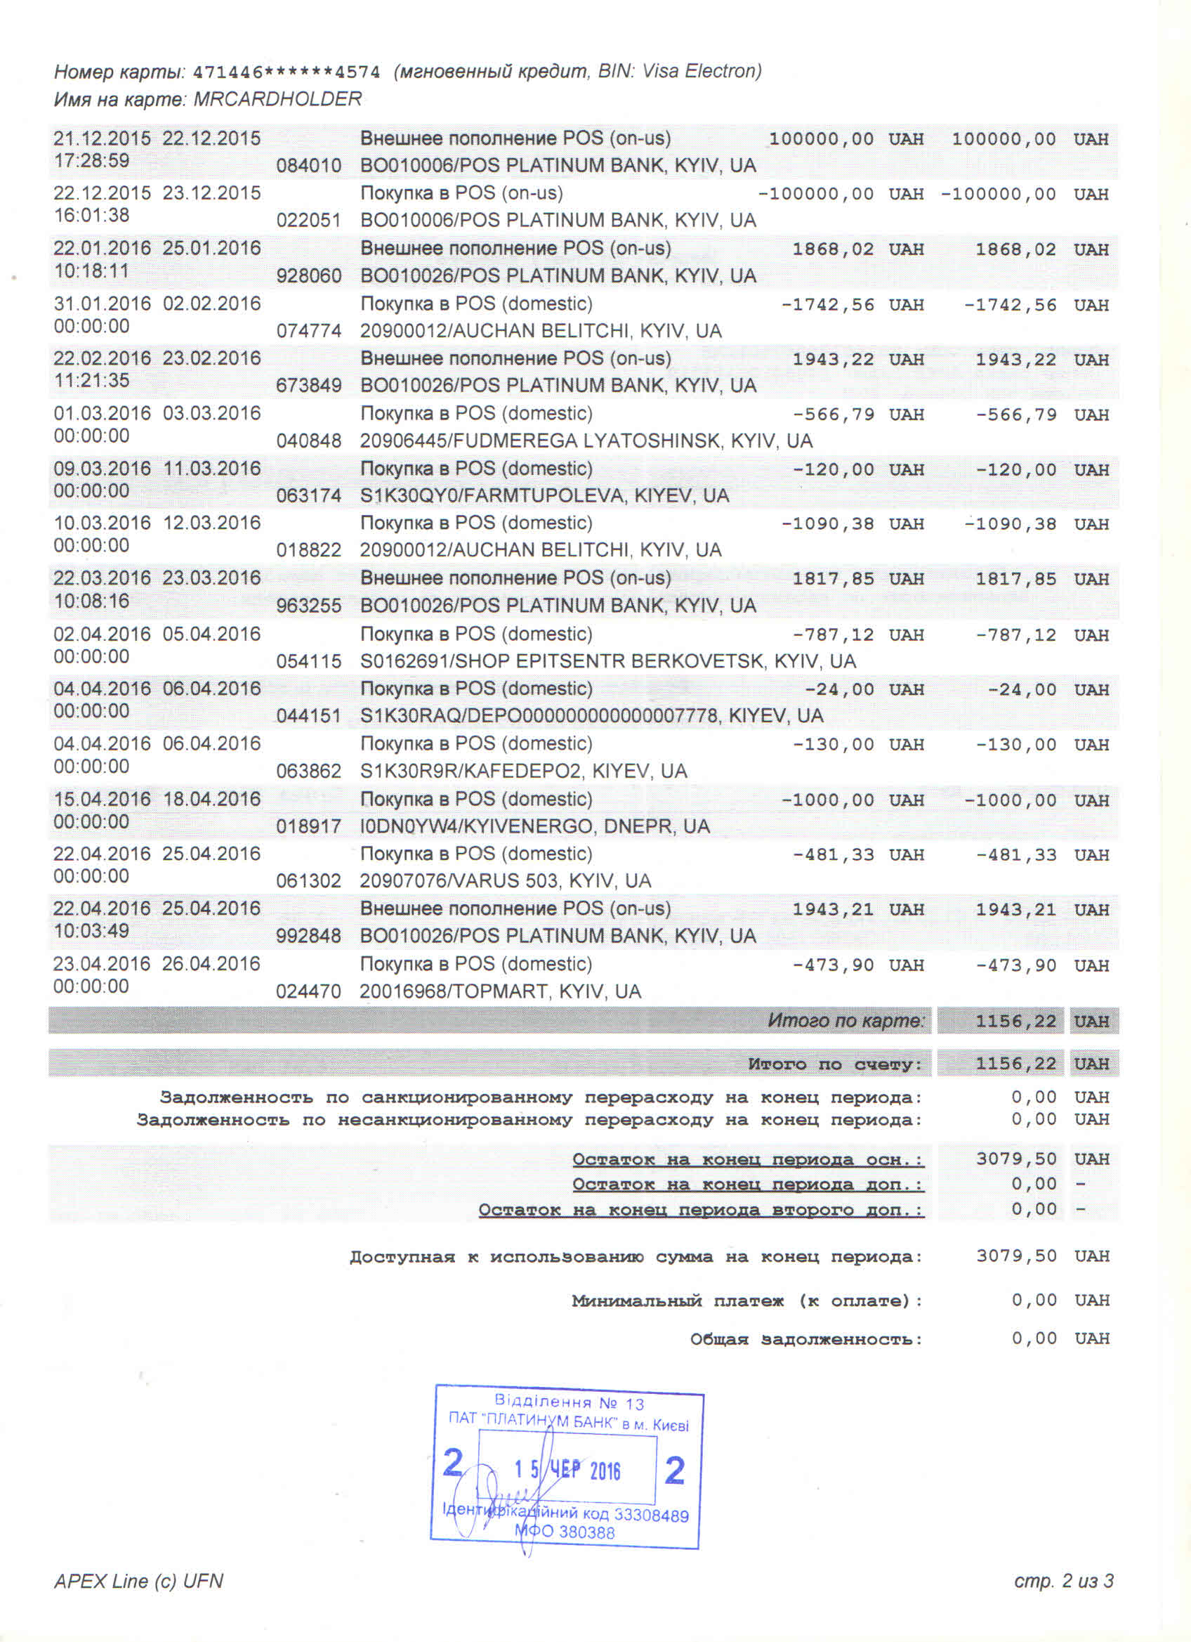

Перевод

Platinum Bank
Recipient:
Formed on: 15.06.2016 17:56:43
Personal account statement
Period: from 01.12.2015 to 15.06.2016
Agreement number: 967501/980
OBD account number: 26258775967501UAH
APEX Line account number: 17000100383319
Key account currency: UAH
Auxiliary account currency: -
Second auxiliary account currency: -
Permanent balance: | 0.00 | UAH
Authorized overdraft limit: | 0.00 | UAH
Lending limit insurance sum: | 0.00 | UAH
Authorized overdraft opening debt: | 0.00 | UAH
Unauthorized overdraft opening debt: | 0.00 | UAH
Key beginning balance: | 0.00 | UAH
Auxiliary beginning balance: | 0.00
Second auxiliary beginning balance: | 0.00
Intrabank account transactions
Date of transaction | Transaction date | Transaction description | Transaction |  | Account
 |  |  | Sum | Currency | Sum | Currency
04.01.2016  19:53:04 | 04.01.2016 | Repayment of interest according to agreement # 26258775967501/980 dd 21-12-2015 for  21.12.2015–29.12.2015 | 15.26 | UAH | 15.26 | UAH
30.01.2016  10:11:56 | 29.01.2016 | Repayment of interest according to agreement # 26258775967501/980 dd 21-12-2015 for  30.12.2015–31.01.2016 | 2.98 | UAH | 2.98 | UAH
01.03.2016  1:45:26 | 29.02.2016 | Repayment of interest according to agreement # 26258775967501/980 dd 21-12-2015 for  01.02.2016–29.02.2016 | 3.36 | UAH | 3.36 | UAH
01.04.2016  1:00:17 | 31.03.2016 | Repayment of interest according to agreement # 26258775967501/980 dd 21-12-2015 for  01.02.2016–29.02.2016 | 6.61 | UAH | 6.61 | UAH
30.04.2016  5:44:33 | 29.04.2016 | Repayment of interest according to agreement # 26258775967501/980 dd 21-12-2015 for  01.04.2016–30.04.2016 | 6.11 | UAH | 6.11 | UAH
23.05.2016  10:59:46 | 23.05.2016 | Interest payment for the period from 22.04.2016 to 21.05.2016 distantly settled according to bank deposit IB.UAH.1549069.1459 dd 22.12.2015 | 1880.54 | UAH | 1880.54 | UAH
01.06.2016  5:35:33 | 31.05.2016 | Repayment of interest according to agreement # 26258775967501/980 dd 21-12-2015 for  01.05.2016–31.05.2016 | 8.42 | UAH | 8.42 | UAH
Sum-total |  |  |  |  | 1923.28 | UAH

Credit card transactions
Date of transaction | Transaction date | Code | Transaction description | Transaction |  | Account
 |  |  |  | Sum | Currency | Sum | Currency

APEX Line (c)UFN pp. 1 from 3
Credit card number: 471446******4574 (immediate credit, BIN: Visa Electron)
Name on the card: MRCARDHOLDER
21.12.2015  17:28:59 |  | 22.12.2015 | 084010 | External payment POS (on-us)  BO010006/POS PLATINUM BANK, KYIV,UA | 100000.00 | UAH |  | 100000.00 |  |  | UAH
22.12.2015  16:01:38 |  | 23.12.2015 | 022051 | Buy in POS (on-us)  BO010006/POS PLATINUM BANK, KYIV,UA | -100000.00 | UAH |  | -100000.00 |  |  | UAH
22.01.2016  10:18:11 |  | 25.01.2016 | 928060 | External payment POS (on-us)  BO010026/POS PLATINUM BANK, KYIV,UA | 1868.02 | UAH |  | 1868.02 |  |  | UAH
31.01.2016  00:00:00 |  | 02.02.2016 | 074774 | Buy in POS (domestic)  20900012/AUCHAN BELITCHI, KYIV,UA | -1742.56 | UAH |  | -1742.56 |  |  | UAH
22.02.2016  11:21:35 |  | 23.02.2016 | 673849 | External payment POS (on-us)  BO010026/POS PLATINUM BANK, KYIV,UA | 1943.22 | UAH |  | 1943.22 |  |  | UAH
01.03.2016  00:00:00 |  | 03.03.2016 | 040848 | Buy in POS (on-us)  20906445/FUDMEREGA LYATOSHINSK, KYIV,UA | -566.79 | UAH |  | -566.79 |  |  | UAH
09.03.2016  00:00:00 |  | 11.03.2016 | 063174 | Buy in POS (on-us)  S1K30QY0, FARMTUPOLEVA, KYIV,UA | 120.00 | UAH |  | 120.00 |  |  | UAH
10.03.2016  00:00:00 |  | 12.03.2016 | 018882 | Buy in POS (domestic)  20900012/AUCHAN BELITCHI, KYIV,UA | -1090.38 | UAH |  | -1090.38 |  |  | UAH
22.03.2016  10:08:16 |  | 23.03.2016 | 963255 | External payment POS (on-us)  BO010026/POS PLATINUM BANK, KYIV,UA | 1817.85 | UAH |  | 1817.85 |  |  | UAH
02.04.2016  00:00:00 |  | 05.04.2016 | 054115 | Buy in POS (domestic)  S0162691/SHOP EPITSENTR BERKOVETSK, KYIV,UA | -787.12 | UAH |  | -787.12 |  |  | UAH
04.04.2016  00:00:00 |  | 06.04.2016 | 044151 | Buy in POS (domestic)  S1K30RAQ/DEPO000000000000007778, KYIV,UA | -24.00 | UAH |  | -24.00 |  |  | UAH
04.04.2016  00:00:00 |  | 06.04.2016 | 063862 | Buy in POS (domestic)  S1K30R9R/KAFEDEPO2, KYIV, UA | -130.00 | UAH |  | -130.00 |  |  | UAH
15.04.2016  00:00:00 |  | 18.04.2016 | 018917 | Buy in POS (domestic)  I0DN0YW4/KYIVENERGO, DNEPR, UA | -1000.00 | UAH |  | -1000.00 |  |  | UAH
22.04.2016  00:00:00 |  | 25.04.2016 | 061302 | Buy in POS (domestic)  20907076/VARUS 503, KYIV, UA | -481.33 | UAH |  | -481.33 |  |  | UAH
22.04.2016  10:03:49 |  | 25.04.2016 | 992848 | External payment POS (on-us)  BO010026/POS PLATINUM BANK, KYIV,UA | 1943.21 | UAH |  | 1943.21 |  |  | UAH
23.04.2016  00:00:00 |  | 26.04.2016 | 024470 | Buy in POS (domestic)  20016968/TOPMART, KYIV, UA | -473.90 | UAH |  | -473.90 |  |  | UAH
Sum-total on card |  |  |  |  |  |  | 1156.22 |  |  | UAH
Sum-total on account |  |  |  |  |  |  | 1156.22 |  |  | UAH
 | Authorized overdraft closing debt: |  |  |  |  |  |  |  | 0.00 |  |  | UAH
 | Unauthorized overdraft closing debt: |  |  |  |  |  |  |  | 0.00 |  |  | UAH
 | Key ending balance: |  |  |  |  |  |  |  | 3079.50 |  |  | UAH
 | Auxiliary ending balance: |  |  |  |  |  |  |  | 0.00
 | Second auxiliary ending balance: |  |  |  |  |  |  |  | 0.00
 | Sum available for using at the ending balance: |  |  |  |  |  |  |  | 3079.50 |  |  | UAH
 | Minimum payment: |  |  |  |  |  |  |  | 0.00 |  |  | UAH
 | General debt: |  |  |  |  |  |  |  | 0.00 |  |  | UAH

Bank’s seal
Brunch No. 13
Pt “PLATINUM BANK” in Kyiv
2
15 Jun 2016
Identification code 33308489
MFO 380388
/signed/
APEX Line (c)UFN pp. 2 from 3

