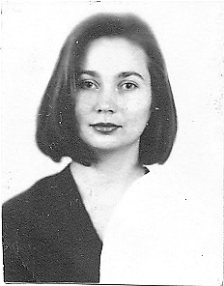
CURRICULUM VITAE

TATYANA PUSTOVIT

Personal date
Born in Zelenodolsk (Dnepropetrovsk region) on March, 28, 1974
Holding the Ukrainian Nationality
Married
Phone: 8-066-748-97-55

Education
1991-1992 – Vocational School in Zelenodolsk – “Tailor of female clothes”
1992-1995 – Kiev Geological Prospecting Technical College – “Searching and electrical prospecting of minerals”
1999 – “Znannya” association, accounting course – “Accountant of factories with different properties form
2000- 2006 – Kiev University of Technologies and Design – “Technology of plastics and elastomers handling”
2004 – 1C Accountant course

Languages
English, Italian – intermediate – spoken, read & written.

Computer knowledge
Word, Excel, Internet – usual user’s level.

Professional Experience
1999-2001 – secretary (personnel department, planning, Private Branch eXchange) at Kiev Polytechnical Institute
2001 – secretary (personnel department) at autoschool “Progress” in Kiev
2002 – secretary, engineer of category II at Institute of chemistry surface
2003-2004 – forwarding agent, production manager at Polynit Textile Ltd., production: ladies hosiery; brand “Prestige”. Functional duty – carry on negotiations with customers, contract concluding, control of production realizalion, forwarding of production.
2004-2005 – office–manager at Vector Invest Ltd., production – coveralls;
functional duty – carry on negotiations with customers, documents, administrative work

Training
Travel to Italy for training language skills for six month

N.B.: More information upon request

