Requirements to the event calendar:
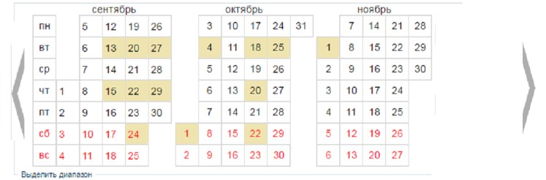
Fig.1.
- There is the display of three months, which go for each other. By default - the current month is in the center (in the middle).
- Every month named, without indication of year.
- Control element (forward and backward, i.e., transition by months) is changes all three months but with shift for one month.
- Switch (Day, Week) is for ability to the choice of display information from the calendar, for a day / for the whole week, accordingly.
- Days of the week are located vertically. IT IS IMPORTANT, and only from the left side.
- Save an icon "Unavailable" when you hover the mouse cursor over a cell without a fill.
- When displaying information from one cell, or a group of cells per a week, these cells are highlighted on the calendar itself, or allocated in a different way, showing to the user - where the information is displayed.
- Cells on the calendar have several effects (it depends on existence of the appropriate information this day and selected additional parameters of display):
a. Background of the cell is poured completely.
b. Frame is in a different color around the perimeter of the cell (possibly with special effects).
c. Labeled cell symbolize the attached media file (photo/video).
All these effects are displayed both and separately, for any number of days.
- VERY IMPORTANT!! There is ability to operate information in a specific cell, and in group of cells.
In one cell, this is done through the PCM, where a list of functions is displayed. See Fig.2.
And as for the group of cells it should be possible to select the first and the last cell in the calendar.
For example, you can do it with separate button «select range». After that, the first click on the cell on the calendar initiate the selection range, and the second click - the end of the range. The selected range is colored until the function is selected for it from the same task list as for one cell.
Moreover, the sample should follow the date!
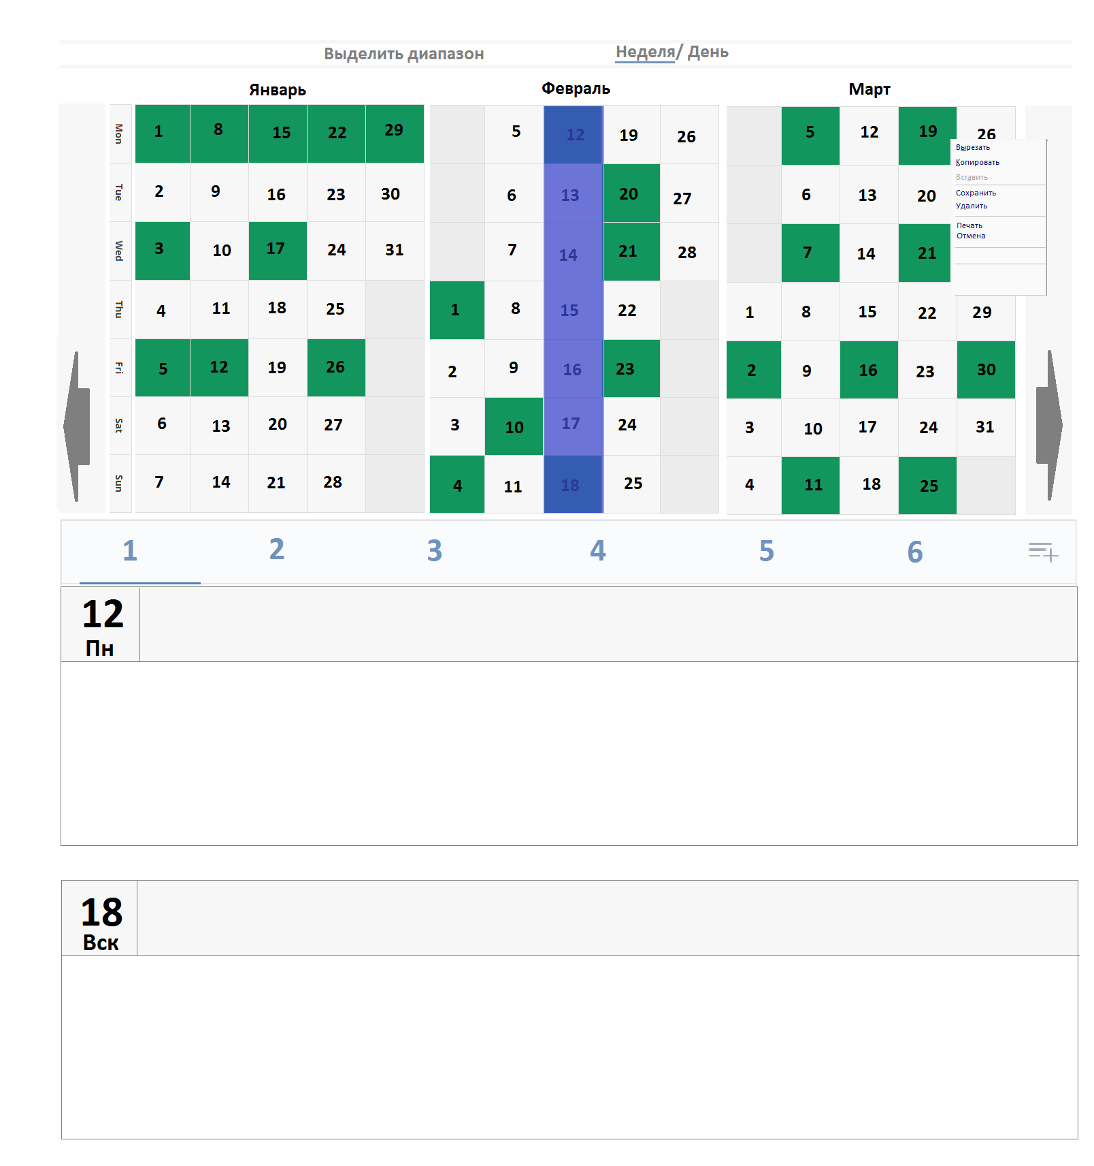
Fig.2.
For example: If you right click on cell you'll see a list of tasks - copy / cut / paste / delete / save / print / cancel - as for one cell. The same list is the same for the selected range, which appears immediately after setting the end day of the range.

The categories must be located in a row as in the social network VK.com in the "Music" section Fig. 3.
Fig. 3

Necessary settings:
- The ability to set the color of the cell selection. (Frames and fills)
- The setting the font type, size and location of a number in a cell on the calendar.
- The number of categories, and their name (Fig. 3.)
- The number of tasks and their name. In the task list for the cell and range.
- The scalability of the cells of the calendar and, accordingly, the overall size of the entire calendar block.

