The Tripartite Identity Pattern
One of the most misunderstood patterns in social media design is that of user identity management. Product designers often confuse the many different roles required by various user identifiers. This confusion is compounded by using older online services, such as Yahoo!, eBay and America Online, as canonical references. The services established their identity models based on engineering-centric requirements long before we had a more subtle understanding of user requirements for social media. By conjoining the requirements of engineering (establishing sessions, retrieving database records, etc.) with the users requirements of recognizability and self-expression, many older identity models actually discourage user participation. For example: Yahoo! found that users consistently listed that the fear of spammers farming their e-mail address was the number one reason they gave for abandoning the creation of user created content, such as restaurant reviews and message board postings. This ultimately led to a very expensive and radical re-engineering of the Yahoo identity model which has been underway since 2006.
Consistently I’ve found that a tripartite identity model best fits most online services and should be forward compatible with current identity sharing methods and future proposals.
The three components of user identity are: the account identifier, the login identifier, and the public identifier.
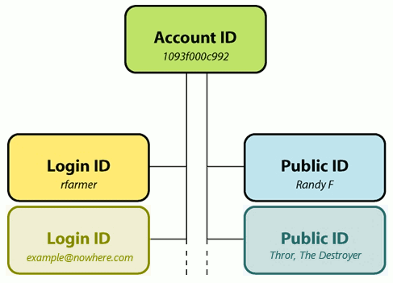

Account Identifier (DB Key)
From an engineering point of view, there is always one database key – one-way to access a user’s record – one-way to refer to them in cookies and potentially in URLs. In a real sense he account identifier is the closest thing the company has to a user. It is required to be unique and permanent. Typically this is represented by a very large random number and is not under the user’s control in any way. In fact, from the user’s point of view this identifier should be invisible or at the very least inert; there should be no inherent public capabilities associated with this identifier. For example it should not be an e-mail address, accepted as a login name, displayed as a public name, or an instant messenger address.

Login Identifier(s) (Session Authentication)
Login identifiers are necessary create valid sessions associated with an account identifier. They are the user’s method of granting access to his privileged information on the service. Historically, these are represented by unique and validated name/password pairs. Note that the service need not generate its own unique namespace for login identifiers but may adopt identifiers from other providers. For example, many services except external e-mail addresses as login identifiers usually after verifying that the user is in control of that address. Increasingly, more sophisticated capability-based identities are accepted from services such as OpenID, oAuth, and Facebook Connect; these provide login credentials without constantly asking a user for their name and password.
By separating the login identifier from the account identifier, it is much easier to allow the user to customize their login as the situation changes. Since the account identifier need never change, data migration issues are mitigated. Likewise, separating the login identifier from public identifiers protects the user from those who would crack their accounts. Lastly, a service could provide the opportunity to attach multiple different login identifiers to a single account — thus allowing the service to aggregate information gathered from multiple identity suppliers.

Public identifier(s) (Social Identity)
Unlike the service-required account and login identifiers, the public identifier represents how the user wishes to be perceived by other users on the service. Think of it like clothing or the familar name people know you by. By definition, it does not possess the technical requirement to be 100% unique. There are many John Smiths of the world, thousands of them on Amazon.com, hundreds of them write reviews and everything seems to work out fine.
Online a user’s public identifier is usually a compound object: a photo, a nickname, and perhaps age, gender, and location. It provides sufficient information for any viewer to quickly interpret personal context. Public identifiers are usually linked to a detailed user profile, where further identity differentiation is available; ‘Is this the same John Smith from New York that also wrote the review of the great Gatsby that I like so much?’ ‘Is this the Mary Jones I went to college with?’
A sufficiently diverse service, such as Yahoo!, may wish to offer multiple public identifiers when a specific context requires it. For example, when playing wild-west poker a user may wish to present the public identity of a rough-and-tumble outlaw, or a saloon girl without having that imagery associated with their movie reviews.

