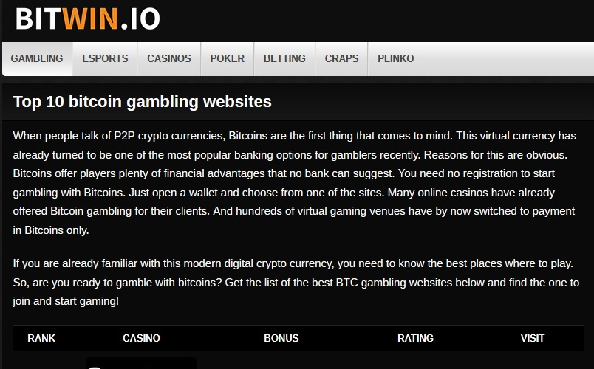
Полностью наполнил сайт http://bitwin.io/ контентом на английском языке на тему Bitcoin gambling. Я лично написал все материалы на этом сайте. Темой биткоинов и других криптовалют в контексте гэмблинга, а также непосредственно гэмблингом я успешно занимаюсь уже пять лет.
Линк: http://bitwin.io/betting/formula-1/
Текст:
Bitcoin formula 1 betting
Formula 1 betting with bitcoin has become amazingly popular and moneymaking since the beginning of 2017. More and more websites offer services for bitcoin bettors who adore the highest class of single-seat auto racing. The fact that over 620 million people regularly view each F1 race have also influenced plenty of casinos to start accepting BTC bets on this type of sport. So, we have done an excellent job and selected for you the top sites which propose Formula 1 betting with BTC. No more words – let’s start!
Best Formula 1 betting sites with bitcoin
Plenty of websites from various developers offer services for bitcoin gamblers. We have tested dozens of them and found out that not many of them provide quality and reliable services for players who like making BTC bets on Formula One.
Sportsbet.io
Sportsbet.io offers perfect bet sizes on various Formula One events across the globe. At this online casino, you can use bitcoin to make wagers on almost any type of F1 events. The tastiest bets are offered on a race winner. Sportsbet.io additionally provides fruitful bonuses and lucrative promotions both for beginners and experienced BTC bettors. The casino proposes live streams of all Formula One events. Moreover, you can use 24/7/365 customer support in case you have any questions concerning F1 bitcoin betting. Mobile betting is also available at this website.
Nitrogensports.eu
Nitrogensports.eu is the most extensive bitcoin Sportsbook which offers to place bets on the major Formula One events worldwide. The casino offers plenty of special perks for all types of players. While placing bets at Nitrogensports.eu, you should never worry about security. The newest kind of SSL-encoding protects all your personal and financial info efficiently. All types of F1 events are available for bettors (driver championship, constructor winners, pole position bets, race winners, and driver transfers). Nitrogensports.eu is also the best online platform for managing your bitcoin earnings successfully (various F1 promo materials, earnings timeline, numerous hints, click counter to enhance your profits).
Betcoin.ag
Betcoin.ag accepts bitcoin bets on all types of Formula 1 events. The website promises utterly fair gambling and 100% security of your personal information. Desktop, tablet, and mobile versions are available. This casino usually offers fruitful bet sizes on the fastest lap. Which driver will do the quickest a lap of the circuit? Please note that in this type of bet, the wager will be changing until the end of the race. Additionally, this casino offers lucrative bets on the qualifying session – the first colossal betting event of the F1 weekend. The casino offers to place bets which driver qualifies in pole position. The session itself has three mini-sessions during an hour. The bet sizes are also changing during an hour.
Cloudbet.com
Cloudbet.com offers every bitcoin bettor to place bets on a variety of F1 events. These are pole position bets, constructor winners, driver championship, race winners, driver transfers, etc. Every new gambler gets 100% welcome bonus that can reach up to five BTC. Rewarding daily and weekly promotions are also available. All-day-round customer support (live chat, email, and telephone). Fair betting. Both mobile and desktop versions. Quick depositing and withdrawal using the most reliable payment means. The most popular types of Formula 1 betting at this site are “Driver Head to Head” and “How Many will finish.” The former offers you to name two drivers of a similar standing and proposes a wager between them, despite of what happens in the race itself. The latter type of bet usually offers in a totals format, where you should make a wager on whether there will be under/over the given figure.
1xbit.com
Since the end of 2016, 1xbit.com has started to gladly welcome BTC bettors who want to place bets on various Formula One events. 100% up to 1 BTC on the first deposit, and other lucrative promos. Though it is necessary to register at 1xbit.com, the process is straightforward and quick. Deposits and withdrawals are no-fee and instant. Various wagering options on all Formula One events. Day-and-night customer support.
Peculiarities of Formula 1 betting with bitcoin
Betting Formula 1 with BTC has many things in common with other popular types of bitcoin gambling (Esports, casino, ice hockey, plinko, etc.). However, it has specific peculiarities.
- To plan your yearly Formula 1 BTC betting calendar, you should just understand how F1 season works. Each season starts in March with Australian Grand Prix and ends in November with the Abu Dhabi race. There are 19 races in every season. The race weekend begins on Friday and ends on Sunday. During it, there are three practice sessions, a qualifying session, and the long-awaited race itself.
- You can place your bets on various F1 events. These are pole position bets, constructor winners, driver championship, race winners, etc. Each of the events goes with different bet sizes depending on the place of race, weather, time, and racer`s list.
- To spice up your F1 weekend, you need to find out all the info about the most appealing bets. Statistics show that every given driver has his luckiest places. For instance, Lewis Hamilton has won the most circles in Formula 1 Etihad Airways Abu Dhabi Grand Prix. It means that he will have the most chances to win in that very Grand Prix. So, the most BTC casinos will give him the best most reliable bet sizes. This principle concerns every F1 driver.
- Before placing your BTC bet on any of Formula One events, you`d better study statistics carefully, so that you know which driver has the best chances to win.
- Many online casinos, which accept bitcoin, offer live streaming of F1 events. During them, depending on the current event results, casinos can change bet sizes. So, you should carefully monitor the situation to make your bet at the most suitable time.
- The leading futures market in F1 is the driver’s championship. All casinos offer you to make wagers on it even before the regular season begins and throughout the F1 calendar until the final race. Constructors Championship is another essential type of bitcoin betting which you should remember about.
Advantages and disadvantages of Formula 1 betting with bitcoin
Bitcoin gambling, like any other type of online betting, has its benefits and drawbacks.
Advantages:
- It is easy to get BTC wallet;
- You can either buy or exchange bitcoin quickly;
- The safest method of online payment;
- More than 50 countries officially plan to give bitcoin a status of the legal payment means;
- Over two hundred of casinos accept BTC for Formula 1 betting;
- Quick and safe withdrawals;
- Deposits without limits;
- Formula 1 betting with bitcoin can never be taxed;
- Two dozens of payment systems allow exchanging your BTC winnings within an hour.
Disadvantages:
- Complicated equipment is needed to mine bitcoin by yourself;
- Many governments desire to regulate BTC earnings;
- Some countries still prohibit Formula 1 betting with bitcoin;
- Some financial experts even consider BTC not stable currency.
Conclusion
So, you will never be mistaken if you choose one of the proposed websites for Formula 1betting with bitcoin. Feel free to start from any of them. The service each of them provides does not principally differ. However, every mentioned site has its peculiarities. Enjoy your bitcoin gambling and good-luck!

