* If , •







.. 

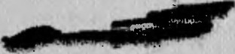

.

• 



nr·ypc 9A'1·113



..

1··EXliftlJ EC:KC)E .()01iCAl·f I1E, •

•

11 Uttc1··PYK UH$1 flO 3KC[1JIYA.1A H 1 •

•

'

*:.,*

•

.:1



'lj •

I.

·

·'

1

• :.,·.:

I '

*.I*

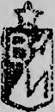

t

•

Ml'IH1'ICTEPCTBO 060POHbl CCCP

*3K3.* M

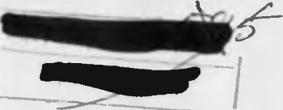



    

=

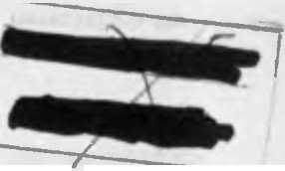

**TEXHYIY ECKOE onYICAHHE** •

***YI* YIHCTPYKU115l no 3KCnJ1YATAUYIYI**

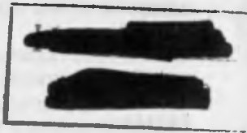

Op.neHa Tpy.lOBoro KpacHoro 3Har.teHH

BOEHHOE J.13,U..'.\TEJi bCTBO

MHHHCTEPCTBA 060POHbl CCCP

*J\-* 0 C K B A -l 9 7 8

**1**



...

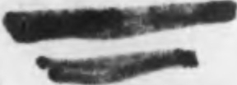

•

.. . "•.

.

..



••

HaCTOSilllee TeXHHtteCKOe onHC3HHe H HHCTPYKUHH no 3KCDJJyaTaUHH pa3pa601a.­



HO, corJJaCOflaJJO H YTBep>K,lleno no COCTOSIHHIO OTpa6oTKH 06pa3uaII Te;'HH'leCKOi\ ceHTH6pb 1977 r. H .nonymeHO )I.JJSI HCnO 'Jb30BaHJISI B BOHCKaX.

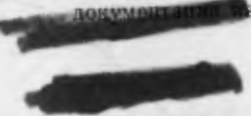

TEXHMlJECKOE onMCA HME

* 1. BBEJJ.E H M E

""

• • •

•.. ._.,.r

*,1 .*

. "'·"191»;,

. •

HacTOHll.lee TexttHlleCKoe onHcattHe H HHCTPYKUHH no .3KCnJiya·ra-

UflH npe)lHa3Ha'tleHo JlJIH H3ylleHHH npoTHBOTaHKOBoro ynpaBJIHeMoro peaKTHBHoro CHapHJla 9Ml13 H 3KCnJiyaTaUlH ero B BOHCKax.

B TexHHlleCKOM onHcaHHH HJJio>K eHbI ycTpofr cTBO, npHHUHn J1eiicT­

BHH. KOHCTPYKUHH cocTaBHhlX qacTefr, pa6oTa 6opToBoil annapaTypbI CHapH)la 9Ml13 OT MOMeHTa BbICTpeJia JlO nopa>KeHHH ueJIH, a TaK>Ke npHBe)leHblCBe)leHHH 06 yqe6HbIX CHapHJlax 9MI13. ·ti-11 ,.· . - .

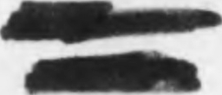

B Htt CTPYKUHH no 3KcnnyaTaUHH H3Jio>K eHbI npaBHJia oopaut"Mffr ,

co CHapHJlal'.tH 9Ml13 npH xpaHeHHH, TpattcnopTHpoBaHH. 1.:..!IPQ§ti.i;"-.­ Hilfl perJiaMeHTHbIX pa6oT, a TaK>Ke npHBe)leHbl He06XO)l.HMbie Tpe6o-'f· ' BaHHH no TeXHHKe 6e3onacHOCTH npH o6cJiy)KHBaHHH CHapH)l.OB 9Ml13

B BOHCKax Jl.0 6oeBoro npHMeHeHHSI.

npH .3KCnJiyaTaUHH CHapH)l.OB 9Mll3 Heo6XOJl.HMO .u.onoJIHHTeJibHO IlOJib30BaTbCH cne.u.y10ll.lHMIiJl.OKYJ\1ettTaMIf :

* BoeBaH MallIHHa 9nl48.TexHHlleCKoe on11catt tte;
* BoesaH MallIf Ha gn148. I111CTPYKUllH no 3KCnJI)1aTaUHH;
* KoHTpoJibHo-npoBepollHaH annapaTypa 9B8l 1M. TexHH11ecKoe OIIHCaHHe H HHCTPYKUHH no .3KCnJiyaTaUHH;
* np116op 9B483. TexHHllec1<oe onHcattHe H HHCTPYKUIIH no .3KC­
  + - nJiv aTaUHH;

•

•

BHHi\'\AI-IHE! DPOBE PbTE HA.flH4l l[ BK lEfl KH.

8 KH·nre BCero npOHY l-!ePOB8•HO 96 CTp ., KpO e Toro, B cue '2Htlrll

BKneiiKa (puc. 51 - J ./t *Ja)<t/J'J HJ,C21c. !3(?sJl* il,11



*'l-"c:1tr I I/* .,

<:TCH 

*("rf*

* PyKOBO,!I.CT,BO )l,'l.H apcetta. OB, 6a3 H CKJia!I.OB paKeT. 6oerrpttna­ COB 11 nTYPC. 4acTb I. 06mee nono>K eHHe. *l\\.,* BoeHH3.o.aT, 1973 r.;
* PyKOBO.ilCTBO no xpatt eHfllO H c6epemeHHIO apTHJIJiepHHCKoro

soopyn<ettHH H 6oenp11rr acoB B BoiicKax. M., BoeHH3.0.aT. 1963 r.;

* npa s11na nepeB030K no >KeJie3HhlM .u.oporat H BoJI.Hhl:M nyTHM coo6n eHHR 6oenpHnacoB, B3pbtBllaTbIX H CHJlbHO,ll.eHCTBYIOlllllX HJl.0- BIITbl A BeIUeCTB, H3)l. BO MnC, 1962 r., H np11JlO)KeJIH51 9 H 10 K yKa-

3aHHblM npaBHJiaM, 1962 r.

B TeKcTe ttaCTOHll.lero TexttHllecKoro on11caHH.H 11lIHCTJ)YKII.HH no 9KCn.11yaTaU.HH npHMeHeHbl CJie.o.y10mHe ycJIOBHble o603HalleHHH H co­

KpameHIIH:

9Ml13 - HH)l.eKC ynpaBJIHeMoro CHapH.ua B KOHT('ttHepe (cttapHJl.

6e3 KOHTeilttepa HH)l.eKca He HMeeT) ; gn148 - HH)l.eKC 6oeBOH Mal1HHbI;

1* 3aK . 166 )c 3



2

9n1351 - HHJI.eKc BhIHOCHoil nycKoBoii ycTaHoBKH KoMnJieKca «KoH- Kypc>>;

9n135 *-=--* HH,lCKC nycKOBOH ycTaHOBKH KOMilJieKca 9KI 11;

98871 - HHJI.eKc KOHTPOJibHO-npoBepollHOH MalIJHHht ;

9B864 -HHJI.eKc KoMnJieKTa KOH..T. POJibHo-npoBepot1Ho11 annapaTy- pbI JI..'.lH 6a3 6oenpHnacoB (JI.JIH c6opKlf ynpas.11HCMblX

CHapH.lOB 91\\ lll f 9.\\ 113) ;

2. HA3HA '-IEHM E, 60EBblE CBOA CTBA M TA KTMKO­

TEX HM'-I ECKM E ,ll.A HHblE CHAPSl)].A 9/\\ 113

npoTHBOTaHKOBblH ynpaBJIHeMblH peaKTHBHbl}I cttapHJI. 9Ml13 (pHC. I) npeJI.tta JttalleH JI.JISI nopa>KeHHSI 6pOHHpoBattttblX IlO.!I.Bl >KHb!X

9B811M - HHJI.eKC KOHTpOJibHO-npoBepollHOH•

annapaTypbl JI.JISI npo-

H HeilOJI.BH>KHblX ueJieH H JI.pyrHx tta3eMHblX o6neKTOB Ha JI.aJibHOCTHX

BepKH ynpaBJISleMblX CHapH.ilOB *91\\l* ll H 9Ml13; • '9X237- l - HHJI.eKC 3Jie..KTpOBOCilJiaMeHHTe.TIH pa3rOHHO-l\1ap111eBOH

.ll.Bl raTeJibHOH ycTaHOBKH;

9Xl79 - HHJI.eKc nopoxoBoro 3apHJI.a pa3ro11Ho-Maprneso1"1 JI.BHra-

* " " .• TeJibHOM ycTaHOBKH (c BOCnJiaMeHIITeJieM) ;

9Hl31 - HHJI.eKc 6oeBoi1 11acT11 c npeJI.oxpattHTeJibHO-JI.eTOI11py10-

OT 75 JI.O 4000 M.

np H M e 11a H H e. OpOTIIBOTaHKOBblll ynpaBJJSieMblH peaKTHBHblH CHapSI;J. 9M 113

,1.a.r1ee no TeKCTy 6y.neT 11'.\ICHOBaTbCSI CHapSl.!1, 9.\\ 113.

CTpeJib6a cttapHJI.OM 9Ml13 npoH3BO.ll.HTCH H3 60CBOH MalllHHbl 9TII48, c BhIHOCHOH nycKoBofi ycTaHOBKH 9nI35M K0 1nJieKca «KoH­ Kypc>> H c nyCK OBOH ycTaJIOBKII90135 KOMn 11eKca 91 111.

.• ...

..:•.. *:-1,i-•* lllHM l\1exaHH3MOM;

MHHHMaJibHaH JI.aJibHOCTb CTpeJib6bI onpeJI.eJIHeTCSI JI.aJibHOCTblO

93234.1\l -HHJI.eKc npeJI.oxpaHHTeJibHO-JI.eTOHlf PYIOll ero MeX aHlf 3Ma;

9X 180 - HHJI.eKc nopoxoBoro 3apHJI.a Bhill1H6ttoi1 JI.BltraTeJibIIOH ycTaHOBKII (c BOCnJiaMeHHTeJieM) ;

951684 -HHJI.eKC yKynopOllHOfO SllllHKa JI.JIH CHapHJI.a 91\\113; 6Pn - 6JioK pyJieBoro np11so.n.a;

nll/\'\ - npe.n.oxpattHTe.TlbHO-JI.eTOHHPYIOllliH MexattH3M; PM -pa3rOHHO-MaprneBaH JI.BHraTeJibHaH ycTaHOBKa;

-9 . 13JlY - BbllllH6HaH JI.BHraTeJibHaH ycTaHOBKa;

B3BC!I.eHHH npe.J.OX paHlf fC.1hHO-,leTOHlf PYIOl{ero MexaHil3Ma.

CHapHJI. *91\*113 pa6oTocnoco6eH B JI.HanaJotte TeMnepaTyp oT

-50 .ll.0 +50°C.

Ynpa sJieHHC c11apH!J.OM 9Ml13 noJiyaBTOMaT11t1ecKoe no nposo.nttoif JIHHHH CBH3H.

C11c1pHJI. 9.lV\ 113 HMeeT cJie.ny10m11e TaKTHKo-TexHHllCCKHe natt11h1e:

.. aKCIIMaJlhHaSI JI.a.. bHOCTb nopa>KeHHH Ue.TIH:

'.-M -n·..HAY -:- ttaJeMHaH annapaTyp a ynpaBJiettHH;

* + Kf A -KOHTPOJibHo-nposepot1tt aS1 annapaTypa;

EKEH52 -6JioK KOHTpoJIH 6aTapeii BTopofl tta3eM11oi1 6aTapeH; Pl - peJie KOHTpOJIH nepBOH Ha3eMHOH 6aTapeH;

P3 -peJie KOHTPOJIH GopTOBOH 6aTapeH; P4 - peJie KOHTPOJIH 6aTapeH cpapb1.

nepellettb KOMnJieKTYIOll HX 3JieMeHTOB CHapHJI.a *91\*113, ycTatt aB­

JllBaeMblX npH CHapH>KeHHH, npHBeJI.eH B Ta6JI. l.

T a 6 n u u a 1

J.13 6oeBOH MalllHHbl 90148 . . . . •

C BblHOCHOH nyCKOBOH ycTaHOBKH 90 135M • c nyCKOBOH ycTaHOBKH 90 135 . . . .

MHHJIMaJibHaSI JI.aJibHOCTb nopa>KeHHH ueJIH • . EpoHcnpo6HBaeMOCTb (noJI. yrJIOM 60° OT HOpMaJilf ) CpeJI.HHH CKopoCTb noJieTa CHapH.na • • . . CKOpOCTb BpameHHSI CttapH.n,a B IlOJICTe • . . KaJIH6p cttapH.na . . • • . . . . PaJMax KphIJiheB . .

|  |  |  |  |  |  |  |  |
| --- | --- | --- | --- | --- | --- | --- | --- |
| .  . | .  . | .  . | .  • | • .  • • | | .  . | 468 MM  25 Kr |
| • . . . | | | | •  . | .  • | .  . | 14,5 Kr  1260 X 188 X |

Macea cHapH.na *91\i*113

Macca cttapH.n.a (6e3 KOHTeffHepa) . f a6apHTbl KOHTeiittepa

faoapHTbl yKynopo 11Horo HlllHKa • • • • •

Macca yKynopOllHOfO SIUlllKa C 0.ll.HHM CHapH,UOM

4000 M

3000 M

3'000 M

75 M

250 MM 208 M/C 5-7 06/c

135 MM

X 230 Ml\,I

1373 X 292 X

X 353 MM

47 Kr



 •



|  |  |  |
| --- | --- | --- |
| Ha1tMeH0BaH11e | 030 JHa< eHHe | f pHlf) CeKpeT HOCTH |
| EoeBaSI 11acrh  nopOXOBOA 3apst.n PMD.Y (c BOCnJla­ MeHHTeJieM)  DopoxoBoil aapst.n BD.Y (c Bocnna­  MeHHTeneM}  3neKTpoBocnnaMeHHTeJlb aaMe.nneH-  u  11oro .neHCTBHSI 3neKrpoBocnnaMeHHTeJlb BD.Y | 9Hl31  9X179  • 9X 180 9X237-1  9X284 |  |
|  | |

1. COCTA B, 06UlEE YCTPO A CTBO M PA60TA

 CHAPSIAA 9M 113

* 1. COCTA B ff 06ll.{EE YCTPOA CTBO CHA PSIAA 91\\113

CHapSIJI. 9Ml13 COCTOHT H3 KOHTeHttepa *I* (pHC. 2) , peaKTIIBIIOfO

·CHapHn.a *2* H BbllllH6HOH JI.BHraTeJibHOH ycTaHOBKH *3.*

Ko11TeHttep CJIY>KHT repMeTHllHOH yKynopKOH JI..TIH cttapHJI.a 11 BLI­ U1116ttoi1 .ll.BHraTeJibHOH ycTaHOBKH. OH npeJI.cTaBJISleT co6oi'I nJia CT-

,4

• ,5

1acc0By10 Tpy6y *4* (pHc. 14), 3aKpb1Ty10 nepe.nttefr *JO* H 3a.ntteft *19* (pHC. 15) KpbIWKaMH. Ceapy>KH KOHTei:rttepa B cpe.nttefr qaCTH ycTaHOB­ Jielf hl 6JIOK *8* (p11c. 14) n11Tatt11H 11aJeM1roii annapa Typbl ynpaBJie1r11H H po3eTKa *9* pa3'beMa, npe.ntt a3ttallettHaR .nJIR 3JieKTpHti:eCKOH CTblKOB­

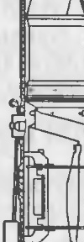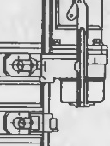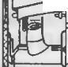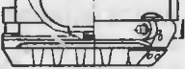

.

1

-

|  |  |  |  |
| --- | --- | --- | --- |
| KH ceapHna 9.i\\ 113 c | nycKOBOM ycTaHOBKOH. |  | |
| CttapR.n cocToHT | H3 cJie.ny101UHx octtoBHblX | qacTeff : | 6JioKa *I* |

(p11c. 3) pyJieBoro np11Bo.na, 6oeBoi1 qacTH 9H 131 *2,* pa3roeeo-Maprne­ Bof1 .ns11raTe.1hHoii )'CTaHOBKll *3,* annapaTypeoro OTCeKa *5.*

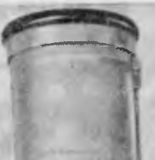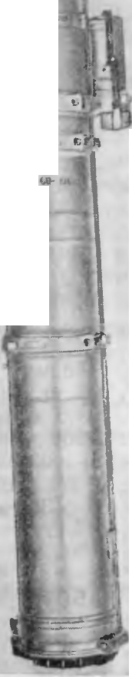

~~.---~~

CQ

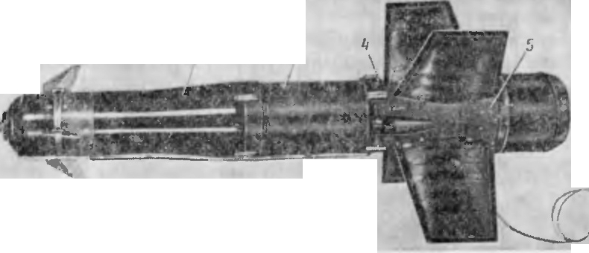

*1*

*I*

*2*

.l

*I*

*8*

Cl

--

0

C..Q.

*(.)*

»

---

ti:

Cl,

:c

.0

i,:

c..:.,

--

CQ

L,

-c

Cl

cc

·=

--

S'

"..,_'..

-

-

:;:

CJ')

ct

-

0:

ti:

CQ

:c

:s:

-• • -

3

,!I

M-

Cl

I

co:,

CJ') ••

I::{ ti:

0: c.

0. ca

co :c

:c *(.)*

u ,-::.:

--

PMc.3. CHapSI.l (061UHf1 BH..'1.) :

*I* -(5noK py.1csoro np1:1eo.na; *2* - 6o<>eaR qacTb; *3 -* pa3rOHHO MapweeaR nsnraTe:lbHaR ycTa· IIOBKa; *4* - 06Tt>l<3Tenb; *5* - annapaTyp11b1n OTCeK ; *6* - 06Te1< aTCnb

0.

r-o

u

-•

•

C'I

C-l

6JIOK *1* pyJieBoro np11Bo.na, BXO.nHlUHi' B COCTaB 6opTOBOH annapa­

v• -

-...

:: :;:

c. <';!

-

T pbl ynpclBJieHl H ceapHJlOM, npenHa3Jf alleJf )lJIH ynpaBJieHJ SI CHapH·

.nol\1 B noJieTe no Kypcy H TaHra>Ky H npe.ncTaBJIHeT co6oi1 .nByxKa-

• c-:,

*u*

:: I

v u u

Ha..'IbHhll 3.eKTpOMarHlITllhllI MexaHl 3M, npHBO)lHlUHH

B JlBH:iKett11e

c. c..,

•-

-•

-

C-J

c:: •

c..:.,

-

0

I

-

•

a 3p0.llHa t lllleCKlle P}'Jlll 7 (p11c. 4 ) ' c IIOMOlUhJO KOTOpbIX ocyll eCTB­ JIReTCH ynpaBJieHHe ceapH.nOM.

6oeBaR qacTb *2* (p11c. 3) npe.ntta3eaqeea .nJIH nopa>K eHHH ueJIH np11 nonanaHHH B eee ceapHna.Oea pa3Memeea Me>K.ny 6.TIOK OM *I* pyJieBo­ ro npHBo.na 11 pa3roeeo-MaprneBoii .ns11raTeJihHOH ycTattosKoii *3.*

6oeBaH llaCTb COCTOHT H3 KOpnyca *8* (p11c. 4) , KYMYJIHTlIBHoro 3a.

pR.na *9* H npe.D.oxpatt11TeJibtto-.neToe11py10mero Mexa1rH3Ma *10.*

Pa3rOHHO-MaprneBaSI .nB11raTeJibHaH ycTaHOBKa *3* (pHC. 3) npe.n­ Ha3Haqeea .nJIH o6ecnelleHHH 3a.nattttoii CKopocT11 noJieTa cttapH.na. Otta pacnoJio>Keea Me>K.ny 6oeBoit qacTblO *2* H annapaTypttblM oTce­ KOI\l *5* H COCTOl T H3 CJie.ny101UHX OCHOBHblX qacTeH: KaMepbl *12* (pHC. 4) ' nopoxoBoro 3apSI.na *11* H 3JieKTpOBOCTIJiaMe HHTeJISI *13.* ,[leo KaMepbI *12* 111\leeT .nsa ;J.HaMeTpaJibHO npOTJ BOTIOJIO>KHbIX conJia.

AnnapaTypHblH OTCeK *5* (pl C. 3) npe.nea3HalleH .nJIR pa3MemeHHSI

'3JIOB 6opTOBOH annapaTypbIynpaBJieHJIH CHapHJJ.OM.

AnnapaTyp 1rh1i1'

oTceK npe.ncTaBJIHeT co6oii Kopnyc *15* (pHc. 4)

UHJI IH.npHlleCKOH cpopMbl c yKpenJieHHblMH Ha HeM lleTbipbMH Jiona­ CTSIMH *14.* B annapaTypeoM oTceKe pa3MemeHbIcJie.ny10m11e y3JihI6op-

6 • 7



I Toso i annar} aT}'ph1: Kl>Op.!lllHaTop *tJ'*

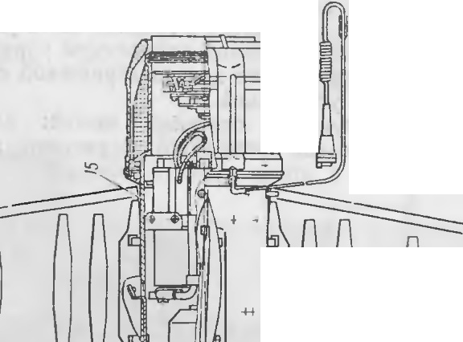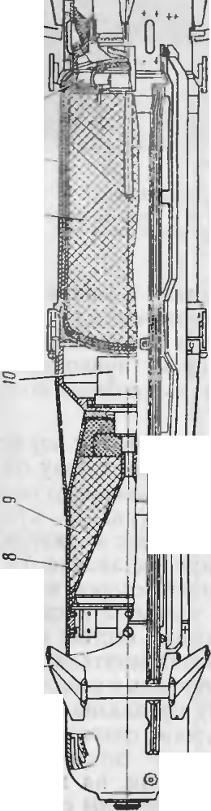

-

0

-

-*I*

-

-*..::,*

W-')

r-,J -

--·-

I :;rt;.,:.._ ·

I 11 -•

lj

111

I

r---

(p11c. 1 1) , 6 1101( *8* )11pas.neH11s:i,..

<--:,





,e;

0

c:

0

:-:

0

c.

c0

I



GJ • •

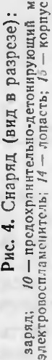

KaTylllKa *14* npOBOJI.HOH JIHHHH CB513H, Jia Mna-¢apa *13.*

JlonaCTH *14* (pHc. 4) npH pacnOJIO}KeHHH CHapH.na B KOHTeHHepe HaXOJ].SITCH B CJIO>KeHHOM nO llO}KeHHH H ynep}KHB3IOTCH TIOJIYXOM)'Ta­

111 (pHC. 12). nocJie Bb JieTa CHapHJI.a H3 KOJ TeHIepa no.:'IyXOMYTbI

pac11.enJIS1IOTCSI H OT6pacbIBalOTCH pacKpblBalOlH:\ HCSI r1 OnaCTHMI . Bb1lllH6HaH JI.B}f raTeJihHaSI ycTaHOBKa *3* (pHC. 2) npentta3Hat.IeHa

AJIH coo6u e1111H cttapHD.Y tt at.IaJihHoii cKopocTH noJieTa. Otta pac no 10-

>KeHa B KOHTefittepe Me>Kny c11apS1JI.oM *2* H 3antteff KpblIJKOH *19* (pHC. 15) H COCTOHT H3 KaMepbI *JO* (pllC. 16) , CTOeK *11,* nopoxoBoro sapHJI.a *5,* nopoxoBoro COCTaBa *12* H 3JieKTpOBOCnJl a MeHHTeJISI *15.*

Ha CHapHJI.e H KOHTeHHepe pa3Mell{eHbI a BTOHOMHble HCTOt.IHHKH IlH- TaHHSI, 06ecnel111Ba10m11e 3JieKTp 03Hepr11eii 6opTosy10 annapaT·py ynpa s 1e11115I c11apHJI.Ol\1 u 11a3eM 11y10 arrnapaTypy ynpaBJie1111si.

5opTOBOH I CT04lllll,ITlT cll!ll I- oaT, peH 'f -4 17 *8* ( pllC. 20) BXO.ilT

B COCTaB 6Jio Ka ynpaBJieHHSI H COCTOHT H3 JI.BYX OJI.HOTl TIHbIX CCKUlll (p11c. 23).

CeKUH l YCJIOBHO Ha3BaHbI: 6 aTapeS1 <papbl (5<1>) H 6opTOBaH 6a­ rape51 (55) . B ttat.IaJibHhIH MOMel T nocne aKTHBau1111 6opTonoro 11c­

TOt.IH IKa nHTa HHH HanpH>Kett11e 6a·rape11 6cI> nonaeTCSI Ha nonorpeB

..,

HHTH HaKaJil(B3HHH naMnbI Ha IlOJI.>KHr 3JieKTpOBOcn... aMeHHTe.r1e11 ap-

,a:

"-"

:c

Cl

...

IC

c,;

r::;

>,.

:E

I

••

CJ

>,.

i:::

c.

0

peT11pa, pa3rOHHO-MapllleBOH• JI.BHraTeJibHOH• ycTaHOBKH H Ha npe.no- xp aHHTeJibHO-JI.eTOHHpy10m11H MexaH}f 3M; tt anpH>KeH} e 6aTape11 56 nonaeTCH Ha 6JIOK pynesoro npHBOJI.a, npHeMHHK, TIOJl}KHf 3Jie TpO-

v v u u .,

BOCnJi aMeHHTeJieH nepenHeH KpbilllKH KOHTeHHCpa H BTOpOH Ha3e:'.\1HOH

6aTapeH.

np11 npeKpamettHH nefr CTBHSI Ha cttapHD. neperpy3KH oT BnY HHepuHOHHblH 3aMbIKaTeJib coeJI.HHSleT 6aTa peH 55 H 5<1> napaJIJie b-

110 (I Ha llpH}{(Cl-ll C 06e11x ceK UIIH no.naeT CH 11a Ji a:'.\t rry-cpapy, oPn, npHeMH}f K H TI)lfv\.

6JIOK *8* (pHc. 14) IlHTaHHH Ha3eMHOH annapaTypbl ynpaBJieHHH, co­ CTOSIIUHH 113 JI.BYX 6aTapeff T307-6, cny>K1f T JI.JISI nHTaHHH Ha3eMHOH

annapaTyphI ynpaBJieHHH H no.n>K11ra 3JieKT posocnnaMeHHTeJIH BnY .

3.2. PA liOTA CHA PSIJlA 91\\113

Ilp11 CTpenh6e H3 6oesofi MallillHhl 90148 onepaTop Ha}{<Jt MaeT 11a

n'.. hTe 11a KHOnKy OYCK, np11 3TOM c OJIOKa n1-1raHllH annapaT ·pbl y rrpaBJieHJ(H M3llil(Hbl gn148 nonaeTCH Hanpfl}{{ell) C 12 B TIOCTOHHHO­

ro TOKa Ha 3JieKTpOBOCilJiaMeHHTeJIH 6opTOB0fO HCTOt.IH}f Ka IlHTaHHH, BTopoi' Ha 3eMHof1 GaTa pe11 6noKa n11Ta1111H 1-I.. Y 11 nopoxosoro 3apS1-

*n.a* poTopa KOOPJI.HHaTop a.

901351\\ onepaTop Ha}KI Ma­

:w:

I

•.c•

J:;

»

0.

I

8

Opll CTpeJih6e c nycKOBOH ycraHOBK l

eT tta cnycKoBoii KplOt.IOK MexaHH3Ma nycKa, pacnono>KeHHoro Ha ny­ CKOBoii 'CTaHOBKe, TI()}f 3TO:M 13 MCX aHH3Me nycKaIIH.'1yKT11pylOTCH J(M­

nynhCbl 8,llC, KOTOpbie nonalOTCH Ha 3ne1<TpOBOCn Jiai\1:e1111TeJI1i 6opTo­

Boro (ICTOllHHKa IT}ITa HHH, BTopofl 1133('MHOH ·OaTap c11 6 10Ka CT ·IT3 l!H

HAY H nopoxoBoro 3apHJI.a poTopa Koop.n1HaTopa.

•

naJibHeHlllee B3al MOJI.e.11CTBHe 3JieMeHTOB Ctt apSIJI.a npH nycKe H B

KOTOporo, OTKJIOHHff Cb OT csoero cpe.nttero IlOJIO>K eIHH, C03)J.alOT y n-

no 1erc np11 CT pe.' b·6e 1(3 OOCBOil '\ila lllllf bl gn148 H c nyCKOBOH ycTa­

u

paBJIHIOll.llH

MOMeHT, KOTO

..

pblH

v

CMemaeT .. eTSIUl l l

cttapSIJI. K JlHHl I

HOBKIIgnl35M a11aJiorHllHO.

B npouecce BhlXOJI.a Ha peiKHM 6opTOBOro HCTO'lHHKa IlHT aHHfl' np11 JI.OCTH>KeHHH Ha 3a>KHMax 6aTapeH cpap bl ttanps:r >KeHHSl, paBHOro 3 B,

cpa 6aTbIBaeT 3., eKTpOBOCnJla M.eHHTeJib appeTHpa KOOpJI.HHaTopa. Bop­ TOBOH ICTO'lH}lK IlHTaHHH, BTOpasi Ha 3eMlaH 6aTapcH 6JIOKa Il (TaHIIH HAY H KOOpJI.HttaTop BblXOJI.HT tt a pe>KHM; cpa6aTb1Ba10T 3JieKTpoBoc­ nJial\1e1-r HTeJilI nepe.ntteii KpbilllKlI KOHTeifttepa H nepBoii tt a3eMttor"1 6a­ Tape11, BCJl€JJ.CTB He 11ero OTl<.pb BaeTCSl nepeJI.HSISl Kpb lll {a KOHTe1itt epa H tt all11tt aeTcH npouecc BhlXOJI.a tta pem11M ncpsoiI tta3eMHOH 6aTape11.

U}l31lpOB3HIISlIi ·.lep:>KIIBcleT (>KOJIO HCe B TeLieHlle -Bcero speMeHll 11a-

aeJI.eHl Sl.

np11 BCTpeqe cttapH.na c ueJiblO KOJinaK *14* (pl C. 31) 11 KOHTaKT *15,* uaxOJI.HIUHeCff B 6.110Ke pyJieBoro npHBOJI.a, conpHKacaIOTCH, 3aMb KaH 9JieKT p11qecKy10 uenh 3JieKTpoJI.eTott aTopa nl.t\'\ 6oesoii •1acT11. 3JieKT­

poJI.eTo tt aTop, cpa6aTh BaSI, HHHUHHpyeT B3pbIBllaToe semeCTBO, LITO npHBOJJ.HT K no,nph BY K)'MyJIHTHBHoro 3apsi.na 6oeBoH IIaCTI .

nepeJI. c6pocOM KOHTefr ttepa c nycKOBOH ycTaHOBKH noJI.aeTCH Ha­

npsi>KeH11e c 6oeBOH MalllHHbl gn148 tt a 3.',IeKTpOBOCnJiaMeHHTeJib

B pe3}'Ji bTaTc ublX O.li1 1r a 11cit{ll:\-f ncpBof, 11a3Cl\. Hoi1'

6aT,11>e11 (11e­

(3BnJ1C) , nptt cpa6aT bIBaHHH KOTOporo npoHCXOJI. f T OTCTpe I KOJ O)I.-

pe3 0,3-0,8 c TIOCJie OTKpbIBaHHH nepeJJ.HCH KpbllllKH KOHTeHHepa) cpa6a ThIBaeT 3ieKTpOBOCTIJi aMeHHTeJib B)lY. nopoXOBOH 3apHJI. Bn1· noc n 1a t\1e11HCTCH, 11 non ..1aB.. e1111eM ra3oB ctt apH;i. BL16pac1,1saeTcH 113

KOHTe111-r epa B ttanpasnett lH ero npo.no.. hHOH oc11, npJ1oopeTaH tt allaJih- 1ry10 cKopocTb He Mettee 64 M/c. B MOMeHT cpa6aThIBaHHH BilY OT JI.eHcTBHH ee ra30B cpa 6aTbIBaeT 3aM.b1KaTe.nb, KOTOpblH 3aMbIKaeT

.. u -

uenb no;i.a ll}IHanpH>KCH}IH Ha nnM.

CT p11 Jl.BH}KeHHH CHapsiJI.a B KOHTeMttepe OT JI. } CTBHH CTapTOBblX neperpy30K cpa6aTblBaeT }(Hepu110HHbi1 3aMblKaTeJib, KOTOpbl'l CBOII­ Mll KOHTaKT aMII 3aM bIKaeT uenb noJI.allJItt anpH>Kelf H 1r a 3 1CKTpOBOC ­ nJia'.\leHHTeJib p.lV\nY. 3JieK TpOBOCilJiaMeHHTeJib cpa6aTbIBaeT H BOC­

nJia '.\1€HHeT nopoxosofi 3apHJI. Pi\\ lY.

3anycK PMnY npOHCXOJI.HT Ha TpaeKTOpHll noJieTa CHapHJI.a Ha paCCTOHHHH 10-15 1\1 OT MeCTa CTapTa.

Bb16poweHHblM H3 KOHTei1Hepa CHapHJI.a npOJI.OJI>K aeT JI.Bll} {Clf He

..

KH npOBOJI.HOH JIHHHH CBH3H.

1. A 3PO,ll.MHAMMIJ ECKA SI l(OMnO tlOBl(A, COCTA B M YCT POA CTBO CHA PSIJl.A
   1. A 3POJlHHA/\\ H11ECKA SI KO/\\ nOHOBKA CHA PSIJlA

C1-1apH.J. CK01nOHOBaH no a3p0.!ll1Ha :\1114eCKOii CXC MC «YTK3 >>, T. e.

a3pO.lIH8MHtJ:eCKI e P)" 111 pa3Mell.lelf bl snepe J,11 IeHTpa TH) {eCTII Ctta

pHJI.a.

. Y npaBJIHIOUlaH CHJl a, o6ecnellHBalOU aH MaHeBp CHa pH.na, COJ,na-

u

eTCH 3a Cl!eT nosopoTa a3pOJI.HHaMHlleCKIIX pyJieH.

8 lC.'1HX CTaO ((.',Ill3a UII)( Ha TpaeKTOpl J.I CHapH.l 13 noJ1eTe spa ma· eTcSI. Bpamett11e cttapHJI.a B noJieTe o6ecnellHBacTcH JionacTHl\.111 11 con­

no TpaeKTOpHll no lei' CTBHeM 11ea KTI BIIOfl Cll.l'

bl pa6oTa (Oll Cii p.\\,.J Y.

Jia M11, ·cTal OB leHHblM ll TIO.LI. yrJia MH 2II9° COOTBeTCTBeHI-10 K npo;i.0 1b-

v

nocJie BblneTa c1-r apHJI.a 113 KOHTei11:1epa CBeTOBOe H3JIYllCHHe Jia\1-

.Tibl-<p apbl, nonal(aH BO BXOJJ.lf OH 3pal10K onTHKO- Mexa tt1111ecKoro KOOp­ Jl.}lllaTO·pa HAY, co611paeTcH o6oeKTHB0'.\1 B cpoKaJihHOM n rzoc1<ocT11, rJI.e pacnoJio>KeH MOJI.YJIHpy10m11i1 JI.llCK. npoMOJI.}'.'.IHposa11ttb1 1 JI.ICK0'.\1 CBeTOBOH CHrHaJI npeo6p a3yeTCH B 3JleKTplllleCKIIH c11rtt a.;1 cpo·TO;I.HO­ Ll.0!\I, pacnoJio>KeHHbIM. HenocpeJI.CTBeHHO 3a Jl.HCKOl\1. C _ Q)OTOD.HOJI.a 3JieKTplllleCKli l CHrttan B BHJI.e qaCTOTlf O-MOJI.YJIHpOBaHHOrO 1r anpH>Ke-

..

lllH nocTynaeT B annapaTypHb1 1 oJIOK 1-IA Y•

•\nnapaTypHblH 6JIOK aBTOMa T} lleCKH BblpaoaTblBaeT ynpaB 1HIO­ [ll}le tt anpH>KeHIH no Kypcy 11 Tattra}Ky, nponopu11ott aJihHb1e seJIIIllH.He Jll Hellf Oro OTKROHeHHSl cttapHJI.a OT JlllHHH Bl 3HpOBaHHH. )lanee Ha- 3evf Hi1H a nnapaTypa y11panJ1eHllH ¢opM11pycT CHrtt aJi bI )"npaBJi eHI H

8 BI ;l.e npHMoyroJibHbIX CTynett tJaTbIXllMnyJibCOB, KOTOpbIC no JI.Byx-

I

u

npoBO.rJ.HOH JlHHlICB513H nocTynaIOT Ha BXOJI. npHel\ HHKa.

Ha BXOJI.e npHeMHHKa ynpaBJIHIO[UHe CHrHanbI pa3JI.eJIHIOTCH no

l

·KattaJia M Kypca H Tatt rama. 3aTeM c noMOU bIO JiaMeJibHOro .naTll Ka rHpOCKOnHlleCKoro KOOpD.HHaTopa 3TH CHrHaJibl pacnpeJI.eJIHIOTCH no BblXOD.HbIM KaCKa.naM npl Cl\ HHKa B 3aBJ,( CHMOCTH OT yrJlOBOrO IlOJIO­ m.e1-11 H Bpau aIOUterocH CHapHJI.a. C BblXOJI.HblX KaCKaJI.OB )·npaBJlHI0-

I

.1.Ul e Cl rttaJibl, ycHJieHHbie no MOll.lHOCTH, nocrynaIOT Ha OOIOTKll

3.1CKTpOM af HHTOB 6.T. JOK a pyJ1eBoro npHBOJI.a, a3pOJI.HHaM1111ecK11e PYJIH

IO •

HOH OCll CHa pHJI.a•

CHCTeMa ynpaBJieHHH CHapSIJI.O.M B noJieTe - noJiy aBTOMaTHlleCKaH

u

c nepe.nalleH Ko.Matt)]. 1r a cttapHJI. no npoBoJI.aM.

nplHUllTI rroJiyaBTOMaTlJlleCKoro ynpasJieHHH 3aKJII011a eTCSl B TO:\ ,

v

l!TO onepaTop C MOMeHT a BblJieTa ctt apHJI.alf 3 KOHTeHttepa .no 1\- OM.eH-

Ta nopa.i eH IIH le.111 )·.lep}Klll33 CT nepch:pcc1·11c ceTKII onTllllCC hOfO BI- 311pa Ha UeJIH, npH 3TOM CttapHJI. a BTOMaTi1 eCKH yJI.ep}!{l(BaeTCH Ha

Yz

*· ,t r_ .:*

-

-

*a* r

..,

*M*z- .....

);

Y3

.

'1'r\

. -

- - - -*p*

"

I

*U.T*

x

M3

-

*I*

_:)

-

':\

•

.

*12*

*11*

*()*

• *M 1* -

Puc. 5. Cxe!'vla CHJI H \l OMeJITOB, ,UC ICTB)'IOlU} '( Ha CHapH.n B noneTe

11

OG.TeKaTeJib *4* 3am1-1maeT 3JieKTpOBOCI1JiaMeHHTeJib J)a3fOHHO-Map·

OJeBOH Jl.BHraTe.TibH

" ycTaHOBKH B noneTe H KpenHTCH BHHTa MH K an-

Jl (l}l(( (( Bl 3llpOBclHllfl. /\\ ecToHa X O}K,lCHl e <:Hapsi,!I.a onpeJl.e11HeTCH no HHq>paKpactt oMy HJJiylleHHIO naMnb1-q>apb1.

CxeMa CHJI 11 MoMeHTOB, AeHCTBy10m11x Ha cHapH,a. B noJieTe, npH­ seAett a Ha pttc. 5:

p -c11na TSlrH peaKTHBHOfO Jl.Bl raTensi, HanpaBneHHaSI no OCH CHa-

PHAa;

X -CHJia no6oBoro conpoTilBJieHHH;

\ -BeKTOp CKopoCTH ctt apHAa, HanpaaneHHbIH no KaCaTeJibHOH K

OH

napaTypHOMY OTCeKy *5.*

* + 1. 6oeBaSI qacTb c npe.noxpaHHTeJlbHO-AeTOHHPYIOlllHM MexaHH3MOM

5oeBa H llaCTb 91I 131 1<yMy TIHTllBHOf O ,!I.ei"1CTBH51 npe,!I.Jf a3Ha11e1-r a

.nnH nopa>KeHHH 6poHHpoBaHHb X ue 11efi. Otta Bb1non1r e11a B Bl Ae ca­

TpaeKTOpHH;

MoCTOHTeJibHOro oTceKa, pacnoJ.

io>KeHHoro Me..tK.ny 6JioKoM-

p).. eaoro

)"1 -IlOJl.beMH3SI CHJia, C03A aBaeMaSI nonaCTSIMH H HanpaBne11HaS1 nepneHJl.llKYJIHpHo BeKTopy CKOpOCTH;

} ·2 -TIOJl.'heMHaH c11na, C03.llaBaeMaH PYJIHMH H HanpaBneHHaH nep­

neHAHKYJIHPHO BeKTopy CKOpOCTH;

*Ya* -TIO,ll.beMHaH CHJia, C03Jl.a BaeMaH KOpnycOl\1 H HanpaBJieHHaSI

nepneHAHKYJIHpHO BeKTOpy CKOpOCTH;

Q -CHJJ a TH.tKeCTH CHaps:1Aa;

11 -nJiello no.nneMttofi CHJibI¥1;

*1'2* -nneqo no.n'heMttofl ClJJi bl ¥2;

/3 -nneqo no.nneMttoif CHJibl ¥3;

0. -yroJI aTaKH (yroJI, o6pa3oBaHHblH BeKTOPOl\1 CKOpOCT I 11 OCblO

cttapsi.na) ;

npHBOlI.a H pa3rOHHO-MapweBOH JlBHraTe.TibHOH ycTaHOBKOH, H COCTO-

ff T H3 Kopnyca *14* (pHC. 6)' KyMyn.SITHBHOro 3ap.S1Aa H npe)loxpatt11- TenbHO-Jl.eTOHHpy10mero MexaHH3Ma *JO.*

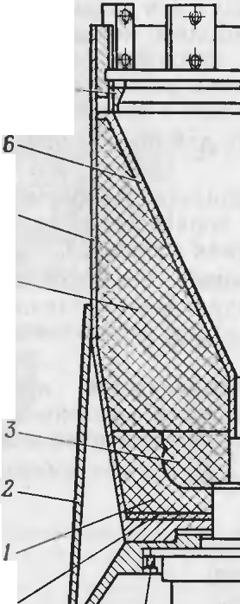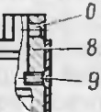

*1--*

•

*14*

•

M1 -y npaans:11om11ii MoMeHT,C03A a10m11if yroJI aTaKH; 5

M'2 -cTa6HJIH3ttpyrom11if MOMeHT, ypaBHOBe1IIHBa10m11i't ynpaBJIHIO­ UlHH MoMeHT M1;

[\,\3 -MOMeHT BpaUleHHH BOKpyr OCH CHaps:1.na. •

4.2. COCTAB H YCT POHCTBO CHA PSl)lA

|  |  |  |
| --- | --- | --- |
| C1-1a pH 1. coCTOJlT 113 c.'.1C..l\·1om11x | OCHOBJ-l hlX | qacTci1: 6 'IOJ{a *I* |
| (p11c. 3) pyJieBoro npHBOJla, 6oesoi1 | qacTH *2* c | npe.noxpatt11TeJihHO­ |

AeTott11py10m11M MexaHH31\101\I, pa3rOHHO-Map 1IIeBOH ABHraTC .'.IbHOH

}'CT allOBK ll *tJ'*

11 annapaTypl OfO OTCCKa *5.* •

6.. 0K *1* py 1esoro np11so,!I.a pa3l\1eme11 s roJIOBHofl qacr11 c11aps:1-

,'la (I 13.XO.lllT 13 COCTal3 oopTOBOll a nnapaT)'Pbl ynpaB 'teHl H. 1-l aJHaqe­

HHe, ycTpOHCTBO H pa6oTa 6JIOKa py.1. 1eBoro npl BO!l.a paccMoTpeHbl B

n. 5.1.4.

6oeBaSI qacTb *2* H pa3rOHHO-Map1r1eBaH ABHraTeJibHaH ycTaHOBI<a *3* BblilOJIHeHbl B Bl )le caMOCTOHTeJibHblX OTCeKOB, coe)l (HeHHblX Me>KJ1Y co6oi1 lleTbipbl\1H BHHTaMH.

AnnapaTyp 1rbIH oTceK *5* HBnHeTcsi XBOCTOBOH qacTblO cttaps:1.aa "

KpenHTCSI K pa3fOHHO-Map1IIeBOH .llBHraTeJibHOH ycTaHOBKe *3* lleTblpb­ MSI BHHTa MH. Tpoc KaTylIIKH npoBOAHOH JIHHHH CBH3H yJIO>KCH BJlOJib

CHapsi.na OT KaryW KH .no f OJIOBHOH ero qaCTH B na3ax n11poK *16*

(pHC. 4) . npHKJieeHHblX K o6TeKaTeJIIO *6* (pHC. 3) H Kopnycy CHapH)la,. II 3a KpenJi eH l{OJlO..lKOii *5* (p11c . 18) Ha BHyTpeHHeH CTOpo1-1e nepe..11.-

HeH KpbllIIKH KOHTeHHepa.

" a

3JieKTpHqecKaH CBSl3b annaparypHoro OTCeKa c 6JIOKOM *1* (pHC. 3) pyJieBoro npHBO,ll.a ocymecTBJIHeTCH C IlOMO[UblO >KryTa, 3aKpbITOfO o6TeKaTeneM *6.*

12 •

*13*

*a* ,.,r. -+- -1- --1

12 , *10*

PMc.6. BoeBaH qacTb 9l-l l 3l:

*I* -.nononHHTeJlbH8H mamKa; *2* -o6TeKaTenb; *3* -nHH'la;

*4* -OCH08H8H W8WK8; *5* -CTa KaH: *6* -BOpoHKa: 7 -no.n­

>KHMHOe l<Onbl O: *8* -nepexo.nHOe KOnbl.lO; *9* -DHHT; *10* -

npe.noxpaHuTenbHO .neroHHPYIOlUHA MeX 8HH3M; *II* - no.n­

:IKHMH8H raiiKa; *12 -* nepcXO.llHOe .llHO; *13 -* npoKna.nKa;

*14* - KOpnyc; *a* - yWKO; *6* - PC3b60aoe OTBePCTHe

13

Kopnyc CJIY>KHT JI.JI.SI pa3MemettHH H MOHTa>Ka y3noB 6oeBofi 1.1acTH " COCTOlfT H3 CTaKaHa *5* c nepeXO)l.HblM )].HOM *12* H o6TeKaTeJieM *2* no)l.>K HMHOH raHKH *11,* nepexo,ltt oro Konhua *8* H no)l.>KHMHoro Konh­ ua 7.

CTaK aH *5* npe)l.Ha3Ha1.1eH JI.JI.SI pa3MemeHHH H 3a KpenneHHH B He:\1.

KYMYJIHTlIBHoro 3apHJl.a.

nepexoJJ.HOe JI.HO *12* CJiy>KHT JJ.JIH KpenJieHHH npe)l.oxpaHHTe 11bHO­ JJ.eTOHHPYJOlllero MexaHH3Ma *JO* H coeJJ.HHeHHH 6oeB011 11acTH c pa3roH­ Ho-rv1apmenoit JJ.BHraTMbHOH ycTaHOBKOH. nepexOJJ.HOe JI.HO *12* KpenHT­

CH K CTa t<a Hy *b* BOCeMbl{) lIIHTaMI{ . 1-12 nepexO,lH0:\-1 .lHe *12* lMeJOTCH

lieTblpe ymKa *a* c OTBepcTH.SIMH IlOJJ. BHHTbl, KOTOpblMH 6oeBaH 1.1aCTb

u u

KpeniJTCH K pa3I'OHl O-MaprneBOH )l.Blf f aTe.llbHOH ycT aIJOBK e, a B ueHT-

pe -OKHO, B KOTOpoM c IlOMOUlblO IlO]l>KHMHOH raHKH *11* KpenHTCH

npeJJ.oxp aHHTeJihHO-JJ.eTOHHpy10mHfl MexaHH3M *10.*

*JJ. -11.*

*B-B*

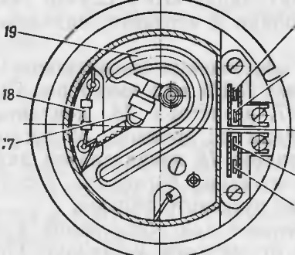

*20*

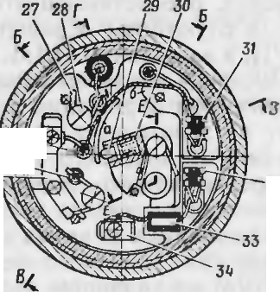

2,

26 ci4W

25- +d-l-- .....-"'

2lf

*22*

23



*3Z*

6-6

·Oe prx 0 ..,11oc KO "J bUO *R* c-. y>K ' T .11H coe.!I.l JieH11H 6oesoi1 llaCTlI c

6noKOM pyneBoro npHBOJJ.a. nepeXO)l.HOe KOJibUO HMeeT BOCeMb pe3b- 60BblX OTBepCTlf H *6* JJ.JIH BHHTOB, KOTOpbIMH 6JJOK pyJieBoro rrpHBO)I.a KperrHTC.SI K 6oeBOH 1.1aCTI, H BOCeMb pe3b60BblX OTBepCTHH JJ.JIH BHH­

TOB *9,* KOTOpbl!\111 nepe:\O.J.HOC KOJi hl O *8* KpenITCH K CTa KaHy *5.*

IloJJ.>KHMHOe KOJihUO 7 cny>KHT D.JIH no)l.>K aTHH BopoHKH *6* K KYMY­ JIHTHBHoMy 3apHJJ.y.

KyMyJIHTHBHhIM 3apHJJ. npeJJ.Ha3Ha1.1eH JJ.JIH cpopMHpoBaJIHH KyMyJJH­ TI BHOH CTPY H, o6ecnellIBalOIUel{ nopaiKeJiHe ueJJH, 11 COCTOI T H3 oc­ HOBHOH *4* H JJ.OilOJIHHTeJihHOH *1* rnarneK c JIHH30H *3.*

npeJJ.oxpaHHTeJibHO-JJ.eTOHHpylOlll J MexaHJ 3M 93234M (pHC. 7) npe'l11aJHa11e11 JI.JiH no;1.pb1sa KYMY.'IHT1t s11oro 3apH.aa 6oeB >i' 11acT1r np11 BCTpe1.1e CJ apSIJJ.a C ueJiblO II JJ.JIH caMOJIHKB11nau11H CHapH.ua B

c 11y1.1ae npoMaxa.

*nosepHymo*

*nD8epHymo*

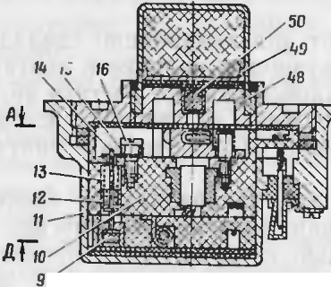

*E- E*

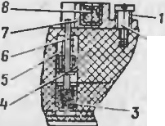



47

*•P. 116*

r- r

*noBepHymo*

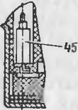

*noacpH ymo*

J5

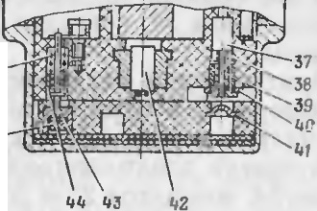

._36

CTJllv\ - Jl.OHHb H,..

.3JieKTpol'v1exaHH1.1ecKHH, npeJJ.oxpa Hl TeJibHoro '2

THna.. , MfHOBeHHOfO JJ,eHCTBl H, C )l.aJJbHIM B3Be)l.eHHeM H caMOJII KBHJJ.a -

UHeH, OCHOBaHHblH"

Ha nHpOTeXHHlleCKOM npHHUHile MexaHH3M.

O Jl\\ cocro11r 113 c 1c 1y 10Ul.ll'\ YJ 10B 11 Mcx a11113.MOB :

* Ko11neHcaTopttoro y3na;
* nycKoBoro MexaHH3Ma ;

Mexa HH3M a .naJibHero B3Ben,eHI H; 1ex a1Il3Ma caMOJJI KBl{)l.aUHH; u1y11T1r11y1011 ero l\1exa 1-11I3Ma ;

* JJ.eToHHpy10w.ero y3na; ..
* KOpnyca H BCIIOMOraTeJibHblX JJ.eTaJJCH.

Kc,H 1r•1c aTOf)l-1bli y 3eJI C.1\.)1 IIT J.'1H 3 KK}' t y 111pOB3HIIH :JI CprHit

OT 6opTOBoro HCTOllHHKa IlHTaHHH CJ apH.n.a H MfllOBellHOH pa3pH.n.KH

•

PHC. 7. f lpe.a.oxpa HHTe.1bllO- CTOIIHPYJOII LHll r.1ex a11H3M 932341\.1:

*1* -. py nna .nBlliKKa; *2* - BHIIT JJ.BHiKKD; *3* -3aMCJl '1HTCnb; *4. 12. 4-1* - 11awe11K11; *5. 13. 47* -

DP} iKHIIh, CTonopou: *6, / 4. 41* CTOOOf bJ: *7* -JJ.DlliKOK; *8* - n:tphlB'laToe aeu CCTBO ; *9* -COCTaB: *10* - MOHTa >Kuaff BTynKa; *I I* - KOpnyc; *15* -npy)t<HHa BKnlO'leHHSI; *16* - BHIIT npy>t<HHt,1· *17* - 3 1CKTpouocn i;1'\1e1111Tc.·,: *18* -··pe311cTop: *19 -* coc TaB; *20* - Ho:me nol! KOHTaKT I· *21 -* HO>Kenoft K911Ta KT 2: *22* - HOl+.Cl\t)H K011T aKT 3; *2,J* - HOiKCBOii KOHTa KT 4: *24* - KOIIT3 KTl a SI n18CTIIJll\a·

2.1, • ,, - iCOIIT8KTbl; *21* npyiKHJla Bl<JllO'iellHSI; *28* - BHHT npy>t<Hllt t ; *29* -c),HKCa Top; *30 ...:*

npy 111a cfi1tKCaTopa: *.11. 32* .'JCDCCT KII; *J ,1 -* pC3HCTOJ>: *34* -KOIIT3K T DKnlO'iCIIHfl; *35* -o6o­

,'10'iKcl. *J6* - B. pl,B'iaToe BE'U eCTBO; *37* - nyCKOBOil CTonop; *JB* - DflYiK llla DYCKCIROro CTonopa ·

*,19*. - DTy 1Ka : *.J(}* - I\OHTaKT nyCKoBoro CTonopa; *41* - l(()JIT a KT: *42* - 9JlCKTP0.l.('T01UlTOP" *45* _:

KO,l.!lCHCaTop; *41* - COCTa n: *48* -BK."13.:l.hJW ; *49* - KPhJW Ka; *50* -B3PhlB'laT RClUCCTBO; *'a. 6* -

B,CT yn hi

3anaceHHO1i

.3JieprHli KOH.neHCaTopa Jia 3 lJCKTpo.neTOHa TOP *42* { p11c. 7)

n.erOHHP)'lOIUero y3na npH 3a MhlKaHHH KOJinaKa *14* (pHC. 31)ll KOH­

Ta KTa *15,* Haxo.nHlllHXCH a BPn, B MOl\t eHT BCTpe1.1H CHapHJJ.a c UeJiblO lfJIH B c.. y1.1ae pa6oT bl MexaHJ 3Ma caMOJil KBlJJJ.aUIH. OH COCTOlJT 113

HO>KeBblX KOHTa KTOB *20* (pHc. 7)II *21,* KOHTaKT a *34* BKJIIOlleHHH, KOH-

1aKTa *25,* npyn<HHbl *15* BKJIIOlleHHH, BHHTa *16* rrpy>KJ Hbl, pe3HCTOpa *33*

H 1{0H.neHcaTopa *45.*

14

[,>

Pe311cTop *3,'J* npe.QHa3Ha 11eH .!lJISI or paH11llett1-1H BeJ111•11111b1 TOha, npo· xo.nsiw.ero t1epe3 MOCTHK 3JleKTpO;leTOHaTopa *42,* .no MHHHMaJibHOrO aHat1eH11si, 06ecne111-1aa1ow.ero Hecpa6aThIBaHHe ero B cJiyqae aaMKH\'­ ThIX (B cny}Ke6HOM o6paw.eHHH) KOJinaKa H KOHTaKTa, Haxo.nsiw.1-1xcsi B BPn, H B3Be.neHHOM n.uM.

nycKOBOH MexaHH3M cny>KHT .ll.JlSI o6ecneqeHHSI 6eJonacHOCTH *n.Ui\*

e CJiy}Ke6HOM o6paw.eHHH 1-1 BJBe.neHHH TI.UM npH Bb CTpene. OH co­ CTOHT H3 3JieKTpOBOCnJiaMeHHTeJISI *17,* pe3HCTOpa *18,* KOHTaKTa *41,*

KOHTaKTa *40* nycKOBoro cronopa, BTYJIKH *39,* npy}KHHbl *38* nyCKOBoro CTonopa, nycKoaoro cronopa *37.* Pea1-1crop *18* npe.nHaJHalJeH Jl.JISI 1-1c­ K 110•1e1111H B03MOLKIOCTIIKOpOTKoro JaMbf KaJllf SI 6opTOBOro lf CTOlJHff Ka n11TaHHSI CHapsi.na BO BpeMSI aaMhlKaHHSI nyCKOBOro CTOnopa.

.\\ exaHl 3f\.1 ,la 1Llll'l'O B3Re,1,e11Jf 5l CJIY iKHT .QJISI o6ec netf eIIIH B3Be.n. ,e­

HHSI n.uM Ha Ja.naHHOM paccTOSIHHH OT nycKOBOH ycTaHOBKI . OH co­ CTOHT H3 3aMe.rt.JIHTeJISI *3,* CTOnopa *6,* qaruellKH *4,* npy.>KHHbl *5* CTOnopa,

.ll.BH>KKa *7,* npy>KHHbl *1* .ll.BH>KKa, BHHTa *2* .ll.BH>KKa, q>HKCaTopa *29,* npy­

>KHHbl*30* q>HKCaTopa.

MexaHH3M caMOJIHKBH.rt.aUHH CJIY>K HT .rt.JISI JlHKBH.rt.aUHH CHapSIJJ.a B

cnyqae npoMaxa no ueJIH npH He3aMKHYBIIIHXCSI KOJinaKe H KOHTaKTe, H3XO..l.Sllll 1XCSI B BPn, H COCTOHT H3 aanpeccoBaHHOro COCTaBa *46,* co­ CT Ba *19,* CTOnopa *43,* qalllellKH *44.* npy}KHHbl *47* cronopa, KOHTaKT­

lf O i n 1acTif Hl\ll *24,*l{OlTaK Ta *26,* npy}KHHbl *27* BKJllOlJeHHSI I BIIHTa *28*

np)'>KI Hhl.

lllyHTHpyIOW.HH MeX3HH3M cny>KHT .ll.JlSI aaKopaq1-1BaHHSI 3JieKTpo­ lJ,eTOHaTopa *42* B cny>Ke6HOM o6paw.eHHH B ueJISIX orpaHHlleHHSI .no

MHHHMaJibHOro 3Ha11eHHSI TOKOB HaBO.ll.KH, KOTOpble MoryT npOXOJl.HTb

4epe3 MOCTHK 3JleKTpo.neroHaTopa. OH COCTOHT H3 KOHTaKTHOH nJia­ CTHHKH *24,* KOHTaKTOB *25* H *26,* CTOnopa *14,* npy>KHHbI *13* CTOnopa, qa­

IIIellKH *12,* npymHHbl *15* BKJIIOlleHHSI, BHHTa *16* npy>K HHbI, COCTaBa *9.*

.1leTOHHpy1om11ii y3eJI 06ecne1111saeT no.QpbIB 6oesoii 1JacT11 cHa­ pR.J.a H COCTOI T }13 3JieKTpo.neTOHaTopa *42,* B3pbIBllaTblX semecTB *8*II *50,* pac noJIO}K CHHbIX B .!lBl .>KKe *7* H BO BKJia.Qbillle *48* COOTBeTCT­

BeHH,!), 060JI01lKH *35* c B3pbIB'llaTbIM aew.ecTBOM *36.* KpbllllKH *49.*

Kpo ,c Toro, .l.Tf H BKJ11011eH11si 3Jie1\T po.1eT0HaTop a B 3.:1eKT p11qecK)'IO uenb KOH.rt.eHCaTOpHoro yana npH BCTpeqe CH3pSI.na C ueJib O CJiy>KaT

,HO>KeBhie KOHTaKTbI *22* H *23,* coe.nHHSIIOll.lHeCSI COOTBeTCTBeHHO c KOJI­

naKOM H KOHTaKTOM, HaXO.ll.SllllH?\1HCSI B 6Pn.

Kopnyc cny>KHT .nnR paaMemeHHSI acex y3nos H r,.1exaHH3MOB n.U v\. PaCCMOTpHM pa60TY npe.noxpaHHTeJibHO-.neTOHHpyrow.ero Mexa­

·HH3fi.1a.

B CJiy>Ke6HOM o6panteHHH 6eaonaCHOCTb n.u.rv\ o6ec nelJI BaeTCSI cne.nyrow.1-1M:

* Ha HO}KeBb e KOHTaKThl *20* H *21* KOH.neucaTOpHoro yana HanpSI­

.>KeHHe OT 6opTOBOro HCTOllHHKa IlHTaHHSI CHapSI.na He no.naeTcSI;

* nycKOBOH CTOnop *37* HaXO.rt.HTCSI a KpaiJHeM BepxHeM nO.i O>Ke­ flHH H pa3MbIKaeT uenb 3JleKTpOBOCnJiaMeHHTeJISI *17* nycKOBOrO Mexa­

HH3Ma;

* 3JleKTPHlleCKaSI uenb KOH.neHCaTopHoro Y3Jia f\.1e.m:.ny KOHTaKTOM

*34* BKJIIOlleHHSI H npy>KHHOH *15* BKJIIOlleHHH pa30MKHyTa, TaK KaK npy-

16

I >KHHa *15* BKJIIO'lleHHSI HaXO.ll.HTCSI a IlOCTOSIHHOM aauenJieHH I co CTOilO­

poM *14;*

* 3JieKTPOJJ.eTOHaTop *42* HaKOpOTKO 3aMKHYT lllYHTHpylOlllHM Me-

xaHH3MOM;

* 3JieKrpo.neTOHarop OTJJ.eJieH OT B3pb1BtJaToro aemecrsa *50* so BKJiaJJ.b llle *48* Jl.BH>KKOM 7, KOTOpbIH y.nep>KHBaeTCSI OT nepeMemeHIISI CTOilOpOM *6.*

npH BblCTpeJie (B Hat1aJ1e Jl.BH}KeHHSI CHapSI.na) nycKOBOH CTonop *37* IlOJl. .neHCTBHeM CHJl HHepUHH OT JlHHeHHOro ycKopeHHSI, npeo.none­ BaSI conpoTHBJieHHe npy}KHHbI *38* nycKoaoro cronopa, npoJJ.BHraeTCSI Jl.O ynopa B KOHTaKT *41* H 33MbIKaeT 3JieKTpH1 eCKYIO uenb nycKOBOrO MexaH l3Ma. HanpSI.>K eHHe OT 6opTOBOro HCT01 HHKa IlHTaHHSI CHapSI.na qepe3 HO.>K CBbie KOHTa {Tbl *20* H *21* no aaf\.f KHyTOH uenH nycKOBoro Me­ xaI H3Ma no.naeTCSI Ha 3JieKTpOBOCnJial\1eHHTeJlb *17,* KOTOpbIH cpa6a­

TbIB3eT H no.n>KHraeT aanpeccosaHHbIH COCTaB *9* H aaM eJl.JIHTe.Tib *3* .ll.JlSI cpaoaTbIBaHHSI myHTHpyrow.ero MexaHH3Ma H MexaHH3M a .naJibHero

B3Be.neHHH

B noneTe npH BhiropaHHH aanpeccoBaHHoro cocTana *9* cTonop *14*

110.Il .neilcTBHeM CHJibI c>KaTOH npy>KHHbl *13* CTOnop a npOJl.BHraeTCSI B pacnnaBJieHHhie runaKH 3anpeccosaHHOro cocTaBa *9* H npy>K HHa *15* BK.T IOlJeHHSI, BblXOJl.SI H3 aauenJieHHSI co CTOnopoM *14,* nosopa1 fII3aCTCSl

I

.no ynopa B KOHTaKT *34* BKJII01 eHI SI, 3aMbIKaSI 3JieKTpH4eCKYIO uenb

KOHJJ.eHcaTOpHoro yaJia Ha 6opTOBOH H TOlJHHK IlHTaHHSl . Gepe3 pe3lf ­ CTOP *33* KOI.ll.eHCaTOp *45* 3apSI>KaeTCSI. no HCTelJeHHH speMeHH, o6ecne- 1 HBarow.ero .naJibHee B3Be.neHHe noCJie no.n>K1-1ra aaM eJl.JIHTe.. S1 *3,* cTo­ nop *6* no.n .neftcTBHeM CHJihI c>KaToff npy>K HHhI *5* cronopa npo.ns1-1raeT­ CS1 B pacnJiaBJieHHbie runaKH aaMeJJ.JIHTeJISI *3* H Jl.BH>KOK 7, BblIJl.SI H3 3auenJieHHSI co CTOnopoM *6,* no.n .neflCTBHeM npy.>K HHbI *1* Jl.BH.>KKa IlOBO­ paq11BaeTCSI .no ynopa B BbICTyn *6* MOHTa>KHOH BTYJIKH *10.* 0.nHonpe­ MeHH() q)IIKCaTOp *29* no,1 '1ef1CTBICM Clf.Tlhf C) \ a1·or1 npy.>KIIHbl *30* Q)lf KCa·

Topa BXOJl.HT B aauenJieHHe C Bb CTynoM *a* ?\10HTa>KHO"lf BTYJIKII .n1S1 y.nep>KaHHSI .ll.BH>KKa OT nepeMellleHHSI B MOMeHT BCTpell I CHapsi.na c

uenhro. TI.UM Baae.neH.

3anpeccoBaHHhIH cocraa *9,* Bh ropaSI, no.n>K1-1raeT Me.nneHHoropsi­ lllHH COCTaB *19* MexaHH3Ma caMOJIHKBH.rt.aUlf H.

npH BCTpetJe C ueJiblO KOJinaK C KOHTaKTOM, HaXO.Jl.SIW.HeCSI B EPTI,

conp1-1KacaroTCS1, 3aMbIKaS1 3neKTp 1-1qecKy10 uenh .neToH1-1py1ow.ero y311a. K<)lf l,el C aTOp *45* pa3psi:maeTCSI Ha 3JieKT pO.leTOHaTo p *42,* BhfJl>IBa51 ero cpa6aTbf BaHI C. 3JieKrpon.eTOHaTOp *42,* c pa6aThIOaH, lf HI Ulf P)·er B3pblB'laTI1e BemecTBa *8*II*50,* lJTO npHBOJTJ T K IlO.QpbIBY KyMy 1SITI BHO­

ro 3apR.na 6oeBOH qacTH cHapsi.na.

B CJ1y11ae npoMaxa no ueJIH H He3aMKHyTbIX KOJinaKe H KOHTaKTe, 11axOJl.SllllHXCSI B EPn, nocJie BbiropaHHSI COCTaBa *19* MeXaHH3Ma ca­ MOJlHKBH.rt.aUHH CTOnop *43* IlOJl. .neilcTBHeM CH Tf bl c>KaTOH npy>KHHbl *47* cTonopa npo.naBJIHBaeTCSI B pacnnaBJieHHhie runaKH cocraBa *19* H npy­

>KHHa *27* BKJII01 eHHSI, BbIHJl.SI H3 aauenJieHHSI co cronopoM *43,* noBopa- 1.IHBaeTCSI .no ynopa B KOHTaKTHYIO nJiaCTHHK)' *24.* 3neK1'pHlJeCKaSI 11e11b MeXaHH3Ma caM0 1f KBI!laUHlf 3a?\11:JKaeTCSl, H KOHJl.eHc aTOp *45*

'2 3aK . I669c 17

pa3pH>KaeTCH Ha 3.',1eKTpo.neT0HaTop *42,* KOTOpblH cpa6aTblBaeT II Bbl- 3bIBaeT .neT0Ha11.1110 3apH.na 6oeBOH tI8CTll.

PacCMOTpHI'tl pa6oTy 3JICKTpHt.JeCKOH C.XeMbl DJl]V\ (pHC.8) .

B c.ny.>Ke6HOM o6pameHHMIla ll()}K('Bhlf' K()HT3l(T bl *I* }I *2* (iOih.CBbl KOHTal Tbl *20* H *21* Ha PHC. 7) 11anpH}KCH11e o·r 6opTOBOf O l{ CT04lll1Ka IlHTaJI IH CHapsi.na He no.naeTCH. Ho:iKeBble KOHTaKTbl *3* H *4* (l O}h:en1>1r KOHTa KTbl *22* H *23* Ha pHc. 7) coe.n1111eHbl c KOJIIla KoM H KOHT 8 hT0:\1.

B cny11ae npoMaxa no ueJIH H He.:iaM 1..::11yrh1x KOJinaKe 11 KOHTaKre, Haxo.nH HXCH B BPD, no HCTet.JeHH 11 BpeMeH11 cal\10 'lHKB11.na u1111 h.OH· raKT B3 (npy>Kl Jia *27* BKJIIOlleJ-ll H, KOHTa <T11aH nJiaCTHl· Ka *2-1*Ila

pHC. 7) 3a MbIKaeT uenh KOH.neHCaTop a c Ha 3.' eKTpo.neTOHaTOp

3)l-0,5-9. KoH!leHcarop C, pa3p51>K aHcb Ha 3.CKTpo e1·011arop, Bhl3h ­ saeT cpa6aTbIBaH11e 3J CKTpo.neToHaTop a 3Ll-0,5-9, no.npHBa10mcro

3ap..H,1. 1 ,ll1\ , OT Koroporo llHIIUllllP)'CTCH I33()1ll3lli]TOC BemecTBO 6oc- BOH 1.1acrH.

*6Pn 1<0H ma1<111*

*nJJ,M*

\. -d--, ..*4*,,

*, l* I ·"

L

l

* + 1. Pa3fOHHO-M aprneBaSI Jl.BHfaTe.TibHaSI ycT aHOBKa

Pa3fOHHO-MaprneBaSI .llBHraTe.nbHaH ycraHOBKa npe.nHa3Ha tieHa .llJlSI

, *y*-----

*Konno*K r ---,

.

..,, .

'-

I o6ec net.JeHHH 3a.naHHOH CKOpOCTH noJieTa cHapH.na II npe..ucraB.nHCT co-

I • '- I

I 60H o.nHoKa MepHbIH, .llByxpe>K11MHh1 1 peaKTilBHhIH .ns1iraTeJih, paGo-

I 2 1

*r* + *3.0.- 0,5- 9* - *}* 83

•

ralOlllHH Ha TBep.noM TOilJIHBe.

·+ 0 I

I I -

I I

PM)lY pacnoJio>KeHa Me.>Kn.y 6oeBOH tiaCTblO H annaparyp11b1M OT·

1 - ceKol\f H COCTOHT H3 CJICJI.YIOlll X OCHOBHblX 11aCTCf : KaMepbl *10*

-

I

I -

- •

I I *}/ 82*

I

\,

(pHC. 9) ' BOCnJiaMeHHTeJIH *8,* 3JieKTPOBOcn.11a MeH11re'IH *13.* nopoxoBor o 3apH.na *11,* KPhlW KH *2.* onopbl*3,* pe311HOBblX npOfu a.noK *1* H */ 6.*

!._ _ ...,_J .......

*6opmo8oii* ·

I Bf ,-

R1

I KaMepa *JO* npe.ncTaBJIHeT co6oii c Bap1-1ofi ToHKocreHHhIH 6a11., 011,

*ucmo'4HUK* I . ''

B cq>ep11t.Jec KoM .n11e Koroporo 111\1e10rcH .ntte ;i.11aM cTp a.',lbiO pacno., 0-

*RZ* -

0

I

>KeHHble COTIJIOBbie 6o6bllllKM *5.*

B OTBepCTHH OOO l>lWCK BCTaB 1e111:,1

*numDHUfl*

L_ _

_ _ _ _

_ _Mfi-4- f_ _

_ _ ,

Bl{Jl a.nbIWli*6.* Bo BKJla..Uhllll IIla repl\lCTlf Ke nocraBJICllbl a.. 101\ HH}leBhie

7, 06ecnet.J11sa101u11e repMeTl 4 HOCTh pa3rc>HHo-!\1apweson

P11c. 8. .3.l('t.Tpll 11cc1,a Sl c\ C\I a f l 1.\\ 93231.\\

11axo.nsim11MlCH B pa30MKHYTOl'v1 COCTOHH1111 B 5PD. KoHTa KT B I *(* nv­

CKOBoil CTOnOp *37* H KOHTa KT *41* Ha pHC. 7) pa3MblKaeT 3JieKT p114e­

CKYIO uenh 3JieKTpoBocn.naMeHHTeJIH 1'16-4- 1. KoHTaKT B2 (KOHTaKT- 11aH IlJiaCTl HKa *24.* KOHTa KTbl *25* H *26,* npyn<J[Ha *15* BKJIIQl eli 51 Ha p1-1c. 7) rnyHrHpyer 3JieKTpo.neTOHaTop 9Ll-0,5-9, a uenb r-.1em.ny pc311- cropoi\1 R I (pe3Hcrop 33 Ha pnc. 7) H KOH.neHcaropoM C pa30MKH)Ta.

npH Bb CTpeJJe KOHTaKT BI 3aMbIKaer 3JieKrp11t1ecKy10 uenh 3·1e1\r­

poBocnJ1aMeHHrensi M5-4- . HanpH.>KeHHe OT 6oproBoro HCTOt.JH111<a nHTaHHSI CHapH.na t.Jepe3 HO>K eBbie KOHTaKTbl *I* H *2* no.n.aercs:i Ha 3 1e1-.r­

pOBOCnJiaJ\,1eHHTeJib fv\ 5-4- 1, KOTOpblt cpa6aTblBaeT H IlO.ll>Kl raer 3a- 11peccoBaHHblH cocra B *9* (pHc. 7) H 3aMe;J..T HTeJib *3.* Pe311cTop R2 (pe- 311crop *18* Ha pHc. 7) B 9TOH uenH npe..u.Ha3Ha1!eli .lJIH orpa 1111l1r1111s:i

TO Ka KOpOThOl'O 3cl::\1l>lh.aHIIH 6opTOB()rO ICTOl!Hll\ a n111a1111H 11p11 cpa- 6arblBaH}III3JleKrpoBocnJi aMeHHTeJIH M5-4- l.

B noJiere 110 HCTet.JeHHll BpeMeHH 0,2-0,3 c KOHTaKr 82 33Mblha eT

3JieKTPHlleCK)'IO uenb KOl .,lI.eHcaropa C Ha oopTOBOiI HCTOllHlK nHTa­

HHSl CHapH.J.alI pa3:\1bIKaer uenb w y1-1r11poBaH1IH 3.. eKTpO;I.CTOHaTopa 9l -0,5-9. 1-Iepe3 pe3l CTOp R I npOl CXO..U.1-IT 3ap51;:I.Ka KOH.llCIICaTopa

c

06ecnet.J:11Ba10ulas1 JI.aJibHeHw ce B3Bc.a.ett 11e D..JM. •

npH BCTpe11e C ueJiblO KOJIIlaK C KOHTaKTOM, HaXO.lHlllHCCSI B 5Pn, 3aMhlKalOTCH IIKOfl..Ue•1carop c (KOl ..UeHCaTop *45* }la pHC. 7) pa3p51iK,lCT­

CHIla 3.. eKTpo.neTOl aTop 9)1-0,5-9, Bbl3bIBaH ero' cpa6arbIBaHJIC.

18

•

3arJiyrnKH

llBllf aTeJibHOM ycTaHOBK H np11 ..u.. 1TeJ1bHO:M xpa11eHI II ll CTa oI·Jlbl OCTb socnJ1aMeHeH1H nopoxosoro 3apH.na. )lJIH npcJI.oxpa11eH1 H .nHa Ka:Me­ pb1 I npHJ1era10 ei1 K HCl\1Y BHyTpeHHeH 60KOBOH no·BepxHOCTH or Ha­

rpeBa npH pa6oTe pa3rOHHO-M apW eBOll JI.l311f aTC1bIOii ycTaHOl3Kll B KaMepe ycTa HOB.. CH n1acr 1accoBbIH 3KpaH *4.*

B ll,CHT (1<1Jlhl-lO M )·r., ·6Jl t'Hll l .l}l 3 3hJ)c11Ia no 1emcH BOCnJi a !'\1C}ill­ TeJib *8* c nopoxOl3blM COCTaBOM *14,* KOTOpbl ll<penllTCH K 3KpaHy *4* .lBy­ MH Bll TaMH *12.*

Bo s11yTpeHHei1 no 1ocT11 Ka:\t epbl *10* pcl3:\1e11 e1-1 nopoxoBoH JapHA 9X 179 *11,* npe.ncTaB.TJ HIOlll li' co6oii UHJ111H'lp114ec Ky10 maw Ky c rJiy-

X JIM ueHTp aJibHblM OTBepcT1 eM B 3a.nHCM ropue, opo1111p0Ba}ll 10 no 00 bllleH t.JaCTH Hapy>KHOM 60KOBOH noBepxHOCTII H cq>eJ)ll4eC KOM)

ropuy.T a KaH KOHCTPYKU f H 3apH.na 06ecnet111saeT ..usa pe>K11 1a paoorbI

..U.Bl f aTCJIH: pa3rOHHblfl lf Mapw eBbii. fl "IOCKI MlleopOHllpoBa HJlblM TOPUO:M 3apH.n onllpacTCH Ha 3Kpa11 *.J.* 3aps,.n B KaMepe 3a<p {KCl1pOBaH KpbIWKOl *2* t.Jepe3 pe3l }i0B)' O onopy *ti.* ,llJIH 06ecne11e1111H IlOCTOHHHOf O 3a3opa Me>K.ny KpbIW KOH 11 onopoii npe;i.Ha3Ha 11eHbl npoKJiaJI.K H *21.*

Kpb1111Ka Kpen11rcH B KaMepe c noMoUth O pe3bOOBoro coe.n11HeHHH. Pe3HJ OBhle ynJior1111reJihJihie npoK 11a.nh11 *1* 11 */ 6* ouecne41-1Ba10r rcp,1c-

,, C)

THll lOCTb pa3 ro1-1110-J\Iapw cBOll..U.Bl rare.uHOll )'CT 31-i OBKI.

l} t•Tl>l. pe CTOif hll *{J* l\ aMepulII 1-1<1 npa13 1Hl(> Ulll1 1lOHCO ,. *a* Ha Kphlll ­ Ke cJiy}1<aT .llJIH coen1111c1111H PJ\'1.llY c ooeBof1 t.Jac1b10 c11apsi.na .

Dp11BapeH11h1e K .n11y Ka Meph1 1.1erb1pe cThIKOBot1111.,1e 6oob1WKH *20*

11 KOJibllO *9* npe..u.1-1a3ua4e11hl .llJIH coeJI.11HeH11H P,\l;JY c annapaT\ p­ HblM OTCeKOM . CTOHK H *6* KOJihua *9* CJI)'n<aT }ianpaB.T HIOl lll'v111 npH .nJBl-

2* 19-

*eHHH cHapHJI.a no KOHTetiHepy. K nenecr ey *19* npucoeJJ.HHHeTCfl npo-

u

BOJI.,HJJ.YlllHl-1 H3 annapaTypHoro OTCeKa.

3JieKTpOBOCnJJ aMeHJ TeJJb 9X237-l *13* BBlf Ht eH B lllTyuep *17,* np11Ba­



peHHb H K JI.HY KaMepbI. 113 Kopnyca 3JleKTpOBOCTIJ13MeH1'1TeJJH BbIBe­ JI,eHhl npOBOJI.3, OK3Ht HB310lll.HeCfl BHJIKOH *181* cny>Kam.ef'1 JI,Jlfl fl0JlKJ1IO­ l{CHl1fl 3JieKTpoBocnnaM eHHTeJJH 9X237- l K uenu aocn.rr a MeHeHl1H PMJJ.Y.

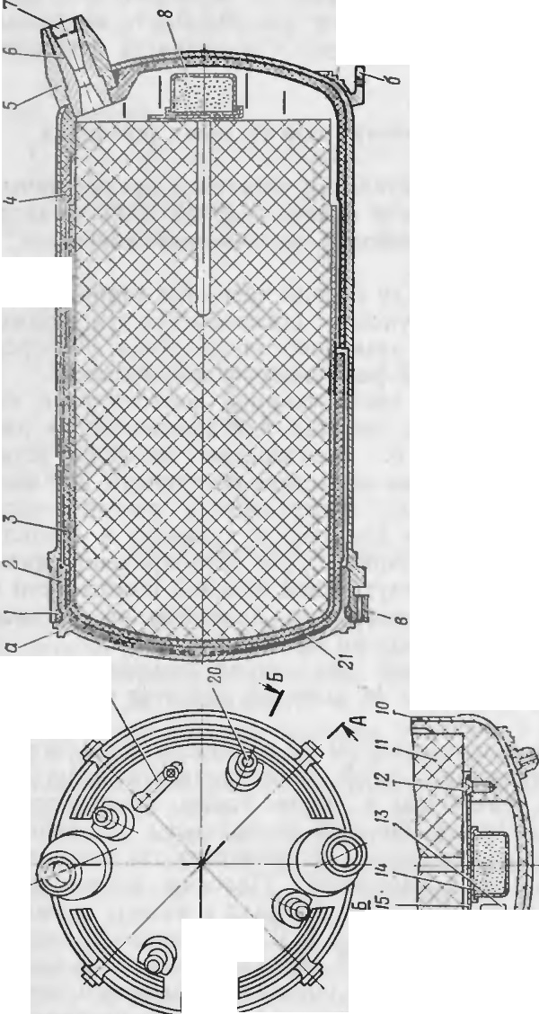

C")

*I*

•

•

I

,

O-')

.

.

I

'

lO

I I !:!?

*-fr;_*

.-...... r/ ,. -

",/

'

B Kopnyce 3neKTpoaocnnaMeHHTeJ1H pa3Mem.eHhI 3a>KuraTeJ1hHh1ii COCT3B, BOCnJJ aMeHfllOlll.HHCfl OT JJ.BYX MOCTI KOB H3K3J111B3Hl1fl, 33MeJl-

u u

nfllOlll.HH H n11poTeXHHlleCKl11'l COCT3Bbl.

3aMeJJ.nHIOlllHH COCT3B 3JleKTpOBOCilJl aMeH1'1TeJJH cny>KI T JI.JlH 33-

JI,ep}KKH MOMeHTa BOCnJJ aMeHeHHfl nopoxoaoro 33Pf1Jl3 *11* OTJ OCHTenb­ HO MOMeHTa nycKa CHapHJI.3 (pa3roHHO-MapllleBafl JI.BHraTeJJbH3fl ycTa­ HOBKa H3l HHaeT pa60T 3Tb Ha HeKOTOpOM paccTOHHl111 OT nycKOBOH ycTaHOBK11, t1To 06ecnet1uaaeT 6e3onacHOCTb pact1eT a) .

Pa6oTa P/v\llY HatiuHaeTCfl c noJI.at111 3J1eKTp11t1ecKoro HanpH}Ke­

HHfl Ha 3J1eKTPOBOCnJ1a MeHHTeJ1b 9X237- l . npu cpa6aT bIBaHJ H ero cpopc

u

nnaMeHu npo>KuraeT an10MHHHeBbIH Kopnyc tsocnnaMeH11TenH H aoc-

nnaMe11SieT nopOXOBOH COCTaB *14,* KOTOpbll C03JJ.aeT B K3Mepe JI,aBJJ e­ HHe u TeMnepaTypy, ,Heo6XOJI.HMbie JI.JJ H BOCnJJaMeHeHHH OCHOBHOrO

nopoxoaoro 3a pHJI.a *11.*

IloJI. JleHCTBHeM nopoXOBbIX ra30B 3arnyuJKH *conen* Bb 6HBalOTCH

H ra3bI, HcTeKaH qepe3 conna, c03JI.aIOT peaKTl1BHy10 cuny, JJ.BH>KY­ my10 CHapSIJI..

* + 1. AnnapaTypHbl.U OTCeK

AnnapaTypHblH oTceK npeJI.Ha3Hat.1eH JJ.Jlfl

pa3Mem.eHllfl 6opToaoft

annapaTypbI H nonacTefl. OH pacnono>KeH B pflJI.3.

XBOCTOBOH"

t 3CTH CH3·

AnnapaTypHblH OTCel( COCTOHT 113 cJJeJI.)'IOlllf X OCHOB} hlX tI3CTefr : Kopnyca *2* (p11c. IO) , nonacTeH *1,* KaTylllKil *14* (p11c. 11) npono;i.Hofl Jll llllll CU51311, Tia;\1llbI- q>,lpbl *13,* KOOJ) 1.1111aTopa *3,* UJIOKa *8* :y npan.. eHl1fl, 33 MLIK3TeJJH *9.*

I(opn}·c *2* (p11c. 10) npe.ncTa n.,1HeT co6tJii u11111H;tp 113 aJIJO t IHHe­

aoro cnnaaa. B nepeJI.11eft 43CTlI Kopnyca 11MeIOTCH '4eT hipe OTBepcTJIH *a* (p11c. 11) JI.Jlfl Bl1HTOB, Kpen51l1'1X annapaTypHbli' OTCCI( K P.lv\JJ.Y. JlonacTI-1 *1* (puc. 10) Tpaneu11en1-1.nH011 cpopMbI B n 1aHe ycT a110B-

•TJ eHbl no ly rJIOMI\. npo,.1,0

•• OC II CHa p51.la IIy KpenJieI-lbl Ha KOpnyce

JlbHOI[

annapaTYpHoro oTceKa. Ka>KAaH nonacTb cocTOHT 113 .aayx coeJI,11He1-1- HbIX Me>KJI.Y co6ofl ynpyrux r116KHX MeTaJJJIHtleCKl X nnacTl1H *6* ( p11c. ll). IIp11 C)K 3TblX n Ti aCTI Jf a .. onaCTII or116a10TCSI BOI\ pyr KOp·

n}·c a. np11 pa3)1{HT LIX n'IaCTJIJia JlOIIaCTll np11061> e1a1<>T l\CCTKOCTb H B pacKpblTO 'I nono>KeHHH yJJ.epiKJIBalOTCH 3a meJIK8:MII 7II ynopa­ MH *15.* 0TBCpCT11H *8* cny>K aT JJ.JIH )lOCTyna 1-IHCTP }'.MeJITa np11 CKJ13,Ubf­

B3HHl1 nonacTeil. B CJlO>Ke HH0.:\1 no 10:>KeHHII J10fl3CT JI y..ucpiKHB310TCSl

JI.BY.t.'lfl nonyxoMyTaMH (p11c. 12) ' KOTOp bie TaK>K e npeAila3Ha tJeHbl H

)lJJH 33JJ.ep>KK JI pacKph T11H nonacTei'1 np11 Bb CTp ene. Ka>K.nh H noJ1yxo­ MYT COCTOI-IT 113 cpna>KKa *1* H CT51)K Kl1 *3.* nonyxo:MyTbl coeJI,HHHIOTCH

Me>KJJ.Y co6ofl cuenneHHeM cT51>K Kll OJlJioro no1yx.o!\1yTa c aau.ena\111

20 :21

----- --

-

JI.pyroro nonyxoMyTa. nocJie Bb JJeTa cttapflna 113 Ko11Tc ii11c pa ¢.. a)l{­ KM *1* noaopa4 nBaIOTC5l., 06ecncq11aas1 pacuennctt 11e CTH>KeK */J* c 3ar te- 11aM11 *a,* i no.yXOMY Thl OT6pac bIBalOTCH pac Kpb1B810IlJl\1: 11C fl .1ona­

*B-B*

I • r

*B*

CTH'.'\i l. Ha KOHuax.Ti onaCTCfl HMelOTCH )nopbl *6* (p11c . 11) . KOTOpble npCJ].0TBp3IU3IOT Cl\.1elll,eHMe nonyxoMy TOB np11 nn11>Ke111111 CH3 Pfl..'l8 B KOHTe1"1Hepe.

*R*,, *-6*

(

r _J 6 - 6

*10*

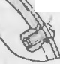

*I*

# m-6

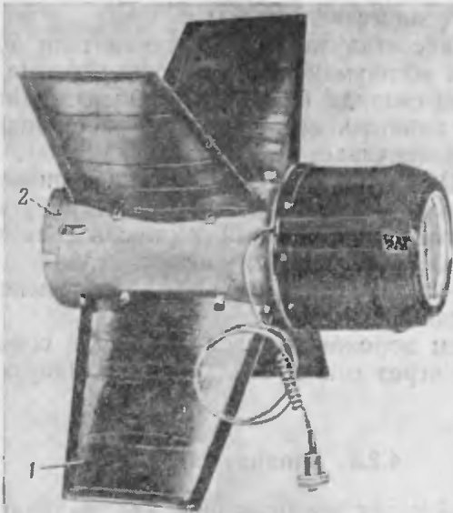

5

'

7

•

|  |  |  |
| --- | --- | --- |
| . | | |
|  | ' |  |
| c ' J  .:*> t- - .* ·=  ...--'- | | |

1

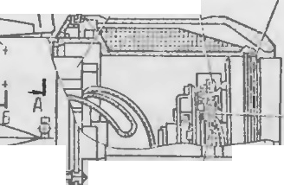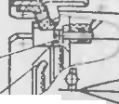

*a*



l B-l---

8 If

*9*

'

*-12*

j / - .J •

*r*

1 •

• G! )

+ t + ...

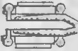

\

::f======!::.=1 *I*

if .. +

 . '"  *13*

* ik

I

P11c. 10. Annapa Typ·HblH oTCeK (o6lllHH BHJl) :

*1* -nonacTb; *2* - Kopnyc

*P.-* /J.

*noBep ttymo*

18

*B* ID

*A-A*

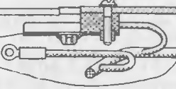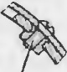

J 1J nu,. ::·- )

*15*

Koop.n11ttaTop *3* np111{penJ1eH I\ Kopnycy annapaTy pHoro OTCeKa *19*

BI-IHT8Ml1 *4,* 6JJOK *8* ynpaaJieHMH -BI- HT3i\111 *10,* Ka1·y w1<a *14* nponon­ llOH JI11H1111 CBH3II- B11HT3 111 *J i .* •T a '.'\ir t a-q)::ipa *l «'J* 3ah.pen.1etta BH).TPH

KaTyWKl-1 npono.1::.i 11011 JIH1-11111 CBH3H onopttoii raflKoi'1 *11.*

Po3eTK a *16* np11Kpen.'1eHa K KOpnycy c Il01\. 01 tbl0 .TlOTI{a *19* Ii BIH­

17

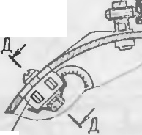

*r- r*

*•r;*

PHc. 11..<\nnapaTypHbltt OTCCK:

Ta *18* 1-1 cJiy>K 1-1T .nnH coen11HeH11H c BHJJKOH *18* (p11c. 9) .

3aMbIKaTe 1h *9* (p11c. 11) npe.nHa3HaqeH .D.J15l. 33 Mh1K3HJIH l{C n1-1 n11-

*3* - KOOpJlMHaTop; *4, 10, 12. 17, 18* - BJIIITbl; *5* - CKo6a: *6* - nnacTMHa; 7 ·- 3aw.e 1Ka; *8* -6JJOK

ynpaR 1e11MH ; *9* - 33MblK3TCJib; *11* - onopHaH ra1'Ka; *13* -JJa'.'o! na-q>apa; *14* - KaTyWKa npoeo.n­ HOA:111HMII CBH3M; *15* - ynop; *16* - P03CTKa ; *19* -JIOTOK; *Q, 8* -oTnepCTHH: *6* - ynop XOMYT3

Ta HIIH n.LJ, \\ ooeBOli 48C TIITOJl bh.O nOCJJC c paoaTbIB8Hllfl *BLL11*

*•*

OH CO·

CTOl1T 113 KOHTaKTl py10111c ro pb14ara *3* (p11c. 13) ' 1-:opn)'Ca *1,* KOHTaK­ TOB *2*II*6,* npy)l 11Hbl *5,* BIIHTa 7.

3aMhIKaTe 1h KpenHTCH K KO>K )'XY *1* (p11c. 33) J1a'.\1nb1-<pap1,1 n1111-

TOM *12* (p11c. 11) I npoXO!l.fllUlM 4Cpe3 OTBepCTl1e *6* (p11c. 13) .

n1>11 cp::i6::1T1>11 :..1 111111 B,lY ra31)1, npo,o.lH l1c pc3 0TnepcT11e *o.* (p11c. 34) B na Mne-cpa pe 1-1 -0TaepcT11c *a* (p11c. 13) B 3al\t hlKaTene, ;1.e11- CTBY10T Ha kOHT3 KTIIP}' OIUIIH pbI4a r *3.* (o11TaKT11py101U11f1 pbt 4ar, npco-

11.0JieB Ill)OTIIBOD.CttCTBHe npy.iKIIIl,J *5,* noaopa4lf BaeTCfl Ha OCH *4.* KoH­

T3KT bl *2* 11 *6* COflJ)11Kac aJOTCH 11 3aMbIKalOT uenh no,1a 111 Hanpfl)l{eHMH Ha OJ].i\16oenoi1 t1acT11.

23



22 •

4.3. KOHTER HEP

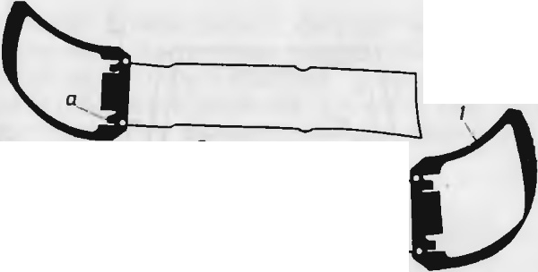

J

'

,

PHc. 12. IlOJJyJtOM}'Tbl:

*I* -4>J1a>KoK: *2* -JIHpKa ; *3* -CTH>KK a; *a* -sa1..ten

KoHTeHHep npeJI.Ha3HalleH JI.JJ H npo113BOJ1.CTBa HanpaBJJeHHoro BbI­

CTpeJJa, nepeJIOCKl-1 1-1 TpaHcnopT1 pOBaHHH CHapHJl.a, 3all.l 1Tbl ero OT MexaH11tJecK11x noBpe:>KJ1.eH1111, B03JI.ei1cTB11H MeTeopoJ1or11qecK11x <paK-

, u

ropoB 11 Ol10J10f JilleCKIIX Bpe,'lJ TeJie11 np11 x paHeHJII11 3KCnJ1yaTa U1111.

KoHTef1Hep COCTOHT 113 CJ1eJ1.y10ll.lHX OCHOBHblX tiaCTCH: Tpy6hI *4*

*(* JJIC. 14) , nc pC.:J.H eit KpblW KII *10,* 6J10K a *8* n11TaHJIH c po3eTKO i *9*

pa3beMa,3aJJ.11ei1 KpbIW Kl1 *19* (p11c. 15) , nepet1.Hero *26* 11 3aJJ.11ero *24* 3a­ uenoB, tt aK.r1anK11 *2* (p11c. 14) , nnyx xoMyToB *3,* cpet1.Hero *5* 11 3a,.1tt ero *6* xoMyroa, p) t1K11 *17* (p11c. 15) .

*7*

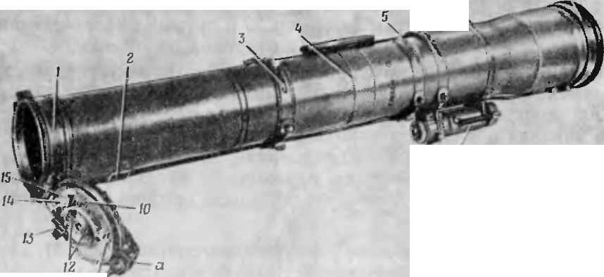

•

'

*6* '•

'

*9*

,,

-

.·-·-

I

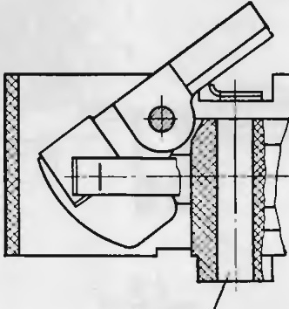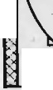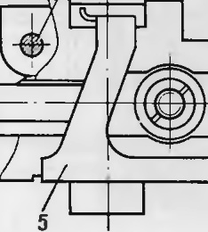

*1*

2

3

4

•

,

'

•'

•

•

~~I~~

*a*

PHc.14.KoHreiiHep (o6mHii BH.ll):

.,.

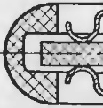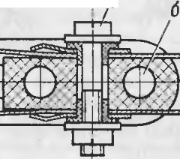

*6*

7

P11c. 13. 3a:\11,11,ar e.1b:

*I* -KOpnyc; *2. 6* - l<OHT, KTLI; *3* - l<OIIT3KTIIPYIOW.1t n pbl'lar ; *4* -Och; *5* - npy>K Hna; 7 - BHIIT;

1. *6* - OTBepc THSI

*I* -4>naHe1..t: *2* -H8KJl8.llK8: *3* -XOMYT : *4* -TpyCla; *5* -cpe.nHHA XOMYT ; *6* -38.llHHA XOMYT;

7 -raAKa; *8* -<SnoK nHT&HHJt (<S aTapeH T-307E); *9* -poseTKa pas'beMa ; *10 -* nepe.nHHB KPhIW• Ka; *11. 12. 15* - KOJIO.llKH; *13* -BKJll0'18Tenb; *14* - repweTH'leCKHA aao.n; *a* -DPHJlH8

Tpy 6a *4* (p11c. 14) 1<0Href111epa BhIIlOJIHeHa 113 cTe1<JI0Bo IOKt1a. Cne­ pe.l11 Ha Tpy6e }°CTaJIOB.rr e1-1 Q>JJaHeil *1,* 11MClOll.l l1 JJ.BC npO}" Willl )I i)> (p11c. 15) H np11.'.ll18 *K* }1.J1H np11coeJ(IIHCHIIH ncpCJI.HeH Kpblill (H.

ncpCJI.HHH KpblWKa *10* (p11c. 14 ) JI.O MOMe11ra BLICTpe.1a rep ICTlll[-

110 3a1<:pbIBaeT Tpy 6y KOHTei111epa. ( llh'.CJIP)'H CHapS'l,.l OT npo,'lO.. bl{Of O 11 Kp)·ronoro nepeMemeHJ-IH H Tpy·6e. I-Ia 11cii pa3Mcu.1.c11b1:

- l{OJ OJJ.Ka *15* (Ko.oJJ.Ka W4A Ha p11c. 51) JJ...1H np11coe,a1111c1111H KO­

J10.!l.K11 *5* (p1-1c. 18) KaTy lll {I( (KO.T O.l{a lli-1 Ha p11c. 51) ; B KO,TIO.lJ e *15'* (p11c. 14) ll tCCTCS'l 3J1CKTpOBOCnJJ a'.\f eHJ TeJlb ;:I_.l H OTCTpe.1a 1(0., 0,!lKH IJ l-1 npOBO,lHor1 JJIIIJ HM CBS'l311;

-,OJ10.!1,Ka / 2 (KOJ10,T1,K a llil6aIla p11c. 5 1), 06ecneq11BalOU13 H

3 'ICh.1p11lleC1<y10 CBH3b po3cT1<11 *9* pa3bCMa (po3CTKa WG Ha p11c. 5 1) co c11a p51,10M;

- KOJ10J1.Ka *11* (KOJIO.!l.Ka KCT 4 Ha p11c. 5 1), 06ec r1e1111na1oma H :>1c. 1<­

Tp1111ec1<y10 CBH3h 3.i eKTpOBOCn I3 MCJITeJIH 3ana 1a *39* (p11c. 15) c O<> p-

TOl3 bl 1 IICT01l lll OM n lT311llH;

..

* BK.'.IIOtJare Ih *13* (p11c. 14) nycKOBOii 11en11 BnY,

IICK 11011aI011 ll i

24 

•

B03\f O.iKIIOCTL cpa6aTbIBal llH ee 3'leKTpOBOC nJia MeHHTc.. 51 .',1.0 l'v10:\ e11Ta nOllOfO o rKpb1BaHJI51 ncpC.lHCfi I(pbIW,11 KOHTei Hcpa.

ncpen.HHP. h.pb1ll1Ka coc 1.1111c11a c q) 1a11rleM *1* rp)·6h1 c noM01uh10 npo­

y11111111,1 *2* (p11c. 15) 11 oc11 *,10.* Oc h *30* 3aK penne11a B n1Joy1111111c W TIIQ>­ TO t *32.* B 3 aKpb1TOM no.TIO)h e111111 nepC.!1.HHH Kpbllll (a }"..J.Cp:..KIBaCTCH rai11 011 *42,* HaUIIIJllCHHOii Ha pC31)00IlOH KOHCU pa3pbIBHOro BI HT a *41,*

38KpcnJJe HOro Ha 11p11.r111Be *a* (pHc. 14 ) rrcpe'l.ICH Kpb W T(II BllHTa?v111 *27*

..::,-

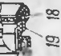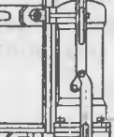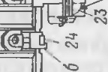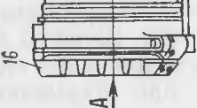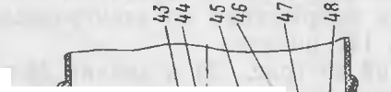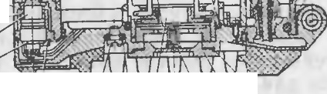

'c

0 ' \ 0)

• l01E le:' *.;:;r* )t,o

* + Cl.-

I.Q QJ ..p-I'

(p11c. 15) .

nepe..'l. l5l51 1-i:pblUKa ,lJ151 aBTOMa Till{CCKoro OTl pLIBaHIIH nepC.l Bbl­

,- c"o

°: =

O')

P")

<:T peJJOM H:\1.eeT }"CTpOi CTBO, BI<w'll01 aIOIICC pa3pb1BII0ll BHIT *4 J,* BIyT­

• \ "

co t'--

c.o

Ir)

.*.*.*.:*.*,*.*-*, C)

p11 KOTOporo ·craHOB.rteHbl nopu1e Hb *40* II 3anal*39.* Pa3pblBIIOii Bl-11-]T

..., ....,

P'")

Ir)

*..Jt*

*1* 11MeeT Ka11aBKY *u,* no 1 0Topof1 OH pa3pbt naetCH np11 OTKpW BalIIIH ne·

u

cc'v

C'b

pe!I.HCII Kpbllll -i:11.

-

B OCII*30* J)aCIOJIOiKCHLI ¢1-11<.Ca TOp *3,1* 11 npy)KIIHa *31,* 06cc nc1111Ba10-

U{llC <p l[(C3 UIIO nepC 1. t'l <pblW KI[ B OTl-i:pl TOM nO.'.IOiK eHllll.

np11 BhlCT pe.1e la 3.' CKTpOBOCI JlaMCHHTew bI<pblill (II Il0}l,3CTCH 1-l a­

N :1

' Q,)



"'"> "'">

' "'">

N

TipSl}l(CIIJle OT 6opTOBOfO IICTOLIHII a n11T a1111H, cpa6atbIBaeT 3ana.1 *39.* np11 Henons11}1<.1101 nopw1re *40* nan 11eH11c ra3oB J)a3pLIBaeT s1-111T *41* no 1 aHaBr<e *u* 11, nei'1cTB 51 Ha nepeJJ.111010 Kpb1lll1<}·, coo6macr eii 11M­

n ·11oc 11a OTK pb BaHJIC. 11p11 o rKpbIBaHl-111 nepe..'l.11ei1 l{pblW Kl1 BblCTy n

¢111c aTopa *33* no1 nci CTBHCM np}·)K11HbI *31* nepc '1emaeTcH B na3 *B* cJ.>JJ aHua *1* (pHC. 1-1) H {pll (C ipycT ncpc.111-11010 KpbIWl(Y B OTl<pblT0 '.\1: no­ JI Oi CHI H.

B cpe 11.Hett LiaCTH l(J)blW K Ill\1CeTcH 01'BC pCTl C *:JIC* (p11c. 15) , 3a1 pb1- TOC 3arJl'illl\Oii *34,* o6ec ne411831()1UCC .ilOCTyn I( J-i:OllTJ) OJibJIOMy pa3'beM)' ( llIa 11a p11c. 5 1) . ra1'iKa *43* 11 Liaw1ca *44* 06ecnet111Ba10T ¢11Kca1t1110

·CH apSina B I{OHTeitHepe. B1111T *35* npC..'1.0TBp au1acT OTBIIHIIBaHHe raft ­ Kii *43.* 0TBepcTJ-le, 3:Jl pblTOe BIIHTOM *37,*lICnO 'lh3} erc H np11 nponc pl'i.C

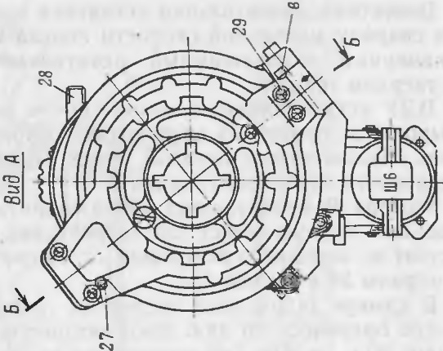

TCH

•

c )

r--...



ll")

....),

KOJf

•• HepaIla repMCTif lHOCTb.

CHap)'iKII 11a nepe.aHeii KpbIW J{C pacno., 0:m:cH 6·¢c p *16.* npC Jla3- Hallett11b1f n 151 aMOpTll3a UIIJI np11 cJiyLiai HOM na, CHllli CHapH..la 9,\ \ 113 Ha nepe}1.111010 1<phlw Ky. b)'q>ep *16* 11p1-11<pen.. cH K nepe 'l ·lcii 1 p1>1w1<e BllT3 Mli*29.*

•

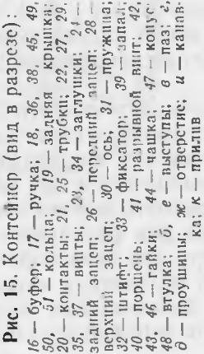

CoC. JIJ(CIIIle 1{0HTaK1'0B KOJIO..'l.01{, pacn0.. 0iKCHHbl X Ha nepC, HeH

KpblW KC, c po3eTKOM *9* pa3'bCl'v1a ( p11c. 14 ) OC}'1UeCTB 11s1eTCH KryTOM, 3aK.'JIQl eIIHbl\f n MCTaJJ.rJ J[4eCKYIO Tp}0 6K}. *25* (p11c. 15) . )Kr)1T nne 1e1I

B ne peJJ.HIOIO KphilllKY 4epe3 repMetHtleCKli l BBOJJ. *14* (pHc. 14 ) , COCTOH­ lUilii 113 BTYJJKli *48* (pl-IC. 15) , KOHyca 47 1-1 raHKlI*46 .*

B cper'I,Hef1 l!aCTII KOHTeHHepa pacno., OJKCH 6JIOI{ *8*Il lT3Hllst (pHC.

14) . COCTOHlllltt 113 D.BYX oaTapeA T-30713.

Po3erKa *9*l)a3beMa np111<penJJeHa 1-c Tp}·6e 1-coHTe1111cpa xoMy ToM *3.*

b lJOK IlHTaHHH npl1Kpcn rreH K p03CTKe pa3nCMa qCTblpbMH BIIT a­ MII *22* (p11c. 15), a K rpy6e KOHTCMI cpa - 3aD.HHM XOMY TOM *6* (pHc.

14) .

Jl.JJH 3aIUITbl OT MCX aHJILieCJ(HX noBpeiK,leHllHIiB03 1.e1iCTBl H MeTeo­ poJJOfl 4CCKIIX cpa KTOpOB JJ 03CTKa *9* pa3 LCMa 3aKpbITa 3 a r1)'ill (OI[ *23*

(p11C. 15) CI<OJlhUOM *51.*

26 27



)KryT, 3 aJ(Jl10l!elll-Ibii:°1 B Tpy6Ky *21,* 11 KOHTa ({Thi *20* rrpen11a3HatJeHbl JJ.Jl fl IIO)l3lll1 11a11ps:i>KeHJIH Ha 3JJeKTp OBOCilJiaMeHJ TeJ1b B.UY OT 6JJ O­ Ka *8* (p11c. 14 ) IllT a HIIH.

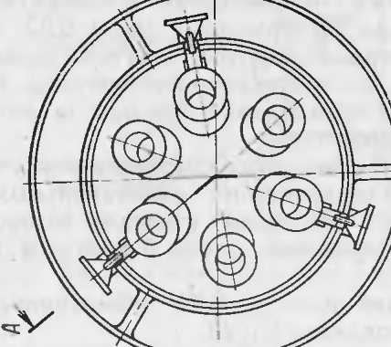

nepen11.Hft *26* (p1-1c. 15) H 3aAH11fl *24* 3auenb1 11 BhicTyrr *6* cJiy>K aT

., " .,

JI.Jl fl CTblKOBKl1 KOJITCI Hepa c nycKOBOl1 ycTaHOBKOl1.

BepxH1-1e 3auenh1 *28* npe.n.Ha3 HalleHhI AJIH 3aKpen 1eH11H ctta ps:iAa

*91\il* 1 13 Ha JlOTKa x rro.n3aps:!JI.Kl1 B 6oenofr Malll.HHe 9CT 148.

3a;i.Hflfl KpbllllKa *19* npe.nHa3HatJeHa JI.Jlfl 3all.lHTbl BJlyTpeHHeH no­  JlOCTI KOITett11epa OT IlblJlH 11 BJ1ar1-1. Otta 11MeeT B cp e)lHeH t{ aCTH qe­

Tbipe 3auena JI.ns:i coe)l1111eHHH c B.UY 11 Kpen1-1Tcs:i K Tpy6e raflKof1 *7* (p11c. 14 ) , KOTOpas:i 0].lJIOBpeMeHHO CJJY>Kl1T JlJlfl aMopT113allHll CHa pHJI.a 9/\\ 113 B CJI)'lJ ae na.neHl1H ero Ha 3a)lHIOIO KpbllllKy.

,llJIH 06ecne11eHl1H repMCTHllHOCTl1 BHyTpeHHeH IlO,, OCTH KOHTeHHe­ pa B MeCTaX pa3'bCMHb X COC!l1HCHl1H 1-IMelOTCH pe31'1HOBhie KOJlbUa *18.. 36, 45, 49* 11 *50* (pHC. 15) .

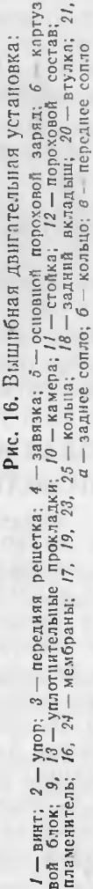

)lJJH nepeHOCKH KOHTefiHep 1-1MeeT py·tJKY *17.*

4.4. BbllllHEHAjl nB11rATEJl b HAjl YCTA HOBl(A

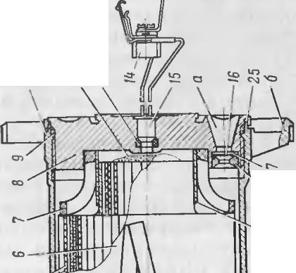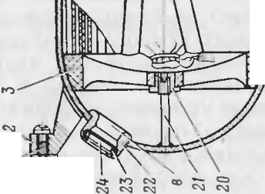

«-:::>

-C"-1 "-">

-

0-0

c-:n

.

'

-

'

BbllllJI6HaH !lBHraTCJlhHa s:i ycTaHOBKa npenHa3Hat eHa .!].J151 coo6me­ Jllfl cHa ps:i.ny H8'43JlbHOll CKOpOCTIIno 1J eTa H npe)lCTaB fleT co6ofl OJl­ llOKaMepHbli, 0..l' .HOpe>KJ MJlblfl peaKTIIBHblH JI.B11raTe.I' h, pa6oT310lllHH Ha TBep,lOM TOilJJHBe.

B,JY ycTaHaBJ111naeTc s:i B KOHTeHHepe Me>KJly cHap s:i.noM 11 33JlHeft

KpbllllKOii l COCT011T H3 cJ1eny1om11x OCHOBHblX qacTeii: KaMepbl *JO*

(p11c. 16) , COilJlOBOro 6 TJOKa *8,* CTOeK *11,* 3JleKTpOBOCilJ1a MeH11TeJ1H *15*

11 ocHonttoro rropoxoBoro 3apH,la *5.*

KaMepa *10* npe"lcTaB.' 51eT co6oi-i cnapHy10 KOHcTp)·1<u1110. CcpepHLie­ c1 oe .ntto KaMepb1 11 1ceT rnecTh nepe.nH11x conen *B.* l(a.>K..1oe conno

cocT011:T H3 nepe.nHcro BK Tianh1U1a *22,* 3anpecconatt ttoro B AHO KaMepbl, MeM6paHbl *24* III{O lhit a *23.*

B Ka Mepc 3 a1(penJ1eHa nepe.UHHH perneTKa *3,* 11:\1eioll1aH ynop B •

ue111·pe ccpcp11Liec1 oro n11a. 'nop ocy11tccTB TJ HeTc51 t1epe3 ll1TH¢T *21* 11

BTY JJ (Y *20* 11 cJJy)l{J T JlJl fl yBe.1, I lllCJ-IJ 51 npOLJHOCTH perneTI<H np1-1 pa6oTe  B)lY.

Con.i1.osoii 6 OK *8* BB111111e11 B 1<a'.\1eP }' *JO* 11 11:\- eeT nHTHaAuaTb 3a.n- 1111x conen *a.* (a>K)loe conJJo 11MeeT 33.ll.HI-IH BI(JJa.J.billl *18,* l\teM6paHy *16* 1-1 1{0 1bUO *17.* B COIIJlOBOM 6 TJOKe 3aKpenJJ eHbl 33..'l.Hflfl perneTK a 7 H B1')'Jll{a *19.*

1\ \ e16patt b1 *16* 11 *24* 06ecncq11na10T repMeT1111HOCTh BllY 11 JI.aBJ1eH11e B l\.3 \1Cpe, Heo6xo.n111oe JJ.JlH CT3 011JlbHOro BOCilJ1aMeHeHl151 OCHOBHOro nopoxonoro 3aps:ina *5.* PerneTKH *3* 11 7 npeJI.Ha3HatieHhI n,r,z s:i ¢11Kcau1111 3 a ps:i,.la OT npo,10J1hHoro 11cpeMe11teH11s:i 11 JI.JJH ycTpaHeH11:s:i 3 a1<ynop11Ba- 1111fl cone., qacT11uaM11 Hecropeslllcro nopoxa B npouecce pa6oTbIBJlY. CT0111<11 *11* npe.nHa31:Jat1eHbI JlJlfl ¢111<cau1111 cHap s:i,J,a OT npoJJ.OJibHO­

ro nepC;\ CIUCHllfl B KOHTeiHepe np11 Tp aHCI 0pTl pOBaHl11'1. W T11¢T hl *26,*

B'XO,l5lll111C B na3bl *2* ( p11c. 18) o6TeKaTeJ151 KaTylllKl , yJI.epn<I BaIOT CHa­



PH!l OT ca Monpoi 3BOJibHOfO nepeMemeHJ fl Bncpe;t np11 OTKPbIBaHI-111

u u

nepC JICll Kpbllli {l-1 KOHTelt Hepa nepe)l BbICTpe,, 0M.

28 29

•

3 1e1(TJ>Ol\l)C.: II.,1c.l MCllll[C 1L */ fj* ( r> llC. l (i ) uu111111e1-1 B 11eHTpa.. bHOe OT­

BC pCTIIC con t)BOrO O.lI'

OK a. 1'13 KOPil) ca BOCnJla '.\1€ 11lT€J1H Bb BeJ].eHbJ

*'6JW;y-;;p-a6JleHu*

).lBa np0Bo,. a,I(OI[l bl l(OTOpbIX np11COC,J.Iltle1-1h1 K I{OITa KTHOMy 6 '10- I<y *14,* npeJl1-1a311a1I('I-IHOl.\1y }1.JlH 3J1e 1i:1p11 1cc Koi'l CBH311 B.1Y c KOllTa 1(­

I *6upmosoii* I

:;.._4--( *ucmo ttux* i---

*/laMna-lfJ(lpa*

--::

f 6/IOX

*py11esoiu*

TaM11 *20* ( p11c. 15) Ko1-1Tei1Hep a. B Kopn)·ce 3.r1e1<Tponocn.. a:\1eH111eJ1H

1 *numa11u11* 1

*npuaoifa*

pa3rv1eme11b1 3a:iK11raTeJihJ-lh H 11 n1lJ>OTe Hil1Icc1<11H cocra Bhl, noc n.-1J'.\te­

HHIOllllecH OT ..lB}'X MOCTIKOB Ha KaJIIIBaIII-l5l npll nosaqe HanpH>KeHI H Ila KOHTaKTbl 3., eKTpOBOCnJ1aMelllT€.'151.

l I '-----..--

I



|  |  |
| --- | --- |
| *npoooiJHaR*  *JIUNUR CBJIJU* | I |
| I |

1-1opox 0Boi'1 3apH.!l 9X 180 *5* (pHc. l G) pa3:'\1emeH B Kapr13e *6* 3apH-

11a 11 COCTOl[T 113 Ha6opa Ul-lJIHHJJ.pi '-leCKl[X OJ].HOKa11aIhHblX Tpy 6oK.

*npueMNUK*

::;;.+-

I

*KoopiJu Nam*

-i

KaJ Ty3 3ap51;i_a 11MeCT JlBOtt11oe JJ.JIO, 1em:,.1y cTe11Ka'.\111 Koroporo noMe­ meH nopoxoBoii cocTa a *12.* CTopoxonoii 3ap51,1. *5* Kpen1-1TcH K 3a.1.11er1

I_ _

_ _ _ J

perneTJ(e 1.Bytvt H 3aBH3K8 Ml1 *4 .*

f ep 1eT11qHoCTh BHyT peHHei'1 no.r1ocT11 B;lY 06ccneq11BaeTcH no;i.­

)K3T11e'.\1 }n., 0THIITeJ1LHblX np01(.Tl8Jl01( *9* II *13.*

JlJIH ucHTp 11pona1 11R 1-1 cp11Kcau1111 *Bil ·* B K011TeHHeJ)e c.r1y>K aT TPH

}'nopa *2*llI(OJibUO *6* KaMepbl. c IlOMOI..UblO BIIHTOB *1* K y nopa 11,,1 *2* Kpe­

f[HTCH Tpll CTOll (II*11* CO lllTI-lcpTa tvtll *26.*

PaooTa BbllllI611o i JJ.BJlf aTeJihHOii ycTal[OBKH 3a K.. lOLJaeTCH B CJie­

ny1011 eM. CT p11 no 1,aqe 3J1eKTp111 ec1<oro Hanp 1>KCH11H HaI<OHTar.THhlH 6 'lOK *J .J* cpa6 aTblBaCT 3J1€KTpOBOCn.ria'.\t €Hl-1TeJ1h *15.* ¢ope nJial\(CHI( 33 -

.iJ(IlraeT nopoxonoii COCTaB *12,* OT KOTOporo Bocn.r1a Me1-151eTCH OC HOBHoii nopoxoBOH 33PHJJ. *5.* no.!]. J].€HCTl311€Ivt ,.l3BJI€ l-lIIH nOJ)OXOBblX ra30B pa3- P}'lllaIOTCH MCM6paHbl *24* ll *16* COOTB€TC1'B€HHO nepeJ.HllX *8*II3 a)l.HJJ'( *a*

con*en.*

PHC. I7. CTpyKTyp11aH CXCMa 6oproooii annapaTypbl

*s,* ,,..

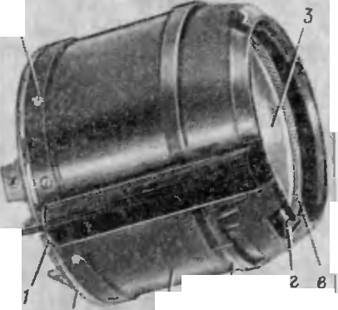

'', 4 1

*;f*

*I*



*r*

,, *11*

Jlan.. eH11e nopoxOBhlX ra3oB, 11cTe1<a1om1-1x qepe3 nepeJJ.HI e con.r1a,

..1ciicTB}·eT Ha cHapRJJ. 11 coo6maeT e:\1y Hat1a.'.ILHy10 c1<opocTb no 'leTa. PcaKTIIBIa5l THra nopoXOBhlX ra30B, IICTCI(aIOll X qepe3 3anH11e

CODJlOBblC OTBCpCTI H I[ qepe3 KO/ hUCUOC ce1IeH11e, o6 pa30Ba1-11-1oe BH)"T-

v •• " ,,,.,

peHHCJI nonepxHOC ThIO KOHTeI-1HepaII 113P)"}KH011 IlOBCpX HOCTbIO BbllllIO-

u *v*

HOii .!1.B If aTC.TlbHO II }.C T3110Bl\ l, YMCHl)W aeT OT.l3 4Y np 11 BbICTJ)CJl e.

,

I) i t

1:..----

I

*6*

2

*Q*

1. 60PTO BASI A nn.l\ PATYPA Y nPA BJl EHHSI CHAPSIJI.OM

5.l. H:\ 3HAIJFHHE, COCT.i\B H P1\3M[lllEHHE 60PTOBOM

.,. nnA PATYPhl

6op10BaH annapaTyp a yr1pan.r1e1111H npc.:t.Ha3Hat1eHa .J.JlH np11e1a CIIrHa., 08 ynpaB.'IeHl1H, Bblpa6aTbI,B3C:\[b X Ila3e'.\ I[OH annapaT}'POi'I )'I­ paB 1eHIIH, J[ X pa.3.!1,€J1CHIIH no COOTBeTCTB}' Oi il:\-1 BblX0 1lltII\I KaCl\ 3.l3 t npt lC'.\ III Ka B 33 BIIC JI\I OCT11 OT yrnosoro nO., OiKLiIIISl spalll31 lleroc5l Clla pH '1.a C noc.1c,.1.y10Illll-1 npeo6pa3oBaHI e'.\t KJ\13H.l B OTKJl() l[eIIIIH py 1ef1 1-1 .JIsi nepe.na411 Ha nycK ony10 }-cTaHOBKY 11Hcpop'.\1au1111 o 110.. 0- mc1111H c11a p51,.1.a OTI OCIITCJ bIIO.111111111 B1131IpOBa111151.

EopTOBaH annapaTypa ynpaB 'lelllH COCTOllT 113 KaTy lllKI , npOBO.l­ HOII Jl lHIIII CBSl3 JI, 6J10Ka ynpa n1e111151, KOOp.!I.lll aTopa, 6 10Ka py.'IeBoro 11p11so <J 11.1a Mnb1-cpa pb1. Bc5l. anna1)a1 ·pa pa3:\ ellleHa B anna paT}'P · HOM OTCCKC, 3a l[C K.. l01[CHIIeM 6 no1....a p JICl30ro np11Bo1a, pacnoJ10) (e11- HOro B ro1on11oii 11acT11 CHapHJ.a.



CTpy1<T·p11asi cxc)1a 6opTonoii annapaTyphl ynpa.BJie1111H 1np11•Be.!le­ Ha 1-1a p11c. 17.

30

PHc. 18. KaTywKa (061UHH BHJI) :

*I* -o«STIOparop; *2 -* Ko>Kyx; *3* -Kap1<ac: *4* -BHHT; *5* -KOnO,'.lK8;

*a* -n0Rco1<; *6* -BblCTyn; *B* - peab<5a:e - aa3

* + 1. l(aTyw Ka npOBOJJ.HOH JIHHlili CBs:1311

I(aTylll Ka npoBOJJ.Hofi n1rH1-111 CBH3II npe:i.11a311aqeHa ,.l'15!. 06ccne1Ic- 1H11s1 11Ppe.!].a1III c11rHaJ10B y npaBJiel-lIH C nycKOBOH ycTaHOBKl1 Ha c1-1a­ pH..l. 011a pacnO.O>K CHa B annapaTyp1-10M OTCCK e 11 HB.. H€TC51 X DOCTO-

•• 4aCThlO CHapH,.1.a .

80

11

Ka T\·111Ka fl T C cocTOI T i3 c.1e..1y1om11x oc110B1-1L1x qac1c1"1: KapKa- ca *:J* (p11c. 18) ' o6TIOpaTopa / , KOn<yx a *2,* l(OJIO;.lKll 5, o6TCKaT CJI51 *1:!* ( p11c. 19) 11 113MOTKII*6* npoBOJJ.a,I(OJlOJlKII *16.*

l(apKa c *3* (p11c. 18) CJIY >K HT J]. 'IH YK.TJ a]J.Kl1 npOBO.la JI Kpenne1-111H

1-18 lie\[ OCTaJll)HblX J].CTa., e11 KaT}1lllKl . CT OHCOK *a* KapKaca npe.i1. .1133- tt a 1e11 .!1.JlH HanpaBJleI-11151 ,!l;BH>KeHHH B KOIITCl1Iepe BOCTOBOl[ ac,:11

" u

CIIapH,.la. 8 Ka1[a., e noRcKa pa3M€UlCH npy)KIIIIHUlll l pape3HOII 00- T OpaTop / , a B .MecTC pa3pC3a 06T1opaTopa -pe311HOBhll[ BKJI3,.1.bllll

*13* ( puc. 19). 06r1opaTop 11 BK.'.la.lbII Ic., y>K aT ;i.., 51 npe,lOTBpame1-111H

31

•

*tJ*

::s:

Q.

npoph ·Ba nopoxoBb X ra30B B.llY tvt e)KJI.Y cHapHJI.Ol\t 11 BHyTpettHeH no-

u

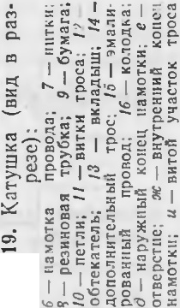

eepXHOCTblO KOIITeH11epa•

•

Ko>Kyx *2* (p11c. 18) aa.KpbtBaeT ctt apy)K fI npoBO.ZI., yny11u1aeT ycno­ Bl1H ero C 10TK11 fl Kpen -ITCH K KapKacy necHThlO Bl1HTaM fl *4.* Ha KO­

>Kyxe Hl\t elOTCH Bh1cTynb1 *6,* B KOTOphte yn11pa10TcH CTOHKH B.llY, u na3bl *2* .ZI.JJ H cuenJ1eH11H co lllTHcTaMH cToeK B,UY.

Pe3h60BOe OTBepCTHe *e* (pHc. 19) cJiy>KH.T .ll.Jlfl BHHTOB, KOTOpblMH KaT}'lllKa KpenflTCH K Kopnycy annapaTypHoro OTCeKa.

Pe3h6a *8* (pf1c. 18) cJ1y>K11T .ZJ. TJH HaBHHllHBaHfIH onopttoii raHKH

*11* (pf1c. 11).

Ha KapKac HaM0Ta11 .nsyX)Kl1JibHhJH 61-1MeTa.1JJ1HlleCKJ H 9!\t aJIHpo­ BaHHh H nposo 1. *15* (pHc. 19). HaMOTKa npOBO,!la pH,!I.OBaH, nJIO Tl 3H, BHTOK K BliTKy. BHyTpeHHHH KOHeu 11a l\tOTKfl ·Bb Be.ZI.eH K KOJIO.ZI.Ke *16*

Jl1H coe,lHHeHHH C



.npHeMHHKOM. Hapy>KHb H KOHeu *8* HaMOTKH npe.n­

0

I:

0

(Y)

0

c::c.1 X:.

O'l

-0

c;:

0

E

Q.)

c:::t

32

=--

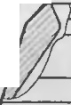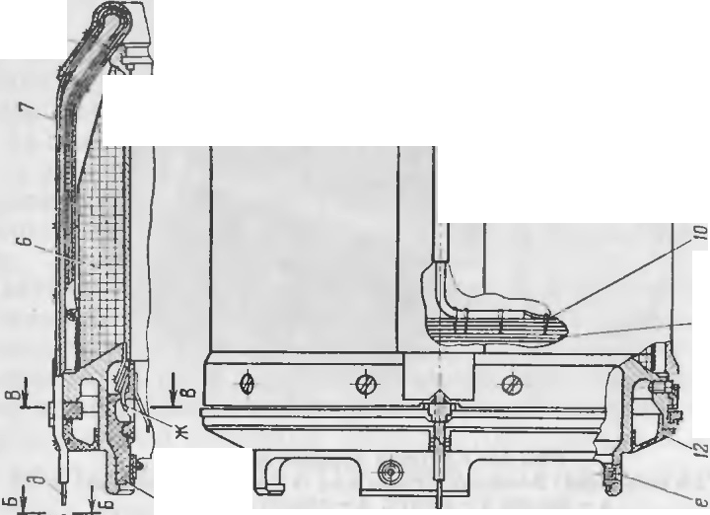

I

I

:s:

-

·- -

_

.

•

<-.o

-

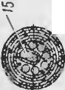

.!-----,-Cl')

--

I 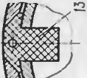



•

•

CT3BJIHeT COOOH Tpoc, COCTOfllll.HH H3 OCHOBHOro TOKOHecy1U.ero 3:MaJIH­

poBaHHoro npoBO]la *15* 11 Tpex .nono 'I · TeJibHhlX TpOCOB *14,* Ka>K)lblH r13 KOToph .X cBHT 113 nsyx npoBO.ll.OB. ToKoHecylll.HH nposo 1. c JtonoJJ­ HJ TCJihHhil\tH TpocaMfl ynpotIHeH HHTKaMH H KJleeM. nocJie)lHHe BHT­

KII *11* Tpoca, YJIO>K€11Hble Ha nosepXI OCTl-1 HaMOTKH, nO.ZI.THHYTbl K npe­

JI.bl,.lYlll.fl:\1 BHTKa!\-t Tpoca neTJIHMH *JO* Ha HHTOK. Tpoc npHKpenJieH K KO>Kyxy *2* (pflC. 18) HHTKal\1H 7 (p11c. 19) 11 Bb ·BeneH t1epe3 OTBCpCTHe BO BKJ13,.lblll1e *13* K KOJionKe *5* (pHc. 18) . BHTOH yt1aCTOK *u* (pHc. 19) Tpoca yl1eHhU1aeT HaTH)K eHHe ero npf1 cTapTe ctt apHJI.a. BepXHHH pH:I. HaMOTKH B!\1eCTe C Bf1TK3MH Tpoca noKpblT TepMo3alUJ 'I'HhlM COCTaBOM.

Tpoc *14* aa1U.H11teH OT B03AeficTBIH ropHmux ra30B pa60Ta10IUeH B,UY peaHHoBoft Tpy6Koii *8* u HaKJianKaMM 113 nJIOTHOH 6yMarH *9.*

npH nycKe KOJJOJI.Ka *5* (pHC. 18), coe.nHHeHHaH c KOJJOJI.KOH *15*

(p11c. 14), OCTaeTCH Ha nepentteft KpbllllKe KOHTeHHepa, TpOc BblXO,!J.HT 113 JlflpOK H BKJJa.ZI.b llla *13* (pliC. 19) , pa3pb1BaeT 6yMary *9,* HliTK fl 7, neT TJ fl *10* H 11a11H11aeT CM8Th BaTbCH c KapKaca K3Tj'll1Kli nJIC.

* + 1. 6JIOK ynpaoJieHHH

BJIOK ynpaBJieHHH npenHa3Ha11e11 JlJIH npHeMa, pa3JteJieHHH H ycH­ JieHHH no MOlll.HOCTH CHrHaJIOB y npasJieHflfl, nocTynalOl.llHX Ha cHapH.ZI. no JI.ByxnpoBO:llOH JIHHl1H CBH3H c nycKOBOfl ycTaHOBKH, H. 06ecnet1e­

HHH 3J1eKTpH11ecKofl 3Heprueft 6opTOBOH annapaTypht ynpaB ieHfIH rt no,.1a4u HanpH>KeH1-1H Ha 3JieKTpoBocnJia MeHuTeJih Plv1.llY, CT.llfi.\ M

.fJaMny-cp apy.

DJIOK ynpaBJieHHH pa3MemeH B annapaTypHOM OTCeKe H COCTOflT H3 CJ1e.ny10m11x OCHOBHb X qacTef1: npfleMllflKa *6* (pHC. 20) I )KfyTa *1,* llHepuMOHHoro 38MbIKaTeJIH *1* (pHc. 22) ' 6aTape11 T-4 17 (pHC. 23) .

CTpfle:\ HflK CMOHTHpOBaH Ha .ll.BYX nellaTl blX nJiaTax *3* (pHC. 21) fl

*4* fl3 q>OJ1brHpoBa1111oro CTeKJioTeKCTOJIHTa. Me>Kny nJiaT3MH pacnOJIO­

)KeHhl sJ1eKTpopanf103J1eMeHThl. PaccToHHMe Me)K.ny n TJ aTaMfI onpene­ JJeHo ,BTy.. KaMM *5.* llinHJibKli *1* npeJI.Haa11at1eHbI JJ.JJH B3aMMHoro Kpen­

lie11 1H nJiaT *3* H *4.* Ha nJi aTe *3* flMelOTCH lllTblpH *2,* KOTOpble coeJI.HHe­

ibl c npOBO.ZI.aMH )KfyTa *1* (p11c. 20) . ,llJIH 06ecne11e 1HH 11eo6xOJI.HMOH

-3 3aK. 1669c 33



 *5-;;f!·*

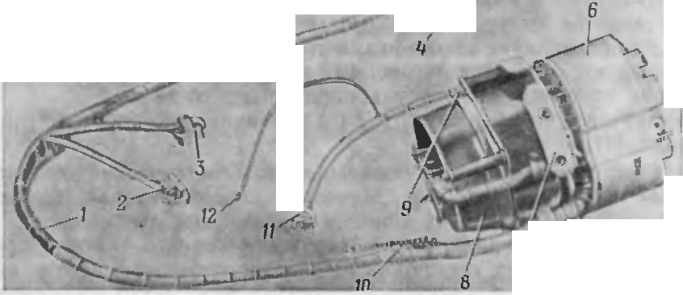

....

' ;si

•

*r*

*!>'<.,.*-

7

npoqHocTH np11eMHHKa npocTpattcTBO Me>K.ny nJ1aTaM 11 3anoJ1HeHo neHo­ non11ypeTaHoM *2* (p11c. 22) . CTa3 *a* npe.n.Ha311at1e11 JI.JJ H yKJia KH npoBo­ JI.OB KaTy W KH. BHyTpH np11eMHHKa pa3Mew.eH HHepUHOHHb H 33Mb Ka­

TeJJ b *I.*



PHc.20. 6.'lOK ynpanJieHHS1:

*I* ->KryT; *2. 3. I J* -p03CTKH; *4, 5. 10* -KOnOJlKH; *6* -npHCMHHK ; 7 -OCHOB3HHe; *8* -

6aTapeH T·4 l 7; *9 -* BHHT; *12 -* nenecToK

-- ---- --

PHC. 22. TipHC\1HHK:

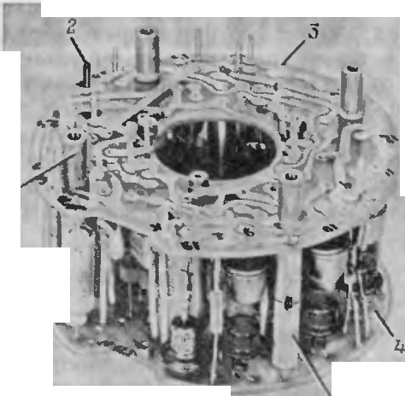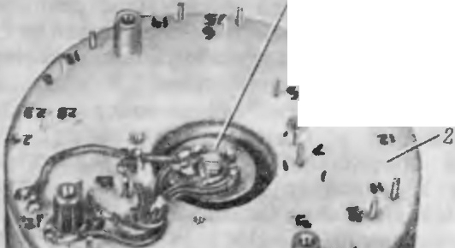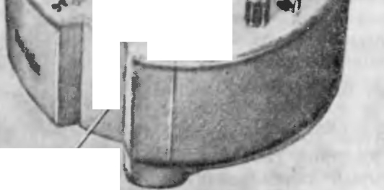

'

*a*

*l*

*I* -HHepHOHHblA S8MblK8TeJib; *2* -neHononHypeTaH; *a* -033

*1*

)KryT *1* (pHc. 20) c noMoWhlO nenecTKa *12* 06ecneq11aaeT 3J1eKTpH­

' qecKy10 CBH3b 6JJOK a ynpaBJlellHH c KopnycoM CHa pH.na, c IlOMOlll.blO po-

.

) 3eTKH *11*-c 3JJeKTpOBOCnJJaMeHJ TeJleM P/\1)],Y, c noMOUlblO KOJJO.D.KH

*JO -* c Koqp.n1-111aTOpOM, c noMOUlblO KOJJOD.OK *4* H *5* -c 6JJOKOM pyJie­ Boro npHBO,!la H c noMOIUhlO po3eTOK *2* 1-1 *3* -c CTJJ.M 6oeaoi1 qacTH.

HttepuHOHHbIH 3aMhIKaTeJJb npe.uHa3HaqeH .D.JIH 3 aMbI<aH11H ueneu

.....------ -- *5*

Puc.21. npHe'.dHHK:

*I* -WnHnbK3; *2* -W Tblpb; *3, 4* -nn&Tbl; *5* -

eeynKa

34

no.n>K11ra 3JTeKTponocnJ1aMeH11TeJJ H PMJJ,Y 1-1 JT aMnhl- cpapbI.OH cocTOHT H3 cne.ny10utHX OCHOBHbIX tJaCTef1: Kopnyca *4* (p11c. 24) ' rpy3HKa 5, npy­ iKHHbI*3,* .nayx KOHTaKTOB *JO,* Tpex KOHT3KTOB *6,* KpbIW KH 8, JIOBYUJKH *11,*

cTep>KHH *1,* rnap1-1Ka *2* H .neTaJJei I<penneHHH. Httep1tHOHHbIH 3aMbIKa­ TeJJb KpenHTCH K nJJaTe *4* (pJ-Ic. 2 1) JI.BYMH B 11 Taivf H *12* (pHC. 24) .

Pa6oTa 1-1Hepu1-10HHoro 3a1"t bII<aTeJJH 3 a <JJI04aeTcH B cne.ny10meM. B 1"10MeHT CTapTa cHapHJI.a non. JI.CHCTBl€M CTapTOBbIX neperpy30K cTep>KeHb *1* c rpy31-1KoM *5,* nepeMerr taHch OTHOcHTeJJhfIO I<opnyc a *4,* >Ke­ cTKo cBH3aHHoro c KopnycoM cHapH.na, non)l<HMaeT npy>K11Hy *3.* KoH­ TaKThI*10,* >KeCTKO CBH33HHbl€ c KOpnycOM *4,* CKOJ1b3H no rpy31-IKY *5,* no­ na.nalOT Ha ero MeTaJJJJHt1ecKy10 qacTh, KoTopaH 3a MbII<aeT uenh no.n­

>KHra 3JJeKTpoaocnJJ aMeHHTeJJH PJ\\Jl.Y. a rnap111< *2* Bbt KaTbIBaeTcH B Jio­

ByUJKY *11,* >KeCTKO CBH3aHHYIO c KOpnycoM *4.* nocne npeKpaUI.eHHH .nett-

35



CTBHSI CTapTOBhlX neperpy30K no..n. ..n.eHCTB leM C:>KaTOH npy>K HHhl *3* CTep­

>K.eHb *1* c rpy3HKOM *5* HallHHaeT nepeMelll3TbCH B o6paTHOM HanpaBJie­ HiH. Bb1naBillHJ[ rnapHK n03BOJ1HeT rpy3HKY *5* nepeMeCTHTbCH .no corrpH­ KOCHOBeHHSI ero MeTaJIJllllleCKOH llaCTblO c KOHTaKTaMH *6,* np11 3TO!Vt 3a­

MhIKaeTCH u.enh HaKaJla J18Milbl-4>apbl.

BaTapesi T-417 (pHc. 23) npe.nHa3HatieHa ..lI.JlH 06ecneqet111R 3JieK- TpHtJecKol1 3HeprHeH 6opTOBOli annapaTy phl CHapH..n.a. 0Ha npeACTaB­ JISieT co6oi1 repMeTHllHh H MeTaJ1J1Ht1ecKHH U.HJJlH.llP c noMemeHHhIMH B Kero 3JleKTpOXHM llleCKHMH 3JleMeHTaMH, Me K..lI.Y KOTOphlMl-1 pacnoJiara-

lOTCSI n1-1poHa rpeBaTeJ1H C 3JleKTpOBOC­

u u

op.n11HaT rrycKOBOH ycTaHOBKH, C Cl CTeMOH KOOp..lJ.HHaT BpamaromerocH

cHapH.n..a (pacnpen.eJJ HeT KOMa H..lI.hIno Kypcy H TaHra:>Ky Ha 3JJeKTpoMar - HHTHblH npHBO.ll qepe3 BhlXOJJ.Hh e KacKa,llhl npHeMHllKa nocpe..n.cTBOM na-

MeJibHOro ..n.aTllHKa B 3 aBHCHMOCTH OT )7f J10BOrO nOJJO:>KeH lH Bpamaio­ merocH c11a pH..n.a) ..

Koopn1111aTop cocTOHT H3 cJie..n.yromHx ocHOBHh X qacTeii: Kap..n.a110Ba no..n.Beca 7 (p1-1c. 25) , JlaMeJlhHOro ..n.aTt HKa *23,* KOpnyca *2,* OCHOBaHHH *25,* appeTHpa *26,* KphIIllKH *21,* Ko>Kyxa *18,* ..n.eTaJ1ef1 KpenJieH1-1H.

Koopn.HHaTop Kpen1-1TcH nocpe.ncTBOM tieTb pex yu1eK *a* B annapa­ TYP HOM OTceKe, a KOJlO..lJ.KOH *5* 3JleKTpO} CryTa coe..n.HHHeTCH c OTBeTHOii

nJJaMeHHTeJieM. n11poHarpesaTen1-1 no­ eJie BocnJiaMeHeHHSI OT 3JleKTpOBOC­ IlJiaMeHHTeJIH pacnJi aBJIHIOT COJIH 9JleKTpOJIHTa H npHBO..lJ.SIT 6aTa pero B pa6ot1ee coCTOHH le. Ka:>Kn.aH 6aTa­ pesi BhI,llaeT HanpH:>KeHHe U = I6+ B.

BaTa peH KpenHTCH K OCHOBaJIJ1IO 7

(pHc. 20) BlllTaMH *9.*

* + 1. Koop.nHHaTop KoopJJ.HHaTop 966 1 npe..n.cTaBJIHeT

co6oi\ TpexcTeneHHOH cB060D.HhIH rH­ pocKon, KOTOpht ii o6ecnellHBaeT co­ rJi acoBaHHe KOMaH..n. ynpaBTJ eHHH, Bb ­ pa6aThIBaeMhlX Ha3eMHOH annapaTy­ poi\ y npaBJieHHSI B CHCTeMe KO-

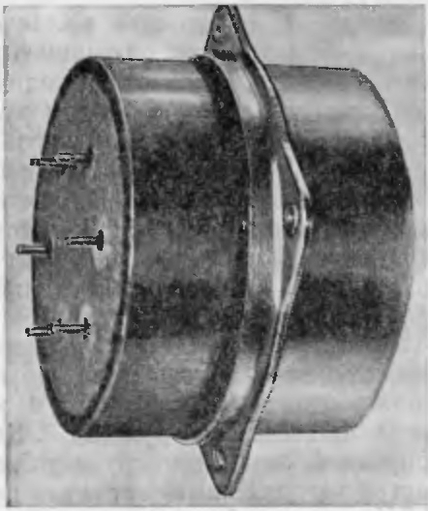 '

PHc. 23. BaTapest T-417

.36

*A-/J.*

*no11oeHU e iJemaneu 2 U* f2

ycnoeHo noeepHyrno tta 90°

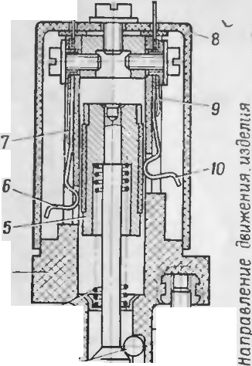

r.

J

/

:

*2---* u:i...-.J.!,..-,

/ .

.

..

11- -11·•

........i

-: ,,

*I* ::::..-_._.,.....'-.-........._.:..,,.,JL-JL,,_j *IZ*

tA

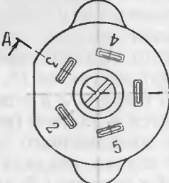

PHc. 24. HHepuHoHHblH sa-

MblK3TeJib:

*I* -CTep>KeHb: *2* -mapHK; *3* - DPY>KHHa; *4* - KOpnyc: *5* -rpy - 9HK: *6, 10* -KOHT8KThl; 7. *9* -

ynop1,1; *8* -KPblWKa: *I I* - *no-*

BYWKa; *12* - BHHTbl

•

KOJlO.llKOH >KryTa 6J101ca ynpaBJieHl-151..

l(ap..n.aHOB no..n.Bec ycTaHoBJJ eH B Kopnyce c ocH0Ba1-11-1eM Ha no..n.w1-1n­ H11Kax KalleHHSI 8, *24* B 3aappeTHpOBaHHOM IlOJlO:>KeH IH. noJJ.lll lnHHK *8* 3aKpblT KpblW KOH 9, ycTaHOBJleHHOH Ha Tpex BHHTax. ToKOilOJJ.BO..lI.bl*4, 19* IlO..lI.BOD.HT IlHTaHHe K 3JleKT pOBOCnJiaMeHHTeJJIO 3Bnf-2.1\11 poTopa rHpocKona H KpenHTCH K OCHOBaHHIO raHKOH *20,* a K appeTHpy -BHH­ TOM *3.*

OcHOBaHHe C pacnoJJo:>KeHHblMH Ha HeM TOKOC'beMHHI{a l\1H *JO,* TOKO­ nO..lI.BO.llOM *17,* KOHTaKTHOH rpynnoii *11* ( Kn) , cTa61 JIHTpOH8MH *15* H ap­ peTHpOM KpenHTCH K Kopnycy TpeMH BJ,IHTaMll *14.* ToKOilO.llBO..lJ. pacnoJIO­ iKeH Ha CTOHI{e *16,* 33Kpen rreHHOfl Ha OCHOBaHHl-1.

,lJ, H npe.noxpaHeHllH Y3JJOB H .neT aJICM rHpOCKOna OT MexaHHt eCKHX noBpC:>K!}.eHIIH Ha OCHOBaJIHe ycTaHOB,,'JeHa KpblW Ka *21,* a Kopnyc 33- KphlT KO:>K yXOM *18* c OKHaMH JlJIH BhlXO,lla nopoXOBbIX ra30B. 01<Ha 33- KJleeHbl U.CJIJI04'aHOBOf1 nJieHKOl *6.*

Kap;1.aHOB no.nnec COCTOIT H3 poTopa *3* (pHC. 26) , BHyTpeHHeH *1* H Hapy>KHOll *2* paMOK. PoTop r11pocKona ycTaHOBJieH Ha JJ.BYX nO;J. llHTIJIH­ Kax KalleHHSI *12* B KpbllllK8X *10* BflyTpe1111eH paMKH. no.nrnHnHHKH 3a­

KpblTbl q)JlaHuaMH *4, 13* c OTBepCTHRM l ..lI.Jlfl BblBOD.a XBOCTOBHKOB POTO· pa. Cl>JiaHUhl KpenHTCH BHHT8MH. ,lJ,JIH per)'Jll pOBKll Beli lll lHbl JIIO<!>Ta OCH pOTOpa Me>l<D.y <1> riaHIJ,aMH Il\.pbIW KaMH ycTaHOBJleHhl npOKJ13..lJ.KH.

KphllliKH *10* BHyTpeHHeH paMKH KpenHTCH K KOpnycy DHyTpeHIIeH paM­

KH. BHyTpeIIHHH paMKa ycTaHOBJieHa B Hapy:>KHOH Ha .lBYX IlO,'l.WllilHH­ Kax KalleH l51 *6.* 3aKp1>1Tl:JX ..7. 1.By"MH l\.pblW KaMll *5.* KpbllllKH )'CT a HOBJJC­ Hhl Ha BHHTax. f py3 7 CJIY>K J T ,llJIH KOMneHcauHH MOMeHTOB TpeI[I H B no..n.IllHTIHHKax OCH Hapy:>KHOH patvt KH H JJ aMeJlbHOro D.aTll lKa. BHHTbl *B 9* o6ecnetIHBalOT cTaT1-1t1ecKy 10 6ana11cHpoBKY Hapy:>K11ofl paMKl-1.

PoTop COCTOHT H3 KOpil)'Ca *5* (pHc. 27) , KphllliKH 4, nopoxoBOH 1ua1u4

KH *3* (9X 147) , 3., eKTponocnJ1al\-t eHHTe.11H *1* (3BCTf-21\1) .

B IlOJlOCTH poTopa pa3MeIU.aIOTCH IlOJ)OXOBaH w aw Ka H 3JICICTpOBOC· nJiaMeHHTeJlb, BBIHqeHHblH Bl{Opnyc. KoHTaKT *6* 3J1eKTpOBOCil.1 aMeHH­ Te.'.1H BbIBe.,.lleH qepe3 ..IlOJIYOCb Kopnyca poTopa, a BTOpOH KOHTaKT *2,* co--

e.n11HeHHblll C MaCCOll poropa, BBHHlleH B nonyoch KphlWKli poTopa.

K KOHTaKTaM 3J eKTpOBOcnJi aMeHJ TC.'.IH KpenHTCH TOKOfl0..1.80.llbl

*4* H *19* (pHC. 25) . B KOpnyce *5* poTopa (p11c. 27)lltvt elOTCH TPH conJi a *6,*

llepe3 KOTOpble npOHCXO.UHT HCTel!CHHe rropoXOBblX ra30B np1-1 cropaHHll lllalll \ll. 1a TOpUOBblX noBepXHOCTHX poTopa IIMeIOTCSI rHe3.na *a* noJt

KJJIOLI.llJ'l fl CBJ HllHBaHI- H Kopnyca c KpbIW KOii.

37

:-i: I

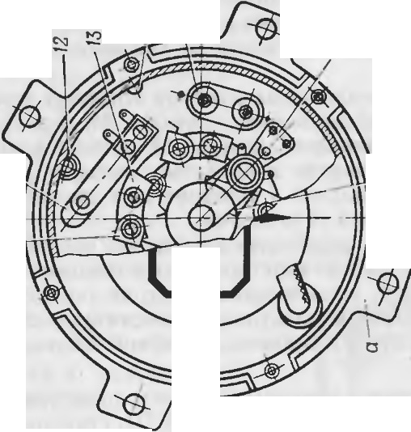

I

I

!

c-.o

-'

c-::,-

-

-r---.

I

c=c.,:,:.,

3 ·­

ct X

0...

c iE

,

I

coc..o..

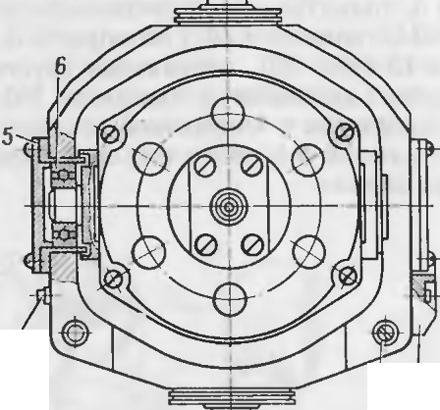

*9*

*B 7*

P11c. 26. KapJJ.aHoB nOJJ.Bec:

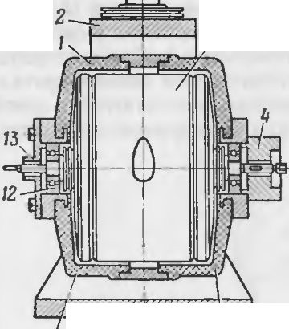

I

3

,,

'/

*10*

*I* - BHyTpeHHJUI paMKa: *2* -Hapy>KH8H

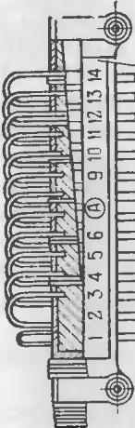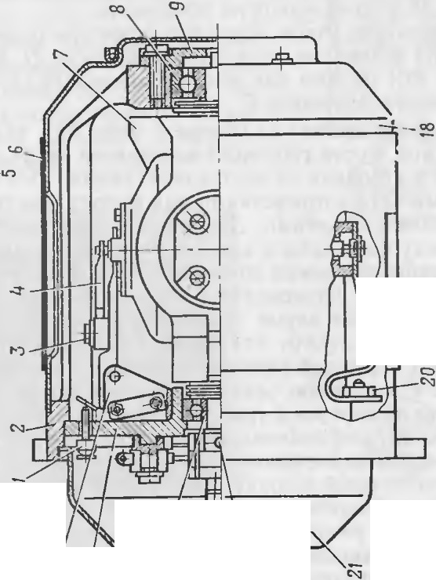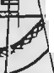

O')

\r+--r--

*J,*

N

"/

N

N



par.iKa; *3* -porop; *4. 13* -4>naHl\bl, *5, 10* -KPbllliKH;

*6. 12* - no.nmHnHHKH; 7 -rpy3; *8, 9* - BIIHThr; *I1* - Kopnyc

' '

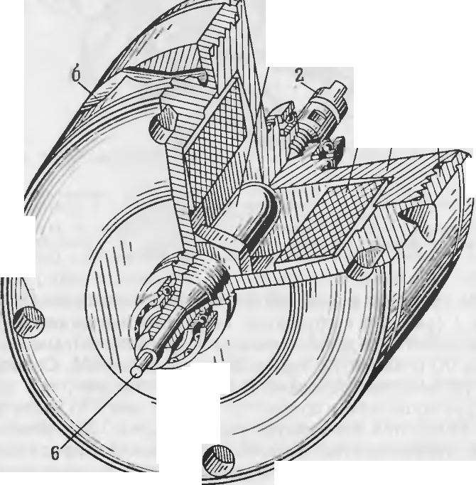

1

0

//

'

I

\

\ \\ \\\ \

3 4 5

,

38 •

--

P11c. 27. PoTop:

*I* -sneKTpoBOcnnaMeHHTenb 3Bnf-2M; *2. 6* -KOHTaKTbl; *3* -DOPOXOB8H wawKa 9X 147; *4* - Kpbr WKa; *5 -* Kopnyc; *a -* rHea.no.*6* -conno

39

AppeTHP o6ecnetJHBaeT 3aappeTHpOBaH11e r11pocKona B 1 epa6oqe1 fIOJIO>KeHHH H pa3appeTHpOBaHHe ero npH Bb XOJI.eIf a pemHM B MOl\-f eIT CTapTa CHa p.HJI.a H COCTOHT H3 pbltJ ara *1* ( pHc. 28) ,npymHHhl *14,* KOpny­ ca *3,* TOJIKaTeJI.H *9* IIHpOTeXIf HlJeCKOrO )I.eHCTBH.SI T.'V\ - 1, naJibUa *12,* cepb­ rH *11,* TOJIKaTeJI.H *10* H CTOnopa *4.* K appeTHpy OTl[OCHTCH: CTa 6HJIHTpO­

Hbl *15* (pHC.25) , KOif TaKTif a.H rpynna / / , TOJIKaTeJib / . CTa 611JIHT pOif hl cJiy>KaT JI.JI.SI 3all.lHTblTOJIKaTeJI.H TM- 1 OT CTaTJlieCKOf O 3JieKT pHtieCTBa, a TOJIKaTeJib c KO f TaKTif OH rpynnoi1 o6ecnetJHBaeT OTKJIIOtJeHHe uenH

IIHTaHH.SI TM- 1 nocJie ero cpa6aTh Baif HH JI.JI.SI HCKJI OlJe f H.SI KOpOTKOro 3aMhIKaHH.SI.

B3Be)I.eHif OH npy>KHHbl *14* pbitJar OTKHJI.bIBaeTCH H pa3appeTHpyeT rHpO­ CKOII.XBOCTOBOH qacTblO pb tJar )I.aBHTIf a TOJIKaTCJib *1* (pHC. 25) H pa3-

Mh KaeT HOpMaJihHO 3aMKif YTble KOHTaKThl KOHTaKTif Oll rpynnhI Kn.

CTpH nOBOpOTe pbitJara OCB060>KJI.aeTCH CTonop *4* (pac.28) .

JiaMeJihHblM JI.aTlJHK C TOKOC'beMHHKaMH H TOKOnOJI.BO,.'l.OM npeJI.tf a3-

HatJeH JI.JI.ff pacnpeJI.eJieHHH carHaJIOB ynpaBJieHHH, nocTyna10IUHx Ha KOOpJI.Hif aTOp no COOTBeTCTBYIOlllHM KaHaJiaM npHeMHHKa B 3aBHCH­ l\10CTH OT yrJIOBOro nOJIO>I{eif lH Ci apHJI.a. JlaMeJibHbIM JI.aTtJHK 3a1<pen­

neH Ha OCH iapy>KHOH paMKH rHpOCKOna BHHTOM *22* (pac. 25) .

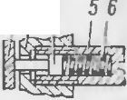

*I 3 4*

I t

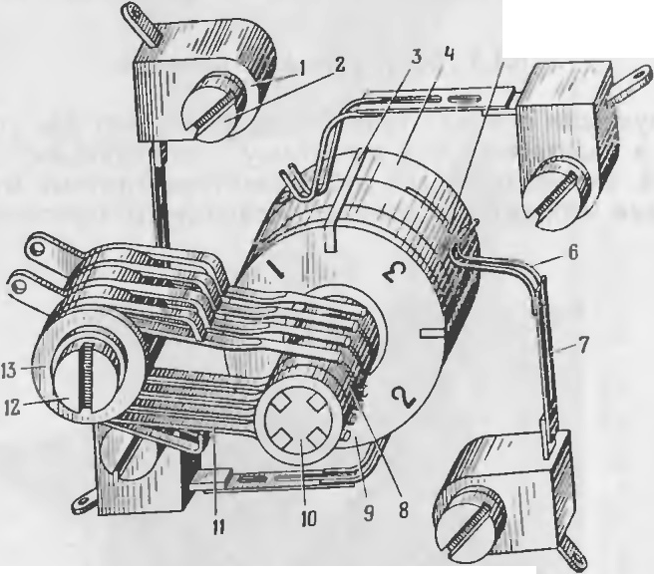

5

8

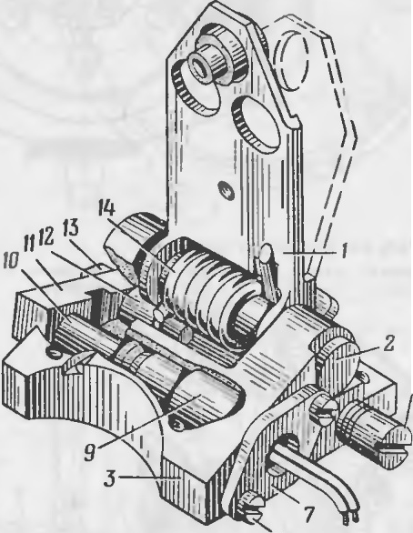

*5*

P11c. 28. Appe-r 11p:

*J* - pbl'l&r; *2* -OCb; *3* -KOpnyc; *4* - CTonop; *5* - CT3K3H; *6, 14* -npy»cH­ llbl; 7 -(J)J1a11eu; *8* - BHHT; 9 -T0 1KaTen& T,\1- 1; *10* - T0 1KaTe.1b; *I 1* -

cep&ra; *12* - naneu: *13 -* ranKa

Kopnyc KpenHTC.SI K OCHOBa HI O qeTblpbM.Sl BIHTaMH *12.*

Pb1t1ar *1* (p11c. 28) c np)'>K HHOH *14* ycTaHOBJie11 Ha OCH *2.* ToJIKaTeJ1b TM- 1 3a KpenJietf B KOpnyce q>JiaIIUeM 7, j'CTal OBw'leHHbIM Ha BHHTaX *8.* ToJIK aTeJib *10* H naJieu *12* 3aKpcnJieHhIHa cephre *11.* CTonop *4* c npy­

>KHHOH *6* )'CTaif OBJie f B CTaKaHC *5,* BBIIIILJ:elIHOM B KOpnyc.

B 3aappeT11poBaHIOM TIOJIO}K e111111 Bh CT)'na10utaH qaCTb q>Jiaif Ua *13*

(pHC. 26) HaXO)l TCH B OTBCpCTIIH pbitJara *1* (pl C. 28) . B 3TOM IIOJIO>Ke­

HlH pb tJar y;tep>K HBacTc.H na.nbueM *12.* CTonop *4* npeJI.Ha3HatJeH ,.'l.JIH

cpHKCaUH l pbILiara B OTKHHYTOM IIOJIO>K CHI H np11 pa3appeTilpOBaHHH r11- pOCKOna.

Dp11 cpa6aThIBaHH I TOJIKa TeJIH TJ\\- 1 TOJIKaTeJih *10* c cepbrort *11*

11 naJibueM *12* nepeMentacTcH, ocBo6o>KJI.aH pb tJar *I.* CToJI. JI.eiicTBHeM

40

• •

PHc. 29. JlaMeJTbHblH Jl8TIIHK c TOKOC'beMIIHKa ,H H TOKOilOJI­ BO.llOM:

*I* -TOKOC'bCMHIIK; *2, 12* - BHHTbl; *3* -H30JIS1TOP: *4* -BTYJIK8 ; *5* -naMeJlb;

*6* - KOHT8KT; 7 - npy>KHHa; *8* - KOJlbUO; *9* - naMenbHbl8 )18T'IHK; *JO* -

KapKac: *II* - W.CTKa; *13* -TOKOn0)1B0)1

r al\,teJihHblH )I.aTlJHK *9* (pHc. 29) COCTOIT H3 BTYJIKH *4*ll KapKaca *lOr­*

If a KOTOpOM pacnOJIO>K eHhl TOI<OIIO!l.BOJlHLUIe KOJibUa *8* H tJeTb pe Jia ;\,t e­

.111 *5,* pa3JI.eJieHifhie H30JI.HTOpaM H *3.* (a>KJia.H Jia:\1e., b coe,l1111e1f a c co­ OTBeTcTBy 10m111\1 KOJibUO11.

ToKOnOJI.BOJI. *13* npeJI.Ha3HatJeH JI.JI.SI noJlatJH HanpH>I{elr H CI rHaJIOB

}'npaBJieHH.SI Ha KOJihUa JiaMeJibHOrO )laTlJHKa JI COCTOHT H3 tJeTb pex nap meTOK *11,* oxBaTbIBa OlUHX KOJibUa *8.* ToKononB0.!1 BHIITO\i *12* Kpe­ IIITC.SI K CTOHKe *16* ( p11c. 25) .

u

ToKOC'beMHHKH *1* (pHC. 29) npeJI.Ha3 f atJelr bIJI.JI.Sl C'beMa c Jia:\1e 1ew·

*6* CI rHaw'IOB ynpaBJieH HH. Ka>K.!lhltt TOKO C'beMif HK BhlnOJIHeH B BHJI.e JI.BYX UteTO {, COCTO.Slll HX H3 KOlf TaKTa *6* H npymHHbl 7. PeryJIHpOBKa ycTal!OB­ KH TOKOC'beMHHKOB npOH3BOJI.HTC.SI nepeMemetf ieM HanpaBJI.SI OLUl,C *13'* (pac. 25) no OCif OBaif HIO. BHHT *2* (pl C. 29) npeJIJia3HaLJ:eH JI.JI5I q>l {Ca­ UHH TOKOC'beMif HKOB B pa6otJeM nOJIO}K eHHH.

41i

Pa6oTa KOOpJlHHaTopa 3a KJIIOt.IaeTcH B cJie)ly10meM. DpH noJla t.Ie Ha­ npH:H<ettHH 3JieKTpOBOCDJiaMeHHTeJlh 3BCT f -21'v1cpa6aTb BaeTll DO.ZI.}KH· raeT nopoxOBOH 3apHJl 9X l 47. 3a Ct.IeT peaKTHBHOH CHJlbI ra30B, HCTe­

Ka OlllHX qepe3 conJia *6* (PHC. 27) , pOTOp paCKPYllHBaeTCH JlO MaKCl ­ MaJlbHb X o6opoTOB (90 000 06/MHif ) . no Mepe BblXOJla Ha pe}KHM 6a­ TapeH 13<1> 6opTOBOro 6JJOKa IlHTaHHH qepe3 0,2-0,3 c cpa6aTbIBaeT n11- pOTeXHHt.IecKHH TOJJKaTeJlh T1'v1-1 H pa3appeTHpyeTC H rHpOCl{Oil.

C MOMeHTa pa3appeTHpOBaHHH rHpOCKOil HallHHaeT coxpaHHTb CH-

U U

CTeMy KOOpJlHif aT nycKOBO l ycTaHOBKH, a JiaMeJlbHb H )laTt.IHK -pac-

npe.neJJHTb KOM3HJlbl ynpaBJie f HH Ha Bb XO.ZI.Hble KaCKa)lhl npHeMHHKa.

* + 1. 6noK pynesoro npHBOAa

oJIOK pyJieBoro npHBOJla (pHc. 30) npeJl f a31f at.Ie1f .ZI.JIH ynpaBJiett11H CHapHJI.OM B IlOJieTe no Kypcy H TaHra}Ky C IlOMOll b O a3pOJi HaMHt.Ie­

-CKHX pyJieii. On npe)lcTaBJIHeT co6oi'I 3JieKTpoMarttHTifhIH Mexaif H3M c

nOBOpOTHblMH HKOpHMH, Ha KOTOpblX ycTaHOBJieHbI a3p0)l Ha:\1f tleCKHe

P)'JlH.

r

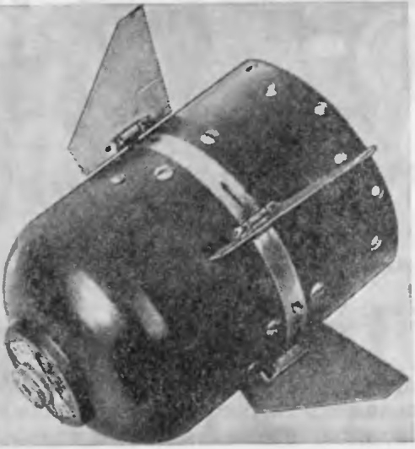

..

PHc.30. BJIOK pyJieBoro npHBOJI.a

oPn COCTOHT H3 paMKH *4* (pHC. 31) , Ha KOTOpoii Bl HTaMH 3aKpen­ JieHhl t.IeTbipe napbl 3JleKTpOMarHHTOB *8* H ll€ Tb pe HKOpH *3.* (a}K)lbIH

....

....

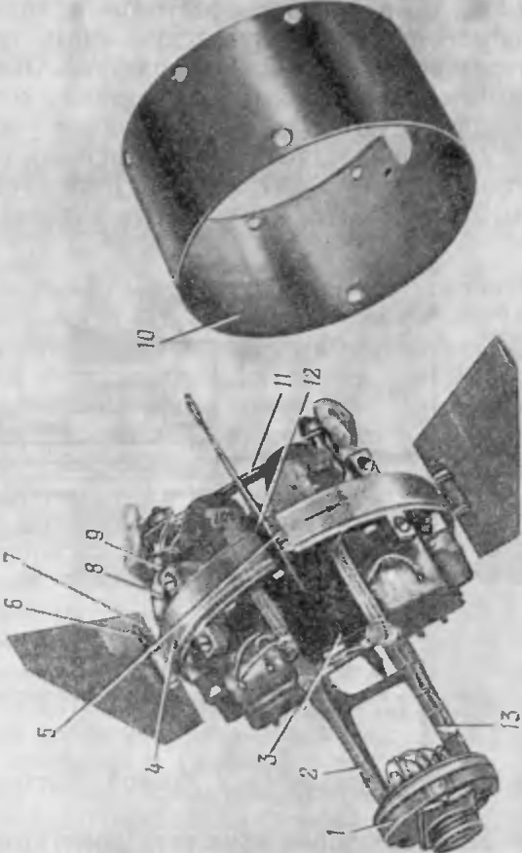

--

x

C";l

'1

0

...

A

:,:

*C)*

c;

('l

I

ao



- 

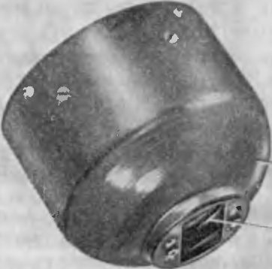

:,,:

c

11KOpb }KeCTKO CBH3aH c noJiyOCb O H uancpoii *12* PYJIH 7, KOTOpbie *)* CTa­

HOBJieHbl B paMKeIf a IlO.ll.llllilHHKax Kat.Ielf HH.

51KOpb *3* coe.nHifeif c TOpCHOHOM, KOTOpb H B CBOIO Ot.Iepe.nb CBH3aH c peryJIHTOpOM. TopCHO f COBMeCTHO c peryJIHTOpOM o6ecnellHBalOT 803- BpaUI.eif He HKOpH B HCXOJlHOe (HyJieBoe) IlOJlO}KeHHe.

42

' l-!'".'., 0r::

*c.*

0...

0

,0

..I.

43

DpH Bbt xone c11apHna H3 Ko1:1Tefittepa pyJIH pacKpb1Ba10TcH c no­ MOll blO npy)KH f bl *5.* <l>HKCaU H pyJieil B pac1 pb1TOM IlOJIO}KeHHH ocy­ mecTBJIHeTcH CTOnopaMH *6,* Ha KOTOpbie JJ.eHCTByeT f!.PY)KHHa *5.* ..

K KpottrnTeiftf y *13* BHHTaMH KpenHTCH 6opT0Bo11 H KOHTpOJibHbIH

pa3oeM *1,* KOTOpbIH ocy11tecTBJIHeT 3JieKTp1-1q ec1{y10 cB3b cHapHna c

KOHTeHHepOM 11 c KOiTpOJibHO-npoaepOll}l011 annapaTypo . 06MOTK H ... n­ paBJieHHH 3JieKTpOMarHHTOB coeJJ.HI[elf bl c KOHTaKTHO l KOJIOJI.KOH *9.,* 06ecnelIHBa1omeii 3JieKTpHlICCK yro CBH3h EPn c 6JIOKOM ynpaaJieHHH.

Ko3q><pHUHeHT KOMaHJJ.hIHa BhIXOJJ.e EPCT onpeJJ.eJI.S1eTc.S1 cooTHorne­ l-lHeM apeMeHH HaXO)KJ{eHH.S1 pyneit B KpaHHHX IlOJIO>K eHHHX H nponop­ llHOHaJielf BeJ1HlJHlle KOt aHnblf a BXO.z:te npHeMHHKa.

* + 1. JlaMna-(J)apa

JlaMna-cp apa 5lBJIHeTC.S1 3JieKTpHlleCKHM HCTOlIHHKOM HHq>paKpaClf Oro

KoJinaK *14* H KOif TaKT *15,* conpHKaca.HCb B MOMeH.T.

BCTpelIH CHap.HJJ.a c

CBeTOBoro H3Jiyll lf SI 11 npeJ{Ha3HatieHa JJ.JI.S1 onpe.neJieH lH IlOJIO)KeHHH

ueJiblO, o6ecnelIHBa OT 3aMbIKaIHe 3JieKTpHlleCKOH uenH 3JieKTPOJJ.eTO- HaTopa nnM, lITO Bbl3bIBaeT nOJJ.pblB KYMYJI.S1T HB lOro 3ap.S1.la 6oeBOft

llaCTH.

c1 apHJJ.a OTHOCHTeJihtto JIHHHH BH3HpOBaHHHIIAY. 01f a pacno O)KCHa B anna paTypHOM OTCeKe B KapKace KaTylllKH npOBOJI.HOH JIHHHH

CBH3H.

JlaMna-cpapa COCTOHT H3 cJieJJ.ylOlllHX OCllOBlf blX qacTeii: onopbl *2*

" 3M4

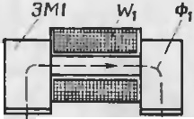

*I*

w,. 4>,

*I*

(pHC.33) , KO)Kyxa *1,* CTBOpOK *3,* JiaMilhl*8* (pHC. 34) ,XOMyTa *6,* npy)KHH

*r* .. ./. . •"

:J •• •• ..

'

*12* H *19,* OCHOBaHHH *4,* OT pa}KaTeJI.H *14,* KOJlbUa *15.*

*r-* -

JlaMna *8* ycTalf OBJietf a B naTpo-

I

-Of

I .,... .... .. ,_. • _*!*i,I I

..J

'

. ,-

He *9*ll3aKpenJieif a BIf eM XOMYTOM *6.* 2

\.. _



-

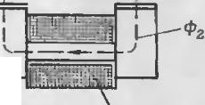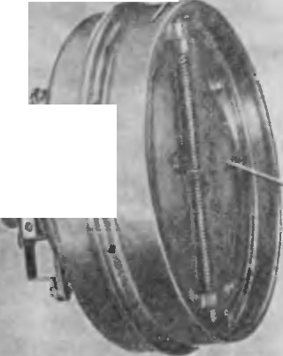

/

J

\

'

.

*.1* .-

DaTpOH 3aKpennetf Ha npy)KHHe *12,*

i-r-it---,.

_--+--,

-• I

*_ _* I :'.t,- •

e

-• -- ·-

I • ,- -- ,.

KOTOpa.S1 IlO,l.>K aTa B lf Ta MH *5* K OCHO­

*.J*

BaHl1lO

11 yKpenJietf a Ha tte11 JJ.BYM.H

,ct

I , .... ......'·..'.:.: L

HHTa MII *13.* 0Tp a>I<aTeJib *14* 3aKpen-

I • • ... . .. ·

-o'!

B

'--- .... --*,...) --* 4'z

* i]

. .

•r·.h...

\ ' \

JieH ia onope *2* (pHC. 33) KO>KyXOM *1*

c IlOMOUJ.blO pe3h60BOro KOJibUa *15*

(pHC. 34) .

3M3 *'II*3

*3M 2* Wz

Ko>Kyx *1* ( p11c. 33) npeJ{Ha3Halle 1

Pnc. 32. Cxe1-1a '.\t arHHTIIOll CHCTC\1bl:

\V1+\V,-ot5MOTKII ynpaaneHHfl; o•. 2 - B03.D.YU llbte 3830pbl; cf>a. cf>2 - MarHHTHble nOTOnKH;

3M1 + 3f.\4 - 3neKrpo111arHHTbl

oJIOK pyJieBoro np1-1ao.ua coen11HHeTc.S1 c 6oeaoii qacThlO cTaKa- 110M *10.*

DpH o6eCTOlleHlf b X 06 10TKa X ynpaBJieHHH 3JieKT pOMarif ITOB HKOpH

HaXOJJ.HTC.S1 BIf yJieBOM noJIO)K e f HI.

06MOTKH ynpaBJieHI H 3JieKTpOMarHI TOB BKJIIOlleir bI B Bb XOJI.Hbie KaCKaJI.bl npHeMI[HKa (p11c. 51) .

Op11 npoTeKa t:11111 TOKa no o6MOTKa M ynpaBJieH11H \V1, \V, (p11c . 32) 3JieKTp0}1arHI TOB 3 1l 11 31\14 (OT f OCHI1t11xcH K o.u1-10My Ka11aJiy EPCT)

B03HHKaeT 3Jiel{TpOMa rHIITHOe noJie, MarHHTHble nOTOKlI<l> 1 KOTOporo 38 MbIKalOTC.S1 qepe3 cepJI.ellHHKH o6MOTO ( ynpaBJie} H.S1 3JieKTpOM arHH­ TOB 3M H 3M4, 803..71.YlllHb e 3830pbl *6,* HI{Op51 IC03.UalOT 3Jie <:TpOMar-

1

...

HHTHb e MOMeHTbl, 06ec nClllBalOI.UHe np11T.S1}1{eHHe HKope11 K IlOJIIOCaM

9JieKTpOMarif HTOB 3Ml H 3M4.

DpH nepeKJIIOlleHHH 06 10TO K ynpaBJieH11.S1 3JieKTpOM ar11HTOB npo­ HCXO.llHT cnan nOTOKOB <I> l H HapacTalf He IlOTOKOB <1>2, C03naromHx 3JieKTpOMar 1f HTHble M01eHTbl, KOTOpbie 06ecneq11Ba10T npHTH>KeIHe HKO­

peit K IlOJIIOCaM 3JieKTpOMarHHTOB 3M2 H 3M3.

B o6MOTKH EPn nocTynaeT cHr1r aJI qacTorofl I O + 1 ru c nepeMeH­

Hoi'I CKBa)KHOCTblO.

44

JI.JIH o6ecnelleHI.S1 HHTeHCHBHOro 060- rpeBa OTpa)K aTeJIH ra3aMIIBnY, npo­

XOJ{Hll HI\ H qepe3 lleTb pHaJJ.uaTb npe­ Ha)K HblX OTBep,cT11H *a* (pHC. 34) H·3a-

30p Me.>KJI.y OTpa)KaTeJieM H KO>KyXOM,

B ueJI.HX npe.n.ynpe)KnettH.H o6pa30Ba­ HHH Hif eH Ha OTpa>K aTeJie npH CTpeJih-

*6e* B 311Mlf HX YCJIOB HHX. f epMeTH3a- Pnc. 33. JlaMna -$apa (OC5lllHfi

UHH BHyTpe f f ero 061>eMa JiaMnb q>a - BHJI.) :

pbl co CTOpOHbl OTp a>KaTeJIH o6ecne- *J* - KO>KYX; *2* -onopa: *3* -CTBOpKa

Gl1BaeTCH ma 16oi'1 *11* H npOKJiaJI.KOH *6.*

..

v

3anpeccoBaHHOH B onope.

BHyTpeHI HH noBepxHOCTb OTpa)KaTeJI.S1 H JiaMna npenoxpaHHIOTCH OT IlOBpe>I<:.UeHHH ra3aMH B,UY JI.BYM.S1 CTBOpKaMH *3* (pHc.33) , KOTOpb e

npHJieraroT K onope *2.* fepMeTHllHOCTb Bif yTpeHHero o6oeMa JiaMnb1-cp a­

pb1 co CTOpOHbl OTpa>KaTeJIH o6ecnetIHBaeTC.S1 pe3H IOBOH npOKJiaJJ.KOH *8* (pHc.34) , 3anpeccoBa f f OH B onope. CTBop1<:H ycTaHOBJie1f hIf a oc11 *18* H B 3aK pb TOM IlOJIO}Ke f lI y.n.ep.>K 1BalOTC.S1 npOKJ18.!I.K a MH *21* H3 HHTp0-

IlJieHKH, ycTalOBJieHHbll\111 B na3 onOpbI*2* (p11c. 33) H 3aKpenJieHHblMlI Ha CTBOpKax BHHTaMII *20* (p11c. 34 ) . B OTKpbITOM IlOJIO>I(e f HH CTBOpK11

npH>K 11 13lOTCH K ynopaM CTOi' KH *17,* KOTopaH COe IHeHa c onopott

BHlfTa M l *16,* IyJlep)KHBa lOTCH npy.>K HHaMH *19.*

45

5.2. ct>OPM H POBA H H E KOMA H.lJ. Yn PABJJ E H H,SI

t-.O

-r-- c-o

«:)

KoMaHJJ,bl ynpaBJieHHH, nocTyna10m11e c tia3eM1 of1 annapaTyp1:>1 y n­

.. paBJieHHR B npOBOJI.HYIO JlHHl lO CBH3H, npeJI.CTaBJlH OT co6oHllMilYJlbCbl

--

JS

:c HanpH>Kett11H onpeneneHHOH cpopMbI H 3t aKa c aMnJIHTYJI.OH ± 11,5 B

\ ~~'~~ \'

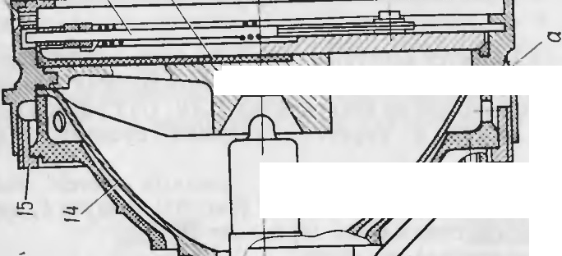

\

:Ii:

;..

Q,

c

-

l,f JIH ± 50 B II qacTOTOH CJleJI,OBal HH l0± l ru.

P

a3.ne.. eHHe KOMaHJI. }'npaunetiHH no KattaJiaM n:y pca H Tatt ra>Ka

I

•

°' OC)"llleCTB 'lHeTCH .nemHcppaTop a MH npHeMHI (a.

" , c-s•.

Llem11cppaTop (at aJia Kypca COCTOHT H3 BXOJI. OfO ycTpOHCTBa H

'' -"<:)

..

:s:

::.:

<'3 t:{

'Cl CV

oa: c:

CV ::,,:

30

a lTIJlHTYJl.1- Oro C('.1CKTopa . .[lcm11cppaTop KaHa 1a Tatira.>Ka COCTOHT 113-

BXO;l. OrO }'CT poi CTBaIIKJ11oqcBoro KaCK3JI.a (pHC. 35) .

* I c:

- 1

*I< T*

- I:)

\

\;)•

.-

0 • •

::J G>

,Q :c

R5 R6 R7

*-166*

Cl: r::; ...

c o

I ....... ::.: c.

....., -G>

c:( -:!" I

ll) 0

..I

a

:c

*I* ... ..

0

0.

t< T3 Tl *r2*

*RZ*

*JI.I*

K T4

- ...........

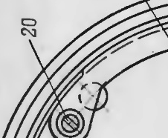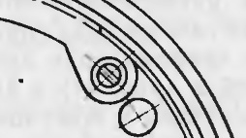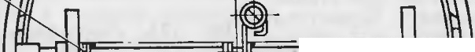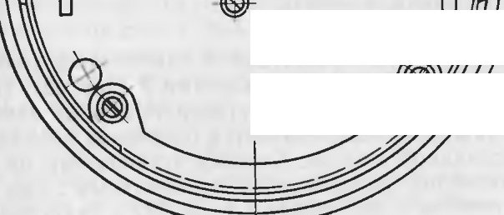

-C\l

•

I

-

-

I

I

•

•

I

C-) co r--- c.o o.

* + • co

0) Cl:I <'3 ::,:

i:: er

. l CV

°'

c.

2 1

*c,*

R3 Rf *:::cz*

Cl3

-e- c::.::

Cl:I O

t:: · c R4

:- jg l

r:C:;l::I

..,...,- •

t,

c-+

O")

• •

*"*C*"*':)*'* I..a•

* co u

*(,J* • • 0

:s:: '"" I

0.. QC)

0 ...

:><

I..

CV

<c ::,:

c

Puc. 35. npHHUlnHaJJbHaH 3JJCKTpH'llCCK aH CXe t a 8'1(0.lJ.HOfO ycTpOHCTBa npHe'.\f ­ lHKa 6 10Ka ynpaBJJel HH C K.JJIOlcleBbl:\I K3CKa)l.O.M 11 aMnJlTY.!l.HbIM ceJieKTOpo:0.1

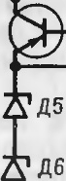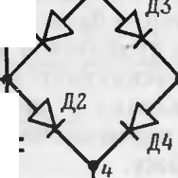

BxO.ilJIOe )'CTpOHCTBO 06011x 1(311a,l'IOl3 OJI.HO II TO )l{e II COCTOHT H3:

- :ao...

i- v

,,.. ~~.~~.

* 1. 1,0B nl -n4, pe3HCTOpOB R 1, R2 Hl{OHJI.eHcaTOpOB cl, C2.

A Mn111T}'JI.Hbl I ceJJ CKTop co6pati Ha TpaH3ICTope T 1, pc3HCTopax

I

o:l

r

R3, R5. R6

H cTa6HcTopax

LJ,5,.[lG. KJI10qeuo1iKac1can co6patt Ha Tpa1 -

cc:-:,. •-

,Q

r:

...

* + - QJ

I.:, ...

.,,

:E

-,er.

... 1-:l.

c..::., *,:,*

* I

.1-

)---

t-. ....

"

----

.

)

-C1l

IQ

0

:c

*(.)*

0

I

"I"

311cTope T2 11 pc311cTopa x R4IIR7.

n.'IH Bb JI,e.. {'HIIH KOM3 11;1. ynpaBJieJIH no hal aJiy KypcaiCnOJlh3yeT­ CH .lByxno TI }1nep1101t Hoe Bb1npHMJie1 11e c ar,.1nJI11Tyn1-1ort ceJ1eKu11e11, a

.J.JlH Bb ,J.e.1CHHH KOMaiJI. ynpaBJieHHH no Ka HaJiy TaHra>Ka - O;I.HOTIO­

.riynep110,n.ttoe BhlnpHMJJeHIIC.

Al\t n HTYJl.Hblii CeJICKTOp KaIaJi a K)1pca pcarHpy'eT 11a 113MeHCHHe BCJIJ llHbl aMTI.;IlTYJl.bI KOM311)lHhlX Hl\t nyIbCOB. npH TIOJI,atie KOMaHJI.­

HblX 1-11\ ny TJ bCOB i3 BXOJI.IIOe ycTpOHCTBO 11anpH.>KCI lle B TOqKc 3 (CJJe­

Jl.OBaTeJlbHO, If 1ra 6a3e Tp aH31-ICTOpa T I ) 6y.neT OTp11uaTeJibHOH IlOJIHp­ HOCTll OTI-IOCHTeJJ blIO TOI KH 4, T31{ KaK Ia MOCTHl(OBOM BhlnpHMIITeJie

npoHCXO.J.l T JI.I3yx no 1yne1111011HOC BblilpHMJICI He.

3To H3npH>KeHi e H3MelIHeTCH no BE\,liq111-1e B 38BIICl l\ OCTH OT aM­ nJIHTYJI.bICHf H3Jla ( + 50 B HJlll + 11,5 B) , TIOJI.aBaCMOro Ha BXOJI. .J.Byx-

npOBOJl.HOH"

46

•

JIHHl-111 CBH3l.

47

c nocJ1e.D.OBaTeJ1bl O BKJlIOlJeHHblX CTa6HCTOp0B )l5, )l6 11a 31\. HTTep

Tpa1-13HcTopa T l nonaeTcH cTa6HJ1H3HpoBa1-11-1oe tt a npH:>Ke1-1He cMeme­ HHH. 3TO tt anpH:>Ke -l He Bb 6HpaeTC51 TaKOH BCJllllJHibl, lJT06bI TpaH- 3HCTOP T l 6b J1 OTKpblT, Korna B JIHIIHIO CBH3H nonaeTCH tt anpH}KeH11e

±50 B, H 6b J1 3aKpb T npn tt anpH>KeHHH Ha BXO)J.e Jll iHH CBH3ll

± 11,5 B.

C11r1-1aJI c Tpal-13HCTOpa T 1 ycHJIHBaeTCH no MOlll,HOCTH nocnenyro-

lllHMH K3CKa.D.aMH npHeMl HKa H npeo6paayeTCH 6.110KOM py.11eBoro npl ­ BOJ].a B Mexatt 11qecK11e nepeMeme1-1HH pyneii, ocyuteCTB.11H OlllHe ynpaB-

neuHe ctt apH.no 1 no Kypcy.

K.1110t1esoii KacKan Ka1-1aJ1a Ta1-1ra:>Ka pearwpyeT Ha H31\.1e1-1eu11e no-

JIHp11ocTn KOM aH.Z .llblX HMny.11hCOB.

B c.11yqae Korna .111-1HHH T tt axoJJ.HTCH non nOJ10:>K HTeJ1hHhlM noTe1-1- uHa.noM OTHOCHTeJlbl-10 JlHHHH K, TOK OT TOlJKll l K TOIKe 2 npoTeKaeT qepe3 nwon Jl4 H pe3HCTOp R l . TpaH3HCTOP T2 B 3TOM cnyqae aaKpb T,

*u*

*0 t lf a sxoBe nnc*

T

*lJ*

TaK KaK nepexon 6aaa -3MHTTep HaXOJJ.I-ITCH non noJ1o)KI- TeJ1bibIM no-

rettu11aJ10M.

8 C...'IytJae 1-i:Orna JIHIHH T 11axonHTCH non 0Tp 1-1uaTeJ1bHb M noTeH-

u11a10tl OTHOClTeJibHO JlHHHH K, TOK OT TOlJKH 2 K TOlJKe I npoTeKaeT qepe3 J]. IOJ]. )l2, nepexon 9MHTTep -6a3a TpaH3HCTopa T2 II conpOTHB­

JieH11e R2. 3ToT TOK oTKpbIBaeT Tpa1-13HCTOp T2.

C11r1-1 aJ1 c TpaH3HCTopa T 2 yc wJ1HBaeTcH no MOIIJ,HOCTH nocJ1eny10-

lllHM I KacKanaMH 6J10 <a ynpaaJleHHH H npeo6paayeTCH 6J10KOM py.11e-

u

,Boro npwsona B MexaHHtJecKHe nepeMeIIJ,eHHH py.11e11, ocymecTBJlHIOlllHe

ynpaB TJeHHe CI apHJJ.OM no TaHra:>Ky.

*o ----;-----+------1--- t*

*UcM =O*

*u t*

*Ha BbrxoBe nnc*

•

*Ha BxoBe aMnnu­*

TaKllM o6pa30M, c BblXOlJ.OB aMnJlHTY.IlHOfO ce.11eKTOpa H KJ1lOtJeBoro *0*

acKana paane.11ett1-1ble KOMaHJI.hI ynpasJ1eHHH nonaroTcH ua Kac1<a.D.bI - ycH TJeHHH COOTBeTCTBylOIIJ,ero Ka1-1 aJ1a.

BeJ1llJHHa KOM aHnhl ynpaBJlel-lHH onpe.neJ1HeTCH no cpopMy.11e



I



*A , UcM*

*myBHow ceneK­ mopa Ka Hana KljpCa*

K = -1•

rne K - aenHqwtt a K0Ma1-1.nh1;

'tn -.ll.J1HTeJ1bHOCTb HMnyJ1bCa ynpaBJleHHH; T - nepHOlI. nosTope1-1HH HMnynbca.

113 cpopMYJ1b1 CJlcnyeT, lJTO npH BCeX B03MO>KHblX H3Me1-1eHI HX n.11n-

iu= z T .I t

 I.\ •

*Bnpaao u*

\ f

Tu= -T '

*Omt<IIDHeHue*

PY*neu* no *KQ­*

*Hany maHZWKa*

*Omt<110HeHue*

•

TeJibiOCTH H1nyJ1bCa 3a nepHO.ll. BeJIHlJHl-la KOMaHnbIH3MeHHeTCH B npe-

*0* 2 t *pyneu*

no *l\a-*

)leJla X ±1.

Ha pnc. 36-47 np.H.

seneHhIsn10pb1 ttanpH>KeHHi' H cooTBeTCTBy10 -

•

*6*:'Ieao

*nany r<ypca*

ll.lHe OTKJIOl-leHHH pyJ1eH CHapHna.

np H M e q a H H H: 1. Ha BXOJle H BbIXOJle TIJIC H3o6pa>K eHo HanpH:>KeHHe Ha nHHHH T OTHOCHTeJJbHO K.

1. Ha BX0Jl8X aMnJJJ TYJlHOfO ceneKTOpa KaHana KYPC8 H KJIIOt.teBoro KaCKa.rr.a

+

.KaHa.lJa TaHra:>Ka H306pa:>KeHLI HanpH:>KeHHH OTHOCHTeJJbHO 16 B npHeMHHK8.

1. Uc M -HanpH:>KeHHe CMeW.eHHH Ha 3MHTTepe aMn TJHTY.!l.HOfO ceneKTopa.
2. 0TKJJ0 CHHe pyneH no KaHanaM Kypca H TaHra:>Ka H306pa:>KeHO OTHOCHTeJib-

u

ftO np0.,1.0.'lbHOH OCH CHapHJl8.

PHC. 36. 3nJOp b1 HanpH>KeHHH H OTK 10HCHHH pyneH npH.

K.K = 0

l<.T = 0,

4-8 4 3:n,. lo69c 49



I '\ ..' *T*

*u*

*t*

*u*

0 *lfcI 6XOOe nnc* '

I

•

f -•

T

-=-

1-,

jL-------------- .!... *Ha atiixoiJe nnc*

*U UcM =0* t *Ha* 6XOiJe *y_;;l{)-*

O L.-----------...L...------ eaozo *r.acK aiJa*

*l<QHQ/i Q mJHWtt<a*

0

*u*

*ol----..:.._*

*u*



-*.-Ha Bxo8e nnc*

*..t.,..Ha Bb1xoiJe nnc*



*t Ha 6XDik* Knt0-

*O* J.- ----------:-- -L- -- l/f 60ZO *r<ac1<aoa*

* *Kattana maHwma*

*V I t Ha Bx oiJe a.Ai1nnu ­*

O 1--- ------------::-:--.-=- my8ttozo celier<-

*UcM mopa* xattana

't'.ypca



*U t* tta *axoiJe aMnnu­*

*D* l-----------------,.--- myilHOZO ceneK­

c.===

,L *lTcM* mopa *r<aHana*

4

*"----.J*

_L Kypca

),(

Q.

'f = o  *t Omr<noHeH ue*

>2<-i;....--------------

*o* J.-

c:c *t* OmKJJOHf ttUe

u::

..,.. *pyneri no r<a-*

ccoi Tu= T

3 pyneu *no t<a-*

*Hany maH 2,ama*

:::s

:c

|  |  |  |
| --- | --- | --- |
| *Bnpaao*  'fii= 1T | *I* ' | *t* |
| \ |  | I |
|  | |
| Bneeo | | |

"--------------------------

*Hany maHtama*



*,Bnpaao*

*r. =-*I *T t*

Omr<no;1eHue

cc *'u*

*Omlf.nOHeHue*

u z

0

\ ' I

*Bneeo*

pyneu no *KQ­* 0

*Hany t<ypca*

*pyneu no* 1<a-

*Hany i<y pca*

PHc. 37. 3nJOpb1 HanpHH<eHJ IH OTKJ!OHellHR py.1c11 npn •

KT = + l, KK = 0

Puc. 38. 31110pb1 HaHpR:>KeHHH H OTKJJOHeHHH p} eii np3

KT = -1, KK = 0

50 5-1

•

*ti*

01--------------,t..*Ha BxoiJe flRC*

*u*

01--------------t *Na 8brxoiJe nJIC*

*u*

Ot----------------!tl- Ha *axoiJe nnc u*

0 f *Ha Bb1xoiJe nnr:*

*u t /fa* axoiJe *KIIKJ - u*

•

*UcM = O*

*lfa* axoiJe J<.Jlffi-

0 *t.JeBOZO KQCKaiJa*

*UcM =O*

*t l/ eBOW KaCKada*

*r<anana ma11wma*

*0 1<.aHana maHzama* •

*u t Ha 6xoiJe aMnnu- u* t *ffa BxoiJe aMnnu -*

*D myiJHow ceneK-*

0 *myiJHozo cene1<.-*

*VCM mopa 1<.aHana*

Kypee

*UcM n1opa KaHana Kypca*

><

* cCul.

>c;: CD

co

Cl.l 0

"fu=O *t Om1<.ngH eHue*

cCcD *t OmKJ!OHett ue pyneu no*

"fu= T

*0*

*py11eu no Ka- "*::s*'*

*"aHany maHeaH<a*

l") *nany maHzama* :t:.

:::s co

:r:

*BnpaBo*

cc *Bnpaao*

Tu = T *t Om1<.npHeH ue* =T t *OmKnHeH ue*

*0 pyneu no Ka- 0* u *pyneu no*

*Bneao Hany Kypca B11eao 1<.anany 1<.ypcn*

'PHC, 39. 3nl0pb1 HanpH>KeHHA H OTK,10HeHHSI py11eA npH

KT = +I, KK = +I

, PHc. 40. 3nJOpbl 11anpst:>KeH1tH 11 oTK.TJOlfCHHst pyJieA npH

KT = -1, KK = + 1

-

'

•

53



•

*u u*



*0* t *Na axoi3e nnc*

*o* 1---

+------_.--

+----,,*t*.... *"ta exoiJe nnc*

*u T*

*o* J- --\--_:_ -1 - --+- , t *Na BbrxoiJe nnc*

*u* 0

|  |  |  |  |
| --- | --- | --- | --- |
| *ucM =0* •  *1 t* | | | |
|  |  | ' |  |
|  | | |

*Ha exoi3e 1<n10-* •

'

·-.

. .f

Ha Bb1x ooe *nnc*

*0 l./e6ozo 1<ac1<aaa* •

*KaHana maH2ama*

'-"'

u

*0*

*1VcM = D t*

Ha *exoiJe Knt0 -*

*u*

ir----

*t Ha exoiJe aMnnu­*

*O* - ---r----"T"""""T:-:-- *myiJHoio ce11e1<­*

*UCM mopa KaHana*

"-- - -..._ . """""'- *r<yp ca*

t-- -----L---r---..----ill- *a.ietJ oio l(acKaOa*

*KaHana maHzama*

*u Ha 8J<D0e aM nnu ­*

|  |  |
| --- | --- |
| t | |
| - | •*ir*  - .1_ *CM* |

*0* myiJHOZ.0 *cene1'.­*

*mopa KaHa/1,l*

Ky*p ea*

*Om1<noH eH ue*



I

,

*Tu = z T*

I-<

Tu

"I

*t*

\.

-

*pyneu no Ka-*

.._. _T_,u., ->._,

I,



I

I

...u=4*3 T*

*Hany maHZ.a)l( a*

' *- t Omr<!lf.!Hettlle -*

 *--p yneu no xa*



' *Hany maHzamtt*

*BnpaBo*

Tu-= o *t OmKnoHeHue*

*Srpaeo* oE · j *T*u*= l r*

*o --------------- p ynei1 no Ka­*

I • *t*

"*Omlf..nOHeHUe*

•

*Bneao*

*Hany t<ypca*

*0*

\

*Bneeo*

*Pvne no 1<a­ Ha*ny *1<ypca*

.PHC. 41. 3n10pb1

HarrpR>KeHHH•

H OTKJJOl CHHSI

py.r1eu npH PHc. 42. 3nJOpb1 Harrpst>K CHHH H OTK.TJOHeHHSI

py.I' eHv

npH

KT = 0, KK = -1

KT = +o,s, KK = +o,s

•

54 •

55

*u*



u

•

*D t*

*Ha 8xoi1e nnc*

*uf ,*

*T*

*0 t Ha.* exooe *nnc*

*o* -------i --1--------+--

*u*

*t* Ha *BbrxoiJe n11c*

T

*u*

*O*t-------..----r---..L...-.

---,--;.*t*....*N*l/e*a*ao*ex*w*oi1e Knf'O­*

*1<attana manzama*



*KacKafJa*

L---- -t---·----it *Ha* er,rxoiJe *nnc*

*UcM = O*

*u*

*U* /

*t tta axoiJ*e *xn HJ-*

*0*  ~~t~~ *fta exoi1e aMnnu­*

L------r- :._ *1.1eBozo "acl\aiJa*

" n *UcM*

*myi1Hoeo cene1<­ mopa KaHana*

O *P<UHUna maHwn<a*

, ..._



*1<.ypca*

*u* L------ -r---i:-

*t Ha exoae aM nnU-;*

-myiJHOW *ceneK-*



' *r.* =-r •

O *UcM mopa KaHana*

u " *t*

J

*I* '

i u

*Omr<.noHeHue pyneu no* xa­

*Hany maHzama*

t<ypra

1 7 I *t Oml\ll!)HeH ue*



*Bnpaao*

R,

T = *1* T

-

O ·- - u - j4i...: _,·,-_t-------!-*py11eu no xa-*

*nany maHiama*

*0*

•

*Bneao*

u *4* •

*t Om1<no,'1eHue pyneu no 1<a­*

I *na11y Kypca*

I

*BnpaBDI-* Tu

'

I

0

Tu=3 T

4

*OmKnoHeHue*

*t*

*pyneu no l<Q­*

PHc. 43. 3rrropb1

HanpH>K CHHI-I H OTK.7JOHCHHSI

1(K = -0,5 pyJieH npH *KT* = -0,5,.

\ \

*BneBO*

PHc. 44. 3rrropb1 HarrpH>KeHHff H OTK 'JOHeHIIR

KK = + o.5

*Hany "'ypca*

py 1ei1 npn KT = -0,5,

56

57

*u*



*u*

*u*

*D* '- - ---

S:t.:.

T -

*0*

*t Na et11xoiJe nnc*

*t Na Bxo8e nnc*

\ \

*u*

*I Uc;M =0 t Ha exo8e r<nt0-* T

*O* r----r--------.--- L *-11eaoia 1<ac1<a{Ja*

*KaHana maHroma*

*u* , , ,

*']* ' *t*

\

*v* l j

*u*

*Ha Bb1xoiJe fl/1C*

l

*0* ·, *t*

*UcM*

••

*Ha Bxooe aMnnu­*

*Uc;M=O*

*t Na B oi3e xn,o-*

*myoHozo cener<­*

' j *mopa 1<aHana*



, ...

'

Tu

)lo I

•

Tu= 3

-T

*4*

••

I

*0*

'

.

*O* r-----,------,.....L..----.------; l/esoeo *KaCKada*

*KaHa11a maHw ma*

'

'

*u*

--\- -



*1<ypca*

*t Omr<nOHeHue*

.-.*pyneU no KQ­*

*Hany maHzama*

.

*0*

"' /\.

• -..- •

,



1

l

*t*

* *UcM*

*Hn exoiJe aM nnu­ mviJHozo cene1<­ mopa KaHana t<ypca*

*BnpaBO* .

T.u*=* 2 *T I*

* + *f Om1<noHeHue*

*pyneu no*

*0*

*Bneeo*

•

•

L • • • - f--



*t Om"KnDHeHu e*

* *pyneu no 'KQ­*

*Ha.'Jy 1<ypca*

\ J

•

Tu

*l(Q ­*

*Hany n1attza)t(a*

PHC. 4 5. 3n10pb1

H:inp i:i »;enn n-

n CTJ. 01:eaHfl

PY.1ci1

11p11

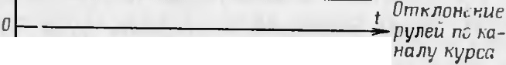

*Bnpaso*

*Bneao*

KT = + 0.5, KK = -0,5

PHC.

46.

3n10pb1

u

Hanpsi:>KeHUII H

KT = o. K K =

OTK.'lOIICH HH

..•.L I

py.1e11 npH

58 59

•

* 1. OPE06PA 30B \ HHE KOMA HJ]. Y OPABJJ EHHSI B OTKJJOHEtf HSI CHA P}IJJ.A no KY PCY " TA Hf A )l(Y

*u*

0 *t Ha exoiJe n11c*

.

*u*

*T* I

Ko:.\1a11..1b1 y npan 1c1111H no K}'pcy 11 Ta11ra*y no.na10Tc H Ha ax on.Hoe

)'CTp011CT.B. O npl CI'v llHKa c11apHn.a no n.nyx nposo,a.11011 Jll Hlf l CBH311 OT H83('J1101f annapaTypbl } npa B.r CHHH.

u u

Ilpl C:\J HII{ (pHC. 48) COCTOHT 1-13 Ka Ha.ria K)'pcall Ka11a 1a Ta 11ra>K.a. Ka.il ..lbtii 113 1-:a11a.rios co.1ep:ih11T B ce6e .1ew11¢paTop, 1..:ac1.,;a.il. }·c11... e- 1111H, ¢a30IHBCpCHbIC IIBblXO;I.IILIC KaCK 8..1bl. 8 h8Hcl'Ie 1-:y pca, KJ)OMe To­

ro, H1eeTC Sl KaCKa,a. .rIHKBH,U.8UHH nposa.ria IMilY JibC a H yc11.. HTe rih-or­

pa1111411Te.. b.

B ha11a.1e K}'pca 1"0MaH.na y nJJ 8BJ1e111-1H c Kac 1<a.na } c11rieH11H no­

.n.acTCH 11a KaCKa,a. .rilf K BII.U8U ill nposa.1a HMnj".ribC a, 3aTeM Ila yc1 'll ­ Te rJb- orpa11H4HT€.rib H C Hero 1-1a ¢a30IHBCpC Hble KaCK8.llbf .

B Ka11a.1e Ta Hra}Ka KOM aH.i].a }·npaB 1CHI H C KaCKa.na )"C 1J1el1 IH no­

0 --------------

* + .;t.-*Na Bb1xo8e n11c*

,a.ac1·c H 11a cpa301111sepc11b1e Kac Ka.D.bI.

I(an<...lblf1 ¢a301111Bepc11b1ii KacKa,a. npco6pa 3}"CT no.aasaeMbie 11a

r \ \

*u* '

*UcM =D*

0

\ '

*t Ha Bxoae* r<RHJLle-

*BOZO l<UCKaOa*

*KaHana mattiama·*

Hero c 11rHa.11:i1 B ..lBa c11rtt a.1a. npor11sono 10.iK Hb1e no cpaJe, KOTOpbte C Hl:\1a lOTCH C pa3..J.e.'lbHl>I X BblX0..108. C ¢a30IIH13CpCl[LIX Kac1..:a. 0Bll'.', ­

ny.ribCbl ·ripa u 1eH1IH IlO.la lOTCH Ha .naT111f .,; KOOp.J. IHaTopa . np11 3TOlvl JI8 }1('. b I,l3T4 11Ka Koop 111HaTopa COOTBCTCTBYCT npoXO.iK..1€111110 1(0\f 8H­

.llbl s1r 113, 1a:\te·1b I I -BBepx , .rial\1:C 'lb I I I -nnpaso 11 ., arv1e.rih IV -

I \_

*u t Na exoBe aMnnu-*

*0 myaHoiO ceneK-*

U,'1CBO.

Koop.!1111,aTop pacnp e,le.,1HeT K0Ma11,a.b1 y npas., ett11H no cooTseTc T­ B)'IOllllt :1.1 Bbl:\0,1. .t-lbl!\f KaCK a;I.aM np11eMHIKa B 3aBllCI MOCTIIOT }'r riosoro

* *UcM*
* L

I

*mopa r<aHana*

no., 0.iKcH11}1 npawa1omeroc H c11apH,a.a .

\ t \ xypca

I

'

><

·

IU

co

BI> XO Hhie KacKa.J.1)1 -np11crv1H111{a pa60Ta10T B K 11oqe1J0}1 pe.iK t \1e , co6pa11b1 no ,a.11¢¢cpc11u11a.rihHOtt cxerv e, T. e. cc.111 c o.n11oro 113 pa60- Ta 1ow11x B nape 1(8CKa.aon Bbl.!].e.l HCTCHIIMny 1bC }·npa B '1€Hlf H, TO 11a Bb ­

XO}lC ..lp)·roro Hl'vlil "., bC OTCYTCTBycT. C BblXOLI.HLIX K8CK8.D.OB lf }1ny.. bCbl

cc Tu= T *t OmKnHCHUe*

0

<")

*py11eu no 1<a-*

vnpaB CHIIH, yc11.., e11HblC no MOlilIIOCTH, nocTy nal-OT Ha o6l'vtOTK H 3.rieK­

:3 • *Hany mattw ma*

:z:

ro

TP0"18 f Hl TOB 3M- I, 31-2, 31\1- 3, 31-4, 3rv - 5, 31\1-6, 3M-7, 3:\1-8 6 10Ka

*BnpaBo*

*I* 1

0

•

'

*t Om1<n0Het1ue*

-

pyneu *no 1<a-*

p)'.TJ CBOrO np11BO,Ua. Op11 IJ381f l\10;I.C' f CTBl H l\1a f IITHLIX nOTOKOB, 8031111·

Kal-OlUIX B pe3)' bTaTe npoXO}K,.lCII1SI TOKa no o6MOTK8 l'vl 3.rI<:' KTpol'vt ar­

HI TOB 0 101(8 py., e1Joro np11no;r.a, C03.LI.alOTCH ncpcMcmeHl1H HI\Opeii II

*Bneeo*

. I.*T*. *u* ... j ' •

*Hany 1<ypca*

>KC'CTKO CBH3811IlblX C IIHMH P}''ICii.

Py.111 C fiapH.18 pa6oTalOT B Ko 1e6aTC.ri bl10l\.1 pc>K IIMC, C01Jep111aH yr ­ IlOBblC nc pe:\1ClllCHHH OT no 110ca OLI.l Of O 3 rJCKTPOi.\t ar llHTa LI.O no., 10ca

PHc. 47. 3nJOphl HanpH>K HHH H OTK.'JOHeHHH

KT = + I, KK = -0,5

py eH-

npn

n.py roro. Orpa60Tha KOM8Il.il py.HMH 38BI Cl T OT COOTI OU1<:' H 1H IJpeMe-

...

HI{ 1-1a xon<...J.CHIIH IIX B Kpa,11111.:... no ()}KC.IIHX }' no., OCOIJ 3,1CKTpor,..1a r1111-

TOB, ()npc..1c 'iHCMblX K<>3Cpcp11u 1c •1Tal'v HlOl\.1aHn. la BXO,U.C np11erv1H11Ka. Ha p11c . 49 no1.,;a3a11a CXCi.\t a OTK.1011('HI H py 1eii IIJ)H noLI.atJe la CHa pH!l KOi\.t a111no Katt c1.1a l\tl<)·pca 11 Ta 11ra*a npH K =± I.

Ha p11c. 50 n0Ka 3a11u1 :>n10pb1 Han11SI>Kl'HllH np11et1H11Ka 6.rioKa }·n­ pa B.1cH11H.

Bo BpC:.\IH no.CTa c11a pH.n BpamaeTCH B()Kp·r CROC'H npo.UO.i bHOff

OCI , a n<.CCTl{O C BH3, llllblC c 11111\.1 TOl{()Cl-,('l\t ll f f(II I . 2. 3, 4 *(* p11c. 48) 1 o­ op.n11HaTopa Cl<O."ll3HT no.1a MC'.: HM I. II. III. I\' naT1111Ka KC>OJ),a.1111aTo­

pa. npo113B0..1H ncpc1< 110t1C'1111H P)'.1c ii c 11a pH..1a. B

60

Ta6.1. 2 noKa3 a11a no-

61

u

C. ')lOBaTe bllOCTb nepc1..: 110•1r1111H p) 1c11 H 3aI3 1fCI MOCTlf OT I3J)3ll.'lC'l IH

*r'*

•::,

Oct:>

rt::> lie:

:i:: c

0 c<..>

.0 lie:

a::i

'

....

..

'

..,

::, .0 :r: c::

I I 3° .I)

c: c:; c E

:::s II) t:l..

;,. 0 ::r

'-' E N :S

::, .0n::,

:i:: - .c

* Cb -

O :z:: ts

.., <..> :IC

& II) c

Cl Q.t.>

II) le

--

'

" ]

•o:::s<o

,s

oucs

.c :ic

-

.

,::,

ore,

re c

0 >c:

>( (.)

aa

-.0 t:.:s::

,

-

-..,

I

/

*?*

,

I

"< '

Q.

II)

II) '

CCI

,.,.,

...

p

*:..::.*

..

*I*

..,

-

"' "'

ts lb

>

>

cl

..,

:s

-

;&

..,

'

II) Q.

O ts

co

:r:

..,

•:::s

ort::>

E E

g.ts

I.Q'O

.::,-

:i:: ts

..,

z::

.....

-

•

C')

:.::

...

•

,:.

ct:) le

O c..,

ts

-

p

cl

-C')

) -

.0 :ic

'°

I

I o.)

0

Cl.

""

er,

:s

.0

0 :c :IC

:::i::s: -Cct:>

.., <..> <..>

-

II)

<D

p

o a.c

-

0

'->

I

a::i

cl

co

:.r.::.

<"I

•

-

...

:r:

-

.., >,::;

...

...._ *L*

.

:.::

'

-

-

'

?

s le

=

:r:

Ct:> ::,

<"J

c E

°'

..,

p

<

-

cs

E

c:;

:s

r)

°'

II

)

cl

-

>

'

*v?*

>c: ,:;.

<..> ::,

Cl <..>

lo::.

' .

•::S

Oct:)

0

:r:

0

°' ---

<..>

In

:s0

:i::

+I Ir)

"' +1

Ets

..,

-

*::r* :IC

2 c..,

...,

c:;

>,

q

:i:::

:s

--

c:, -

It) :::

.\

+I +1

•

II

...

:.::-:ic

<:; Cl

Q

E

::::i ::::>

"

.

•

II)•::'a

c

o O

t:,

t:l.

ct:1 E E

:i:: Q.

-

-

-

>C

:$

::,..

c:,

0 0

c:; C)

::::,..tD

Cl._::S

(t::)

....

-

le: 0

*s*

::,..

o u u

E

.:,-

:s E

:.t.:s::

b.:s

-

-

'

,,.,

:r O

I

.

C',;j

E §

,::, Q.

Oro

:::s .., E

•

..,

-

Cl..

c::::{

c::,

Cl..

c:; :i:: ""

c:

:,;: ::,...

<t:, II)

:le:

:s

:r:

C)

c:;

u::i

')C c

c:,

:.:;

,::,::

* E c::

re, !§

-

2:

t>cs: II)

:i::

:c..::: :gs_

<..> c:;

-

-

Cl)

:s

t:l.

c::

c:,

<:o

/

-

5

"° . :::s cs

..,

cs :::s ::, cc;s:

0

-

0..

c:

I..

p

..

x :!"Cl>

loo

cl

0

<D

II)

t.> :s ts O

-

c;

co

')C c:

O c:;

C"I:)Q.

*;:::* :.:: '("

•

:r:

•

-

...

:.::a:i z::

- -

'

.

'

p

-('")

cl

*v'"*

J

-

0

<r>

0

0

ID

II.)

Q..

-

.

-co

c:

z::

I.a

I

..

-

co

c;

.,.,

•

')

•

:r:

..

0

t.)

(?)

*>* -

-

'

t:l.

::::,....

')C

:

'

\ J

\

"i\

-

..

'°

a;

\

c:;

0

:t::

0

:ic::

...,

..,

-

c11a pH.la.

I lp11 yr Jie nonopoTa c11aps:1;1.a OT O no· 7G B 1..:oopn1111aTopc 3a 11..:1-1y­

1

T bl n,1pb1 Ko11Ta KTOB l-1, 3- Ill.2- II.4- 1\

. 4rpc3 K01rTa1..:Tbf 3-111.

4-1\" Korv1a11ab1 )1npaB 1e1111H no 1<ypcy no,la1orcH 11a pyJI11 l-3, a ll e­

(JC3 I\OHTa KTbl l-1, 2-ll KOM 311'll)I }·npan l 'IIIH no ra11ra:tK)' no)lllOT­ C H 1-1a py 111 2-4.

r *Bua C3DOU 1*

(]

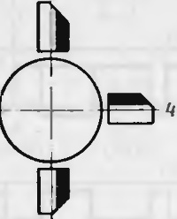

-------

- 2 -

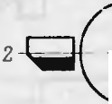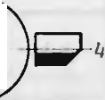

I

{]



*3* ., 3 •

*KaHan* II ,,+ *1* , *BnPABO*

---0

*Cl*

*KaHan I ..- ,* - *BHM 3*

*.KaHan* II..- ,·'- *Bfl E BO*

*Kattan* I ..+r .- BBf *PX*

-

0 *1* r

I-<

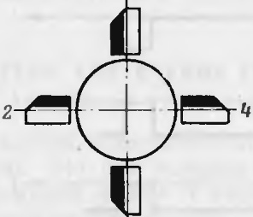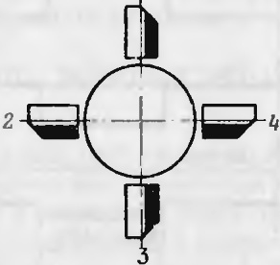

0.

0

'c°:,::

-

"C.">

;.,:

u

ti:::

--

c::

-::::

c--o

-.-..

3

,.

co•

.,,.

*\O Han I* ..- I''- *BHW 3*

*'<QHan* II..,+ ,..- *BnPA BO*



--

:,:::

*=t*

*t<aHan l ,. +1*"- BBEPX

*l<a Han H ,,-1* - 8/lEBO

u•

::s::

Q..

Puc. 49. CxeM a

OTKJIOHCHHH

py.1Jeft :

Kanan I-Ta nra>K; Kanan 11 - Kypc

CTp11 yr 1e nouopoTa c11aps:ina oT 80 ,a.o 166° B Koop,a.1111aTopc 3a MhI­ KaIOTCH KOHTaKTbI I-IV, 3-1, 2-111, 4-11. 4cpc3 KOHTaKTbI I-IV,

|  |  |  |
| --- | --- | --- |
| p  C | | cl  q  >  ' • |
| *L*  p | |
|  | •  r |

2-11I K0Ma11.llbl )

npasJic1111H no 1..:ypcy nona10TCH 11a pyJIH 2-4. qep e3

KOHT aKTbl

3-1,

1

4-11 KOM 311)J.bl)'npa B.IClliH no TaHr a>Ky no.n.aIOTCH Ha

PYJJII1-3 IT. *11..*

Jl rr s:i 1<0Mne11cau.1111 cpa3ouoro 3ana3.llblBa HIH 0Tp a60TK11 1<01t aH11. CHa pH.llOM, B031111Ka1ow.ero 113 3a Bpaw.eHJIH eroIIIIIICPUIOHHOCTH pa-

 6oThI 6.1. 10Ka py 1enoro npHso.na, B Koop,a.111-1a Tope BBe,a.eH yroJI )·npe>K-

11.e11HH, paBHhIH 14°.

62 63

•

*l( 'JPC*

*U* axo8a npueMttu1<a •

.



•

OP-----+----+-----=;i,.. t u

TAHrA>K

*U exo8a* npue.MHUt<a

,-

•

t

I *l*

T a 6 JI H: ua 2

Ta6JIHua nepeK 110lleHHH JiaMeJibHoro ,naT11111<a KOOPJl.HHaTopa " pyJieH 6Pn

B 33BHCHI\ OCTH OT epauteHHH CHapHJl.3

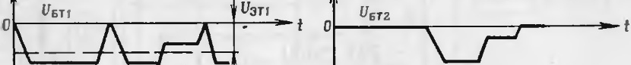

U11.r 1• u6T3

0

.... -

t *O*

*U3r 1*

U3r3

o.

*lrr.r 2*

*Up,s*

t

no eopoT c HapR.la

no..1o>KeHHt!

1a "''e 1b11or o

A 3

T•IHK 3. pyncA

0-76°

I

80-166°

I

li0-236°

l

2€0-346°

350-360°

•

•

no o>Kenne

JIa\1e bHOro

t -1

3-111

t -1\'

3-1

J -11

3-1\'

1

-III

I-Ill

3-11

2-1\"

4-1

1-1

3-111

2-11

4-IV

noJTO>K eHHe

p}.1efc

1-3

1-3

1-3

1-3

1-3

(Kypc)

2

4

(TaHra>K)

|  |  |  |  |  |
| --- | --- | --- | --- | --- |
| J(.aT'IIIKa | 2- | 11 | 2-111 | 2- |
|  | 4- | 1\' | 4-11 | 4 |

,,._. t

|  |  |  |  |
| --- | --- | --- | --- |
| (Kypc) | (TaHrail<) | (1<ypc ) | (TaHra>K) |
| 2-4 | 2-4 | 2-4 | 2-4 |
| (Tanra>K) | (K)"PC) | (Tanran<) | (K)•pc) |

0 - UKT3-

*t*

*Up,9*

•

) •



BcJie,11.cTIJit e ncprK.'llOt.Je1111 1 1\oop;I.1111aTopolt 1 01a11::i. )'npa a.1e1111H

0 UKT6 . t



*Up,n*

-

\.

'

-

UKT10 •



nocJI€)lllle nO 'J.8 IOTC H TO Tl bl{O 11a Te napbl p)·1ei1. KOTOpb C 38IIHM8IOT B npocTp a11CTIJ€ COOT!1CTCTB}" OlU€ € 3T lli\,f 1(0:'vt 8 l,!l.8l'vl no 10>KCHI €.

B pe3)'JibTaTe oTp a6oTKH KOl\ta 111. . 06e111v1H napaMH p)r.ileii c11apH,a.

pa3BopaqasaeTCH B CTopoHy pas110,a.eiicT1J )"I01Ueii a3pO.JIH8 l\t f J€ Cl{I X

u

c11JI, JJ,e11cTu}·10m11x 1,a p) 11.

5.4.PA60TA 60PTOBOH AOOA PATYPbl YnPABnEHH CHA PAOM

Ot-r-------.-...,-----'J.l-t

•

Ot-- *UK* TIS,'T-J7- -+ .;.-f



PacCMOTplt I pa 6oTy np11Hu11n11a., l>IIOH 3.;1eKTpilJ€CKo i CX€l\t bl 6op­

*0*

-*U3111*

U3r 14

-

t

t

UK T9,T JJ

UK T l6,Tl8 1

Omt<nOttettue

*p*  'Jleii eeep)(

*_...,._U*3T JS,TJ7

I

T0130H annapaT}'Pbl y·npaB :teHIIH ( p11c . 5 1) np1-1 yc 101J1111. qTo ctt apHD.

1{ 8 XOLI.HTCH B ropl130IIT8Jlbll0l\1 Il0.1 O>Ke111111 P)•., eM I BBcpx II He apa­ maeTCH. B 3To.M cJiyt.Jae B 1<oopA 111-1a Topc T0Koc'herv1H1-1K11 I , 2, 3, 4 cToHT cooTneTCTBe11110 Ha.TJ aMe.. st x I , II, I I I , I V ., aMeJib11oro JJ,aTt.J J Ka.

Pa6oT a CX€Mbl no KaHaJiy T8Hra>Ka COCTOIIT lJ c 1e,a.y10meM. np11 11a.. H lJ JI 11a 6opTy c1-1a pHAa 11anpH}K € HIH n11Ta 11HHII OTcyTCTIJJ II

or-;:==========;;;---;=:;t----t

0 t

- *U3r3,*TJJ

*Oml'Jlo*-*HeH ue* •

KO f 8l )J,bl }·npaIJ., € HI H TpaH3HCTop T2 3a i:pbIT, Ta K Ka K 11anpH>K€ Hl-f €

- *C nt:.JloHeHue pyneii*

,t:;;;;;;1--·- I *U*3Trs

rrs

*pvneu 6HU 3*

3 111TTep -6a3a Tpa H3HCTopa T2 paBHO HYJIIO. TorJJ,a qepe3 6a3y TpaH­

--e:n=e-e;o;;:--- ,

UKT19. T.ZO I

s11cTop a T4 TeqeT TOK no uen11: + 16 B, nepexon. 3.MHTTep - 6a3a Tpa 11-

311cTop a T4, cTa 611cTop )l.8. pe311cTop *R 7,* -16 B: cJieAoBaTeJibHO,

0 - umKnONeNue pyneu

Bnpaeo ._

t

*U3r* 19,T20

Tpa113HCTOP T4 OTKpb T, naJJ,eHHe HanpH>KCHHH Ha He f H€,U.OCT8TOlJHO JJ,., H OT1i:pbIB81-IHH Tp aH31-ICT0pOB T5IIT7.

Y *c n o e H bl e*

1. *HanpsimeHue ;*

U6-HanpjjmeHue *Ha 6a3e mpaH3ucmopa ;*

*o 6 0 3 H Q l/ e H U 7' :*

U3- Hanp1nt<ettue t1a 3Mummepe ;

*Up,- HanpjlH<e Hue Ha crna6unr1mp0He*

* 1. Jepe3 KOHTaKTbl 2-11 Jl8 1'v C.ilbHOf O ,a.aTq1-1Ka TOKIle npoTeKaeT.

CTpH 3a Kpb TOM TpaH3HCTope T5 TOI{ qepe3 nepCXOJI.bl 3MHTTCp - KOJIJ1€KTop TpaH3HCTopa T5Ii31HTTCp -6a3a Tp aH3HCTopa T9 HC T€­

*VK- nanpjlm ett ue 11a xonnexmope mpa113ucmopa;*

PHc. 50. 3nl0phl Hanpst>KCHHfi npHetH111< a 6110Ka y npas.eHns:t

64

•

t.J€T; CJie,U.oIJaTeJibl lO, Tp 8H3HCTOp T9 38 Kpb T, 38KpbIT TaK>Ke JITp all3H­ cTop Tl3, T. e. B 06rv10TKax 3JICKTPOl\18 fll-fTOB 3rv -2, 3M-3 6Pn TOK8

IICT.,np1-1 38 1(pb TOM TpaH3HCTope T7 qepe3 nepexo,a. 3MHTTep - 6a3a TpaH3 -IcTopa T8 TeqeT TOK no u.enH: + 16 B, pe3HcTop R21, nepexo.n

5 3aK. 1669c 65

3MHTTep -6a3a Tpa1 3HCTopa T8, pe311cTop RI8,- 16 B; c rie.nonaTe 1b­ Ho, Tp aH31 CTop T8 0T1 pb1T.

4epc3I<OHT aKTbI 1- Ina:rv1e rib11oro ,1aTq11Ka npoTe1{aeT TOK, or1 pb1-

1ue11H10 K J11111111-r K, py 111 !JI) I-J OTK 1otte111>1 Tai<, qTo co3;1.aeTcH } npas-

•• II

JlHIOlUIIH M0!\1e11T, OTKJ OHHIOlUllc11a pH.U BBepx.

Pa6ora c:\cr-.1b1 110 KaHaJI}' Kypca a11anor1141-1a pa6oTe cXCl\.1bI no

sa1om11A TpaH3icTop Tl5 no uc n11: + 16 B, pe3HCTop bI R35 11 R36, ne­

KaHaJiy Ta11ra>K.a. B 0TJIH1.J11e OT Katt ana Ta tt r..a>K a B 1<a11a.1,

e {ypc a u!\1e-

pexo 13l1HTTep -6a 3a Tpa H3Jf,cTopa Tl5, KOIIT3 KTbl Jla:\1eJi bHOro }laT­

lJII a 1-1, rrepexoA 3lHTTep - KO.'.l.'.leKTop OTKpbt Toro Tp a113I CTopa T8, peJ11cropb1 R20 11 RI5, -16 B. rio o6MoTKe 3JieKTpoMa r1111ra 3:\-t-4

CTO K.lOI €BOro I(aCKa.!].a CTOl T aMn.1HTY.ll.Ilbl f ceJieKTop Ha Tp att 311CTO-

pe T I (p11c. 5 1) ' {OTOpbIH OTKpbIBaeTCH TO 'lbKO npH npeBb IIICI-IHll a 1- n.,1HTY.ll.bl 11:\1n)' IbCOB onpe.n.ene111-1oiiBC rt f l111-1bl.

EPIInpoTeK aeT )'npas 1H101UHH TOK, K0Topb1i1'

oT1<pb1s aeT TpaH3HCTOp

IpH OTCYTCTBlll KOM 811.ll.bl y·npau.,11e1· HH TpaH3I CTOpbl Ha XO]l.HTCH B

Tl7. UenI> npoTc1<aH11H ToKa, oT1<pb Ba1omcro Tp aH3ItCTop Tl7: + 16 B,

pe311cTop R38, nc pexo;1. 3MI TTep -6a3a Tp a H311cTop a T l7, 3111TTep - KO 'lJi eKTop Tpa H311cTopa T l5, 06:\10TK a 3JieKrpo'.\-1a rtt11Ta 3'.\1-4 EPrI,

-I6 B. rio 06 10TK e ::.1J1e1 Tp0Mar1111ra 3 1- l EPn nporeKaeT )·npaBJIH­

JOIUHH TOK. P)".,111 2-4 (p11c. 49) OTK.T OHHIOTCH npOTl R XO,la qacoso 1

CTpe.11(11 (CC. iCl\. uTpeTb co CTO()Ollbl P}" 1H 2) ,C03;la Ra H }·npan HIOlUIH

u

* 1. \' CI T, rrosop atl 1Ra l01UH11 CHa p}IJl. 81-1113.

Toq110 Ta K *n< c* Ka 11a.1 Ta 11ra>K a 6)',leT pa6oTa Tb 11 np11I{OMa1-1;1.e

<<-1>>, TaK 1{81( R 3TOM c., ytJa e.111HIH Tatt ra>K.a HaXO.!]. lTCH non noJIOiK l­ TCIbl bll\.l noTCHilf a.110:\1 no OTIIOlllCl {IO {.'1IIHII1l()'pca,Ii Tpa1131 CTOp T 2 6y.ueT 3a KpbIT.

flp11 nocTy n CHIIIl{OM8Il,lbl << +l>> Tp aH3HCTOp T2 OTKp blsacTCH. 4l'PC3 6a3y TpaH311CTop a T4 TOI{ HC npoTCKaCT, TaK Kai{ 11a11pH.1K€HI C

51\ HTTep - 6a3a HC}lOCT8 T04110 .!I.JIH OTl{pbIBaHIH Tp aH3HCTopa T4.

Tpa H31 cTop T5 0T1 pb1T, TaK h'.a KlJepe3 ero nepexo.u 3MIITTep - 6a- 3a npoTe1<aeT TOI{ no uen11: + 16 B, pe311cTop R 19, nepexo;1. 3MHTTep -

6 a3a Tpatt3Hcropa T5, pe311crop R I1, -16 B. 4epe3 KOHTa KThI 2-11

:1aMe rtbHOfO ;1.aTll \ a npoTeKa eT TOK, OTl<pbIBaJOIUHH Tpa11 l CTop T9, no uen11: + 16 B, pe311cTopbI R36 11 R24, nepexo;1. 3MHTrep -6a3a Tp all3 HCTop a T9, KOHT a KTbl 2-11 Jiarv1e., hHOf O .uaTtIHKa, nepexo;1. 3MHT­ Tep -KOJIJieKTop Tpatt3HcTo pa T5, pe311cTopb1 R 5 11 R20, -16 B. no

06rv10TKe 3JieKTpoMar1111.Ta 3M-3 BPCT npoTeKa eT ynp aBJIH1om11tt TOK,

hOTOpbIJI OTKpbIRaeT Tpa113HCTop T l3, a no o6MOTKe 3Jl€1{TpoMar1-1HTa 3M-2 Tet1eT TOK no uen11: + I 6 B, pe311cTop R38, rrepexo 3MI TTep -

Ko., JieKTop Tpa H311cTopa Tl3, o6MoTKa 3M-2, -16 B. Py 111 2-4

( pi C. 49) OTKJIOI-IHIOTCH no xo.n.y J 8 COBOI1 CTpeJIK 1. (ecJIH Cl\.10Tp eTb co

cTopottbI pyJIH 2) , co3;1.ana H ynpaBJIHIOlUiH MoMeHT, rr0Ropaq11Baiom11 1 cttapHJI. aaepx.

TaK KaK TpaH3HCTop T4 3aKpbIT, TO qepe3 6 a3y TpaH3 HCTopa T7 nporeKaeT TOK no uen11: + 16 B, nepexo.n 3MHTTep -6a3a Tpa tt3HCTO­ pa T7, pe3HCTopbI Rl2 H R I1,- 16 B; CJIC.!lOBaTeJihHO, Tpatt3 HCTop T7 OTH:pbIT, a TpaH31 CTop *TB* 3a Kpb T, TaK KaK 11anpH>KeHI C 31\.1HTTep - 6a3a HC..UOCTaTOlllO ..UJIH OTKpbIBaHHH Tp all3HCTopa. 4epe3 KOHTa KTbl Jia MeJlbHOro .uaTqJf Ka 1-1 TOK He npoTeK aeT, H Tpa H3HCTOpbl T l5llTl7 38 KpbITb . 06MOTKli 3JI€KTpoMarHHTOB 3M- I H 3M-4 o6ecTOlJCHbl.

TaKi M o6pa3oM, Kor.na CHfllaJibl ynp aBJI€HIIH B np0130.!l OH Jl Hlf H CBH3H OTCYTCTBYIOT HJlH JlHIIHH T H8XO.!l TCH no.!). noJIO>K HT€J bHbIM no­ TCHLlHaJIOM no OTHOIII€IIHIO K Jll HHII K, PYJIH oPn OTl{ TJOIIHIOTCH Ta K,

c., e.U)"I01UHX cocTOHHIIHX: T I-3 a1\pbIT, T3 -OTKpb T, T6 -3a KpbIT,,

T lO -oTKpbIT, T ll 11 Tl2 -3aKpbIThl, Tl4 -oTKpbIT,i1cpe3 Ko11TaKThI 3-111.1a Me 1b11oro ;la Tt1111{a TOK HC npoTc1<acT, T l6 11 Tl8 -3aKl)hITbii,­

l1Cpe3 KOHTa KT1>1 4-IV.1aMe 11:i11oro .!].aTtIIKa TOK rrpoTcI<aeT, Tl9 H

T20 -OTI{pb1Tbl. no 06:'vtOTK arv1 3 1Cl<Tpor,.1a r11HTOB 3M-5, 3M-8 BPTI

npoTeI<aeT )'npaB.. H10m1-1 i TOK, a o6MOTK1f 3.' €KTporv1a rHHTOB 3M-6, 3M-7 EPn o6CCTOll Cl- bl. Py.111 l-3 ( p11c. 49) OTl lJOJT HIOTC HIlpOTI U xo­

}la qacOROll CTpe 1KII (eCJIII C!\-loTpCT b co cTopollbl PYJIH l)ll C03.UaIOT

* + - u

ynpaB.' HIOlUIJI MOM€11T, noRop atIJlna1ow.1111 c11aps:1;1. BJJ CBO. .

Totll-10 Ta { IKe KaHaJIl{)'pca 6)'.ll.CT pa60T8 Tb np11 Ha., H J JIIIla BXO-

;1.e npl € MIIl\ a KOlall.!J.bl )'npaRJI€1JlH C aMn 'lHT)'.ll.Ol , l'V CI- bllICHu na.uc1111H 11anps:1>Ke1111H 11a cTa 611.cTop ax ,ll5, ,ll6 (p11c. 51) , T. e. np11 Kor-.t a H.ue

<<-l>>, Ta K KaK R 3T0:\1 CJiyqae Tp a113l CTop T l 6)'.1. .€T 381\.pbIT. np11 no-

u

s:1n 1e111111 Ila BXO,le npl €1\. ll1Ka I\OJ\1811.ll. }·npanJieHI H C 81\.1nJII T)'.!l0ll

6o.. bllICH, llCM na.n.e1111e 11anpH>K CHIIH Ila CTa6H.! H3aTopa x ,ll5, ,ll6 ( KOM 8lT.ll.8 << + 1>> ) , rpa113HCTop bl 11aXO.ll.HTCH B c rie.!).y10m11x COCTOHil HX: T l-oTKpbIT,T3 -3aKpbIT, TG -oTKpbIT, TI0 -3a1{pb1T, T ll 11. T l2 -

or1<pb1Tbl, T 14 -3aI(pb1T, 4 epe3 Ko1-1Ta1\Tbl 3-II npoTe1\ aeT TOK, T 16 H T 18 -OTKpbITbl, qepe3l{OHTaKTbl 4- 1\T .. a MeJibllOfO .uaTlJ Ka TOK

11e npoTeK aeT, T 19IIT20 -3a Kpb1Tbl. no 061\.10TKaM 3Jl€KTporv1a rHHTOB 3M-6, 3M-7 EPCT npoTe KaeT ynpan., H1011 1t ii TOK, a 06MoT1{11 3JICI<T po­ Mar1111Ton 31\1-5, 3M-8 06ecT01.Je11bl. Py ri11 l-3 (p11c. 49) OTl{JIOHHIOTCH

no xo.uy qacouott crp e rt KH (CC H C MOTpCTb co CTOpOl-lbl PYJIH 1) II C03-

u u

.!).alOT ynpan 1HI01Ult MoMeHT, nouopa 4 HBa10m1111 CiapH..U snpaso.

TaKi M o6pa3oM, B HCXO,nHOM noJio>Ke111111 KO!v al.Ubl ynpasJieHlH no Kypcy no.uaioTcH 11a pyn11 1-3, a no Ta11ra>Ky ia pyJIH 2-4.

l1Tal{, HanpH}KCIIIIHM pa3HOf 0 3HaKa H a Mn 'IHTy;I.aM (1-1a.rt iHJI T OTHOCl TeJ bllO JIIIJ T li K) Ila BXO.ll.C npoBO.ll.HOH.rt lll ll CBH31i COOTBCT­

CTBYIOT onpe.n.ene11lbl€ ynpaBJIHIOIUif e MOM€HTbI, pa3Bopall B8101Ule· c11aps:1;1. cne.n.y1ow.11M o6pa3oM:

-50 B-BnpaRo -ssepx;

+50 B -Bnpaso -B11113;

-11'5 B -BJieBO -BBepx·,

+ 11,5 8 -BJICBO -BHH3.

0TcyTCTBHC KOMal.!J. )1npas rieHHH - B.rieao -Bll113.

Op11 npoxo*.UeHHH 4epe3 rrpono.n.•1yio Jil HHto CBH3H )1npaans:1iom11x Hl\t ny 'lbCOB ( KOl\.1811.U y npa n rie11HH) 11a6J110;I.aeTCH sasaJI cppoHTOB, 1{0-

qTo C03.UaeTCH ynpaBJIHIOIUIM NOMeHT, OTKJIOHHIOIUHfi c 11aps:1n BHl13.

TOpbl

"i npH .usyxnonynepHO.ll.HOI'VIBb1npHl\.1JI€HHli B KaHaJie Kypca Bbl3bl-

ECJIH Jil HHH T HaXOJ(l TCH noJJ. OTPHUaTeJihllbIM noTeHuHa.rioM no OTI O- 66

•

Baer nponaJIIMnyJihCa . .llns:1 ycTpa tteHHH 3Toro nposaJia *B* Katt a 11e Kyp­

ca Il\t eeTCH Kac Ka;I. JIHKB11;1.au1111 nposaJia 11Mny ri1:ic a 11a rpa11311cTope

67

-

T6 (p11c. 5 1). npH 0TcyTc1s1111 c11r11a.. a Tp att3ICTop T6 aa1<pb1T, Ko11-

.uettc aTop C3 3apH>KaeTCH 'l.0 11anpH>KC11HH CTa6H 1113a UIII CT3 611v111Tpo­ Ha *)l* ll nJitoc na.ne11He 11anpH>Ke11HH nepexo.n.a 3!\tlf TTcp - 6aaa 1paH-

311cTop a T I0. BpeMH 3apH.J.a 1<ottnettca Topa C3 10 11anpH.>Ke11J1H cTa 6H­ JIH3au1-111 CTa 61 Jll1TpOHa .illl 60Ji bllle )l., 11TCv bl OCTII nposa.. a H:'A ny., b­ ca, B pC3YJibTaTC 11a Ko1JICK1·ope Tpa113 ICTOpa TIO 13bl.ll.ev1HeTCHllJ\, ­ ny 'IbC 6c3 npoua.ria. Pe3 HCTop R 16 11 cTa6J11HTpo11 )llO c., }">K aT .n..1H no.. yLie1111H cTa6HJIH311poBa1-11·1oro speMeHlf 3apH.aa 1<011n;c11c aTop a C3. YcH.111TeJib-or pa11H1"lf TeJib Ha Tp a11311cTope T IO 06cc ne41113a cT pa6oTy

¢a30H11BepctthlX Kac1<an;os T II H T 14 s pe>K ll\te nc peK.i l04CHHH.

Ko•1ne11c aTOpb1 C I H C2 c 1y>K aT 4>111bTpa 1J1 BbicoK011 qac ToTbI 111- HJ111 CBH311 11 YJIYIIlllalOT noM€X03a W. IW.eHtlOCTb 6v'IOKa ·npaB.r eHIH.

B KO rtJie1<Top11b1e uen11 shr xo.n1-1b1x Tpa H3If cTopoB T9, T l3, T l5 -T20 BK:110IIett b1 <>6MoT1<11 3 rtc1<Tp0M ar1-111TOB 6PI I. 4To6bI 3)lC ca::\101111.n.yK­

UHIInp f nrpCKJII04 €1-l -fHX tie npeBbllllav a npe.ll.CJlbHO ,a.onycTlf '.\f Of O Ia­

np11 3THX 1(0:'Ja tt.nax Tp a1 3JICTOPLIT 5 II T lI OTKpolTbl, a T8 JI Tl4 3c!1<pb1Tbl (pHc. 51) . p11 CKOJi b>KCH1111 no Ka>K.n.011 113.11aJ1;1e., eiiII11 II

())lH()fO 113 TOKOCbeMl-lIKOB no HHl\1 6yJlCT npoTCl{aTb TOK.

B 1i xo Ho r no.. o>Kctt1111 Tpa113HcTop b1 T5 11 T 11 OTKpbITbI, a 18 I T l 3a1\ pb1Tbl. Kai,}'Ka3bIBa.. ocb Bb1111e, R bIXO.UHblC Tpa H311cropb1 T9, Tl3 H T l6, Tl8 01Kpb1Tbl, a py.. H 1-3 H 2-4 OTl{ 10HHIOTCH Ta K, 4TO

C03alOT }'npaR.. HIOW.lle l\toMel Tbl, CTP{'M HllllleCH noRep1iyTb ctta pHA Bnpano - uRepx.

nPlf }'r 1e nosopoTa CHa pH)la OT 80.o 166° B )laT lll{C 3aMI:i1Ka lOTCH lOIITal..:Tl ble nap1,1 3 I, '1-11, 2-111, l-J \ '.

I-Ia 6a 3y . Tpa tt311cTop a T9 4 cpr3 3al\l <ll}'Ty10 l<OHTa KTH }'JO napy 2-111 noCT} naeT c1-r r11aJI ynJ)aB 'ICIIIIH no l)·pcy, Tpa11311CTOpb1 T9, Tl3 0T1 p1:i1ua10TC HII r10 O?:'\lOTKaM 3 1CI<Tp0:\{ 2 fll!TOl3 3:\1-2, 31\r-3 5Pflnpo­

T€K aeT.YnpaB.1H1om1111 TOK . P)·1111 2-4 ( JJlf C. 49) or1<JI<>HS110TCH no X O.ll.)'

npH>KE'l·li.H Ha .3TI X TpaH31-fCTopa x, OHII aaw y11Tl poBa Hol COOTBeTCTBeII­

4aCOBOIICTpc 11 11u(

cc.111 Ila l f X Cl\lOTpeTI> co CTOPUIILI P}'.1H 2 ) IIC03.Ua ­

HO cTa6HJIIITJ)OHa Mlf .lll2 II*)l* l6 c no10lllbl0 pa313 H3b BalOlll f X 1.110.J,OB

)ll3-)ll5 H )ll7-)l2 l. Pe3Jf CTopbIR3, R4, R9, Rl3, R l4, R22 -1<24 , R27, R33-R35, R37, R39 11 R40 HR.'lHJOTCH 6a30BbIMII conpoT11s 1e- 1111HtH COOTBeTCTB}'lOlll lX Tpa113HCTOpOR H Cll}·>KaT ,a. 'IH C03.!l.a JIIIH HOp­

Ma.. bltOro pc>KHM a pa60TbI3TIIX Tp a11311CTOpOB.

8 noJieTe c11apHJI. spama eTCH OTHOCITe.. bllO npo.aO 'IblOil OClf , no­

.3TOl\ty Ha ero 6opTy HMeCTCH }·cTpottCTl30, )'ll' f TbIBaIOw.ec 3TO upamctt11e. Tal{HM ycTpOHCTBOM HRJISleTCH li.OOP.!1.HHaTop C ,a.aTIIIIKOl\1 noJio>K e­

HIIH c 1apH,a.a OTHOClTe., bHO npo.nOJi l Oi OCI . Koop.UHHaTop C no­ MOll.lblO cTa6 11Jil 311posaHllbIX B npocTpa HCTBe JiaMeJieH r.{aTII IKa H TO­ KOCbel\1H f KOB, >KeCTKO CBH3 a HlblX C lpaw.a10w.HMCH CHa pH.ll.OM, pacnpe-

11.e 1HeT BI{ a>K.ll.bii MOMCl T Rpel\lCI I C Hf HaJibl ynp aR 1CIIHH Ha PYJIH l-3II 2-4. TOI\OCbeMHI KH I, 2, 3, 4 CKO 'Ib3HT np11 spatILeHHH CHa pSl­

.na no Jial\1eJIHM I,I, I,IV B 11anpasJi e111f Jf , yKa 3a11HOM Ha cxeMe

p11c. 48 no x o.n.y qaCOBOH CTpe 11(11 (CCJIH CMOTpeTb la c11apSI.ll. C3a)l f ) .

f0T )'npaB lJHIOlllllll l\101V1CIIT, CTPl'l\tHllliicH noIJep11}'T b C HapH...l nnpaBO. llcpc3 Ko11Ta1<Til}'JO napy I-IV (p11c. 5 1) c1-rr11a.,1 }'npaBJieHI H 1e

noc rynacT, Tp a H311CTOpb1 T 15, T 17 3a KpoITbI " no 06MoT1<a r 3JieKTpo­ l\t arHlf TOB 31- l, 3M-4 BPn TOK 11e npoTeKaeT. - a 6a3 y Tpa H3HcTopa

T 19 ll 'PC3 32:\tI<H} T)'IO h::011Ta1"TH}'JO r1ap}' 4- 1InocTynaeT c HrHaJI yn­

paB 1e1-111H no Ta Hra:iK y. Tp a11311CTOpb1 119, T20 OTK()blBa10TCHIi no 06- f OTl{al\1 3JICl<Tpo1ar1111TOl3 3M-5, 3J\, -8 6Pn npoTeKaeT y·npaBJIHIOW.Hl T(> K. P)'.. 11 I-3 ( p11c . 49) ' }'npaB.1H€Mb C TOl<OM, npoTe <a JOw.11 1 no 3Tl M

)OM011(a 1. OTl( IOHSllOTCH npoTIB xo.n.a 11aCOl30tt CTpC..11{11 (cc.111 la HHX C !<.10Tp Tb co CTOpOHbl P}'.. H l) H C03XJ,cllOT )'npaB 'lHIOW.HH l\101', CHT, CTpe­

'.\1HW.11l CH noRep11)Tl, c11a pH.n. BBCpX. llcpe3 K011Ta KT11y10 napy 3-1

{ pHc. 5 1) Clf rHaJI ynpa BJICHIIH IIC noCT}'naeT' Tpa1-1311CT0pb1 TI6. T l8 3a k.pblTLIIf no 06r.10TK aM 3 '1Chrpol\1ar1-111Tos 3M-6, 31\,J-7 6PI-I TOK 11e

npoTcKacT.

0

8 no.'IO>K Cll lH nepe.n BLICTpe.'I0!\1 B ,a.a Tll fl{e KOOp)lHI aTop a 3al\f {ll}'­

T a K IM o6pa 3o\t , np11 nosopoTc c11apH.n.a oT 80 .uo 16(>

pyni-r 2-4

Tbl KOHTal{Tllble napbll-1, 3-111, 2-11, 4-1\'. 4epe3 KOTOpblC no.aa­ lOTCH KOMa ll)lhl ynpaB rt CI- HH noI{ "PC}' Ha pyJilf l-3, a no Ta ttra>K y -

11a PYJIJI 2-4.

npH yrJie nosopoTa c1-1apH.n.a or 80 .no 166° B .J,aT4I KC 3al'vt b11<a10TCH Ko11TaKTHb1e napb1 IIV, 3-1. 2-11 . 4-11, KOl\t a H.UbI}·npaR.1eHI H no Ka 1-1any KY JJc a no.naIOTCH 1 a py:111 2-4, a noI<a tt a.. y Ta ttra il<a - 11a py-

Jl ll 1-3IIT. !!;.

Ta KHl\,Io6JJ a3oM, np11 nosopoTe c11a pH J.a Ha Ka>K,1.y10 1/4 o6opora ero pyJI11 J1;1e1-1H 10TcH poJIHMII, T. e. Te PYJIH. K0Top1,1e *JJ..o* nosopora Ha 1/ 4 o6opoTa BbinOJIHH.' H KoMa H.n.y no Ta11ramy, nocJie nosopoTa c tta ­ pH.1.a Ha 1/4 o6opoTa BbinOv'lHHIOT KOJ\,Jall.ll.Y no Kypcy, II Hao6opOT.

B Ta6JI. 2 noKa3a Ha nocJie.nosaTeJib HOCTb .3r11x nepeKJIIOIICIIHH npH

.npyr1-r x yrJia X nosopoTa CHa pH.ua OTl OCHTC.'.IbllO HCXO.ll.HOfO noJio-

}K.e11lH.

PaccMotp11M cJiyqa ft, Kor.ua no o6oHM Katt aJia M 11a sxo.n11oe ycT- poiicTso np11.eMHHKa no.naIOTCH KOM al .ll.bl << I>>, T. e. MaKCHl\,JaJibHbie

1<6'.\if aii.Ubl sIJepx - snpaso.

68

H nepcKJia.J.blBa JOTC H. Ta h KaK noc.. e nosopoTa ynpas.HIOlll H TOK

lpOTCKaeT 4Cpe3 Te >KC o6MOTK1i 3.',ICKTpoMarlllf TOB 3l'r -2, 31-3 EPn, 4TO II () nouop<>Ta ...P}' 111l-3 n 'Pl'K rta.ll.bIBaJOTCH, noTO!'.t y lTO .no no130- pora } npaBJlHIOll.l lH TOI( np0Te1{ a.,1 4Cpc3 06J\, OTKl,f 3J\,J-6, 31-7 6Pn, a noc 1c noRopora - 4epe3 06:\10TK11 3M-5,3rv1-8 .6Pl .

* CTpJI Ko1a11.1,a x, paRIIhIX << + l>> no 060Hrv1 Katta.,1a M, 1-1a ., a MCJIH I f

I\ c11rHav bl }'npaR.1€1-IIIH 11e no.J,a lOTCH. Tai( KaK Tp a113HCTOpb1 T8 II T l4 3a 1 pbITbl f TOK 4CpC3 3TII 'Ia\1C 'III•re npoTeK aeT.

np11 KOMa 111.ax, pan111,1x <<-1>> no 00011M Ka11a.,r1a 1 ynpa sJieIIHH

rpH311cropbf T5_ 11 T lI 3a1 pblT b , a Tpa ttJ11crop1,1 T8 11 T l-1 OTKpblTLI; c1f 1 H3., bI 11a BbIX o1.e np11e:'A 11111..:a no.J,a1orcH liepe3 JIa \tc.111-r I HIV 1-r

)'.,111 ()TK.,'IOIIHIOTC51 ...... ·CTOpOilbl, npOTI IJOil010>KHble OTKJIOHeHl HM npH

Ko,1aH,1,e << +l>> no 000111 ha Ha.1a \t )·npa B 1e1111H.

Bo Bpel\1H npo.xo)la TOKOCbetHIIKaMli1130IHUHOHllbIX y4aCTKOB J\, C>K­

.l) .a :'A e }1"111 3 1eKTPllieC Kl1e u.en f pa3pbI11aIOTCH, BblX0.11Ible T (J a11311CTOpb1 nJ)l eMIIIIKa 3a Kpb1BalOTCH JI K0\1a H.ll.1>1 Ha P}"Jllf He r10J.a IOTCH.

• 69

no.1b3YHCb Ta6JI. 2 H np1111ur1n11aJ11>ttoii3 TJeKTpttt.1ecKott cxcrv1oii6op­

6aTape1f cpapbl (P4) , 6opTOBOH 6aTa peH ( P3) H 6JIOK KOHTp0 1SI nep­

,ouoiia nnapaTyphIynpaBJie11HS1 (pttc. 5 1), rv10>1< Ho npocJie.n11Tb npH 3a-

BOtt Ha3C i\t11o i6aTa pc1-1 tta xo;I.HTCH B H.t\Y.)

.n.a11110M cttr ttaJie ynpaB.rie111f S1 nc>JIO.>Ke11He p};1e11 np11 11.pyrr1x 'r.11x no- aopoTa CHapH.na OTIOC HTe 1bl: O 11cxo.n11oro noJIO.>Ke11JISI.

u

* 1. PA 60TA 60PTOBOH A nnA PATYPbl Y OPABJIEHH51 C H1-\ PSID.OM 9Ml 13 nPH nY CKE H B nOJIETE

K 3aiKHMa:\t 6aTapett cpapbI 6<1> noJI.K.11roqcHbI .ztBc napaJIJICJihHO co­ e.n1111t' 111ble 3 1CKTpHllCCl(lle UCTII , nepsas:i 113 KOTOpblX COCTOlT H3 no­ CJIC.Zl.OBaTe 11.>HO coe.n1111e1111b1x ¢apb1 H pc3HCTopa R44, BTopas:i -113 pe- 3HCTOJJ,l R45 11 3 tKTponoc n.,aMciHTC..r H appeT11pa KoopAHHaTopa

(3B.t\ P) .

4epe3.'lal'vt n}·-cpa py r1pore1(acT TOK , 11ar11eBa rom11i1 111f Tb 11aKa.r1a Jial\tnbl AO TCI\-InepaT}"PbI, np11 KOT(>poii OHa 06.1a.naeT AOCTaTOt.IllblMII

Ip11 Ha.>K aT1111 H,l 1 11on1<y YC K (np1f cTpe.1b6e 113 6ocBoi1'

11,1a 11111-

np04HOCTl>.0 II n.1acTll l lOCTb O. lITOObl IIC pa3p} LIIITbCH OT neper p}·3oK

lihI 911148) IJI IHa cnycKOBoi-i Kp10401{ r..1ex att f3?.t a n)'CKa (np11 CTf1C 'lb­

oe c nyc KoBoii ycTa ttoBK11 9CT I 351'\ ) Ha npH>1\ e1111e 12 B nocT<>H11Horo TOKa c 6JIOK a nHTa HIH annapaTy pbl ynpa J3JlCl l5{ l\f alllIHbl gn14 8 HJIII H t n.bC bl TOKa C OOMOTOK JIHA}'KTOpa, pacnoJIO.>K eHHoro 11a nyCI(OROii

·cTa •10BKe gn1351\\, t1rpe3 pa3bC?-.1ll6 (pHC. 51)' CThIKY.OU{IIIKOilTe i· ttep c Ha3e111011 annapaTypoi-1 y npaBJICHHSI, nocTynaroT 11a noA.iKHr 3J1€I\TpOBOC nJia MCHHTCJieii 6opTOBOro HCTQqHHKa nHTaHHH (3866) ' BTopoH 11a3CM11oii 6aTape11 (38H62) H nopoxoBoro 3apsi.na poTopa Ko­ oprc.1111aTopa (38P) .

.. u

Ha no,'l.>Kllf 3..r CKTpOBOCnJi ar..reIIHTeJISI nopoXOBOrO 3apSI,'la poTopa

,..

1<oop.n11HaTopa HMny., hCbl TOKa C OOMOTKH HH.nyKTOpa nocTynaroT 11cpe3

l<OIITal(TbJ 6II8 pa3b€Mall6 no uen11: KOHTa KT 6 pa3ber..r all6, KOH­ Ta KT -1 pa3beMa *lll* l 6a, KOHTa KT 4 pa31,eMaIl16, 3JieKTposocnJiarv1ett11- TeJib nopoxonoro 3aps:i.na poTopa (38P ) , KOHTa KT 5 pa3oeMa ll116, Ko11TaKT 5 pa3beMaIlll6a, KOHTaKT 8 pa3oeMa lli6. 3JieKTposocn.. arv1e- 1r1fTe rib poTop a cpa6aThinaeT, no.nmttraeT nopoxoBoii 3apSIJI. poTopa KO­ opn11HaTopa H 3a sper..rsi, He npeBb1U1a romee 0,3 c, npottcxo.u11T pac Kpy r­

«a poTopa .no MaKCHMaJihHblX o6opOTOB.

Ha nO]l)Klr 3JlCK TpOBOCnJia MeIIIITeJIH GopTOBOro IICT011llf Ka TI T3 -

l-l1151 (3866) HMn}'JlbCbl TOKa c o6MOTKII Hll,'lYKTOpa nocTyn a 10T qepc3 KOHTaKThI 7If 8 pa3beMa WG no 1c.cntt : KOIITa KT 7 pa3beM a W6, Ko11- Ta l(T 6 pa3b€ Ma U1l6a, KOHTa KT 6 pa3bCI'v a *lll* 16, 3JieKTponocn TJ a!\tel·II­ Te 1b (3866) ' KOHTa KT 5 pa3bCl\-1aIll16, KOHTa KT 5 pa3b€M a ll1l6a , KOIITa KT 8 pa3bett a ll6. 3JICI<TpOBOCnJia!'v CIIHTeJib 6opTOBOfO IICTOll­

Hl11{a nttTa H11s:1 (3866) cpa6aTb1saeT 11 no,'l>KHracT ero n11po11arpcR a­ TeJIH. Tcn.rio, Bb1.UeJ11tBllleecsi 113 nttpo11arpenaTeJieii 6aTapett, paJorpc­ BacT 3 1CKTPOJIIIT 3JieI{Tp11qec1{llX 3.T.J eMeHTOB (11p1{ 80,llT IX B eiicTBI C ) ,

,1 Ha K.1eMl\1a x 6opToBoii 6aTape11 (56) H 6arape1f cpapbI (6<1> ) noHB­ JISieTc H 3.llC.

Ha TIO,!I.:iK lr 3JICKTpOBOCn 1al\f eHI TC 1H BTopoH Ha3CI'v HOM 6aTa peH (38H52) HMTIYJibCbl TOI<a c 06rv10TK11 H11,'lyKTopa nocTy naIOT qepe3 KOHTal(TbI9If 8 pa3'bcrv1all6 no uen1f :I<OHTa KT 9 pa31,erv1a ll16, Ko11-

Ta KT 19 pa3bcrv1a ll16, 3., eKTpouoc nJia rv1ctt11TeJi b oa Ta pelf (3B -162) , KOIITal{T 20 pa3beMa ll16, KOHTal{T 8 pa3beMa ll16. 3JieKT pH4€CKlf e 3 '1C­ l\1CHTL>l 6ara pc11 pa3or pesa roTCSI,II6aTa peH BbIX011,I T Ha peiKJ M. oc.1e

Bb1 0.1.a Ha pe.>Klf M BTopott 11a3eM11011 6aTape1-1 cpa 6aTbisaeT ee pc.rie KO ltTpOJIH p lII no,'lrOTaBJIHBaeTI{ pa6oTe 6JIOK KOHTPOJISI ncpBOH 11a-

B 1\101\l('IIT BblCTpc 1a.

4 epe3 3 1e1'-T ponocnJi a McH11Te 11b appcT11pa 1<oopn1111aTopa TOK npo­ TeKaeT no ucn11: o6mtt i-i << +>> 6arapeif 66 11 6<1> . 11opMa.11>Ho Ja:\tKH·­ Tbie KOIITa KTbl 2-3 appeT11pa, 3JICKTposocn., a:\ CHIITC b apper1-1pa, pe- 3 HCTOp R45, -5<1> .

np11 ,'].OCTH.>KeilllllIla 3a.>Klll\ta>. 6aTape11 6<1> HanpH>KCIIIH, pa BIIoro

3 B, .9 1eKrponocn.1a 11,1eHHTeJib appcT1-1pa cpa6aThinaeT. npo 1cxo.J.HT pa-

3appeT1-1poaaH11e paMOK KOOp,'lHHaTopa H pa3Mhll(a11He KOHTa KTOB 2-3 appeT11pa .

06m11w << +>> 6aTa pcfl 66 11 13<1> noJI.na eTcR 11a pe ne P4 KolITpo.ris:i Hanpsi 1(ett1151 oaTa peH cpapb1 no ucn11: 06m11if << +>> 6a Tape11 65 11 6<1>, KOIITa KT 2 pa3bCM aIll16, KOHT aI<T 2 pa3ber.,taIll6a, KOHTaKT 4 pa31,­ eMa lll6.

OT 6aTapett E<l> <<-16>> B no,'laercsi Ha pe.ae P4 Ko11rpoJIH 6aTape11

<papb1 t.Iepc3 KOHTaKT 5 pa31,c11,1all6 no uenr1: <<->> oaTa pett 5<1>, KoH­ Ta KT 3 pa3bCl\1a *lll* 16, KOHTa KT 3 pa3b€Ma illl6a, KOIITaKT 5 pa3nel'vt a ll16.

np11 UbI O,'lC 11a pC)KI I'vl6aTapeH 13<1> cpa 6aTbIBaCT pe.. e P4 1(011Tpo­ JISI 3TOH 6aTa pc11, 3att bIKa.OTC SI HOpMaJibHO pa30l\lh'.H}.TblC h011TaKTbl pc 1Ie P4If COCAllHHIOT l(OIITa KT 4 pa3bC!'v a ll16 C KOHTal{TO.M 10. nptt

coe.u11HC lllHl(OHTa KTbl 4 ( +66, + 6<1> ) c KOHTa KTOl\1 10 pa3bCl\1a ll16 cpa6aTLIUaeT .9 1CKTpOBOCn 1a l\ CIIIITe 1b nrpBOII J: a3el\.1l{Oii 6a Ta pc11 (38H61) no uen11: 06m11f1 << +>> 6aTa pci-i 66 11 5<1>, Ko11Ta1(T 4 pa3o­ eMall6, 3a!'v1Kl }.BlllHCCH llOp.MaJibilO pa30.MKH).TblC hOHT aKTbl pcJIC P4,

KOHTa KT 10 pa3nerv1a lll6, KOI Ta KT 22 pa3be.Ma ll16, 3Bll51, KOH­ Tal(T 20 pa3oeMa 1116, Ko11Ta 1 T 8 pa31,erv1a W6, nepe'.\t 1.>1t11 a MC),.J.}.

KOJITa KTa MH 8 II 3 pa3be tall6, -66.

flp11 n1>10.1.e 11a pcm11wt 6a Ta pett 66 cpa6 aT1.>1naeT pe 1c Ko1-1Tpo.i1si P3 11 JaMbIKaeT c no11 Ko11Ta KTb . - a o6MoTK). pe.;1e P3 <<->> no.naeTcH qepe3 KOi Ta KT 3 pa3neMall6, a << +>> no.naeTC H OT KOHTal{Ta 4 pa3b­ eMa ll16 qepc3lOHTa KTbl pe.. e P4. 3 aMKl{}'Ullllf ('CHl(OHT a KTbl pe.1e P3

coe l.llllH.OT 1 011Ta KT 4 pa3b ' la W 6 c l(OHTa KTOM 16.

np11 3 a .1bll(3111111 KOl{Ta KTa 4 ( + EE. +6<1> ) c l(OHTa RTOM 16 pa3b­

€M a W 6 cpa 6aTHBaeT 3 1c1<TposocnJia Mr1:111Te.1b I(pb1U11<11 ( 38K ) no len1-1: +135, KOiiTaKT 2 pa3beMa lll 16, KOHTaKT 2 pa3bC::\-ta w 16a,

l{OflTa KT 4 pa3bC.Ma ll16, KOHTa KTbl P3, KOI Ta KT 16 pa3bC.Mall6, KOH-

|  |  |  |  |  |
| --- | --- | --- | --- | --- |
| 3e f HOtt 6aTa peH. (PeJie KOHTPOJIH | BTopoft | 11a3eM110H | 6aTapeH | (P I) ' |
| *10* |  |  |  | • |

71

Ta KT 3 KOJIO)lKlf K04, 3BK, KOHTaI{T Il{0 10.!l.Kll Kn4, KOIITa KT 1 pa3'b­

e:via ll16a , KOHTa KT 1 pa3oeMa llll6, -BB.

... Ooc., e cpa6aTbisa1111s:1 3 BK OTKpLinaeTCH ncpr.!I.HHH 1.;:pbilllKa 1(011-

BO.U IOH JIJlll f f CBH311 no.uaioTCH nporpaM'.\ Hble KOM8H)lbl no Ka11aJiaM Kypca H Ta Hra*a, }'.. ytJt11aiom1f e scTpeJIJf BaHHe cHa ps:i.ua B no rie 3pettif H

..

a nnapaTyp bl.

Te11Hepa, P..a.

cCTb KBbIBaeTCH pa3bC1f lll16 - W l6a '.\1C)K,!l)' CHa ps:1 1.0I\l

rIocJie n}1c Ka cHa pHJla poJib onepa Topa CBO.lHTCH K )'.Uep>K aHlf lO c

nol\tOll.].b O MeX 8H l3l\10B 11ane,UCH IH ncpcKpCCTllH ceTl(II onTH4eCKoro

fIpbllllKOli KOHT€11Hep a, pa3pblnaH BCC 3JieKTp1111eChie uen11, 111\'ll.].He

qepe3 3TOT pa3beM, I3aMbIKalOTCH KOHTaKTbl 1-2 KOHl€BOrO Bb KJII0- 4 aTe ris:i ( KB) Ha ncpen11ei-i 1<pb1lll1<e Kc>11Tc A 11cpa.

. Op116 11f 3 T .1bHO II('PC3 0.3-0,8 c noc., c OTKpbIRa 1111s:1 nt'pc,!l11c1i

KpblW KI l(OIITCHllepa BblX0.'1.IIT Ila pe}Klf M ncpR a H Ha3(';\f ila H oaTapeH HBI, cpa6aTbIBaeT cc 6.rioK KOHTpc> H, 6 101< a BT<lMaTJf KII H..\Y 3a 1b1- KaeT !\1('Ll</ }' co6oi1l{OIITa KTbl 1 1 I 15 f)a3be11a lll6.

1. Jcpe3 3 el{Tpouoc n a tCIIITl'., b 13bllll l61101i.il.BHraTc 1blIOii ycTaIIOB­

KII (3BB,llY) npoTeKaeT TOK no uen11: << +>> Ha3CMH01i6aTa pe1i 115 1, KOHT8 1{T 2 1 pa3oeMa 1116, KOI TaKT ( l pcl3beM a W6. 3a Mhll}'l31Ulf €CH

HOpMa., 1,Ho pa3orvt KHYTbie KOI TaKTbl 6.10Ka a BT01aT1In.H Hr\ Y (1.;:oiiT­ po 1b 11a npH>Ke1111s:1 H5 1 H HB2) , Ko11Ta 1{T 15 pa3bCMa Ill(). 1<0I1TaI(T I

l{OIICBOro Ubl {.110 J 8TC 1Sl , 1{01IT8 1(T 2 KOIIL CBOro Bbl{ lOl aTe 1H, 3BB,ll '.

KOlT81{T 23 pa3bCla l6. <<->> 6aTaf)C'lf Ho 1. 38 B,llY cpa6aTbiBat'T, Boc n.1a MCHHCT 3apH.a. B,!JY.

Dpo1f cx o.n.1fT n'CI< c11aps:1..1.a. B Mo:vic 11T n\'CKa n 1a tH B lY cmif raeT npo ( 'la,!lI<y 113IIHTpon.1c 11K11If CTBOpI 11 .na 1nbJ- q:> apbI TIO)l )leiiCTBHeM npytKHil orKpbIBalOTCH. B M0\1e1rT cpa6aTbIBaHif H B,llY JI.aB TJeHIe no­ poxonbIX ra30B nosopa HB8t'T pbIIIar 3 3a MbIKaTCJIH (pi c. 13) . (oII­ Ta KT 2. pacno'lO>KCl ll-{ biH Ha pblllare, IlO.lCOe.nJ,[liHCT l{OHTaKT 2 J) a31,­

e 1a n)l.\.1 (pHc. 5 1) K 061Jl('MY << +>> 6opTonoro HCTOllHI Ka n11Ta11iiH.

K flt'fJBoMy KOHT KT)' CT)ll\\ noJI.coe..'lif HeH <<->> 6aTa pelf Bel>.

Bo Bp 1H .UBH>Kl' IIH CHapH/ a B KOHTClf liepe OT ...1ei'1CTBI H oceROI( crapTOBOlf neperp·31{lf npolf CXOJll T 331\ blla111f e KOHT81{TOB 1-2 llllt• p­

ll.HOIIIIOro 3a l\ >l(aTe 1H (3) f l 11anpH>KCHlf C 6aTa pc11 E<ll no;1.aeTC S1 Ha 3JJeKrposoc nJia Mc1111Te.1b Pi\'l,llY no urn11: << +>> 6 aTa peif Eel>, 3a \t Kiiy­

Tbt e KOHTa KTbl 1-2 1111epu1f OHHoro 3a MbIKaTe.. H 383,ll <<->> 6aTa- pC1f Eel>. ' '

rIp1f cpa6aTh1BaH1111 3 1c1.;:Tpoaoc n 1a11ei,111Tc.. H P \'l,!l · np011cxo.uiiT soc nJi al\1e1 eHHe octtosttoro nopoxosoro 3apH.ua. 'a3bI, 1tcreKa s:1 qcpe3 con.. 0Bble OTBepCTilH.C03)J.alOT peaI<T IBHYIO Clf .'.IY, ,lBll>K}'ll.l}.IO Clla pH)l.

Ip11 npeKpa meHiflf ;teHCTBHHIla CHapHJI. neperpy3KII OT pa6oTbl

Jl KOHTaKTbJ 1-2 HHcpu1-10 1111oro 3a:\ttblKaTeJIH no)l .uciiCTBJ1€M npy­

}K HHbl pa3MblKalOTC51, a KOIITaK TLl 3,4 I 5, 3a MbIKaHCb :t,.f C}Ki Y co6ott, ruyttTHpy10T pe3HCTop R44, coeJI. IHHIOT <<->> 6aTapei1 55 11 5¢ 11 no)l- 1< 110IIa10T uf X K Jlal\f ne-q:>. pe. 1.Jepe3 .. aMny-cp apy npoTeKaeT TOK no ue­

n11. o6IUH << +>> 6aTape11 BBIf 5¢, ria Mna-q:> apa, 3a MKHYBlll11ecs:1 :r..te>K­

JJ.Y co6011 \.OHTa KTbI 3, 4 11 5, <<->> 6aTa peA EB 11 5¢. Jla Mna-cpa pa Haq11HaeT pa6oTaTb B HOMlf H8JlbHOM pe}Kif Me.



C11a pH)l BXO)l f T B no rie 3pCHHH OflTIIKO-MeX a llf llCCl(OrO Koop.u1111a­ Topa HAY. ,llo HatJ a.. la aKTif BHoro ynpan rieHHH (tlo sxo)la cHa ps:iJI.a s noJie 3pc11 fH Ha3eMHoiI annapaT}·pbI ynpa BJiett11s:1) Ha c11apHJ( no npo-

*72*

•

13 11311pa Ha ueJI f . Bb1pa60TKal{Of a H)l y npas., e1111H ocyIUCCTBJIHeTCH 11a-

u ..

3eMHOH annapaTypoH anToMaTIIllCCK JI.

r- oc.e sxo.[la ctta ps:i)la B no 1e 3pctt11s:1 Ha3eMttoff annapaT}"PbI }·n­ paB.eHif H annapaT}·pa onpe.ue 1s:1cT yr.. 0Bbie KOOfJ;J.HHaTbI 1a Mnb1-q:>a p1>1 C Haps:i.uaII Bblpa6aTbIBaeT l{Ol\ a H)lbl }'npaB.. CIIHH, COOTBCTCTB}'IOIUlf e BCJIHlJJ HC CMell.].eHHH CHapH.Ua OTHOCI TCJibHO .'lHIJ Hll Bl131 pOBallHH. CTo

npoBOAHOH .'.IIIIHH CRH3H K0!\18H,lbl nepe,!lalOTC H 11a c11apH.U. BopToBaH annapaT} pa ynpaB TJ Ci HH ocymccTBJIHCT npi1erv1, pa3)le., eHHe, pacnpe­

.uc 1e1111e 11 npeo6pa30Ba1111e cHrHa..'IOB )'npaa., e1111s:1 B l\1ex a11111.Jec K11e Il 'pe:r,.,1emellHH py TJ: t' i 6JIOI{a py 'leBoro np11no)la B COOTRCTCTBHH c spa­ ll.].CHtte:r..1 CHapHJI.a. CHaps:i.u aBTOl\t aTHIIeCI{lf 11aBo;t · TC H Ha .TJHIHIO Blf 31f ­ poBaHJf H H YLlCJ)>K HBaeTCH OK0 10 HCC B TCl1€Hif C BCero 13 pc 1e1111 no 'leTa

JlO uc.. 11.

1. OKPACKA,MA PK 11POBKA 11 Y KY flOPKA CHA P51,ll.A 9Ml13
   1. OKPA CKA H J\i\A PKHPOBKA CHAP51.D.A 9Ml13

Hapy> (Hbie nosepXHOCTH cttaps:1;1.a 91\\ 113 (KpoMe nJiaCTl\JaC COBh X

.lera.. ei'1 c11a ps:1,1.a, JionacTei , py rie11) 11 yKynopoIIHoro s:1m11Ka 951684 oK palll f BaeTCH B 3aw.11THbIH useT 3:vtaJi blO X B- 124 f OCT 10 144-74.

l\\a pK1 pOB04Hbie 11a.n.ifCJI H8110CHTCH Ha c11a pH.U (pHC. 52) , CHa­ pH.1. 9.\'\ ( 13 (p11c. 53) If yKynopo4HbiiHll.].lf { (p11c. 54) qep,HOII 3 '.\1a.. bJO

X B- 16 TY 6-10- 1301 - 72.

6.2. Y KY OOPKA CHA P51JlA 91\i\ l13

,KynopK a 951684 npe)lHa3HaIIe11a ,!l"IH x pa11eHlf HIf rpaHc nopTif po­ BaHHH s HeM CHaps:i;i.a 9.l\11 13.

YK }'nopKa 951684 npe.lcTa RJIHer co6oi1 nP5IMoyroJibl bii'1 .uepess:111- 111>1 iHW.111{ C Kp l:dlllKOH.,UJIH y..1.06CTBa nt·pe110CKII 1r a TOpUOBblX CTCIIK8 X

f!W.Ef a 11 1ciorc s:1 pyIIKJI *19* (p11c. 55) . I a 0.1,1-1011 Topu0Bof1 cTeHKe pac­

noJio>Ke11 1.;:a p'.\1aH *12.* B KOTOpbi i BK a.J.blRaercs:i r10.'.lH3TI.T.J €110Bbiii na­ l{f!T ;l..'ISl x pa11eHifH ¢opMyJIHp a. BHyrp11 Hll.].HJ(a 11 1CIOTCH nepe;J.HHH *16.* cpe.J.JTHH *15*If 3a.J.JIHH *14* onopbI, npe.a.Ha3licllJeHHble )lJIH KpenJieHlf H H 11onepetJ HOl a:viopT1 33Ulf H cHapH.la 9i\'ll l 3, ,1,Ba a;\,t0pT13aTop a *2,*

npe.lHa311alJeHHble ,l H npO,lOJl bllO f a MOpTH3al if CHa pH)la 9l\'\ 1 13. KpblW Ka *1* C0€.'1.I HSleTCH c f!ll.].J KOM w ap1r11plr bl1H nerJIHMH *18.*

Ha CTe llK8X Hll.].l{Ka B }1ecTa x Tlpl{JICr aHJIH K 111-11\f KpbllllKlf H!\t eeTCH pe311HOBaH n TJ aCTHlla 7. ,llJIH or pa11HllCH f H npO..lOJlbHOro nepeMell.].elr f H HW.IKOB B 11rraoe.1e if ,nplf Tpa HCnopr 11pona111111 OHlf Jl'.\1CIOT BepX HHe

*8* f Hlf }KIIHC *13* n.".IaHKli.

73

-

I I

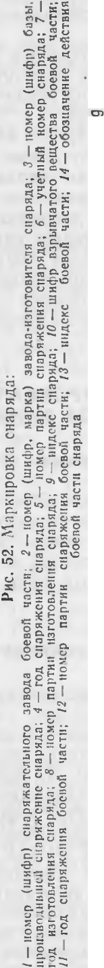

'

0...... ......

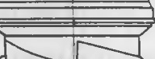

1

I

-- - --.......





•

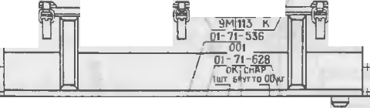

-tt

I \

I

I

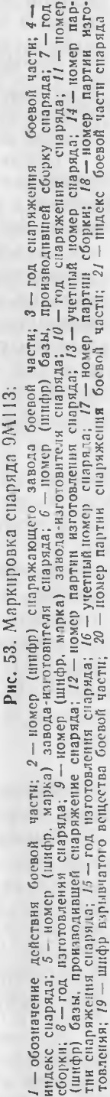

' -...._

3 4 *5 6* 7

I *I I*



'

...

-

"' lll:i!!J:

!J "f)O',

21*ZZ* ZJ z,

I

*ID* 9 8

L--..... I

uu -

00 uu

cm---- .

- OD

- -00.ffll'

........_ r-..

_.... ,..... •

co \. *Im*

*19* 18 *17 14 15 16*

*20*



*I*

II 12 *13*



oa oo oo

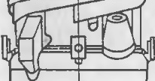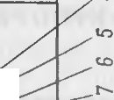

---- ,,,. ,,,,,

O!l CO 00

---......_ 00

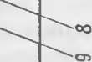

I

'

I

g)(S) I (S) (g

I

I

PHC. 54. f\.\ apKHpOBKa yKynopO'-IHOrO 11\lll<a 951684:

*I* -060311aqeHHC' ;tcilCTBIISI 6ocaoi\ '13CTH; *2* -yqeTnbln HOP.leP CHapsina; *3* -HoMep napyHH H3- roTOBJ1CHHSI cuapRna: *4* - HHneKC CHapR.na; *5* -roa H3rOTOBJ1CIIHSI c11apsi.1a; 6 -o(50311a•1c11HC nencTBHst 6ocao,1 qa CTH: *7* - Ho11ep (w11¢0. MapKa) 3aao.aa-H3roTOBIITe1si cHapRna ; *8* -*060·* SHa qe11He nci\CTBHSI (>ocaoit t{8CTH; *9* - yqeTHblA IIOMCP CHapsina ; *JO* - HOMep napTIIH 113roTOBJ1e­ HHSI CHapst;(a; *I I* -HO.Mep napTHH c6opKII CHa pR.'la; *12* - ro.a c6opK H CHapsi;ta; *13* -HO\ICP (wH¢p) apcenana (Ga3bl) . npou3BOJ.HBWero cGopKy cuapR,;i,a ; *14* - ron c(SopKH cHaPRna: *15* - Macca siuu. tK 3 co cuapsi;i.o\l; *16* - 110,1ep (w u<i,p) apccHana ((ia3&1). npOH3BO.J.HBwcro c(iopKy CHap si 1a; *17* -KOJlll'IC'CTBO cuapRnon a Rlll,HKe; *18 -* IIOMCp napTHH c6opKH cuapR.na ; *19 -* yqeT­ Hbli\ IIOMep cuapRna; *20* -pa3pRn onaCHOCTH rpy3a; *21* - HOMep napT HH H3rOTOBne11HR CHapR­

.na: *2t -* HO"ep napTHH c(SopKu c1tapsina; *2J* -- ro;t c6opK11 cuapRna: *24* -HO\ICP (w1-1¢p) apce· Hana ((5a3b1). npoH3eo..a.11au1ero cGopKy cHapsina

Ha onopbI }'KynopotIHoro Hllttla 95IG84 y1.: 11a.lblBaeTCH ctt apH.l

9/V\ 1 13.

f I!'116

Oepe.l yK o1 a.lKOfl

CHapH.la 9.\\ 113 13 fllII< H€06XO.llMO:

* paccTerHyTh 3a MKII*4* f OTI(pb TbI<pLilll ()' *1* flllJ.HKa;



* 113BJ1Cllb tt3 HllI. Ka nepe 1111111 *5,* cpe.1.1111ii *9* H 3a.lHHfl

xoMyThI;

*11* no.. y-

.....

t- .:)0 {';) *<[*

--r--

* y 1o>K f TL CHap51.J 9"111 13 Ha Ol OpLI TaK, llT06hI BblCTYTI *8* KOH­

TeMHepa c0Bna..1a.. c na3oM *6* onop;

- nn --

- ·-·

* noJIO>K J Tb nOJI}.X 01YTblIla c11a pS1;t. 9,\\1 13 COOTB€TCT13 €I-IHO ono-

...

(.J:)

* cm I-r)

00 oo'"O'fi oo

r&LW6 -

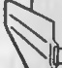

paM. np11 3TO\l pyq1(a Hero 110.. yxo'.'.1yTa *9;*

••

KOHTCI Hepa ,l0 1:iK Ha pa3M€CTHTbCSI B na3e cpe.l-

....-- c::,

fidi'>IO -- - .<-:n

* 3aI<pb1Tb h.pbllll ..:y *1* Hlli.Hha If 3a CTCrHyT b 3a:\llII *4 :*
* nposepI Tb npa Bf f ., bHOCTb ocpopvt JICI HH ¢op '.\1)' 11pa Ha CHap51.J

- 1-104->'>-10--- - --

.

LIJ46 0

0000 00 -

-

LL H6



)I --....--...._

- o..ll[Q]'-· --

- - 51

-

I I

## I

,-.

'

C"C

.

c..;i

9M l 13;

* I3JIO>KHT b ¢opMy.r151p B no.', llf 3Tlf.. € H013bli°I na KeT II TIO \f CCTHTb B KapMa I*12;*
* 3a1{pb1Tb Kap 1a H *12* n a HKOfl / 7:
* onJI01611poBaTh y Kynopoq111>1ii HllJ. f K 11 Kap:'.\1att no cxe.Me.

I

*) _ :* -

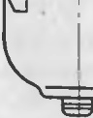

.

l13BJiet1ett11e ctt apH.la 9.1v'

cS1 B c•.i1e,.'.I.y 1ome:\-1 nopH,,.'.I.Ke:

- CHHTb Il10:'.'.-16bI;

\ 113 H y1.,;} nopo411oro Hlll f h.a npo113BO!I. f T­

*-=_.-·*

 I

I !

I

74 •



l'IISITb ll€1{If C 3a.MKOB *4 ;*

OTCTCrHyTb 3a:\1KH H OTK pb Tb KpbllllKY HllI.HK a; CHHTb no,1 }'X0'.\1yTLI co c11ct PH.la 9.\\ 1 13;

lt 3BJI€llb ctt apH l9.\\ 113 113 )·1..:}·nopot1ttoro HlUlt Ka 3 a P).'-J hY *10.*

75



C\;J - --

0 <'l M IO ti:

c;: C"l =

• ' .. . I u: I

t: ::s:: 0)

>, 1 .".... o-i :c:: - 111 -

Q'l ••

t'tJ :c •• c. ••

*u* ..

:c cu o:

M I:( - I:( :.: c:: ,:;

- • • c::: - :c E,-,

7. YlJ E6H bl E CHA P51.Ubl 9M 1 13

* 1. tf A 3tf A'IEl-!HE H 8Hllbl Y'IE6Hb1X CHA PSIJ.J.O B 9MI 13

YLJ e6HbIC cHa pHl,bI 9[\\ 1 13 npe.1.Ha3Hat.Je11h1 ,JJIHIf 3}'t1e1111H ycTpoit c1-

..• ,.

co -

<'l

c. <'l I 111 c:

9.\\ 113If no.J,­

r:.o *-:;:_* :.: C!l c:: I c:<.o r:: »

Ba, np11ef OR " npa BHJI )Kcn rJ)"aT ill llooeBblX CHa pH.UOB

111 :i: c:

...

I ) • 0. 0:. *a;* ::r u cc ... ti: u

pa3;I.€.'.lHIOTCH:

:3 C')

*-;:*

I I i:: ::: u: •- oa

:i: !:: <'l :i:

:t: ::.: o o,:, 'Cl •• :i: c. c. I

- Ha npaKTl 4CCKlf 1 CHapH..l;

, t:s ::sf: t::{

i::i: .•c.<'l :IE O :i:

---- u

ti::

0 o.. O

lC

t-- 111 :,,: Co c.Q)

="' - L"U • •

- Ha y t1e611b1 i cHa pHJ. c ,1ei1cTay10mei'1 6oproaoi1 annapaTypoi'i;

, - I

I IJ:

I "'

• -.....,

.

Q..

ti: :;;

::r:

::i:! I t I i:: a :a

0

-lla )'4€0-110-TpeHHpOBO JHbluf CHap.SI.l;

' *=E*

,.g'?

,:::a::: u

>: CIC)

i-

o,:, • 0

;>, •· ...

0 o c. c: oa c 111 co I

. IC:; :z: '- o o = - :.:c.-.

O')

- Ha )' lle6Ho-pa3pe3HOiICHa pH..l.

I

I:c:: c. I ":.': ci

I !'----

c:

t:s

0 00

:r *().)* ::;: c:: :i: - v

O 1- ·• l'l • •IO

::r:

c. r:, u ..... ::s-:

a, ;:,,,,

npa hTlllleCKll i C HapH.J. 9!\\ 1 13 (<<CT pa KT.>>) npe.J.Ha3Ha4eH .i{JIH yqe6Hoii cTpc 1b6h1 11 npe,1craB.11Her coooH ooenoii cHa pH.a c HHepTHOH

.-:;:r .c:: t::

- c-.. - c o x - t'3 ••

6oeBOH qaCTblO (l Ji l ra6R pHTHbf I BCCOBhl'.\I .'.\1a K€TOM 6oenoii llaCTH) .

r::; C\;J O i:Q :;::: :: 1-r.) :c

::,>::-. :":"s i:: x I

,:;a:.,:

....,

c::

9.\\

113 (<<Ylle6HhII>> ) c .lCit' cTny1011 ef1 6opToBoH

I --

•<'l :C:.>i. Cnl cO:.,.. °' I :;,,,,.

Y1Ie6Hbli1 c11apH,1

. :*(*:*)*r*.)*: 3:.: r::: 0 .r::: 0c::...._ c:i.

tr.> ;E I= = ..o...,.

l L") :3 ".::: .!,-.-.. I

=

anna paTypoii npe,1Ha3HalleH ,lJIH H3Y 4€Hl H Ha 11e:\1 np11e10BIi npaBl JI 3KCnJiyaTa u1111 6oeR bIX c11a pH 1,oR 9,\1.113. OH npe,1cr an.riHeT coooii a n­

:::.."9- l CJ

• • :.: c. ::>: cu

C-.> .. o :r c.

f

t-::l I ( .....-,1

"' . l

c-o ..-.

r--..

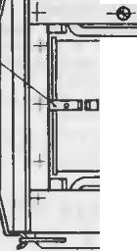

!::

l :!!: ' 111 i< O

-. c

- a:,

:F. 1, U t-; M O

napaTyp 11h1 1 6. OK, COCTOHW.Hfl 113 f>PCT, npHCMllHK a, nJiaTbl C pe31 -

v

cropa 1H, >KryTa H HMl Ta Topa , ycTa,110BJie1111LIX B KOllTCIIHep .

KottcrpyK UHH ctt apH,la 06ec neLJ11Bacr cpyH1{U 101--111pona 1111e 6opTo­ sof1 ar1napaTy ph1 11 np0Be 1.ett11e per.'.la MeHTHbIX pa6oT.

Ylle6tto-rpett11poB01111h1 i cHapH.J. 9.1\1113 (<<i\'\.a KeT>>) npentt a3Ha-

lJe11 .l.i H o6ylleHHH pacqera np11eMa:\1 nepeno.,la K0:\1n.. eK ca B 6oesoeIi

O)"

"'

.....

I

"I'I •

'

I

---

noxo,111oe no1o>K e1-1HH. 0,H H'BJIHeTcH ttep a36op11blM ra6apHTHhIM H ne­ COBbl:i.1 3KBIIBcl1€HTOM 6oenoro C HapHJ.a *91\*113, B l{OTOP0 :\1 B:\1eCTO

I

.......... .

t- r---

I

•

I

•

L-r., +

-o-,

CHapH,laIi B,J·y cTaHOB 1CHhl rpy3hl,lll Tl py10m11e IIX 1a ccyIi no­ JIO>K€HHC ue111pa TS1>K €CTH.

Ylle6tto-pa3pe3Hoi1 c11apH.il 9.\\ I I 3 (<<Pa3pe311oi1>> ) c.,1y>K HT ](JIH

.01I ,, t

t

r--._ ... .

I

<.O_ - -- •

- -

'l'l

...............

t--.....



'

i3Y 4CHl H ycTpOiCTBa 6oeBoro c11apH,la 9.'V\ 1 13.

* 1. OTJ1H'IHTEJ1hHA51 OK PACKA H MA PK HPOBKA Y'IE6HblX CHA P51}10B 91\\ 113
     1. 0TJIH'lHTeJJbllaR OKpacKa y1Ie6HblX CHapRJJ,08 9M 113

1l.1 H pa3.i 41 H Y4e'6J.Jbl.X CHapH,108 *91\t* 113 OT 6oeBbl'( OT;J.eJibHble LJaCTJI KOHCTpy KUHH OKpaIIJHUa lOTC H B llBCTa, OT.i H11HblC OT OKpacKli HX

Ha 6-oeahIX c11apH,1a x 9/\1113 (ra 6 11. 3) .

Ko1rTeii•1epL1 yt.Je6HbIX c11apH.lOB 91\l ll3, KpoMe yLJ e6Ho-Tp e11Hpo­ BOllHOro (<<J\ a KCT >>) , HM€IOT OKp ac Ky 3alllHTI Oro U.BCTa. KoHTc fi•1ep

.:;:r"...

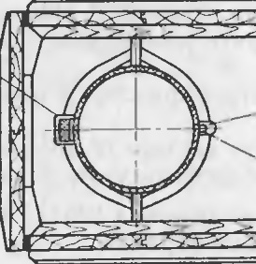

|  |  |  |  |
| --- | --- | --- | --- |
| BHA c 11ap1t3.a | l.{BC T 0Kp8CK II | | |
| 6oeBoi\ ..3CTII | Kopnyc a | Kpbl 1bC R |
| DpaKTH"leCKHH Yllc6Ho-pa3pcJHoA | LJepHasi 3amnTHaH | 3amHTHaH 3alUHTHaH | He OKpaw11aa JOTCSI  He OKpawnsa IOTCH |

- .I

•

- _ c.o



T a 6 n 11 u a 3

tf-

II. -

I

*J*

*I* I

......,- -

•• - I •

- I

·-.............. ' *)*

-

~~-~~-"'

.

7G

~~--~~

I /

•

77

•

yqc61-10-Tpe11HpOB04HOro CHa ps:11.a 9.\\ 113 H'.\1eeT oKp ac Ky cepe6pHCTO­ ro l!BeTa. Ha KOIITeiittepe npaKTl t.Jec Koro c11a ps:1n.a 9.\\ 113 1111>1 e CJIO­

Ba OPA KT. 1-1a HOCJ TCSl t.JepHaSI KO ribuesas:1 noJioca.

* + 1. MapKiipOBKa yqe6HblX CHapSl)].OB 9M 113

Ha KOHTeH11epax CHa pSl,lOB 91\1.113 BCex Blf,lOB yKa3bIBaJOTC Sl:

- 1111,lCI{C CHaps:1;1.a ;

I



Ctl

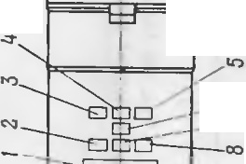

•

I

I

f

_c.o

-c-...

-

t::t

x

-u

'

•

-

I

u

....

--

I

0

c::

-

I .. .-..

.- Q:rJ

ro,a. H3f OTOBJieHISl CHa pSl,la;

* HoMep (lll cpp, MapKa) 3a BO,la-l 3 fOTOBITe.11Sl CHa pSl,la;

v

* yqeTHblH IOMep c1-1apSl.J.a;
* Ha,a.nHCb '4E6Hb f1, i\\A KET. P.-\ 3PE3HO:V1, CT PAKT. B 3a-

•

I

t

'

0 ;,,,.

I

E- ....

c::.. ••

C"J

c:: 0:

c:: &:I.

u

B CH'\10CTH OT B ,la CHaps:1,.1.a.

Ha KOHTCMHepe npaKTHlJCCKOro CHa pSl,la 92\'1113, Kpo'1e Toro, yKa-

•

c-;:;

•::::

-C-tl

3 blBa lOTCSl:

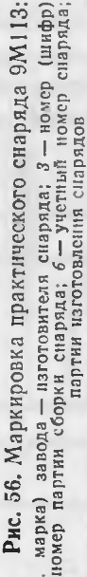

i=1"')

0 0:

Q

0 ...

HOMep napTiliI3f OTOB 1€1111Sl CHa PSI.J.OB;

cI:::..

:s:

Cl

·- b

HoMcp napr1111c6op1<J-Ic1-1a pS1.J.OB; ro..1 c6opK11 ctta p.s:1,a.os;

- Ho1ep (11r11cpp) apcctt a 1a (6a3 bl) , npo113so..l11swero c 6opKy

c1-1a ps:1;1.a.

0 0

\0

- I:'r":):

*Q)*

•

I I

>, Ctl Q t::t

g

I-

Ha KOHTei:ittepe yqe6110-Tpe1-11-1posoq11oro c11a ps:1n.a 91\11 13 (<<Ma­

t:sJ:

*Q)*

..:

KCT>> ) .lOfIO 'IIIHTe1bHO yKa3bIBa€TC Sl TO 'lbKO HOMep napTI11 H3f OTOBJie­

HISl CHap Sl,lOB.

Ma pKHpOBKa yqe6HblX CllclpSl.lOB 9/v\ 1 13 npHBC..leHa 11a

a:::( -;;;-

*(.)* 2.

M co

I - :E

pl C. 56-59.

_..

ci.

7.3.MAPK HPOBKA YK Y OOPKH C Yl!E6Hb11"\ H CHA P.sI.llA1"\ H 9Ml 13

11 l

*...?:.* -&

*C])* :s:

::,

ro .::.

a:::(

er:: &:I.

0. QJ

-c;: "

-c.., :c

Ha ne pe.1.HCH npo,lO.. bHOH CTeHI<e yKy nopKli c npaKT '-IeCKI M CHa- PSl..l0'.\1 yKa 3bIBa10rc.s:1:

-lf H,leKC CHa p.s:1,a.a;

I

=l=

o l

'c-- (':,

\-0 ••

1. Ctl

:r' t::t

:>. b:

-

- HOMCp na PTl-f f H3rOTOI3JieHIISI CHa p.s:1.1os;

* + ro

:.::

I

&:I.

c-o

* rO]l. H3fOTOB.. €HHSl c11aps:1..1a;

Q *(.)*

0 0:

* HOl\ ep (lllHcpp, MapKa ) 3a B0.18 -Jf 3f OTOBl TeJISl CHa pSl.J.a;

- ' •:S:

::s: ==

* y qeTIIbIH"

H0'.\1cp c 11aps:1n.a;

- ---

{::i -

0.

:.:: C)

0.. ,-;

* HOMep napr1111 c6op1'"11 ctt a pH,.1.oB;
* ro.J. c6opKIIctta ps:11a;

3 .•

-

Ctl

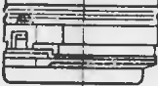

'

'

'

1\tdU

I

t::t

c.

0:

..c

::r::

• *.r,*

*1* ILC

/ w

-

_C.'.tl C2l

.c:. 0...

• I')

- HoM ep (1111-Icpp) apcctt a 11a (6a3bI) , npoH3B0.1HBwero c6opKy c11aps:1,11.a;

*()* c.

= u

* :r

"*v.,*

--

::s:

'-

* KoIH4CCTBO CHa pSl.1.0B B yKy nopKe;
* Macca yKy,nopKIIco ctt a p.s:1..10'.\1.

};·1 r.epen.tteH npO,l0.. bllOH CTel-IKe y Kynop.Kl,f c yqe6Hb!M CHapSl.ll.OM

"o:Ctl /

.... --

I

c.

...\0

:::

Ct:t:lt u

0: t::t

&:I. 0 I

* + t::t

tJ 0

0. I..

..

Ctl

t::t

'C:::

Q,

C-l!

c .ll.€I CTB)·1omei1 6opTOBOii a nna parypofl, yt.Je6HO-TpeH1 pOBOllHblM H

)' le61-1bIM pa3p€3Hhl'.\1 CHa pSl,.1.0:\t y Ka3bIBalOTC Sl :

* HH,J.eKC CHa ps:1,.1.a;
* ro,a. H3rorosJie11HSl c1-1ap.s:1,.1.a;

Ho:rv ep (lllHcpp, MapKa ) 3 a BO,J.a-H3fOTOBHT€JISl CHa pHJ.a;

C::stl: '- f

u I I

•

u:.:""' 'fi

QJ • •

t::t Ctl



- t::t

:s:

-0:

&:I.

I-



• •

I

!i '

*J*

-u

u

:.:

---

*(.)*

t::t

...

-

I

- yqeTHbl"'

78

HOMep CHa ps:1.n.a; - u

79

•

..

«I

--

c:{

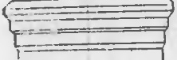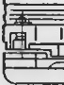

•-

I

-

('J

--

c::

-«I

u-

---

o;

C-J

u--



:=::

--

CL>

c;

* K0 111qecTBO CHapH;I.OB B Hll{HKe;

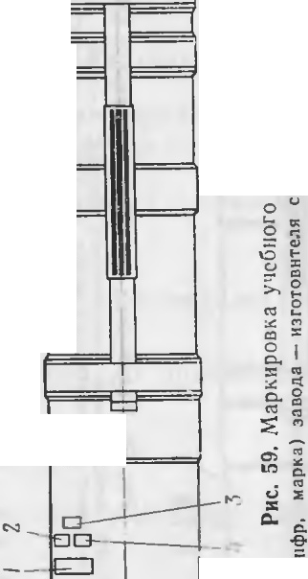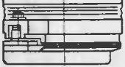

* tacca st mH1<a co cHa pHJI.O.M.

Ha nepe;i.tteii npo.u.oJihHOtt cTeHKe y KynopKH c yqe6tto-TpeHHpoeo11- H1.>IM CHapH,1.0M 9.l\1.113 (<<1\'laKeT>>) , ,Kpo11e Toro, yK a3bIBaeTCH HOMep napTifll H3rOTOB,1 eHHH C HapH)lOB.

0::

a::

..

0....

0

C')

-

0..

I

!ti

0

..

*b*

C')

:::

Ha o6eHX TOpUOBblX CTeHKax yeynopKH c y11e6HblM 91'\ 113 c ;1,e1i cTsy10mei:i 6opToeo fl annapaTypoii, a TaK>K e TpeHHpOBOqHl> M Ho11H yqe6Ho-p a3pe3HblM CHapH.UOM 9M I 13

IOTCSl:



I

* yqeTHbIH HOMep C Hap st .na;

CHapH)lOM C y11e6HO• yKa3blBa -

""t'

•.•,

ct

o;

c.

-

M• • -«I

-

c:,.,

..

«I



t:t

o;

c:,.,

«I

-

* + • u:c

I

- *c..*

- Ha,lTIHCb Y4E5Hbl:VI, MA KET, PA3PE3HOH B 3a BHCH\f OCTH

OT BH,la CHa pst.na.

Ha 06e11x TOPUOBbIX CTeHKax yKynopKH c y4e6HO-TpeH11poBOqHl>IM c11a,pS1,lO:M 91\tl l l 3 .:I,OTIOJIHHTeJlbHO yKa3 hlBaeTCH HOMep napTH I3rO­

TOBJieHI[S1 c Hapst.J.a.

u M

Cl> *;*

O"l

""t

0--

• 0

C> :c

co

:c:

Ha o6eHx TOpUOBbIX CTeHKa x yKynopI<H c npaKTHt.JeCKJfM CHa pH,lOM

91'1113 yK a3bIBalOTCS1:

0:: ,:::

0-.. -::

0::

Ha.J.TIHCb TIPA KT.;

·- - «1

0. =

- t- :,:

-

(j ....

*(.)*

0

0---

'-

= c:t

c., _

::r -

>,-C':!

I u

":I o--;

........ C::Jr

*(.)* >,

-- ..

*e*

I

* HOlep napTlf ili3f OTOB.1 eI[I H CHapH;I.OB;
* y11e6HbIH HoMep cHapst,1a;

IO} ep napTif ICOOpKH CHa pst.!I.OB;

* ro,1 c 6opK11 cHapH.J.a;

0 ..--

0

(")

<"")

Cl C':! c.,

C) «I

:::, c:{ c;

0. t:t

-:.:.:.i...

o...

.... :,: --

:,: Cl

-

-- - ...

(") ::

Ho 1ep (rnH<P p) apceHaJia (6a3b1) , npoi-r3BO.ZI.HBrnero c6opKy

o

QJ u ..,

*c..*

• =

-

C";l -

-' «=I

ctta pst;I.a.

Ha nepe,lHeH npo,lO bHOtt H npaBOH TOPUOBOH CTeHKax yKynopKH c Hapst,loB 9.i\\ 113 Bcex BHJlOB HaHOCif TCH 3Ha K BHK-1 no OCT

0CJ -

.... t-

-

•S:

0

\::) =:-:; -.-,

C)

*::r* ,. c:

::c:

C"')

4 f 0.010.020, a .n1S1 npaKTHl.leCKHX CHa pH.!I.OB 91'1113 yKa3hlBaeTCH

•.,.,

c:,.,

1.1.J

0..

pa3pst,1 onacHOCTif rpy3a.

::, ;;; c.,

:( =

Cl I0-

,::::, -

-0. «i i

er,

ex:

c..

- cc:{

I".')

.,

;,:

c::

0..

(")

""""-'

•

00

u,

u•

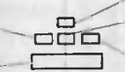

---

....... I

«I

:,,:

.,

*c..*

'S: •

• .::,..

----

•

---

-

--

..

«I

ct

-

o;

«--I



u

----

-I

80

--

Q.

--

CL>

0

:c

I

C'f

••

«I

t:t

o;

Q.

«I

=

u

u

:,,:

CJ

--

t:t

::c

-I

•

6 3aK. 1660c 81

•



00302 6-

BK.1, 1e1i Ka .NI? 2

np11Jio>KeHHe K ABX.07.63

*_:..*

BKJieHTh MeiKJlY CTp. 82 11 83

J

f

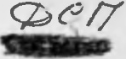

11HCTPYKU 11.ff no 3KCflJIYA TA UM M



8.06lllME Y KA 3A HMSI no 06PA lllEHMIO CO CHA P51Jl,A MM 9M113 B BOfl CKAX

XpaHCHHe tt c6epe.iKeHHe CHapHJI.OB 9?\,1ll3 B BOHCK ax opraHI3y­ eTCH B CT,porOM COOTBeTCTBHH c Tpe6oBaHHHMH PyKOBOJI.CTBa ,lJIH ap­

ceHa JIOB, 6a3 11 oKpyiKHhIX CK 1a,!J.OB 6oenptt nacoB. 113.l. l964 r•• Py Ko­ BO)lCTBa no xpaHeHHIO H c6epe}KeHl1IO apTHJii epttttCKoro BOopyiKeHHH II 6oenpHnaCOB B BOHCKax 11 Tpe6oBaHl HMH HaCTOHlllett 11HCTP YKUHH

no 3KCnJiy aTaUHH.

B BOHCKa CHapHJI.bI 9.i\11 13 nocTynaroT B OKOHllaTe 'lbiO CHapH­ iKeHHOM Bi )le. CHapHiKeHie CHapH;I.OB npOH3BO,!JJ TCH Ha 6a3aX B C'O­ OTBeTCTBHl1 c HHCTPYKi 151MH Ha c6opKy H CJ apHiKeHHe C HapHJJ,a

*9.l'v*ll3 c 11onO., b30BaI{I[eM KOMnJieKTa KOHTpOJib HO- nposepot.IHOH an­

napary·pbl 9B864.

..CHapH.lI>I 9Ml13 B BoficKa x ,:i;OJI)K Hhl co11.epiKaTbCH B no., Hoii 6oe- BOif roTOBHOCTH K HeMe..lJieJI HOMY npiMCHeHHIO.

noCTOHHHaH fOTOB HOCTb CHapH,!1,0B 91\1.113 K CTpeJib6e JJ,OJI>l(Ha

o6ecnet.I 1B8TbCH Ha,lJie:>K al1{11M YXOJI.OM, C BOeBpeMeHHO npoBO,l1Mb lH OCMOTp aMJi H ycrpaHeHHeM 061r apyiKeHHbIX ICHCn,pa BIIOCTeB.

OcMOTpbl C HapH.lOB 9J\11l3 ,l0.. :ihHbl np01 3BO.l TLCH.1HUa MH, xo­ pomo 3HaIOllllf MH ycTp OJ[CTBO. np11HUHn .lCICTBHH CHa pH;I.OB 9fv\ ll3 H npa BHJia o6pameIIHH c HHMII.

Pa36opKa CHaps:iiK eHHbIX CHa•pH,lOB 9i\1ll3 B BOHCKax 3anpema­

eTCSI.

B BOHCKa x Jl.Oo11iKHbl npOH3BOJI.HTbCH perJia MeJ THble pa6orbl B co­ OTBeTCTBHH c pa3JI.. lO HaCTOSllllett 1HCTpyKUHli no 3KCnJiyaraUHI.

CHapHJI.bl 9Ml 13 c HeHc n,paBHO·CTHMH. ycrpaHCHl e KOTOpblx CBS13a­ HO c pa360pKOH, flOJl.i e}l(aT OTnpaBKe Ha CHapHiK aTeJ bHbie 6a3bl, HMe- 1011..lHe He06XO.l11MOe 06opy,1:0Ba1111e 11 Te XHlf t.IeCKYIO ..lOKyMeHT8UIIIO Ha C Haps:1,1 9Ml13.

9.Y KA3A HHSI no MEPAM 6 E30nACHOCTM

J1l4HblH COCTa B, )lonymeHHb I K pa6ore co CHapH,!1,a MH 9Ml13. JJ,O iheH xopomo 3HaTb ycTp011CTBO CHa pH,la H npaBHJia 06pa11teHHH c

'

•

i:;:

t:(

0

t::

.01 -a,

--

•

Cl 00

3anpemaeTCH 3KCn., yaT aUlS1 nT}'PC 9Ml13 [I nTYPC 91\ \ 113 c nyCKOBOIIycTaHOBKoi'i 9nI35M B 30He, pacnoJIO­

}KeHHOl OT 113Jiyt.I a1om11x pa)lMOTeXHHt.IecK11x cpeJJ.CTB KB

II r KB 11.11a na30[ OB c BblXOJI.J{Or1 MOlllHOCTblO 6oJiee l00 BT

_(pa11.11ocTaHUIIITI na P- 135, P- 137, n-12) , 6TJH}l{e 150 M.

•

Hl1M. Tip11 pa6oTe co CHa,ps:1na MH 9Ml13 )lOJiiKHbI co6JIIOJJ,a TbCH BCe

82

•

:s::

"L-"t:'")

npaBHo1 a 6eaonacHOCTH, ycTaHoBJieHHhle .ll.JIH pa6oThl c 6oenpHna­ ca.MH.

3anpemaeTcH :

* npoH3BOl1Th B BOHCKa x pa360pKy C HapHAOB 91113;

npoK3BOAHTb perJia MeHTHhle pa60Thl Henoc peACTBeHHO B xpa­ HHJIH1Uax;

* npOH3BO..lHTb J{a,Ktte-.. 1160 3JieKTpOMOHTa>KHhie pa6oThl Ha CHa­ pH;KeHHOM CHapH.ne 9M l 13;
* npH.MeHHTb 6oeBbie H npaKTH4eCKHe CHapHAbl 9.\1.1 13 Ha )'11e6-

( bIX 3aHHTl HX.

CT pH nposeneHHrf ocMoTpa 11 perJi aMeHTHhlX paooT He pa3pema..

I eT H npHcyTCTBJie nocTOpOI llHX .Hi , He rrpHHHMaIOWMX Henocpe.J.CT-

3eHHOro Y 4 3CT l151 B rrpoBO,lH:Mb X pa 6oTax.

I

Per a MellT Hb(C rrpoBepKH npH x paHeHHii C HapH,lOB 9.\1113 B CKJian.­

CKHX ycJIOBIIHX rr poH3BO.!l,HTI, TO 'lbKO B c neuHa.i hHO o6opy.n.oBa HHOM MeCTe, y.J.aJieHHOM OT xpaHH.',ll W H }K l1TJ b X nocTpo eK Jte MeHee tJe.M Ha

50 *.M .*

I npoBCPK Y Ha q>y11KIJ.HOHHpoBaH11e CHapH,la 91\1113 npOH3BOAHTb B

Tpa Hwec pa3.MepoM 1,65X 0,5 M, rJiy 61111oii 0,75 M. Topr 1osb1e cTeHKH

I Tpa HWeH BblJlOJIHHTh BCpTil{3., hfl> MI(. Optt rrpOBCpKax anrrapaTy py

pa3MemaTh Ha paCCTOHHHJi ,J.1HHbl Ka6eJIH B Harr paB Cl!Hi, ncp11CH,!J.H­ KYJIHpHOl\1 OCH CHa pH,!I.a 91\t\ 113.

nepeHOCK Y H rrorpy3KY CJ apH..lOB *91'1.l* 13 B yKynopo4HOM HlUHKe

95I684 rrpoH3BO.l Tb .J.BY\151 llUaMH c co,6.. JO.leHHC.M MCp 11pC,lOCTO­

po:tKHOCTJi llCKJIIQlJalOWI-iX naJ,eH11e. 3anpcmacTCSI nepeHOCHTh HlllHKH co C HapH.l8 Mll 9lv1ll3 KpbllllKOH BHII3, KaHTOB8 Tb H GpocaTb J X np11

•r1orpy3KC H Bh1rpyaKe.

;lOJl}'CI<aeTCH npH rrpOil3BO.!l,C'TBC rrorpy304HO -pa3rpy304Hh X pa6oT npJ MCHeHi C 3 BTOnorpy3l lKOBII .!l·pyr11x cpC.ll.CTB MeX 8HH3 aUHH, HCK ­

.1l04aH B03.MO}KHOCTh na.neHHH Hlli.J(J<,OB co c1-1aps:1,la Mii 91\t\ 113.

3anpemacTCSI B BOHCKa X xpaHJITh 11 npHMeHHTb CHapH;lhl 9Ml 13 (OHi{ JlO,l eiK aT OTIIpaaKe Ha 6a3y c COOTBeTCTBYIOIIeH ·OTMeTKOM B cpop:\ ),·1Hpc) :

* y rra BillHe 6e3 yKy rropKI{ c Bb COThl OT 0,5 .1.0 1,5 :\I;
* yna BlllHe B yKynopKe c BhICOTbl OT 1,5 *)J.0* 3 M.

Tip11 rr a)lCHIIH CHapH.1.0B 91\'\ l 13 6e3 yKynopKli c BhICOThl 6oJiee

1.5 *.M* Ji B yKyrropKe ·C Bb COTbl 6oJiee 3 M OJ Ji CT8HOBHTCH orraCHbIM.Ji B 06pameH1111 I IlO,'.I.JIC.iK8T ).HH4TOn'i'..eHHIO 6e3 OTCOe)l HeHHH 6oeBOH qa­

CTH B COOTBCTCTBJll c PyKOBO,lCTBOM no xpaHeHIIJO H c 6epemeH) lO ap­ TJi 1.Cpl HCKOrO BOopyiK Cl JiH J( ,6oenp11rr acoB B BOMCJ<ax.

C.H. apH.lhl *9[v*l l 3 B yKy rropK c, yrra BWHe c BhICOTbl .MeHee 1,5 M, MO-

ryT ()blTIJ ,1.onymeHbl K x paHeHHIO JI iCilOJib3013aHHJO TOJihKO ·IlOCJie Ha-

pymHoro OCMOTpa H npoBepKH QJY HKUJiOHHpoBaHl1H, Y.ll.OCTOBepHIOlUHX HX ueOCTL Ji rrpa BHhHOCTb pa60Thl 6opTOBOtt annapaTyphl.

A Ha 1orH1IJihlM o6,pa30M MOryT 6b1Tb ,J.ony11teHbl K xpaHeHHIO H HC­

*I* IlO b30Ba HHIO CHapH,lbl 9.l.\t\ 113 6e3 yKynopKl1, yna BWHe c Bh COTbl Me­

HeC 0,5 *M .*

• 6* 83

I

CpnIC np08 '.'lCH IIR

nepe11eHb pernaMeHTHblX pa6or

Oo1>eM perJI3.MCHTHblX pa60 T

T a 6.1H u a 4

noc e

yp a tcnopTH·

10. **PEf JIAMEHT HblE PA60T bl**

Ilp11 xpaHeH111r Ji 3KCn.. yaTa UJll CHapH,!1.0B 9M l 13 B 38 B Cl MOCTH OT yc.11>BIit 11 cpoKOB xpaHeHJf H Heo6XO,l.HMO nepHO,lHt.JeCKH npOH3BO­

,llT bIIX OCMOTp II nposephy B COOTBeTCTBHH C nepet.J HeM per 1a MCHT­ HblX pa·6oT (Ta o.11. 4) .

pcrnaMeHTHblX pa60T

O.n.1111 pa3 a

.nee 11e..1.e 1u

O.nnn pa3 B

ro.o.

npa xpaHeHHH

8 He0T8 0 1H88e­ MOM

nOMeIUeHHH

-

npH x paHeHHH a noneoblx yc noan.Ax

-

BHCWHHH. oc-

MOTp, npoeeo- Ka repMeru11- HOCTH, npoeep­ Ka Ha ¢YHKUIO­

HllpOBaHHC 50°/o

cHapH!lOB

9.\.1113

npH H8XQ)l(.leHHH Ha Hanpa8 1RI01UIIX

H a 6oeyIC.1alltee MSWHHbl 9CT 148

B11cw11Hfi oc- MOTp, y.nane11ue OblJJH, rpH3H, BO)l.bl, cHera co cHapst.noe 911 13 6e3 Cllff THSI

HX c HanpaBJJff lO­ lllHX H 6C3 H38.'1C­ '4CIIHH H3 6oe­ yK.'13,llKH

-

pooaHHR o 6oea oR M8ll1Hlle

HJt ll & OTOMO•

6U 1b'iblM Tpa ncnopTOM

-

-

np H P.1e *'l* 3 H H H: I . D.JIH npoee.neHHH npoeepKH I 0°/o CHapHJJ.08 (npH xpaHe­

llHH B xpaHHJll-flUe) OT6Hpa10TCH CHapst,llbI, He no.neepraBWHecH npe)l.bIJJ.YlllHM npo­ BCpKa!d.

2. ..11H npo.ee.neHnH npoeepKH 50°/0 c11apH.D.OB (npu x paHeHHH a no 11eBbIX yc 10- e11Hx) or6Hp310TCH cHapH.n.1,1, He no.neepraewHecH npe,nbI.D.ymeu npoeepKe.

1. B CJ! 11ac 0611apy>he11Hst 11cncnpae11ocru npH npoee.ncnHH npoet'phn 10 /0

cnapAJJ.OB .nonOJIIIHTe 'lbHO npoecpHCTCH y.neoeHHOC KOJJH'le<:TBO CHapH,nOB. npH no­

fiTOpHOM 06Hapy:>1 C'HHII 11encnpaeuocTeii npoeeph.e no.neepraioTCH ace c11apH.D.L1

9.\\ ) 13, 11axo.nsiw.11ecs1 B ,.lllllOM Xpd11H '111JUe, Tex 11apTHii, Bl{OTOpblX 0611apy}Kellbl

.D,eq)CKTbl.

-t . B CJiy11ac 0611apy>KCII IIH HeHcnpaBIIOCTH npu npoecpKe 50°/o CHapH,llOB npo­ BCpS!IOTCH BCC c11apH.D.bl, xpaHHlllHCCH Ha .na11110(1 OTKpblTOfi nnoma,nKe. HeHcnpae­ Hbie CHapH.D.bl no,nJIC;)K8T ornpaBKe Ha 6a3bl H apCCH8Jlbl .D.JJH pa360pKH H KOHTpO 'lH B ue'lHX onpe)).eJJCIIHH HX npHrO,llHOCTH K Jl.81IbHeHWCMY HCil0Jlb3083HHIO H nepeKOM­ nneKTaUHH.

CT ptt npoBe.neJ lI OCMOTpa II nponcpoK cHa pH.l 91\\ 113 JICOU"\ 0,Jl ­ MO J 3B 1Cl.Jh H3 6oeBOII MallliHbI 901-18 .111 Jl3 yKynop041JOrO HLUHK8

95I684 H IlO,.'lO:i{HTbI{ a IIO,lCTaBKY H.. 11 Ha KpbllllK)' yKynop04HOfO HlllHKa. .i \ ecTa onop Ha KOJ TCHirepe He pcrw a\1el1TIIP)'JOTCH.

Dp11 npoBe.n.eHJil npoBrpoK B noJieBblX yc.. 0Bl1HX CHapH.lbl *9Jv\***ll**3

,!l.o.. >1<HL1 6hITb yKpbIT bl <)T ao3,1,ci c TB1 H oca.lKOB.

O.nn11 paa B BHeWHHfi oc- -

2.5 ro.na Morp, npoeep-

Ka repMeTH'l-

nocrn, npoeepKa Ha q)YHl<UHOHH­

poBaHHe 10°/o

cuapstJJ.OB

9M113

* npr1 npoBepKax 11co6.\o,1,11"10 co6JI10,JaTh yKa3 aHHH no *McpaM* 6e3- onac1rocT11.

n,pir BHCillHeM OCMOT pe 11co6.>..0.ll1MO npoacpI Th:

* + OTCYTCTB HC ,lCcpopM8Uil l 11 noBpeiI<.lCHJI I KOHTCMHepa; ..
  + IaJ111t.JHe H npaBH blJOCTI> r1ocra J OBK l1 Kpene>KJ bI"\ ,1,eTa.11ett ;

KatieCTBO aHTl KOp p031f OHJ h X noKpbITJIH;

* + OTCyTCTBl e nospeM,leHJIH KOHT3KTOB pa3ne:\f a 6w OKa TIJ T 8IHH;

nocne - -

2000 KM rpaHC­

nopTHp088HHH

BHewHui1' OCMOTP,

npoeepKa

w Hpa.

COOTBeTCTBl1C \1a pKJipOBKl1 c 1r apH.. a 9/v\ 113 ,l8 llllblM tµOpM} ­

no flCTetieHHHl1roroeb1e pernaMeHTHbie pa-

repMeTH'lHO- CTH, npo- BCpKa Ha

<f>YIIKUHOHH­

pOBaHne

I OO o/o cHa pst.noe

9!\,11 13

npoBepKy repMCTl14HOCTl1 CHapH,1,a 9.\. 1113 npo t3BO.lHTb npH6opo'1

98483 B cJie,1.y10m.eM nop.H11Ke:

a ) no roroBl TI> nprr6op 98483, .LI.JIH tt ero:

* CHHTI> pC3HllO RyJO Tpy6Ky co WTy uepaITIOI0.1K JITb IllTY itep D

311CT nptt6opa 98483;

* B3HT b rUT}'uep c MapK11posr<ofi 108 H3 Ko 1n 1eKra *KCT l\'*

98871;

- Ha,JCTI> I{ a HIInne., 1> IllTy ucpa pc31f HOBYIO rpy6Ky npH6opa

rapaHTHH.IIOrO cpoKa xpatte­ HHH IIJlH noCJie TpaHcnoprupo­ eaHHH na rapaH­ THi\HbIII KHJIO­

MeTpa>K

84

60TbI no HHCTpyKUHH «O nopH.n­

Ke npo,n11eHHH rapaHTHi\HbIX cpo­ KOB xpaHeHHH npOTHBOT3HKOBblX

ynpaBJIHeMblX peaKTHBllbIX cna­ PHJJ.OB»

98,183;

6) ycTaHOBi Th CHapH,1. 91'\113 Ha paooqee Mecro B KCT.\\ 98871;

B) RhlBHJ THT b BHIIT *37* (pI C. 15) c nOMOlllhlO OTBepTKl1 7810-0052

.\\1-1 489-60 I3 K0:\1nJicKra KCTJ\'1. 9B87 l;

r) BBlf HTHTb Illryuep c MapK HpOBKOH I08 !(0 OTKa3 a c nOMOLUblO K,1 l04a 19 X 22 rocT 2841-7 1 113 KOMTIJl()K Ta KflJ\\ 9B87] ;

.l) 33 BH IT11l> spy 411yJO HaKlf r lYIO raf1Ky lllryuc pa C MapKllpOB­ Koii 108 .lO OTK a3a;

8,5

•

e) HaKa 4a Tf> 803)1.Y X B C HapHn. 9Ml 13 c nOMOll.ll.>10 pe3HHOBOfl rpy­ lIIH np116op a 9B483 .no ,ll.aBJieHHH 500 MM BO.l. CT.;

iK) Rl.>I,ll.ep.>K aTb l MHl . Tia)leHHe .naBJieJ HH 33 BpeMH Bhl,1,ep)KKH

lie .!l,OnycKa eTcH;

3 ) OTBHl-lTHTh Ha KH,!llYIO ratt.Ky UITyuepa ;

11) BhlBHHTHT h lllTy uep. OcMOTpeTb COCTOHHI C pc3HHOBoro KO.bit a

*36* Ha B f HTe *37* H npH HC06X0,1,HMOCTH 3 aMeHHTh M3 COCTaBa 3l1TI;

K) BBHHTHTh BHHT *37* )I.O OTKa3a B orBepCTHe nepe,a.Heii KphllllKH

CHapH)la 9/v\ 113.

TipoBepKy repMeTHtIHOCTH npoH3BO;I.HTh B COOTBeTCTBHlf c Tpe6o­ BaHHHMH,l3i O}KeHHhJ MH B TexHHlleCKOM on11caHHH H HHCT·PYKUHH no

3KCnJiyar auH11 np116opa 9B483.

TipoBepKy CJ apH,!la Ha Q) YHKUHOHHpOBaHlf C npOH3B0,1,HTI.> B COOT­ BeTCTBHH C Tpe60BaHJIHMH,Il3v'lO.>K eHHhlMH B TCXll 14eCK0 \1 OnHCa HHH H

HHCrpyKU.HH no 3KCn., yaTaUHll KOHTpOlibl O-npOBCp04HOH annapaTyphl

9B8l lfv1.

* 1. nPABMJIA XPA HEH1151 CHAPSIJJ.OB 9M I 13

CHa pH,lbl 9/\1113 xpaHHTCH B HeOTanv1HBaeMhlX n0'\1Cl tCJl;ISIX .111

B no 1eBhIX ycJIOBHHX B yKy nopKe no.rt TIJIO'.'v1 68MH. YcJIOBHfl H nopH;l_OK xpaHeHHH CHapH)lOB 9M l 13 Jf.O.T }K Hhl COOTBCTCTBOBaTb 11pa BH 1aM H

1pe6oBaHHHM, ycraHOBJieHilhlf\f ,!lJIH xpaHeH11s:i 6oenp11nacos.

B 1a>K HOCTh B03Jly xa B xpa HH 1Hmax lie ,1,0J1}1 118 6bITb Bblllle B aiK­ HOCTH aTMOC<.J)epHoro ·B03,1,yxa.

B noJICI3bIX ycJIOBHHX xpaHeHJf e CHapH.J.08 9M l 13 npOH3BO!I.11TCH

no.n HaBeCOM H1H Ha cneUH3JihHO o6opyr OBaJ llhlX TIJIOW.a.lKaX, npH 3TOM Hl.>KHHe PH.lhl Hlli.HKOB o6H3a TeJibHO ,lOJI}J{Hhl 6 b1Tb y.r. io.>KeHbl Ha

.nepeBHHHbie nO)lKJia)lKH, lllTa6ev1H yKpblTbI 6pe3CHTO \f OT Henocpe..1,CT­ BeHHOrO 803.UeHCTBHH aTMoc¢epHblX oca.nKOBII COJIHe 41IbX iy 4 ett , a

T3 K)Ke )lOJI.>K Hbl o6ecne4J BaTbCH MCpbl no 3aW. f TC CHapH,lOB 9/V\ l l 3

OT 6110Jio·rH4CCKHX Bpe,lHTe.iieii.

CHapH.!1,hl 91'1113 B HW.HKax yK 1a!I.hIBa lOTCH B lllT a 6e 'IH Bh COTOH He

60 1ee lllCCTl1 HlUHKOB. fv\ em.uy llJTa6{'.. H111 ,1,0JI}KJ)bl 6bITh CB060!J.Hble npOX O,lhl W Hp llJ OJf He MCHee 0,75 M, a HlllKll B wra6e 'ls:IX ,1,0.1-

}K Hhf 6h1Th )'JIO}J{eHbl TaK, 1lTOOhl 6blJI CB060.UHb111,OCTyn K <.J)op­

MyJIHpa M.

* 1. TPA HCnOPTHPOBAHME CHAPSIJJ.OB 9M I 13

Tp aHcnoprHpOI33Hl1C CHapH.UOB 9\ 113 MOilCT np0113BO,!l T l.>C5T as- TOM0611..1hHbI , .>KCJie3110)I.Op0)KHbIM, BO;I.HblM H B03.!J.Y WI{ l.> M BH,la \111

Tp aHc nopTa.

TicpCB03J Th Cl13l}H.lbl 9M 113 pa3,pC·W aeTCH TOJil>KO B HCr1paBHLIX yKy,nopOtil hl HlltiKaX. Tiep CB03K3 CHapH.lOB 9.i\\ 113 aBT()M016Jf.1b} blM

Tpa11cnopT0).1 npo113 BO,]_lTCH C co6110.lCI HCM BCCX MCp 6e3011ac 110.::Ti,

yKa33HllblX B P)'J OBO.lCTBe no xpa11e111110 11 c 6epejKeHHIO apTH.'1Ji e­ p11HCKOro soop}' i eHHH H 6oenpHnacos B BOH('.Kax . .i\'l., BoeHH3.laT,

1963 ·r.

86

YK.1a,1,Ka yKynopo4 HhlX HlllHKOB co CHapH)l8MH 9M l 13 Bhillle 6op­ Ta aBTOM0 6HJIH 60 1ee qeM Ha no..r OBHHY Bh COThlHlllHKa 3anpemaeTCSI. YKynop04 Hhie HlllIKll YK..':13.lhlBaIOTCH n.'.IOTHO, Han.e.>K HO 3a·KpenJIHIOT­ CH ·B KY30BC 8 BTOM 06JIJIHIi YKPhIBalOTCH 6pe3eHTOM. 3anpel.l.laCTC.H O,!l.­

HOBpeMeHHO co CHapH.l8MJI91''1113 nepeB03HTh B3pb1B4 aThle BemeCTBa

H ropI04I e MaTepHa 11,1.

TiepeB03Ka CHapH!lOB *9l\\l* l3 .>KeJie3HO,J.OpO>K HhIM H BO;I.HhIM Tp a Hc­ nopTOM opraI H3y'CTCH JI npoH3B0,1.HTCH B COOTBeTCTBHH C TipaBH'laMH

nepeso3oK, oxpaHhl H conpoBo.>KaeHHH no .>K eJie3HbIM ,!lopo,ra.M H Bo.u­

Hhl f nyTHM 6oenpHna coB, B3pb1B4aThlX Ii CH..1 hHO 'leHCTBV., IOlllHX H.UO- BHThlX Bew.e-cr s, I13.l-BO 1\'\CT C, 1962 r., H np1110.>K eHHHMH 9 H IO K yKa3 a HHhIM TipaBIJI8M, 1962 r.

TipH norpy3Ke B sarOH yKynop04 Hhle Hll.ll-IKH co CHapH,1,3MH 9Jv11l 3

YK..118,lbIBalOrCH B lllTa6eJIH BhlCOTOil HC 60 11ee Uiec rH HlUHKOB H Ha­

.n.e.>KHO 33 KpenJIHIOTCH OT nepeMemeHJ H.

T a 6 JT H U a 5

llop!\-lbl 3arpy3KH aBTOI06HJTett cHapsr.naMH 9M I 13 B ynaKOBO'IHb!X SllUHKaX

|  |  |  |  |  |  |  |
| --- | --- | --- | --- | --- | --- | --- |
| MapK a  a BTOM06H.1II | Ko11uciecT- BO pR.1100  Rllllf KOB | l!ucno S[UIIKUB B OAHOM pRAY | Pa3Me[UeHHe RlllHKO B B OAHOM p11.11y | | OOlllee  •111cn o BlUHKO B | OomaR Mace a  ,UUH KOB  B kJ30Be •  x r |
| nonc pcK Ky30B 8 | BAOJJb xy3oe a |
| rA3-51 fA3-63 f A3-66  3Mn-151  3Mn-164  Ypan-355.:\\ 3MJI- 130 KpA3-221 MA3-200 | 2  3  3  3  2  2  2  2  2 | 12  12  13  (e nepeoM psr.ny 11)  16  16  16  17  28  22 | -  -  1  2  2  2  3  -  I | 12  12  12  (e nepeoM psr.ny 10)  14  14  14  14  28  21 | 24  36  37  48  32  32  34  56  44 | 1080  1620  1665  2160  1440  1440  1530  2520  1980 |

T a Ci JT H U a 6 HopMb! 3arpy3KH >Ke lJeJHOJlOPO>KHblX earOHOB CHapsr.naMH *91\*113

8 YKYTIOpO'IHblX Sl UHK ax

|  |  |  |  |  |
| --- | --- | --- | --- | --- |
| MapKa aarouoe | KOJIH'leCTBO pR,'J.O B HIUHKOD | l!11c no RlUltKOB B OAHOM  PR.!ly | 06mec 'IHcno BlUHKOB | no JJ H8S  Macca RlUHKOB  e a aroHe Kr |
| 4cTbipexocHbttt Kpb!Tb!H earoH Ha | 6 | 81 | 486 | 21 870 |
| 60 T  4erb1pexocHbtH Kpb!Tbli't earoH Ha | 6 | 81 | 486 | 21 870 |
| 50 T  .[{ByJ\.OCHblH. Kpb!Tb!H BarOH Ha 20 T | 6 | 38 | 228 | 10 260 |

•

87

*H3npaaneH ue aaumeHus:1 aamoMo6uneii*

*TA 3-* 51, *rA3-63*

I

I

I

,

np1i nepeB03Ke CHapHtI.OB 91':1113 3 arpy3K a aBTOMO·OHJiefi I llie JJe3-

HO.!lOPOlliHblX B8f OHOB npOH3BO,ll1TCH no HOp:\t aM, npHBe;:t.eHHhlM B· T a6 1. 5 H 6. CXCMbl YKJia,lKl1 yKy nopOlllblX HIUHKOB co CHapH,l8MH

9.\\ 113 B KY30Bax a BTOMOOHJieii H B }K e1C3HO)I.Op0}K HhlX Ba roHax npH ­ Be,leHbl Ha p11c. 60-62.

*ttanpaaneHue iJeun<eHu11 aBmoMo6uneu*

3"117- 130

|  |  |  |  |
| --- | --- | --- | --- |
|  |  | | |
|  |
|  |
|  |  |  |
|  |
|  |
|  |
|  |

f A 3- 66 l<PA 3- 221

|  |  |  |
| --- | --- | --- |
|  | I I  I I  . |  |
|  |  |
|  |  |
|  |  |
|  |  |
|  | . •  I I  I I |

|  |  |  |  |  |  |
| --- | --- | --- | --- | --- | --- |
|  | | | | | |
|  |  |  |  | |  |
|  |  |  |  | |
|  |  |  |  |  |
|  |  |  |  |
|  |  |  |  | |
|  |  |  |  | |
|  |  |  |  | |

MA 3-200

*3l1fl-15 1,3i1fl-161/,YPAn - 355* M

|  |  |  |  |
| --- | --- | --- | --- |
|  | | | |
|  |  |  |  |
|  |  |  |
|  |  |  |
|  |  |  |
|  |  |  |
|  |  |  |
|  |  |  |

PHC. 61. CxeMa YKJT a.ll.KII H[llllKOB co CHapH.ll.a'.\ H 91\\ 113

|  |  |  |  |  |
| --- | --- | --- | --- | --- |
|  | | | | |
|  |  |  | | |
|  |  |
|  |  |
|  |  |  |
|  |  |
|  |  |
|  |  |
|  |  |

B 11.yJonax asr0Mo611neii 31'1JI- 130. Kp1\-3-22l , i\\.\ 3-200

Puc. 60. CxeMa yKnaAKH RIUHKOB co CHapR-

.nat H 9M 113 B Ky30Bax aBTOM06HJTefi

f A3-51, fA3-63. rA3-66, 3HJ1- 151.

3HJ1- 164. Ypan-355M

Op11 rpa Hc nopTHpOB8Hlf l1 CHapH.!lOB 9.v\ l 13 B yK y.nopollHhIX 51W.H­ Ka'{ Ha a BTOM 0011IHX JI.pyrHX MapoK HOp.MI:>I 3arpy3K11 ycTa HaB.. HBa­ lOTCH B COOTBeTCTBH11 C ra6apl1T8 MH K}'30BOB H rpy30TIO)lnel\,tHOCTblO

aBro110611Jieii.

TpaHc nopTHpoBaH11e CHapH,lOB 9Ml 13 B yKy nopol!:IlblX HlUHK8X

h.0.1eCHhlM H ryc eHHllHblM TpaHcnopTOM no BCeM BHJI.8 M )l.Opor H 6e3JI.O­ po>Kbl0 MO}K eT npoH3BO)l.11TbCH C MaKCHMa.. bHO .nonyCTHMblli CKopo­ CT51 MH )I.BH>KeHHH JI.JIH )l.8HHoro BHJI.a Tp aHCnopTa H COCTOHHif H ,!lopor.

88 89

----· --

BhlCOTa Tpa HcnopTHpOBa HHSI 803..1.Y llIHhl:M TpaHc nopTOM B Herep­ MeTM3HpOBaHHh X Ka611Hax He 6onee 12 KM. HopMa 3 arpy3KH H nopH­ Jr.OK yKJi aJr.KH CHa pSI.LlOB 91v' l l l 3 onpe.LI.eJIHIOTCH B 3a BHCMMOCTil OT rpy-



30D0,1.'beMHOCTl1 caMo., eTOB (seproJieToB) .

*l./emb1pe1.oc;1r,1u 1<pr,1mb1ii saio1-1 60* r, 50 r

|  |  |  |  |
| --- | --- | --- | --- |
| HeHcnp aaHOCTb | np,11ii1Ha uencnp3BHO• CT II | Cnoco6 ycTp aHeHIIR | rne  yc Tpa HReTClil |
| Hapy wel!bl MapKHpOBKa H JJaKOKpa­ COlfHOe OOKpb!THe Ha 11apy>KHb!X no­ eepXIIOCTHX I<OIITCiiHepa II yKynopot.r110- ro HIUHKa 951684  lIOBpC>K.llCIIO KOJTbUO *50* (pHc. 15),  ooecne'lHB,llOWCC repr..teTH'lHOe COC..J.11· HCHI C 3arJ1yu1KH *34* c nepeD.neit Kpb!UJ-  u u  KOH KOHTCJ IICpa  noepe>1<.neHa pe3b6a 3arJTyWKH *34,* 3aI<pb!BaJOWe-f KOHTpOJTbHb!Hu pa3ber..1 B ncpe 1.11ei'1 I<pb!WKe KOHTei'i11epa  noBpC>K)lCHa pe3b6a BHHTa *37,* 3a­  Kpb!Ba10wcro OTBCpcTHe. Hcnonb3yer.1oe npH npoecpI<e Ha repMCTHlfHOCTb  noepe>K.J.CIIO KOJTbUO *36.* o6ecnC'lH-  BalOLUCe rcptCTH'lHoe coe.nHHeHHC BHH-  v • *v*  Ta c nepe.nncu KpbIWKOli KOHTCHHepa  noepc>1<..J.CH0 K0 1bUO *51,* 06ecnettn­ aa1011tec rcp'.'..ICTUIJIIOCTb p03CTKH pa3'b­ eMa | Henpa­ | BoccTaHOBHTb | 8 BOi'sCKO |
| BH'IbHaH |  | BOU t.r aCTH |
| 3KCnJTyaTa- |  |  |
| 1111H |  |  |
| To >Ke | 3aMCIIHTb KOJTbUO *50* | To n<e |
|  | 3aMeHHTb 3arnywKy *34* | > |
| > | 3aMCHHTb  BillT *37* | > |
| > | 3aMCHHTb KO 'IbUO *36* |
| 3aMeHHTb |
| KO 'IbllO *5J* |

XapaKTepHhle He11cnpaBHOCTH H c noco6hI HX ycTpaHeHHH npHBe e­ Hhl B Ta 6.:-1.8.

T a 6 JT u u a 8

XapaKTepHblC HCHCnpaBHOCTH H cnoco61,1 H'X ycTpaHeHHH

-



|  |  |  |  |  |  |  |  |  |  |
| --- | --- | --- | --- | --- | --- | --- | --- | --- | --- |
|  |  |  |  |  |  |  |  |  | - |
|  |  |  |  |  |  |  |  |  |
|  |  |  |  |  |  |  |  |  |
|  |  |  |  |  |  |  |  |  |
|  |  |  |  |  |  |  |  |  |
|  |  |  |  |  |  |  |  |  |
|  |  |  |  |  |  |  |  |  |
|  |  |  |  |  |  |  |  |  |
|  |  |  |  |  |
|  | | | | | |  | | | |

·

 -

*J].* r



*eyxocHb1u* Kpb1mb1u *BaioH 20*

--

--

PHC. 62. CxeMa yKna.nKH Hlll.HKOB co CHapH.na,,I{ 9,\11 13

B >Kene3HOJJ.OpO>KHb!X BaroHaX

13. CBEJ].EHMjl O 3 Mn

llJIH pcMOHTa H o6cJiy}KHBaHHH CHapH.llOB 91\,11 13 B BOiic·Kax Bb .la ­ eTCH Ha 100 CHapH,lOB rpynnoBOH KOMn.. eKT 3l1n, COCTaB KOTOporo

np II l\1 e 'l a H H c. npn o6napy>KCHIIH AP)'f l1X HencnpaBIIOCTCU Ha cHapH.ne

9M I 13 OH 00..J.!JC>KHT OTnpaBKC Ha 6a3y (apceHa 1) .

}'Ka3aH B Ta 6.11. 7. f pyn.nOBOH.

KOMilJieK r 3l1n Tpa Hc nopTi p, ercH JI

1. CBEJ].EHMjl O MACKMPOBKE

xpaHHTCH Ha CKJiaJJ.e BOHCKOBOH 1laCTH.

T a 6 JJ H u a 7

fl., H pCMOHTa H 0·6C.T: y}K HBaHJ H CHapH..1.0B 9M l 13 BHe 3a Kpb1ThIX

noMeI..UelIIH i,1eo6X0..1.I MO o6ecnet.J:I Th MaCKHpOBKY CHapH,lOB nyTeM CKphlTHH 11X IlO,!l. OKpy}KalOll.l'HH <floH.



Be,IJ,oMocTb rpynnonoro KOMnneKTa 3Hn cuapsr,IJ,a 9MI13

Kon1111ecT­



1. nPA BMJlA 06PAIUEHl1jl C Y'-IE6HblMM CHA PjiJJ.AMM

HaHMeHOB3 KHe so

npHMe HeHHe

9J\i\ 1 13, XPA HEHl1E M C6EP E)l(EHM E

9M l 13 04.00.018

Konbuo

5 06ecne'leHHe repMeTrtttHOCTH

}4 c6 11bre 3a HHTl1H Heo6XO..l MO npOBO.lHTb TO.. hKO c onpe;ie TieH­

COC,llHHeJIHH 3arnyWKH 9M 113

7

HblM BH.lOM..

y4e61{blX CHapH..1.0B 91"\ 113, npc..1.Ha 3Ha tte1 J blX ;J.JIH H3yt.J: e-

9MI 13 04.00.019

9M l l l 04.00.114

9i\11 I l 04.00.115

9Ml 11 04.00.033

3arnywKa BHHT

KoJTbuo KOJJbUO

04.00.019 c nepe.n11cn KPblllJKOH

KOHTei:inepa

5 .llnH 3aKpb!THH KOHTPOJTbHoro

pa3'bCMa

5 Jl!JSI 33KpblT H OTBCpCTHH,

HCOOJJbJyeMoro npH npoeepKe Ha repMCTH4HOCTb

10 .llJTH BHHTa 9M l 11 04.00.114

5 .ulJH rcpMCTH33UHH p03eTKH

pa3beMa

HHH ,!l.a HHOIIreMbl.

Ha }"1le6HbIX 3a HHTl1HX c }"lle6Hb1M l CHapHJJ.a f i 91'1113 cw11e,1.yeT 06-

pamaTbCH 6epe}K HO, He 6pocaTb HX, He cryqarb, 6CJ Ia.l06HOCTJi He npOBO,J.HT b npoBepKH ¢YHKUHOHl1pOBaI HH 11 o6eperaTL OT B..'larH.

Opn HapyllICllli 3MaJICBOro IlOKpl.> THfl Ha y t.J:e6HblX CHapH,la X

9M 113 He06 \'.0)l11MO cro BOCCT aIOBHTh.

l(aTeropH1.1eCKl.f 3 anpemaeTCSI npHMCHHTb 11a y t.J: e6llblX 3a HHT HX B Kat.J:eCTBe ytJe6Horo r1oco611H npaKTHLJ: eCKHe C HapH,!l.bl 9M l 13.

lliafioa 3·082

rocT 11648-75

90

10 .llJTH KpenJTeHHH sarJTyWKH K

6 !JOKy OHT3HHH

•

3anpemaeTcsi:

- pa3611paTh }·11e6Hb1e cHa pfl;I.hl 9M l 13;

91

- ycTa HaB 'l11BaTb y4 e611h1e CJ apH.lbI *9,.\t*113 Ha yqc6rib1e no..l­ CTa BKl1. HC np11cnoco6 1e11Hh1C ,l_. fl HHX.

Y 4e6Hble CHapHAbl 9M 113 xp a HHTCH B yKynopo4HblX HLUHKax

95!684 B yCJIOBIHX, npe,!lyCMOTpeJ HhIX ,U.JIH xpaHeHiH 6oeBblX CHapH-

CK.1a.1c K11e no\1c1Uc1-111H .rr.1H xpa1re1111H c1r apH.1os 9Ml13 B rnraT- 1ior1 Y {\'!lOpKC .1.0 I>l,IILI lf ),1CTI, eCTCCTBe11Hy10 HJIH np11HY.UHTC 1bHY JO BellTJ,[ s:! l.J,IIO. B CK.Ia..lCKHX n0Meme111 HX HLUHK11 co CHapH.!1.a M11 9,\1.113

10.. :il<Irhl pa3Me rlaT hCH J{ a c re 1Jia >K ax . o6ec,ne4Haa10m11x npoBeTpHaa&

AOB 91\1113. .

1111e rnraf,'. (.\ Jl H

.C.

R060.ll-Ilil i ..1.ocryn ,J. H OCMOT·pa COCTOHl[JIH 11apyjK-

KaTerop111.1eCK11 3anpemaeTCSJ xp ar{HT h y 4 e6Hb1e c1{ aps:t.a1>1 BMecTe

|  |  |  |  |
| --- | --- | --- | --- |
| c 6oeBh[ li CH3 pH.rr.aMH 9M l 13. TipaKTH4CCK | | | l e Cl apH.l,[ 9.\\1 13, Kp·o­ |
| :\1(' .Toro. 3anptll\ae1csi x pa! lT h | BMeCTe | c | y4e6HO-TpCH HpOB04HblMI{, |

pa3pe31Ib1MH H •cHap5l.l3:\1li C ;i;ciCTB}'IO l CH 6opTOBOi't annapaTypoii.

1. OC06E H HOCT l1 3 KCnJJ YA TA U.11M CHA PSIJJ.OB 9Ml 13

B YCJIO BMjl X CYXO f O T POnMlf ECKOro K.JI HMATA

np11 3KC n.) aTaUil Ctlaps:t,.lOB 9/\\113 J C06XO.llMO OC}'li eCTB.1 HTh

u ••

3aI HTY CJr apH,1.0B OT 803,J.el CTBl H npHMblX COJIHe JJ blX .. ytIClf , 11c no.. 1,-

3 \'H .1.. H 3TorollMCJOll HeCH MaCKHpOB04Hb[e cpe,L\CTBa , TeHTb[ CBeTJlb[X TOI O IJIf ..1.pyrHe no 1.p)'lllble cpe.lCTBa.

Tpa Hc nopTl pOsau11e CHapH.!1,08 Ha 60.. hlllHC paCCl'OHHIIH a BTOM0- 611.. blhIM Tp a [ CTIOPTOM .no.. :>K J O np0113BO,J.lf T bCH no..1. TCIJTa\1H CBeT-

.11IX TOHOB.

CKw11a... lCKlle noMeLUCJI HH ,1.H xp aHeJll1H c1raps:i.10B 9.V' l l13 B llITa T­ HOH yKy nopKe ;:r.oJI:>K HhI HMeTh ecTecTBeHHyio n1111 npHH)'..1.11Te 1hHy10 BeHTHnHUHIO. Me:>K,u.y BepXHHM CJIOeM Hllll1KOB ll TeHTOB l.OJI)KeH

6bITb 3 a3op ,U.JIH o6eone4eHHH BeHTH 1HUHJ .

PerJiaMeHTHhie pa 60T1,1 co crrapH.!I.a MH 9M l 13 npn xpa HeHHH Jt

::jJ(('n 1yaT3Ilf ll npOBOLl. Tb B o6beMe, yKa3 aIHO:\.f B JaCTOHLU ' lIIICT­

P)'(l HII no .:;KcnJiyaTa u1111, np11 3TOI'vl cpOKl[ nponepOI{ .!1,0.i }K Hbl 6bJ Tl> co1<pa11.J,cr11>r BO Bcex cw11y1IaHx B ;i_ sa pa3a, Kpo11.1e npoBepoK. r1poso,1.1f ­ rv1 hlX C:>KC.IT,[[eBIO.

1. OC06EHHOCT l 3KC nJJ YATAUMM CHA PjlJJ.O B 9M l13

8 YCJlO BMjl X BJlA)l(HO ro TPOnMlf ECKO ro KJl MMATA

Tiptt 3KCilJ yaTa l.J,HH C HapH,":lOB 9M l 13 He06X0,1HMO 3allI IlaTb HX

u v •

OT B03,!lel CTBHH npHMhlX C0 1le4HblX w11y 4e1r, a B nepHO;I. ,llO:>i{,.leH npe-

HblX noBep XIIOCTel1 yKynopKH.

B c.1) 11ae yKpbITHH HIIIKOB 6pe3eHT01 11111 TCHTaM11 ire ;I.OTI),'CKa ­

cTcH cKon 1eH11e a., ar1r Ha J apy>1<Hb1x noBepxHOCTHX 6pC3 e11Ta 11.. 11 T€' J[TOB. Oco6oe BHH\1aHJ C HC06XO.l f MO )',le HTb o6opyJJ,oBa HJ lO nJio­

|  |  |  |
| --- | --- | --- |
| manoK. K< ,ropLle .1,0 >Kllhl 61>1Tb | paC4IllUCllbI H | oc1,1na Hhl rpaBHeM, |
| me611eM H. H w. 1aKOM TO LUHHOH | C. OH HC Me11ee | *b* CM H HMCTb B0.!1.0- |

0TBO.lflll \·10 KaHaBy no BCCMY r1cp11MeTpy.

5Im11K1r,"lOJJ>r Hbr 6hITh )'J10;,1 eHhl Ha 6 pyc Krr c o6ecne4eHHeM 3a3opa

vi:e>l{;J.Y nOBC'l)X!IOCTHMll n.. .0IIa,J.KMII HlllJ[I{OB Ile MeHee 20 CM .

Per 1a \.leJ THJ,e pa 60Tb[ co CHapH,J.a\1:Jl *9l\'1*l l 3 n,pi,1xpaHCI HH H 3KC· 11'IV aTal )[I[ HeOOXO.IIMO npoBOAIJTb B 061>eMe, y1<a3aHHOM B HaCTOH-

111('M TeXHi llCCKOM on11c aill{H, np11 3TOM cpOKII npoBcpoK ,U.OJ .iKHbl 6blTI, COKp aIUCHbl BO Bc ex CJiy tia s:t x B .lBa pa3a, KpOMe npOBCpOK, npo­ BO.l :\1h!X :il e.rr.11eBHO.

.noxpa HHTb OT nonaJJ,aHHH oc a.rr.KOB,ICDO.'.Ih3YH ,1.

... H 3TOroIi1CIOIIHeCH

MaCKipOB·04Hble cpe11.CTBa , TeHTbl CBeTJihlX TOHOB c YlieTOM Heo6XOA H­ MOCTll MaCKllpOBKH, nJi am-na.'.IaT J{][ 11 .npyrHC TIOAPY 4llb[C cpe.ncTBa.

TipH HaXO:>K,.leHHH CHaps:t,!lOB 9,\11 13 Ha orHeBoit Il03Hl.J,lll Heo6xo­

,lHMO:

* npoBO,.ll[Tb e>Ke,J.HeBHblH OCMOTp C Hap51',lOB C *y* ,laJreHJt eM C Ha­ PY:>K HblX noBep x11ocTeH nhr 1J1, Bw11arn 11 n.r1ec tt eBhlX rp116KoB;
* C:>Ke.n.HeBIO KOHTpo.. 11poBaT b BJ1yTpe11H11e noBepX HOCTH pa3beMa

W6, He .J.onycKa H Ha HHX noHB'leJ HH 11 CKOnJieHHH BJiarH.

Tpa Hc nopT11poBa1111e CHapH.J.OB 9.\1113 B IllT8THOil yKy nopKC Ha 60.hllIHe paCCTOHHHH a BTOM06HJlbHblM TpaHc nopTOM ,.lOJI}K J[O npOH3- BO 111TbCH TIOA TeHTaMil CBeT.. blX TOHOB, KpOMe Toro, HC06XO,J.HMO

o6ecne4HTh 3am111y yKy nopo4HblX HLU11KOB OT npHMOro B03,l_eHCTBHH oca.lKOB.

92 93

•

**Jl HCT PEf HCTPA U.1111 113/\\ EHEHHH**



|  |  |  |  |  |  |  |  |  |  |
| --- | --- | --- | --- | --- | --- | --- | --- | --- | --- |
| CII  ==  II)  z  CII  :..i,i  **::s:** | HoMep a ntrCTOB (CTP& HHll) | | | | Bccr o nHCTOB (CTp& HHU)  B .AOKy-  MeHTe | HoMep  .ll.OKY-  MeHTa |  | | |
| Bxo.11simHli HOMep  conpoeo-  .ll.HTCnb• HOro .AO• KyMeHTA H .A8T 8 | IlO.ll.UHCb | lta?a |
| I<  :is  ==  II)  =  CJ  2'  =M | I<  -.:Z.S.  =  CII  =  II)  :r  M | I<  :ZS  m  0  :c | .....  :ZS  CII  *I*.*i*.*i*.  M- |

# I

I

94

I •

--

*·p.*

3

.-'.)

-

9

II

12

13

19

21

25

28

JO

-

31

*33*

36

·12

•1.5

47

61

fi.S

*7:{*

-

-

77

-

-

78

8:?

-

85

86

90

95

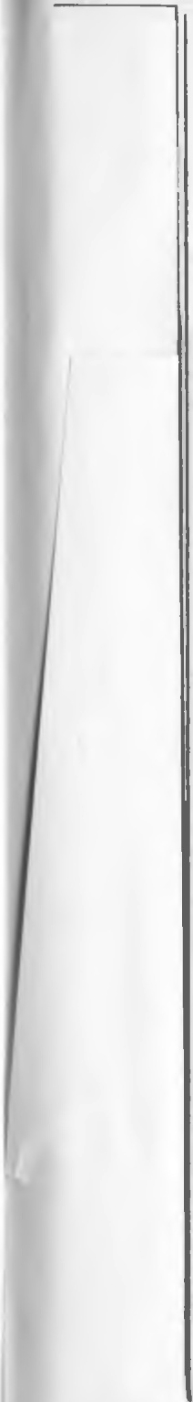

• • ~~-~~· •

W 4 /J. ill4

*KOHI ILE11b ll,e11b KOH T.*

*J( Kypc K ypc K*

*T TaHZQtt<. TaH ZQ'JK T* -

•

I

•

* **6Pn**

•

I

•

I

fK

*BHU 3 BBepx BBepx 8HU3*

•

*3M- I 3M-2 3M·5* JM-4

*1*

4 *4*

I

*Bncso B11paBO BnpaBo*

*Bneeo* '

*3M- 5* 3M-6 *3M-7 3M- 8*

-

I

I

•

•

I

•

'

*W 1a* -

I

*l1,enb* l<OHT. •

*- 168* 56 *1*

+-168 66 2 2

*CUZHUJI* 6HU3 3 .

*GUZ.Han* •

4

*Bnoaao*

* *tPapa* 5

*3B PM/1, Y 6*

*CUZHUJJ* 7

86COX

*CU2HU 1l*

*B*

*BneBD* -

I .

•

I

I

I

' . •

*w 16a w 16*

I

KOH T.

*ll,enb L1,e11b KOHT.*

*1* - 16 8 56 *- 168* 66 *1*

·-

.

2 *+ 16B* 56-,-6"-

4 *3B ,:JOmorca* 38 *12omoga* 4

.

*+16*-*8* 66, 6<P 2

.3 *- 16B*

6 QJ *-16*. *B 6<P* 3

*l<OOD'OUHIJ fl oua 1<oociiJuHa* r *0,1* •

' 5

...

*OOW,Q5f mOl/ l<Q oo,u,a5f* n104Ka

*3B pornopa 11*61 *3B mooa u* 66 5

6 36 66 38 66 *6*

•

- • • •

I

~~I~~ •

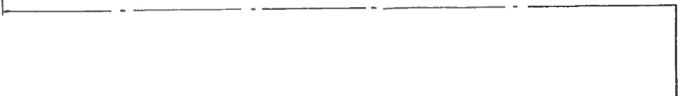

•

I **r**

------- ------- .------- - --------- - -------- - --

-------------------·--

- - -

*r* T T '

- *Kypc*

*TDH ZD>t<*

-

\.- -J. •

*fK* 3 *nJJ,M* 2

I

I o'J *BJ*

• +

+ 0 -) *BT*

j ' 22 *c*

\' •

4 n

- I. 9

82 *l\oopiJuHamop*

I i *R 1 ; 1,5 K 1* 7

I -

*()*

• •

R2; 30

3

*9*

I, ' 4

-

*13* , IV -

m

r)

.. 5

*J*

-

I - 6

*11*  -

*//// / /7/7* •

8

c

*11 3BP*

*10*

*("'*

- I

I

383/L

2

1 38,q [) "'

.7 3 "''

'' -.... 2

J

- ,

• "'"- L ..-.....-Jll_J

*/1.Z*

I •

-

-

-

'

•

I

'

I

---.tI--- -------- ·-----------

1_ _______ ...

I I r- --- ------ - --





BKneiiKa h. 113Jl. .NQ'

5/2 l68c. BocHH3Jl3T, 1978.

--------- -·--------- - ------------

- ---- *C 1;* 3. l10

RJ;2,7r<..

*Jl.1* '

y

*.D,18* •./ *Jl.Z'*

oJJOK

I

*ynpas11eHU7'*

/" 3 . A_,s ,...... _

' ,ll.18 , JJ. 4

*7-.v* "\. ' *Jl.18* .

• / .... r 1,R2 ,2,7K

R3 :15 r<..

*Tat-1za>+<*

T Tl ' •

... ,i--" .a. J. 1,......1------+--<>----------'Ht,---..---4

- - - R4 5.1K

*CZ;* .300 H 1- ,

*v 7* 5 *1* T2; Mn *166* / ...

Mn166 ' 'I JJ.5

R 5;8,2 K *j* 1 2CJ 7A

rl •

•

Jl.6

2C l07A

- .......

"" I

',

+-"c

;::,J*fK-*

*--- J* 1

}- '1R9;1j4-•

H :1--..,. ,

*2C 107A* / .., r4 ;

fl; 1,!K \ / M n 166

t-iLJ--,RR°i1?z:-:--*6 ..- R* 13·2, *o*

T5 £=-t r,-C""

Mn l66 •.li.... r 7 / ...

*R10 ; 1,1t<*

JJ.9 *\J i* R 1'4;1 K

Jl.814A L ri- -1

*R16; 510* R17;680 , \)

R 18

*R15 ;* 180 *M* /

H -: *n* -.....

*166* 1

H t,

JC: : ?---;;;---1 I

------..

*1* 1,IK ..... R19:24 0

T6 */1.*10

- • ....

-

*TB* / ...

*Mn166* ....._- Jl.8148

7

3 3-

9 2

9

....R, Z0;360

Mn 166l/ l RZJ. 240

•

*T9* / ... R22,680

* H

7 T403H1 '...., ...

*J1.*11

2Cl3.3A 1 \/

C.3; 22

+

*R* 23;1 K

/1.12 J].13 *j* \

*RZ 4 ;* 2,4

*RZ 5;*

*T 11 r* T l O

* 1. n l6L *J* 'M n 166

fl.8168 - 2 *n 1021*

-.....

*5*

*T 13*

'"-+­

6 / ...

*1T 40M V*

'"1 • /' - *R Z6 ;* 680 R27;24C

R Z8; 180 *1* 1 : • , I

.....,

""' I- , ... *T 12*

c29;J. 1Kt--,-+ JJc\ Mn*16*6

,,, *1"/ / /* , 8

- */1.14*

R 30;240

2A102A

'

Tl '

::0 I ,

10

I

*T15*

*1T* 4 0311

-

*1-4*

• •

M n l66 R 3Z :240

*R34 ; 6Bi* ,

*---•1"*

/" "I

*R 35 ;* 2,4

*R 3.3 ; 6BO*

T16 / ....

IT403"1 / lit R 37; 2,4

r---+-+-+---+---.----+- <11; _-+---f--l-c: 1·::-f-1 C'::::J•,

]..

'"-- - -lic'.""" 1-4

• I "",,,,

.3b; *1*

- - JJ. 17 •

Tl 7

*,a.15*

,. ...._..\ Z,ll.102A T J8

• ..

*1T40J M.:..+,.*"*.*

*1Z*

- 7

5

- 8

13

*ZP.102/l*

-......

/1. 16

*Jl.8168*

Jl.19 '.....+-.:;....-:-403.-1

2*Jl.1*OZA *1* 1t'---+.-.

r-.... , R39 ; 680

I,""

·-----·---·--····----·™-··=· _ .. ;1.20 r"':

- *6* 21l.10ZA T20 / ,

• I

R 41;I I

+- .._ -- -t-_ 15

Iii

-+ ....1 fT4ffiH / \



.,.,• ..*·,,:,*

u

t., t.. .,.. ,....

-

I

.a.z1 .....

2/1.IOZA *v*

6- -+..1

R 42;1,S

6 2

t

I + +

c I

*- 1* • •

2

......

I.O

I.Cl

*i*

CXl

CT)

r.,

64> r 66 3

I

3

•

4

•

11, 29

20.26,30

- 24

- *21.* 25

17. 18

I 5 I 3

E-5

*R '-14 ,5,!* R 45;8

•

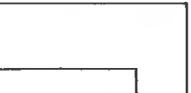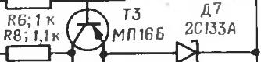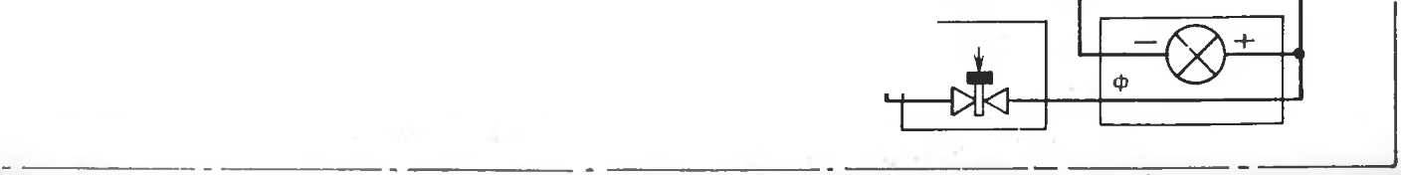

*31*

-- -----

*I* -

• -

•

I

'

*W 1a* I ·

I

LJ,enb *KOHI*

*- 16 8 66*

*1*

•

-+ *16B* 66 2

··

2 -'

*CUioon BHus* 3

*CuiHan* •

ennaeo

' . *¢apa* 5

*313 PMJl,Y 6*

*CuZHQn*

7

*ooeox*

*CUZHa n*

*B*

*BneBO*

I <

•

'

I

•

KOHI

I

*W 16a W 16*

*LJ,enb LJ,eTl b KoHT* •

*1 - 16 B* 66 *- 168* 66 *1*

2 + *16 B* 66, 6¢ *+16B* 66, 6¢ 2

3 *- 16B* 6<P *-16 B* 6<P 3

*38 12om°,£Q 3B eomogQ t<OOU10UHIJ ova P<DOriiJUHQT oa*

*4* 4

I

I *06w,a.R* m Ol/P<a *001u,a n104P<D*

-5 38 *po,nopa u 61 3B vomopa u 66* 5

6 *3B* 66 JB 66 *6*

•

I

'

- - - - I -

I

.

• O g_ 0 1..0 co

lC -& 0 ... :r - o;. lxO: Nl 0

-

-&

.0 0

lO

o.. c :,.:: LD

LO E

NI -

\0 lO

:,.:

:II:

Q.) :r: Q.. lO r::o 0 ::::s lO Cl. x: x: IX) 'l) C'S

-LO

t: N t.:) LO LO LO ' E0

:i:::::ss

lC lO :z:: c:{ t:S x:

I c.o

*:::{* ::>.. r::o - Q.<t:> o:; 0 r::o Cl) x co

:r::

- tO

I (X) O

(")

3 I -

-

) 0 'Cl

-+ x: E -I

c.o

<.o (X) to 0.. CC) cs ... CC) (X) tO ,::; ::r

2 --0 *KB* 3

+

...,

CT

)!::

CT)

::f &

c

CT) CT)

<.o ::>. 0 <.o r::o

+

z: - C'J "") LO <.o r-,.. 00 O') C-) -- C-'-J I-"'.) - I-I")

0

**A A A** A A **A** A A A A **A** A **A A A**

• I

*1<.n 4*  3BK

*- 16 B* 66 *HQ 3BK 1*

*3B n11c* 2

*-16 8* 66 *HQ 3BK*

• *3B n11c*

+ J6B fi6 Ha *3BK* 3 +*166* 66 *HQ 3BK* 3B *nnc r<.ottmeu ttep*



• •

*38 nnc* 4 3B *nnc* - •

•

--------- --------- --- ----- ---



JK. !669:

" I I

I I I , I

* + - I I I I

)I 12

38 8/1, Y II **1 1** I

I III I I I

)I *13*

•

*H y11eea9,*

mo 4xa *H 6*

I I I I I I I I I I

)! *14*

*- 16 B H* 62 I I 1 1 • I I I I I I I I I **t** I I I I , **1 1 1 1 1 1 1 1 1 *i*** I I 'I:\)

) *15 +16 B H61 HQ* KBI

) *16* + *16 B 66 HQ 381<* '

) 17 - *16 B* 66 •

CJ.)

0)

C.IJ

p

•

I .. .

W 6A 1)1 18

38 H52 119 I ) 1)1 19

*06W,a5i* T04K 1 ol) 1)1 20

2

*38 6amapeu*

• *•16 B H 6 1* !21 [) 1)1 21

38 *nnc*

38 H 62



1. *UiaSi* T04 K_ct I II**-I** I I

38 6ama peu

*+ 16 B H 6 1*

-

N. c...., 0

I I I.. I.. t-----+1---

I **1 1** II

>

l 38 *H 61* 1221) 1)1 22

38 *H 61* I

I I I II I *Hyneeali* 1231 1>123

, , 1 , , , 1 mo41<a H6

l>l

t -16 *B* H6 2 1241) 24

I I I I I I

I

I

*Hy11eeaf!*

mo4 t<a H5

* f 6 *B H* 62
* . t

• • • • •

*(*

- • .. . .. . . . . . .

*H 62 H 51* •

I - +

J::::i

N ,*,1*

r

-• --

".."..' w

uJ

CXl

p

'<.

CXl

)

l

0,

l·,\ . ,

38 *H 61* 38 H 62 I

.,

I

*r*

- · ):::,

L

-

I ,-- ,-

1::::1 r

J

*(_,J* I

J

- . - l

...

(

t\)

\

*J*

CJ.) ...... ..,.

Cl:)

-0

I

**-f** = ....

::.:..., :, *<*..*.*.*L*.*.*.

:,

***w***_ --= :'\.-....

*t,:*

- -

J

' --

' " ' '

-S: c:o., ,.,".

,.. c., I

*\N* ., -l

*7.*:.. ::) ..,

:"' I-') ,,

-:, :..

:::, ;:,...

; 'C

=

***r; = ,... =>***

**-**-l -**-' ir**-**.**

*:r.* ..... -:,"

:**:**:**;**: ::::,

"--':, --. -.-. -,

- - -

-**:A,**

::: .:.. "'.

..

:..,

*.*-*J* :.., .-,

I

-....,

_,-.,

0- ex:: 0) c.,, ' l!" tO

,-.. -- . --

......

**=-**,.,. ..... **::1**-**-1** ''

::: I=') -·-"'- ..,

I

.-.. =-._, 'O' !-".":J -·

**-1** .

,, **-f r.,.:**

-.-.I. ,-....., ...... ,.,

--- -

--o

:**=**:: !**:**:J**r -**

**C\ c...>.**

.......

**--.I**

=

-

"""

-

==--,:: ·· ;.-..;...-. =

...--...,.-.......,. --

---

- ::., .., --

= ...,.._-,... - --

-

·,

,::

-

0

;-; ...

--**...**

;:. --:, **0 C,,)**

• . - - !-

--

...

;.:.;. _:.i,

**· ,.J**

.......-. -

'

e:

::::

- A; I



. ...

9 *IT:o ff "1.,.*. .., 1 R22,680

R 23 ;1K

•

' · --

4

+-----

r----r--j'i"" o- -;--;;T1?2;----,;-!:;-1u

·

·, 2,'

T11 , .., T tO

---...-



-t-------t----.

*AB16 B* -- 2 A l.311/\ "l4 ·

*R*25;I,*fKM n*16L *I* ,.i-:M-,.:.n;.;:..1;.66:;....._

n 102

""

5

-

" ..,

..... ., / -.., *RZ 6;* 680 R 27; 240

*R* 28;180 *) \}* L-t :Jrlr: - -,.,._. I

6 *T 13*

*1T 403 ff r* "

8 r- -+ ----J--+-J-- -oIU:._ +- - lt/-::':11-4-

I- , , T l 2

t2.9::..i...J;._ K+-.-- ·/c *M n* 166

R 30;24 0

-----..--+- -t- - t-, - */1.14*

R31;36*=*0

*/*...a*'*.-" • •

*10 T 15*

2AI.0..2..A..

T l 4 •

Mnt66



*_('* , .

I

IT 40311

-

-.......

• •

• •

R34;

•

----•'"

•

, ' R33;680

T 16 , ..,.

*6,gu·o.*o1,,,,,- ,

•

II *U* \ R35; 2,4

I T4Uj *I* iL_-tRi=7=;2;4

,---t--r-1---1 -,t----t---C->----+-- . .t::-t-t...· 1·-1

• ........

1

*R36 ; 1*

A17 •

Tl 7 15

*1T403 .-.* 2102

*r* "

' 2 *V* , --t R:3{=8;=lj5._J

12 ,.., *J1.*f 8

rt--t-t- -t---t--+--<->-1 -+--.._----lK......, ._ 2 *n* I OZA

...*,J*

-.......

/1.16

.lt8168

/\ 2,ll,IOZA T18

....1:."!'"403.-1

J].19 ' '1

ZAIOZA • *1* -''--_.....,

• •

- 5 Tl9 ' "

. -4--- ,-8 1T403M

*J* R 40; ,4

+---+-----------+---it--·------+---·

13--------·--·--------·-----·...1

,-----+- - ,-, '

/J. 0 • I

0

..._-·-----+--

-·fi

15

2J1.

1*z*2A

(; I

*TZ O* ,, ...., R 41;J I

+---+-----------------t---- 16 -ll------------------l 1T403M *1* \

- 23

2"- ·..·•'·'""--!

•

r

6 2

I + +

c

/J.ZJ *r-...*

2J]. I02A... ....:. :.-....

t :R'43;2H7·11

..·.---+...

.,

11,29

20.26,30

- 24

*Z I.* 25

' 17.18

LO LO

co

CT)

4

I 6¢

5

I 66

3

I

i

:"7-,r=J+-c::i:-

.... R 44, 5,! R 45; 8

•

I

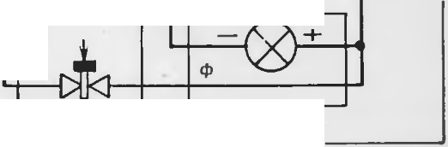

31

-- ------ - -------- ------- - ------- .---------- ----------------

• • •

PHc. 51. npn Hu111111a.1J1>H a S1 3.1chr p114c-c1,a ST c,e,,a uopTonoii annapa Typb1 y11pae.riett11S1:

38 3n -:1t•l< Tl)OIHll"n 1a \l l'I IIITE:'Jl h 3.1 \I C'JlJlC' II IIOrO Jtl'i1CTBHSI; 3B BlJ.Y - Jl<'KTl)OJIOCn,18\IC'II HTC'Jlb Ohl Ull16IIOA nn11ra TC'J1bllOfi y CTa HOnl< H ; 13f, 60fl

TOB3H 6aTapcH : <l> - qia pa: u<l> - Ucl T8pC'H 4>a p1,1: Hl> I- 11C'J)B3H 1183('\I II..I SI (i,1Ta peH : Hri - nTopa H llcl.iC\1118SI 6a Tapesi: 31 1161 - 3J1C'l<TPOIIOC•

11, 13\ll'II IIT(' 11, lll'PllOil 11:1:JC'\I IIOii 6a T3 ilC'II ; 30 J-11,2 ·- ·-. 1('K Tpu nocn.1a MCII II TC'Jl b IITOpOi"t 11,13('\III Oli 6aTapeH; 38 Ap - 31C'KTl>OnocnJ1a Mell llTC' 1b a ppe· THJ>a ; 3BK '1 ll'l< TflO!IOl'll 13\I C'II IITC' lh l< l'l·lllll< M ; ::>B J.>-:1 IC'tiTpOnocnn a \!C' IIIITC'Jl h flOT0():1: 31J r,r;-,neKTponocnn a \lCII U TeJlb (,opTonoro HC:TO'I·

1111i,..i n11T,11t HS1: . --J ,11l'JltU11111111,1i"t 1a \11,11<aTC'J1 b: I- :ia\11o11<:1TC' JJ h; KB 1<011ttC'no,I 111,11<J1101.J ,1Tl'J1b

I ......



 

COJ],EP)KAHH E

TEXH H II ECl<OE Oil HCAH H E

J. Bee.neHHe • • • • • • • • • • • . • • • • • •

* 1. Ha3HalleHHe, 6oeBhlC CBOHCTB8 H TaKTHKO-TeXHHqecKHe JI.8HHble cuapst.na

*CTp.*

3

**9,'1113** . . . . . _ . . . _ . . .. . . . . .

.-'.)

* 1. CocTan, o6mee ycTpoifcTBO H pa60Ta cHapH.na 9M1 13 • • • • • -
     1. CocTaB H o6mee ycTpoiicTno CHapH.na 9Ml13 • • • • • •

3.2. Pa6oTa cHapHJJ.a 9M113 • • • • • • • • • • • 9

* 1. 1\spO,LUfH8MHllCCKaS1 KOMnOHOBKa, COCT3B H ycTpOHCTBO CHapH.LI.8 • . 1 I
     1. Aspo,LI.HHaMHl'.JecKa ff KOl\f nOHOBKa CHapH,LI.a • • • • . .
     2. CocTae H ycTpOHCTBO CHapHJI.a • • • • • • • • • • 12
        1. BoeeaSI lCaCTb c npe.noxpaHHTeJlbHO·.neTOHHpylOWHM MexaHH3M0'1 13
        2. Pa3rOHHO-MaprneBaSI JI.BHraTeJlbHaSI yCTaHOBKa . . 19
        3. AnnapaTypHbiii OTCeK • • • • • • • •

• 21

4 .3. KoHTefiHep • • • • . • • • • • • • • • 25

4.4. BhlUJH6HaSI JJ.BHraTeJlbH3SI ycraHOBKa . • • • • • • • 28

. 5. EopTOBaSI annapaTypa ynpaBJleHHSI CH3PHJJ.OM • • • 30

* 1. Ha3Ha4eHHe, COCTjlB H pa3MeweHHe 6opTOBOif annapaTypbI • • -

5.1.l. KaT}'llIKa npOBO,LI.HOH JlHHHH CBH3h • • • • • • 31

5.1.2. DJlOK ynpaaneHHSI • • • • • • • • • • 33

5.1.3. Koop.nHHaTop • • • • • • • • • • • • 36

5.1.4. EnoK pyJ1eaoro npneo.na • • • • 42

5.1.5. JlaMna-¢apa . • • • . . • • • • • • • 45

* 1. <l>opMHpOBaHHe KOMaH.n ynpae.TJeHHSI • • • • • . • 47
  2. npeo6pa30Ba11ue KOMaH.n ynpaaneHHSI B OTKJIOHeHHSI CHapH)I.a no Kypcy H Tattra.>Ky • . • • . • • • • • • • 61
  3. Pa6oTa 6opToeoh a nnapaTypbl ynpaeJJeHHSl CHapSl)l.OM . • fi.:>

1. 0KpacKa, MapKHpOBKa u yKynopKa CHapH,!lo 91\,\ 113 . • • . • 73
   1. 0KpacKa u MapKHpOBKa CHapst.na 9.v'\ 113 • . • • • • -
   2. YKynopKa cuapst..na 9Ml 13 • • . • • • • • • • -

7. Y 4e6Hble CHapH)l.hl 9M113 • . • • • . . . • • • • • 77

* 1. Ha3HaqeHHe H BHJlbI y qe6HbIX cHapst.noe 9Ml 13 • • • • • . -
  2. 0TJlHqHTe 1bHaS1 oKpaCKa H MapKHpOBKa yqe6HblX CHapH,LI.OB 91\1113 -
     1. 0TJJU4HTeJJbff3Jl OKpaCKa yqe6HhlX CHapSl)l.OB 9Ml13 • • • -
     2. .i\\apKHpOBKa yqe6HbIX CHapH,LI.OB 9 \1113 . . . • . 78
  3. MapKHpOBKa yKynopKH c yqe6Hh1MH CHapSlaMH 91\\113 • • • • -

H HCTPYKl.lHSI no aKC ilJIYATA l.lH H

8. 06wHe yKa3aHnH no o6pameHHIO co CH8pH,!l2MH 91\1113 8 BOHCKaX • 8:?

9. YKa3aHHSI no MepaM 6e30naCHOCTH

• • •

• • • • • • -

IO. PernaMeHTHh1e pa60T bl • • • • • • • • • • • • • • 85

1. flpaaHna xpaHeHnS1 CHapSl,LI.OB 9MI 13 • • • • •

• • • • 86

1. TpaHcnOpTHPOB2HHe CHapHJX.OB 9.1113 • • • • • • • • • •



13. C·se.neHnH o 3Hn . . • • • • • • • • • • • • • 90

94

95



1. Cne.lellHSI O M2CKHpOBKe . • • • • • • • • • .
2. npanHJia 06pamc1111si c y'-le6H1.,1MH cHapsiJI.a u 9M l 13, xpaHeHHe H c6epe-

**.>l\.eH11e** • • • • • • • • • • • • _ .. • • • • •

1. Oco6eHHOCTH 3KCn yaTaUHH CH2PSIJI.OB 9,l\,\1 13 B ycnOBHSIX cyxoro Tponuqe- CKOrO KJIHMaTa . . • • • • • • • • • • • • • • •
2. Oco6eHHOCTH 3KCn yaTaUHH CHapSIJI.OB 9MI 13 B ycnOBHSIX BJ13>KHOro TponH-

lleCKOrO KnHf aTa . • • • • • • • • • • •

.JlHCT per11crpaUHH H31eHeHHH • • • • • • • • • • · • •

•



91

-

92

-

9-l

I

CAaHO e Ha6op 12.5.78 r.

Pe.11.auop *A. P.. Basu.1108*

TexHH ecKHA peAaKTOP *A. n. 6a6uHa*

J(oppeKTOP *E. JI . X apuroHosa*

no.nnHcaHo e ne11aTb 13.9.78 r.

I I cl>opr. aT 60X90/1e. ti ne11.*n.•* 6 yen. ne11. *n.*+ 1 eKn. 11/,ne'l. JI., I ,2a yCJt. ne'l• •••

J,:l1'l. .:\"e 5/2 I68c

3ax. 1669c

96