А 4th generation blockchain platform which called “AERGO” could become the most valuable development of nowadays. The main advantage of new project is vast number of spheres its application. Experts expect the inventing the new mainstream in modern IT field, called “AERGO” the real breakout of present times.
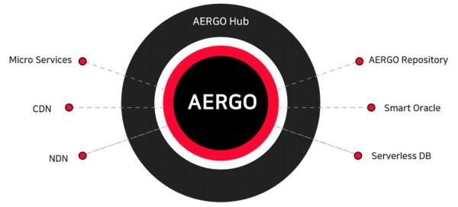

The main characteristics of “AERGO”
Here is the general characteristics about new blockchain project:
- Core elements of AERGO are built on technologies developed by Blocko. It means that the structure of platform is modern and highly improved;
- The modern platform consists of 3 parts connected to each other: Chain, Hub, Market. Each one has own functions;
- The project can be called as an SQL based smart contract platform/ The structure helps to increase usability;
- The protocol is built on the parallelism, that requires an efficient architecture. Each block could work separately – all transactions would be successful anyway. It makes such kind of protocol reliable.
- “AERGO” has modern file system and unique domain-based partitioning.
- The platform contains 2 kind of repositories. Both ones are used widely – the type of repository depends on the kind of enterprise. For open host ones would be better to use public repositories, for closed enterprises with secret data – the best variant would be private repositories;
- The platform has a vast number of tokens that could transferable within the protocol.
This new project is expected to be high level adoptive platform that will change concept of blockchain in the better side. Now many people are not ready to redirect own enterprises to ecosystems because of their disadvantages and risks for the business. But developers of “AERGO” are sure that their project will be widely used in different spheres – not only in IT field.

What pluses has the new platform?
- The real simplification of supply and value chains (no more “middle-men” in the enterprises);
- The businessman can settle transactions and close deals automatically. Moreover, all actions can be done anytime;
- All transactions are fast – users will forget about long term waiting for any deals with their investments;
- Security of data and Apps is on the high level – the confidentiality is improved too. The appearance of private repositories;
- More options for business. The masters of enterprises have many advantages for their permanent transactions, even while businessman on the other side of the planet;
- The overhead costs were reduced and much lower average transaction costs because off improved structure of protocol.
The experts see in “AERGO” very perspective project that could solve many problems of existing blockchain platforms. Nevertheless, the creative team should be ready that “AERGO” all the time will have many rivals. That is why creators of modern protocol should continue improving their project.
