Effect of laser radiation on the cultivation rate of the microalga Chlorella sorokiniana as a source of biofuel
N Politaeva, Y Smyatskaya, V Slugin, A Toumi, M Bouabdelli.
.

Abstract. This article studies the influence of laser radiation on the growth of micro-algal biomass of Chlorella sorokiniana. The composition of nutrient medium and the effect the laser beam (2 and 5 cm diameter, 1, 5, 10, 15 and 20 minutes exposure time) for accelerated cultivation of microalgal biomass were studied. The source of laser radiation (LR) was a helium-neon laser with a nominal output power of 1.6 mW and a wavelength of 0.63 μm. The greatest increase in biomass was observed when LR was applied to a suspension of microalga Chlorella sorokiniana with a beam of 5 cm diameter for a time of 10, 15 and 20 minutes. The results of the microscopic study of the microalga cells show a significant increase in the number of cells after an exposure to LR with a beam diameter of 5 cm in diameter. These cells were characterized by a large vacuole, a thickened lipid shell and a large accumulation of metabolites prone to agglutination. This study proposed to obtain valuable components (lipids, carotenoids, and pectin) from the obtained biomass by extraction method and to use the residual biomass formed wastes, after the extraction of valuable components, as a co-substrate for anaerobic digestion to produce biogas. The composition of biogas consists mainly of methane and carbon dioxide. Methane is recommended to be used for economic needs in supplying the whole process with heat and electricity. The carbon dioxide formed during fermentation and after combustion of methane for energy production, is planned to be used as a carbon source in the cultivation of Chlorella sorokiniana for photoautotrophic biomass production.

- Introduction
Microalgal biomass is seen as a promising renewable source of raw material for biofuel production, as well as, a source of valued nutrients in livestock feeds, dietary supplements and in cosmetology. The considered biomass source has a high reproduction rate and the ability to accumulate a significant amount of high-energy lipids due to the photosynthetic activity of the microalgae. As a source of biofuel, microalgae significantly exceeds the photosynthetic productivity of land oilseeds, such as canola, soybean, sunflower and palm oils (in the same land area under the influence of sunlight). Under optimal growth conditions, microalgal biomass is able to produce yields of 20 to 70% of lipids by dry weight besides other by-products with high added value such as proteins, pigments, carbohydrates and biopolymers [1]. Microalgae Chlorella sorokiniana among other species of Chlorella have the highest yield of nutrients. In order to maximize biomass growth in the shortest time, it is necessary to select the optimal growing conditions, such as temperature, illumination, agitation, sparging, and additional external physical actions [2-4].

Laser radiation (LR) is generated by an optical quantum generator. This technical device emits light in a very narrow spectral range in the form of a directed high-coherent monochromatic polarized beam, that is, in the form of a highly ordered electromagnetic one-color radiation in space and time. A report on laser radiation appeared for the first time in 1954 - these were the works of scientists of the Physical Institute of the USSR Academy of Sciences (N.G. Basova, A.M. Prokhorov) and the staff of the Columbia University in the City of New York (Ch. Townes, A. Shavlov)- discovery for which they were awarded the Nobel Prize [5]. Laser has a very broad spectrum of application. Its sharp focusing combined with its high power of radiation makes it useful in technology processes for cutting, welding and piercing holes in solid materials. Laser radiation (LR) is also employed to conduct monitoring studies on air pollution [6].

The effects of lasers on the human body is widely studied and applied in the medical field. In fact, it is used for surgical interventions (laser scalpel), which made it possible to perform operations with minimum bleeding and to open new possibilities in eye microsurgery. It is also used in procedures to enhance the immune system, in cosmetology and in other therapeutic actions on the human body [7]. In agriculture, laser treatment is used to accelerate the growth and development of plants, which leads to an increase in productivity [8-9]. It is also known from the literature [10] that a low-intensity LR stimulates the metabolic activity of a cell. These processes are based on photophysical and photochemical reactions that arise in the body when exposed to laser radiation. The photo-physical reactions are primarily due to the heating of the object (within 0.1 - 0.3°C) and the spread of heat in biological tissues. The temperature difference is more pronounced in the biological membranes, which leads to the outflow of Na + and K + ions, the opening of protein channels and the increase of the molecules and ions transport. The photochemical reactions are due to the excitation of electrons in the atoms of a light-absorbing substance. At the molecular level, this is expressed in the form of photo-ionization of the substance, photo-reduction, photo-oxidation, photo-dissociation of molecules, or in their rearrangement – photo-isomerization [11]. In this case, water absorbs visible light and the red parts of the spectrum. The membranes change the structural organization of the water layer and the functions of the membranes’ thermolabile channels [12]. At the optimum exposure doses of bio-objects to low-energy laser radiation, appropriate energy swap is realized. In response to this, the systems and organs undergo activation processes of self-regulation and mobilize their own sanogenesis reserves [13-14].

Laser radiation is, for any living organism, an unusual irritant that cannot be found in natural conditions. Its biological effect depends on the wavelength and intensity of the radiation. In this regard, the entire wavelength range is divided into several regions: from 380 to 780 nm-the visible region; from 780 to 1400 nm - the near infrared, over 1400 nm - the far infrared region. There are several types of effects of laser radiation on a living organism [14 ± 15]:
• Thermal (thermal) - the release of a significant amount of heat in a small volume and in a short period of time;

• Energy - high electric field strength, which causes the polarization of molecules and other effects;
• Photochemical - fading of many pigments;
• Mechanical - appearance of ultrasound oscillations in the radiated organism;
• The formation of an electromagnetic microwave field within the cell.

The article [15] examined the use of laser radiation as a bio-protector for plants growing in chemically contaminated land. The results of laboratory experiments on the effect of laser radiation on two plant species using arsenic solutions of different concentrations are presented. The laser emitter was a neon laser LGN-207A No. 1063 with a power of 1.8 mW and a wavelength of 0.63 μm. The experiments showed that the plants exposed to radiation had a longer life span than the neighbouring plants that had not been laser treated. These samples were more efficiently restored and less exposed to tissue necrosis. Thus, the positive effect of the helium-neon laser was confirmed [15]. According to the literature [16], laser radiation has a positive effect on the growth of protozoa (infusoria) when exposed for 45 seconds at a 1.3 μm wavelength.

Objective: the study of the effect of laser radiation (LR) on the biomass growth of microalga Chlorella Sorokiniana.
- Results and Discussion
The object of the study was a suspension of microalgae Chlorella sorokiniana in a culture media. The composition of the culture media is given in Table 1.

Table 1. Composition of the culture media.
Substance | Concentration, mg / l
ZnSO4•7H2O | 100
CuSO4•5H2O | 10
CoSO4•7H2O | 100
MnCl2•4H2O | 500
H3BO3•WF | 50
Na2MoO4•2H2O | 100
FeCl3•6H2O | 4.000

The radiation source was a single-mode red laser LGN 208V with a nominal output power of 1.6 mW and a wavelength of 0.63 μm. To measure the optical density of the Chlorella sorokiniana suspension, a UNICO 1201 spectrophotometer was used.
11 samples were prepared in 125 ml conical flasks. The volume of each suspension was 100 ml, with an initial optical density of 0.174 (at a wavelength of 750 nm). The biomass cultivation was carried out with a constant supply of air at a rate of 1.5 litters/min and with a constant exposure to daylight and short-term exposure to Laser radiation (LR).
The installation schema is presented in Figure 1. The lens is disposed almost close to the laser exit port. The sample is located at a 5.4 m distance from the lens, the laser ray diameter on the sample is 2 cm for samples No. 1-6, the radiation power density of the objective is 2.5 W/m² and the illumination is equivalent to 340 lux.

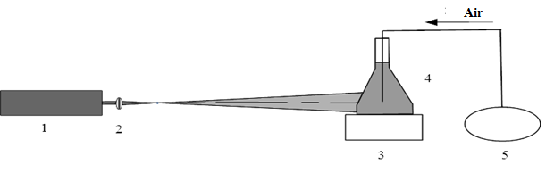
Figure 1. Schema of the installation put in place to investigate the effect of LR on the suspension of Chlorella sorokiniana: 1- laser LGN 208B, 2-convergent lens (F = 110 mm), 3- adjustable support, 4- test sample, 5- aerator.

A telescope was then used to increase the laser ray diameter on the sample to 5 cm (samples No. 7-11). The radiation power density on the sample was 0.3 W/m2 and the illumination was equivalent to 40 Lux. The distance between the laser and the telescope (angular increase of 30×) was 2.1 m and the distance between the telescope and the sample was 0.1 m (Figure 2).

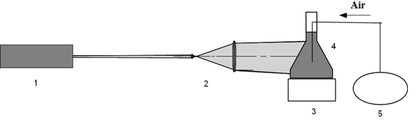
Figure 2. Schema of the installation put in place to investigate the effect of LR on the suspension of Chlorella sorokinian. 1 - laser LGN 208 V, 2 - ray expander (telescope), 3- stand, 4- sample.

The laser ray exposure time (2 and 5 cm) is shown in Table 2.

Table 2. Time of exposure of the LR beam on the suspension of Chlorella Sorokiniana.

D, см | 2 |  |  |  |  |  | 5
№ of the sample | 1 | 2 | 3 | 4 | 5 | 6 | 7 | 8 | 9 | 10 | 11
t, min | 1 | 5 | 10 | 15 | 20 | 0 (control) | 1 | 5 | 10 | 15 | 20

t: time of exposure (min)
D: diameter of the LR beam (cm)

- Results and Discussion
After the exposure to LR (D = 2 cm), a daily monitoring of the optical density was carried out on the Chlorella sorokiniana’s suspensions. The results are shown in Figure 3. On the first day after exposure to LR, a decrease in the optical density of the suspension of Chlorella sorokiniana (except for the control sample) was observed, which is explained by the stress state of the biomass cells. However, in the following days, an increase in the number of cells was observed in proportion to the exposure time. After 7 days, the maximum biomass increment was achieved. Based on the obtained data, it can be concluded that the effect of LR (D = 2 cm) to accelerate the growth of biomass is not significantly advantageous.

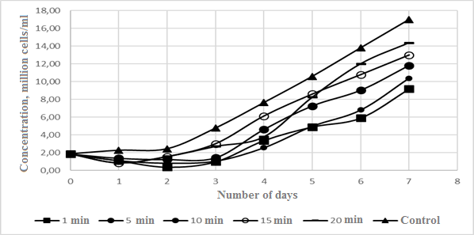
Figure 3. Relation between the cell concentration and the number days (with a 2 cm diameter laser ray).

After the exposure to LR (D = 5 cm), a daily monitoring of the optical density was carried out on Chlorella Sorokiniana suspensions. The results are shown in Figure 4. On the first day after exposure to LR, an increase in the optical density of the Chlorella sorokiniana suspensions was observed in comparison with the control sample. In the following days, there was a significant increase in the number of cells treated with LR. After 7 days, a maximum biomass (15 times) was achieved with the LR treatment (D = 5 cm) for 15 minutes, which indicates the benefit of LR treatment (D = 5 cm).

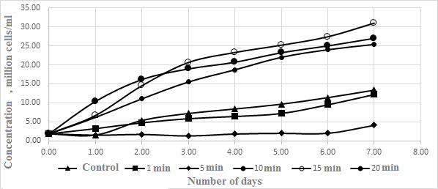
Figure 4. Relation between the cell concentration and the number days (with a 5 cm diameter laser ray).

Figure 5 shows the biomass’s growth on the seventh day after exposures of the samples to a 2 cm and 5 cm diameter laser ray. The greatest increase in biomass was observed when exposed to the 5 cm diameter expanded ray and an optimum exposure time of 15 min. The D=5 cm ray was more efficient than the D = 2 cm focused laser ray. This is most probably due to a more uniform distribution of the LR and a power drop of 2.5 W/m² to 0.3 W/m² due to scattering. At a power higher than 0.3 W / m2, the microalgae cells are destroyed.

Figure 5. Increase in the number of cells after exposure to a laser of different diameters.

Microscopic studies were conducted to study the effects of laser radiation on the growth of biomass (as shown in Figure 6). To observe the shape of chlorella cells, photomicrographs were taken using a digital camera IS-500 and the FOTO microanalysis program in ten fields of vision. The analysis of the photomicrographs using the Levenguk computer program allows to contrast and change the brightness of photos and additionally enlarge the images.

 |  | 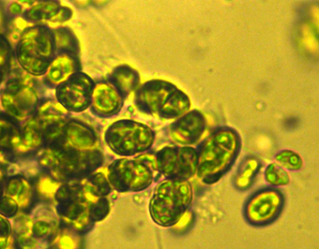
A |  | B
Figure 6. Microstructure of microalga Chlorella sorokiniana before (A) and after (B) laser radiation

After the exposure to LR, a significant increase in the number of cells is observed. Cells are characterized by a large vacuole, a thickened lipid shell, a large accumulation of metabolites and are more prone to agglutination.
Later on, it is proposed to obtain valuable components (lipids, carotenoids, and pectin) from the obtained biomass by extraction method and to use the residual biomass formed wastes, after the extraction of valuable components, as a co-substrate for anaerobic digestion to produce biogas (Figure 7). The composition of biogas consists mainly of methane (CH₃) and carbon dioxide (CO₂) which should be separated. Methane is recommended to be used for economic needs in supplying the whole process with heat and electricity. The carbon dioxide formed during fermentation and after combustion of methane for energy production, is planned to be used as a carbon source in the cultivation of Chlorella sorokiniana for photoautotrophic biomass production.

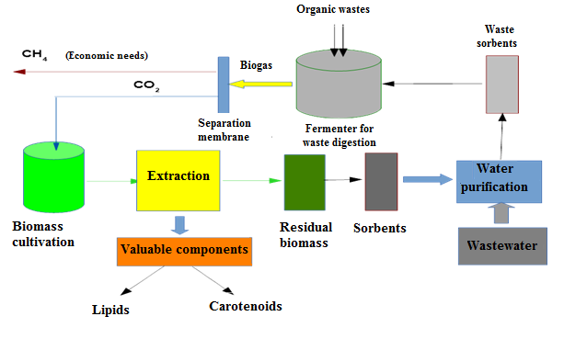
Figure 7. Schema of biomass processing of Chlorella sorokiniana.

- Conclusion
As a result of the study, the following conclusions were drawn:
1. It was found that the action of Helium-Neon LR with a power of 0.3 W/m² with a laser ray diameter of 5 cm on the suspension of Chlorella sorokiniana increases the biomass growth by 15 times in 7 days.
2. It was determined that the tolerable exposure time for LR with a power of 0.3 W/m² and a laser ray diameter of 5 cm per suspension of Chlorella Sorokiniana provides an optimal biomass gain is 15 sec.

References
- Piligaev AV, Sorokina KN, Parmon VN Production of high-energy biomass in heterotrophic cultivation of microalgae in water purification processes // Vestnik Novosibirsk State University. Series: Biology, clinical medicine. 2015. Vol. 13, no. 4. P. 19-26.
- Influence of ultraviolet on the development of duckweed Lemna and extraction of copper from contaminated sewage Olshanskaya LN, Sobgayda NA // in the collection: promising polymeric composite materials. Alternative technologies. Recycling. Application. Ecology ("composite-2016") reports of the international conference "Composite-2016" (dedicated to the 60th anniversary of the Engels Technological Institute (branch) of the SSTU named after Gagarin Yu.A.). Editor Panova L... 2016. P. 404-408.
- Effet d'un champ magnétique sur l'extraction des métaux lourds des eaux usées avec des lentilles d'eau / Ol'shanskaya L.N., Sobgaida N.A., Tarushkina Yu.A., Stoyanov A.V./Elaboration chimique et pétrolière. 2008. P. 44. № 7-8. Pp. 475-479.
- The influence of the magnetic field on the extraction of heavy metals by duckweed / Olshanskaya LN, Sobgayda NA, Stoyanov AV, Kuleshova ML // News of Higher Educational Institutions. Series: chemistry and chemical technology. 2010. P. 53. № 9. P. 87-91.
- Kuklev, Yu.I. The ecological ecology: Textbook. allowance / Yu.I. Kuklev. M.: Higher School, 2001.-357 p.
- Reggie, J. Industrial use of lasers / J. Reggie. M.: The World, 1987. - 236 p.
- Priezzhev, A.V. Azerne diagnostics in biology and medicine / A.V. Priezzhev, V.V. Tuchin, L.P. Shubochkin. M.: Science, 1989.-321s.
- Belsky, A.I. Quantum processing of laser radiation in a magnetic field in the technology of annual growing of tree seedlings of fruit crops / A.I. Belsky // Plant growing. - 2007. - №2. Pp. 15-19.
- Patent RF RU No. 2240663 Method of industrial cultivation of agricultural crops using laser radiation. Zhurba PS, Zhurba TP, Zhurba EP 2003.03.11
- Alekseev, Yu.V. Some Aspects of BioPhotometry with LED Light in the Near-IR Range / Yu.V. Alekseev, M.E. Sokolov, Т.V. Degrave // ​​Laser and Information Technologies in Medicine of the XXI Century: Materials of the Intern. Conf.: at 2 pm - St. Petersburg, 2001. - Part II. - P. 462 - 463.
- Fain, S. Biological effect of laser radiation / S., ayn, E. Klein; trans. with English - World, 1968. - 336 p.
- Gamaleya, N.F. Some questions of biodynamics and bioelectronics of the organism in the norm and pathology, biostimulation by laser radiation / NF. Gamaleya // Materials of Intern. Conf. Krasnodar: KPI. - 1972. - P. 286 - 289.
- Engineering ecology: a textbook / ed. prof. V.T. Medvedeva. - M.: Gapdariki, 2002. - 687 p.
- Kaplan, M. A. Biological action of a laser of low intensity of a near infrared spectrum / M.A. Kaplan // Radiation Biology. Radioecology. - 1999. - T.39, No.6. - P. 683-691.
- Kaplan, M. A. Biological action of a laser of low intensity of a near infrared spectrum / M.A. Kaplan // Radiation Biology. Radioecology. - 1999. - T.39, No.6. - P. 683-691.
- Combined action of electromagnetic radiation of optical and millimeter bands on the growth of unicellular ones TI Belaya, LD Gapochka, MG Gapochka and dr // Moscow Vestnik university. Ser. 3. Physics. astronomy. 1994. Vol. 35, No. 4

