+ p21WAF1 and tumourigenesis: 20 years after
Warfel, Noel A.; El-Deiry, Wafik S.
Current Opinion in Oncology: January 2013 - Volume 25 - Issue 1 - p 52–58
CANCER BIOLOGY: Edited by Pierre Hainaut and Amelie Plymoth

Abstract
Purpose of review This review provides an overview of the structure, regulation and physiological functions of p21, the product of the cyclin-dependent kinase inhibitor 1A (CDKN1A) gene, with a focus on its dual role in promoting and repressing biological processes that are hallmarks of tumourigenesis.
Recent findings Recent work has provided a better understanding of the molecular mechanisms of how oncogenic signalling pathways influence p21 expression. In response to cellular stimuli, p21 expression is tightly regulated at transcriptional and post-translational levels through mechanisms involving RNA stabilization, phosphorylation and ubiquitination. As a result, growing evidence reveals that several important tumour suppressor and oncogenic signalling pathways alter p21 expression to elicit their effects on cell cycleprogression and survival. Thus, p21 expression can both promote and inhibit tumourigenic processes, depending on the cellular context.
Summary Since its discovery, it has become increasingly clear that p21 can function as both a classical tumour suppressor and an oncogene. In order to effectively utilize p21 as a therapeutic target, it will be necessary to design therapeutic strategies that preferentially block the ability of p21 to promote senescence, stem cell renewal and cyclin/CDK activation, while leaving its tumour suppressive functions intact.

INTRODUCTION
Loss of control of the mammalian cell cycle drives cellular transformation and promotes tumourigenesis. As a result, eukaryotic cells have developed multiple checkpoints that regulate cell cycle progression. Aberrant expression and activity of the proteins that mediate these cell cycle checkpoints leads to the development of cancer and greatly affects the efficacy of anticancer therapies. One such cell cycle regulatory protein, p21 [also known as wild-type p53-activated fragment 1 (WAF1), CDK-interacting protein 1 (CIP1), senescent cell-derived growth inhibitor 1 (SDI1), melanoma-derived antigen 6 (MDA6) and cyclin-dependent kinase inhibitor 1A (CDKN1A)], functions as a cyclin-dependent kinaseinhibitor. In response to DNA damage or other cellular stressors, p21 expression is increased, resulting in the activation of cell cycle checkpoints until repair has taken place, so that cells can survive and maintain genetic fidelity. Since its discovery, an abundance of research has unraveled the complex mechanisms regulating p21 expression and function and provided insights into the role of p21 as a positive and negative regulator of tumour development and progression

STRUCTURE
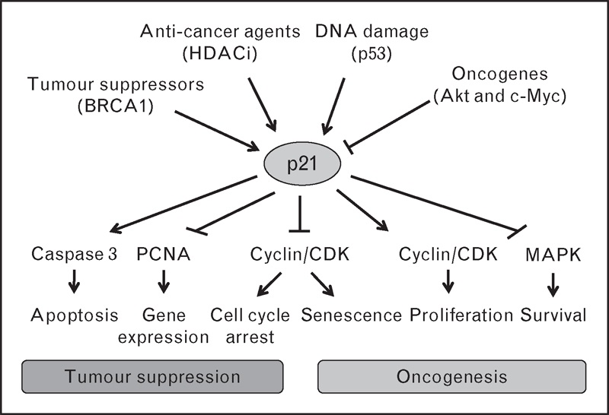
The wild-type p53-activated fragment (WAF1) gene is located on human chromosome 6p21 and encodes a 21-kDa protein (p21) that was originally identified through subtractive hybridization screening for transcriptional targets of the p53 tumour suppressor protein ^{[1]}. Simultaneously, p21WAF1 was independently discovered from a yeast two-hybrid screen as a 21-kDa protein that interacts with and inhibits cyclin-dependent kinase 2 (p21CIP1) ^{[2]}, as SDI1 ^{[3]}, and as MDA6 ^{[4]}. p21 is a member of the Cip/Kip family of cyclin kinase inhibitors (CKIs), which includes p27^{Kip1} and p57^{Kip1}. These family members share significant sequence homology in their N-terminus, which has been demonstrated to harbor cyclin/CDK-binding domains that are necessary and sufficient to inhibit CDK activity and cause G1 arrest when overexpressed in cells. They also share a C-terminal nuclear localization signal (NLS), but have no other domains in common. Unlike other Cip/Kip family members, the unique carboxyl-terminal domain of p21 harbours a second cyclin binding site as well as a domain that interacts with the proliferating nuclear antigen (PCNA), a subunit of DNA polymerase δ.

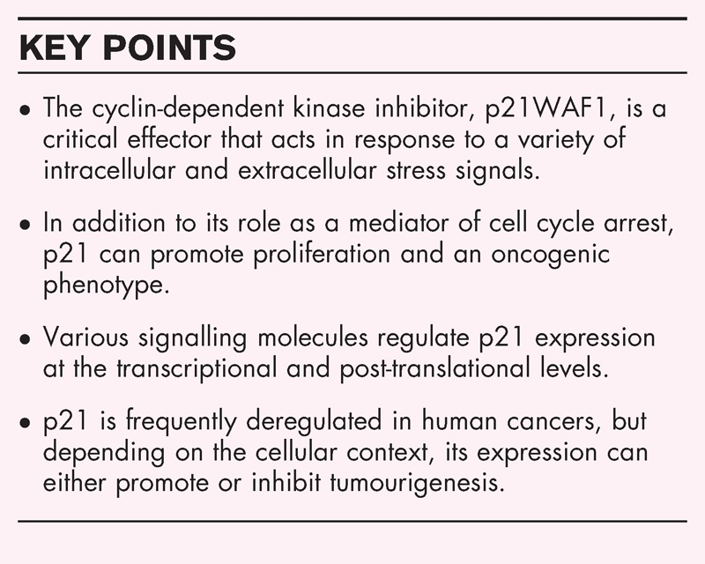
p21 responds to a variety of stimuli to elicit physiological effects that can promote or inhibit tumourigenesis. In addition to activation by p53 in response to DNA, various proteins, mitogens and anticancer agents induce p21 at the transcriptional level. Post-translational modifications, such as phosphorylation and ubiquitination, inhibit p21 by altering its stability and cellular localization. p21 elicits its growth-inhibitory activities primarily through the inhibition of cyclin-dependent kinases (CDK1 and CDK2). p21 can also reduce proliferation independent of CDKs by inhibiting PCNA, which is required for S phase progression. p21 induces apoptosis by activating the caspase 3-mediated signalling pathway. However, the various physiological responses triggered by p21 are complex and can also promote tumour growth. Cytoplasmic p21 directly binds to and inhibits proapoptotic MAPKs (p38 and JNK). At low levels, p21 enhances the assembly of cyclin/CDK complexes to promote cell cycle progression. Through its inhibitory effect on the cell cycle, p21 can induce senescence, which promotes resistance to radiation and chemotherapy. p21 expression is crucial for maintaining tumour stem cell populations and can activate processes such as EMT that promote metastasis. Thus, p21 is a master regulator of the cellular response to stress. CDK, cyclin-dependent kinase 1; EMT, epithelial mesenchymal transition; PCNA, proliferating nuclear antigen.

Box 1

The Cip/Kip family members are highly conserved throughout evolution. However, there are structural differences between the family members that support the idea that each of these inhibitors serves a distinct function in the cell. Interestingly, in Drosopohila, the dacapo (Dap) protein has been identified as a homologue of p27^{Kip1} that functions as a key regulator of the exit from the cell cycle. However, although Dap contains low sequence homology to the eukaryotic Cip/Kip family members, there is striking conservation in the CDK-interacting domains and the PCNA motif, which is specific to p21, indicating that Dap may be more closely related to p21 in some of its regulatory functions. A recent study on the role of Dap as a regulator of premitotic S phase and genomic stability showed that dap −/− flies enter the meiotic cycle with high levels of cyclin E/CDK2 and accumulate DNA damage in ovarian cysts, independent of the double-strand breaks that initiate meiotic recombination ^{[5]}. These data suggest that CKIs, such as p21, may play essential and no redundant roles in meiotic cell division.

REGULATION OF p21 EXPRESSION LEVELS
Since its discovery as a transcriptional target of p53, much progress has been made towards unravelling the mechanisms that govern p21 expression at both the transcriptional and protein levels.
Back to Top | Article Outline

Transcription
The transcriptional regulation of p21 has been exhaustively studied. p21 expression was originally found to be induced in the p53 tumour suppressor protein and was decisively shown to be the central mediator of p53-induced G1 arrest ^{[1]}. The WAF1 gene harbours several p53-response elements in both its 5’-terminus and in the body of the gene. Thus, in response to DNA damage, activation of p53 induces p21 protein expression and causes G1 arrest in a p21-dependent manner. In addition to its regulation by the classical p53 pathway, p21 expression is also modulated at the transcriptional level by an array of oncogenes and tumour suppressor proteins that induce p21 expression via the binding of different transcription factors to specific cis-acting elements located in the p21 promoter. For example, transforming growth factor β (TGF-β), nerve growth factor (NGF) and the tumour suppressor protein, breast cancer gene 1, induce p21 transcription through Sp1–3 sites in the p21 promoter ^{[6–8]}. Alternatively, the oncoprotein, c-Myc, has been shown to inhibit the transcription of p21 through its interaction and subsequent repression of multiple transcription factors ^{[9]}. Furthermore, c-Myc has been shown to interact with the carboxyl-terminus of p21, which disrupts its interaction with PCNA and decreases p21-mediated inhibition of DNA synthesis ^{[10]}. Due to the importance of c-Myc in cancer, this finding has wide ranging implications on the physiological outcome of cells in response to DNA damage. For instance, in tumour cells expressing high levels of c-Myc, the p53-dependent induction of p21 would be blunted, allowing for the proapoptotic arm of p53 to prevail. Thus, the regulation of p21 transcription is complex, and in addition to p53 and serum, a variety of other transcription factors, such as activator protein 2, E2 transcription factor (E2F), signal transducer and activator of transcription (STATs), and CCAAT/enhancer binding protein alpha, can induce p21 transcription in response to different signals ^{[11]}.
Back to Top | Article Outline

RNA stability
It has long been known that inflammation and cellular stress can upregulate p21, and one mechanism responsible for this response was recently elucidated ^{[12▪▪]}. The ZO-1–associated nucleic acid binding protein (ZONAB)/DbpA is a Y-box transcription factor that is regulated by components of intercellular junctions that are affected by cytokines and tissue damage. In response to several types of cellular stress, ZONAB binds to specific sites in the 3′-UTR of p21mRNA, resulting in mRNA stabilization and enhanced translation. Furthermore, Rho-stimulation induced binding of ZONAB to p21 mRNA influences Ras-induced p21 expression. These findings demonstrate RNA stabilization as a unique mechanism that links the cellular stress response to p21 expression and cell survival.
Back to Top | Article Outline

Proteasomal degradation
Under normal growth conditions, p21 is an unstable protein with a relatively short half-life. At the time of synthesis, heat shock protein 90 (HSP90) is recruited to p21 via the WAF1/CIP1 stabilizing protein 39 (WISp39) adapter protein and protects p21 from proteasomal degradation ^{[13]}. Confirming the importance of HSP90 for p21 stability, treatment with geldanamycin, a HSP90 inhibitor, decreased the half-life and steady-state levels of p21. Also, p21 was not upregulated in response to DNA damage in cells lacking WISp39, suggesting that the stabilization of p21 is necessary for its upregulation, regardless of transcriptional activation.
To date, a majority of the research on p21 turnover suggests that it is primarily degraded through the ubiquitin-proteasome pathway. Several distinct E3 ubiquitin ligase complexes, including SCF, cullin4A-RING E3 ubiquitin ligase (CRL4)^{CDT2}, murine double minute 2 (MDM2) and MDMX, CRL2^{LRR1} and anaphase-promoting complex/cyclosome (APC/C)^{CDC20}, have been shown to mediate the turnover of p21. Interestingly, each E3 ligase complex seems to preferentially bind p21 at different stages of the cell cycle or in different locations within the cell to regulate specific pools of p21. For example, CRL4^{CDT2} promotes the ubiquitination and degradation of p21 only when bound to PCNA in S phase ^{[14]}, whereas APC/C^{CDC20} ubiquitinates p21 in prometaphase to allow for full activation of cyclin/CDK1 during mitosis ^{[15]}. Due to the cytoplasmic localization of the E3 ligase subunit, leucine-rich repeat protein 1 (LRR1), CRL2^{LRR1} specifically targets the cytoplasmic pool of p21 for proteasomal degradation ^{[16▪▪]}. Interestingly, the canonical ring-finger E3 ligases that target p53 for degradation, MDM2 and MDMX, also promote the turnover of nuclear p21 by brining p21 directly to the proteasome, independent of ubiquitin, via the binding of MDM2/p21/14–3–3τ directly to the C8 subunit of the 20S proteasome ^{[17]}.
Back to Top | Article Outline

Post-translational modifications
There is mounting evidence of the importance of post-translational modifications in controlling p21 expression levels, cellular localization and activity. The identification of post-translational modifications that alter the localization of p21may be of particular importance considering that nuclear accumulation of p21 is associated with growth inhibition, whereas its oncogenic activities are primarily associated with cytoplasmic localization. Most notably, the prosurvival kinase, Akt, phosphorylates p21 at Thr145, which disrupts the binding of p21 to PCNA, decreases its inhibitory effect on cyclin CDK complexes and results in the cytoplasmic accumulation of p21 ^{[18,19]}. As a result, in tumours that have constitutive activation of Akt due to amplification of receptor tyrosine kinases, among other mechanisms, the phosphorylated, cytoplasmic form of p21 can no longer initiate its growth-inhibitory functions.
A recent report from Brian Hemming's group revealed a novel link between p21 and the tumour suppressive mammalian sterlie 20-like kinase (MST) signalling pathway through activation of the downstream nuclear Dbf2-related (NDR) kinases ^{[20▪▪]}. Specifically, NDR kinases control the protein stability of p21 by direct phosphorylation at Ser146, which destabilized p21. Therefore, inhibition or genetic depletion of MST3 or NDR stabilized p21 and led to the accumulation of cells in G1. These findings are the first to describe the existence of a novel MST3-NDR-p21 axis as an important regulator of G₁/S progression in mammalian cells and provide new insight into the potential regulation of p21 in organ development and tumourigenesis.

