Lesson 1. Far Away Stars
Learning Objectives:
- Learn what celestial bodies there are in the Universe.
- Expand the students’ knowledge about the stars.
- Establish what the color of a star depends on.

Hello, I’m Whikey. (Whykey) I will learn with you. My job is to ask questions. My favorite one is “Why?” Do you like asking or answering questions more? Why? Why do you want to learn more about the stars, planets and our Earth?
- Write down the answer to the last Whikey’s question.
I would like to _______________________________________
____________________________________________________
- Recall what you can see in the sky at night. Draw a picture of it.

Tell the class what is there in your picture.

- Discuss in small groups what celestial bodies there are in the Universe. Fill in the first column of the table with the words given after it. Then discuss with the teacher and fill the second column.
I think celestial bodies are… | Celestial bodies are…
 | 1.
 | 2.
 | 3.
 | 4.
 | 5.

stars, spacecrafts, astronauts, comets, moons, the sky, planets, asteroids, hot air balloons, birds.
5. Now let’s examine the stars closely. What songs or films do you remember about the stars?
- Formulate a hypothesis answering the question: are all the stars in the Universe the same or do they differ?
HYPOTHESIS: ________________________________________
- Let’s think and experiment. Why do some objects seem big and others seem little? Write what you think about it: ___________________
_____________
- Take two books – a smaller one and a bigger one.
- Leave the smaller one on the desk.
- Take the bigger one to the far end of the class or to the blackboard.
- Return to your place and look at the books. Which one seems bigger?
- Now complete the sentences below.
The objects that are situated closer to us seem _________ but those that are far away seem __________. The larger the distance to the object, the ________ the object seems to us. So, I think that the stars are _______________ (very close, not very far away, far away).

- Read the text and get ready to answer a couple of questions below.
The world of stars is extremely diverse. In ancient times, people believed that lanterns mounted on a crystal vault of heaven were burning up above them. Today we all know that these are not lanterns, but stars. The more you learn about the stars, the more exciting and interesting it will be for you to look at the starry sky. On a fine cloudless evening, the sky above your head is strewn with lots of stars. They look like small spots because they are very far from the Earth. But in reality, the stars are huge burning-hot balls of gas and plasma. The hottest ones are light blue (about 25 000 ◦C), not so hot ones are white (about 10 000 ◦C), those less hot are yellowish (about 5 000 ◦C), and those least hot are red (about 3 000 ◦C). Stars also differ from one another in size. Some stars are new, some are extremely old. Besides the stars, there are planets, comets, asteroids, and moons. They all, including the stars, are called astronomical or celestial bodies.

Complete the sentences on the text.
- There are ________________ of stars in our Universe. (hundreds, thousands, more than a million)
- It’s better to observe the stars on a ________________ day. (cloudy, cloudless)
- Stars are made of _________________ (stone, gas and plasma, water, light)
- The color of a star mostly depends on its _______________. (distance from the Earth, components, temperature)

- Here are some stars. Color them in the right way. Remember that the color depends on the temperature of the surface of a star.

A picture of stars with the names and temperatures. (the stars should be colorless as students will color them)
Рисуем звёзды с названием и температурой. Все они бесцветные, т к дети должны их раскрасить
You may see
https://yandex.by/images/search?pos=46&p=1&img_url=https%3A%2F%2Facademics.uccs.edu%2Frtirado%2FPES_1060_Astro_2%2F10005682446_f92ff13bb9_b.jpg&text=the%20color%20of%20stars%20and%20size&rpt=simage
https://yandex.by/images/search?pos=26&img_url=https%3A%2F%2F2.bp.blogspot.com%2F-myYBR4hwKgg%2FVb3kJe2AYFI%2FAAAAAAAABxs%2FibACIu2XkD4%2Fw530-h363-p%2FStar-Colors-and-Temps-1.jpg&text=the%20color%20of%20stars&rpt=simage

Sirius 11 000 $℃$ white
Sun 6 000 $℃$ yellow
Aldebaran 5 000 $℃$ orange
Betelgeuse 3 600 $℃$ red
Antares 3 000 $℃$ red
Rigel 28 000 $℃$ blue
Sirius 11 000 $℃$ white
Sun 6 000 $℃$ yellow
Aldebaran 5 000 $℃$ orange
Betelgeuse 3 600 $℃$ red
Antares 3 000 $℃$ red
Spica 25 000 $℃$ blue
Vega 10 000 $℃$ white
Bellatrix 28 000 $℃$ blue

- Read the names of the stars from the previous task. Which of them are familiar to you? Write.

______________________________________

Did you know that the Sun is also a star? It is a yellow dwarf. Most of its gas is hydrogen (91%). It is converted in the sun’s core. The energy moves into the sun’s atmosphere and is released into the solar system as heat and light.

- You can find a fascinating map of the starry sky below. Examine it carefully.
There should be a map of two hemispheres , a big one (the names of the stars – in usual letters, the names of constellations – in capital letters)
Карта 2-х полушарий, названия звёзд – с большой буквы, названия созвездий - большими

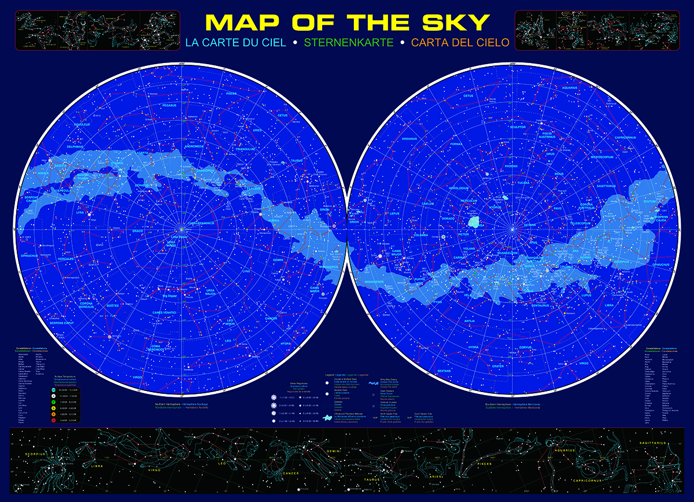

- Find the following stars on the map: Vega, Antares, Altair, Sirius, Rigel, Pole Star, Spica, Algol, Pollux, Mizar, and stick numbers from 1 to 10 from your Sticker Page next to them.

- Suppose you discovered a new star, what name would you give to it? Why?
Draw your star; give it a name, and say why you want to name your star so. Remember to color it according to its temperature.

_______________________

Conclusion

- Summarize the information you have learn during this lesson. Complete the statement:
The stars differ in
- ______________
- ______________
- ______________
- luminosity (brightness)

- Go back to the hypothesis. Select and circle (underline, mark with a highlighter) the appropriate statement.

- The hypothesis is fully proved.
- The hypothesis is partially proved.
- The hypothesis is not proved.

Your mission for the week.

- Look at the starry sky. Try to find familiar stars.
- Experiment. Make sure that stars move on the sky’s dome. Find the brightest stars after sunset, using certain objects as references, such as buildings, trees, and so on. Note the time of your observations using a watch. If you come to that place in 2-3 hours, you will see that the observed stars have moved. Remember which direction they have moved.

Hello, friends. I am Pr. Wantoknow, Doctor of Science. I enjoy reading, especially encyclopedias and reference books. I can share some curious facts with those who are eager to learn more.

Do you know that…?
- Some stars are so far away that their fire has burned out by the time the light reaches us.

- The temperature of the Sun may reach 15 million ◦C (about 27 million degrees Fahrenheit.) As far as you remember, water boils at 100 ◦C.

- The biggest known star in our Universe a red hyper-giant star. Its size is calculated and estimated to measure 1,800 times bigger than the Sun! It is called VY Canis Majoris. The star was first observed by a French astronomer Jérôme Lalande on 7 March 1801.

