ООО «Мой любимый двор»
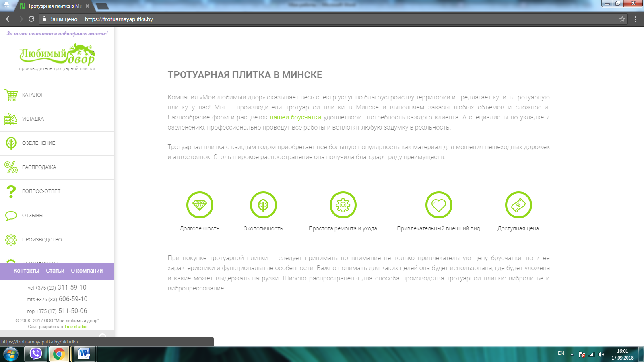
- https://trotuarnayaplitka.by/cena
- https://trotuarnayaplitka.by/ukladka
- https://trotuarnayaplitka.by/
- https://trotuarnayaplitka.by/stati/trotuarnaya-plitka/chto-luchshe-trotuarnaya-plitka-ili-asfalt
- https://trotuarnayaplitka.by/stati/trotuarnaya-plitka/sostav-trotuarnoy-plitki
- https://trotuarnayaplitka.by/stati/trotuarnaya-plitka/kakaya-plitka-luchshe-vibrolitaya-ili-vibropressovannaya
- https://trotuarnayaplitka.by/stati/trotuarnaya-plitka/ekologichnost-trotuarnoy-plitki
- https://trotuarnayaplitka.by/regiony/smolevichi
- https://trotuarnayaplitka.by/regiony/zhodino
- https://trotuarnayaplitka.by/regiony/borisov
- https://trotuarnayaplitka.by/regiony/bobruysk
- https://trotuarnayaplitka.by/dostavka-trotuarnoj-plitki
- https://trotuarnayaplitka.by/stati/trotuarnaya-plitka/sovety-po-vybory-trotuarnoy-plitki
- https://trotuarnayaplitka.by/stati/trotuarnaya-plitka/razvitie-rynka-trotuarnoy-plitki-v-belarusi
- https://trotuarnayaplitka.by/proizvodstvo
- https://trotuarnayaplitka.by/stati/trotuarnaya-plitka/bruschatka
- https://trotuarnayaplitka.by/vopros-otvet
- https://trotuarnayaplitka.by/cena/starij-gorod
- https://trotuarnayaplitka.by/cena/colormix
- https://trotuarnayaplitka.by/cena/trotuarnaya-plitka-staryj-gorod-na-belom-cemente
- https://trotuarnayaplitka.by/cena/colormix-old
- https://trotuarnayaplitka.by/cena/starij-gorod-old
- https://trotuarnayaplitka.by/cena/trotuarnaya-plitka-skandinaviya
- https://trotuarnayaplitka.by/cena/trotuarnaya-plitka-gollandiya
- https://trotuarnayaplitka.by/cena/trotuarnaya-plitka-avstriya
- https://trotuarnayaplitka.by/cena/trotuarnaya-plitka-bez-faski
- https://trotuarnayaplitka.by/cena/trotuarnaya-plitka-c-kroshkoj
- https://trotuarnayaplitka.by/cena/trotuarnaya-plitka-kirpichik
- https://trotuarnayaplitka.by/ozelenenie

