«Фабрика окон» Витебск
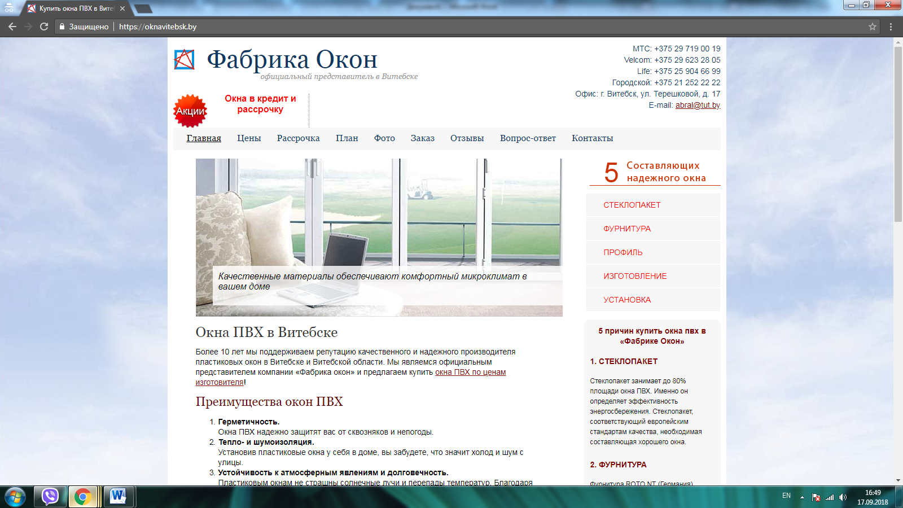
- https://oknavitebsk.by/
- https://oknavitebsk.by/ceny/
- https://oknavitebsk.by/steklopaket/
- https://oknavitebsk.by/furnitura/
- https://oknavitebsk.by/profil/
- https://oknavitebsk.by/izgotovlenie/
- https://oknavitebsk.by/ustanovka/
- https://oknavitebsk.by/vopros-otvet/pochemu-poteyut-plastikovye-okna/
- https://oknavitebsk.by/vopros-otvet/okno-otkrylos-v-dvuh-polozheniyah-odnovremenno/

