«GQ Travel»
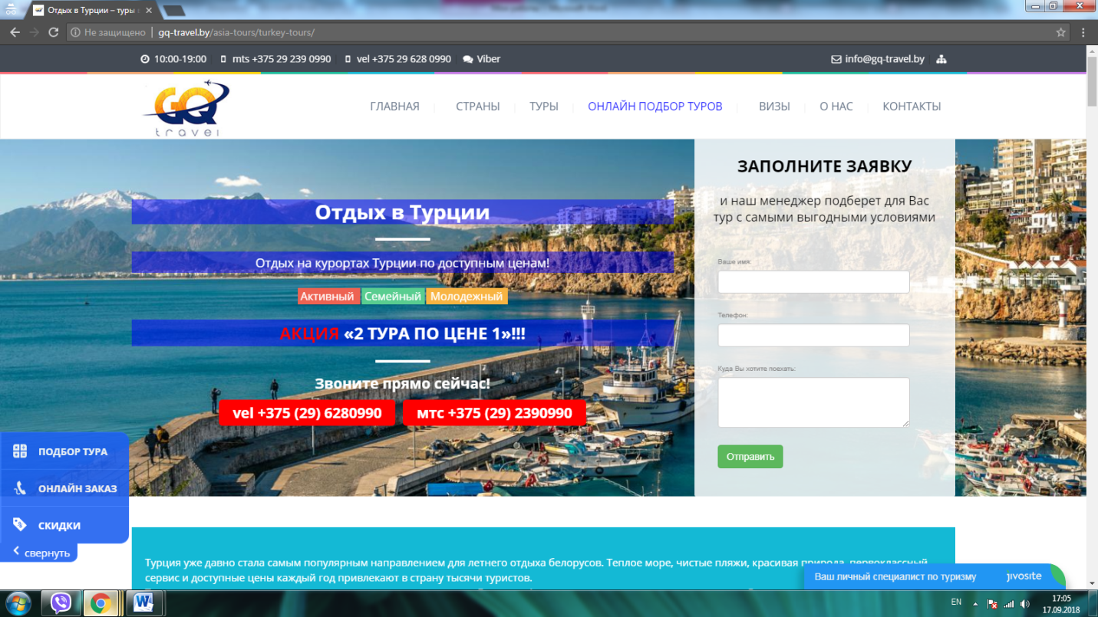
- http://gq-travel.by/asia-tours/turkey-tours/
- http://gq-travel.by/africa-tours/egypt-tours/

