«Pro Мебель Studio»
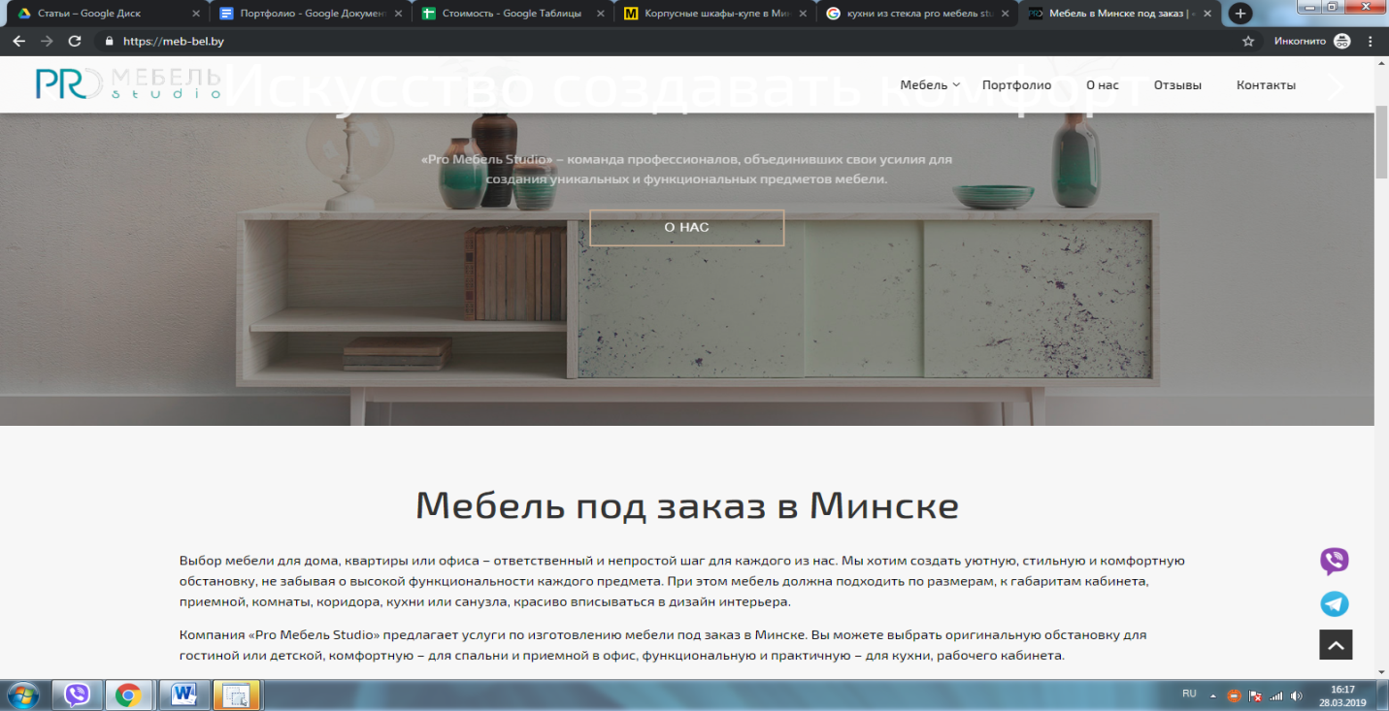
- https://meb-bel.by/kuhni/iz-stekla/
- https://meb-bel.by/kuhni/iz-akrila/
- https://meb-bel.by/kuhni/s-patinoy/
- https://meb-bel.by/kuhni/iz-shpona/
- https://meb-bel.by/kuhni/vstroennye/
- https://meb-bel.by/kuhni/podvesnye/
- https://meb-bel.by/kuhni/s-barnoy-stoykoy/
- https://meb-bel.by/kuhni/s-ostrovom/
- https://meb-bel.by/kuhni/s-poluostrovom/
- https://meb-bel.by/kuhni/bez-ruchek/
- https://meb-bel.by/kuhni/bez-verhnih-shkafov/
- https://meb-bel.by/kuhni/sovremennye/

