How To Survive in IBDP
(A guide for all the newbies!)

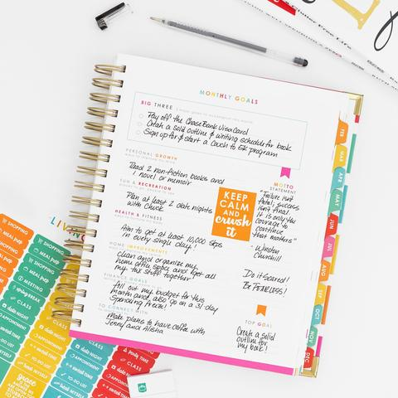
If you’ve stumbled upon this blogpost, chances are you either are or are going to be enrolled in one of the world’s most challenging and headache-inducing but also one of the most effective and rewarding programs known as the IBDP. You will often here phrases like “hell”, “nightmare”, “I have so many deadlines”, or my personal favorite: “Haven’t really slept in 4 days” from IB students. So, if you’re already mortified, we will try to make it easier for and give you a few tips on how to survive IBDP!

Number 1. Keep a Planner!

Seriously, this piece of advice is neglected by so many, but it’s probably the most helpful. Keeping a planner helps you to stay more organized, have less sleepless nights as all the work you have to do (which is of terrifyingly large quantity) will be assigned to a specific time and date. And remember, if you ever open your planner and there’s nothing to do, there are only 2 possible option:
- You’re asleep (somehow) and it’s just a dream;
- Option a lot more likely, something’s wrong with your planner



Number 2. Stick to your deadlines and do everything in advance!
Deadlines are the nightmare of every student. Whether it’s turning in the final draft of your English IA, sending the TOK essay, or submitting the EE (you’ll learn all these abbreviations in no time), every student experiences tremendous amounts of stress when doing those last-minute. Not only is it a lot more stressful, but it also has been shown that students who do their writing in advance and piece by piece score better than the procrastinators, who “work better under pressure”.


Number 3. DO NOT Choose 4 HL Subject!

While some schools choose to prohibit such kind of torture for students, some schools do not. If you’re studying in such a school, just a little tip: don’t get too ambitious! At the beginning of year 1 you’ll think you can manage everything, and since you’re interested in your subjects it won’t get boring; but this is so not true!



Number 4. Study in a friendly environment!

When you have a study buddy, or go to Starbucks or somewhere else, other than your workspace you will be a lot more motivated to work productively and get more work done. Just go to a local cafe and study there. Just, at the end of the day don’t forget to live a tip for the waiter that served you.

And last, but certainly not least,
Number 5. Remember: It’s not supposed to be easy!
If IB were easy, everyone would do it! 45 wouldn’t be such a rarity and top universities wouldn’t be willing to accept it as a means of assessment.
So, at the end of the day do your best, work hard and more importantly work smart and Good Luck with your academic progress in IBDP.

