HOW IS HEMP OIL PRODUCED?

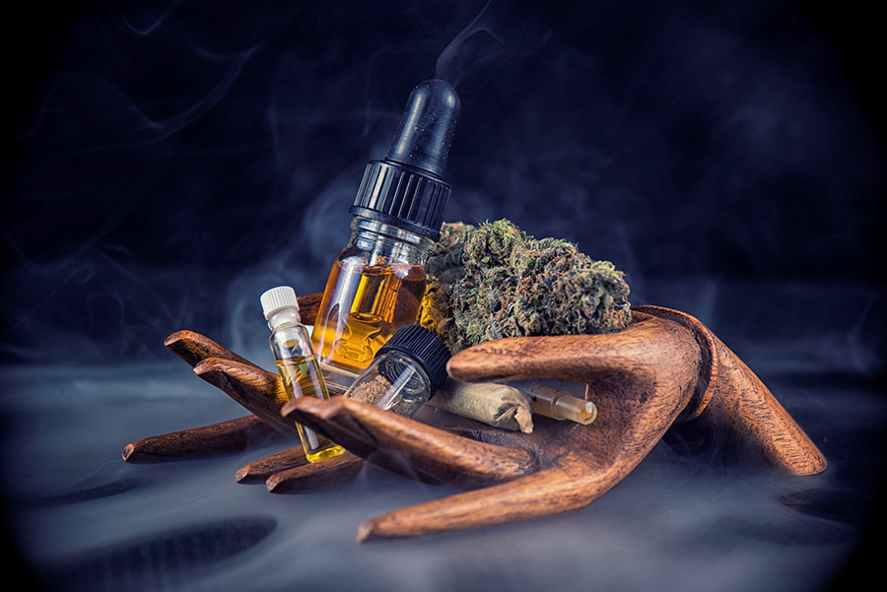

The method of **extraction is one of the very important points of the price and the quality of the product.**

Once the cannabis plant with high CBD content has been cultivated, it is extracted without the use of solvents or ketones.

Hemp seed oil, when extracted by cold pressure, is going to be very pure but not very rich in CBD or cannabinoids.

Other methods use petroleum derivatives, solvents such as ketones, as these are rich in THC but not in CBD. The next method is with alcohol and olive oil; this method is not the most suitable for a concentrated oil.

The **best method but also the most expensive is the extraction with Co2,** with this we will get the richest and concentrated in cannabinoids.

TYPES OF PRODUCTS WITH HEMP OR HEMP OIL

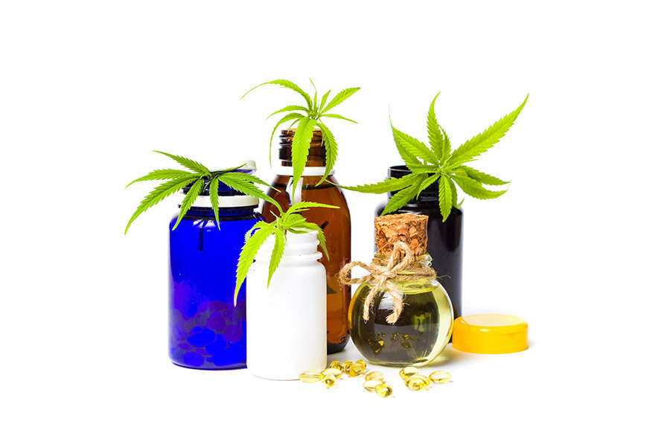

The hemp oil can be found in capsules, in liquid or in topical products, both cosmetic and balms or creams with different beneficial actions in health.

The dose of the **capsules** is usually 25mg, and is usually added to omega 3.

**Tincture of CBD** or CBD liquid is achieved by diluting the extract of CBD in alcohol or oil. Tinctures are more concentrated than 1-20mg.

**Topical CBD**

Balms and ointments can be added in cosmetics or in massage ointments

WHAT COMPONENTS DOES IT HAVE?

Apart from cannabinoids, hemp oil has other active ingredients such as fatty acids, omega 3 and 6, tocopheroles, vitamin E mainly, terpenes and minerals, phytoceramides.

WHAT ARE THE BENEFITS?

Once we know what the components of this oil are, we can understand its actions and benefits.

**1.- ON THE SKIN AND HAIR WE TALKED HERE**

**2.- HORMONAL BALANCE:**



All fatty acids are beneficial in hormonal production, but especially omega 6, specifically GLA, gamma linoleic acid, this is highly recommended in women with a significant premenstrual **syndrome,** in women with pain important menstrual or the appearance of acne before menstruation.

Omega 6 also becomes **prostaglandins PGE1,** which also regulates the hormonal balance in **menopause.**

**3.- ANTIOXIDANT:**

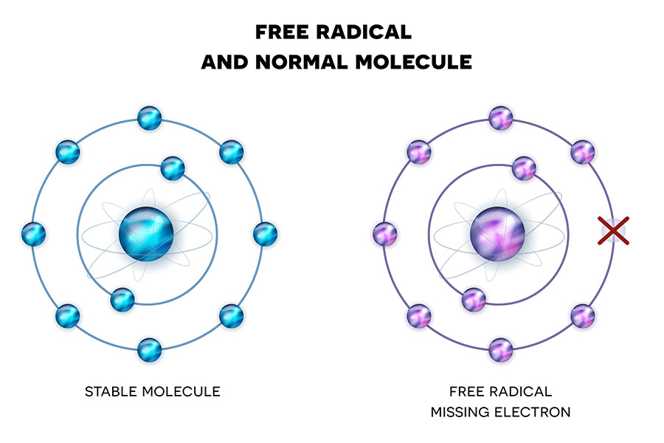

Vitamin E and fatty acids are the best antioxidants. In fact, they are used in many products with that function.

It has a great ability to capture free radicals, which helps protect cellular DNA. cannabidiol is more potent free radical scavenger than vitamin E.

**4.- IMPROVE THE IMMUNE SYSTEM:**

Again thanks to fatty acids, it is a great help to the immune system. The endocannabinoids of which I have spoken at the beginning, are molecules derived from fatty acids, the **endocannabinoids are part of the improvement of the immune system.**

**5. IMPROVES MOOD**



It has a high content of **terpenoids,** volatile molecules closely related to the smell they have. In cannabis we find beta-Caryophylene and Myrcene. The **Myrcene** helps relaxation, improve mood and become active. It has antidepressant and anti-inflammatory actions. Endocannabinoids are essential of course when we talking about the mood. The endocannabinoid system regulates the production of neurotransmitters, especially during depression and anxiety.

**6.- HEALTH PROTECTION**

We already know that **omega 3** protects the circulatory system. Since it helps lower LDL, cholesterol and prevent the accumulation of saturated fats in the arteries, and in addition to this function is **anti-inflammatory.**