What is an online marketing case study
Marketing case study is a detailed description of the successful implementation of business projects. Cases allow you to attract customers due to the fact that the target audience gets access to detailed information about how the company works.

What is a case study
The term "case study" is used in business to describe various concepts. So, in business training, interviews, and professional certifications, cases are practical tasks that an employee needs to solve.
In this case, brief initial data are provided, and it is proposed to find the best way to achieve a specific goal like making a deal, selling a product, solving a technical issue, and overcome customer objections.
Cases can be individual and group, which are designed to determine the level of competence of the applicant and the ability to work in a team. Cases allow you to assess the professional level of the employee more effectively and get an idea of how successfully he will solve production issues and interact with other team members.
Online marketing case studies are descriptions of tasks that are already solved, helping to illustrate the work of the company at all stages from the start to the endpoint at which the desired result was achieved.

Marketing case study
A marketing case study is a tool aimed at building trust and increasing brand trust among the target audience. To achieve this effect, it is important to use the correct data and real examples with numbers, deadlines, and labor costs.
A clear explanation of the goal and the need for individual actions to solve the issue based on real-life examples will help a potential client evaluate the qualification and performance of the company.
Two-thirds of marketers consider cases to be a very effective tool for generating leads and sales. The most popular use of cases is in the B2B segment. Most often, cases are used in such business sectors as:
- content creation and internet marketing;
- construction and repair;
- consulting services;
- business development and promotion;
- online services promotion;
- training and education, etc.
Cases studies are used in all cases when it is possible to clearly and structurally describe a solution to a problem by showing the starting point and adding screenshots with numbers, graphs, and charts confirming that the goal set by the client has been achieved. Besides the text, cases are also created in video format.

How to create your own case study
1
Focus on a specific target audience, not trying to attract all users at once.
2
Add clear initial data: a description of the client and his problems, an initial assessment of the situation in numbers.
3
Indicate the goals set by the client in order to increase website traffic, sales, attract new subscribers, and more.
4
Describe the client's problems and methods that turned out to be ineffective while he was trying to achieve his/her goal.
5
Provide a detailed description of the actions of the company while working on the project in understandable terms for a non-professional. Use graphics, tables, pictures, gifs to help perceive text material better.
Don't write too voluminous texts, as this will frighten away your readers. Depending on the niche and complexity of the task, the volume of the case can be from 3 to 20 thousand characters.
6
Work through a few potential objections from potential customers.
7
If difficulties have arisen in some aspects, or the desired indicators have not been achieved, use the following method: honest recognition of minor errors contributes to the credibility of the case.
8
Indicate the achieved result, illustrate the benefits of cooperation with the company for the client. It's also good practice to include a customer's review in the case confirming the information provided.
9
Promote cases using SEO website optimization, contextual advertising, social networks promotion, and e-mail marketing.

Examples of case studies
In content marketing, cases are used by many companies. Let's have a look at some case studies, examples of which confirm the effectiveness and relevance of this tool to attract customers.

Example of a design case study for Raiffeisen Bank
Statement and description of the problem:
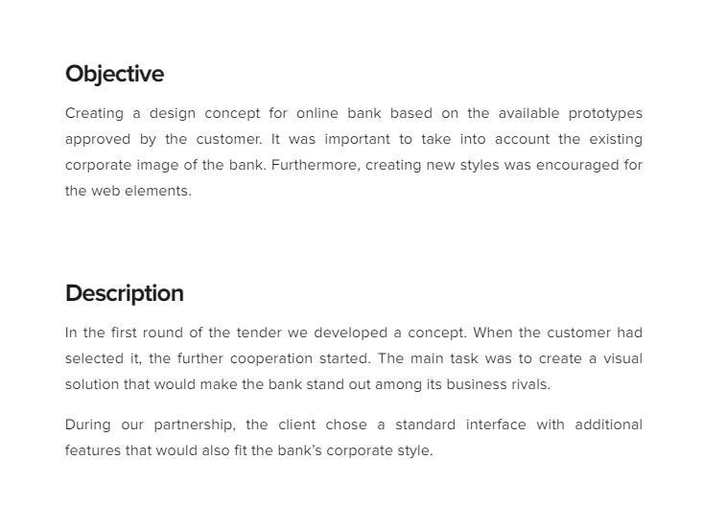
Description of the stages of work:
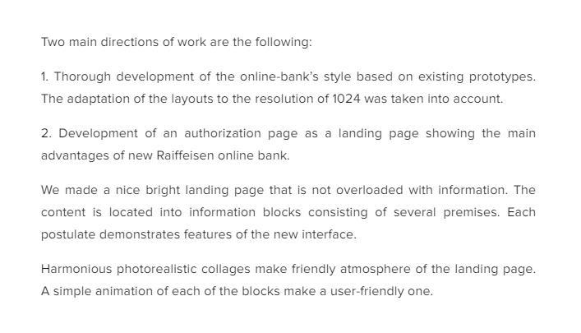
Result of the work:
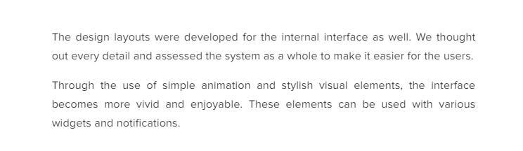

Example of a case study on setting up contextual advertising
The case study in the example below illustrates the setup of an Adwords advertising campaign. Customer description:
Result of the work:
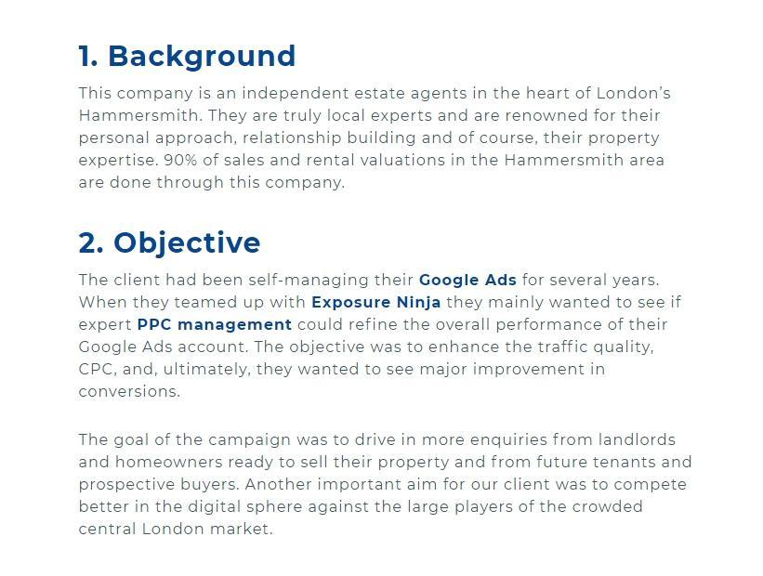
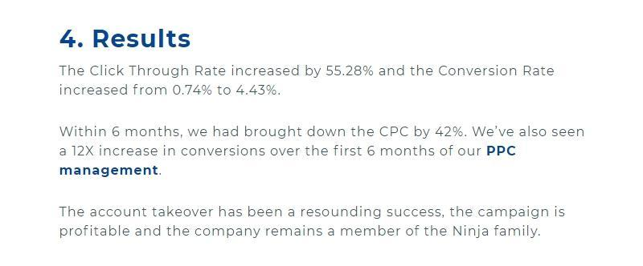

Marketing case study for website traffic growth
This case study provides an example of promoting an online store.
Stages of work for an online store promotion:
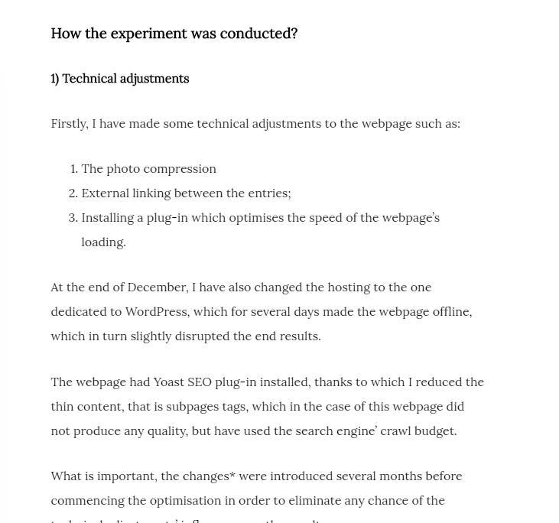
Result of the work:
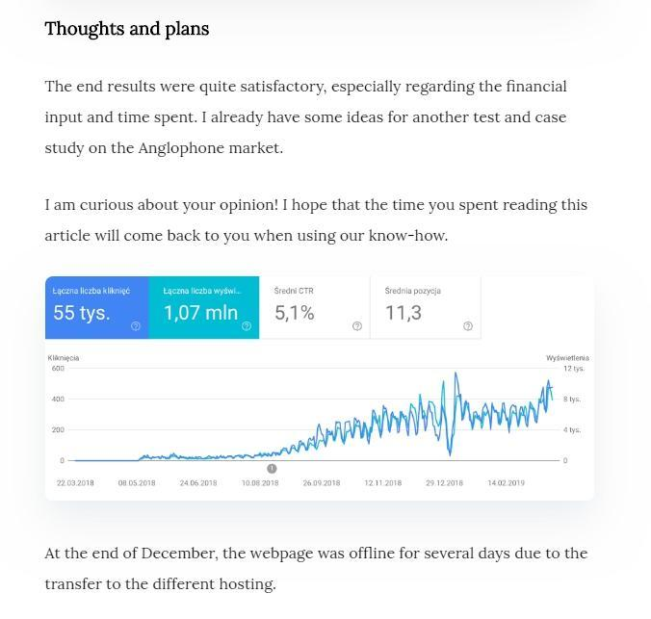

Conclusion
- A case study is one of the most popular marketing tools in the B2B segment; it can also be successfully used for small businesses, service sites, information resources, and training companies;
- the use of cases will increase sales, as well as attract traffic to the website. Thanks to the case studies, the user gets a complete picture of the company's working methods and is able to evaluate the effectiveness of decision-making;
- in case studies, a clear comparison of the "Before" and "After" situations is of great importance; therefore, it's important to show how the client's situation was and how much it improved after working with the company.

