Starbucks Gift Card Balance
Starbucks Corporation is an American coffee chain of the same name. Also, Starbucks Corp. engages in the trade of coffee beans. Starbucks brand is one of the most respected and recognizable brands in the world, so the company is trying to maintain this position.
Back in 1971, in the city of Seattle of State of Washington, a certain Jerry Baldwin, Zev Siegl, and Gordon Bowker decided to start trading coffee beans and opened their first store in Pike Place Market. For a long time, the store was not only the first but also the only one. But after ten years, there were five Starbucks stores, and the company also had its factory. In 1987, a turning point came in the history of Starbucks, the owner of the company was Howard Schulz, who made Starbucks the way we know it today. Starbucks today is not just about coffee drinks, desserts, and snacks. The company also deals with related types of business such as cinema, books, music, there is even a special Starbucks division which is called Starbucks Entertainment, and it develops an entertainment direction within the company. Starbucks coffee houses are open in more than 50 countries around the world, with a total of approximately 18,000 establishments. The company’s headquarters are still located in Seattle, the State of Washington.
For comfort and familiarization with the offered drinks and meals, there is the website which is called - Starbucks.com, where you can also order these same drinks and meals online at-home delivery or you can make pre-order in your nearest coffee house. Starbucks coffee chain pleases its customers with constant discounts, numerous promotions, and special offers. For example, they have a very popular and liked by customers Starbucks Gift Card. These cards can be bought on Starbucks.com, or in the mobile app, or the retail chain of these coffee houses. Starbucks Gift Cards come in two types: plastic cards and an eGift Card, which is sent to E-mail or on your account on the mobile app. For the convenience of customers, Starbucks has developed and introduced a mobile app for Android and IOS. The application’s functionality allows you to activate an existing card and scan a barcode or create a fully electronic version, find out about new promotions and offers, find the nearest coffee houses.
You can check your Starbucks Gift Card Balance in three options: by phone, in the mobile application and online on the website.
To check your card by phone, you need to call 1-800-782-7282. Operators will tell you about the current status of your card. If you accidentally lost your card, you can also dial this number.
You can also check the Starbucks Gift Card Balance in the Starbucks mobile app. To do this, you need to download this application from Google Play or the App Store. Then you should go to your account and there you will be asked to check your gift cards. With the help of a pin code, you can check your balance.
To check your balance on Starbucks Gift Card online, you will be required:
- the 12 identification figures from your card;
- the 4-digit PIN code.
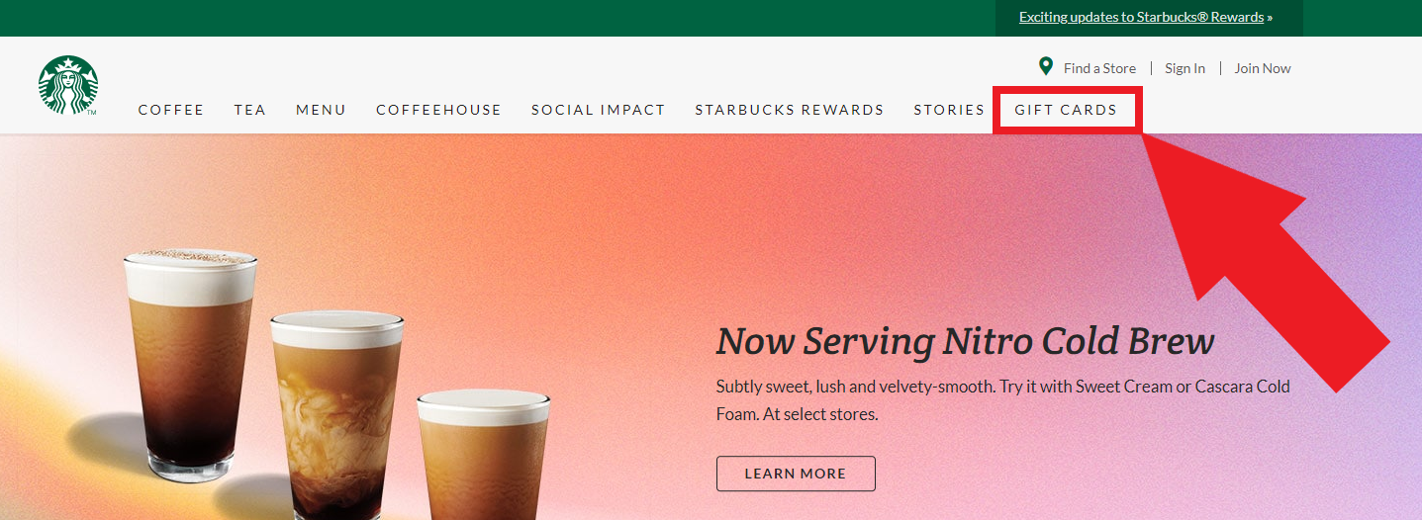
The secret code (or PIN code) situated on the other side of your plastic card, you should turn it over and erase the protective area. Exactly there is hidden your PIN code. If you have eGift Card your data and PIN code is in your e-mail. Then, log in to your account on the Starbucks.com and click to the main page of the website. There you will see in the upper right, there is a column of gift cards, guide your mouse over it.

Just below on the left, you will see a column. There will be a button to check Gift Card Balance, click on it.
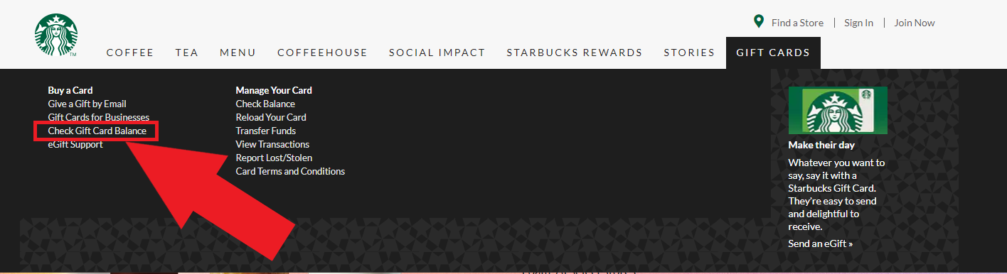
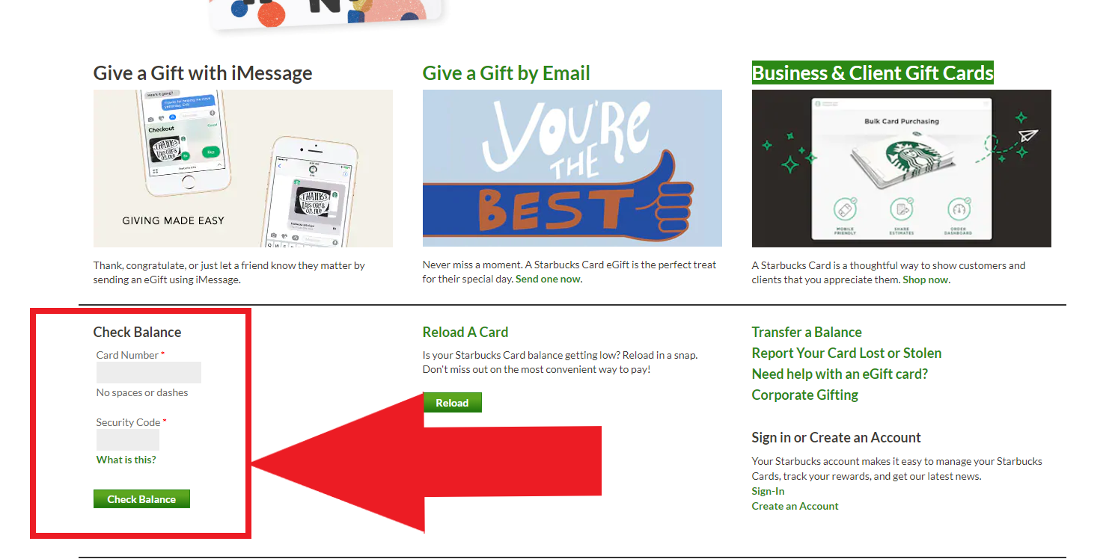
Then the page will open and at the bottom, there will be a form for checking the balance. You should fill the necessary fields and the gift card balance will appear on your account page as well as information about the last payment and order history.

Using its experience, accumulated over years of hard work Starbucks Corporation, the company continues to offer consumers new types and varieties of coffee, as well as other products in new areas.

