American Express Gift Card Balance
American Express (or AmEx for short) is the largest American multidisciplinary company. This company provides tourism services, produces and services card products and traveler's checks.
American Express was based in 1850 in the state of New York, USA, and initially acted as a valuable cargo delivery service. In the 1880s, the president of American Express, Mr. Fargo, made a trip to Europe for relaxation and was furious that throughout the journey he had difficulty using credit letters to receive money. Upon returning from the trip, he instructed the head of the transportation department to come up with a better alternative to credit letters. The solution was the American Express road check - the first product invented by American Express. American Express's emphasis on travel continued over the next decades. Selling checks to travelers and money transfers bring income that justified this direction of the company. Today, American Express is known not only for road checks but also for credit cards, which are extremely popular all over the world, although they are inferior to Visa and Mastercard.
American Express has various types of cards that are designed for different social levels of its customers. Like any self-respecting company, American Express has its gift cards. This gift card is the best option to please your loved ones who are very fond of traveling. It is made out according to your wishes: you indicate the occasion, the names of the future holder or holders and you can issue a certificate on your behalf by signing up. These cards can be purchased on Americanexpress.com, or in the mobile app, or in banks which are co-working with this company. Accordingly, gift cards can be plastic and electronic. The face value of this card may have $ 100 and up to $ 1000.
How to check American Express Gift Card Balance
It happens that you can forget how much you received as a gift or how much is left in your account, and how much you spent. In solving this issue, checking the residue of your gift card will help you. There are sundry verification methods. You can control the residue by phone, online on the company's website or in the mobile application.
To check American Express Gift Card Balance by phone
To address emerging issues, it is proposed to use a telephone call as a means of communication. To control the residual of your card residual by phone, you should to call 1-888-846-4308. You can call anytime. Operators will tell you about the current status of your card.
To check American Express Gift Card Balance in the mobile application
In the mobile application, you can easily and quickly control the residue on your account. To find out the residual of your gift card in this way, you will need to send an SMS message to number 297687 with the text MOBILE. Then you will receive a link thanks to which you can install your AMEX mobile application through the Google Play or the App Store. In the settings of your account, there will be a section with gift cards, going into it you will be asked to find out the residue on your gift account.
To check American Express Gift Card Balance online
To control the residue on the website, you would need:
- the 15 identification figures from your card;
- available term;
- PIN code;
- your e-mail address.

Then log in to your account on the Americanexpress.com and then click to the main page of the website there in the bottom of the page left there is a column of gift cards, click on it.
There you will see in the upper right, not far from the search, there is a button with the name "Check your Balance", press on it.
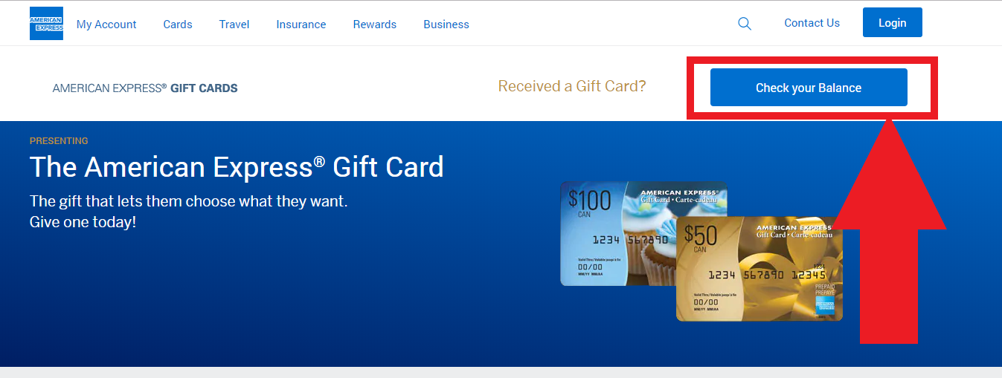
You must enter the required data into a form that will appear on the loaded page, to find out the residue on your card.
