8 reasons for the positive impact of technology on human life
Science and technology are important components of modern life. They have long gone beyond local boundaries and today affect the lives of everyone. Technological products have always changed and continue to change a person’s life. Somewhere in the positive direction, somewhere in the negative, but usually there is more benefit. Therefore, denying the technological process or trying to abandon it is irrational. We invent to live more comfortably, safer, healthier and more interesting. In this article, we would like to share with you 8 reasons for the positive impact of technology on human life. Why are exactly 8, you'll ask? All because 8 is the number of infinity, and that is precisely what humanity is striving for. If after reading the article you still have reasons, we will be very happy if you share them with us. Now let's get started.
- Man replaces his labor with the work of technology.
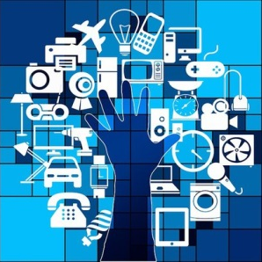
We do this for the sole purpose of freeing ourselves as much as possible from hard routine work and increasing the degree of freedom of our actions. The introduction of innovation leads to the automation of many processes in the economy, in work and everyday life. Many applications have already been developed that simplify our lives. For example, if you need to quickly calculate something, that is, a calculator. If you write an important document and make a mistake, the program will correct you. If you are a businessman and like to control your investments, then the SimCorp Dimension system will help you. Now you can find a technological solution in all spheres of human life.
- The level of education has increased.
From that moment when machines began to replace people in production, the majority of the population in developed countries began to work in the service sector (including complex ones: information and financial), and not in industry and agriculture. Thus, the level of education increased and new educational institutions were opened.
- Internet communication.
The creation of the Internet itself has allowed people to get rid of many problems. Passing borders, the Internet has created what is called a network society, when people from different communities of interest. Also, people can chat with friends around the world, find out news from around the world, get enlightened, etc.
- Cooperation of countries in various fields of activity.
Such cooperation is characterized by a deep penetration of the economy of one country into the economy of the partner country, which leads to technical and economic interdependence and progress.
- Environmental studies.
The first environmental studies about nature, the ability to predict the weather, mining, the use of natural resources, and also animals for human needs became possible. It was this knowledge that allowed us to prevent the complete extermination of certain species of animals, birds, and even plants. We are trying to preserve all the wealth of our nature.

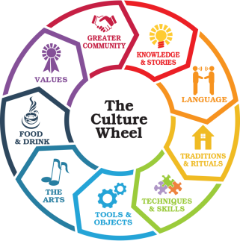
- The emergence of spiritual values.
These include people's views, scientific ideas, hypotheses and theories, works of art, moral and religious consciousness, spiritual communication of people and the resulting moral and psychological climate. The condition for creating a qualitatively new civilization is the comprehensive development of culture as the spiritual potential of labor. The materialization of culture and all its components in practice is civilization.
- Ease of movement.
The invention of the car allowed a person to significantly improve the ability to move both in speed and in the duration of the overcome path. The invention of the aircraft allowed people to travel long distances. The invention of ships made it possible to discover new lands. All this allowed a person to quickly move anywhere in the world. And since the 20th century with the invention of the rocket, people were able to go into outer space.
- Medical development.
Such development has led to the ability to plan a family, to overcome many viruses thanks to vaccination, to successfully and timely diagnose diseases, to carry out operations of any complexity. The real achievements in medicine over the last century are mainly associated with the development of surgery and the introduction of the achievements of other industries into medicine.

Summing up, we can conclude that the development of science and technology is indeed a boon to mankind, but carries with it unforeseen fateful predestinations, affecting all aspects of social life. And from your point of view, how does the development of technology affect a person? Is it worth it to rely on such a rapid development? Waiting for your answers.

