**Goal**

Create an ebook that will help CEOs, CTOs, PMs choose the right software development vendor. In the end, they should get a checklist to easily go through.

## Text Requirements

* Follow our [style guideline](https://docs.google.com/document/d/1zJGUp5tFvBT6jacpluPYksujr-BYhTwMsWWTut38WlI/edit?usp=sharing), pay attention to the *‘Writing blog posts’* section
* To turn your article into an irresistible client magnet, use the following phrases and headers: [502 Phrases](https://websitecopywritingservices.com/blog/bucket-brigade-copywriting/)
* Read [this article](https://growandconvert.com/content-marketing/blog-introduction/) about how to write cool intros.
* Each section should have 1-5 questions to ask the vendor based on the content in the section. It will look like in blocks here: <https://www.arcanys.com/ebooks/Evaluating_Outsourcing_Development_Firms.pdf>

**Recommendation for article content:**

* Using infographics, data statistics and other visual content improves the material value and helps to fully develop the topic.

**Examples of quality content:**

* <https://www.arcanys.com/ebooks/Evaluating_Outsourcing_Development_Firms.pdf>
* <http://solovatsoft.com/HowToChooseOffshorePartner.pdf>
* <https://www.n-ix.com/15-criteria-choosing-software-development-company-2019-beyond/> (the best to get info from)

**Article structure**

|  |  |
| --- | --- |
|  | Deviating the article structure is not recommended, but it’s acceptable if changes will make the result more useful for readers. You can also add some blocks if they’re appropriate. |

Vital checklist to go through when choosing a software development company

* Create a table of contents

## Communication

* Bad communication is one of the common reasons for project failure. Write that the reader should check how fast the company responds to their request (the norm is in 24 hours) and if the company follows up after that, proposing to make a call.

## Company size

* Mention that the vendor should be not too big and not too small for the company. The client wants to be VIC (a very important customer).

## Pricing

* Mention that the client shouldn’t choose the cheapest one and why.
* Write about engagement models (time and material, fixed price, dedicated team). Mention that the dedicated development team model is the best.

## Expertise

* A vendor should have an appropriate tech (React.js, Ruby, etc.) and domain expertise (construction, fintech, etc.)

## Experience

* Vendor should have experience on similar projects and if the client has a distributed team, working with remote teams.

## Testimonials

* The clients should gather references and testimonials from previous clients on platforms like Clutch, GoodFirms, AppFutura, Google, Facebook, etc.
* Mention our company’s Clutch profile: <https://clutch.co/profile/relevant-software>

## Agility

* Use info from the same section in N-ix post: <https://www.n-ix.com/15-criteria-choosing-software-development-company-2019-beyond/>
* Mention that we at Relevant work with Scrum and Kanban methodologies

## Cultural fit

* Write about the importance of cultural fit and that we at Ukraine have a culture similar to the western world.

## English level

* 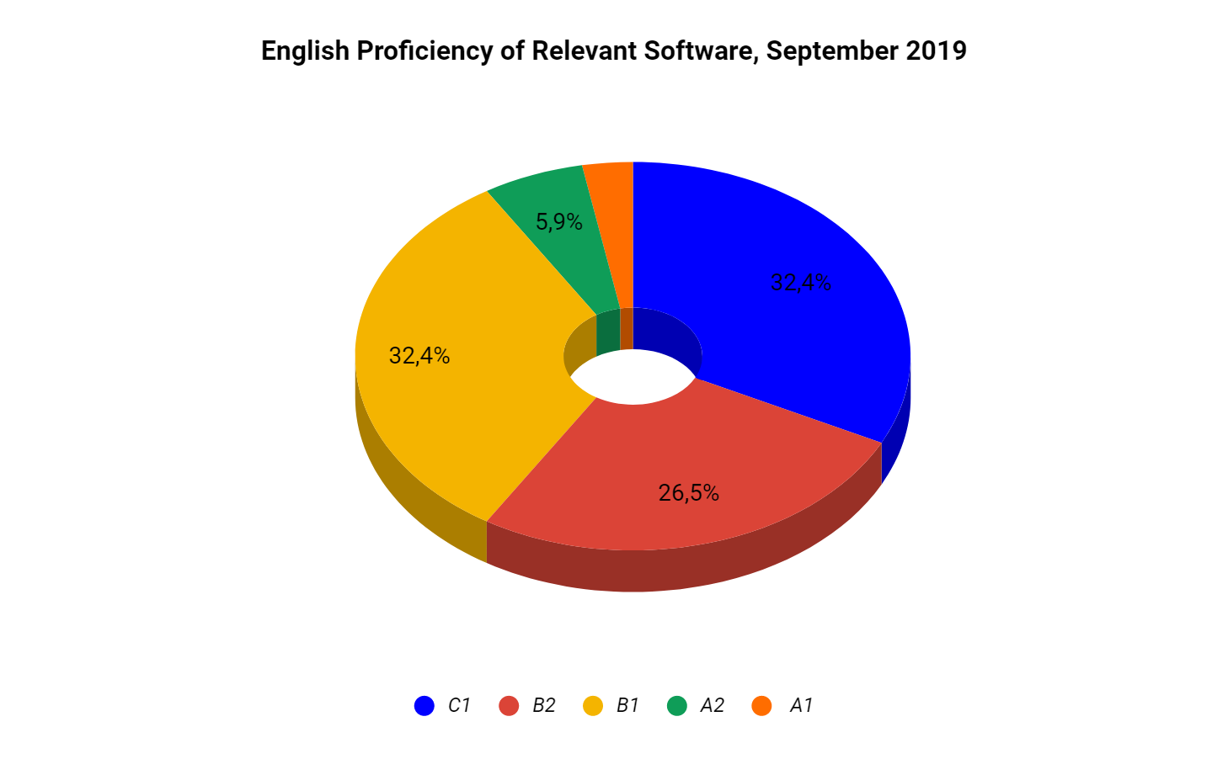
* Mention Relevant Software english level:
  + **Advanced (C1):** 11 employees;
  + **Upper-Intermediate (B2):**  9 employees;
  + **Intermediate (B1)**: 11 employees;
  + **Pre-Intermediate (A2):** 2 employees;
  + **Elementary (A1)**: 1 employee.
* We at Relevant have a full-time English teacher to increase the English level of our employees + everyone who we hire passes English assessment.

## Location

* Mention about the importance of good company location and that we are located in Lviv and benefits of that (like the ease of to getting there)

## Office

* Write that our office is located near the Lviv city center and the park, with great interior design, etc and everything needed for employees’ comfort.
* Mention that the client should ask the vendor to send photos of the office.

## Internal training

* Write about the importance of the internal development of employees, upskill activities, lectures, mentorship.
* We at Relevant have weekly tech talks to share expertise, invite speakers from the outside and have mentorship programs for developers.

## What happens if the partnership ends

* Write about the importance of sharing knowledge between team members, knowing how documentation and other assets will be transferred after the client decides to end a partnership.

## What happens when you need to scale

* Intro example: Imagine you want to scale the development team and the vendor doesn’t have required specialists inhouse. How do their hiring and assessment process look like, where do they get specialists?

Mention our process which looks like this (don’t copy-paste this text):  
“If we have unoccupied specialists in-house, you can start work immediately. In case we don’t have the desired talent, we do additional hires that can take around 1 month. Or if you need experts fast, we have access to a talent pool of our partners that allows us to provide any desired specialist in under a week.

Our HR team assesses candidates to learn their background, tech skills, English level, and soft skills and then selects a best-fit candidate for a final interview with you”

## Legal and Security

* Quality fo contract and other documents. Security involves not only firewalls and access control at an outsourcing vendor's facilities, but larger issues such as the intellectual property and contract laws of the country in which they're located, civil stability, and so forth.

## Checklist

* Bundle all the questions/points from the sections above into the checklist (table format)
* Columns: Criteria, Yes, No.
* Divide into appropriate sections.