<http://dev.exclusive-selection.ru/>

<https://text.ru/antiplagiat/5d7561a66ee3f>

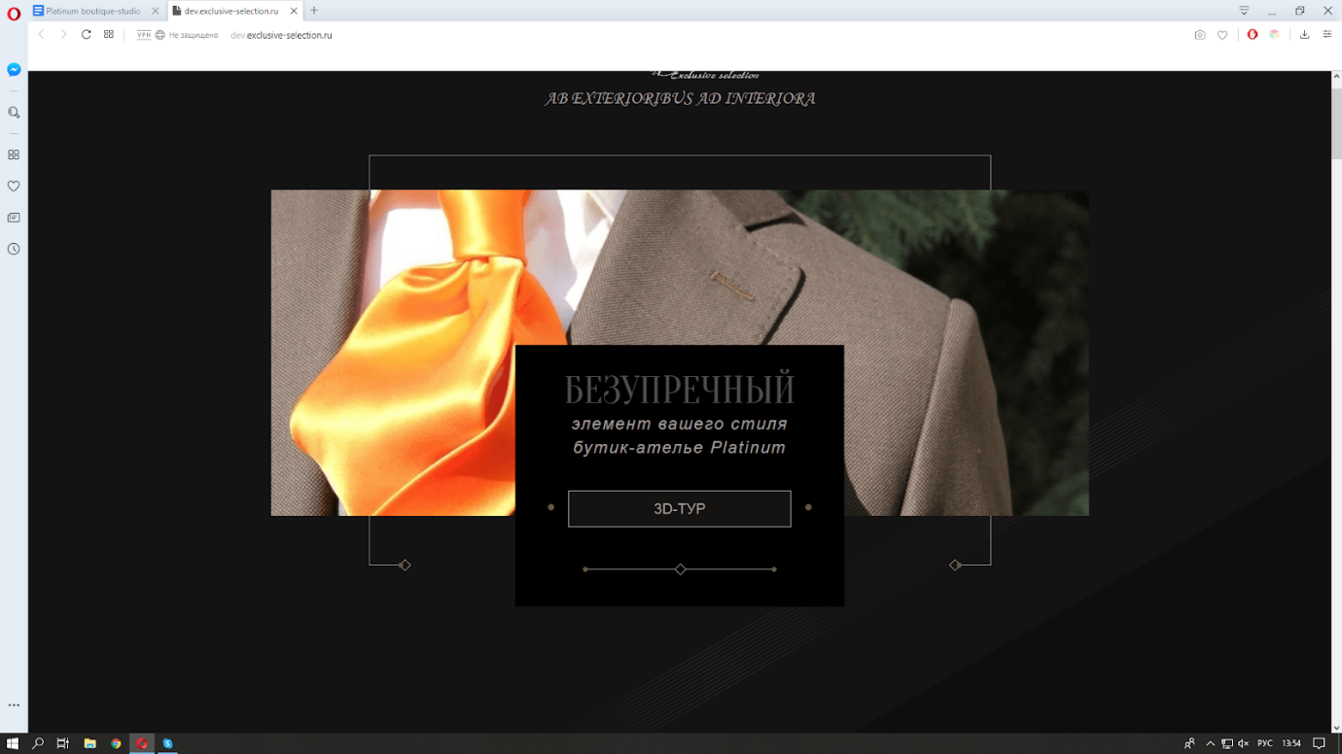

FLAWLESS element of your style

Platinum boutique-studio

3D-TOUR

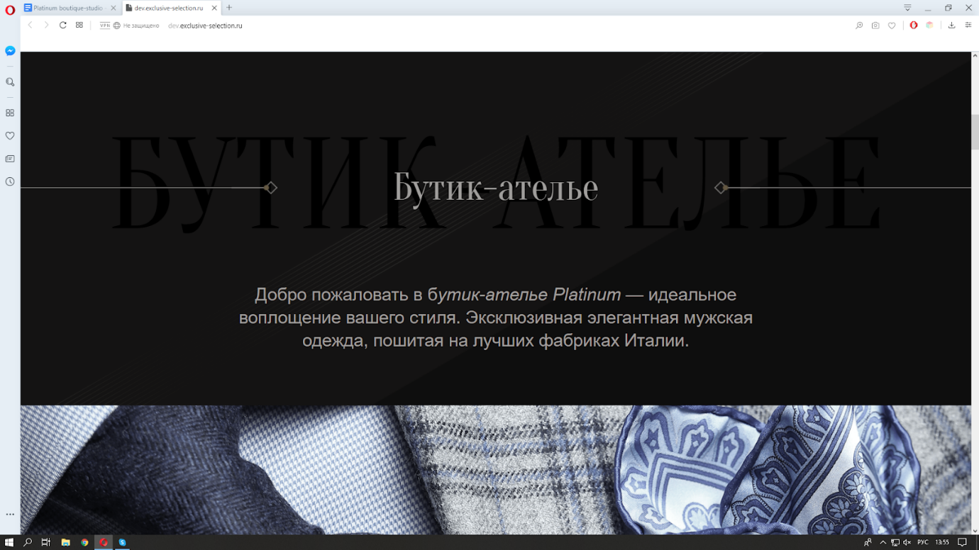

Boutique-studio

Welcome to Platinum boutique-studio - perfect embodiment of your style. Exclusive exquisite men’s wear tailored on best textile manufactures of Italy.

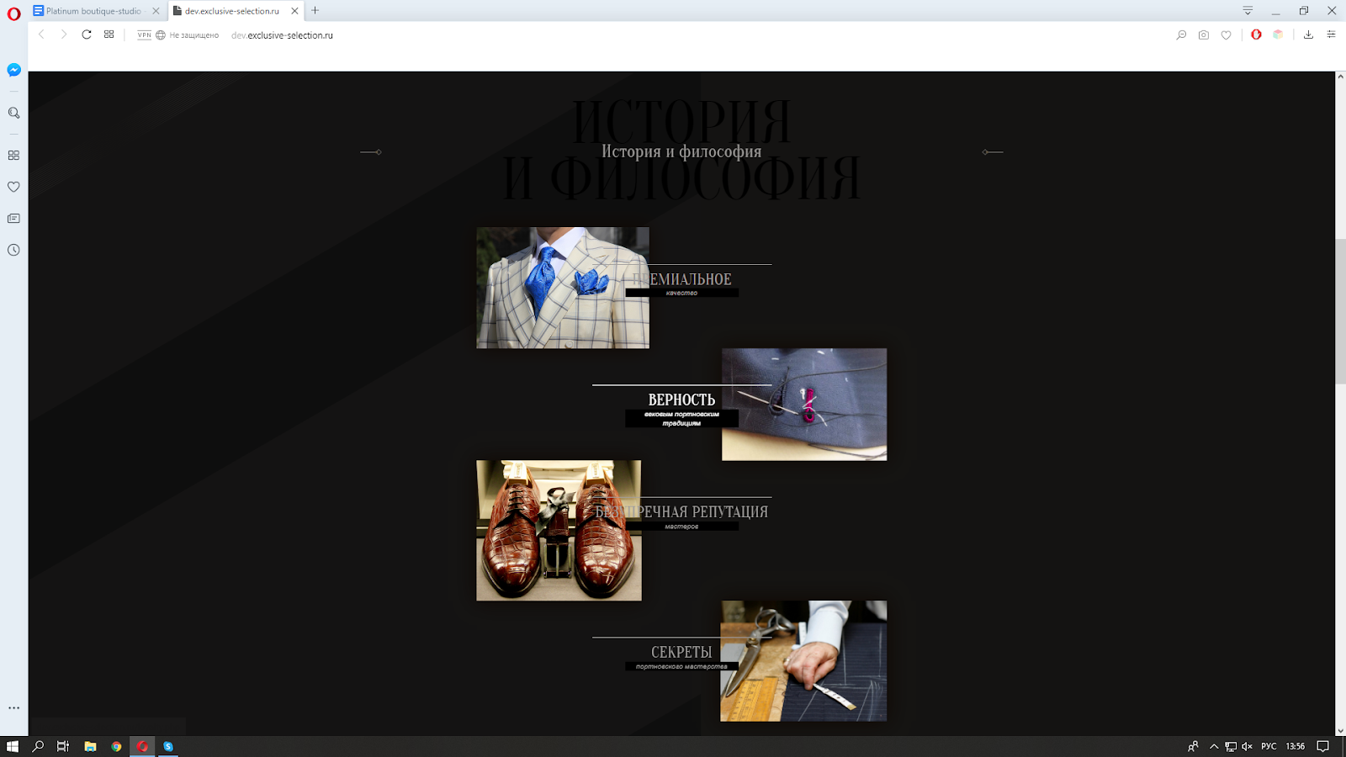

History and philosophy

PREMIUM quality

Our fundamental mission is high quality and unique design. This objective can be realized 24/7 for every customer due to the combination of superior fabrics from Italy, England and Scotland, and outstanding craftsmanship of top-sewers up to 20 years of experience.

Platinum boutique-studio helps to create your ideal stock of clothes. We design unique clothes collections and use superior European textiles for tailoring custom units on famous manufactories of Italy, Scotland and Switzerland.

Platinum boutique-studio is your guide to a perfect selection of clothes due to the advanced European technology, premium fabrics and highly professional services. We guarantee brilliant service, individual approach and maximum comfort to every customer.

Platinum boutique-studio is pleased to offer the services of the leading Master of style.

*ORDER THE SERVICE*

FAITHFULNESS to secular tailoring traditions

All our collections and custom-made units reveal the spirit of the old tailoring craftsmanship. Each item is created at the best Italian textile factories and by small family-owned manufacturers that stay true to the traditional technologies. These tailoring secrets have been preserved through the generations.

Creating your look, our top-notch tailors and shoemakers imply their high professionalism and legacy into each constituent item. Every garment unit is made with love and care for long-lasting wear.

Platinum boutique-studio creates collections and custom-made items that are imbued with the breath of old tailoring tradition. Special techniques preserved by the best Italian textile factories and manufacturers are combined with professionalism and care of our masters.

Platinum boutique-studio is pleased to offer the services of the leading Master of style.

*ORDER THE SERVICE*

UNCHALLENGED REPUTATION of our masters

    Our masters pass the know-hows down to their children who imply the precious knowledge handed by their mothers, fathers and grandparents when grow up. Thus, we observe the appearance of professional dynasties where the successors keep growing and progressing in their skill and reach higher levels.

    Our fundamental is qualification and high level of tailoring skill. 2-3 generations of tailors hold jobs at our partner factories and family manufactories.

Platinum boutique-studio is pleased to offer the services of the leading Master of style.

*ORDER THE SERVICE*

SECRETS of tailoring skill

The skill of our professional masters reach unparalleled levels. Tailoring secrets and craftsmanship know-how are the basis of collections creation. Valuable experience is passed down from parents and grandparents to next generations.

     Learning from their expert patients, younger masters demonstrate outstanding tailoring skills. They keep on developing and succeed to reach perfect mastery level.

    Masters who hold jobs at our partner factories and family manufactories apply the inherited knowledge and experience and go along fostering skills to reach perfection.

Platinum boutique-studio is pleased to offer the services of the leading Master of style.

*ORDER THE SERVICE*

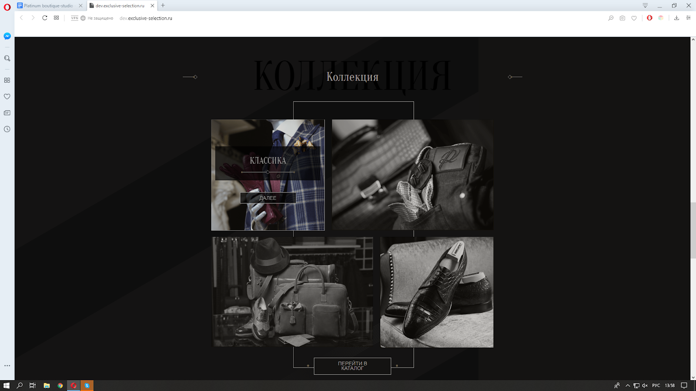

Collection

* Classic
* Casual
* Accessories
* Shoes

Go to catalogue

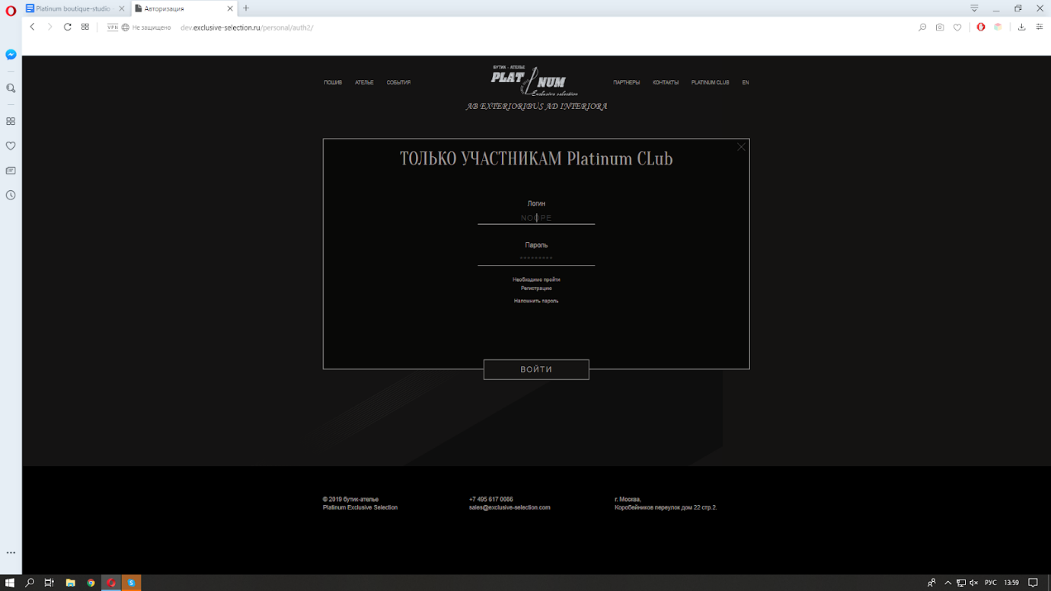

Only for Platinum CLub members

Login

NOOPE

Password

\*\*\*\*\*\*\*\*\*

Registration

Remind password

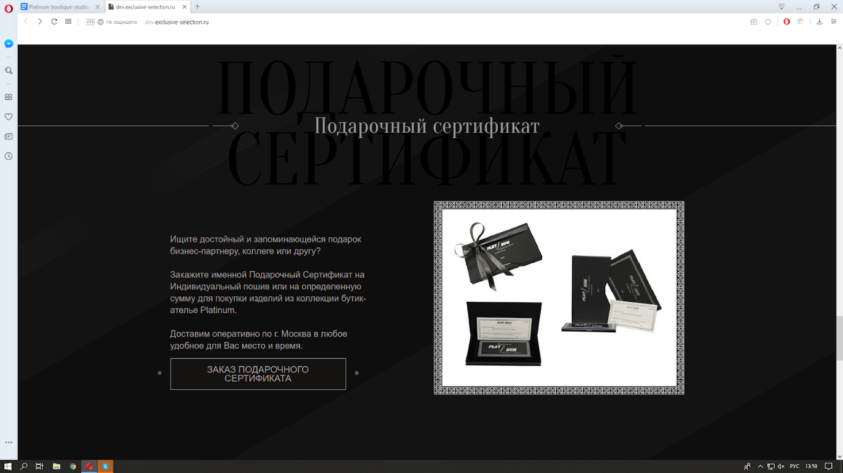

Gift Certificate

    If you need a substantial and memorable present for your business partner, colleague or friend, order Gift Certificate for custom-made garment or for purchasing any items from the collections of Platinum boutique-studio within the identified sum of money.

We provide prompt delivery around Moscow at any time that suits you.

*Order Gift Certificate*

*EVENTS section*

*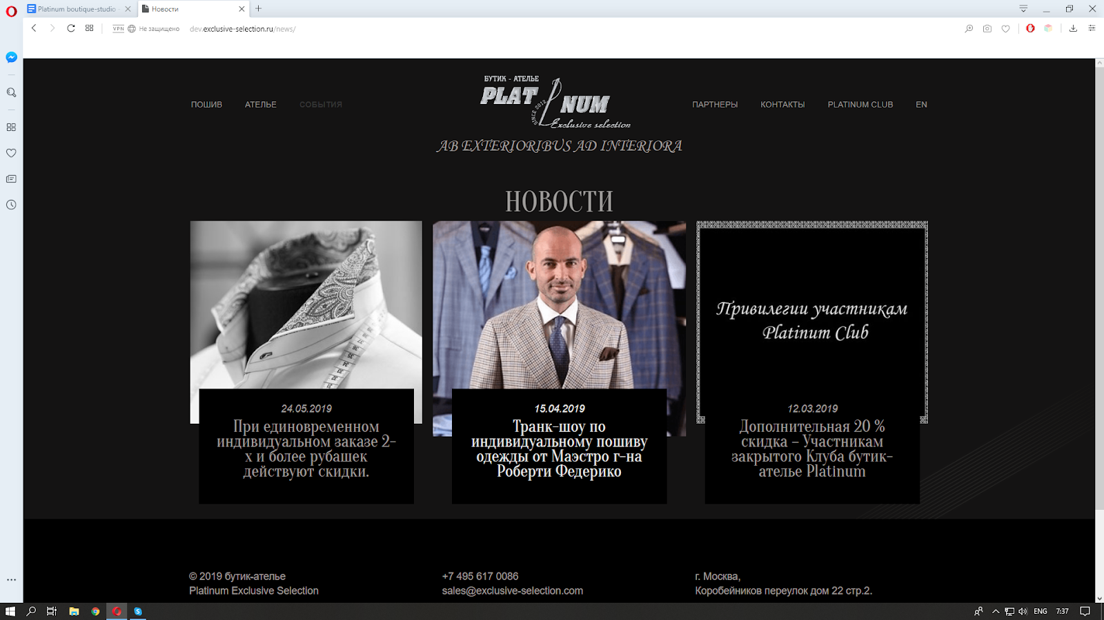*

News

DISCOUNTS ARE APPLIED TO ORDERS THAT INCLUDE 2 AND MORE BESPOKE-TAILORED SHIRTS.

24.05.2019

Discounts are applied to orders including 2 and more shirts. We use the best Italian fabrics produced by Albini, Thomas Maison, D&J Anderson. We target to employ mostly hand work and manual operations while creating shirts; only genuine pearl buttons are used for them. About 20 measures are taken before to achieve ideal fit of the future garment. Firstly, a prototype model is constructed and fitted until it reaches perfection. Through this process, the Master and the Style expert of Platinum boutique-studio strive to deliver an ideally fitting shirt that provides maximum comfort due to consideration of all anatomical peculiarities and the personal style of its owner.

TRUNK-SHOW OF BESPOKE TAILORING BY MAESTRO ROBERT FEDERICO

15.04.2019

Trunk-show of bespoke tailoring by Maestro Roberto Federico.

Once again, Maestro Roberto Federico will visit our boutique. He will introduce a brand new collection of exclusive fabrics produced by the world’s best manufacturers.

Mister Roberto can take measures in order to design comfortable and stylish units like coat, suit, jacket, waistcoat, trousers. All anatomical features of the client and his individual style preferences will be considered. Maestro will present latest fit tendencies and modern silhouette trends.

MEMBERS OF PLATINUM BOUTIQUE-STUDIO CLUB GET EXTRA DISCOUNT OF 20%

12.03.2019

    To show our respect and gratitude to the members of Platinum boutique-studio private club, we provide extra discount of 20% that will be applicable to the whole collection and valid until the 15th of April 2019. We are looking forward to seeing you at our salon. Have a cup of flavorus coffee and take advantage of the extra compliment provided by our boutique-studio...

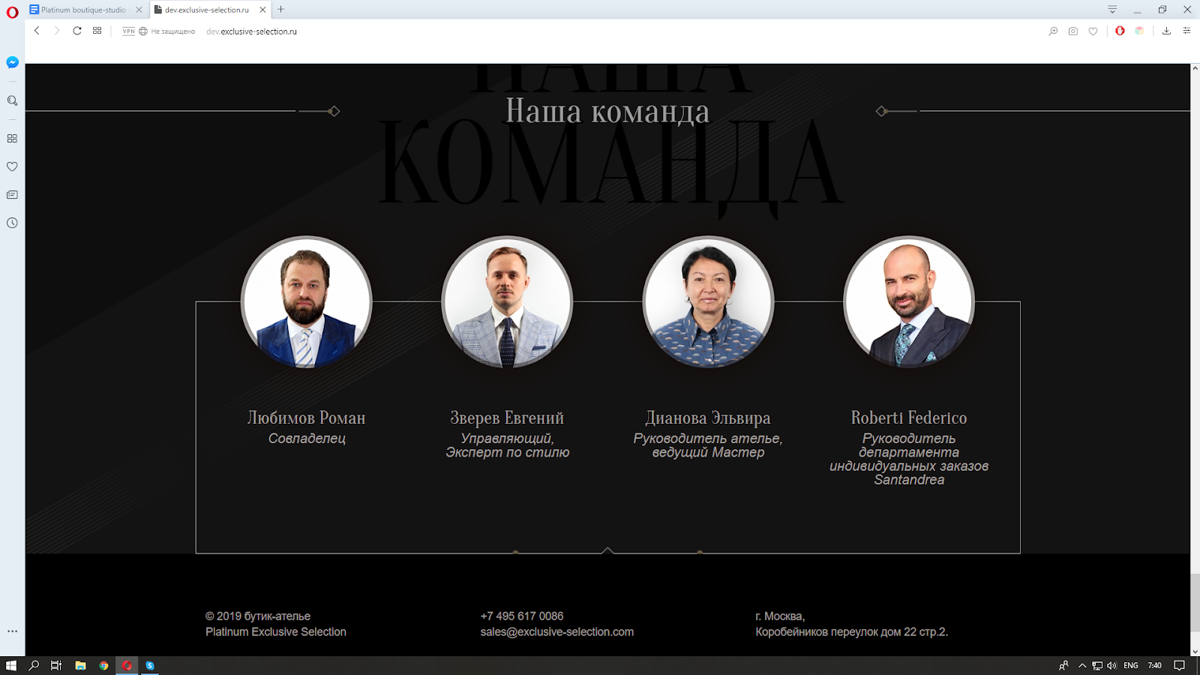

Our team

Roman Lyubimov

Co-owner

Evgeniy Zverev

Managing Director,

Style Expert

Elvira Dianova

Studio Director,

Leading Master

Roberto Federico

Director of Bespoke Department in Santandrea

*Tailoring sector*

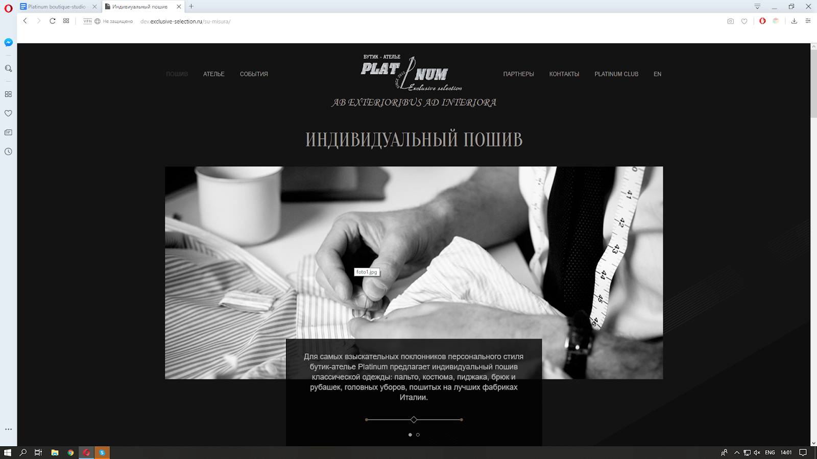

BESPOKE TAILORING

For the most demanding adorers of exclusive style, Platinum boutique-studio offers individual design of classic models of coats, suits, jackets, trousers, shirts and hats tailored at the best factories of Italy.

Bespoke tailoring is one of our major activity areas and the brand identity of Platinum boutique-studio.

Masterly performance. The concept and the space of our boutique has been designed having regard to the demands of exceptional service and privacy of our Clients.

Customers choose Platinum boutique-studio for its superior quality characteristics and first-class services. We hand in the handiwork that embodies perfect Italian custom tailoring.

Our High-class Tailoring Master and Style Expert have experience, expertise and skills evaluated by the most demanding clients. They will be pleased to welcome you in the salon of our bespoke tailoring studio.

The comfortable and aesthetic area of our studio allows keeping total confidentiality of every customer. It is ideal for those who prefer to retain their privacy.

Tailoring Master and Style Expert will take required measures paying attention to all your anatomical peculiarities.

The process of exclusive garment tailoring is not only a mystery, but the result of effective cooperation of Tailoring Master, Style Expert and the client himself.

We take into account customers’ vision and expectations; we design exclusive items of exceptionally high quality perceiving that this garment will be Client’s signature and investment into his success.

Limited collection of exclusive fabrics have been selected with consideration to trending colors and textures. What is peculiar is that it includes very rare fabrics - some of them exist in a unique copy in the whole world. Among over two thousand samples of textiles you can choose the best samples of Loro Piana, Scabal, Dormeuil, E.Zegna, Holland & Sherry, Caccioppoli, Piacenza, Fratelli tallia di Delfino, Albini, Thomas Maison, D&J Anderson.

Our individual tailoring services include designing and tailoring men’s shirts and women’s blouses. Hand-sewn shirts and blouses feel like a second skin as they are created with consideration of your anatomical features. For these items we use premium Inalian fabrics by Thomas & Maison, Albini, D&J Anderson.

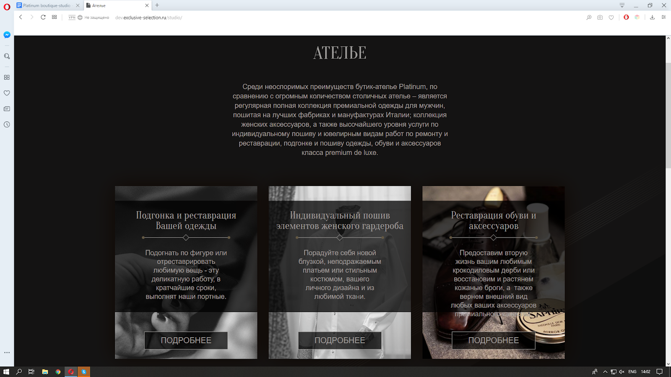

TAILORING STUDIO

One of the undeniable advantages of Platinum boutique-studio in comparison with many other establishments of Moscow is our full regular collection of premium men’s clothes that is tailored at the best textile factories and manufacturers of Italy. Another important point is a collection of women’s accessories and highest-level individual tailoring services, exquisite workmanship and restoration services, designing and fitting of "premium deluxe" class clothes, shoes and accessories.

Fitting and restoration of your clothes

    To restore or fix your favourite item of garment is a delicate work that our tailors can do for you.

*LEARN MORE*

Fitting, fixing, invisible mending, restoration and giving a second life to your favourite premium-quality piece of clothes is a delicate work that will be promptly completed by our qualified tailors. We deal with any kind of garment: suits, jackets, overclothes, sportswear, dresses of any degree of complexity, knitwear.

BESPOKE TAILORING OF WOMEN’S CLOTHES

Set free your imagination… With the help of our tailors you can create your unique and exclusive dress, stylish blouse or suit. Any unit creatively and masterfully made applying maximum hand work of our expert masters will make you feel the star of a business meeting or a social event.

*LEARN MORE*

SHOE AND ACCESSORY RESTORATION

    Shoes or premium quality is an essential feature of a successful person’s outfit. Though the time they wear out, but the specialists of Platinum boutique-studio can bring them back to life. We handle men’s and women’s premium class shoes, sports and children’s footwear.

*LEARN MORE*

    Save your precious time by entrusting your favourite garment units to our caring hands. The result of our masters; work will exceed your expectations.

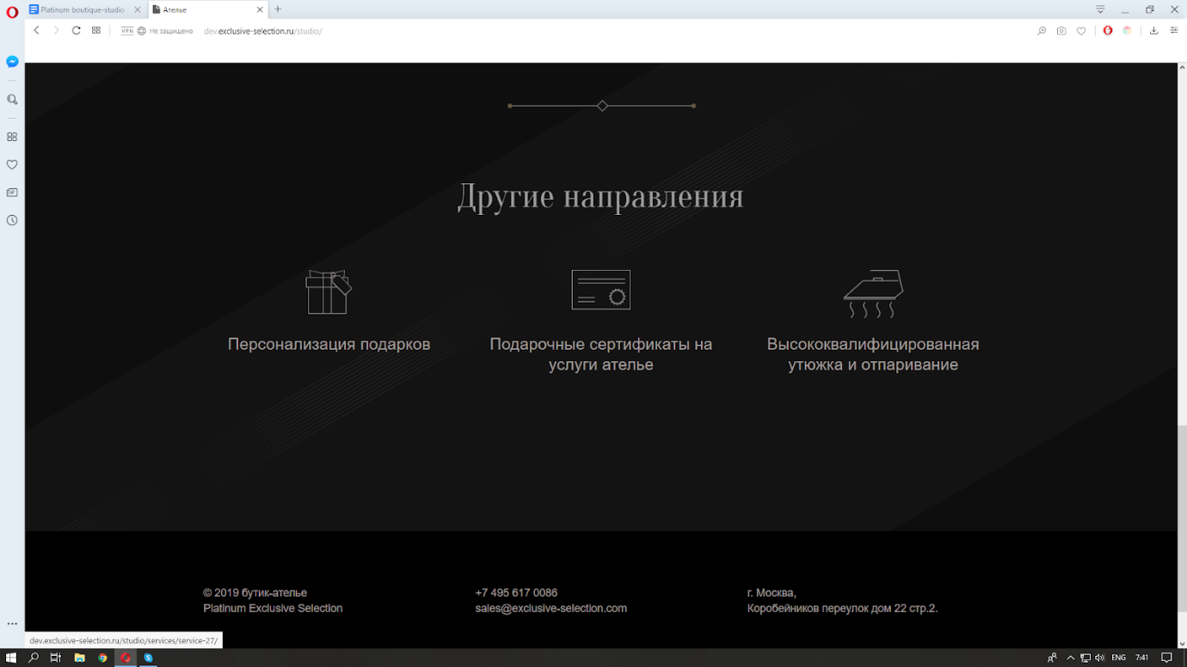

Other activity areas

GIFT PERSONALIZATION

Personalizing presents is a perfect way to underline your special attitude to a person and the desire to surprise him or her by a special gift that will constantly recall your attention and care. Personalization text or monogram can be applied onto the metal parts of your present or on any leather accessories.

GIFT CERTIFICATE FOR TAILORING SERVICES

A gift certificate for tailoring services can be a brilliant present for your friends, colleagues or partners. Our friendly personnel will receive them at the studio and provide maximum comfort and care. They will be delighted by the superior services delivered by our qualified tailors.

HIGH-SKILL IRONING

    Well ironed means half made sewed - says the old tailoring rule. Proper Gentlemen will surely evaluate our service of high-quality ironing and steaming of suits, jackets and trousers. Masters apply old laborious ironing technique that was used by Neapolitan tailors. Upon completion, the fabric looks reconditioned and regains its stability.

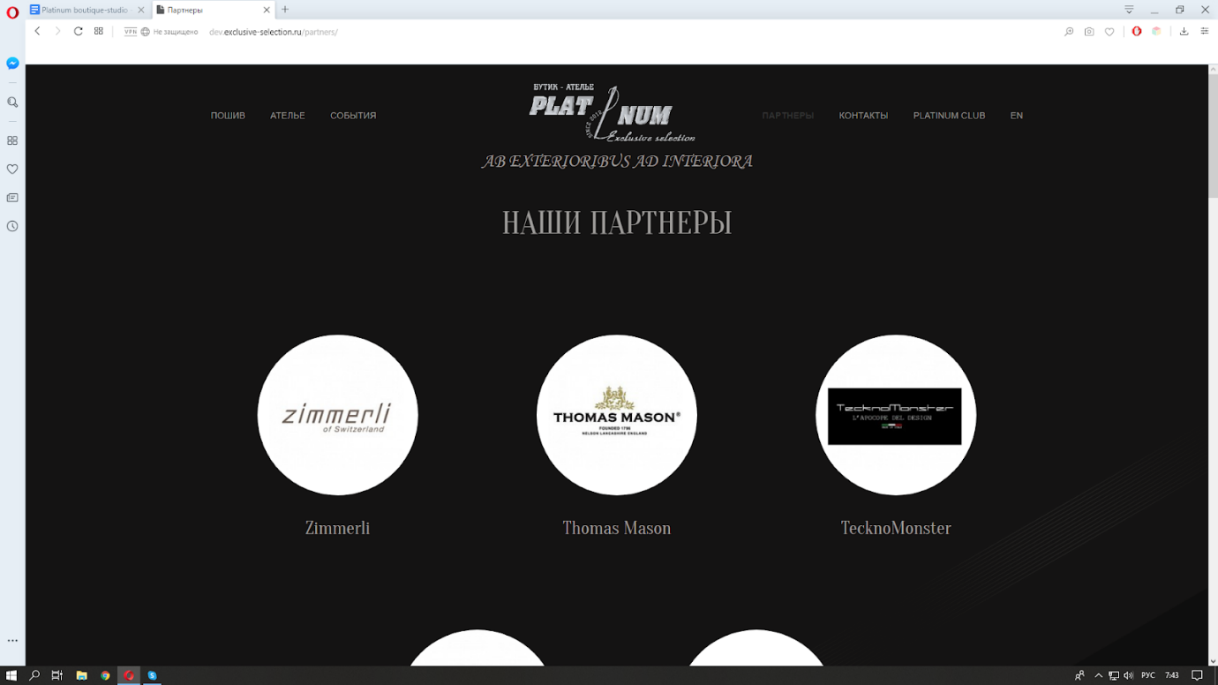

PARTNERS

Our partners

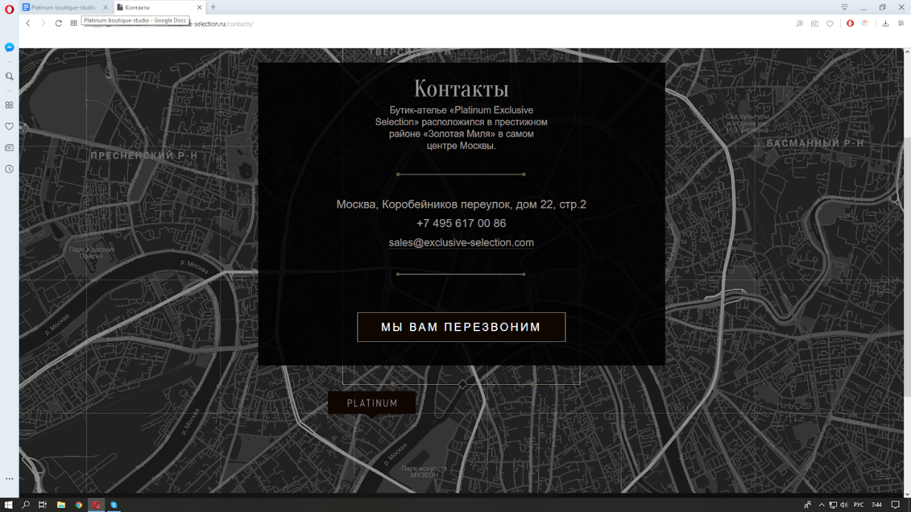

Contacts

Boutique-studio Platinum Exclusive Selection» is located in the prestigious district “Golden Mile” in the heart of Moscow.

Moscow, Korobeynikov per., 22 block 2

+7 495 617 00 86

sales@exclusive-selection.com

 WE WILL RETURN YOUR CALL

Platinum club

Only for Platinum Club members