**Instantly treats you!**

Previously, doctors knew nothing but bandage, alcohol, and morphine! But it’s good that now, if something happens, our readers can turn to high-quality medical facilities in case of anything! So, modern medicine!

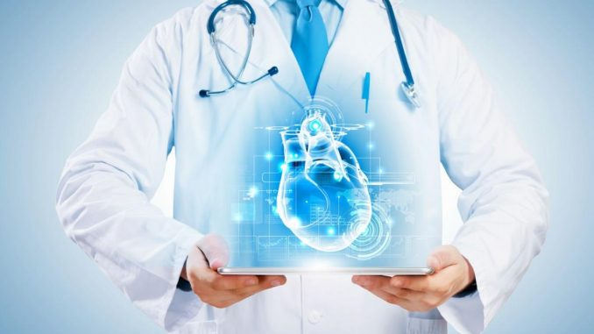

What is modern medicine? Over the past two decades, she has risen to a previously unattainable level. There was an opportunity to diagnose the disease at an early stage, and thereby ensure the quickest recovery of a person and his return to normal life. High technology has firmly entered our lives, even during routine research. Minimally invasive surgical interventions using endoscopic equipment, methods of non-surgical treatment of blood vessels became familiar. Modern doctors return not only health, but also youth, and beauty, and harmony with themselves and the world around them. Which areas are particularly relevant?

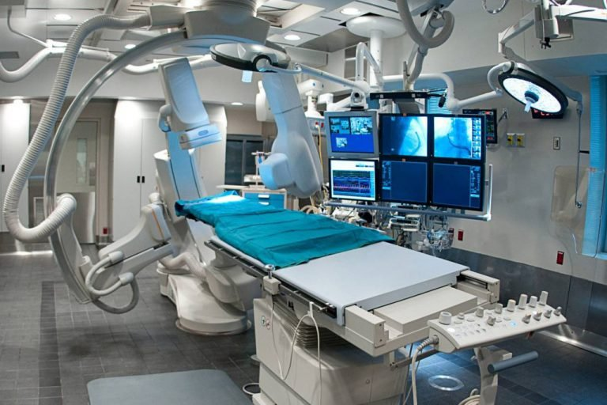

The answer is simple: absolutely all areas are important! Medicine does not tolerate a mediocre attitude to anything and therefore the process of its development and improvement takes place immediately in all areas. Could it be that surgery will be less studied than oncology? Of course not!

And always remember, if our previous article about health did not help you, then be sure to contact the experts!