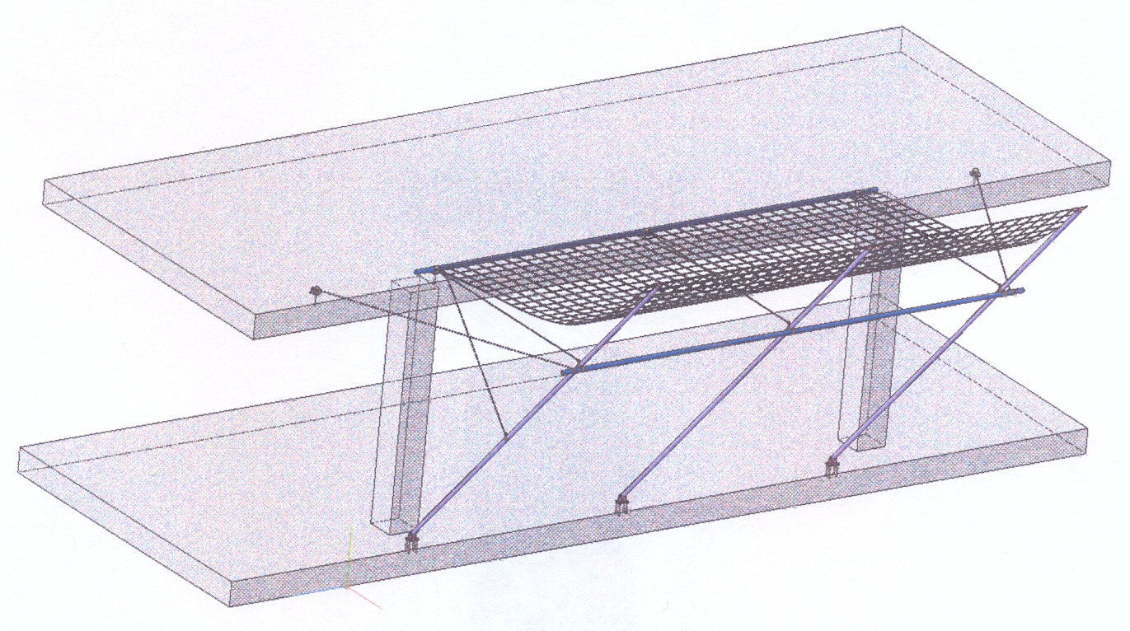

Safety net system (SNS) is designed to catch construction debris, tools and other materials fallen from heights. As well it protects people working right under a SNS from falling objects.

SNS is a metal structure consisting of a bracket (column), two welded supports, a safety net, a set of ropes, safety carabiners, anchor bolts and bent anchor bolts.

**SNS can stand a load of up to 100 kg fallen from a 6 m height.**  
 A load-carrying part of a safety net consists of two supports and a bracket. The bracket length depends on a distance between beams.

**SNS specifications:**

* safety range is 4.4 m wide;
* carrying part weight is up to 50 kg;
* allowable distance between brackets is 2.7 m.

SNS is a metal structure consisting of a bracket (column), two welded supports, a safety net, a set of ropes, safety carabiners, anchor bolts and bent anchor bolts.

Analysis of the impact force of an object fallen onto a net from a 6 m height

The impact force of an object fallen onto a net can be calculated by the following formula, without going into detail on air resistance and surface resistance. Let's simplify the calculation.

F = mgh is the force of an object fallen onto an obstacle, i.e. impact force, where m is the body mass (kg); g is the acceleration of gravity = 9.8 (m/s²); h is the height an object is dropped from (m):  
 F = 100 × 9.8 × 6 = 5,880 (N) = 600 kg.

Assume the area S (m²) of contact of a fallen object with a net is 2.00 sq m (m²). Then the pressure (Р) on 1 m² of a net is Р = F/S = 600 kg : 2.00 m² = 300 kg/m².

Analysis of a safety net system (SNS) in SCAD

The software package SCAD is designed for strength analysis of building structures.

The program itself is a group of software programs. The basic module SCAD is used for analysis of building structures strength. Besides, the package includes some satellite programs tailored for particular tasks. For example, the Crystal satellite program contains a steel structures database, it is used for analysis of bolted, frictional and welded joints, as well as for design of trusses, beams, columns, and plate structures.

**Let's create a design diagram**

The measurement units for building structures are as follows:

Linear dimensions – m (meters)

Section dimensions – cm (centimeters)

Forces – t (tons)

Name – enter the project name: "SNS around the perimeter"

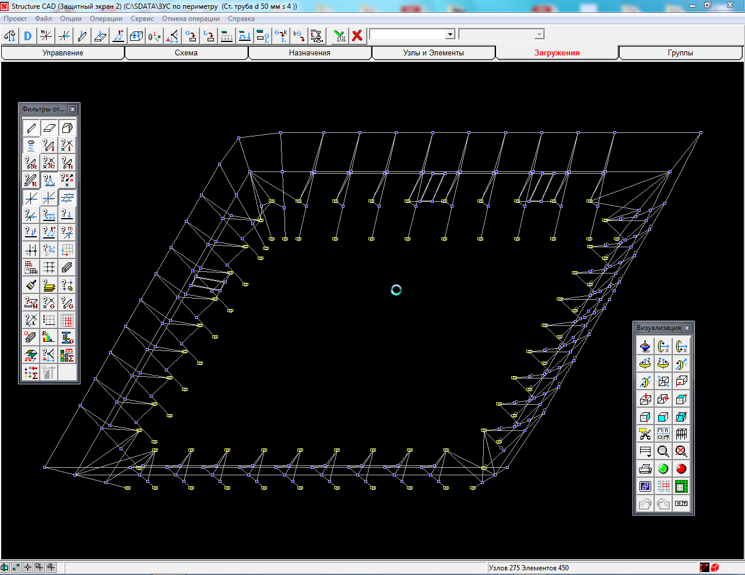

*Safety net system (SNS) design diagram*

Note that we segment the rope-like bars. Kinematic pairs will be installed at the segment borders. This technique will make them more flexible.

**Columns will be made of a steel pipe (St47 steel) with outside diameter D = 50 mm and wall thickness s = 4 mm; horizontal pipe with diameter D = 50 mm and wall thickness s = 5 mm will be made of Al 6063 T5 aluminum alloy.**

In order to make sure that all the profiles are set and to have a look at a design diagram, you can click the “Presentation Graphics” button and see a 3-dimensional model.

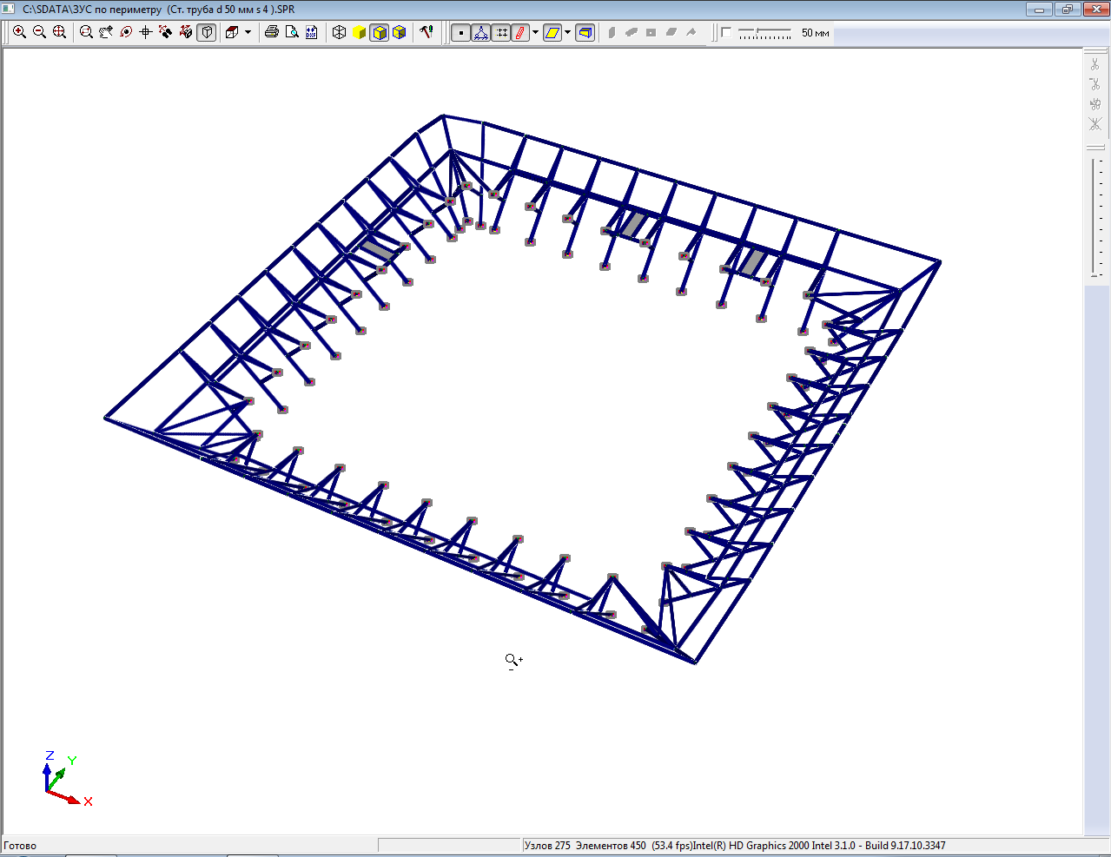

*SNS 3D model presentation*

**Let's specify the loads**

Let's specify the safety net system (SNS) loads

All the loads are specified independently of each other, therefore we are going to specify them separately.

Thus: “Load #1” is **0.3** t/m2; “Load #2” is **0.245** t/m2; “Load #3” is **0.15** t/m2; “Load #4” is "**dead weight**" of a structure.

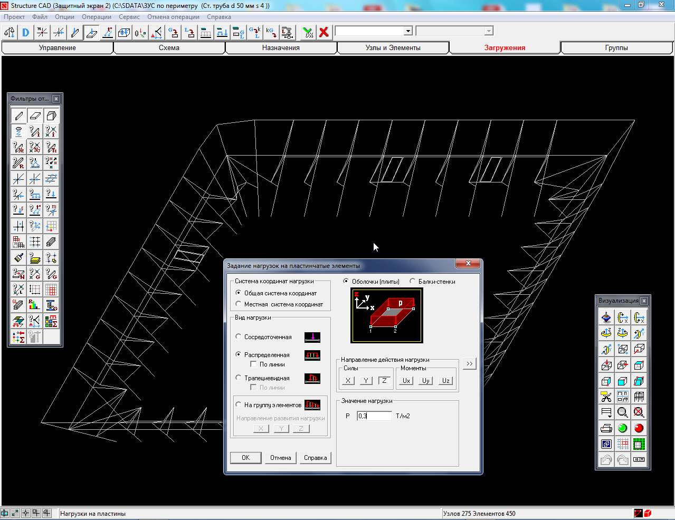

*Load type and value selection tab*.

“Load #1” = **0.3** t/m2 is equal to the pressure of a 100 kg object fallen onto the net from 6.0 m height;

“Load #2” = **0.245** t/m2 is equal to 82 kg;

“Load #3” = **0.15** t/m2 is equal to 50 kg.

Loads at the point of application are displayed as follows:

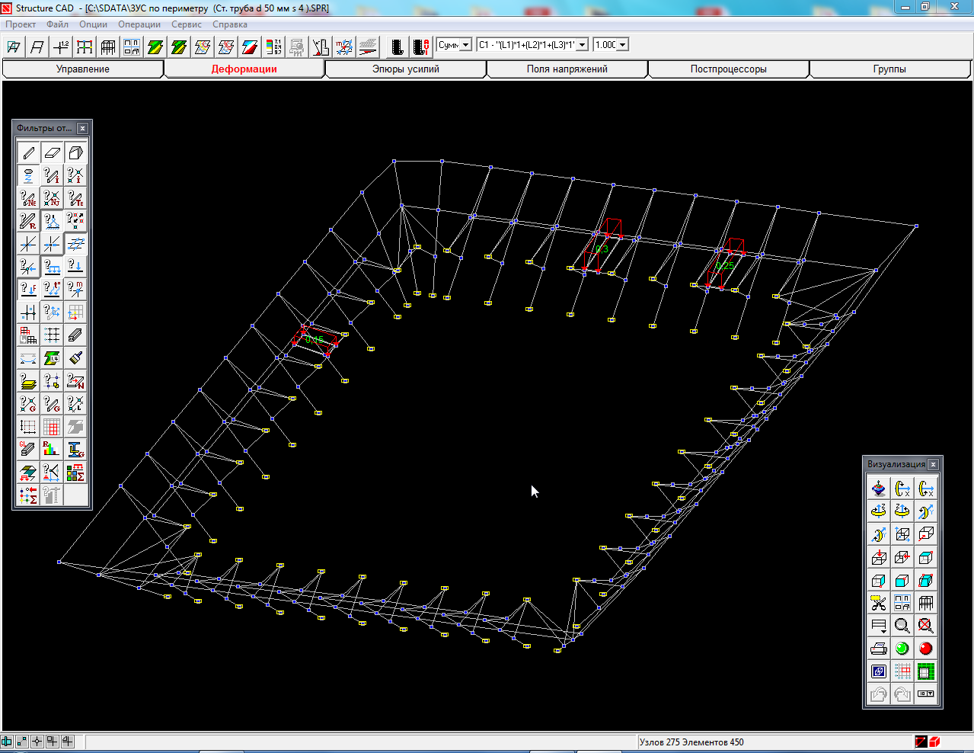

*Diagram in the SCAD tab displaying the loads application points and values*

Load #1 = **0.3** t/m2 is specified by the PRD criterion. The rest of the loads: load #2 = **0.245** t/m2 and load #3 = **0.15** t/m2 are selected for visual display of the way a load value decrease affects (decreasingly) stress values in the elements

**Let's specify the loading combinations**

We assume that the SNS structure is subject to all the four loads 1-4, therefore the combination is recorded as follows: (L1)*1 + (L2)*1 + (L3)*1 + (L4)*1, where (L1) corresponds to 0.3 t/m², (L2) corresponds to 0.245 t/m², (L3) corresponds to 0.15 t/m², and (L4) is the structural dead weight. “1” is load scale factor.

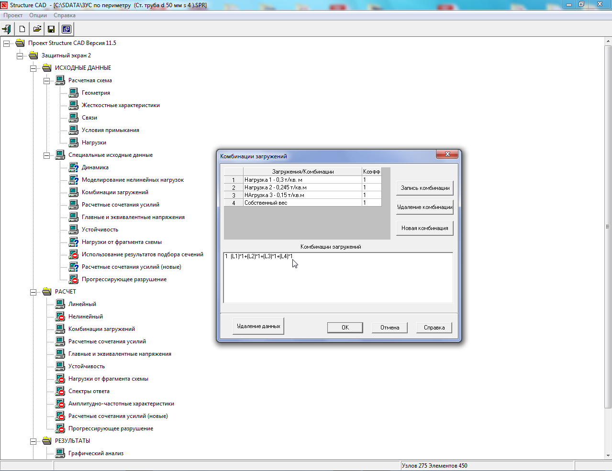

*SCAD tab for setting load combinations*

**Let's make calculations and check the analysis results** After we have made the analysis, the design diagram elements in the **Visualization tab**  are indicated green and red. The **green color** indicates that the elements satisfy **strength conditions**; the **red color** indicates that the elements do not satisfy **strength conditions**.

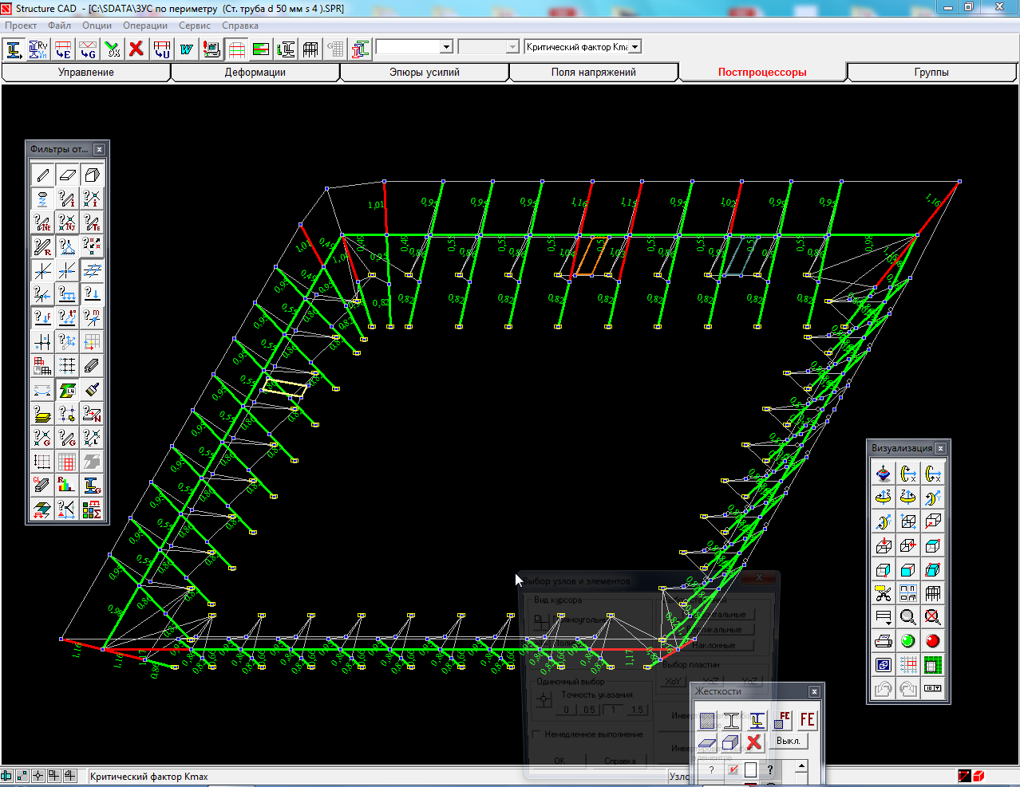

*The colored diagram elements in the graphical analysis tab*

Let's click and zoom the diagram in the points of application of the loads 0.30t/m2 and 0.245 t/m2 and in the point of application of the load 0.15 t/m2 separately.

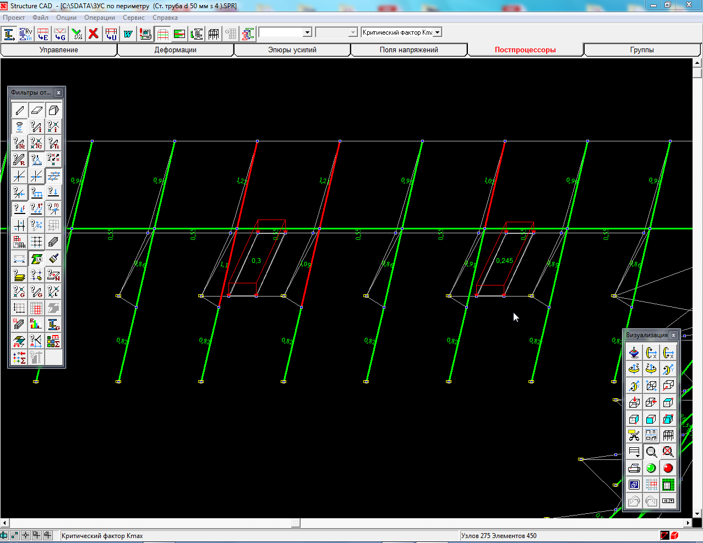

*The point of* ***0.30*** *t/m2 and* ***0.245*** *t/m2 loads application*

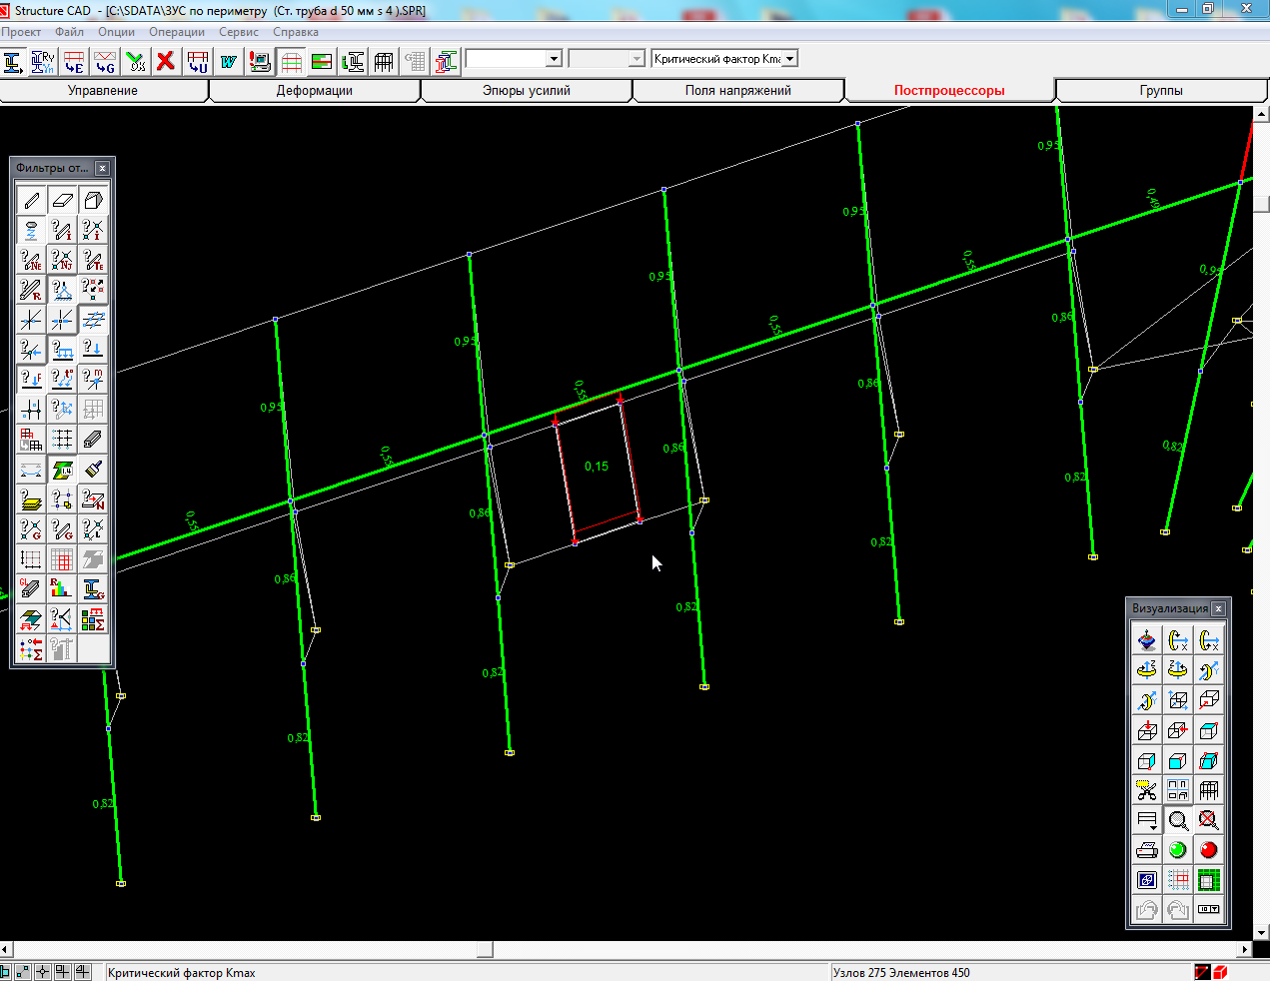

*The point of* ***0.15*** *t/m2 load application*

There are numbers next to each element of design diagram. These are maximum stress intensity factor K max values. It is indicated in the bottom left corner of the picture. If ***K max < 1.0*** (but not equal to), then the element satisfies strength condition; if ***K max ≥ 1.0***, then it does not. Theoretically, K max has to verge to 1.0 (0.85 ÷ 0.99). In this case, the structural element will be considered complying with design standards, efficiency, and durability.

Besides, Max stress intensity factor (K max) tab displays the factors affecting strength condition of a structure as a whole and each element individually. In the screenshots below, you can see a tab with a list of K max factors popping up in the top right corner. From this screenshot, it is clearly seen why the SNS structural elements do not satisfy strength conditions (bars are visually colored red). Let's go through all the components of the drop-down list of K max top to bottom and find the K max components that do not satisfy strength conditions. They are colored red.

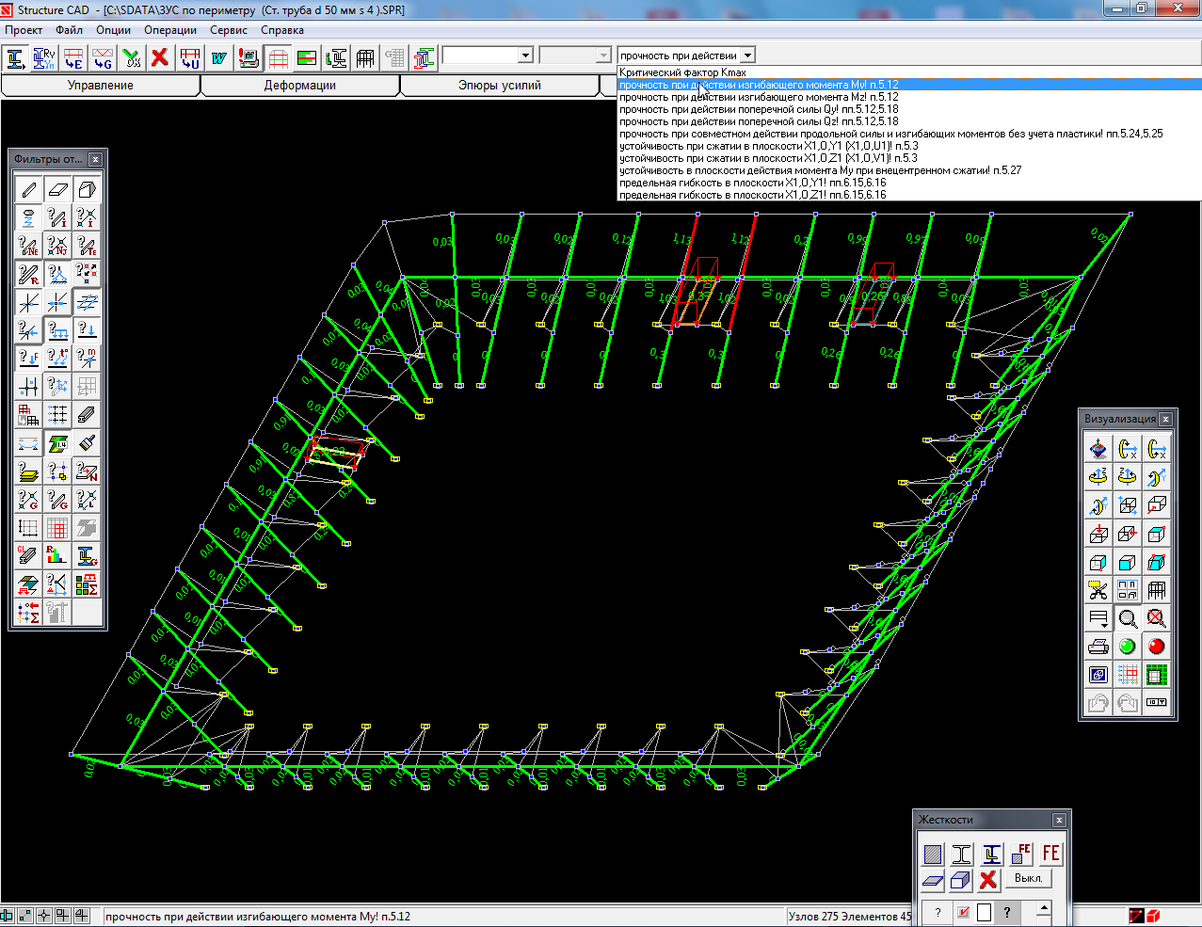

1. *Due to Fragility when exposed to bending moment My*

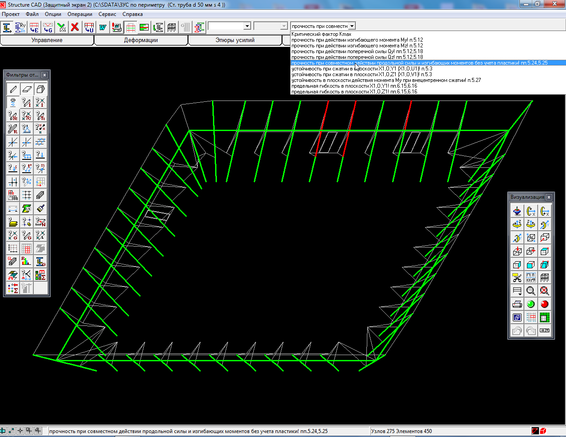

1. *Due to Fragility when exposed to the total effect of combined axial force and bending moments without regard to plasticity*

As for the rest of K max factors, I will provide the following example:

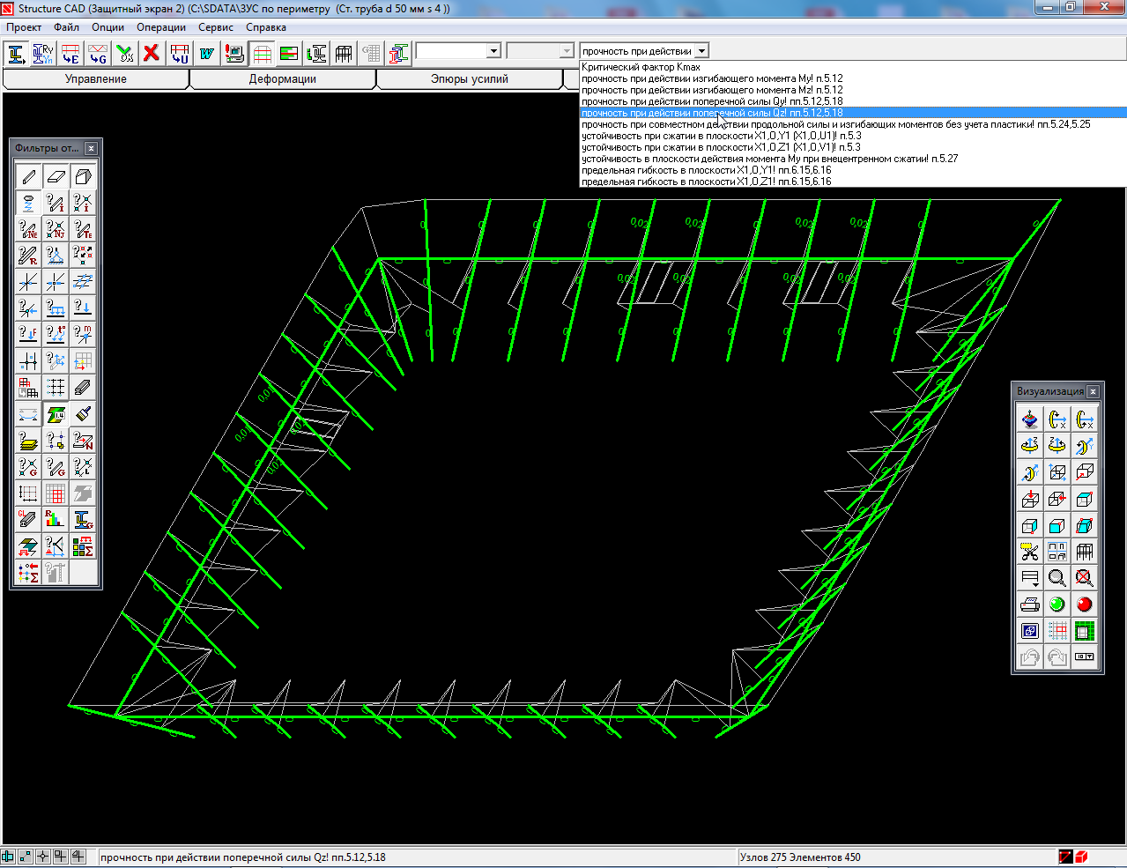

*Strength when exposed to axial force Qz*

***Strength condition in the columns under the action of a fallen object is not satisfied****:*

- when exposed to bending moment Му; - when exposed to the total effect of combined axial force and bending moments; - in case of stability loss in the XoY and Xoz planes.

It is a design feature of this very SNS. In the alternative structure with a column held by a single rope, the key reason of strength condition failure is stability loss of all the columns. This option is presented in the picture below.

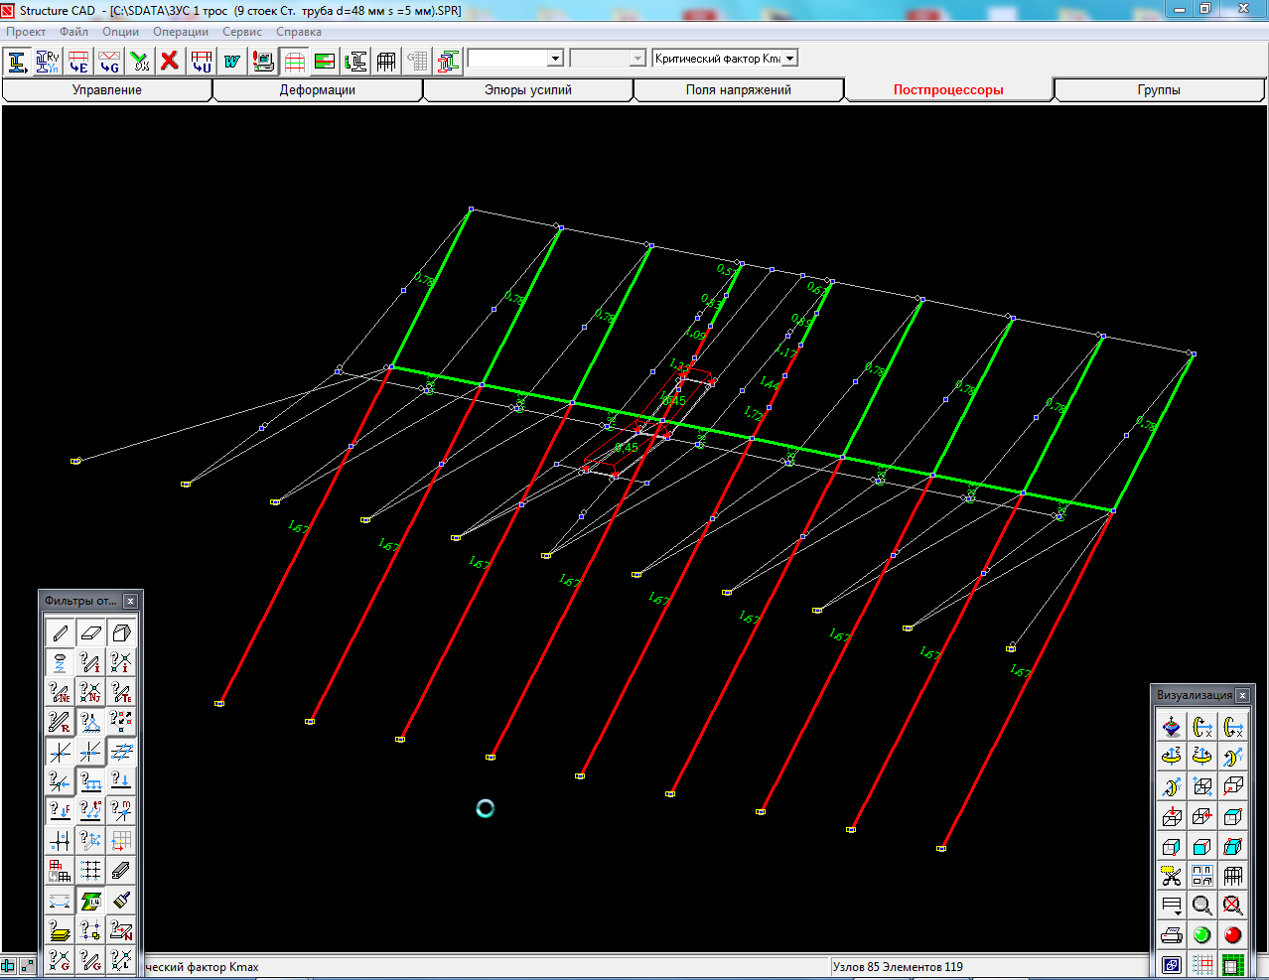

*SNS diagram with each column held by a single rope*

It is noteworthy that the bar stability loss is observed where there is no external load application.

**THUS, we can conclude**

1. The two columns on both sides of a fallen 100 kg object are subject to the maximum load (**0.3** t/m2). Strength condition is not satisfied (the column top end deflection is **514** mm). In other columns located symmetrically on both sides of the overloaded columns, strength condition is satisfied, but deformation level is high – **440** mm.
2. In the case where the weight of a fallen object is equal to 82 kg (**0.245** t/m2), only one column is subject to maximum stresses causing the strength condition failure; in the second column strength condition is satisfied, deflection is **417** mm. It depends on where an object falls relative to the nearest columns.
3. In the case where the weight of a fallen object is equal to **50** kg (**0.15** t/m2), the maximum stresses in the columns do not exceed the allowable stresses, strength condition is satisfied, and the top end deflection is **310** mm.
4. At a distance of 1-2 columns from a fallen object, the maximum top end column deflection ranges from 12 to 32 mm.
5. It is noteworthy that the column stability is satisfied in case the distance between columns is 2.70 meters, columns are 6.0 meters long and are held by two ropes. The rope attachment points divide a column into about three equal parts.

Below is the SCAD picture of movements (deflections), in millimeters, of the SNS column top ends. The deflection values are clearly seen by the top row of columns.

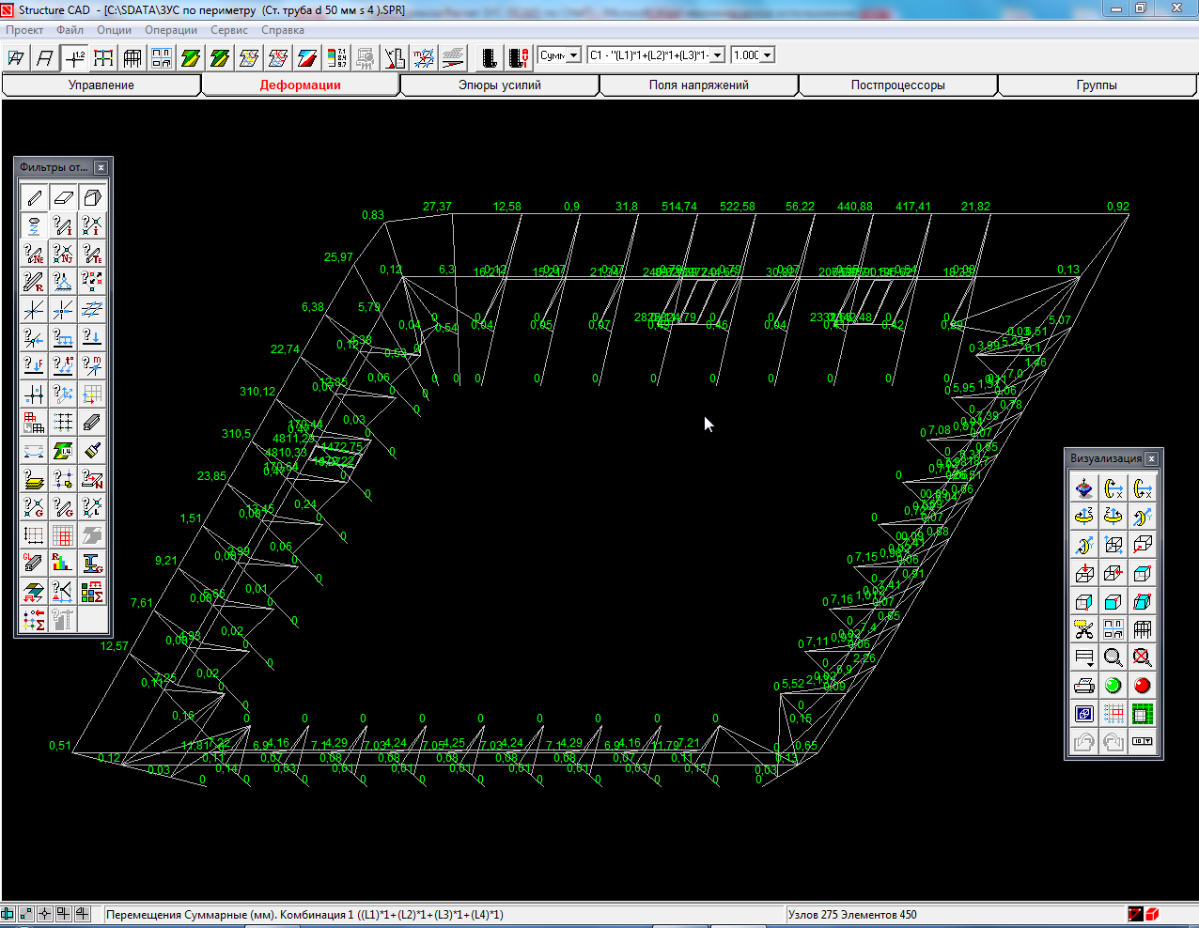

Let’s mouse over the column elements numbered 132, 133, 134, 135, and 177. They are located next to the fallen 100 kg object load application. After clicking "The Element Information" button, in the "Stress Diagrams" and "Deflection Diagrams" tabs we read the bending moments and side forces values as well as the maximum deflection along the axes X, Y, and Z in the selected column element. The items numbered 133 and 134 are colored **red**, while the items 132, 135, and 177 are **green** in the K max tab. Their K max values ​​are clearly seen (for information).

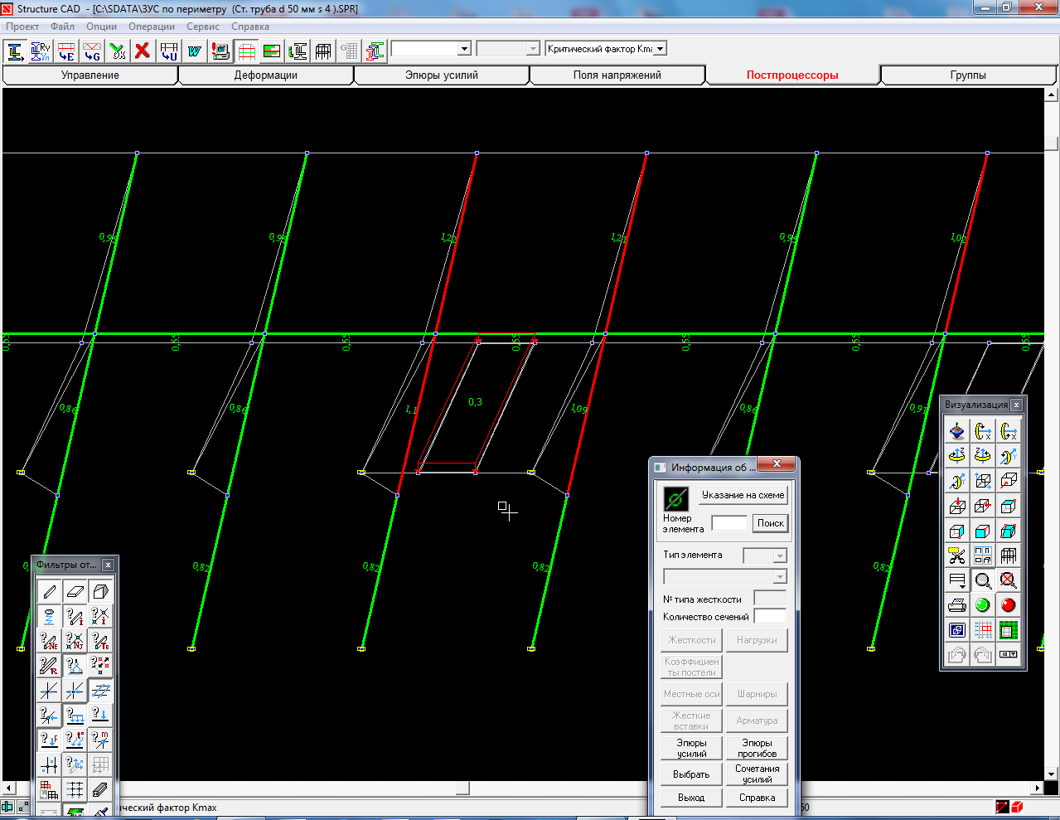

177

135

132

134

133

*Item selection from the SNS design diagram*

**SNS COLUMN ELEMENTS STRENGTH ANALYSIS**

* We are going to analyze the SNS elements in accordance with Standard of Israel 1225 – *Analysis version 1*

Strength analysis for steel beams both with compression and bending and with tension and bending, yield strength up to 530 MPa (5,400 kgf/cm2), has to be made according to the following formula:

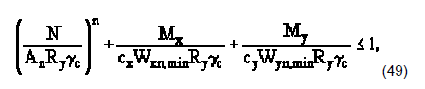

where N, Mx, and My are absolute axial force and bending moments values in case of the least favorable combination of theirs;

n, cx, and cy are factors specified according to Annex 5 (Standard of Israel 1225) (see Annex 1 of the note); A is a cross section area of a metal profile (in our case, it is a pipe), cm2 (see Annex 2 of the note); W x, y are the maximum section modulus, cm³; Ry is design strength under compression and bending of rolled steel (pipe), MPa (t/cm2) (see Annex 3 of the note); γс is structural behavior factor (Table 6 of Standard of Israel 1225) (see Annex 4 of the note).

* Having calculated the SNS structural elements strength by the above formula, let's analyze the elements maximum stresses compared to allowable stress. In the dangerous section of a bar, maximum stress must not exceed allowable stress Ϭ ≤ [Ϭ] – *Analysis option 2*

In this case, the **strength condition** when exposed to the total effect of combined bending and axial load (tension or compression) is **as follows**:

Ϭ max = N /А + Mx /Wx + My / Wy ≤ [Ϭ]

where Ϭ max is stress in the bar cross section dangerous point.

1. Let's start analysis with the element **132**. Having moused over the item **132**, read the values in modulus – axial force N and bending moments М х,у.

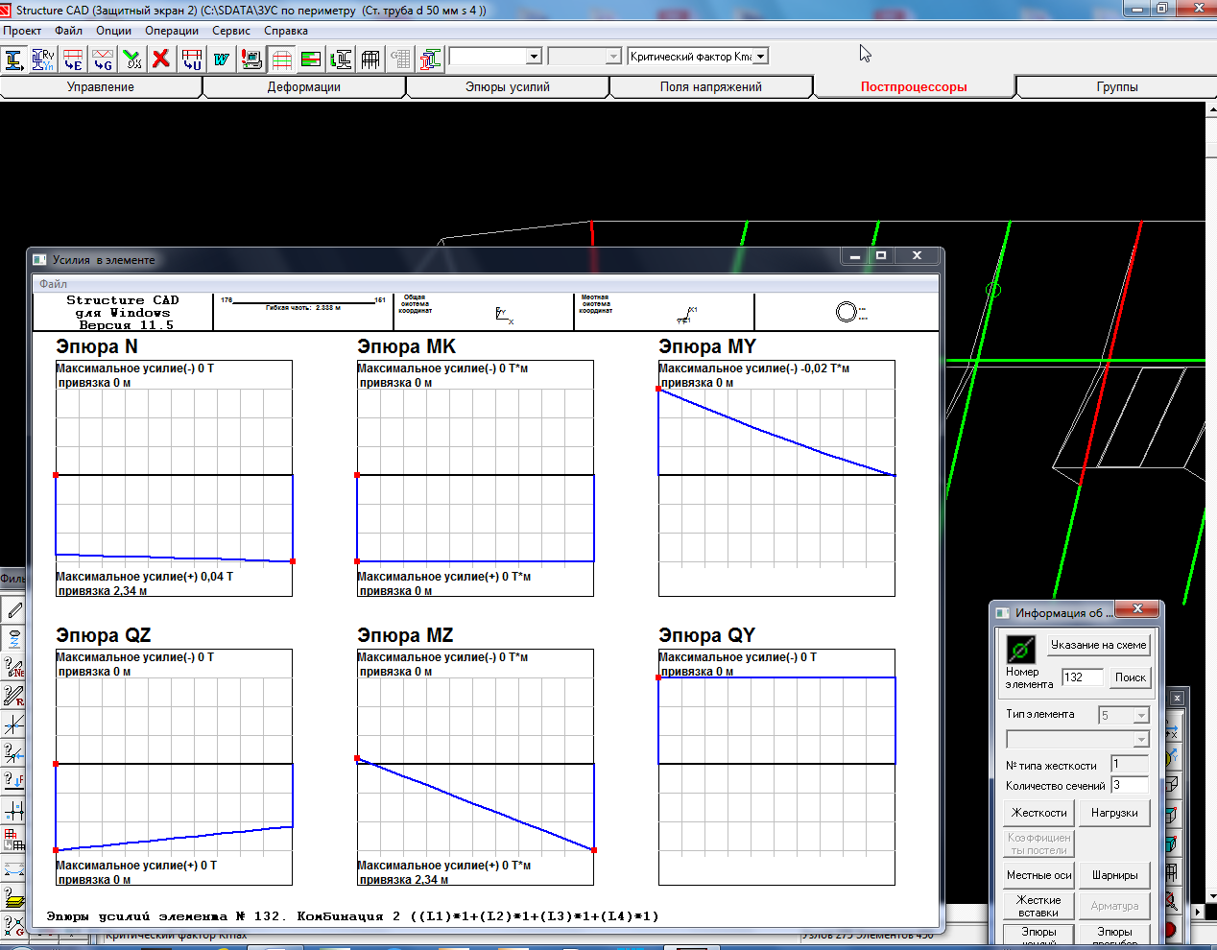 *The selected SNS column element 132 diagrams*

The element 132 is subject to the following loads: 1. Axial force N = 0.04 t. 2. Maximum bending moment Му = 0.02 t*m = 2.0 t*cm

**Option 1** Let's base analysis on Standard of Israel 1225.



It is known that N = 0.04 t; My = 0.02 t*m = 2.0 t*cm ; А = 5.78 cm²; W x,у = 6.16 cm³; Ry = 215 MPa = 2.2 t/cm²; сх = 1.26; γс = 0.95. Since the SNS column is designed of a steel pipe (St47 steel) with outside diameter D = 50 mm and wall thickness s = 4 mm, denominator values in the formula will be repeated in the further analyses. Therefore, we are going to find a product in the fraction denominator in the formula now and thereafter substitute these values into the formula, changing only N and M values.

Thus **А × Re × γс** = 5.78 cm² × 2.2 t/cm² × 0.95 = **12.1** t.

**сх × Wy × Ry × γс** = 1.26 × 6.16 cm³ × 2.2 t/cm² × 0.95 = **16.2** t*cm

Substituting the denominator values into the formula, we get: 0.04 t / 12.1 t + 2.0 t*cm / 16.2 t*cm < 1.0; 0.003 + 0.123 < 1.0 – Strength condition is **satisfied**

**Option 2** The element 132 strength analysis by maximum stress to allowable stress ratio: Ϭ max = N / А + Mx / Wx + My / Wy ≤ [Ϭ]

Ϭ max = 0.04 t / 5.78 cm² + 2.0 t*cm / 6.16 cm³ = 0.332 t/cm² (33 MPa) Ϭ max = 33 MPa < [Ϭ]= 168 MPa  **Consequently, strength condition for the element 132 according to options 1 and 2 is satisfied**.

1. The element **133** analysis. Having moused over the item **133**, read the values in modulus – axial force N and bending moments М х,у.

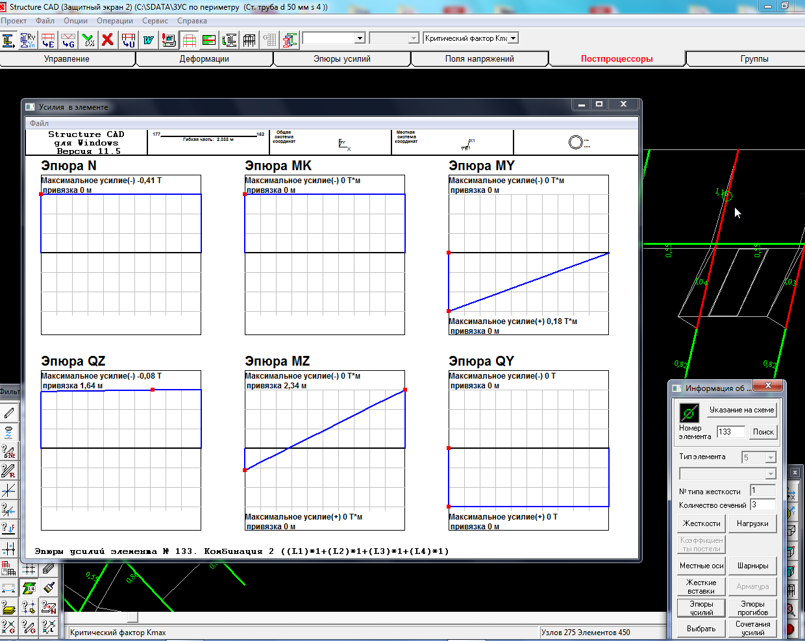 *The selected SNS column element 133 diagrams*

The element 133 is subject to the following loads: 1. Axial force N = 0.41 t. 2. Maximum bending moment Му = 0.18 t*m = 18.0 t*cm.

**Option 1** Let's base analysis on Standard of Israel 1225



It is known that N = 0.41 t; Му = 0.18 t*m = 18.0 t*cm; А = 5.78 cm²; W x,у = 6.16 cm³; Ry = 215 MPa = 2.2 t/cm²; сх = 1.26; γс = 0.95.

Substituting the denominator values into the formula, we get: 0.41 t / 12.1 t + 18.0 t*cm / 16.2 t*cm < 1.0; 0.034 + 1.111 > 1.0 – Strength condition is **NOT** satisfied

**Option 2** The element 132 strength analysis by maximum stress to allowable stress ratio: Ϭ max = N / А + Mx / Wx + My / Wy ≤ [Ϭ]

Ϭ max = 0.41 t / 5.78 cm² + 18.0 t*cm / 6.16 cm³ = 3.0 t/cm² (294 MPa) Ϭ max = 294 MPa > [Ϭ]= 168 MPa  **Consequently, strength condition for the element 133 according to options 1 and 2 is NOT satisfied**.

1. The element **134** analysis. Having moused over the item **134**, read the values in modulus – axial force N and bending moments М х,у.

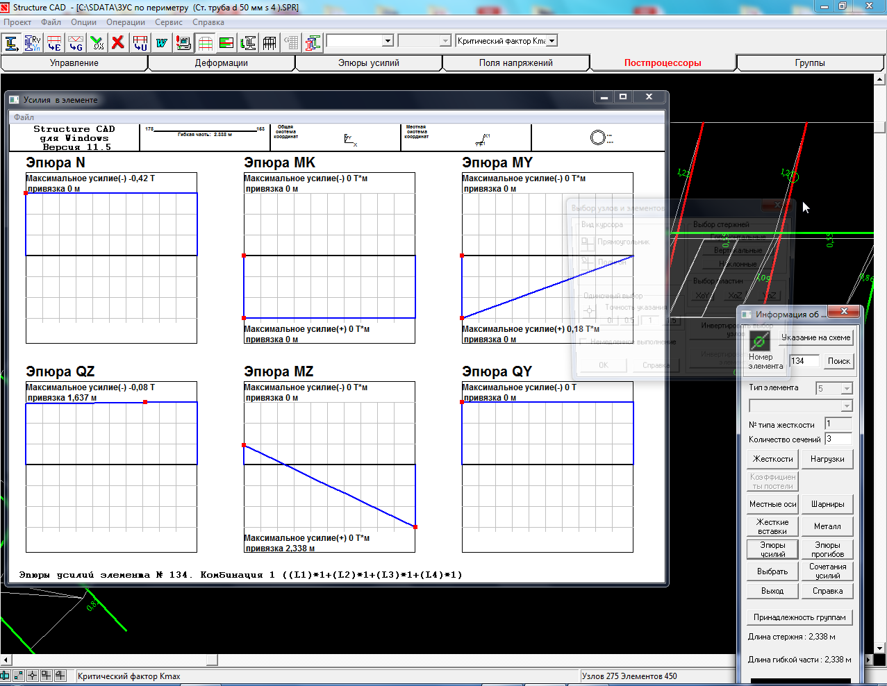 *The selected SNS column element 134 diagrams*

The element 134 is subject to the following loads: 1. Axial force N = 0.42 t. 2. Maximum bending moment Му = 0.18 t*m = 18.0 t*cm

**Option 1** Let's base analysis on Standard of Israel 1225



It is known that N = 0.42 t; Му = 0.18 t*m = 18.0 t*cm; А = 5.78 cm²; W x,у = 6.16 cm³; Ry = 215 MPa = 2.2 t/cm²; сх = 1.26; γс = 0.95

Substituting the denominator values into the formula, we get: 0.42 t / 12.1 t + 18.0 t*cm / 16.2 t*cm < 1.0; 0.035 + 1.111 > 1.0 – Strength condition is **NOT** satisfied

**Option 2** The element 134 strength analysis by maximum stress to allowable stress ratio: Ϭ max = N / А + Mx / Wx + My / Wy ≤ [Ϭ]

Ϭ max = 0.42 t / 5.78 cm² + 18.0 t*cm / 6.16 cm³ = 3.0 t/cm² (294 MPa) Ϭ max = 294 MPa > [Ϭ]= 168 MPa  **Consequently, strength condition for the element 134 according to options 1 and 2 is NOT satisfied**.

1. The element **135** analysis. Having moused over the item **135**, read the values in modulus – axial force N and bending moments М х,у.

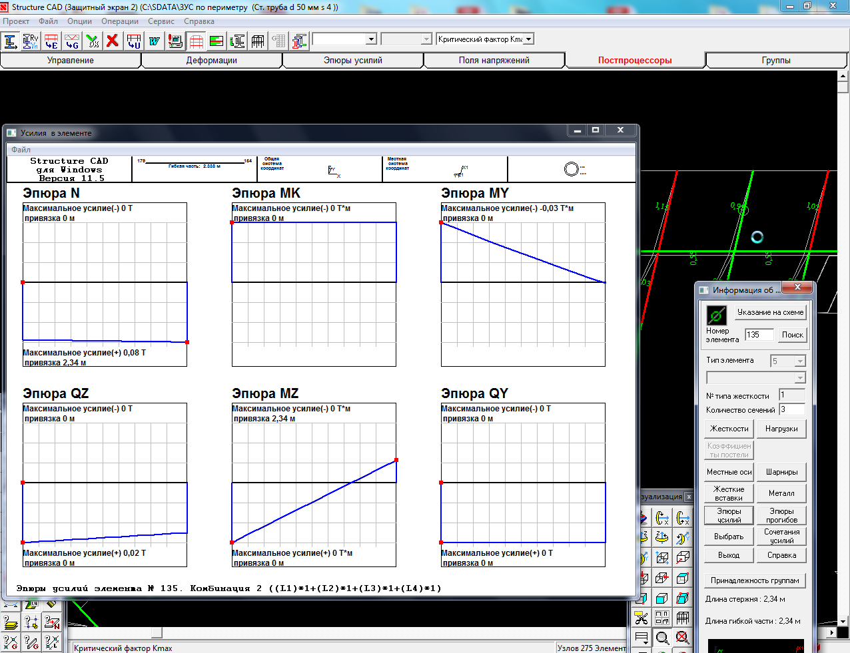 *The selected SNS column element 135 diagrams*

The element 135 is subject to the following loads: 1. Axial force N = 0.08 t. 2. Maximum bending moment Му = 0.03 t*m = 3.0 t*cm

**Option 1** Let's base analysis on Standard of Israel 1225



It is known that N = 0.08 t; Му = 0.03 t*m = 3.0 t*cm; А = 5.78 cm²; W x,у = 6.16 cm³; Ry = 215 MPa = 2.2 t/cm²; сх = 1.26; γс = 0.95

Thus **А × Re × γс** = 5.78 cm² × 2.2 t/ cm² × 0.95 = **12.1** t

**сх × Wy× Ry × γс** = 1.26 × 6.16 cm³ × 2.2 t/cm² × 0.95 = **16.2** t*cm

Substituting the denominator values into the formula, we get: 0.08 t /12.1 t + 3.0 t*cm / 16.2 t*cm < 1.0; 0.007 + 0.185 < 1.0 – Strength condition is **satisfied**

**Option 2** The element 135 strength analysis by maximum stress to allowable stress ratio: Ϭ max = N / А + Mx / Wx + My / Wy ≤ [Ϭ]

Ϭ max = 0.08 t / 5.78 cm² + 3.0 t*cm / 6.16 cm³ = 0.50 t/cm² (49 MPa) Ϭ max = 49 MPa < [Ϭ]= 168 MPa  **Consequently, strength condition for the element 135 according to options 1 and 2 is satisfied**.

1. The element **177** analysis. Having moused over the item **177**, read the values in modulus – axial force N and bending moments М х,у.

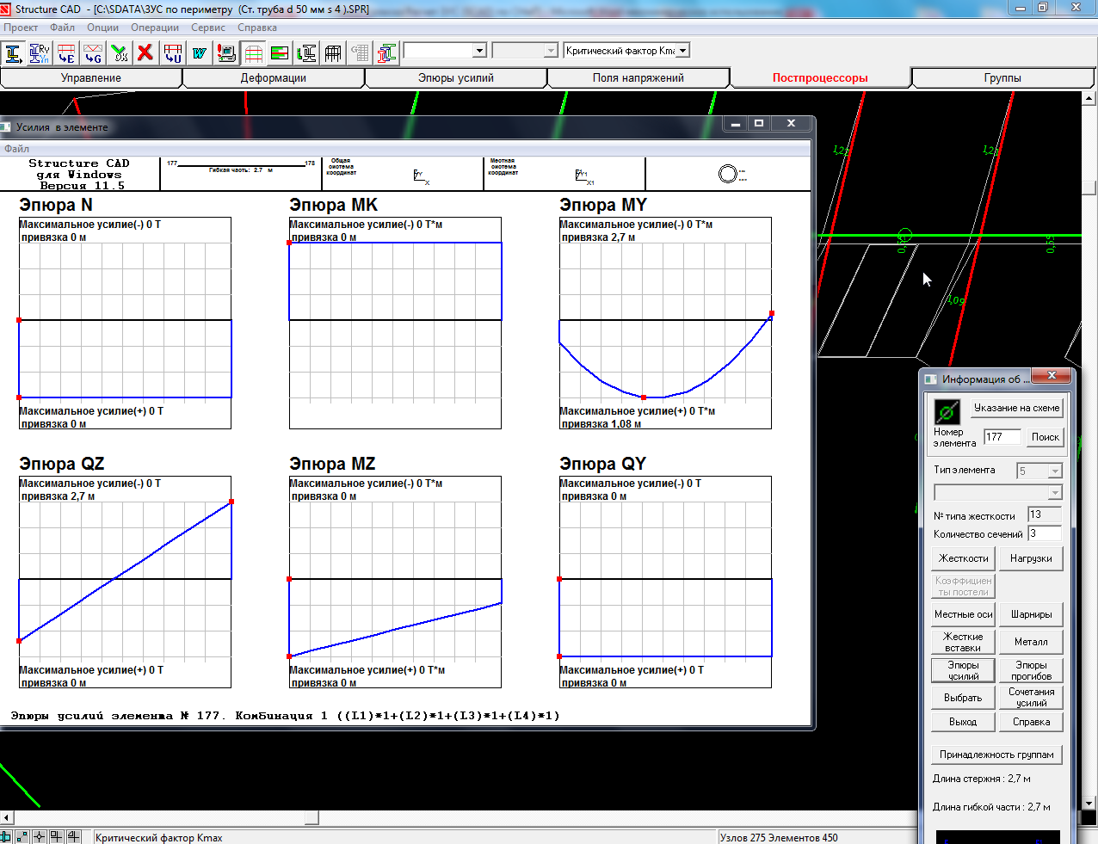 *The selected SNS horizontal pipe element 177 diagrams*

In the element 177 axial force N = 0, bending moments M x,y = 0 It is impossible to analyze a horizontal tube with diameter D = 50 mm and wall thickness s = 5 mm made of Al 6063 T5 aluminum alloy since an object fallen onto a SNS horizontal pipe does not transmit any loads. Calculation by the formulas reflects the colors of the SNS diagram elements accurately.

The SNS design diagram in the SCAD software cannot display elastic behavior of a net, cables and ropes. Ropes in the diagram are presented by the bars divided into 2-3 segments connected by kinematic pairs. The place of an object fall onto a net is presented by a plate (in the first options of the diagram it was presented by two plates) with an area of 2.0 m². This kind of design diagram provides rougher conditions for SNS columns than in practice. It is therefore necessary to include at least 6 (six) columns into a test kit for the SNS testing.

Annex 1. Factors for strength analysis of steel structure elements with regard to plastic flow (Standard of Israel 1225)

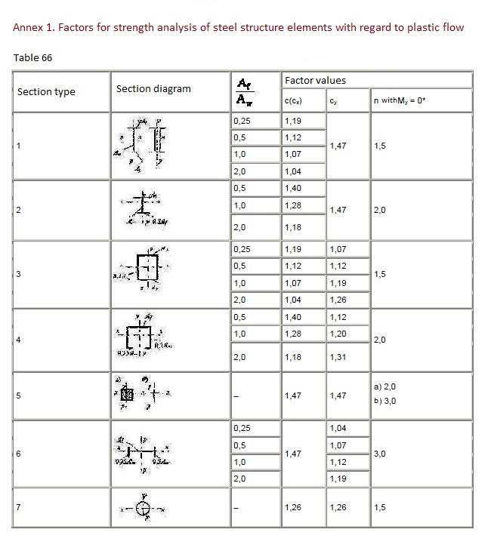

Annex 2. Geometric properties of a steel pipe d = 50 mm; s = 4 mm



| **Section element** | **Angle** | **Inversed manner** |
| --- | --- | --- |
| Hot-deformed seamless steel pipes, GOST (State standard) 8732-78 50x4 | 0 degrees | - |

Dimensions 50 x 50 mm

|  |  |  |  |
| --- | --- | --- | --- |
| **Geometric properties** | | | |
|  | **Parameter** | **Value** | **Measurement units** |
| A | Cross section area | 5.781 | cm2 |
|  | Incidence of inertia axes | 90 | degree |
| Iy | Moment of inertia about central axis Y1 parallel to axis Y | 15.405 | cm4 |
| Iz | Moment of inertia about central axis Z1 parallel to axis Z | 15.405 | cm4 |
| It | Free torsion moment of inertia | 30.81 | cm4 |
| iy | Radius of gyration about axis Y1 | 1.632 | cm |
| iz | Radius of gyration about axis Z1 | 1.632 | cm |
| Wu+ | Maximum section modulus about axis U | 6.162 | cm3 |
| Wu- | Minimum section modulus about axis U | 6.162 | cm3 |
| Wv+ | Maximum section modulus about axis V | 6.162 | cm3 |
| Wv- | Minimum section modulus about axis V | 6.162 | cm3 |
| Wpl,u | Plastic section modulus about axis U | 8.438 | cm3 |

Annex 3. Table 51, a. Characteristic and design strengths under tension, compression and bending of pipes for steel structures of buildings and facilities (Standard of Israel 1225)

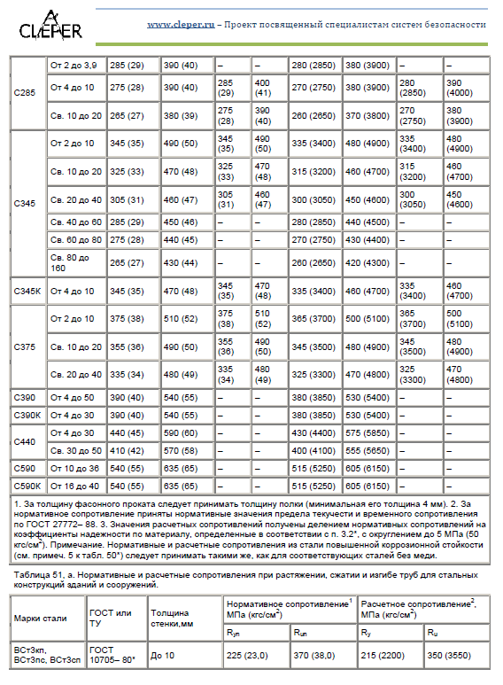

Annex 4. Structural behavior factor (Standard of Israel 1225)

Table 6*

|  |  |
| --- | --- |
| Structural elements | Structural behavior factors, γс |
| 1.Continuous beams and truss compression members of floor structures under theater, club, cinema halls, under tribunes, shop premises, storerooms and archives, etc., with floor structure weigh equal to or exceeding live floor load | 0.9 |
| 2.Public building and water tower columns | 0.95 |
| 3.Compression main members (except supporting members) of compound T-section grate of welded truss L-bars of ceilings and floors (eg, of pitched and similar trusses) with flexibility λ = 60 | 0.8 |
| 4.Continuous beams while analyzed for general stability with $φ_{b}$ $<$ 1.0 | 0.95 |
| 5.Tie-bars, pull-bars, tiebacks, tension rods made of rolled steel | 0.9 |
| 6.Ceiling and floor bar structure elements: |  |
| a)compression member (except closed piped sections) while analyzed for stability | 0.95 |
| b)tension members in welded structures | 0.95 |
| c)tension, compression and joint bars in bolted structures (except high-strength-bolt structures) made of steel with flow limit up to 440 MPa (4.500 kg/cm2) exposed to permanent load, while analyzed for stability | 1.05 |
| 7.Continuous compound beams, columns and joint bars made of steel with flow limit up to 440 MPa (4.500 kg/cm2) exposed to permanent load and made with the help of bolted connections (except high-strength-bolt structures), while analyzed for stability | 1.1 |
| 8.Sections of rolled and welded elements as well as bars of steel with flow limit up to 440 MPa (4.500 kg/cm2) in the bolted joints (except high-strength-bolt structures) exposed to permanent load, while analyzed for stability: |  |
| a)continuous beams and columns | 1.1 |
| b)bar structures and floors | 1.05 |
| 9.Compression members of grate of spatial trussed structures of individual equal-angle L-bars (attachable by a bigger leg) |  |
| a)attachable directly to booms by one leg with the help of weld or two bolts or more along the L-bar |  |