Government of the Russian Federation

National Research University Higher School of Economics

*Faculty of World Economy and International Affairs*

*Educational Programme*

*“Socio-Economic and Political Development of Modern Asia"*

TERM PAPER

Green business in Indonesia

|  |  |
| --- | --- |
|  | Student |
|  |  |
|  | Maksimenko Maria |
|  |  |
| Reviewer | Scientific Advisor |
| ______________ |  |
| Name, Surname | Sergrei Shaposhnikov PhD |

Moscow, 2019

Indonesia has high hopes for 2045. It is going to celebrate a hundred years of independence from the Dutch rule, which Indonesia gained in 1945. Right now, country is very optimistic towards its economic growth and vast opportunities. It is a very attractive place for foreigners, who want to start their business in Asia. This essay focuses on green business opportunities in Indonesia. The reason for that is simple – country wants to develop its potential, for that it needs fresh ideas and lifelong profits. Modern world is changing towards environment-friendly society, famous companies step on the way of conscious production and consumers are tend to trust eco-friendly brands. Indonesia aims to become a fourth world’s economy, it has everything to become it in the future – it is rich in natural resources, and at the same time has a wish to try another sector, that differs from agriculture, fisheries and mining. To achieve its goal, it needs to apply its characteristics to an absolutely new movement, which is green business.

Indonesia consists of five major islands and about thirty smaller groups, which makes it the largest archipelago of 17.000 islands in the world with the size of 1,904,569 kilometers. It is the world’s fourth most populous nation, where 86 per cent of population is Muslim, 6 per cent is Protestant, 3 per cent – Roman Catholic and 2 per cent is Hindu. It is a multicultural, multiethnic and very diverse country, with over 580 languages and dialects. All of these impressive facts make it hard to manage, that is why for many years no one could see a future for this archipelago nation.

However, today Indonesia is one of the fastest emerging economies in the Southeastern Asia. Country is aiming to make a step forward in terms of economic growth. One of the most interesting evidence for it is the passion for smartphones, that occupied every and each Indonesian. Country has a very young population, and this generation is the key for the progress. They like online communication. This is something people overseas need to understand when dealing with their culture. Smartphone is a tool of business, everywhere, but especially in Indonesia. They do business online, buy online, they love new technologies. This can sound as a good opportunity and even advantage for those planning to do business with Indonesia. Yes, it is a far away country, but it is easy to reach. Also, technologies are driving the educational progress. Although local main language is Bahasa, people in Indonesia really can speak English, it keeps them open to the world, so it allows foreign business to enter the local markets.

As Indonesians are willing to grow and attract foreign investments, they try to stay in trend. In terms of eco-business, it can seem to be a hard task, as Indonesia is one of the most polluted countries. This is an upsetting fact, considering that Indonesia is a home for the tremendous amount of animal and plants, both in coastal and marine areas. Indonesia’s flora is estimated at 12 per cent of the world’s mammal, ranking it second after Brazil, 16 per cent of world’s reptiles and 17 per cent at of world’s birds. The growing population, both locals and tourists, and poor environmental management hurt Indonesian’s economy. According to the World bank analysis, total economic losses attributed to limited access to safe water and sanitation are estimated at 2 per cent of GDP annually, while the annual costs of air pollution to the Indonesia’s economy have been calculated at around 400 million dollars per year. Improving this situation require a new vision, supported by the government. It is hard to get the trust of local government, because for them the most trustful areas in business are oil and gas. But common people and activist are trying their best to introduce new areas for business, that can help to reduce pollution.

Source: Asian Development Bank. Asian Development Outlook 2019

Recycling and zero waste are the key drivers for Indonesia’s transformation into the next largest economy. It was mentioned about its vast territories, rich nature resources, plus, do not need to forget about the cheap labor force, willingness to communicate and openness for foreign investments. The combination of all these factors creates a huge variety of green businesses.

For example, Evoware, an Indonesian startup, makes eatable food wrappings. They design cups, straws and other containers, made out of seaweed-based material that can be eaten. This is a perfect alternative to a plastic packaging that is almost impossible to recycle, so it is usually thrown away, which became a major threat to the environment. Marine plastics put oceans in danger. By 2050, it is estimated the volume of plastic will be greater than that of fish in the sea. Countries in East Asia and the Pacific contribute the most to marine plastic pollution.

Evoware introduces seaweed as a solution for this problem, which is a great example of how a biological feedstock can be used for a technical purpose and then safely biodegraded. Evoware is planning to increase its local capacity and to expand internationally, because seaweed has the capacity to grow on almost every coastline.

This is an amazing business for Indonesia, as country is now taking part in a cleanup drive, led by United Nations, after it was rated the second biggest plastic marine polluter after China, according to a 2015 report by Science journal. From shampoo sachets to a handful of peanuts to keropok (a popular Indonesian rice cracker), Indonesians often buy single-use items that are contained in plastic packaging. The first product of Evoware was the seaweed-based jelly cup, then they expanded their production into other types of packaging, such as dissolvable sachets for coffee or seasonings.

Evoware’s co-founder David Christian said the idea of seaweed-based edible packaging was spurred by his desire to fight an explosion in plastic waste over the last few years in his home city of Jakarta, Indonesia’s capital of 10 million people. He says, that inspiration came from a childhood experience when I woke up late for school and to save time had instant noodles for breakfast. Preparing them can be speeded up when there are no small sachets to be opened. The second inspiration comes from the fact that Jakarta, where I live, often suffers from flooding due to plastic waste clogging up the water system. These experiences have challenged me to turn research into real solutions for the market.

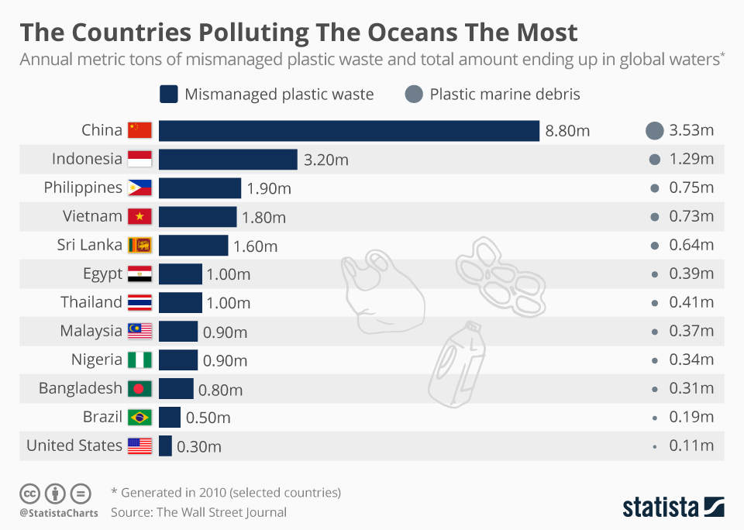

It manufactures the material directly from plant matter, making it not only edible but also nutritious. You can literally eat your burger with the wrapping still on, or dissolve your coffee granules along with their sachet in hot water and drink it. In addition, Evoware has designed a version, made using damar resin from South Asian fig trees, that holds liquids, creating readily compostable packaging for personal care products and medical supplies.

The advantages that make Evoware stand out is that the used seaweed is without chemical additives in applications where its ability to dissolve in hot water or be eaten adds functionality and value. Among unaltered biomaterials, seaweed has one of the best mechanical properties while still being energy efficient and very economical. In addition, its cultivation does not need land acquisition or deforestation as is often the case when land-based plants are used to provide bio-sourced materials.

Advantages for seaweed business in Indonesia:

1. Huge consumer growth predicted.
2. Indonesia is a very large single market – easy access to 264 million people – no many countries have that.
3. Indonesia has the seaweed raw materials, the seaweed processors and the market.
4. The Indonesian government is encouraging in-country production and considering tax incentives.
5. Almost zero capital required: bamboo frames, plastic bottle floats, detergent for reducing epiphytes, dry in the sun.
6. Improvements simple and cheap: seaweed spacing on the line, line separation, cleaning weed with detergent.
7. A major focus of the MMAF (Ministry of marine affairs & fisheries).

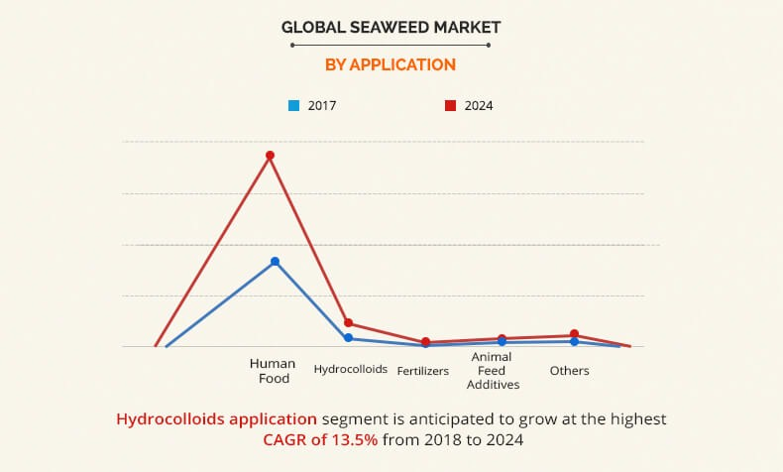

Having analyzed the presented data, it is fair to admit that there is a big future for green business in Indonesia. However, it is a very unique country with specific features and it can be really challenging to do business there. Consequently, many entrepreneurs stick to well-known roads such as China or Japan. However, entry barriers may discourage businesses that do not have a global vision and those who are complacent when it comes to their growth. It should be considered as an opportunity rather than a setback, because if fewer western businesses are entering the market, then there is less competition, making it easier to succeed. The key message here is to have patience, and seek expert local assistance to guide through the entering process.

Moreover, the 2019 Business Confidence Index found that 51 per cent of foreign investors are worried about corruption, compared 43 per cent in 2018 and 49 per cent in 2017. Despite that, other opinions suggest that conditions in Indonesia are improving. For instance, Transparency International’s Corruption Perceptions Index scores Indonesia’s corruption perception at 38 out of 100 points, beyond Brazil and Russia. Indonesia’s rank in this index has steadily improved since 2012, where it scored 32 out of 100 points. Indonesia’s government has made steps to reduce bribery and collusion, such as moving many business application’s processes online.

In the conclusion, it is better to point out more of positive aspects of doing business in Indonesia. As a member of the Association of Southeast Asian Nations (ASEAN), Indonesia trades with nine other member states with minimal or zero tax. Other member countries include Thailand, Malaysia, Singapore, the Philippines, Vietnam, Myanmar, Cambodia, Laos, and Brunei. Businesses are looking to export their goods to other South Asian markets will be able to do so with ease with an Indonesian presence. With ASEAN alone, Indonesia’s traders can access a population of more than 650 million and a 2018 combined GDP of 2.92 trillion dollars. 60 per cent of global growth is expected to come from Asia by 2025. Through its connection to ASEAN, Indonesia also has preferential trade access to India, China, South Korea, Japan, Australia and New Zealand. Another big plus: since 2015, foreign entrepreneurs can legally own land in Indonesia for three purposes: to build (Hak Guna Bangunan), to cultivate (Hak Guna Usaha) and to use (Hak Pakai). Hak Pakai allows foreign entrepreneurs to buy houses and apartments in the country, and become permanent or temporary residents, or even incorporate a buy-to-let business and invest in property. Only entrepreneurs with a local or foreign-owned company or a valid work and stay permit (KITAS) can apply to Hak Pakai.

In the end, do not forget, that green business is not only about making good money. First of all, it is about how to make our blue planet a better place to live on.

Bibliography

1. <https://www.adb.org/countries/indonesia/economy#tabs-0-0>
2. <https://globaledge.msu.edu/countries/indonesia/economy>
3. <https://www.reuters.com/article/us-indonesia-evoware/indonesian-startup-wages-war-on-plastic-with-edible-seaweed-cups-idUSKBN1DN0XA>
4. <https://www.worldbank.org/en/news/feature/2019/05/31/meet-the-innovators-battling-plastic-waste-in-indonesia-mohamad-bijaksana-junerosano>
5. <https://www.indonesia-investments.com/business/item7>
6. <https://greenhouse.co/blog/challenges-doing-business-indonesia/>
7. <https://mybusiness.singtel.com/techblog/5-things-you-should-know-about-doing-business-indonesia>
8. <https://www.pwc.de/de/internationale-maerkte/assets/doing-business-in-indonesia.pdf>
9. <https://www.bizlatinhub.com/why-invest-and-do-business-indonesia-2019/>
10. <https://www.worldbank.org/en/country/indonesia/brief/world-bank-and-environment-in-indonesia>