**WEDDING PHOTOGRAPHY TIMELINE**

Your wedding day is your special day! It’s only your story and this day should be planned properly just to be the best in your life! A good photography timeline for wedding will able to have all details related to the especial events occurring during the day. Also, it should contain information about what is anticipated from those who make good photography. Here, we can imagine your BEST DAY making wedding photography timeline.

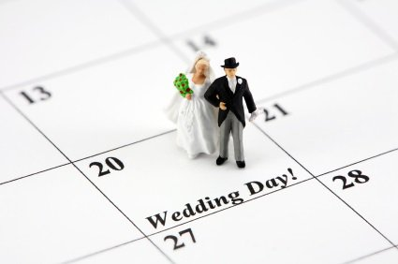 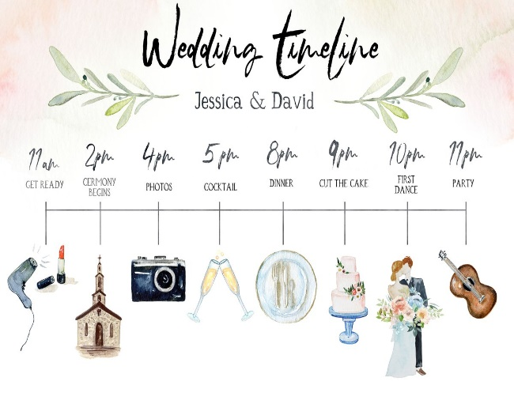

*How Long Do Wedding Photos Take*

First of all, we should remember that all weddings are different. But there are specific time frames and in more cases they are similar in more or less degree. Sometimes we can observe some cases when wedding may be slightly behind schedule. Also, you should always remember that your wedding will fly by so quickly, before one can say Jack Robinson. But, you know, with our photographers and videographers your special day will be full of fun, unforgettable emotions and memories.

Moreover, you should remember that you will get your photo album and video film after wedding and it will warm up you and your family during cold winter evenings. You will see all best moments, all relatives and guests, all smiles, happy tears and the smallest details. Take into account that photographer will be near all your wedding day making the best photos and wedding day photography timeline can last for five, six, eight hour timelines or even more hours if you want, but be sure that all your memory will be captured on photos and videos. Further we will consider all steps for wedding photography planner.

*Details And Wedding Little Things*

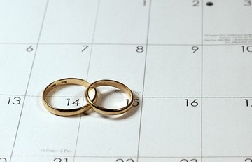

Necessary time: 30 – 40 min

Before ceremony start time all photographers and wedding videographer will arrive to pick up a beautiful story of two lovely hearts. We will start from the magical morning of any bride and groom. The best time for awesome wedding photography schedule.

Capturing all the details of the long awaited day will have to help to narrate the perfect story of your wedding. We know, that this is so important to bride, groom and all their folks. These specifications include bride dress, groom costume, images, jewelry, shoes, wedding rings, and bride to be bouquet.

*Photo And Video Of Wedding Preparation*

Necessary time: 60 min

By that time when you and your bridal party are in the ending stages of hair and makeup, your personal photographer should come to take pictures of all details of the wedding that you are going to remember.

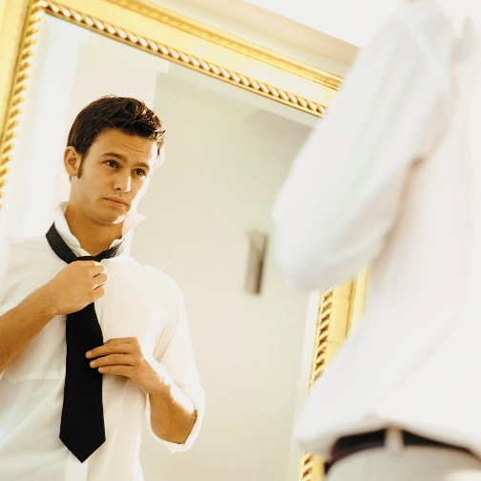 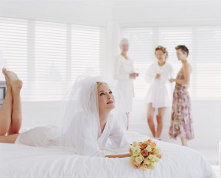

Also, it is so important to make awesome photography timeline for groom. We can send over our 2nd photographer or cinematographer to take some funny shots of the groom and groomsmen getting ready and then if there is enough time, some pics of them as well all hanging out together.

*Individual Portraits Of The Bride And Groom*

Necessary time: 30 min

The best time to make portraits of bride and groom is after preparation time. Bride’s makeup and hair is fresh and groom’s suit is elegantly stroked. They don’t feel anxiety, so that is wonderful wedding timeline. So, because of photographer, equipment and good light refraction we will get ideal portraits.

*Couple Together*

Necessary time: 45 – 60 min

Morning or early afternoon can be the best choice for making timeline with first look. You can choose venue garden or park with plenty of trees and colorful flowers. You know it’s the first time bride and groom met each other in wedding outfits and it can last for 10 minutes. After this timeline with first look photographers and videographer will make some photos of newlyweds.

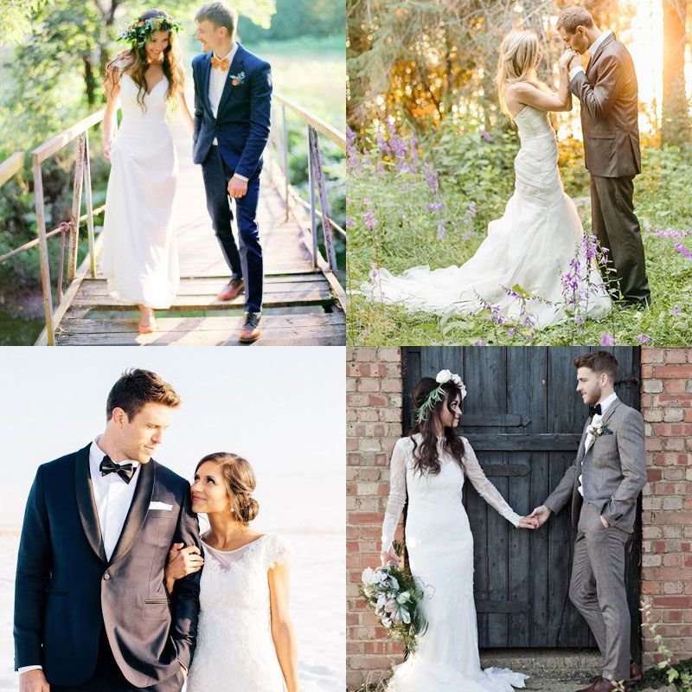 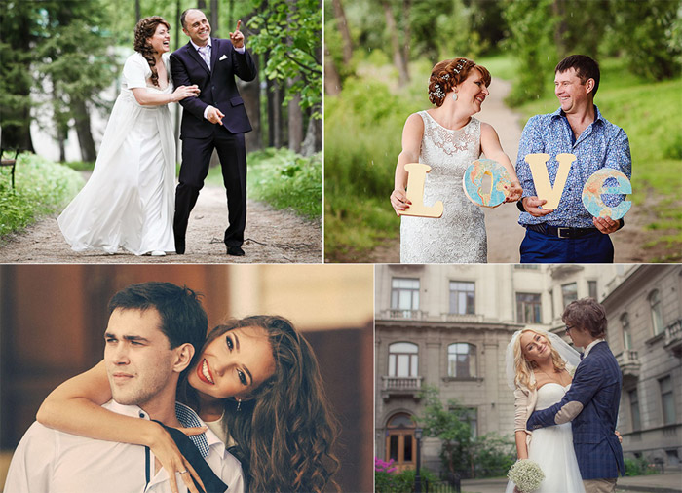

*Family Photos*

Necessary time: 35 – 45 min.

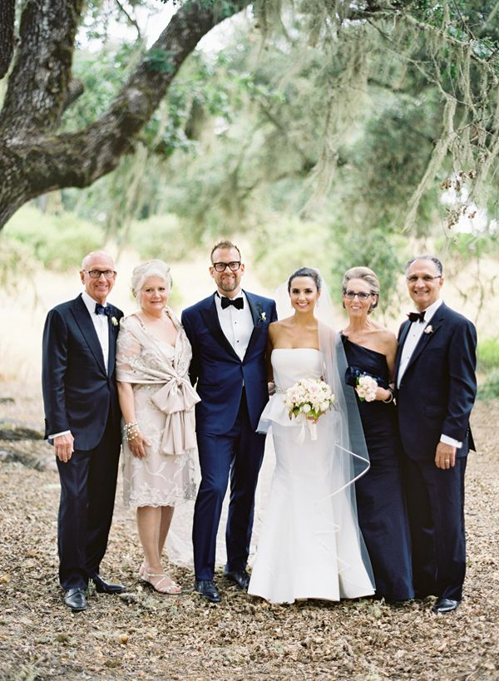

We think that one more important step in your photography wedding timeline is that you should take more photos of your family and close relatives. We can make photos on the seaside, park, garden, lobby or another preferable place. Photographers will take pictures of lovely couple and their parents, grandparents, aunts and uncles, sisters and brothers, and with every person that important to newlyweds.

*Friends Photos*

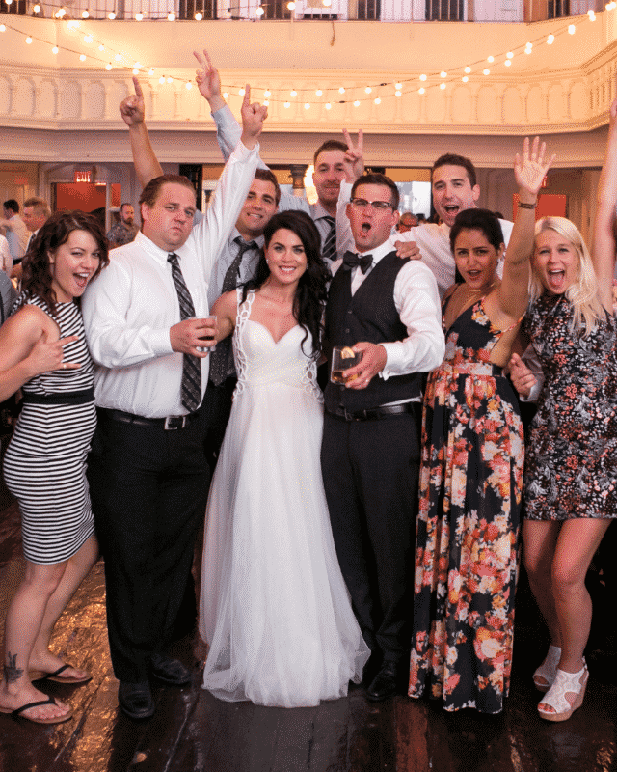

Necessary time: 45 – 50 min

These kinds of photos can be made after ceremony and the ideal time will be afternoon or morning (if you want). On average, we plan on 3 minutes per every group. It can be 10 groups, but it also depends on number of invited people.

*Ceremony Venue Details*

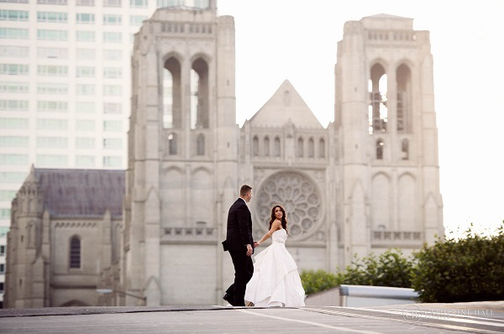

Necessary time: 30 min

Ceremony place will be perfect for these photos. You can ask us “when do you take wedding pictures?”, of course it will be afternoon time. It will be awesome photos without guests or vendors. Before the time guests coming we made all set up of ceremony site.

*Cocktail Hour*

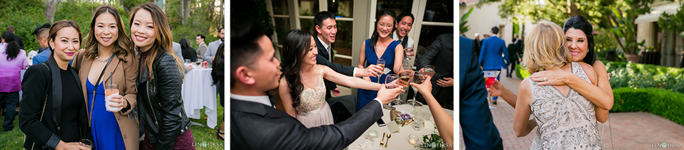

Necessary time: 40 – 60 min

Also, it is so important part of your wedding party photos. Here, you can have pics with all your guests and relatives, you can share these perfect hours with them, and we can capture this. Everyone who was invited on wedding can also take photos with someone he/she wants. There will be plenty of positive emotions and happiness.

*Reception Details And Views*

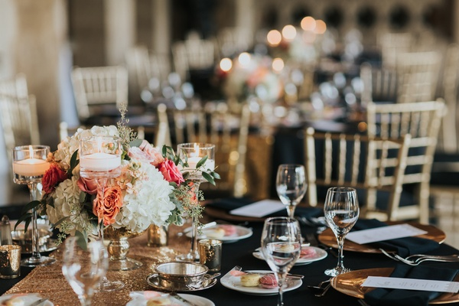 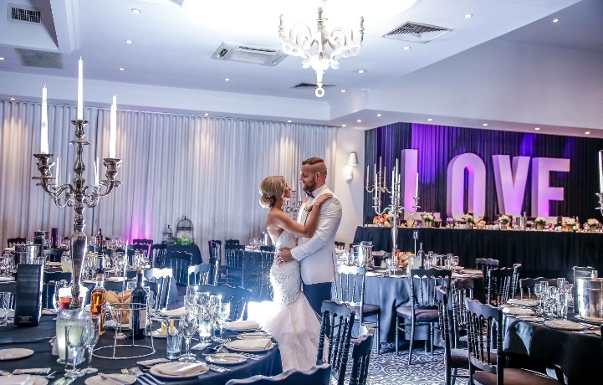

Necessary time: 10 – 15 min

Wedding day photography checklists can include photos of lovely couple in the empty wedding hall and all the details of it. It will be better to do at the end of cocktail hour before guests come in. It will be a great opportunity to capture an honest-to-goodness reaction.

*First Wedding Dance*

Necessary time: 5 – 7 min

Wedding timeline example also include the photos of couple first dance. We will see all details on the photos. Your love, smile, ease of movement and enthusiastic faces of people. This is exactly your moment when you shine as bright as the stars in the sky.

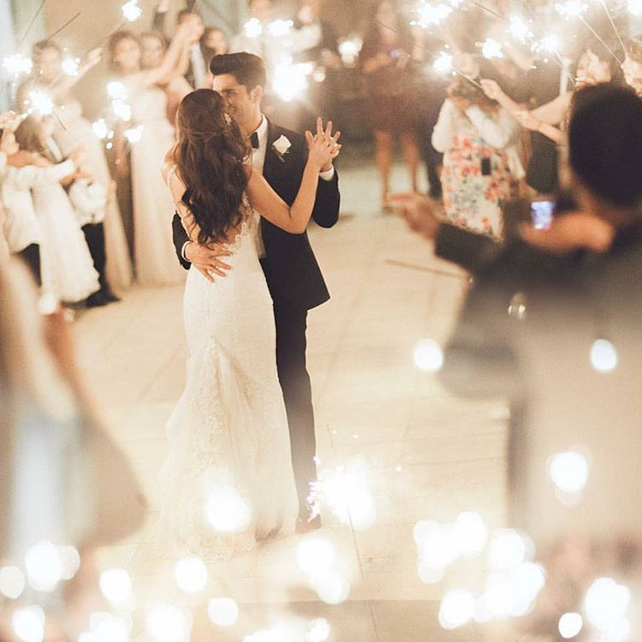

*Night Wedding Photos*

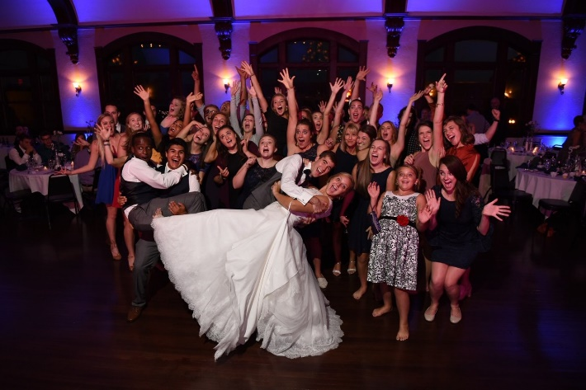 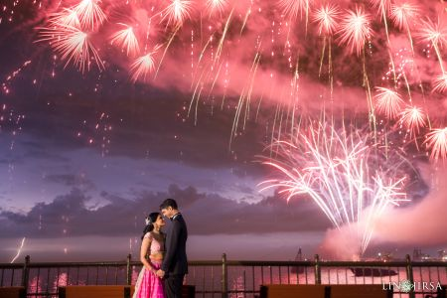

Necessary time: 20 – 30min

Night wedding photos is one of the most magic part of all your wedding day! One of the best timeline will do especially at this moment! It can be areas with interesting lights, fountains, fireworks, cityscapes and so on. These photos will be so bright as you are. Our suggestion is to make these pics at the end of the day, maybe even that time when guests will be departed. Be sure, it will be the best ending of the day, and really great 6, 7 or 8 hour timelines.

*Last Thoughts*

With a finished wedding photography timeline template in your hands, your wedding will be great and there won’t be additional unnecessary worries.

We attached below the example of wedding photography timeline. Maybe it will be useful for you or you will add something from this list to your wedding timeline.

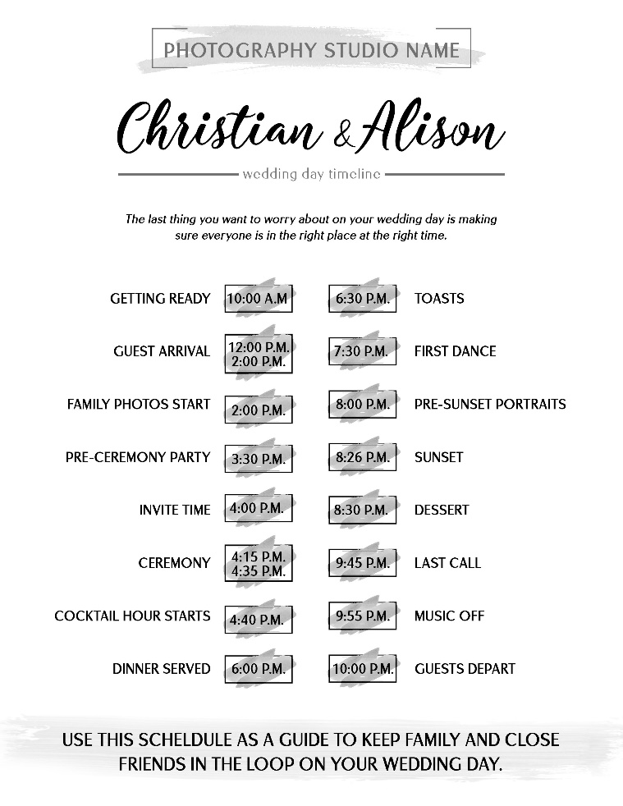

Wish you perfect wedding day!