**Semalt - The SEO Breakthrough**

When you start treating your website as part of your business, you suddenly discover that it needs to be well integrated into the business processes of your company. You can't take responsibility and control the internal processes of the website, because it requires special knowledge in SEO-optimization. The search engines are constantly releasing updates lowering the website's position, so there's no point in hoping that some hired dabbler would help to stay on the top positions. It is the purpose of the highest class professionals, such as Semalt.



To grow your business through the website, you will need not only SEO optimization but the marketing experience as well. Semalt has been promoting sites for a decade and has an impeccable reputation within the field. Our company gives a helping hand to all website owners who have chosen the path to prosperity. If you read customer reviews on our website, you will surely understand why you should entrust the website promotion only to us. Check out the real cases with examples of how people were wrong in choosing partners. They had to beg Semalt for salvation, and we did not turn our backs on them. We made people rich and keep doing it even now.

Semalt is not limited in website optimization, it's responsible for the successful future of each customer. This is the difference between Semalt and the webspace impostors, who claim to be SEO-experts. We don't waste time on self-promotion, and we're not trying to convince people of something, we're just doing our job. Our reputation is based on the customers' success.

Speaking of Semalt, it should be noted that the competence in SEO-optimization was achieved by diligence and the desire to be useful. Therefore, the company does not recognize the levity and irresponsibility. Today, Semalt proudly presents its [powerful team that consists of world-class professionals](http://joxi.ru/RmzN1WvcRn9Wxm). The websites are optimized by experienced SEO experts, qualified IT-specialists and analysts. We must pay tribute to our talented copywriters and designers, who directly participate in website optimization. Each workflow is controlled by professional managers, and only well-coordinated actions of the team allow Semalt to have a reputation of the undisputed leader.

In addition to what has been said, every Semalt specialist speaks several world languages and has deep knowledge in SEO optimization. Now it's obvious that the matter is more serious than you thought it was, and see the difference. If you plan to have a business, Semalt can tell you how to make the right investments. It is worth talking a little about SEO because it's the foundation of further website development.

**Search Engine Optimization**



SEO is a comprehensive development of the website and its promotion for raising to one of the top positions in the search engine. SEO-promotion of the website can be defined differently, namely as a channel to attract traffic to the site and a method to impact the search robots to reach high positions in the search engine. The question appears as to why it's so important to be in the top positions. The answer is given by the search engine statistics on commercial requests, that is, the requests reflecting users' desire to purchase something.

Today, the number of websites on the internet has exceeded the six-digit figure. This indicates that a lot of people want to do online business and earn money on it. People are fighting for a place under the sun that causes fierce competition. Everyone wants the website to be on the front page of the search engine; otherwise, the user can simply miss it. You may have a quality website, creative design, unique content, but it's not enough to appear in the top positions. That's why SEO optimization exists.

Any business person would be happy to draw lots of attention toward the company, brand, product, so it is essential to make every effort to get a leading position in the search engine. The conditions for successful optimization are created by Semalt, because the company is constantly improving its technologies. Fast transformation in SEO makes it possible to conclude the need for tracking the current news in the field of search promotion. This is the only way to expect high promotion efficiency.

The main goal set by the search engines is to make a user-friendly internet-search. So on the first positions would only be the websites that are interesting to users. To achieve this, the ranking algorithm is constantly changing, it means that SEO optimization must be regularly improved and be as much adapted for people as possible. SEO promotion constructively affects the development of any business, and any company can take absolute advantage of it, regardless of the type of activity and the scope of implementation. Semalt has created and willingly offers unique website optimization solutions such as AutoSEO and FullSEO.

**What is AutoSEO**



To promote the site on the internet, you have to take a number of actions, which will increase the resource traffic. AutoSEO provides a set of mandatory procedures that guarantee the promotion of the website to the top positions. [The AutoSEO campaign](https://semalt.com/autoseo) does not require considerable time and financial expenses, but it'll bring huge results in the future. All campaign stages take place in strict interaction with a Semalt specialist, so your website is not subject to any threats. On the contrary, its configuration will be transformed, which will allow you to count on fantastic results. The good results are the indicators of the effectiveness of the method, so Semalt is overly interested in successful promotion of your website. AutoSEO includes the following tasks:

1. selecting appropriate keywords;
2. website analysis;
3. website research;
4. website error correction;
5. forming links to niche-related websites;
6. ranking upgrade;
7. customer support.

In order to launch the AutoSEO campaign, you must [register on our website](https://semalt.com). Then all the processes pass the following scheme: full analysis of the site and delivery of reports displaying the analysis's results. Each operation is divided into a few necessary actions performed by our SEO engineer. The SEO engineer carefully examines the structure of the website and corrects all the errors detected. For your convenience, the campaign proceeds without your participation, but you get all the reports and stay up to date with all the changes on the website. To increase the website traffic, the proper keywords will be selected in compliance with SEO standards.

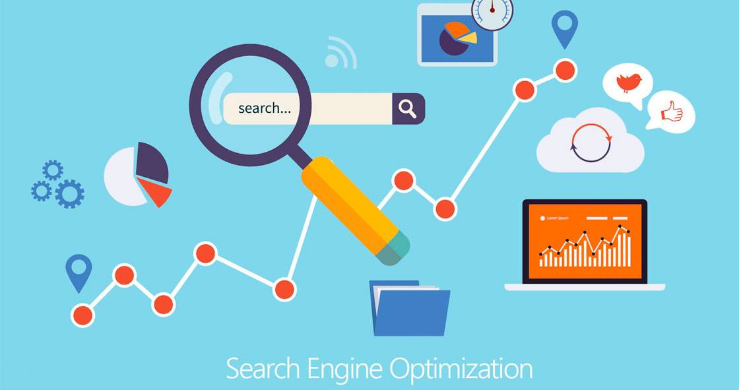

At one of the stages of optimization, it is necessary to select the right internet links for the further insertion into various online resources. Lots of attention will be paid to the meaningful correspondence of the content. The search engine doesn't accept the irrelevant content, so our specialist will check the relevance of the content and make changes if necessary. All the resources intended for the insertion of the links should also be relevant. In order to eliminate even a slight risk for the website, our manager personally monitors the process. As a result, the website properties will be enhanced and contribute to blistering optimization.

After finishing all the preliminary procedures, the final website processing phase begins. This involves making changes in the structure of the website. The Semalt manager oversees the specialist's actions, and after the mutual approval, the decision to perform technical edits can be made. The report makes it clear what components of the structure need to be changed for the productive optimization. The access to FTP (File Transfer Protocol) allows responding quickly to the signals of the search engine, as ranking is periodically updated.

You are always aware of all the updates and may request Semalt for an explanation of incomprehensible data. After all the edits have been made, the process of inserting the keywords starts. The specialist repeatedly checks the keyword compliance with the content. So you're conducting an AutoSEO campaign being just an observer, but your job is to capture the positive results of optimization. It should be noted that the price of the AutoSEO service is more than acceptable, it costs only $99 per month.

**FullSEO**

For those whose business is time-limited, Semalt offers a unique campaign - [FullSEO](https://semalt.com/fullseo). This is an excellent alternative for long-term website optimization methods, which has been appreciated by the majority of the website owners. It also includes several stages, each of them consists of the necessary procedures. FullSEO certainly guarantees the growth of the rating score, moreover, the search engine will direct your website to the top positions. The advantage of the FullSEO campaign is also in discarding your competitors. The positions of their websites will always be lower than yours. Good news from Semalt!

The FullSEO campaign is launched after the registration on our website. If the registration is successful, the automatic analysis of the website starts with no delay. The first task is internal optimization. For more concise description of the process, this phase is intended for thorough checking of the website structure. You receive a detailed report that clearly shows the properties of the structure and the errors detected.

Fortunately, you don't have to take any action because the process is entirely supervised by Semalt, and all actions are carried out by our SEO expert. In other words, you're an observer. The SEO expert will eliminate existing errors and determine the semantic core. Internal optimization also includes selecting the keywords related to your subject. Only our specialists can choose the right keywords and spread them among the pages. The keywords will be the basis for increasing the website's traffic. Access to FTP makes it easier for the specialist to make the necessary changes on the site.

The second task is external optimization. This is necessary to amplify the visibility of the website as well as to raise its credibility. Actually, it's an extension of the resource's link juice by inserting backlinks. A lot of attention is paid to the quality links and the third-party resources, into which these links will be inserted. The higher rating of a third-party resource is, the greater link juice is. This is another reason why you can't act without Semalt. The resources with a bad reputation might simply crush your website. Our specialists conduct a thorough selection of the resources, because the outcome of the promotion depends on it.



Semalt works closely with hundreds of trusted websites, so the resources with only the most relevant content will be selected. After inserting links, you may confidently expect the successful website promotion. You are regularly informed about all the changes on the website. Numerous reports allow you to see the real rating growth. The continual communication with the specialists makes your participation in the process minimal, although all responsibility for the FullSEO campaign stays on Semalt.

Maybe you'll ever have to suspend SEO promotion, in this case, there's no need to worry. Although rankings will start falling after Google removes backlinks from the data archive, the fall won't be too rapid. Anyways, rankings will remain on a certain level, which is much higher than the one before the FullSEO campaign. The state of your website plays a significant role in price formation. So, the final price can only be known after the SEO expert examines the site and makes a conclusion. No matter what the costs will be, you can be sure that the profit will be twice as high.

**Analytics in SEO Promotion**

Some website owners falsely believe that it is possible to evaluate the success of SEO promotion by the dynamics of traffic growth. The increased traffic is a partial assessment of the correct actions of SEO specialists. If the main goal is to boost sales through website optimization, the traffic is not the only criterion for a successful promotion. It's clear that the assessment of efficiency should be formed on the basis of a detailed analysis of all SEO achievements. That's why Semalt developed and implemented a unique analytical system - Analytics, allowing you to make an objective assessment of the website promotion. Analytics is directed to identify the technical errors on the website and offers rational solutions to correct them. So, the [main tasks of Analytics](https://semalt.com/analytics) are as follows:

1. keyword suggestion;
2. keyword ranking;
3. brand monitoring;
4. keywords position analysis;
5. competitors explorer;
6. website analysis.

Analytics will assess the quality of the website optimization, identify factors that negatively affect the positions in the search engine, make a list of the main target requests that have to be included in the semantic core. The system applies the innovative techniques that meet the requirements of SEO evolution. Careful verification of the website's content reveals the minor errors and allows to respond correctly. To run Analytics, you need to sign up on our site. Once you've registered, you'll start receiving various reports with the analytical data. According to these data, our experts will make the right changes to the website. Additionally, the system collects the information of your competitors' websites for comparative analysis.

If you have a valid account, you can add any third-party websites to your personal cabinet. Analytics begins to analyze each added website and deliver a report with detailed information about those websites. It's very easy to check their real position in the search engine. Our experts regularly monitor updates of the search engine algorithms and make appropriate changes to the website. Using analytical data, the right keywords are determined according to the content of the website. You can also add or delete any keywords because the basic set of keywords is already selected. Literally, within a month, you will notice a rapid increase in traffic.



The analytical data is collected around the clock. You don't have to do anything but get the reports on promotion and fixing the positive results. If you want to test the correctness of our experts' actions, look at your website's position in the search engine. It will pleasantly surprise you: your site takes the top positions. As Semalt assures, your former competitors can never catch up with your website's position anymore. Many website owners use the Application Programming Interface, with the help of which all the data is automatically synchronized. The informative reports make it possible not to participate in the process, but stay up to date with the current updates. Semalt offers three Analytics packages with different prices:

1. STANDARD — $69 per month (300 keywords, 3 projects, 3 months position history);
2. PROFESSIONAL — $99 per month (1 000 keywords, 10 projects, 1 year position history);
3. PREMIUM — $249 per month (10 000 keywords, unlimited projects).

Semalt has made great strides in web development. The features of the target audience force to find sophisticated solutions to improve the quality of commercial websites. Applying the unique technologies, our experts integrate the website components with third-party applications and Content Management System. The effectiveness of the methods is confirmed each new day. Our dedicated service for customizing specialized e-commerce modules and APIs has become the most demanded among users.

**Video Production by Semalt**



The internet is firmly embedded in our lives and provides the opportunity to receive information in a variety of ways. The benefits of video advertising fixed it on the high positions in the rating of methods to promote goods and services. It's not a secret that a [promotional video](http://joxi.ru/krDGJN7UJoPVEA) is the most effective method of attracting potential customers. With the help of the video, the impact on the audience goes immediately on two channels - visual and audible. Semalt took care of the commercial sites' owners and launched the Promotional Video Production. The advantages of our video are limitless: in a few minutes, customers will learn not only about the existence of your company, but about all its benefits as well. Also, the video will bring a lot of traffic to your website. The video is available in a template format or by your preference. Our creative video can rapidly spread online, ensuring the prosperity of your business.

After all, what has been said, it is impossible to doubt that the real path to prosperity goes through Semalt. We are proud of being useful, and people wishing to be wealthy reach out to us. We are always open to those who want to be rich. The success of our customers is our reputation. If you want to create a stable business, contact us at any time.