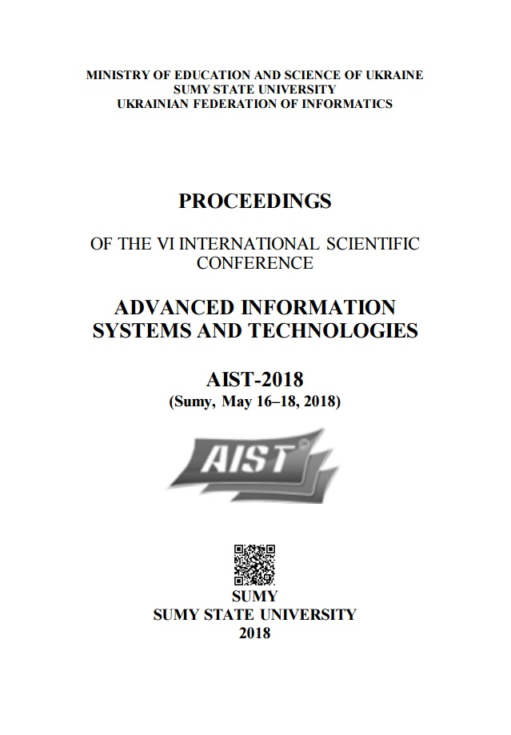

The VIth International Conference «Advanced Information Systems and Technologies, AIST 2018» 16-18 May 2018, Sumy, Ukraine

Mathematical model of the managing strategy selection in public catering establishment (based on Markov decision-making problem)

Abstract – The possibility of introducing a mathematical model for choosing the management strategies of a catering institution is explored. The main business processes of conducting economic activity of the enterprise are analyzed. The optimal mathematical model for constructing a short-term strategic plan of the enterprise is determined.
Keywords – catering institution, business process, optimization, management strategy, Markovʹs process.
- INTRODUCTION
The main strategic goal of using information technologies and systems in the restaurants business is ensuring its rapid and regulated development, manageability and quality, competitiveness, saving financial and time resources for business processes.
The most popular process is the development of software products for performing diverse operations, but processes that focus on building an optimal business strategy at different types of enterprises are also important.
These enterprises include catering establishments, which direct their activities to sales efficiency, taking into account moderate prices, attracting a large number of regular customers in the face of fierce competition, providing services with up-to-date and high-quality products.
The modern restaurant business requires the using of information systems in order to increase its efficiency. The level of introduction of innovative technologies in the organization and management of restaurant business directly proportional to the increase in the volume of progressive processes in it.
In order to achieve the goal of success and competitiveness of the public catering establishment, it is necessary not only to know what types of information technologies and automation systems to use, but also to thoroughly study the algorithms for their implementation and application.
The optimal combination of the type of mechanism and the practice of its operation directly affects the degree of compliance with the general requirements for business profitability.
In the modern restaurant business, information technology is used not only as a tool for business processes, but also as a factor that allows a performing of managerial functions. These include the management of the effective activities of the complex of interrelated divisions, as well as the management of the institution as a whole.
- ANALYSIS OF ECONOMIC ACTIVITY OF THE ENTERPRISE AND MAIN BUSINESS PROCESSES
An example of a catering institution whose leadership is primarily interested in achieving a higher level of profitability by introducing an optimal management strategy is the CoffeeMan coffee shop (Sumy, Ukraine).
To ensure the efficiency of doing business in the CoffeeMan coffee shop, Keeper is used. POS system (POS-Point of Sale) is a software and hardware complex that provides a typical set of cash functions: accounting and product release, reception and delivery money, cancellation of the purchase, functioning on the basis of the fiscal registrar.
The using of the receptionʹs system and processing orders through the introduction of information technology in the restaurant business is aimed at achieving the main goal - improving the efficiency of processing customer orders, due to achievements in the following areas: saving financial, people and time resources.
- ANALYSIS OF THE MAIN PROBLEMS OF THE ENTERPRISEʹS ACTIVITY
In the course of the analysis of the public catering establishmentʹs activity the main issues were identified, which negatively affects the achievement of the main goal of the restaurant business - obtaining and raising the level of profitability:
  - slowed down processes of receiving and processing orders that affect the high level of resource-intensiveness of business processes aimed at working with the client;
  - low level of competitiveness;

  - high level of resource intensity of managerial processes for monitoring the activities of structural units;
  - lack of a well-established system of searching for methods of attracting potential clients;
  - low level of managerial activity to attract additional tangible revenues.
The above problems are significant and create the need to automate the work of the institution through the use of information technology, and also determine the need to choose an effective business management strategy.
- ANALYSIS OF EXISTING METHODS FOR OPTIMIZING ENTERPRISE ACTIVITY
Optimization of the enterprise activity in the global sense is aimed at introducing innovative technologies and improving business processes. In the process of optimizing the activities of the enterprise, the deficiencies of business processes are eliminated, and at the same time, the most effective business processes are improved [1].
Optimization of the catering institutionʹs activity is a complex of interrelated administrative, organizational, information measures, united by a certain technology, aimed at improving the indicators of both individual processes and indicators of the institution as a whole in order to meet the needs of interested parties.
The optimization procedure involves the implementation of six steps:
  - Phase 1. Organization of improvement of the business process.
  - Phase 2. Documentation. A choosing of approach.
  - Phase 3. Analysis. Identify opportunities for optimization.
  - Phase 4. Designing a new, improved business processes.
  - Phase 5. Implementation. Implementation of the strategy.
  - Phase 6. Management of business processes for continuous improvement.
First of all, the optimization of the company's activity is aimed at its improvement, restructuring of the interrelations of the production substructures functional, which allows the raising of the level of competitiveness, profitability of the enterprise [2].
The basis for choosing the optimal strategy for the development of a catering institution is primarily determined by a number of organizational-economic, legal and labor actions aimed at providing the benefits of the business entity to its competitors.
A prerequisite for building an enterprise development strategy is its strategic analysis, for example, by conducting a SWOT analysis (a method aimed at schematically mapping the main objects for analysis: strengths and weaknesses of the enterprise, threats and opportunities of the environment) [3].
- MARKOVʹS PROCESSES AS A MATHEMATICAL WAY OF DESCRIBING THE FUNCTIONING OF COMPLEX SYSTEMS
In order to achieve the highest level of accuracy of the results obtained during the implementation of the management strategy, it is necessary to use mathematical devices that enable to calculate exactly the achieved level of profitability. In order to make the right decisions during the implementation of the proposed project, the choice of the management strategy of the catering institution should mathematically justify the selection of the optimal of the proposed alternatives.
The main task - to develop a model that allows, based on available information about the possible state of business profitability of the enterprise and the transition between these states, as well as about the potential profit, choose the optimal strategy of management through the adoption of strategic decisions. The task of choosing a management strategy is reduced to the Markov problem of decision making, on which the model is developed.
In the process of making optimal solutions should take into account the random factor. This means that the considered random phenomena must obey certain static laws. The condition of static stability allows using effective mathematical methods of the theory of random processes in the decision-making process, and in particular one of its sections, the theory of Markov processes.
The Markov process is a random process with continuous time, the determining feature of which is the exponential character of the functions of the distribution of the time of the process's stay in their states prior to the transition to other states. The advantage of the Markov process is that in addition to evolution, one can investigate such characteristics as the time of the Markov process in a certain state.
In accordance with the complication of Markov processes, the level of their adequacy increases, but at the same time the level of complexity of the mathematical apparatus increases, which is connected with the processing of statistical data.
Markov's decision-making process is a specification of the problem of consistent decision-making for a fully observed environment with the Markov model of transition. It serves as a mathematical basis for simulating decision-making in situations where the results are partially random and partially under the control of the decision maker.

- FORMALIZATION OF GENERAL PRINCIPLES OF DESIGN AND REQUIREMENTS
According to the main theoretical principles of project management, the activity on developing models of choosing the strategies for managing a catering institution can be described by the concept of "IT project".
The concept of an IT project was developed, the main aspects of which were the detailed design of the project goal by the SMART method (that presented with the help of TABLE Î), the description of the projectʹs product functionality, the formalization of the limitations and assumptions of the project product [4].

TABLE I. DETAILING THE GOAL OF THE PROJECT BY SMART METHOD

Feature | Description
Specific | Develop a model for use in the restaurant business, which will allow you to modify the input data and algorithm for solving problems  in accordance with the requirements of the customer.
Measurable | The results of the model implementation will be evaluated both financially (profitability, etc.)  and expert (number of visitors, etc.)
Achievable | The results of the implementation of the model will allow achieving the strategic goals of the enterprise, aimed at satisfying the needs of the institution's management in raising the profitability and needs of visitors in obtaining  relevant services and products.
Relevant | The project will be implemented by a team of 5 people, and the budget will be financed by the owner of the catering institution (for which the  project is being developed)
Time-framed | The project will be executed on time, regulated by the creation of the Gantt chart and PDM  network

Product IT project will be a model of choosing of strategies for managing the catering institution, presented in the form of solved Markov tasks for a specified and indefinite period. The results of the project product will be used as follows:
- calculation of input data (will determine the level of profitability of the institution, choose the best management strategies);
- calculation of the Markov problem for a certain
phases of the development of the technical task, the formation of input data and model research.
- IMPLEMENTATION OF THE TOOLKIT FOR MAKING DECISIONS ON CHOOSING THE OPTIMAL DEVELOPMENT STRATEGY FOR A CATERING INSTITUTION
The solution was performed in MS Excel with detailed explanations of each of the steps performed.
Step 1. To determine the optimal strategic action in the "CoffeeMan" institution, the task set the number of stages (m = 3 months), the level of sales in the institution (excellent, good and satisfactory) and three strategic measures (k1, k2, k3 : 10% discount on orders for the amount of UAH 300, a tenth of a cup of coffee as a gift, not to take measures).
Step 2. The method of conducting expert evaluations was: transitional probabilities between the levels of sales levels and the corresponding profit. These data take the form of interconnected matrices (Fig. 1).

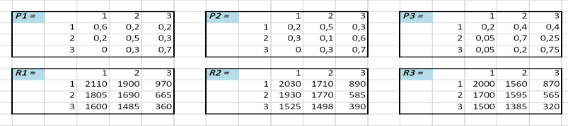
Figure 1. Transitional probability and expected profit
matrices
The transition probability matrix is a matrix that shows the probability of transitions between states of sales levels. In this problem, the number of such matrices is reduced to 3, and they are designated respectively P1, P2, P3.
With each transition probability matrix, income matrices R1, R2, and R3 are related, whose values represent the income or damage, depending on the states between which the transition is made.
Step 3. The calculation of the expected profit is as follows: cells of the matrix of expected profit actually reflect the sum of the products of the values of transitional probabilities for their respective profits.
Expected profit on project implementation will be calculated according to the Equation (1):

period (will allow to create a temporary strategic plan
ѵ^{𝑖} = ∑^{𝑚}
𝑝^{𝑘} × 𝑟^{𝑘}, (1)

depending on the chosen period);
𝑗 𝑗=1
𝑖𝑗
𝑖𝑗

- calculation of the Markov problem for an indefinite period (will allow to form a long-term strategic management plan);
- calculation of initial data (will allow to analyze and compare the levels of profitability in the periods before and after the project implementation);
The product of the project is also allowed for use in enterprises for wholesale and retail trade. Modifications in the course of the project implementation are for the
The results of the calculation of expected profits are shown in Figure 2.

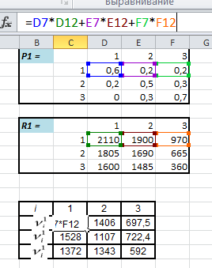

Figure 2. Tables of the calculation of the value of expected
profit
Step 4. Fill in the matrix of expected earnings at stage 3 (3rd month) is reduced to the transfer of values from the above matrix. This is due to the lack of the need to search for the target function, since there is no preceding step (Figure 3).

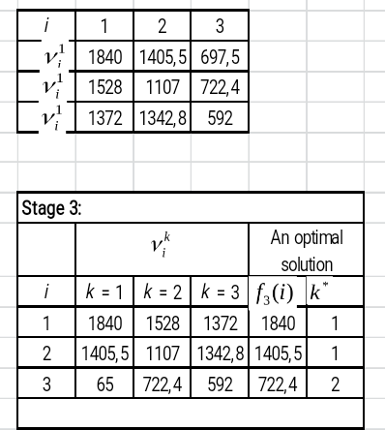
Figure 3. Completed matrix of expected profit in stage 3
The optimal strategic action for the current month has been found for the selected maximum values from each line.
Step 5. Next step we calculate the cells of the matrix of expected income in stage 2 by the Equation (2):

𝑓2 (𝑖) = ѵ^{𝑘} + 𝑝^{𝑘} × 𝑓3(1) + 𝑝^{𝑘} × 𝑓3(2) + 𝑝^{𝑘} ×

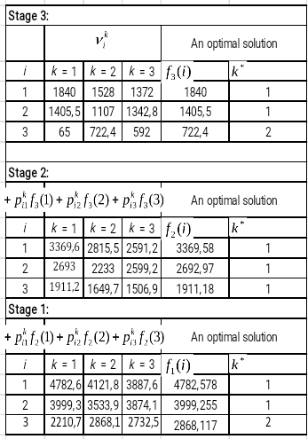
Figure 4. Completed expected profits of three stages
After performed calculations, the best strategic actions should be chosen for each step separately and determine the expected profits for 3 months, taking into account the levels of sales and interconnections between the stages.

- CONCLUSIONS
In the process of scientific research, the following theoretical aspects concerning restaurant business were considered: the peculiarities of the economic activity of the catering institution, the main business processes of the coffee shop, the main problems of the enterprise.
The next step was to analyze the existing methods of optimizing the company's activities and review the main principles and methods for choosing a management strategy for a catering institution.
During the analysis of information on the construction of the strategic plan, an urgent need was made for the use of the mathematical apparatus to calculate data regarding the level of profitability and the identification of optimal strategic measures for raising the level of competitiveness of the institution.
The main problems of the institution are caused by the

𝑖 𝑖1
𝑖2
𝑖3

× 𝑓3(3) (2)

At this stage, the visibility of the relationship between the values of the cells of the filled matrix with the values of expected revenues and target functions that were found in the previous step appears.
Step 6. We find the value of expected income at stage 1 (month 1), similarly using the rules of the relationship with the calculated values of the cells of the previous stage. The calculation is based on Equation (3):
𝑓1 (𝑖) = ѵ^{𝑘} + 𝑝^{𝑘} × 𝑓2(1) + 𝑝^{𝑘} × 𝑓2(2) + 𝑝^{𝑘} ×
processes of strict competition of surrounding institutions. It directly affects the increase of the loss- making enterprise. The above-mentioned factor was conditioned by the necessity of setting the task for modeling an optimal strategic plan, which would increase the profitability, attraction of potential customers, and competitiveness.
During the analysis of the methods of choosing the best strategies for managing the institution to achieve the goals, the mathematical apparatus of the Markov processes was selected as the main method. The staging

𝑖 𝑖1
𝑖2
𝑖3
of the Markov problem for the selection of optimal

× 𝑓2(3) (3)
control strategies is conditioned by the relative simplicity of the apparatus. The following feature is also important: the Markov process serves as a mathematical basis for simulating a decision in situations where the results are partially random and partly under the control of the decision maker.

REFERENCES:
- H. James Harrington, Erik K. C. Esseling, Harm Van Nimwegen, Business Process Improvement Workbook: Documentation, Analysis, Design, and Management of Business Process Improvement. USA: The McGraw-Hill Companies Inc., 1997, pp. 132-144.
- Michael D. Intriligator, Mathematical Methods of Optimization and Economic Theory. Moscow, Russia: Airis-Press, 2002, pp. 54-
67. (in Russian)
- S. Cook, Process improvement: a handbook for managers. Aldershot, Hampshire, England; Brookfield, USA: Gower, 1996, pp. 113-159.
- Project Management Institute, PMBOK Guide. Moscow, Russia: Olimp-Business, 2014. (in Russian)

