Project description
Implement automatic creation of environment for the multi-service Java application that includes:
- Load Balancer;
- Hosting server;
- Separate docker containers for each service;
- External monitoring;
- Internal monitoring;
- Cloud SQL database;
- CI/CD server.

Components
- Applications: identity, messaging, payment, simulation, trip, vehicle;
- DB update: change logs and the property file;
- CI/CD: the .gitlab-ci.yml script for GitLab;
- Deploy: deploy.sh and docker-compose.yml.

Infrastructure
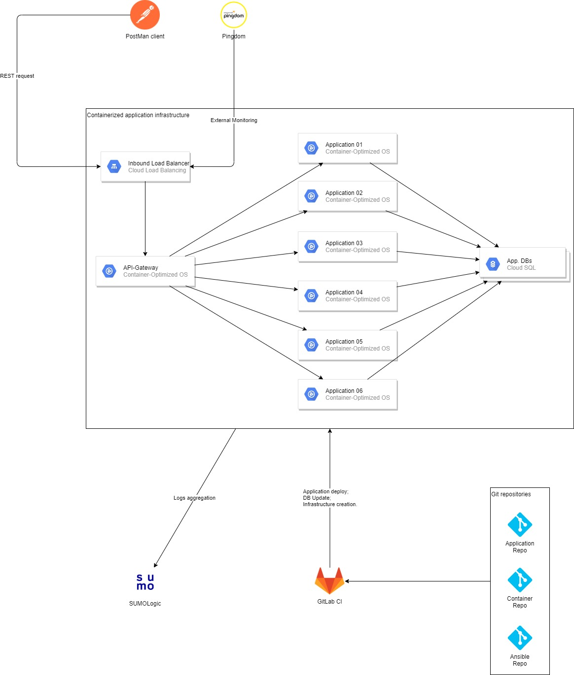

References
- Java application: https://github.com/KickScooterTeam
- Ansible repository: https://github.com/Artemkulish/Ansible

Requirements
- Minimization of external IP addresses;
- External monitoring of all services in a particular region;
- Alerting in case of emergency;
- Logs aggregation to be able to create statistics via various metrics;
- The least possible downtime during the updates;
- Ability to build and deploy the services separately depending on the needs;
- Implement the possibility of database update;

Google Cloud Platform
- Reserve two static IP addresses for GitLab and Load Balancer: https://cloud.google.com/compute/docs/ip-addresses/reserve-static-external-ip-address
- Configure firewall rules in order to open the ports in the range: 8080-8084: https://cloud.google.com/filestore/docs/configuring-firewall
- Create instance, router, and CloudNAT: https://github.com/Artemkulish/Ansible/blob/master/demo3/create_conteiner-opt.yml
- Create Load Balancer: https://github.com/Artemkulish/Ansible/blob/master/demo3/loadbalancer.yml
- Create CloudSQL: https://github.com/Artemkulish/Ansible/blob/master/demo3/cloudsql.yml

