Project description
Implement automatic creation of environment for the multi-service Java application that includes:
Azure:
- Application gateway;
- Hosting server;
- Separate docker containers for each service;
- External monitoring;
- Internal monitoring;
Goocle Cloud Platform:
- Cloud SQL database;
- CI/CD server.

Components
- Applications: identity, messaging, payment, simulation, trip, vehicle;
- DB update: change logs and the property file;
- CI/CD: the .teamcity script for TeamCity;
- Deploy: deploy.sh and docker-compose.yml.
- Infrastracture: azure application gateway, azure VM, azure gateway, azure VPC, gcp gateway, gcp CloudSQL.

Infrastructure
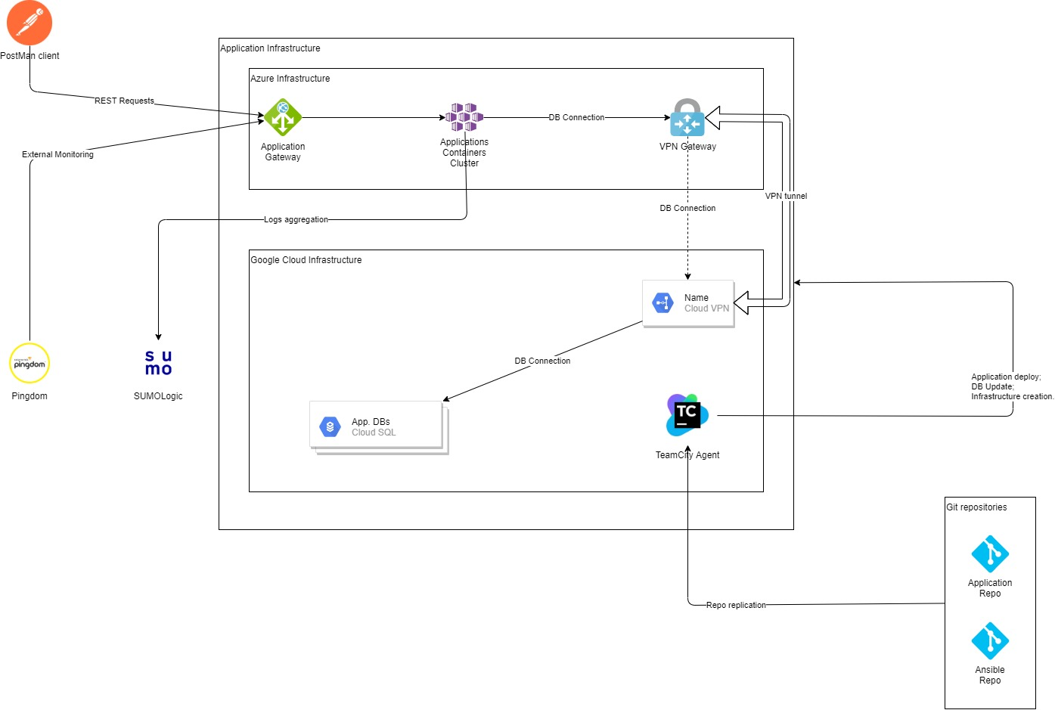

References
- Java application: https://github.com/DevOps-DP-185
- Terraform repository: https://github.com/DevOps-DP-185/Infrastructure

Requirements
- Minimization of external IP addresses;
- Use two cloud providers;
- Creating VPN tunnel;
- External monitoring of all services in a particular region;
- Alerting in case of emergency;
- Logs aggregation to be able to create statistics via various metrics;
- Quality code check;
- The least possible downtime during the updates;
- Ability to build and deploy the services separately depending on the needs;
- Implement the possibility of database update;

