DISTRIBUTION AND PRICE MANAGEMENT

CADBURY Ltd

Student ID

04/07/20

Word Count: 3290

Table of Contents

**Executive Summary** 3

**Introduction** 4

**Cadbury Situational Analysis** 5

**External Analysis** 6

**PESTEL Analysis** 6

**Industry Analysis** 8

**Cadbury Porter Five Forces** 8

**Competitor Analysis** 10

**Internal Analysis** 12

**Cadbury Summary** 12

**SWOT Analysis** 12

**Conclusion** 14

**Recommendations** 15

**References** 17

# **Executive Summary**

This analysis entails an overview of the confectionery industry around the world, and especially on the major markets. The analysis is based on Cadbury’s marketing and distribution mechanism, where a situational framework has been developed and the external factors influencing pricing and distribution discussed. The preliminary findings associated with the external factors show that Cadbury’s distribution and pricing strategies have been greatly influenced by politics, as well as the current economic stand. About its internal standing, Cadbury is facing challenges in terms of production, which it has had a rough legal exposure after having its products contaminated. Also, the company’s pricing mechanism suffers most from its cost of production, with energy factors playing a significant role in this. Based on our findings, we recommend that the company should invest more in other energy production models, which will see a change in the cost of production and improvements in distribution.

# **Introduction**

There has been a recent rise in the consumption of milk-related products, especially milk chocolate bars, and other confectionery products. A report by Forbes showed that Americans consume over 9.5 pounds of chocolate per year (Forbes, 2015). With the high level of consumption, then there exists an outrageous competition between the most popular brands while trying to meet the needs of consumers. Some of these competing brands include Nestle, Cadbury, Ferrero, and Dove Chocolate (Bharucha, 2016). In each of the companies, there is a unique way that they use to ensure that the competing strength is retained, and at the same time gather enough profits from the set prices.

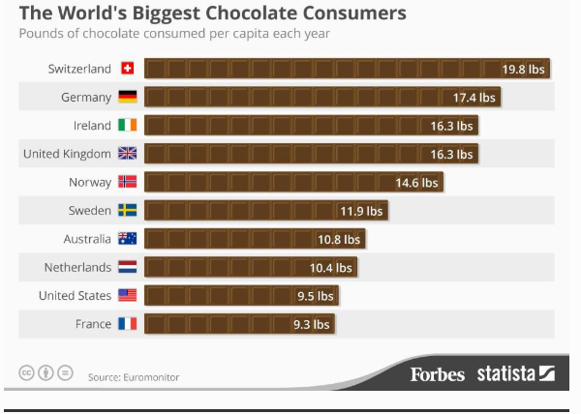

Figure 1: World Chocolate Consumption, 2015. Source: Forbes.

Whereas Cadbury targets all age groups in their product marketing and distribution, other brands such as Nestle embark on flagship campaigns for their leading commodities, and does not necessarily confine itself on specific age groups (Bharucha, 2016, p. 610). To beat the odds in marketing and distribution, Cadbury has managed to place a record of it being the second highest producer of these confectionery products, with its flagship products being among the 50 best-sold chocolates in the United Kingdom (Caster, 2015). Despite the various controversies that the brand holds regarding DNA porcine and Salmonella Montevideo contamination, it has remained unique in its marketing and distribution ways, a move which has helped it retain the relevance in the market (Musa et al., 2016). The purpose of this analysis, therefore, is to study the marketing distribution and pricing strategies that Cadbury incorporates in their system, and how they achieve all their strategies across their major market holders.

The structure that this analysis will follow will include an analysis of the external factors that influence the company either positively or negatively, which will be done using the PESTEL model. Further on, we will analyze the industry competition, and how active the competing companies are, which will be done using the Porter Five forces analysis. Next on, an internal analysis of the company will be done, followed by a description of the underlying strengths, weaknesses, opportunities, and threats that the company has, regarding marketing and price management. Afterward, a conclusion based on the findings will be made, and practical recommendations mentioned.

# **Cadbury Situational Analysis**

One of the fundamental elements in business is an analysis of the various available choices, through which the management decides on what path to follow. Also, the discrepancies in between people’s beliefs and the actual situations in a company get to be cleared (Blythe and Martin, 2019).

## **External Analysis**

### **PESTEL Analysis**

#### Political Influence.

In 2010, Cadbury did gain different ownership, Kraft Foods, which made it shift from being based in the United Kingdom to the American territory (Fearn, 2016). Through the change of the confectionery ownership giant, Cadbury has seen changes in its marketing and pricing strategies, ranging from changes in the tax systems, as well as labor factors, which play a significant role in the pricing mechanisms (Sharland, 2019). Shifting the company to the US regime resulted to changes in tax systems and labor laws, a significant change in the sales level, and a rise in the dividend share by 6% (Reuters, 2009).

Moreover, due to political influence, Cadbury management had opted to source for external labor and market from India, which resulted in a rise in the distribution of products in that particular country (Bharucha, 2016; Kaul, 2019). They also experienced an alteration in their production, which came as a result of the imposed taxes on sugar, and which could result in a rise in the cost of making (Butler, 2015).

#### Economic Factors.

After the financial crisis in 2008, the world experienced a drastic change in economic power (Hanafi et al., 2018). The resultant effect saw the company fail to meet its expectations on extension plans, and an overall effect on the distribution mechanisms. Even though the company managed to record a 30% increase in its sales, the overall price management was altered. Cadbury had to increase the prices of the commodities back then to cater to the high costs of the cocoa product, brought about by the economic recession (Kollewe, 2009).

#### Social Factors

One of the preliminary rules that Cadbury had ever since its inception is the prohibition of mixing its products with any alcoholic goods (Tan, 2014). With this, then there has been a trend in the raised arguments on the usage of the products, which has led to social divisions. Moreover, regarding the religious aspect, the Muslim markets regard Cadbury products not to be Halal and therefore face a challenge in distribution in Muslim nations (Tan, 2014). The western market has also raised concerns regarding the high level of consumption of these confectionery products, which is assumed to be one of the primary reasons for the rise in obesity (Staudigel, 2012). The resultant effect that this has had is a reduction in the intake and an overall halt in the distribution of the products.

#### Technological Factors

The most challenging effect that Cadbury has had is in regards to the production of heat resistant chocolates, as they try and ensure that the produced confectioneries reach the markets without being affected by the external weather conditions (Eyre, 2008). However, in a measure to curb this, Cadbury has devised ways in which chocolates are processed through the use of pathogen systems, and thus the production of heat resistant confectioneries (Eyre, 2008).

#### Legal Factors

In mid-2006, Cadbury did suffer from a legal claim after its products were found contaminated by Salmonella Montevideo (Carroll, 2009). The company had known of this threat and took no action of informing the necessary authorities. The company’s crisis management strategy was castigated, which led to an overall drop in consumer sales and product distribution.

#### Environmental Factors

The environment remains to one of the external factors that affect all companies, especially in the production phase. In chocolate production, there is always input of energy, which entails the use of fossil fuels. The resultant effect is a rise in the cost of production, which calls for changes in the future. Cadbury has had incentives in investing in green technologies, which have not yet taken place effectively (Bairstow, 2019).

## **Industry Analysis**

### **Cadbury Porter Five Forces**

#### The threat of substitute products

Reports by the World Health Organization in 2016 did make estimates on the rise in the number of obese individuals. The number had tripled since 1975, which saw it rise to over 650 million entities (WHO, 2018). In the statistic, most of these obese people were from the countries which recorded the highest consumption of confectioneries. With the rate of increase in health problems, there has been a change in the consumer perspective regarding the available products, as they have become more educated on the relevance of healthy eating (Mielmann and Brunner, 2019). Such changes have seen a drop in the habit of taking snacks as their daily meals and an overall rise in the number of substitute products in the market. These include the production of whole cereals and fruits, which has remained to be the greatest threat to the chocolate industry.

In trying to reduce the overall effect that these new entrants have in regards to the sale of chocolate products, Cadbury has taken the initiative to change their production techniques, and concentrate more on adding vitamins and reducing sugar concentrates (Wood,2018). The effect has seen a change in the direction of the confectionery market and an overall rise in the quality of the produced chocolate. Also, in some specific markets such as India, Cadbury took an initiative to reduce the production costs by altering the weight of its product, rather than hiking the actual costs (Bharucha, 2016).

#### The threat of new entrants

The existing confectionery market has always been dominated by established brands such as Cadbury and Nestle, especially in India (Bharucha, 2016). The underlying problem associated with the dominance is that any new entrants are placed in a critical position where their new products should be in accordance to the health needs, and at the same time consider the existing pricing mechanisms in place (Fernandes et al., 2016). The effect on new entrants, therefore, remains low on Cadbury, as it holds vast experience in the production and distribution of their products.

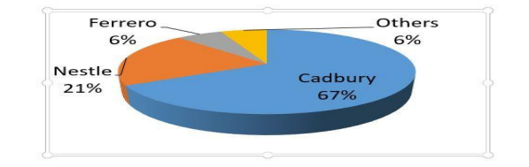

Figure 2: Consumer Perception on Confectionery Brands. Source Chokshi et al., (2016)

#### Rivalry among existing competitors

The existing stiff competition well describes the confectionery market among other brands, which include Nestle, Ferrero Rocher, and Wrigley. According to a report by Forbes, the major brands had an overall rate of 42% in terms of share of the global market (Forbes, 2011). Also, with the high growth rate in the emerging markets, competition among these brands remains to be high, which profoundly influences their pricing and marketing strategies. With the high competition, Cadbury is forced to operate on a lower margin, as it has to adjust its prices to meet the expected market distribution predictions.

#### The Bargaining Power

With their great products, Cadbury main buyers include retailers and consumers. Retailers have remained to be the large group that holds the company’s selling power, as they hold the rule on shelf space and backward integration (Bharucha, 2016). The group plays a significant role in the market distribution and highly correlates with the annual revenue that the company records. In regards to the suppliers, Cadbury relies highly on the supply of Cocoa, milk, and sugar. An alteration in the prices of these commodities sees a change in the cost of production and an overall rise in the pricing. This results in a change in market distribution and an overall problem in pricing.

## **Competitor Analysis**

In the confectionery market, the Indian market remains as one of the best-holding markets in terms of growth. Over the years, the market has gotten larger and better. Cadbury’s preliminary situational analysis did help them in setting up a production unit in India, which sees them market the products by the government standards. The competition between Cadbury and Nestle in regards to the Indian market can be traced back in the early ’90s, where Cadbury’s market share dropped by 10% after the inception of Nestle (Bharucha, 2016).

Also, the company has an excellent distribution strategy as one of the famous confectionery brands, which has helped it in utilizing the strategic performance and managed to break the market bulkiness. Cadbury has retained its strength to distribute its products to over 200 countries across the world, and each receiving over 30 different variants, owed to its corporate governance (Neubauer and Lank, 2016). With its strong brand portfolio, it has managed to beat the competitors by a considerable margin. Moreover, its unique marketing strategy which entails its goods being regarded as gifts to many have allowed it to maintain a considerable share in the market (Kaul, 2019).

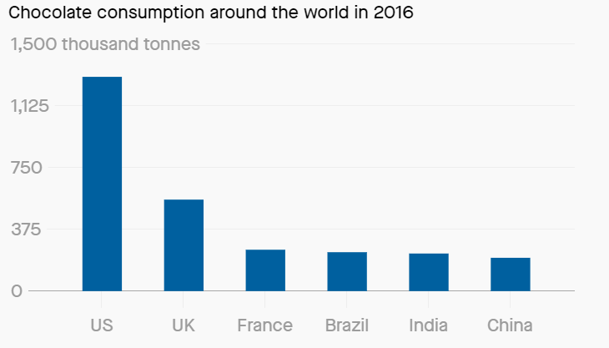

Figure 3: Chocolate Consumption across the World (Thomas, 2017)

In regards to brand positioning and segmentation, Cadbury did identify the need to adjust its marketing, distribution and pricing strategies, which would make a reflection of what is already available in the market. Regarding pricing, the company adjusted its price and aligned itself with the price of similar products. The strategic positioning that Cadbury applies varies from it increasing its brand awareness, as well as rolling out educational plans to their new markets (Kaul, 2019).

Moreover, the company has had cases where it works on improving its seasonal purchases, achieved through campaigns, such as the ‘Choose Cadbury’ campaign, which made highlights on the positive values the brand had. Further on, Cadbury has had instances where it identified segments regarding their customers and introduced the ‘take home’ packages, which came in gift packs (Solomon et al., 2013). The segments were meant to be a reflection of the decision-making process their consumers had in regards to the product to select in a specific store.

Cadbury’s pricing strategy sees them offering the daily milk products on varying sizes, and each gets to be priced accordingly, which sees it serve the respective customer (Kaul, 2019). In a similar strategy, Cadbury gets to sell their products in multiple options and at a lower price than what they would have got if they purchased each item on its own. The discounting option mainly happens during the festive seasons, and when venturing into a new market. In addition, their pricing strategy also incorporates subsidizing the cost of their products which are mostly regarded as gifts, especially in festive seasons. By using an emotional appeal strategy to market, and a subsidy in terms of the actual cost to its selected market, then the distribution of the products is improved. The strategy further sees a promotion in distribution as well as the consumerism, as it persuades the target market to accept the entrepreneurial values (Bell, 2017).

## **Internal Analysis**

An outstanding characteristic that Cadbury holds, which applies to both the industry and competitive factors is its ability to produce different variants. The variants allow the company to compete and beat the other strong confectionery giants, and at the same time reduce the risk of underperformance by having one product only (Thompson, Strickland, and Gamble, 2015). Moreover, with the pricing strategies which are highly influenced by socio-political factors, Cadbury has maintained an excellent market distribution technique irrespective of the vast changes it has had, involving ownership and primary location.

# **Cadbury Summary**

## **SWOT Analysis**

#### Strengths

The greatest strength Cadbury has is that it is one of the world’s leaders in the production of confectionery products and at the same time, one with an outstanding distribution mechanism (Bharucha, 2016). The skills have allowed the brand to widen its markets to over 150 nations all over the continents. Also, the fact that the brand has an extensive product portfolio constituted of high-quality products; then its ability to dominate the market remains inflexible. The company also has a unique promotional method, which has acted as one of its best distribution ways. It remains to be one of the brands with the most active promotions with the Fast-Moving Consumer Goods industry. Another strength Cadbury holds is its connection with the Indian market, which offers a massive audience for the products as well as labor (Chokshi et al., 2016). With the extended population, then the company manages to place and distribute their products in a well-defined strategy, which sees it manage to supply to over 200 countries.

#### Weaknesses

The weakness that Cadbury holds is in its distribution channels. Irrespective of it holding the most significant market share in India, Cadbury has not yet managed to capture the rural population in India, which holds a high population as well. The brand has also failed to secure its market in Muslim zones, from the dogma of most of their variants being haram (Tan, 2014). Another weakness recorded on its products is its inability to guarantee quality on all its variants, as there have been various cases of some of the packages containing rodents and contamination (Carroll, 2009). Therefore, the aspect of quality control remains to be a weakness to the brand.

#### Opportunities

Since Cadbury remains to be one of the dominants in the confectionery market, it has the opportunities of exploring other markets such as new locations and rural markets. Investing in a different market and showcasing what they can offer may place them as the most preferred brand, and boost the overall sales records. Moreover, the company can invest in producing different tastes from what is already available, and which may gather a preference in the market, improving the sales distributions.

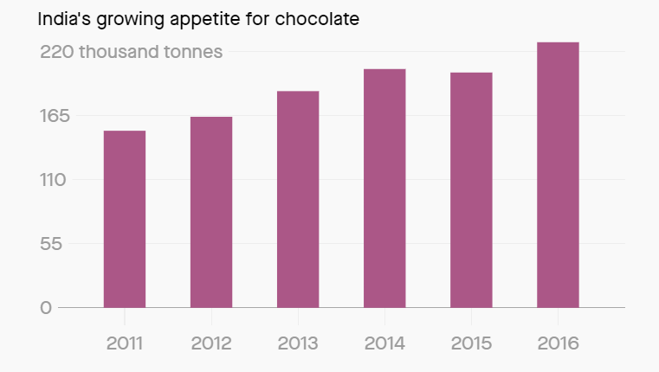

Figure 4: India's Confectionery Consumption (Thomas, 2017)

#### Threats

The utmost threat Cadbury faces is the challenge of changing from the existing forms of energy production to new and cost-efficient forms. The world is currently experiencing an increase in the prices of fuel and adjustments in the cost of distribution (Wallop, 2016). The change in these mechanisms acts as a significant threat to the pricing strategies the company has in place, and alteration of what is in existence may act as an opportunity for other brands to bring in their products. A leading threat in the confectionery industry is the production mechanisms leading to contamination, such as the case in 2006, where some of their items had Salmonella Montevideo (Carroll, 2009).

# **Conclusion**

The analysis of Cadbury’s distribution and pricing strategies has laid out important factors, most of which could be useful in its future planning. One observation made concerning the distribution is that most of the products are gift-oriented. The characteristic acts as an overall advantage over other competitors as the current brand name has already ensured this remains over the years. Moreover, the variants produced favor the rate and quantity distributed, as the target population usually has its preferences (Thompson et al., 2015).

The resultant change in ownership of Cadbury in 2010 did see it shift its desire for labor to the Indian market, which acted as a selling point of the produced goods. Generally, the Indian population has the belief sugary products remain to be healthy and they are also energetic (Thomas, 2017). With the shift, the market distribution rose, which saw a rise in the sales figures recorded. However, the concern on health benefits did act as a drawback to the company, and acts as one of the significant threats that it is currently facing, since people are shifting to the advertised healthier products.

The brand has also failed to make adjustments based on market forces, as well as other inputs such as political factors and the high cost of fuel. In 2016, Cadbury did make statements on it rising the prices of some of its selected products, citing that there had been a rise in the price of the necessary supplies such as cocoa. Also, they ended up shrinking the sizes of some of their pack sizes (Wallop, 2016). The same effect on altering the prices of specific commodities was cited as a result of the British exit from the European Union (Ruddick, 2016). However, the selectiveness and the fact that the company remained to be the only one altering its prices raises concerns on its pricing strategies, which later affects the brand performance.

# **Recommendations**

Based on the findings from this analysis, there is a dire need for Cadbury to look into its pricing strategies, which mainly affect its distribution. A finding made was that Cadbury alters their prices as well as the weight of their variants grounded on the economic performance, and with no reliable statements made to the consumers. To counter this, Cadbury should invest in distributing the extra incurred costs to all their products, rather than shifting prices on selected accomplices only. Moreover, with the underlying threat on food poisoning across the world, there is need to influence a change in their production phases, which will ensure that there are no outbreaks of contamination, as well as minimal recalls.

.

# **References**

Bairstow, J. (2019). *Toblerone, Cadbury and Milka to go sustainable - Energy Live News*.

[online] Energy Live News. Available at: https://www.energylivenews.com/2019/05/03/ toblerone-cadbury-and-milka-to-go-sustainable/ [Accessed 18 Jun. 2019].

Bell, J., 2017. ‘Setting the joy free’ with Cadbury UK. 1-63.

Bharucha, J., (2016). Cadbury Vs Nestle: A Study of the Chocolate War. *International Journal of Research in Social Sciences*, *6*(9), pp.609-620.

Blythe, J. and Martin, J., 2019. *Essentials of marketing*. Pearson UK.

Butler, S. (2015). *Sugar tax will not change diets, says Cadbury chief*. [online] the Guardian. Available at: <https://www.theguardian.com/business/2015/oct/22/sugar-tax-not-change-diets-cadbury-mondelez-childhood-obesity-public-health-england> [Accessed 15 Jun. 2019].

Carroll, C., (2009). *Defying a Reputational Crisis – Cadbury’s Salmonella Scare: Why are Customers Willing to Forgive and Forget?* <https://doi.org/10.1057/crr.2008.34>

Caster, Y. (2015). *British chocolate bars ranked from worst to best | Metro News*. [online] Metro. Available at: <https://metro.co.uk/2015/07/07/british-chocolate-bars-ranked-from-worst-to-best-5276158/> [Accessed 18 Jun. 2019].

Chokshi, P., Shah, H., Arora, R., Agrawal, N., (2016). *Perception of Consumers towards Cadbury and Nestle*. Asian Journal of Research in Marketing 5, 8–27.

Eyre, C. (2008). *Cadbury adopts new pathogen testing system*. [online] bakeryandsnacks.com. Available at: <https://www.bakeryandsnacks.com/Article/2008/02/04/Cadbury-adopts-new-pathogen-testing-system> [Accessed 30 Jun. 2019].

Fearn, H. (2016). *In a final betrayal of the Cadbury brand, Kraft has quietly abandoned its promise to stick with Fairtrade*. [online] The Independent. Available at: <https://www.independent.co.uk/voices/cadburys-chocolate-fairtrade-fair-trade-mark-farmers-kraft-american-brand-abandoned-promise-a7445826.html> [Accessed 15 Jun. 2019].

Fernandes, S.F., Gupta, P. and Vidyasagar, A., (2016). Cadbury India–Sweet Turning Sour. *Ushus-Journal of Business Management*, *15*(4), pp.37-54.

Forbes (2011). Cadbury, Developing Markets Bearing Fruit for Kraft. [online] Available at <https://www.forbes.com/sites/greatspeculations/2011/05/24/cadbury-developing-markets-bearing-fruit-for-kraft/> [Accessed 14 Jun. 2019].

Forbes. (2015). The World's Biggest Chocolate Consumers *[Infographic]*. [online] Available at: <https://www.forbes.com/sites/niallmccarthy/2015/07/22/the-worlds-biggest-chocolate-consumers-infographic/#2ea4550d4484> [Accessed 18 Jun. 2019].

Hanafi, M.M., Setiyono, B. and Sanjaya, I.P.S., (2018). Ownership structure and firm performance: evidence from the subprime crisis period. *Corporate Governance: The international journal of business in society*, *18*(2), pp.206-219.

Kaul, D., (2019). Segmenting and Targeting in Indian Market. *ANVESHAK-International Journal of Management*, *8*(1), pp.121-125.

Kollewe, J. (2009). Dairy Milk sales help Cadbury defy the recession. [online] *the Guardian.* Available at: <https://www.theguardian.com/business/2009/feb/25/cadbury-chocolate-dairy-milk-treats> [Accessed 18 Jun. 2019].

Mielmann, A. and Brunner, T.A., (2019). Consumers’ snack choices: current factors contributing to obesity. *British Food Journal*, *121*(2), pp.347-358.

Musa, N., Muslim, N., Omar, M.F.C. and Husin, A., (2016). The Cadbury Controversy: Blessings in Disguise? In *Contemporary Issues and Development in the Global Halal Industry* (pp. 95-104). Springer, Singapore.

Neubauer, F., Lank, A.G., (2016). *The family business: Its governance for sustainability*. Springer.

Reuters. (2009). UPDATE 5-Cadbury profit up, shares rise on 2009 outlook. *Reuters* [online] Available at: <https://uk.reuters.com/article/cadbury/update-5-cadbury-profit-up-shares-rise-on-2009-outlook-idUKLN62221320090225> [Accessed 18 Jun. 2019].

Ruddick, G. (2016). *Cadbury says chocolate could get smaller after Brexit*. [online] the Guardian. Available at: <https://www.theguardian.com/business/2017/mar/24/cadbury-warns-chocolate-could-get-smaller-after-brexit> [Accessed 15 Jun. 2019].

Sharland, A., (2019). Kraft's acquisition of Cadbury. *Thunderbird International Business Review*, *61*(2), pp.453-454.

Solomon, M., Hughes, A., Chitty, B., Marshall, G., Stuart, E., (2013). *Marketing: Real People, Real Choices*. Pearson Higher Education AU.

Staudigel, M., 2012. How do obese people afford to be obese? Consumption strategies of Russian households. *Agricultural economics*, *43*(6), pp.701-714.

Tan, E. (2014). *'Jihad' declared against Cadbury: What should the brand do?* [online] PR Week. Available at: <https://www.prweek.com/article/1296417/jihad-declared-against-cadbury-brand-do> [Accessed 15 Jun. 2019].

Thomas, M., (2017). Indians are eating more chocolate than ever before because they think it is healthy. *[*online] *Quartz India.* Available at: <https://qz.com/india/968956/indians-are-eating-more-chocolate-than-ever-before-because-they-think-it-is-healthy/> [Accessed 14 Jun. 2019].

Thompson, A., Strickland, A.J. and Gamble, J., 2015. *Crafting and executing strategy: Concepts and readings*. McGraw-Hill Education.

Wallop, H. (2016). The many ways Cadbury is losing its magic. [online] *The Telegraph.* Available at: <http://www.telegraph.co.uk/food-and-drink/features/the-many-ways-cadbury-is-losing-its-magic/> [Accessed 15 Jun. 2019].

WHO. (2018). *Obesity and overweight*. [online] Available at: <https://www.who.int/news-room/fact-sheets/detail/obesity-and-overweight> [Accessed 14 Jun. 2019].

Wood, Z. (2018). *Cadbury to launch Dairy Milk bar with 30% less sugar*. [online] the Guardian. Available at: <https://www.theguardian.com/business/2018/jul/20/cadbury-to-launch-dairy-milk-with-30-per-cent-less-sugar> [Accessed 18 Jun. 2019].