The installation process and demonstration of my program
When I designed it, I used C# .NET Core 3.1
The application interface I wrote on WPF
Russian language interface
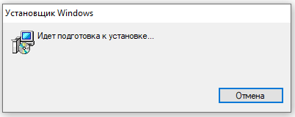
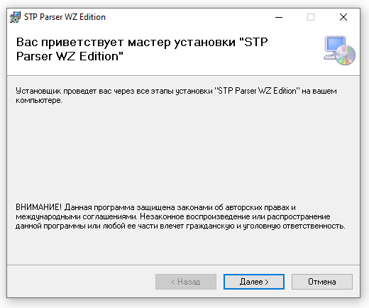
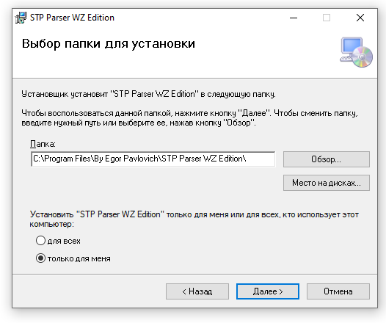
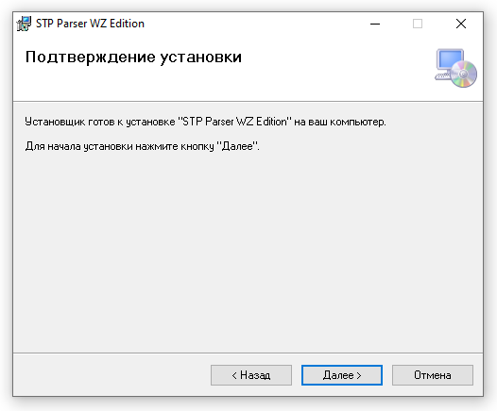
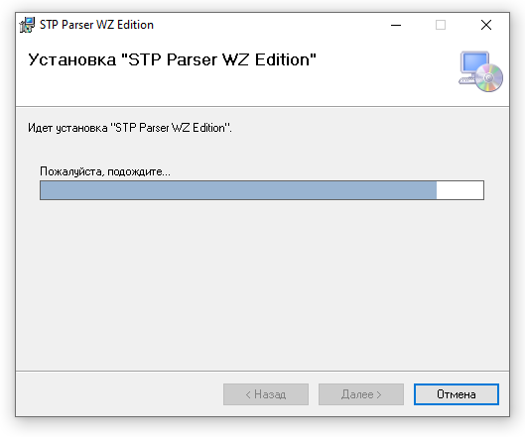
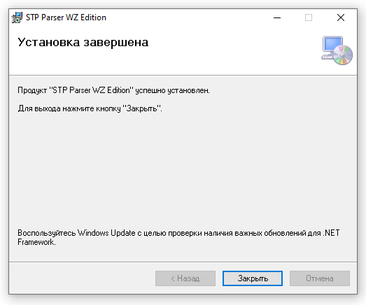
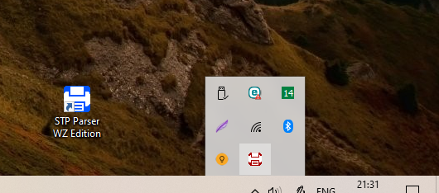
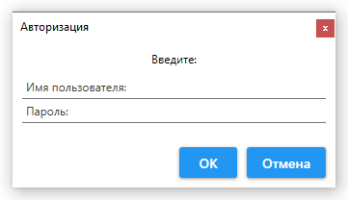
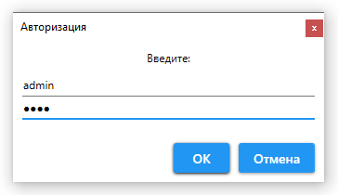
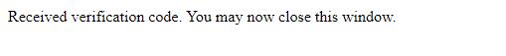
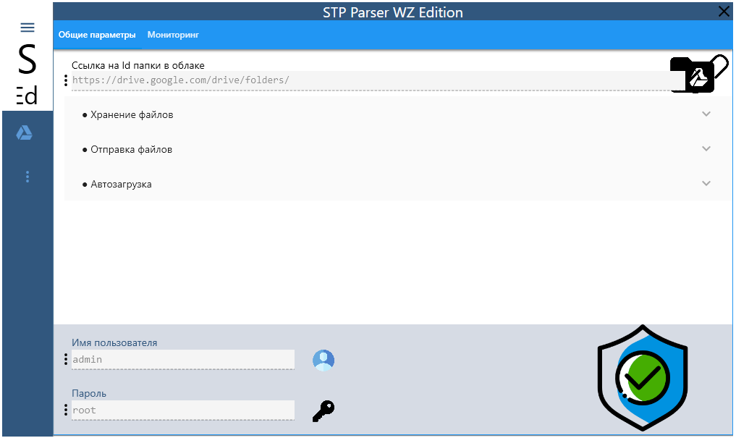
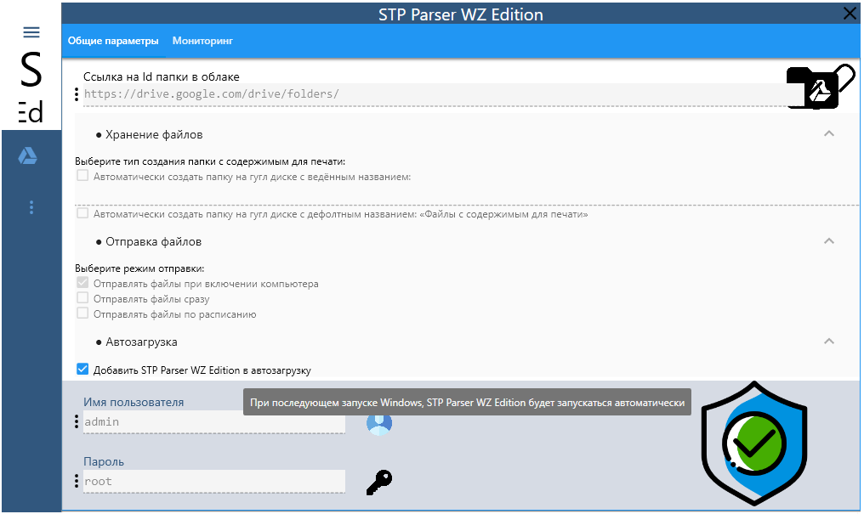
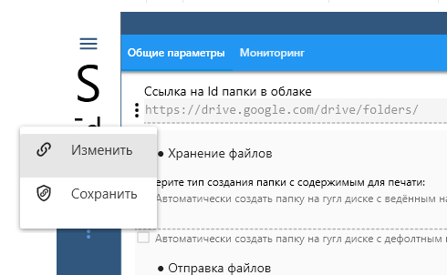
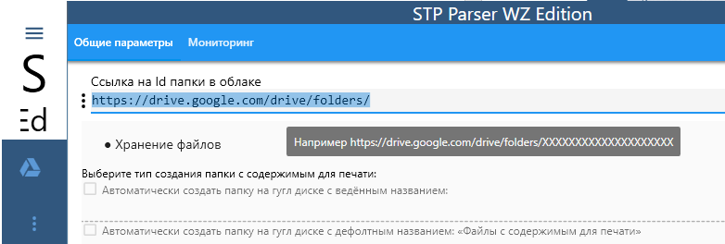
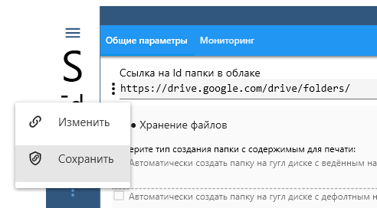
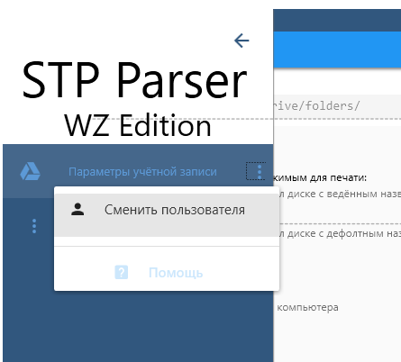
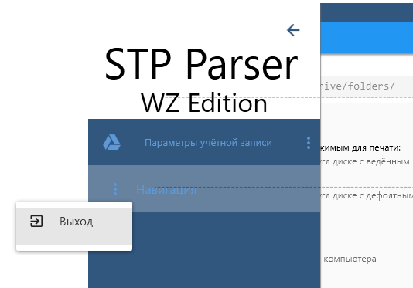
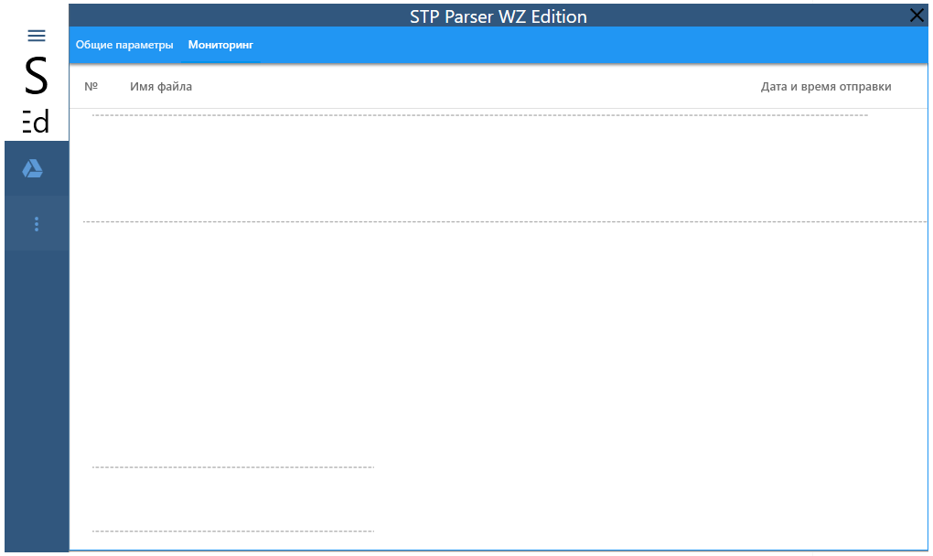
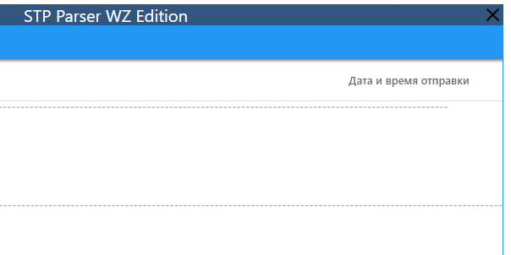
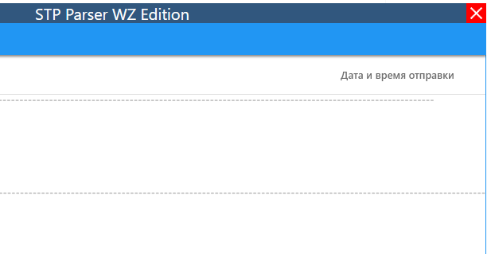

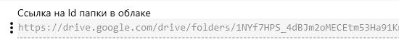
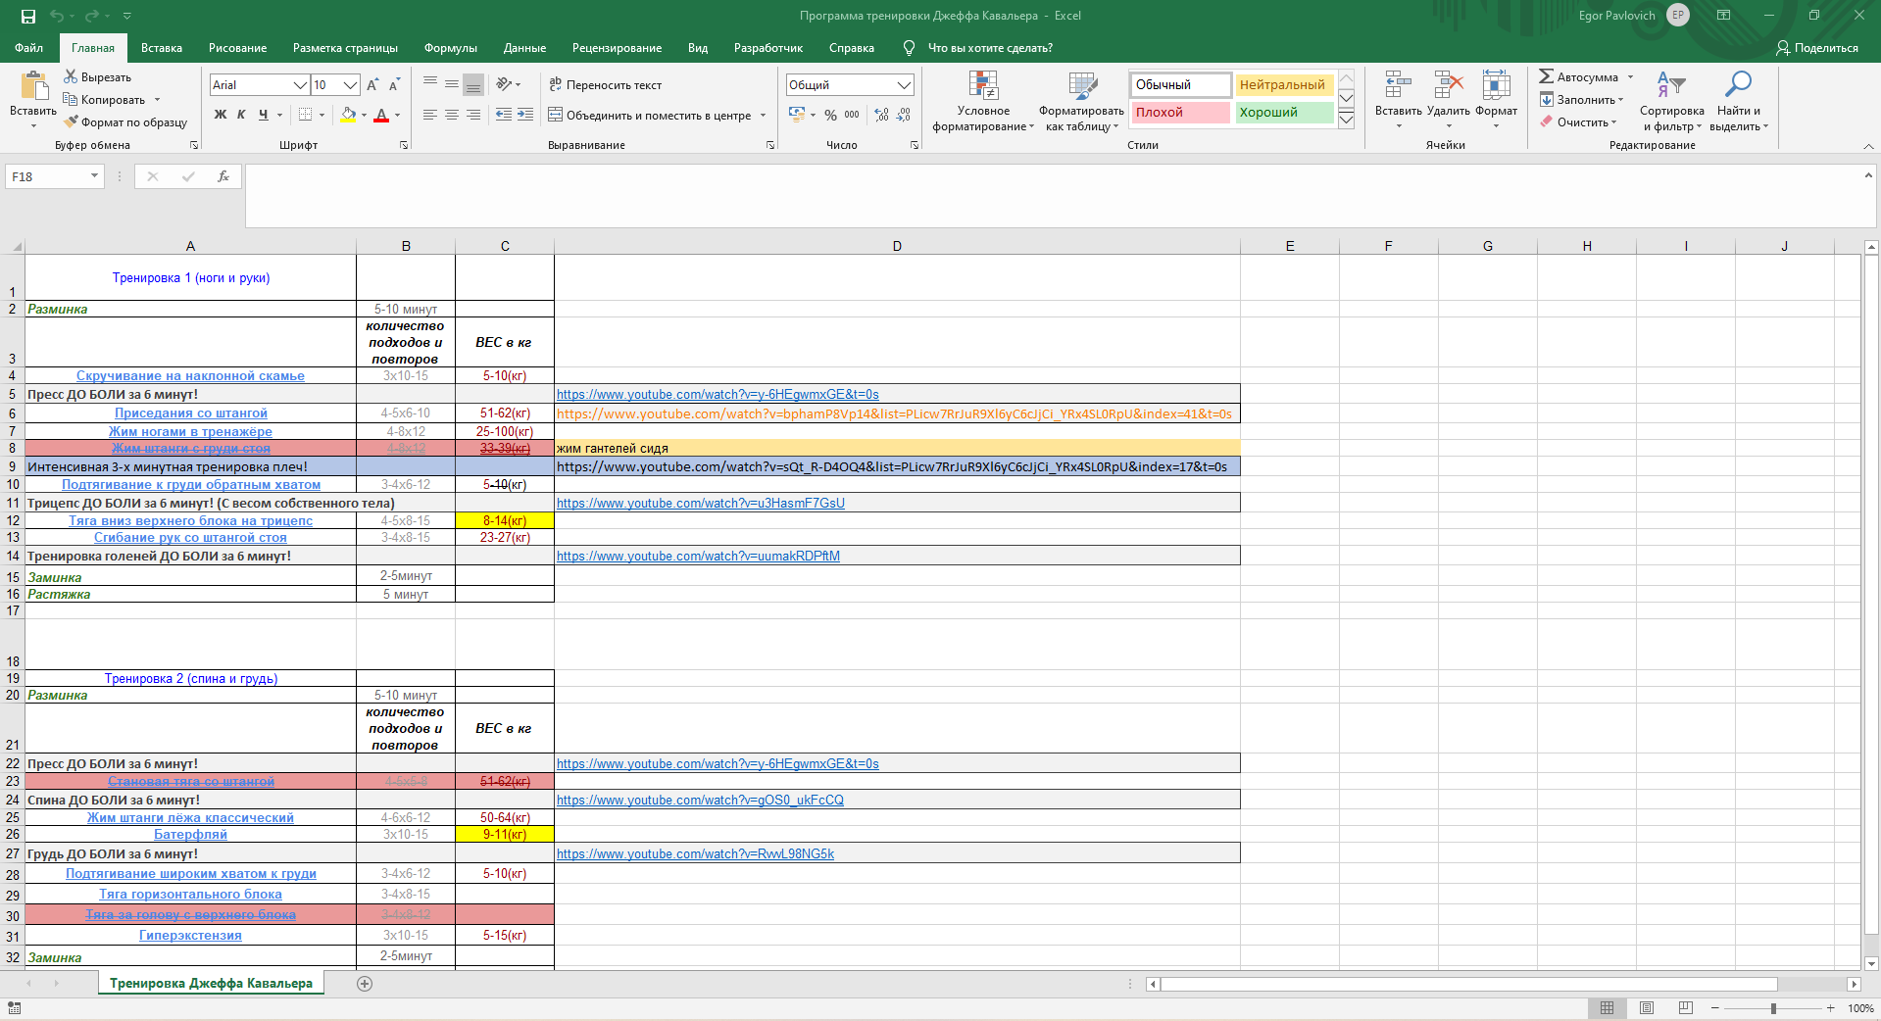
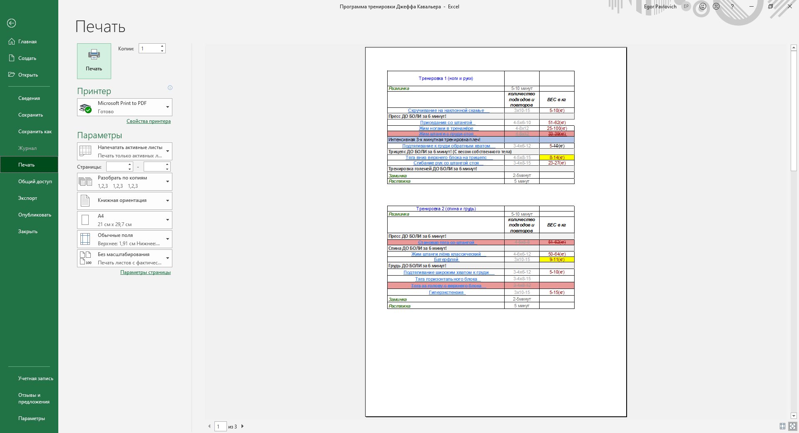
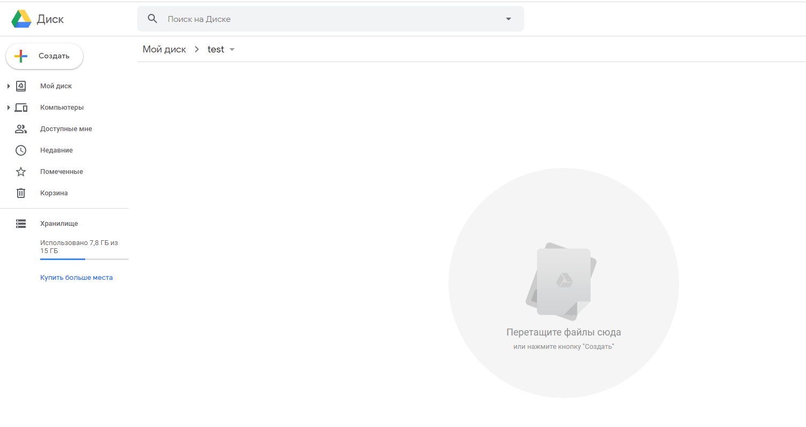
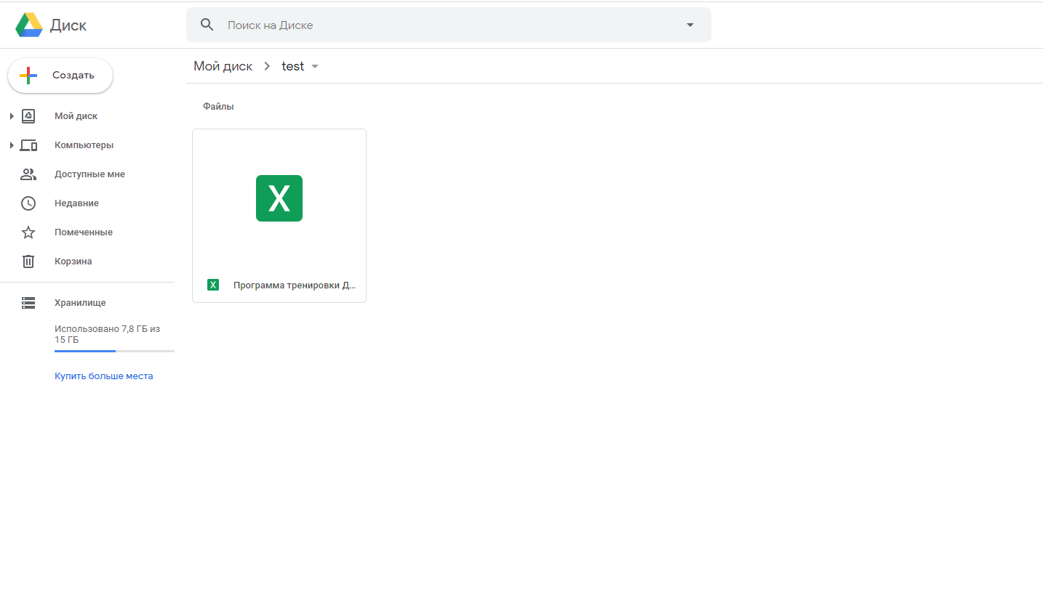

Terms of Reference for the project
The terms:
The printer prints a document (usually less than 1 page) from Excel.
Task:
When sending for printing, form a file with the content to be printed at the same time and save it to a folder,
whose name is spelled out in the program.
And you can't print it any other way.
The file name is the current date and time, or through numbering.
The format of the saved file is also better than Excel, but you can also use PDF.
A folder for saving should be linked to the cloud,
and you cannot delete files from the cloud without special rights.
You can't deny deletion from a folder on your computer itself,
but be sure to fly into the cloud and not get out of there without a password.

Perhaps it will be a program that takes everything that goes to print, pass through itself,
and send the printed file to a folder.
Format unknown to the program - no big deal.
The main thing is that you cannot bypass it in any way, for example, by selecting another printer.

If the presence of the Program is visible to the computer operator, it is okay,
even if there are any windows that pop up.
If the program is deleted or damaged - printing is not possible.

