DiCaprio thanked the residents of Yakutia

By [**YSIA**](http://en.ysia.ru/author/tuyaragrigoryeva/) -

March 21, 2016

62

[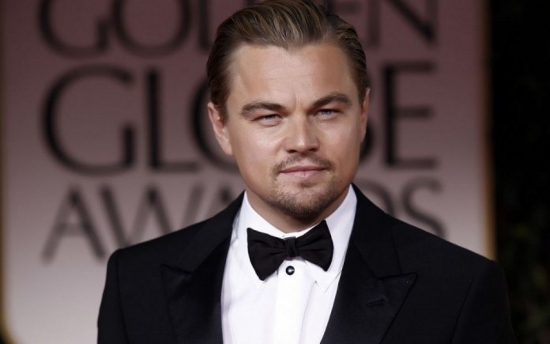](http://en.ysia.ru/wp-content/uploads/2016/03/rabstol_net_leonardo_di_caprio_06-696x435-1.jpg)

**Hollywood actor Leonardo DiCaprio thanked the residents of Yakutia for “silver Oscar”. The actor posted photo of the statuette in his Instagram.**

“Thank you to the people of Yakutia for this wonderful gift, especially all of the women who gathered and donated the materials that went into creating the statue. As they wrote in their letter, Yakutia is home to the coldest inhabited place not only in Russia, but also on Earth – and the region is extremely vulnerable to climate change. Rising temperatures pose a major threat to its people, their way of life and their natural habitat,” – he wrote.

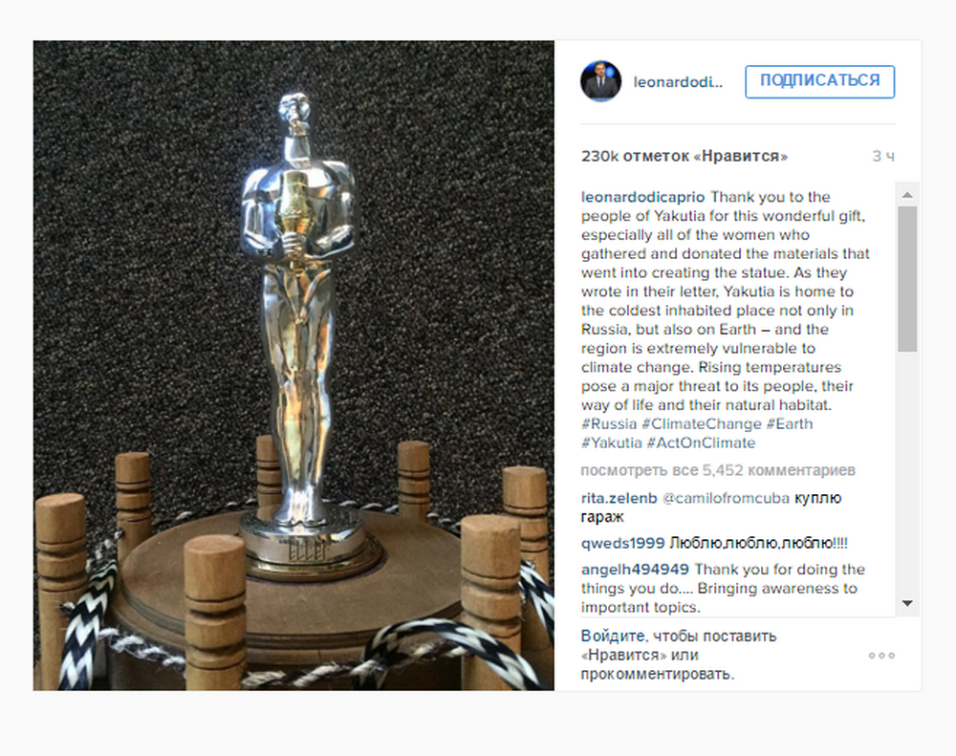

On the creation of silver “Elley” 144 Yakut women cast their silver jewelry. There were collected 1.5 kilograms of silver. The statuette is similar to the original “Oscar”, but it has Mongoloid facial features and in the hands of the statuette – a national Yakut vessel Choron. The organizers explained that the action is a contribution to the image of the region, as well as initiated to draw attention to the problems of the North.

In late February, the Hollywood actor won his first “Oscar” in the category “Best Actor” for his role in “The Revenant”.