Li Fenglin: All Asian countries are interested in close cooperation with Yakutia

By [**YSIA**](http://en.ysia.ru/author/tuyaragrigoryeva/) -

April 26, 2016

112

[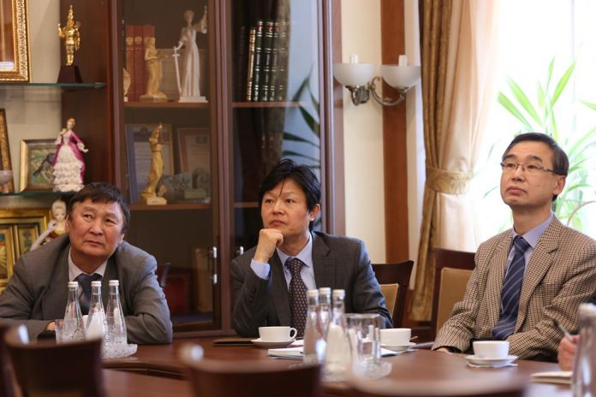](http://en.ysia.ru/wp-content/uploads/2016/04/IMG_4996-Copy.jpg)

**Stability of the region is largely dependent on foreign relations, on cooperation with other countries. This is the opinion of the Director of the Institute for Social Development in Europe and Asia with the Development Research Center of the State Council of China Li Fenglin. On March 25, in the North-East Federal University an annual discussion “Lena meeting: Geopolitics of East. XXI Century” began the work .**

“Yakutia has a huge potential for further development. Mainly this contributes to a favorable geographical location. I think all Asian countries are interested in close cooperation with your republic, – said Li Fenglin. Today we can say that the Republic of Sakha (Yakutia) is the subject of international relations, a subject of geopolitics”.

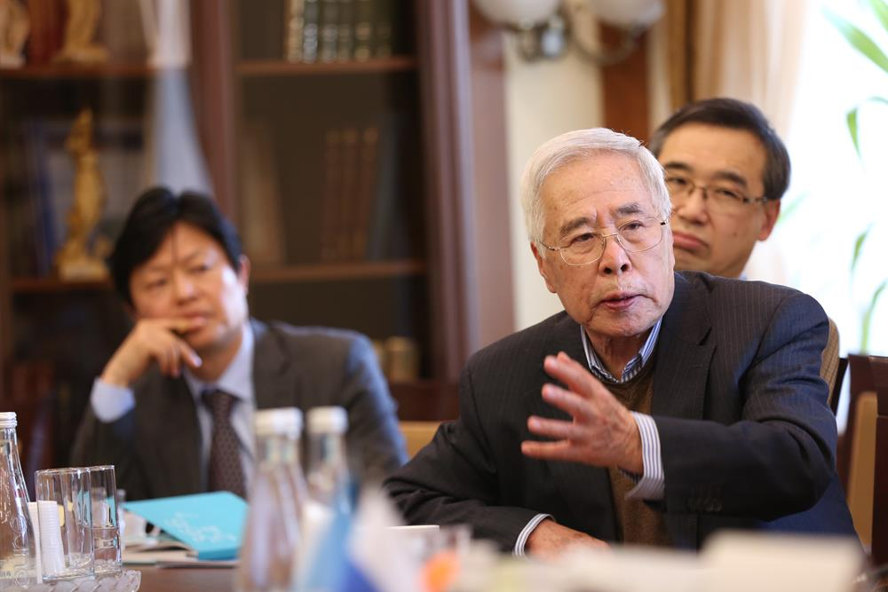

He noted that Yakutia with its rich resources and territory has always attracted the international community. “Therefore it is particularly important to support the communication between scientists, public figures who have common interests in the development of the republic. Exchange of views promotes mutual understanding and drawing conclusions concerning the further development and cooperation between countries,” – said Lee Fenglin.

“Any research on scientific problems suggests some recommendations because knowledge obliges us to act, but the decision have to be taken by politics. I think this is a very important event both for Russia and for the whole East Asia, because important questions are raised here. And despite the “geopolitics” there are discussed a very wide range of problems, both technical and socio-economic,” – concluded the historian, director of the Institute of Systems and Strategic Analysis, director of the Center for Russian Studies of the Moscow Humanitarian University, academician of International Academy of Science Andrey Fursov.