Yakut blacksmiths shared the secret of making knives on the exhibition in Moscow

By [**YSIA**](http://en.ysia.ru/author/tuyaragrigoryeva/) -

April 12, 2016

662

[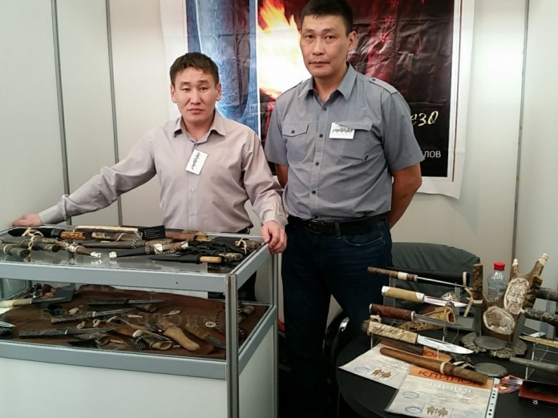](http://en.ysia.ru/wp-content/uploads/2016/04/CYMERA_20160408_170905-e1460372099731.jpg)

**The attention of visitors on the exhibition “Arsenal” in Moscow drew knives from blacksmiths of Yakutia.**

The best samples of modern blade products from the famous blacksmiths of Russia and abroad, as well as dealers from Russia, Japan, USA, France and other countries were presented at the XVIII Moscow exhibition-sale “Arsenal”.

Blacksmiths of Yakutia Alexander Danilov and Ilya Ivanov presented their own method of manufacturing the blade products from damascus steel. The connoisseurs especially accentuated drawing on the knives and blade sharpness.

Alexander Danilov: “We have prepared for the exhibition a month. Prior to this event we participated in another exhibition “Blade-2016”, which took place from March 31 to April 3 in Sokolniki. We won second place in the category “Short sword” and “composition”, for which received two diplomas, as well as the award for professionalism and an active participation in the exhibition”.

