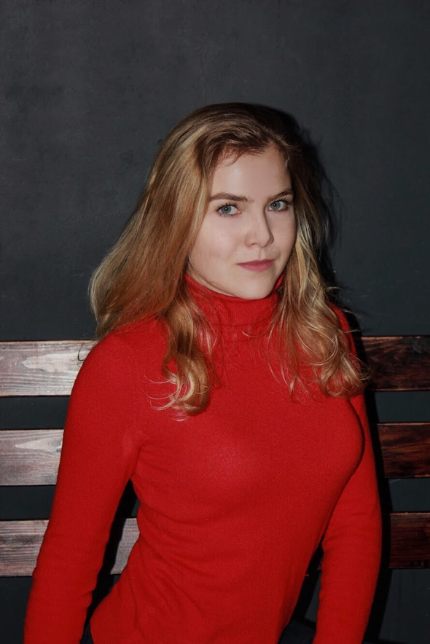
Maria Maksakova

Date of birth: 12.12.1996
Moscow, Russia
E-mail: maksakova.marie@gmail.com

PROFESSIONAL EXPERIENCE

September 2019 – January 2020, Hotel W Barcelona Marriott
Meetings Insider Trainee
Region of responsibilities: Barcelona, Spain

Main responsibilities:
- Preparation of a place and necessary materials for the upcoming event;
- Interaction with other department of the hotel, such as marketing, kitchen, banquet, reception;
- Primary liaison between the manager and the client;
- Coordination of the event itself;
- Attendance to the internal and external meetings;
- Clients’ material reception and preparation;
- Preparation of a necessary documentation;
- Attendance and primary help to the client during the events, such as weddings, summits, meetings, celebrations, gala dinners, etc.

May 2018, ENNOVA Summit (Construction and architecture)
Event Manager Assistant/ Translator
Region of responsibilities: Valencia, Spain

Main responsibilities:
- Preparation of a place and necessary materials for the upcoming event;
- Interaction with the hotel staff, where the summit was held;
- Primary liaison as a translator between the Kazakh and the Spanish guests;
- Assistance in guidance and directing the program and guests;
- City tour guidance.

January 2018 – April 2018, Centre of Consulting of Analysis in Construction
Business Development Analyst
Region of responsibilities: Moscow, Russia

Main responsibilities:
- Preparation of the necessary documentation;
- Collection and distribution of the information;
- Organisation of the effective use of the data;
- Amendments of the data in the documents.

July 2016 – August 2016, Utkonos (Online retail company)
Finance & Marketing Intern
Region of responsibilities: Moscow, Russia

Main responsibilities:
- Preparation of the excel file with the financial data;
- Acquaintance with the financial information of the company in order to prepare the documents;
- Assistance in the marketing department;
- Liaison between the marketing and finance departments.

EDUCATION

October 2018 – May 2019
Ostelea/ EAE Business School, Barcelona, Spain
Universitat de Lleida, Lleida, Spain
Master in Event Organisation, Protocol and Business Tourism
Dissertation in Event Organisation, GPA 8.5/10

October 2014 – May 2017
EU Business School, Barcelona, Spain
Bachelor of Science in Business Finance
Dissertation in Marketing, GPA 3.4/4 Honour Cum Laude

September 2012 – May 2014
High School of Moscow №2086, Moscow, Russia
Gold Medal of Russia and Moscow Gold Medal for the excellent education

ADDITIONAL EDUCATION

September 2019 – Now
ESNECA Business School, Online
Wedding Planner Course

September 2016 – April 2017
DAR Driving School, Barcelona Spain
Driving Licence B category

KNOWLEDGE OF LANGUAGES

English – Advanced (full proficiency)
Spanish – Advanced (full proficiency)
Catalan – Intermediate (good reading and speaking abilities)
French – Intermediate (good reading and speaking abilities)

STRONG SIDES

I am a very communicative, active, and reliable person who feels comfortable working in team. I like increasing my knowledge in many spheres by using my imagination and creativity. I have an experience in working with famous international companies.

