Inna V. Suprun
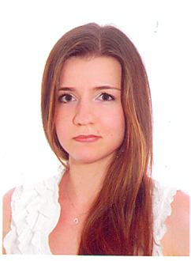

Address:
Nikolaev, Ukraine

Telephone: +380(67) 258-79-28
+380(63) 592-34-38
E-mail: innet.vl@yahoo.com
innet.suprun@gmail.com

Nationality: Ukrainian
Date of birth: April 17, 1985

EDUCATION:

In 2002 have finished Nikolaev secondary school №22 (with deep study of English language).

In 2007 have finished Nikolaev State University named after Petro Mogila. Department: computer science

SHORT WORK EXPERIENCE:

Company: | Hosting company “GeeksForLess”.
General position: | technical support specialist
Work duration: | December/2006 – January/2008
Work responsibilities: | Clients technical support
Used language: | English
Used programme: | WebsiteOS control panel

Company: | Template company “IceTemplates”.
General position: | technical support specialist
Work duration: | January/2008 - May/2008
Work responsibilities: | Clients technical support
Used language: | English
Used programme: | Internet browser

Company: | “Natek” company.
General position: | recruitment assistant (to find candidates for vacancies that company had)
Work duration: | May/2011 – August/2011
Work responsibilities: | To find candidates for vacancies that our company had
Used language: | English
Used programme: | Internet browser

Company: | Company
General position: | Remote work as a photographer
Work duration: | March/2012 -
Work responsibilities: | Сarrying out the photo sessions, photos processing
Used language: | Russian, Ukrainian, English
Used programme: | Photoshop, Lightroom, Vector Magic

PROFESSIONAL CERTIFICATION:

Organization which issued certificate | Date of issue | Branch of knowledge
Kiev training centre «Intellect» | 15 March, 2013 | Software testing and quality assurance
QATestLab Training Center | 26 April, 2020 | The fundamentals of software testing
QATestLab Training Center | 30 August, 2020 | The fundamentals of software testing

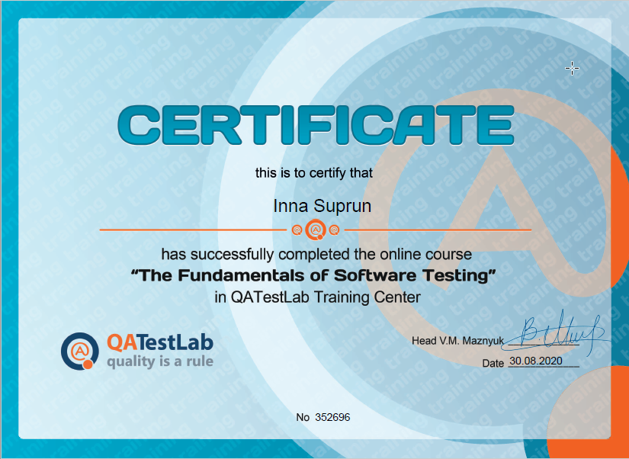

TECHNICAL LEVEL OF KNOWLEDGE:

Qualification level | List of qualifications
Operation system | MS Windows 95-XP, 7, 8, 10
Additional knowledge | MS Office, Photoshop, Lightroom, Vector Magic
Main programmes used for web-templates | HTML, CGI, XML, CSS, CMS
Additional knowledge | Photographing, photos processing  QA testing

Native language: Russian

OTHER LANGUAGES:

Language | Written skills | Oral skills
English | Good level | Good level

